
ECGE4002P-C
Academic Study Skills for Students


Charlene Louise Griffiths
Student Number: 1904882

Contents

Portfolio Task 1 – Developing your skill: vision of Success as a student-teacher 2
My Digital Mind Map 2
My Current Skills Audit 3
What Success looks like to me 4
Portfolio Task 2 – Developing Critical Thinking 5
Portfolio Task 3- Developing Critical Writing 7
References 9

Portfolio Task 1 – Developing your skill: vision of success as a student-teacher

My Digital Mind Map
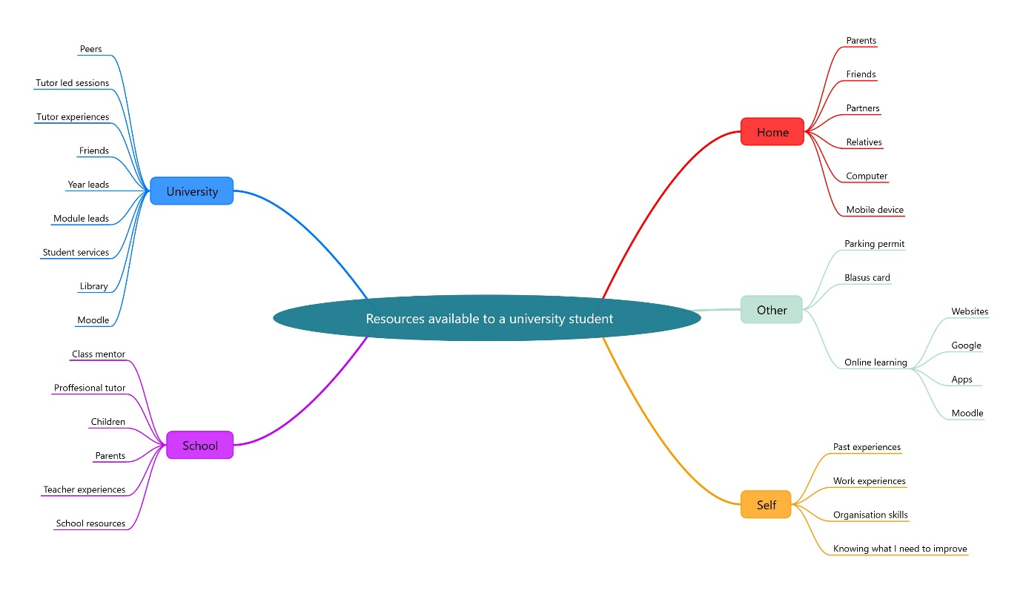

My Current Skills Audit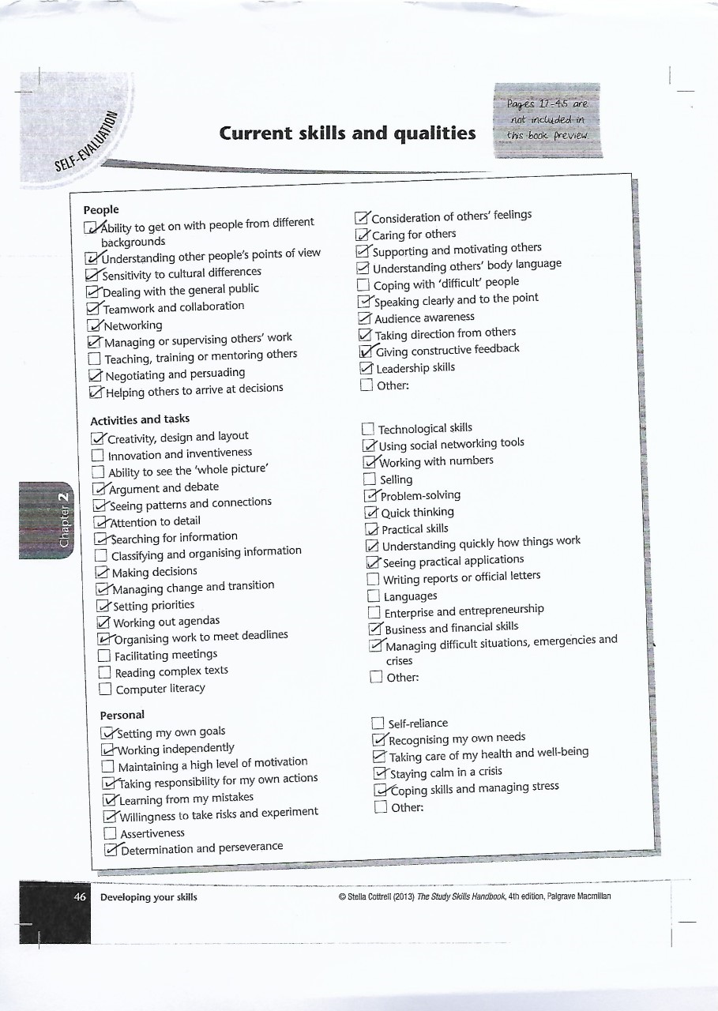

What success looks like to me

I believe that success can mean so much to different people, in different ways. This view is supported by Cottrell (2013) who states:
Students invest a great deal of time, energy and money in their higher education so success at University or at Collage is usually very important to them. However, there are many different versions of what that success would look like.
p.33
Success for me would be to graduate with a first in my degree and proving to myself that I could achieve an academic qualification. Then securing the most rewarding job as a teacher in a primary school and being a brilliant teacher who the children respect and creating a classroom where the children enjoy learning. There is no doubt that success is seeing the children develop new skills and knowing that I helped them to achieve and become ambitious capable learners.
To be successful I would like to develop my skills in critical reading and academic writing further and learn new skills of how to deal with difficult people, for example how to help a distressed parent or a misbehaving child. And to know who there is to help me through difficult times. Success for me is being the best person I can be, never giving up and completing everything I put my mind to. Success is also being able to look back and reflect on how I’ve changed and developed for the better through the years of studying for my degree and becoming a teacher. I want to be successful to provide the best life for my family and to gain the upmost respect from friends, colleagues and peers.

Portfolio Task 2 – Developing Critical Thinking

As part of an academic qualification it is important to use a range of skills such as critical thinking and reading, particularly when analysing information such as research reports or statistical data. Cottrell (2011) suggests that critical thinking is a cognitive activity where we learn to think critically and evaluate in ways using mental processes such as categorising information and using rational judgement.
Critical thinking involves a wide range of skills and attitudes. Thinking critical helps us keep an open mind when identifying other peoples’ opinions, arguments and reasons, and evaluate evidence at different points of view to help us weigh up opposing arguments and look at the evidence fairly. Critical thinking guides us to read between the lines and identify fair and unfair assumptions and information. Cottrell (2011) states thinking critical helps us to reflect on issues in a structured way, being logical about the issues and drawing conclusions if the information is valid and true based on good referencing and evidence and good assumptions. Critical thinking draws together your judgement on the evidence, so you can synthesise the information to create your new point of view and present your point in a well-structured, clear and well organised way that sways others to see your reasoning.
When thinking critical Cottrell (2011) states we must know our own reasons into what we are thinking and remember to keep a rational thought when identifying reasons and conclusions. We must use critical analysis to evaluate whether other peoples’ reasons are supported by their conclusions and the evidence is well-founded.
Cottrell (2011) suggests critical thinking involves accuracy and precision when looking at information making sure you take time to read and note down clues, identifying patterns and trends, such as repetition and similarities in the information. We must look at the evidence and information from several points of view putting aside our feelings and beliefs and to only focus on the information we are analysing.
As a student thinking critical helps us find the most appropriate evidence to help put our reasoning where we stand on the information we are discussing. Helping us decide if the evidence is biased and if the evidence supports our arguments. Thinking critically guides the audience reading your information, referencing and evidence to understand your reasoning or judgement and maybe let them see your point of view clearly and maybe even sway them to think the same as you.
There are also many barriers to critical thinking, sometimes there can be a misunderstanding of what is meant by criticism and people assume you must make negative comments, but we must remember criticising can mean negative and positive comments on other peoples’ information, opinion or evidence. Sometimes people can feel reluctant to criticise experts for example when someone like me has little knowledge over the subject and we must criticise someone’s work who is clearly more experienced than us, this can be very daunting. Other barriers include a lack of methods, strategies or practice and misunderstanding information which effect your reasons. Using insufficient focus and attention to detail can give poor criticism on information if not read carefully and accurately.
Anyone can think critically we just need to follow these steps put in place by Cottrell (2011) and work through the activities provided to improve our critical thinking skills.

Portfolio Task 3- Developing Critical Writing
What I think about Education in Wales

The Curriculum in schools in Wales are similar to other parts of the United Kingdom. Starting with the teacher-led, child- centred philosophy of ‘Plowden’ (1967), to a subject centred rationale of the National Curriculum in 1988 which gave exposure for all children and young people to nationally specified knowledge and skills (OECD, 2014).
I agree that the Welsh Government (gov. wales) have always tried to improve education in Wales by changing the Curriculum in 2008 to include ICT, Physical activity and Sports, Arts and Culture, and the use of Welsh in all schools. When Key Stage1 was replaced with the Foundation Phase in 2010 changed the perspective of how all teachers saw the curriculum. For example, learning through play, giving the child the opportunity to be at the centre of their learning, developing different skills and incorporating the United Nations Convention on the Rights of the Child (UNCRC). Donaldson’s report (2015) is very supportive of the Foundation Phase and its approaches, but ‘Successful Futures’ which starts in schools in 2022 is a better version on how to build on the Curriculum to make sure that the children have the best education.
Donaldson’s ‘Successful futures’ is a further development on the foundation phase and has been designed to help children keep up to date and develop higher skill levels within technology and life skills, which employees currently look for in new staff. There are four main purposes to the new Curriculum which focusses on developing children and young people to become:
- Ambitious, Capable Learners
- Enterprising, Creative Contributors
- Ethical, Informed Citizens of Wales and the World
- Healthy, Confident Individuals
These four purposes will help children want to learn throughout their lives, help them be ready to make the most of work and life, help them become Citizens of Wales and the World and to help them lead fulfilling lives as valued members of Society.
I agree with Donaldson that all children and young people need a wider range of skills to enter the working world these days, as technology is changing the world fast and the best companies are asking for more life skills instead of school skills. To achieve the most out of Donaldson’s successful futures as Davies and Howes (2009,P 4) shows in their research into developing effective schools we must have teachers who have characteristics such as offering the students structured opportunities for practice, presenting information clearly, being task orientated in a relaxed style and also giving clarification and review to each individual pupil.
Achieving these characteristics requires a flexible and dynamic engagement by the teacher, on a daily basis, with the many complex factors that contribute to classroom learning. In order to do this the teacher must be able to reflect upon and respond to the changing demands of the pupils’ learning needs. The teachers who can accomplish this best are often reflective practitioners (Pedder et al.,2005).
As a student teacher I look forward in following Donaldson’s ‘successful futures’ and learning the characteristics which Davies and Howes (2009) found in their research to be the best teacher to bring out the best in all of the pupils I meet throughout my career.

References

Central Advisory Council for England. (1967) Children and their schools. HMSO: London

Cottrell, S. (2011). Critical Thinking Skills: Developing effective Analysis and Argument. (2nd ed). Basingstoke: Palgrave MacMillan

Cottrell, S. (2013) The Study Skills handbook (4th ed). Basingstoke: Palgrave MacMillan

Donaldson, G. (2015). Successful Futures: Independent Review of Curriculum and Assessment Arrangements in Wales. (visited 16th October 2019)
http://gov.wales/sites/default/files/publications/2018-03/successfull-futures.pdf

Davies, S.M.B., Howes, A. (2009) The Welsh Journal of Education 14. University of Wales: Cardiff.
Hwb website (visited 17th October 2019)
http://hwb.plus.wales.gov.uk

OECD (2014). Improving schools in Wales: An OECD perspective. OECD: Paris
Pedder, D., James, M. and MacBeath, J. (2005). How teachers’ value and practice professional learning, Research Papers in Education. Retrieved from Davies and Howes (2009).

Yr athrofa (visited 11/10/19)
http://athrofa.cymru/2019/02/22/an-innovative-curriculum-led-by-transformative-teachers/

