1920269
Congeita Clarke-Young
BMHP5014_BIRM
Dr Azora Huard

Changemakers: Creativity and Value Creation
Reflecting on project outcomes.

Content Page

Page

Introduction 1

Unit 1 - Topic 2, Innovation and developing creative confidence 2/2

Unit 2 - Topic 2 , Storytelling creative solutions why do we tell stories 3/3

Unit 3 - Topic 3 Mobilising support, preparing a strong presentation 4

Unit 4 – Topic 1, Personal Evaluation Measuring Success, 5/5

Conclusion 6

References 7

Introduction

Changemakers: creativity and values creation my own perspective and my own reflection on the individual topics of what I have learnt in a whole from values and creativity makes to common good within (Health and Social Care), how important the information as help me in the units from the E learning online activities. Reflecting on how this has been inspirational in enhancing my knowledge how to be creative and how I will use what I have learnt in future. Recognizing a lot of aspects in changemakers and values creation assignment will have great use for that successful project that I aim for within health and social care sector.

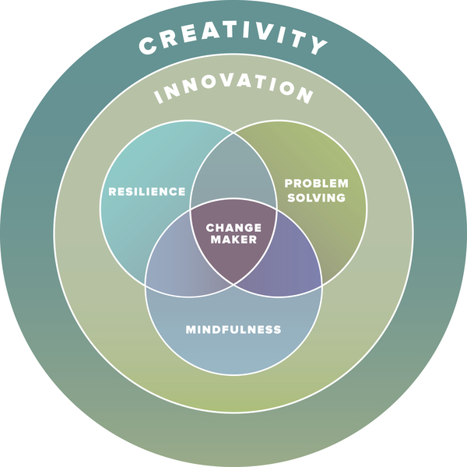

(Creativity & Innovation at CC - Colorado College, 2022)
1
Unit 1 - Topic 2, Innovation and Developing creative confidence.

Innovation my own reflection within my own life and the health care sector which I have been a valued member off staff in many different roles over an establish amount of years, for the last 27 years nearly as been a big part of my life weather on a ward or in the community, I have learnt many things within the years that I give to (NHS). Analysing everything as enhanced my knowledge to work hard if I focus and progress to my success. Worked in (Mental Health Care Sector)’ which has pushed me to study towards Health and Social Care which has given me a lot of insight in enhancing my knowledge, to become a social worker? not too sure yet understanding and what else I need to support developing that successful future or business. Striving for what I want means creating something new that will be relevant for what I need to achieve creativity to be successful with in my new invention, having understood the information from (E Learning) Moodle developing the knowledge how to design that creative mindset motivation to conquer to achieve getting over all the fear because I don’t want to defeat failure.
Innovation importance aspect of my creative ideas for future is very relevant to building solid enterprise towards my chosen career in health and social care with all my aims values, using my knowledge a bit like brainstorming looking at obstacles in my way focusing on what will help me towards my success is making innovation the best of my ability to that success this was also stated According to ( The Innovation Book 2022), “The open innovation model thinks that external brain power is just as important as internal brain power. The open innovation model considers ideas surrounding how to use the innovation as just as important as the innovation itself. The way of making the innovation successful (The business model) matters.” (The innovation Book, 2022).
Creative confidence lays within every individual are born creative as child we all have had that imaginary playful experience and were very outrange and did crazy things asked lots of questions. Over many years times have changed in many ways we moved forward children are growing older wiser trough socialization and also education. According to (Reclaim Your Creative Confidence 2022), “Reclaim Your Creative Confidence, 2022). ”Most people are born creative. As children, we revel in imaginary play, ask outrageous questions, draw blobs, and call them dinosaurs. But over time, because of socialization and formal education, a lot of us start to stifle those impulses. (Reclaim Your Creative Confidence, 2022).
2
Knowledge developing how to find the ability to capture my own thoughts focusing on what I believe will create change, within my own private network for me to achieve that future goal in my own capacity in the way that I find creative towards innovation. Focusing On new ideas and methods which is crucial in having successful organisation, which is what I am heading towards, finding the strength to do this adventure because in the past I have had a lot off set back in my life. According to “ (How to Build Your Creative Confidence, 2022), “Choose Strength Some people have let a single set back early in life, shut them down.” (How To Build Your Creative Confidence, 2022).

2
UNIT 2 – Topic 2, Storytelling Creative Solutions, why do we tell stories.
Storytelling is listening to confident stories and past memories which every individual has a unique story they want to share which is based on influence, past memories can be a good way to pass on history. Heading for that goal that I am looking for has a story to tell. Reflecting on how I reached this fare and were I want my success to bring me in the future, working within the healthcare system over the years engaging with staff and services users.
- Engaging and listening to many different stories sometimes I do believe that listening to other people’s stories passed experiences can be helpful and motivate positive thinking which can make improvement and influenced changes within storytelling. According to (The power of storytelling 2022), ”In health care, stories are proving to be a useful tool in engaging people with quality improvement work.
- Telling the story of one patient’s experience of care can memorably illustrate improvements or problems in a care pathway. Statistics and data have an important place in monitoring and understanding services and facilitating improvement, but the right story can also have the power to motivate and change minds.”(The power of storytelling, 2022).
Storytelling from working in health sector organization what I have learnt over the years as made me a better person in my life towards how I look at clients and cared for how I have changed feel more compassion now within my role. Self-centred very compassionate person My own life can tell stories and the growth and benefits off success that can lead me to managing my own innovation, towards that success worked hard towards and all the obstacles I have taken story telling has help me to build a good academic outcome for that future goal within my chosen role. Also stated . According to (The role of personal storytelling in practice, 2022), “ Storytelling influences change at individual practice as well as organisational level,
- Listening to stories facilitates better person-centred care and can lead to improved services,
- Hearing personal stories engenders greater understanding, empathy, and reflection,
3
- Rapport, trust, and care can be nurtured in practitioner-service user relationships through storytelling,
- Personal storytelling benefits the teller as it can empower, encourage personal growth, and build resilience,
- Due consideration needs to be given to ethical issues in storytelling and telling stories has the potential to be demoralising and disempowering for the teller. ” (The role of personal storytelling in practice, 2022).

3
Unit 3 – Topic 3 Mobilising Support Preparing a strong presentation

Preparing a strong presentation involves lots of hard work depending on what kind of presentation you are doing planning out what direction and actions you need to take, within accomplishing towards that successful presentation. Plan a head look at your strength’s weakness get input from other sources communicate with people in different fields weather group chat if I was doing a group presentation with that other support, Preparing carefully making sure that I give myself enough time to prepare thoroughly how I would plan the right structure what kind of a format I would need what would be my main key factor to focus on. According to (6 steps to a successful presentation | Prospects.ac.uk 2022), ”Give yourself plenty of time to prepare thoroughly, as a last-minute rush will leave you flustered when it comes to delivering your presentation. 'Plan the structure and format - Introduction, the key facts you want to get across in the most logical order, the objective and purpose of your presentation and the conclusion,' advise the careers team at the University of Cumbria.” (6 steps to a successful presentation | Prospects.ac.uk, 2022).
Thinking about what type of presentation I wanted it to be the best of my ability, everything would be in the right order and contents easy to understand for the slides that I was about to use from my technical insight and what I learnt so fare in last nine weeks in collaboration with innovation and creativity entrepreneurship focused on ideas. Reflecting on business prospective they do have form of relation with connection. According to (Study with us, 2022),
“Creative ideas need to be adopted, implemented, and commercialised for innovation to occur which can require entrepreneurial flair. Business leaders need to discuss, consult, and consider where creativity, innovation and entrepreneurship are most needed, what they should be applied to and for what purpose, and what their relevance, significance and value might be for customers and prospects. They should also consider whether they should take a wider range of interests into account when deciding when, where and for whom to be creative, innovative, and entrepreneurial. (Study with us, 2022).
4
Unit 4 – Topic 1, Personal Evaluation Measuring Success, what is success.

Personal evaluation measuring the aspects of my journey and what I have learnt over the last ten weeks has given me lots of ideas and insight to focus on the most important values for that future goal, accomplishing all that I have worked for looking at my own refection. Measuring what I have learnt from my own perspective in my own life takes a lot of energy to focus properly on day-to-day basis, the knowledge that I have gained within storytelling evaluating on everything I have learnt so fare. Makes me release that you have independence to be able to become a leader having competence to develop my own ideas and the ability managing my own my health and well-being are my first priority, has I have not very physical at motivating myself finding energy is my main key factor, According to (Gallup, 2022),
“The first element is about how you occupy your time or simply liking what you do every day: your Career Well-Being.
The second element is about having strong relationships and love in your life: your Social Well-Being.
The third element is about effectively managing your economic life: your Financial Well-Being.
The fourth element is about having good health and enough energy to get things done on a daily basis: your Physical Well-Being.
The fifth element is about the sense of engagement you have with the area where you live: your Community Well-Being.”(Gallup, 2022).
Creating innovative ideas towards being successful developing how to act and work independently to achieve that goal takes challenges, mapping out my health and well-being mind map is positive start towards that future success.
5
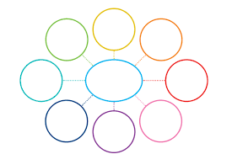
Well-Being
Me
Work
(Twinkle Mind map 2022)
Socializing
Community
Friends
Career
Family
Financial

5
Conclusion

Self-Refection on what I have learnt from doing this model within the Moodle E Learning on innovation and creativity and values creation as enhanced my knowledge, the understanding as thought me more about how to develop were I am now and were I want to be in the future. Innovation can be expressed as the essence of a problem solving in so many different ways innovation as change dramatically since prehistoric times, now in the 21st century the values that innovation brings.
Thought my first semester and leaning about the E portfolio module I have had time to reflect on myself, I’m preparing myself for real world of social work that awaits me at this point in time I’ve got some well needed temporal and practical knowledge that will help me to succeed and give me hat confidence to carry on with my learning journey and help me with my career path. The changemakers module has not only given me the knowledge that I am using right now but has made me better and a lot more critical reader within my learning. The course has been very challenging throughout this has increased my level of knowledge and attitude which will help me to strive in my future career.

6
Reference list

Sourcesofinsight.com. (2022). How to Build Your Creative Confidence. Available at: <https://sourcesofinsight.com/how-to-build-your-creative-confidence/> (Accessed 26 July 2022).

Harvard Business Review. (2022). Reclaim Your Creative Confidence. Available at: <https://hbr.org/2012/12/reclaim-your-creative-confidence> (Accessed 26 July 2022).

Iriss. (2022). The role of personal storytelling in practice. Available at: <https://www.iriss.org.uk/resources/insights/role-personal-storytelling-practice> (Accessed 27 July 2022).

The Health Foundation. (2022). The power of storytelling. Available at: <https://www.health.org.uk/newsletter-feature/power-of-storytelling> (Accessed 27 July 2022).

University of Greenwich. (2022). Study with us. Available at: <https://gala.gre.ac.uk/cgi/stats/report> (Accessed 28 July 2022).

Ebookcentral.proquest.com. (2022). The Innovation Book. Available at: <https://ebookcentral.proquest.com/lib/trinity/reader.action?docID=5174015&ppg=1> (Accessed 01 August 2022).

Gallup, I., (2022). The Five Essential Elements of Well-Being. Gallup.com. Available at: <https://www.gallup.com/workplace/237020/five-essential-elements.aspx> (Accessed 1 August 2022).

Coloradocollege.edu. (2022). Creativity & Innovation at CC - Colorado College. [online] Available at: <https://www.coloradocollege.edu/offices/creativity-innovation/> (Accessed 2 August 2022).

Twinkl.com.au. (2022). Available at: <https://www.twinkl.com.au/teaching-wiki/mind-map> (Accessed 2 August 2022).
7

