

Software Solutions for Business

Module Name: CertHE Computing Skills for Workplace software

Module Code:

Student Name: Vithursha Parameswaran
Student ID: 2442072
Group: 4

Lecturer’s Name: Koushik Modak

Contents
Task 1 3
E-Commerce Website Builders/Software Solutions 3
1.Shopify 3
2. Wix eCommerce 5
Task 2 7
A. Mind Map of Contemporary Software Applications 7
B. Mind Map of Contemporary Software Applications 8
Task 3 9
Office Applications for creating, storing, presenting, and analysing information/data 9
1. Introduction 9
b. Test any two features from the following Mail merge, IF Function, VLOOKUP, Pivot Table, Goal Seek in MS Excel, and document several screenshots with accompanying description to provide evidence of practical use. 16
References 18

Task 1

E-Commerce Website Builders/Software Solutions

1.Shopify



Fig 1: Website template developed using Shopify features [1]

Come to Shopify is one of the most popular e-commerce website builders used by particular and businesses to create online stores. Shopify provides a user-friendly dashboard where store owners can easily add products, upload images, set prices, and manage orders.
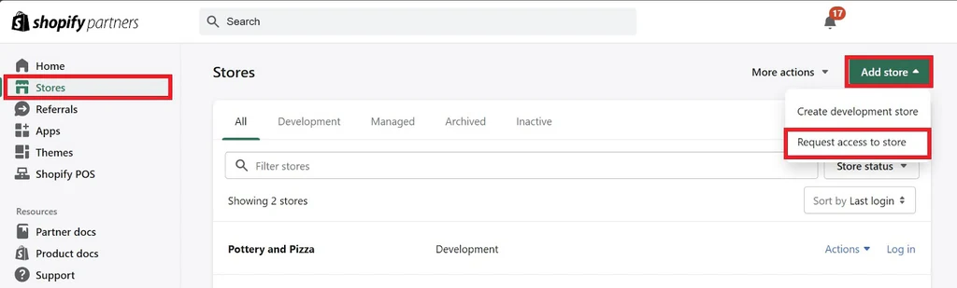
A major advantage of Shopify is the large selection of customizable themes it provides, which makes it easy for users to create polished and attractive websites. All these themes are optimized for mobile use, so customers can browse and shop comfortably on any device. In addition, Shopify includes its own integrated payment system, enabling users to securely process transactions through credit cards, PayPal, Apple Pay, and various other online payment methods.

Fig 2: Website template developed using Shopify features [2]

Besides its design options and payment features, Shopify also provides several tools for managing the overall business. Users can monitor sales, access analytical insights, handle inventory, and even launch marketing campaigns all within the platform. It also connects seamlessly with social media channels like Facebook, Instagram, and TikTok, allowing businesses to sell their products directly through those platforms.
An update advantage of Shopify is that it handles web hosting and security automatically. This means that users do not have to worry about maintaining servers or updating software Shopify manages everything in the background.
Overall, Shopify is well-suited for small to mid-sized businesses that want to set up a polished online store without needing advanced technical skills. It boosts efficiency, provides valuable insights through its analytics features, and improves customer interaction with its built-in communication tools Shopify is one of the most popular e-commerce website builders used by individuals and businesses to create online stores. It is a very based platform that allows users to designing, manage easily, and running an online business without any known its very simple technical or coding skills. Shopify offers a user-friendly dashboard that lets store owners add products, upload images, set pricing, and manage their orders with ease

2. Wix eCommerce

Wix eCommerce is another leading website builder that allows users to create attractive and functional online stores. Wix started as a general website builder, But it has evolved into a comprehensive e-commerce solution that handles online sales, marketing activities, and customer management. It uses a drag-and-drop editor, which means users can design websites by simply dragging elements (like text boxes or images) into place, making it very easy for beginners.
Wix provides a large collection of ready-made templates designed for various industries, including fashion, food, and technology. It also offers features that allow users to create product galleries, track inventory, set up discounts, and generate coupon codes. In addition, the platform supports secure payment options like Wix Payments, PayPal, and Stripe, making the checkout process safe and convenient for customers.
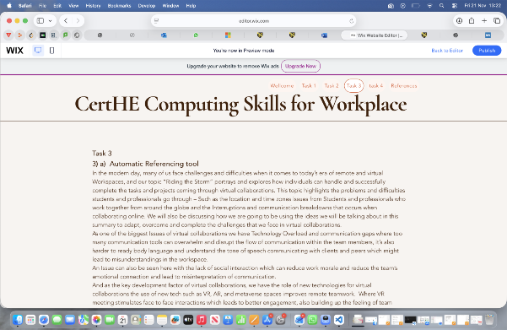
Wix website create
Fig 3: Website template developed using Wix features [3]

Wix eCommerce also has strong marketing and SEO (Search Engine Optimisation) tools that help businesses attract more customers online. Users can run email promotions, link their shop to social media platforms, and monitor customer behavior on their site using the platform’s built-in analytics tools. Another useful feature is the Wix mobile app, which allows store owners to manage their business from their phones.
The main advantage of Wix is its simplicity — it is perfect for individuals or small businesses with little or no web design experience. However, Wix can become more limited for larger businesses that need advanced tools or custom integrations.
In conclusion, Wix eCommerce provides a simple, creative, and affordable solution for small business owners who want to build and manage an online store quickly.

The platform is suitable for small businesses as it provides a drag-and-drop editor, eliminating the need for coding knowledge. It also offers a variety of templates and integrated e-commerce tools. Additionally, hosting, security, and basic site configuration are included, reducing technical complexities for users.

Task 2
A. Mind Map of Contemporary Software Applications
A mind map is a drawing or diagram used to show ideas and how they are connected to each other. It starts with one main idea in the middle and then branches out into smaller related ideas. Each branch can have keywords, colours, and pictures to make the information easier to understand. The idea of mind mapping was made popular by Tony Buzan in 2018, who said it helps people think in the same way that the brain naturally works by linking one idea to another. In business, mind mapping is very useful because it helps people plan, think, and share ideas in a clear way. For example, a company can use a mind map to plan a new project or marketing campaign. This helps teams see all the tasks, goals, and resources in one place. It also helps people remember information better and come up with new ideas quickly.
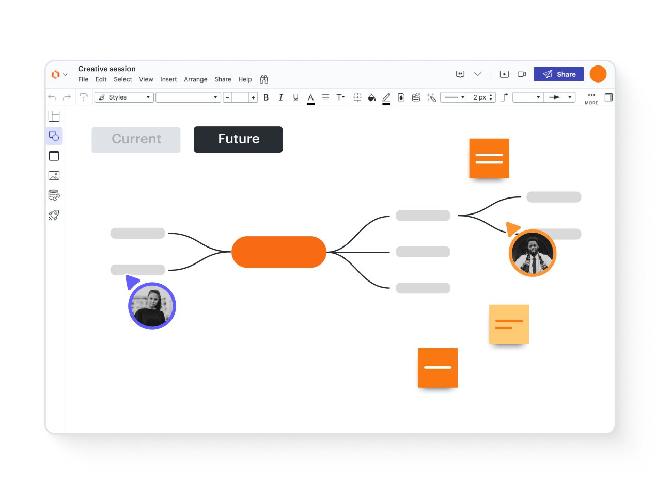
Fig 4: Website template developed using mind map features [4]
Mind maps can also make meetings and teamwork more effective because everyone can see how their work fits into the bigger picture. [5] They are also good for problem solving, strategic planning, and decision making. Overall, mind mapping is a simple but powerful tool that helps businesses stay organised, creative, and productive in their daily operations. strong tool that helps businesses stay organized, creative, and productive every day.

B. Mind Map of Contemporary Software Applications

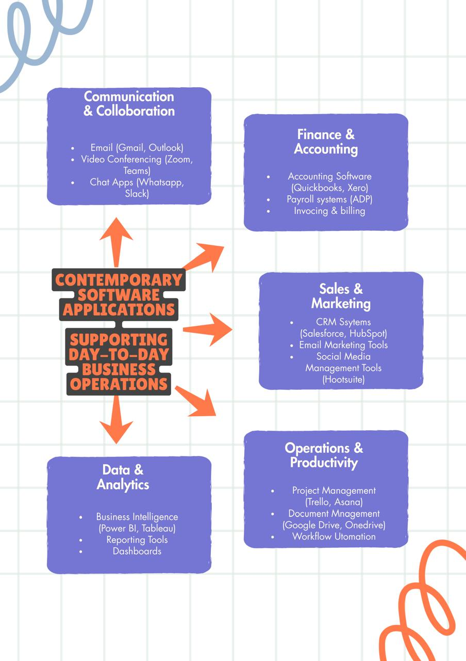

Task 3

Office Applications for creating, storing, presenting, and analysing information/data

1. Introduction
In modern workplaces, computer applications are used daily to complete projects, manage tasks, store information, present ideas, and analyse data. Office software has become an essential part of business operations because it helps employees create, organise, and share information more efficiently. These tools improve productivity, save time, simplify tasks, and support better decision-making.
Microsoft Office is one of the most widely used software suites worldwide, known for its user-friendly design and versatility. It includes programs such as Microsoft Word, PowerPoint, Excel, and Access, each serving a specific purpose but also working together to enhance efficiency and workflow.

1.1Microsoft Word

Microsoft Word is a widely used word-processing program designed for creating and editing documents. It helps users produce various types of written work, including letters, reports, assignments, memos, proposals, and CVs. Because of its simplicity and powerful tools, Word is commonly used in both workplaces and educational settings.

A key advantage of Word is its extensive formatting features. Users can change font styles, sizes, colours, adjust spacing, create headings, and design page layouts. These tools make it easy to produce clear and professional-looking documents. Word also allows the insertion of tables, images, shapes, charts, and hyperlinks, which help make content more engaging and easier to understand.

Word offers a large collection of templates for resumes, brochures, newsletters, invoices, calendars, and more. These ready-made designs allow users to start documents quickly without creating layouts from scratch, making it helpful for those who lack design skills.

The program also provides strong editing and reviewing features. Tools such as spell check and grammar check help users identify errors, while the Track Changes and Comments features are useful for group editing in workplaces and classrooms. These features allow multiple people to give feedback while keeping the original text intact.

One major advantage of Microsoft Word is its support for collaboration. With cloud services like OneDrive and SharePoint, multiple users can edit the same document simultaneously using the Real-time Co-Authoring feature. This improves teamwork and speeds up group tasks. Word is also compatible with many devices, allowing users to open DOCX files on computers, tablets, and smartphones without formatting issues.

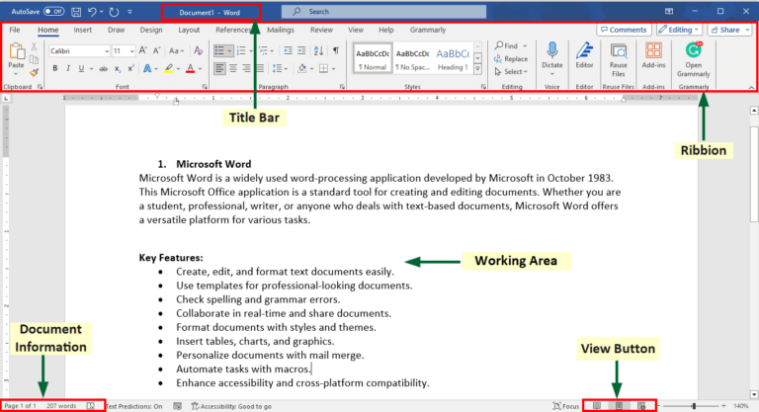
Fig 5: Website template developed using word features [6]

However, Word does have some drawbacks. New users may feel overwhelmed by its many tools. The web version also lacks some features available in the desktop version, which can be inconvenient for users who rely on advanced tools such as mail merge, macros, or referencing functions. Additionally, a subscription or license is required to access all features, which might not be affordable for everyone. Despite these limitations, Microsoft Word remains one of the most important tools for creating and managing documents. Its strong editing tools, user-friendly design, and collaboration features make it a valuable program for business, education, and personal use.

1.2 Microsoft PowerPoint

Microsoft PowerPoint is a presentation software used to create visual slideshows for meetings, classes, conferences, and training sessions. It helps users communicate information clearly and effectively by combining text, images, videos, charts, and animations. One of PowerPoint’s strengths is its wide range of templates and themes. These pre-designed layouts help users create professional slides quickly, even without graphic design skills. Templates can be customised with different colours, backgrounds, and layouts depending on the purpose of the presentation.

PowerPoint also supports multimedia integration. Users can insert charts, audio files, videos, diagrams, and images to make presentations more engaging and easier to understand. For instance, a company presentation may include Excel charts explaining sales performance, while a student project may use visuals to explain a topic.Animation and transition effects help control how content appears on the screen, making presentations more dynamic when used appropriately. The Presenter View feature allows speakers to view notes and upcoming slides privately, helping them stay organised during a presentation.
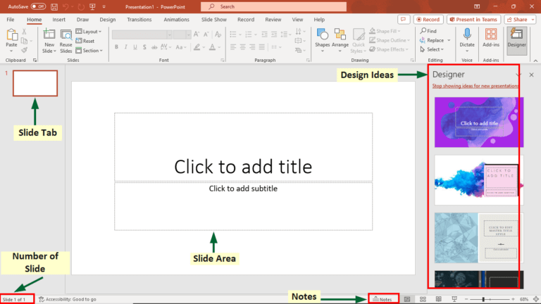 Fig 7: Website template developed using PowerPoint features [7]
PowerPoint’s benefits include the ability to present information visually, which often helps audiences understand complex ideas more effectively. It also allows users to structure information clearly and share presentations easily through email, cloud platforms, or online meetings.
However, PowerPoint also has limitations. Some presenters rely too heavily on slides instead of engaging with the audience. Poorly designed slides such as those with too much text or too many colours can distract or confuse viewers. PowerPoint is not designed for detailed document creation or deep data analysis. Additionally, creating high-quality presentations can be time-consuming for users unfamiliar with design techniques. Even with these limitations, PowerPoint remains one of the most widely used tools for visual communication in both education and business.

1.3 Microsoft Excel

Microsoft Excel is a spreadsheet program used to organise, calculate, and analyse data. It is an essential tool in many businesses for budgeting, tracking expenses, creating sales reports, managing payroll, and storing customer or inventory information. Excel’s main advantage is its ability to perform quick and accurate calculations using formulas and functions such as SUM, AVERAGE, IF, and VLOOKUP. These functions save time and reduce errors compared to manual calculations.
Excel can convert data into charts and graphs such as pie charts, bar graphs, and line charts to show patterns or trends more clearly. This is especially useful in business reports and presentations. PivotTables are another powerful feature that summarise and filter large sets of data, making it easier to analyse information and identify important insights.
Excel is flexible and can be customised for simple or complex tasks. It also integrates well with other Microsoft applications, allowing users to include Excel charts in Word or PowerPoint. However, Excel has limitations. It is not ideal for handling extremely large datasets, as large files may slow down or crash. Spreadsheets can also be prone to human errors; a single incorrect formula or number can affect entire results. Collaboration is possible, but not as strong as in dedicated database systems. Advanced features such as macros or complex formulas may be challenging for beginners.

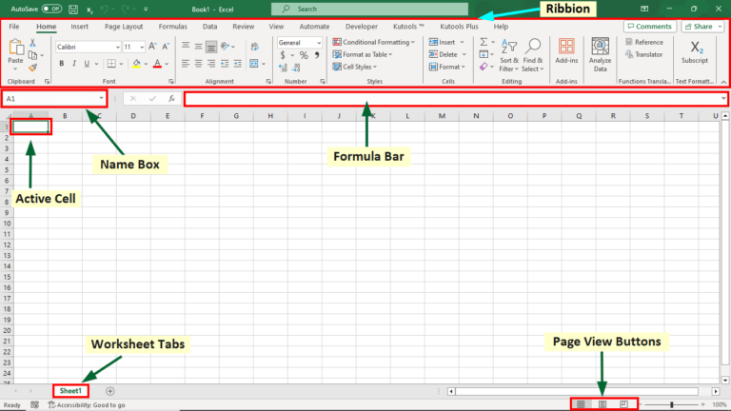
Fig 8: Website template developed using excel features [8]

Despite these challenges, Excel remains a powerful and widely used tool for organising data, performing calculations, and supporting decision-making in business, education, and daily life.

1.3 Microsoft Access
Microsoft Access is a database management tool designed to store, organise, and manage large amounts of structured information. Unlike Excel, which focuses on calculations, Access is used for building relational databases where information in different tables is linked together. Many small and medium-sized businesses use Access to manage records such as customer information, inventory, sales, and projects.
Access allows users to create tables, each containing rows and columns of data. Tables can be connected through relationships for example, Access also includes features such as queries, which help users find specific information quickly, forms for easier data entry, and reports for displaying and printing data professionally. Its main benefits include efficient storage of large amounts of information, reduced duplication of data, and improved accuracy through relational connections. Access also enables users to build customised database applications without needing advanced programming skills. It integrates smoothly with other Microsoft programs, allowing data to be imported or exported easily.

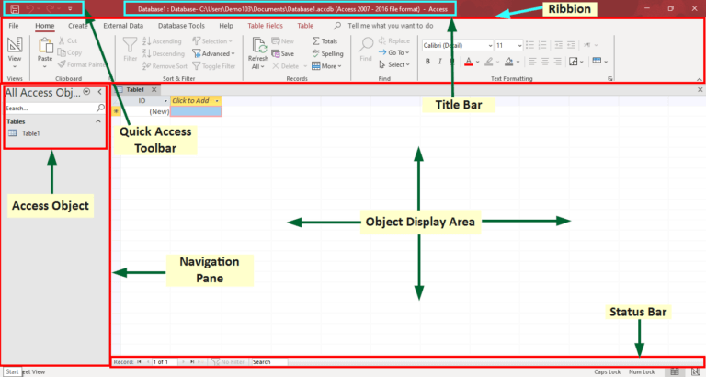
Fig 9: Website template developed using access features [9]

However, Access is not suitable for very large databases or for situations where many users need to work simultaneously. Large files may slow down or malfunction. Additionally, learning advanced queries, forms, and database design can be challenging for beginners.

Despite these limitations, Microsoft Access remains a useful and cost-effective solution for businesses that need a reliable system to manage structured data without the complexity of more advanced database software

b.
features from the following IF Function
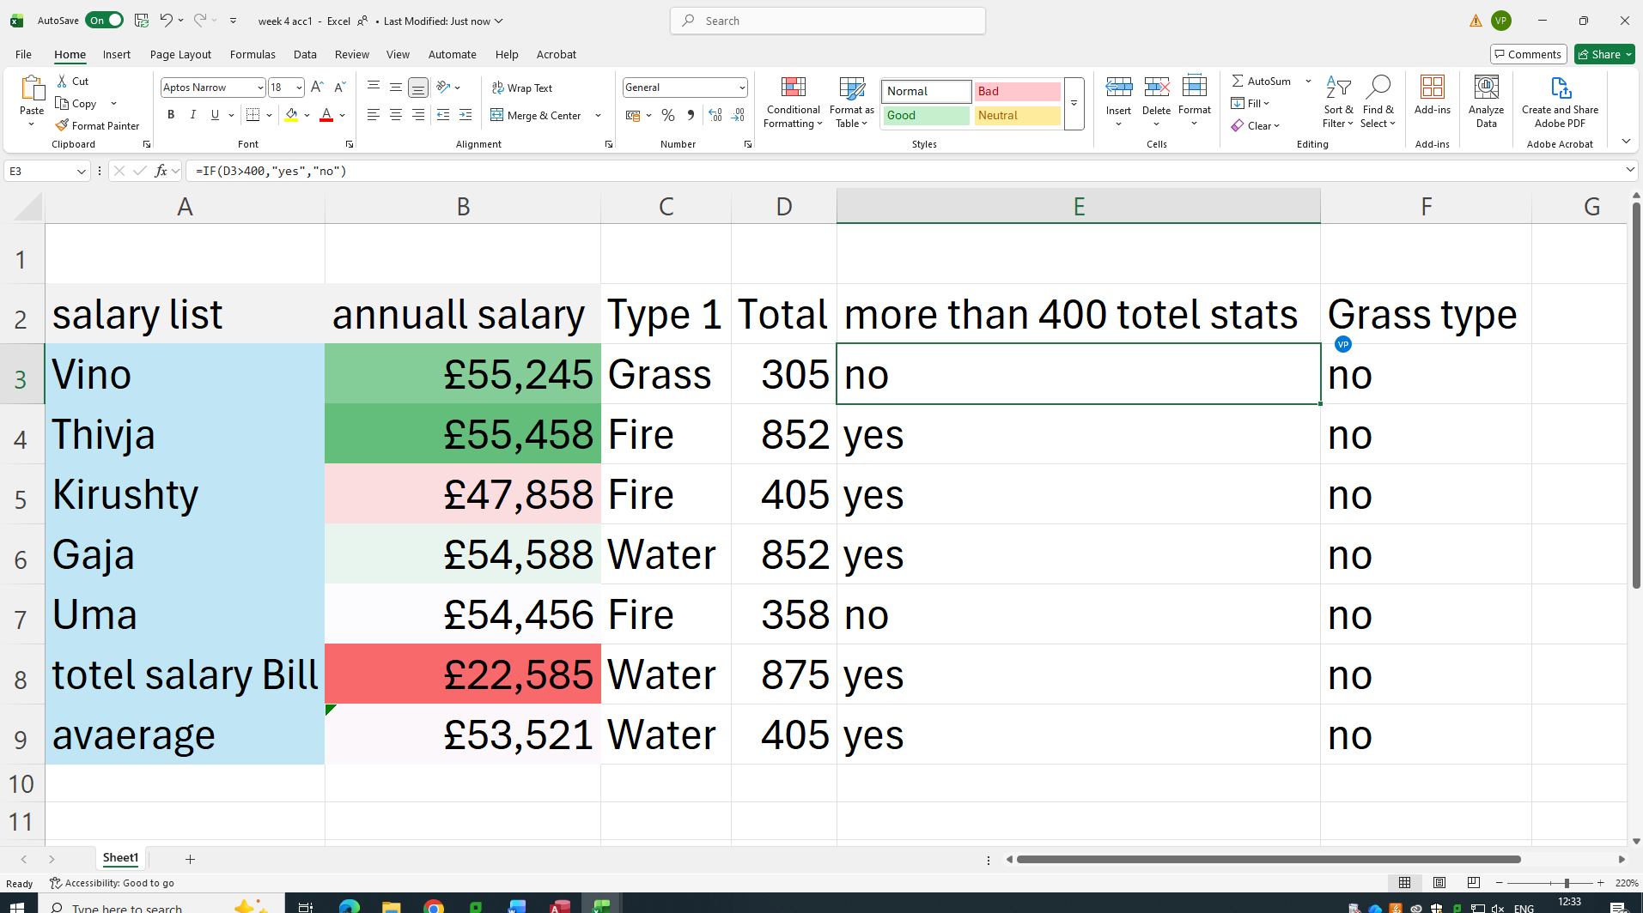

Task 4
Task 4. Communication and Collaboration applications (Approx. 1000 words). a. Analyse one contemporary Communication and one Online Collaboration applications/tools used frequently in modern business world and document a summary of their key features using written text with some images and relevant citations. (approx. 2/3 sources)

Contemporary Communication and Online Collaboration Tools in Modern Business In the modern business world, effective communication and collaboration are essential for remote and hybrid teams. This analysis focuses on two frequently used tools: Slack for communication, which excels in real-time messaging and team coordination, and Microsoft Teams for online
collaboration, which integrates chat, meetings, and document editing into a unified platform. Both tools are widely adopted by enterprises like Fortune 500 companies for their scalability and integration capabilities. Below is a summary of their key features, supported by written descriptions, illustrative images, and citations from reliable sources. Slack: A Leading Communication Tool
Slack is a cloud-based messaging platform designed to replace email with structured, instant conversations, making it ideal for quick team updates and cross-functional discussions. It supports over 10 million daily active users in businesses, emphasizing transparency and efficiency in internal
and external communications.
Key Features:
• Channels and Direct Messaging: Organize discussions into topic-specific channels
• Real-Time Messaging and Huddles: Enables instant text chats with reactions,
threads, and quick audio/video “huddles” for impromptu calls without scheduling,
fostering faster decision-making.
• Integrations and Slack Connect: Seamlessly connects with 2,600+ apps (e.g.,
Google Drive, Zoom) and allows secure external collaboration with partners via shared
channels, enhancing workflow without leaving the app.
• File Sharing and Search: Easy upload and sharing of files, with powerful search
across messages, files, and integrations to retrieve information quickly.
• Notifications and Reminders: Customizable alerts and automated reminders ensure
users stay on top of priorities without constant checking
[Image]
(Screenshot of Slack’s desktop interface showing channels, direct messages, and a huddle in action
– source: Slack official media assets)
Slack’s strength lies in its intuitive design, which boosts productivity by 32% according to user
studies, though it may require paid plans for advanced features like unlimited message history.
Microsoft Teams: A Comprehensive Online Collaboration Platform
Microsoft Teams is an integrated hub within Microsoft 365, used by over 320 million monthly activeusers for seamless teamwork. It combines communication with productivity tools, making it a go-to
for collaborative projects in large organizations like those in finance and tech.
Key Features:
• Teams and Channels: Create dedicated teams for projects with sub-channels for
organized chats, files, and apps, ensuring context-specific collaboration while
maintaining privacy settings.
• Video Meetings and Real-Time Co-Editing: Host HD video calls with screen sharing,
breakout rooms, and live captions; integrate with Word, Excel, and PowerPoint for
simultaneous editing by multiple users.
• Integrations and AI Tools: Connects natively with Microsoft 365 apps and third-
party services (e.g., Trello, Salesforce); includes Copilot AI for meeting summaries,
task assignment, and agenda generation.
• File Storage and Sharing: Built-in OneDrive integration for secure file storage,
version history, and collaborative annotations during meetings.
• Scheduling and Recordings: Easy calendar syncing for meetings with automatic
recordings, transcripts, and post-meeting action items to support asynchronous work.
[Image]
(Screenshot of Microsoft Teams interface highlighting chat channels, a video meeting, and co-
editing pane – source: Microsoft official product imagery)
Teams stands out for its all-in-one approach, reducing app-switching and improving hybrid work
efficiency, but it can feel overwhelming for smaller teams due to its feature depth.
In summary, Slack prioritizes agile communication for dynamic teams, while Teams offers robust
collaboration for integrated ecosystems. Businesses often use them complementarily, with Slack for
quick chats and Teams for deeper project work. For pricing and trials, visit their official sites.

References

[1] | D. Winter, “shopify,” 2025. [Online]. Available: https://www.shopify.com/blog/shopify-themes. [Accessed 3 December 2025].
[2] | M. J. Islam, “Shopidevs,” 2025. [Online]. Available: https://shopidevs.com/shopify-custom-templates/. [Accessed 12 12 2025].
[3] | a. abrahami, “wix.com,” wix, 3 3 2024. [Online]. Available: https://www.wix.com/about/privacy. [Accessed 2025 12 2025].
[4] | Lucid, 2025 . [Online]. Available: https://www.lucidchart.com/pages/landing/mind-map-software?utm_source=bing&utm_medium=cpc&utm_campaign=_chart_en_tier1_desktop_search_strategic-tier2_exact_&km_CPC_CampaignId=687670532&km_CPC_AdGroupID=1238051112953788&km_CPC_Keyword=mind%20map&km_CPC_Mat. [Accessed 10 12 2025].
[5] | A. Athuraliya, “creately,” 2024 9 24. [Online]. Available: https://creately.com/guides/what-is-a-mind-map/. [Accessed 10 12 2025].
[6] | J. Shethna, “Educba Blog,” 2015. [Online]. Available: https://www.educba.com/microsoft-office-application/. [Accessed 10 12 2025].
[7] | J. Shethna, “Educba BLOG,” 2025. [Online]. Available: https://www.educba.com/microsoft-office-application/. [Accessed 10 12 2025].
[8] | J. shethna, “Educba BLOG,” 2015. [Online]. Available: https://www.educba.com/microsoft-office-application/. [Accessed 10 12 2025].
9.https://slack.com/blog/transformation/slack-connect
10.https://www.webdew.com/blog/features-of-slack?
srsltid=AfmBOorIq1W1CJlFglwwqQIG2K0yKRjpukFl5h5Fp7NmB1IzJTyhMCdN
11.https://cerkl.com/blog/slack-communication
12.https://learn.microsoft.com/en-us/microsoftteams/teams-channels-overview
13. https://m.youtube.com/watch?v=4Kx4nHQ_
2Lc

