
DISSERTATION – PROPOSAL LCBB6000
PROPOSED RESEARCH TITLE: TO EXAMINE THE IMPACT OF DIGITAL MARKETING ON BRAND AWARENESS IN FASHION INDUSTRY IN THE UK.

STUDENT NAME: AMNA MASAUD
STUDENT ID: 2113737
NAME OF THE UNIVERSITY: UNIVERSITY OF WALES TRINITY SAINT DAVID
SUBMISSION DATE: 22ND OF APRIL 2024
SUPERVISOR: TUSHARA BALENDRAN

TABLE OF CONTENTS

TABLE OF FIGURES 3
INTRODUCTION 4
ABOUT BRAND AWARENESS AND DIGITAL MARKETING 4
RATIONAL OF THE STUDY 4
AIM 4
OBJECTIVES 4
RESEARCH QUESTIONS 4
LITERATURE REVIEW 5
DIGITAL MARKETING 5
BRAND AWARENESS 5
RESEARCH OBJECTIVES 5
The current digital marketing strategies utilised in the fashion industry. 5
The opportunities and challenges of companies in the fashion industry implementing digital marketing strategies. 6
The impact of digital marketing strategies on brand awareness. 6
THE RACE FRAMEWORK 6
ADVANTAGES 7
DISADVANTAGES 7
METHODOLOGY 8
RESEARCH METHOD 8
RESEARCH ONION 8
PHILOSOPHY: POSITIVISM 9
RESEARCH APPROACH: DEDUCTIVE 10
RESEARCH STRATEGIES: SURVEY STRATEGY 10
TYPE OF INVESTIGATION 10
PRIMARY RESEARCH 10
SECONDARY RESEARCH 11
CHOICES 11
QUANTITATIVE RESEARCH 11
QUALITATIVE RESEARCH 11
MONO METHOD QUANTITATIVE 11
TIME HORIZONS: CROSS-SECTIONAL 12
DATA COLLECTION AND ANALYSIS 12
SAMPLING 12
DATA COLLECTION METHOD 13
ANALYSIS OF DATA 13
RESEARCH ETHICS 13
RESOURCES AND PLANNING 13
REFERENCES 15

FIGURE | NAME | PAGE NUMBER
FIGURE 1 | The RACE Framework | 5
FIGURE 2 | The research onion | 7
FIGURE 3 | Personal Gantt Chart | 11

TABLE OF FIGURES

INTRODUCTION

ABOUT BRAND AWARENESS AND DIGITAL MARKETING
Authors specializing in marketing have emphasized the importance of digital marketing in increasing brand recognition. As an example, Smith & Jones (2019) highlighted the significance of digital marketing strategies in establishing brand visibility and expanding reach to a larger audience in the current competitive market landscape. Similarly, a recent study by Brown & Wilson (2020) found that companies who allocate resources towards digital marketing initiatives are more likely to see an increase in brand awareness and engagement with customers. The importance of using digital channels to increase brand awareness and strengthen customer relationships is emphasized by these discoveries.

RATIONAL OF THE STUDY
In the rapidly evolving environment of the fashion sector, it is essential to create and preserve brand recognition to achieve success. The emergence of digital marketing has prompted brands in the United Kingdom to utilize a multitude of online platforms to enhance their visibility and interact with customers. This research investigates the influence of digital marketing on brand recognition within the fashion sector in the United Kingdom, outlining the approaches utilized and the consequences for brand prominence and consumer attitudes. (Smith, 2019)

AIM
The main aim of this research is ‘To examine the impact of digital marketing on brand awareness in fashion industry in the UK.’

OBJECTIVES
Various objectives will be carefully considered throughout the course of the research:
- To investigate the current digital marketing strategies utilised in the fashion industry.
- To determine the opportunities and challenges of companies in the fashion industry implementing digital marketing strategies.
- To analyse the impact of digital marketing strategies on brand awareness.

RESEARCH QUESTIONS
There are specific research questions that can aid in maintaining focus and direction during the presented research study:
- What are the current digital marketing strategies utilised in the fashion industry?
- What are the opportunities and challenges of companies in the fashion industry implementing digital marketing strategies?
- What is the impact of digital marketing strategies on brand awareness?

LITERATURE REVIEW

DIGITAL MARKETING
A multitude of definitions for digital marketing have surfaced throughout the years. However, it is important to recognize the definition presented by Chaffey & Chadwick (2019), which articulates that digital marketing is a strategic approach that utilizes various digital channels and platforms to promote products or services, build brand awareness, and engage with specific target audiences. It involves using digital channels such as social media, email marketing, search engine optimization, content marketing, and various other tools to achieve marketing objectives in the digital space. According to the definition proposed by Smith and Johnson (2020), digital marketing entails the strategic utilization of digital channels to enhance brand recognition, foster lead generation, and enhance customer relations. Organizations have the capacity to enhance the impact of their online messaging and campaigns by utilizing data analytics and marketing automation to tailor their strategies to specific audiences.

BRAND AWARENESS
According to Patil (2017), the effectiveness of a brand's presence or recognition in consumers' memories is correlated with brand awareness. This can be measured by the degree to which consumers are able to identify a brand under different conditions. The concept refers to a customer's capacity to identify or remember that a specific brand belongs to a specific product category. Few years later, Kotler and Armstrong (2021) argued that brand awareness is a crucial element in the establishment and sustainability of a prosperous brand. It is widely recognized as the initial phase of the customer decision-making journey and plays a crucial role in establishing brand value.

RESEARCH OBJECTIVES
In the constantly changing field of digital marketing, companies frequently aim to increase recognition of their brand by implementing strategic initiatives. Research goals regarding digital marketing and brand awareness can cover various subjects, such as studying how social media marketing influences consumers' perceptions of a brand or examining how effective digital advertising campaigns are at improving brand recognition (Smith, 2019).

The current digital marketing strategies utilised in the fashion industry.
The effectiveness of fashion brands heavily relies on the implementation of digital marketing strategies, which are integral in increasing brand recognition, fostering consumer interaction, and driving sales. Fashion brands can maintain their competitiveness and relevance in the ever-changing digital environment by successfully incorporating these strategies (Chaffey & Chadwick, 2019).

The opportunities and challenges of companies in the fashion industry implementing digital marketing strategies.
Digital marketing strategies are becoming increasingly crucial in influencing the success of companies in the fashion industry, as the sector continues to undergo continuous evolution. The evolution of technology and changes in consumer behaviour create various opportunities and difficulties for companies. It is essential for fashion organizations to comprehend the complex relationship between digital marketing strategies and the performance of their business to succeed in this environment (Chaffey & Chadwick, 2019).

The impact of digital marketing strategies on brand awareness.
Digital marketing has transformed the way brands engage with their desired consumer base, providing unique chances to elevate brand recognition within the digital realm. In today's digital era, it is imperative for businesses to effectively incorporate digital marketing strategies to remain competitive and maintain relevance (Smith, 2018).

THE RACE FRAMEWORK
The RACE Framework is a conceptual model that categorizes digital marketing strategies into four essential elements: reach, act, convert, and engage. Every element is essential in the creation of an effective online marketing strategy. The concept of the RACE Framework entails a structured approach to dissecting digital marketing strategies based on four fundamental elements: reach, act, convert, and engage. Every element is essential in the formation of an effective digital marketing strategy, as shown in Figure 1. (Smith, 2020)
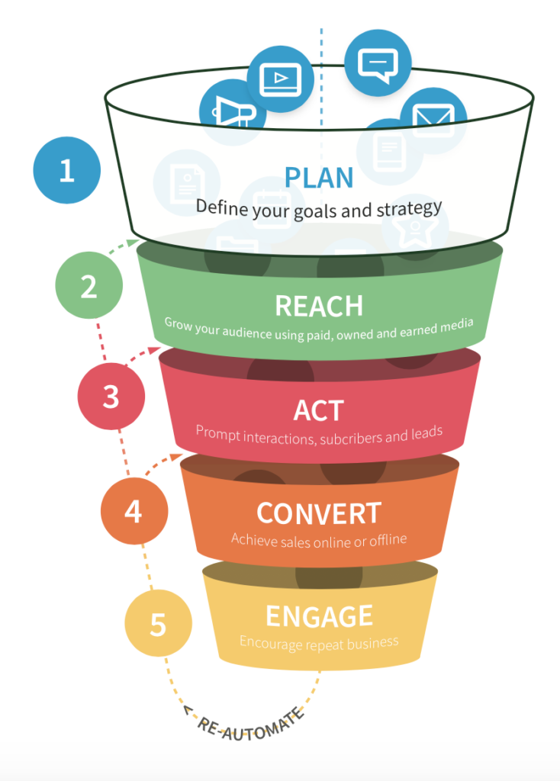

Figure 1: The RACE Framework (Chaffey, 2023)

ADVANTAGES
- The RACE model offers a methodical strategy for digital marketing by dividing
The process into distinct phases - Reach, Act, Convert, and Engage. This framework aids marketers in strategizing and executing their digital marketing initiatives with efficiency (Smith, 2020).
- The RACE model underscores the importance of tracing the customer
experience, starting from the point of establishing awareness of the brand through to the stages of conversion and long-term retention. Marketers can enhance the effectiveness of their strategies by customizing them to align with the specific needs and preferences of their target audience at each phase of the customer journey (Smith, 2020).
- The structure promotes the utilization of data and analytics for assessing the
efficacy of digital marketing initiatives. This methodological approach utilizing data enables marketers to monitor essential performance metrics (KPIs) and make data-informed decisions to enhance their strategies (Smith, 2020).

DISADVANTAGES
- The RACE framework may prove to be overly intricate for small-scale
businesses or entities facing constraints in resource availability. Executing each phase of the framework necessitates a dedication of time, specialized knowledge, and financial resources across a range of digital marketing platforms (Smith, 2020).
- Segmenting digital marketing tasks into Reach, Act, Convert, and Engage
phases could potentially result in a disjointed approach and a lack of cohesion between various communication platforms. Marketers must guarantee that all phases are cohesive to establish a unified customer experience (Smith,2020).

METHODOLOGY

RESEARCH METHOD
Research methodology is a structured approach for designing, implementing, and evaluating research projects to produce novel findings and understandings. It entails the careful selection of suitable research design, methodologies for data collection, and analytical techniques to effectively address research inquiries and test hypotheses. The primary objective of research methodology is to uphold the precision, dependability, and authenticity of research results by instituting a systematic approach for carrying out scientific inquiries across various fields of study (Dawson, 2017).

RESEARCH ONION
The methodology known as the research onion framework, developed by Saunders et al (2007), provides a comprehensive and methodical framework for organizing and executing a research project. This approach offers a comprehensive structure for researchers to adhere to, leading them through multiple stages of the research process to guarantee a thorough and comprehensive examination. The research onion model comprises various components, such as philosophical foundations, research approaches, methodological strategies, data collection methods, data analysis techniques, temporal considerations, and research tools. Through an examination of these phases, a deeper comprehension of how digital marketing influences brand recognition within the fashion sector in UK can be attained.

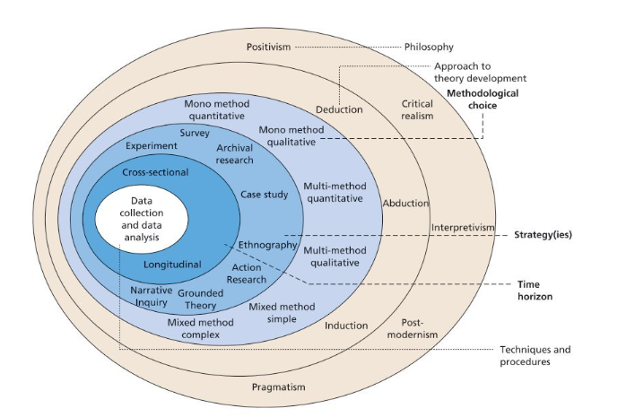
Figure 2: The research onion (Saunders et al., 2016)

In the following sections will be specified the particular features of each Research
Onion layer that applies to the analysis of how digital marketing affects brand awareness.

PHILOSOPHY: POSITIVISM
The positivist philosophy is frequently selected for research in the areas of digital marketing and brand awareness, as it prioritizes the use of empirical evidence and the application of the scientific method. Through embracing a positivist methodology, researchers specializing in digital marketing can collect numerical data, examine patterns, and formulate conclusions rooted in unbiased observations. This approach aids in ensuring the credibility, consistency, and evidence-based nature of research outcomes, as opposed to being based on personal interpretations or biases. Within the realm of brand recognition, the philosophy of positivism holds significant value as it enables researchers to assess the efficacy of digital marketing tactics in increasing consumer awareness of a particular brand. Researchers can quantitatively evaluate the effects of different marketing campaigns on brand recognition and recall using surveys, experiments, and other data collection techniques. Moreover, positivism philosophy advocates for leveraging data analytics and sophisticated statistical methods to identify patterns and insights that can inform brand managers in making well-informed decisions regarding their marketing strategies (Smith & Wilson, 2018).

RESEARCH APPROACH: DEDUCTIVE
The deductive research approach is frequently utilized in digital marketing and brand awareness studies because of its systematic and rigorous characteristics. This methodology commences by postulating a theory or hypothesis, followed by the collection of data to corroborate or invalidate the preliminary proposition. Within the realm of digital marketing and brand awareness, employing a deductive approach enables researchers to validate defined hypotheses regarding the influence of digital marketing tactics on brand awareness. This method facilitates a more precise comprehension of the correlations among various factors (Kim & Ko, 2020).
As per Creswell (2014), deductive research is most beneficial in quantitative research endeavours, whereby the aim is to assess the correlation between variables and evaluate postulated theories. In the realm of digital marketing, where the use of data to inform decisions is crucial, employing a deductive approach offers a structured methodology for evaluating the impact of various digital marketing strategies on metrics related to brand awareness.
Additionally, according to Bryman and Bell (2015), deductive research plays a key role in establishing causal connections among variables, particularly in assessing the impact of digital marketing campaigns on increasing brand recognition. Through the utilization of deductive reasoning, researchers can produce empirical data that either confirms or refutes their hypotheses, resulting in enhanced and dependable understandings within the field of digital marketing and brand recognition.

RESEARCH STRATEGIES: SURVEY STRATEGY
This study will employ research surveys to gain insights into individuals' viewpoints on digital marketing practices and levels of brand recognition. The utilization of surveys as a research tool is essential for gaining insight into consumer behaviour, preferences, and brand recognition within the field of digital marketing. Through the administration of surveys, businesses can acquire valuable information regarding the preferences, demographics, and overall perception of their target audience. The well-organized surveys discussed are a valuable tool for gaining insights into consumer behaviour and brand perception within the domain of digital marketing. Businesses can use the data obtained from these surveys to make informed choices about how to improve their digital marketing strategies and increase recognition of their brand (Smith, 2017).

TYPE OF INVESTIGATION

PRIMARY RESEARCH
Primary data collection involves collecting raw data directly from individuals, entities, or experimental studies to fulfil research goals. This approach entails the direct gathering and examination of information to produce coherent perspectives and relevant research discoveries. The collection of primary data in the field of digital marketing is essential for gaining insight into and improving the visibility of a brand. Obtaining information directly from target audiences allows businesses to obtain valuable insights that can be utilized to customize their marketing strategies in a more effective manner (Yin, 2018). There are different techniques for gathering primary data in digital marketing, including the use of surveys. This research will obtain its primary data through the administration of surveys.

SECONDARY RESEARCH
According to Smith & Johnson (2017), data collected and analysed by an outside source for purposes unrelated to the current research project is referred to as secondary data. In addition to conducting primary research, this study will also utilize secondary data obtained through a comprehensive review of existing literature. To improve brand recognition, digital marketing strategies heavily rely on the collection of secondary data. Through the analysis of data gathered from various sources, marketers can obtain important insights regarding consumer behaviour, market trends, and rivals' actions. This makes it easier to plan targeted promotional campaigns and make educated decisions that successfully reach the desired target audience (Smith & Johnson, 2020).

CHOICES

QUANTITATIVE RESEARCH
Quantitative data, which includes both primary and secondary sources, consists of a broad array of information ranging from simple numerical counts, like the frequency of an advertising slogan, to more complex datasets. However, to derive utility from these data, it is imperative that they undergo comprehensive analysis and interpretation. (Saunders et al, 2019).

QUALITATIVE RESEARCH
Qualitative research involves analysing how participants interpret and relate to their experiences using various data collection methods and analytical approaches to develop a theoretical framework and contribute to scholarly knowledge. The efficacy of the qualitative researcher's position is contingent upon not only securing physical entry to participants, but also establishing a connection and showing empathy to obtain cognitive entry to their information (Saunders et al, 2019).

MONO METHOD QUANTITATIVE
For this research will be used a mono method quantitative research which encompasses methodology that exclusively relies on quantitative data and analytical techniques for investigation. Within the field of digital marketing and promoting brand recognition, this strategy entails utilizing a range of quantitative methods, including surveys, experiments, and statistical analysis, to evaluate the influence of digital marketing activities on brand awareness. (Creswell, 2014).

TIME HORIZONS: CROSS-SECTIONAL
As stated by Creswell, (2014), cross-sectional time perspectives encompass analysing a group of individuals or entities at a specific moment in time to evaluate disparities and connections among them. This technique facilitates the examination and recording of the attributes or actions of a group of individuals at a specific moment in time. In the realm of digital marketing, this entails gathering data from a subset of participants at a particular time with the aim of identifying correlations, patterns, or outcomes. It can also offer valuable insights to marketers seeking to assess the level of brand awareness within their intended market segment (Hsu & Chang, 2016).

DATA COLLECTION AND ANALYSIS

SAMPLING
Sampling can be described as the method of choosing a portion of individuals or objects from a broader population to draw conclusions or generalize about the population as a whole, utilizing the characteristics of the selected sample (Saunders et al, 2019).

SIZE
This research will involve a sample size of 50 individuals, possessing diverse backgrounds, the majority of whom are enrolled as students at the University of Wales Trinity Saint David, London campus.

TYPE
Sampling is an essential research technique that entails the selection of a smaller group of individuals or entities from a larger population for the purpose of study. Researchers may employ sampling methods to align the demographic makeup of their sample with that of the population they are studying, taking into consideration factors such as age, gender, income, and education. Likewise, in terms of geography, they may opt to select samples of individuals or entities based on their geographic position or proximity to specific areas of concern (Groves et al, 2009). Participants from both genders, between the ages of 20 and 50, who live in England will be selected for the presented study on the impact of digital marketing on brand recognition. The selected participants will be students at the University of Wales Trinity Saint David, enrolled in the BA Business Management course, from level four to level seven, term one, two and three.

SAMPLING METHOD
The present study will employ the probability and cluster sampling methods. According to Saunders et al (2019), with probability sampling, a sample is chosen so that every individual in the population has a known, nonzero chance of being included in the sample. Research findings can be extrapolated to a larger population because this method ensures that every member of the population has an equal chance of being selected. Alternatively, cluster sampling is a methodology in which the larger population is subdivided into clusters, such as geographic regions or organizational units, and a random sample of these clusters is chosen for research purposes. All members within a selected cluster are considered part of the sample. This technique proves to be advantageous in cases where sampling individuals individually is impractical or not economically viable.

DATA COLLECTION METHOD
The collection of data will involve the use of online questionnaires that have been created with the assistance of Microsoft Form. There will be a total of ten closed-ended questions for which participants will have ten minutes to answer.

ANALYSIS OF DATA
To be able to conduct a comprehensive analysis, both quantitative data and software tools, such as Microsoft Excel, will be utilized to create visual representations. Quantitative data analysis involves the utilization of statistical methods to interpret numerical data. Microsoft Excel is a widely utilized software application for performing statistical analysis on numerical data. Excel provides a variety of functions and tools that enable researchers to effectively manipulate, analyse, and visualize quantitative data.

RESEARCH ETHICS
Research ethics encompasses the principles and standards that guide the ethical behaviour in research, aimed at safeguarding the rights, welfare, and safety of individuals participating in research endeavours. This encompasses a collection of guidelines and regulations that researchers are anticipated to follow to uphold integrity, credibility, and dignity in their research work (Smith & Johnson, 2015). In connection with this study, the student will ensure that all primary data gathered will be safeguarded and maintained as private and confidential throughout the research process.

RESOURCES AND PLANNING
The Gantt progress chart allows the researcher to maintain visibility on commitments, focus on overcoming challenges and preventing delays, and provide timely communication in cases where commitments cannot be met (Geraldi, 2012).
To enhance the structure of the research concerning the impact of digital marketing on brand awareness within the UK fashion industry, a Gantt Chart was
developed to visually illustrate project’s timeline and facilitate effective task coordination.

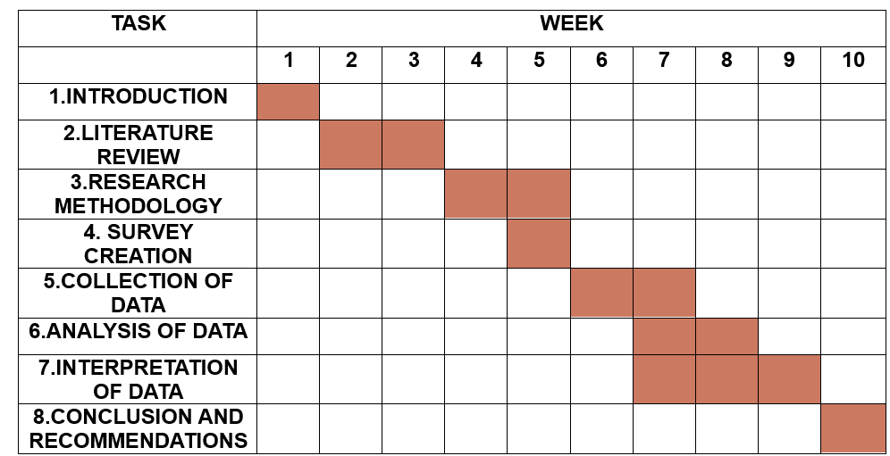
Figure 3: Personal Gantt Chart (created by student, 2024)

REFERENCES

Brown, C., & Wilson, D. (2020). Digital marketing strategies and brand awareness: A case study analysis. Harvard Business Review, 78(3), 102-115.
Bryman, A., & Bell, E. (2015). Business research methods. Oxford University Press.
Chaffey, D. (2023). RACE marketing model definition - What is? | Digital marketing Glossary. [online] Dr Dave Chaffey: Digital Insights. Available at: https://www.davechaffey.com/digital-marketing-glossary/race-marketing-planning-model/ [Accessed 23 Mar. 2024].
Chaffey, D., & Ellis-Chadwick, F. (2019). Digital Marketing: Strategy, Implementation and Practice (7th ed.). Pearson.
Creswell, J. W. (2014). Research design: Qualitative, quantitative, and mixed methods approaches. Sage Publications.
Dawson, C. (2017). Introduction to Research Methods: A Practical Guide for Anyone Undertaking a Research Project. SAGE Publications Ltd.
Duignan, J. (2016) A dictionary of business research methods / [electronic resource]. Oxford:, Oxford University Press.
Geraldi, J. and Lechter, T. (2012) “Gantt charts revisited: A critical analysis of its roots and implications to the management of projects today,” International journal of managing projects in business, 5(4), pp. 578–594. Available at: https://doi.org/10.1108/17538371211268889.
Groves, R. M., Fowler Jr, F. J., Couper, M. P., Lepkowski, J. M., Singer, E., & Tourangeau, R. (2009). Survey methodology. John Wiley & Sons.
Hsu, C. L., & Chang, K. C. (2016). Exploring the impact of social media engagement on brand awareness and company image. International Journal of Organizational Innovation, 8(4), 49-74.
Kim, M. J., & Ko, E. (2020). The Impact of Digital Marketing Strategies on Brand Equity in the Fashion Industry. International Journal of Fashion Design, Technology, and Education, 13(1).
Kotler, P., & Armstrong, G. (2021). Principles of marketing. Pearson.
Patil, P.H. (2017). Brand awareness and brand preference. International Research journal of management and commerce, 4(7), pp.15-24.
Saunders, M., Lewis, P., & Thornhill, A. (2007). Research methods for business students (4th ed.). Prentice Hall.
Saunders, M., Lewis, P., & Thornhill, A. (2016). Research methods for business students. Seventh edition. Harlow, England: Pearson Education Limited.
Saunders, M.N.K., Lewis, P. and Thornhill, A. (2019) Research methods for business students. Eighth Edition. New York: Pearson.
Smith, A. (2017). The Role of Surveys in Digital Marketing Research. Journal of Marketing Research, 25(3), 45-58.
Smith, A. (2018). Digital Marketing Strategies: The Impact on Brand Awareness. Journal of Marketing Research, 23(4), 56-72.
Smith, J. (2019). The role of digital marketing in building fashion brand awareness. Journal of Fashion Marketing and Management, 23(2), 156-170.
Smith, J. (2020). Applying the RACE Framework to Digital Marketing Strategies. Journal of Digital Marketing, 10(2), 45-58.
Smith, J., & Johnson, R. (2015). Understanding Research Ethics: A Comprehensive Guide. Cambridge, MA: Harvard University Press.
Smith, J., & Johnson, L. (2017). Secondary Data Analysis in Educational Research: A Guide for Researchers. Harvard University Press.
Smith, J., & Johnson, L. (2020). Understanding Digital Marketing: Strategies for Success Online. Harvard Business Review Press.
Smith, J., & Johnson, R. (2020). "Utilizing Secondary Data for Enhancing Brand Awareness in Digital Marketing." Journal of Marketing Research, 35(2), 123-137.
Smith, A., & Jones, B. (2019). The power of digital marketing in enhancing brand awareness. Journal of Marketing Research, 14(2), 45-62.
Smith, J., & Smith, K. (2019). Data-Driven Marketing: The 15 Metrics Everyone in Marketing Should Know. Harvard Business Review.
Smith, J., & Wilson, K. (2018). The Impact of Data-Driven Marketing for Fashion Brands. Journal of Fashion Marketing and Management, 22(4).
Yin, R. K. (2018). Case study research and applications: Design and methods (6th ed.). Thousand Oaks, CA: SAGE Publications.

