Include this page in your Part 1 Submission
Name of the Team: Team Coffee
Team Members
Student Name | Student ID
MARK WILLIAMS | 2022279
ASHLEY REES | 2009258
TIRION WALL | 2023509
JOSH ARCHER | 2011907
Team Evaluation (Self Evaluate your Team)
 | Mark | Ashley |  | Tirion |  | Josh
Mark | 5 |  | 5 |  | 5 |  | 5
Ashley
Tirion | 5 |  | 5 |  | 5 |  | 5
Josh
Rate your Teams Contribution with a scale of 1 to 5 (1 No Contribution and 5 Excellent Contribution)
Ashley: Once again our team worked very well together, Mark and I went through the worksheet together and Tyrion and Josh took screenshots, then went away and wrote the descriptions of each step. The team has grown closer much closer this time, I believe it has helped us to complete the work to an excellent standard.
Mark: Our team once again worked extremely well together each brining in their own unique skills and abilities to this assignment, for example I went through the Worksheet with help from Ashley while Tirion and Josh took screen shots and wrote the descriptions of what each of the stages was. Our team have grown close and worked exceptionally hard to make sure the work is to the highest quality possible.

Josh: As before the team worked well together. With Mark and Ashley providing valuable support to myself and Tirion. I found personally, this assignment more difficult however with Mark and Ashley supporting me throughout I was able to fully understand the fundamentals of what the assignment was trying to get us to understand.
Tirion: By collaborating closely, our team worked really well. Mark and Ashley (who study Cyber Security, and therefore have a better understanding on the topic) troubleshooted the issues we came across as we went through the worksheet, and Josh and I provided the screenshots and detailed descriptions. Our ability to communicate well as a team helped us complete the work to a high standard.

Dr. Nitheesh Murugan Kaliyamurthy 29/03/2023

Network Operating Systems and Services
ACCA5023

Mark Williams – 2022279

Manage and maintain network resources, and its services applying suitable policies and drafting security and redundancy practices.

Content page

Team page 1-2
Front page 3
Title page 4
Content page 5
Abstract page 6
Introduction page 6
Task 1: Managing and maintaining network resources 7-13
2.1 Configuring User Environment and Computer Environment 14-26
GPO 1: Moderating Access to the control panel 14-18
GPO 2: Removing Access to the Command Prompt 19-20
GPO 3: Restricting Access to Removable Media Drives 21-22
GPO 4: Restricting Software Installs 23-24
GPO 5: Enforcing Password Policy in the ‘accatask.msft’ domain 25-26
Task 2: Routing and packet filtering within core TCP/I TCP/IP services and critical failover/redundancy policies 27-44
Task 3: Observational tasks 45-50
Small/home office security enhancements 45-47
Enterprise Network failover 47-49
Enterprise Network policy 49-51
Reflection page 52

Abstract
Working within a team to build multiple different types of networking policies, creating routing and packet filters then discussing the subjects individually delving deeper into the tasks covered within the team providing a different perspective to what was covered within the team aspect of the assignment.

Introduction
This assignment tasked our group with following instructions on building manage and maintain network policies such as stopping certain accounts from accessing command prompt and also creating routing and packet filters, while creating security procedures to make a network safe with the help of failovers.
Finally the group was split up and had to write individual parts recording observations providing security enhancing methods for small or home offices and then covering critical failovers and why networks require along with covering network policies, security risks, and providing security changes to keep up with the ever changing threats of cyber-attacks for an enterprise network which covers multiple areas.

Task 1: Managing and maintain network resources using network policy and security practices

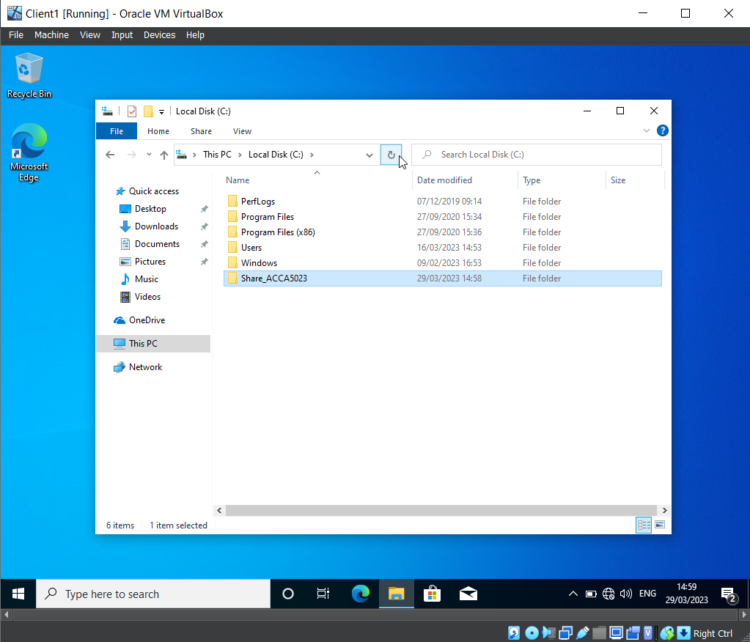
A file has been created within the Local C drive called ‘Share_ACCA5023’. NTFS (local) permissions have been set so that the network user has Full Control permissions, and the other network users have read only access. This helps protect the contents of the file.

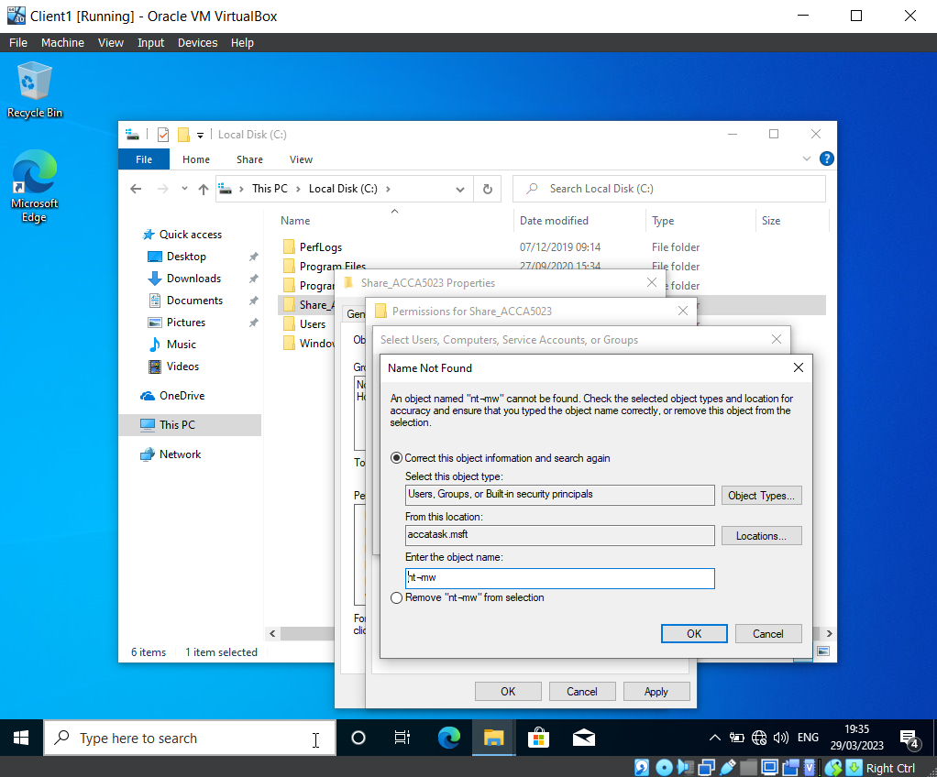
When using the username ‘nt-mw’ to search for the admin login for ‘Mark Williams’, the group encountered the error message in the screenshot above, which indicated that the account could not be found. To resolve this issue, the group retraced their steps, repeating the previous actions. This resolved the problem, as depicted in the next screenshot.

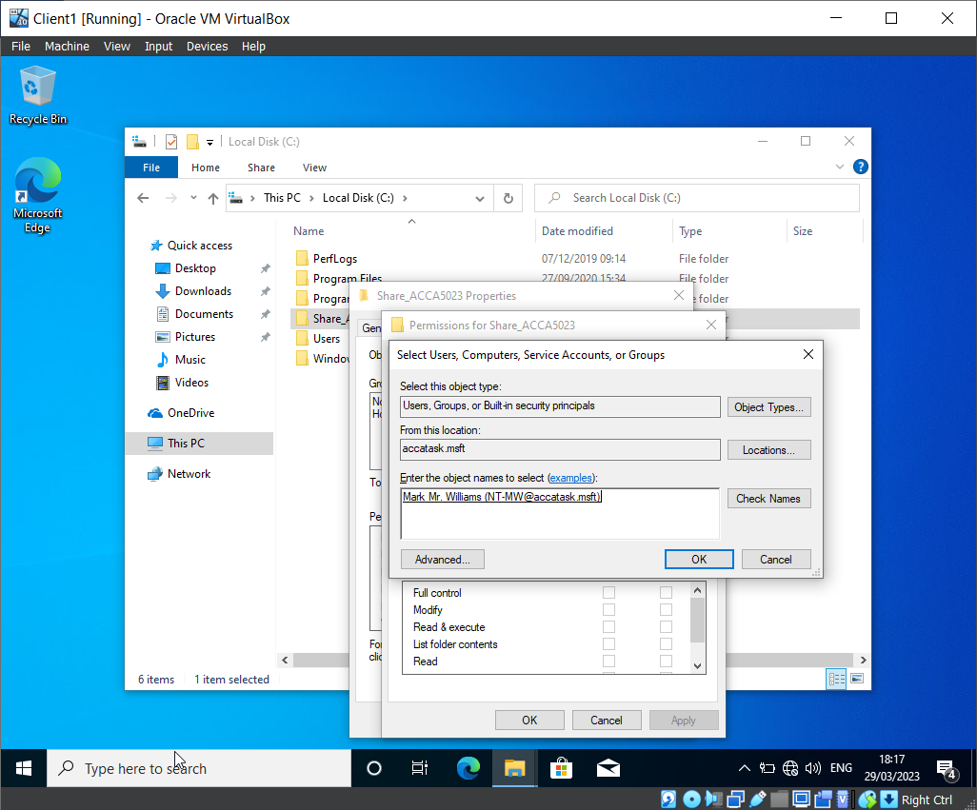

The username has successfully been added to the group, which allows the team to modify the permissions of this user’s access within the file ‘Share_ACCA5023’.

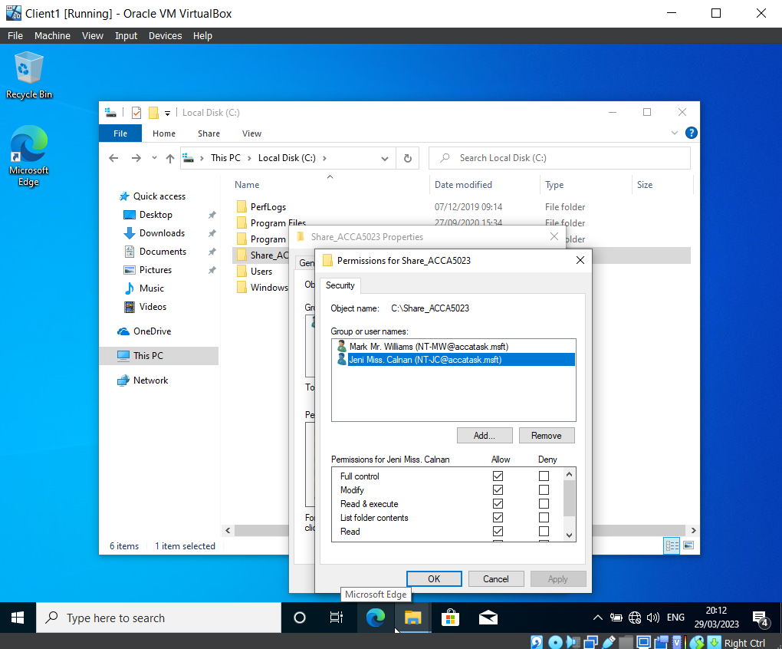
Two users were added to the permissions group for the folder ‘Share_ACCA5023’.

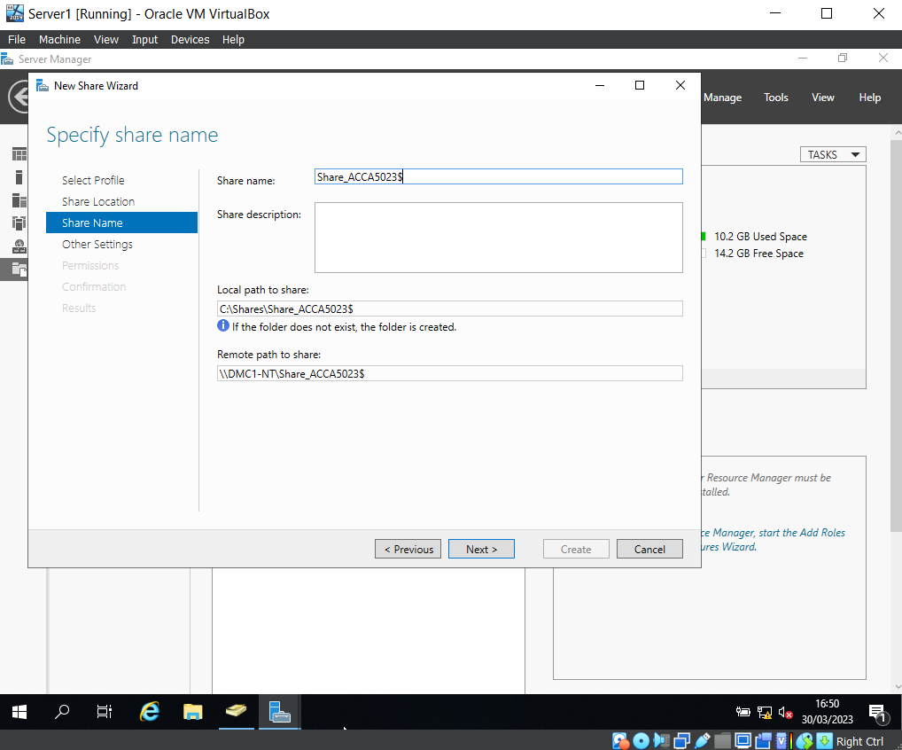

A folder share has been created on the ‘Share_ACCA5023’ server. This shows the local path to share, and the remote path to share. These options have been noted for later use, as they will be needed when the group access the files over the network from a different machine. Additionally, they will be needed to map a network drive to the file server.

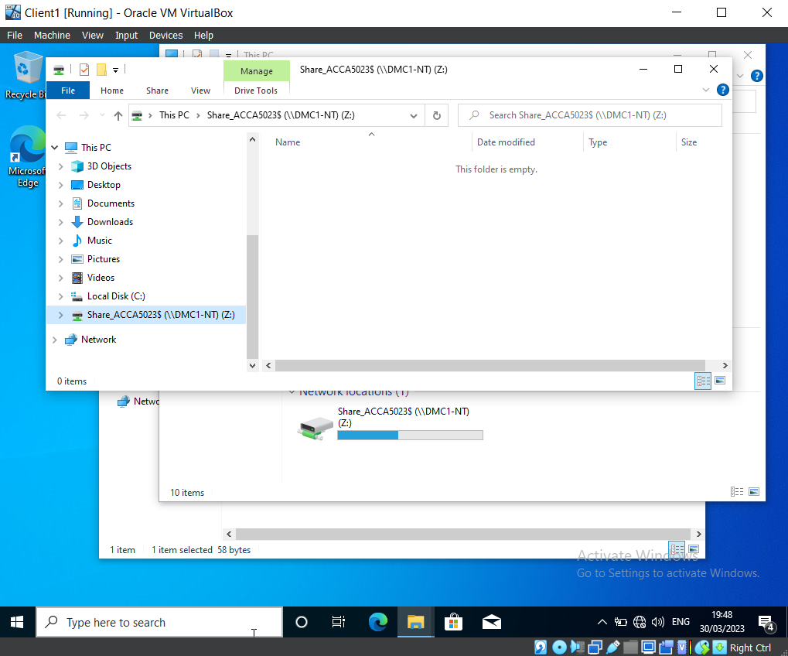

This screenshot shows that the mapped shared network drive is set to drive Z.

2.1 Configuring User Environment and Computer Environment, ‘Network Group Policy Objects’

GPO 1: Moderating Access to the Control Panel

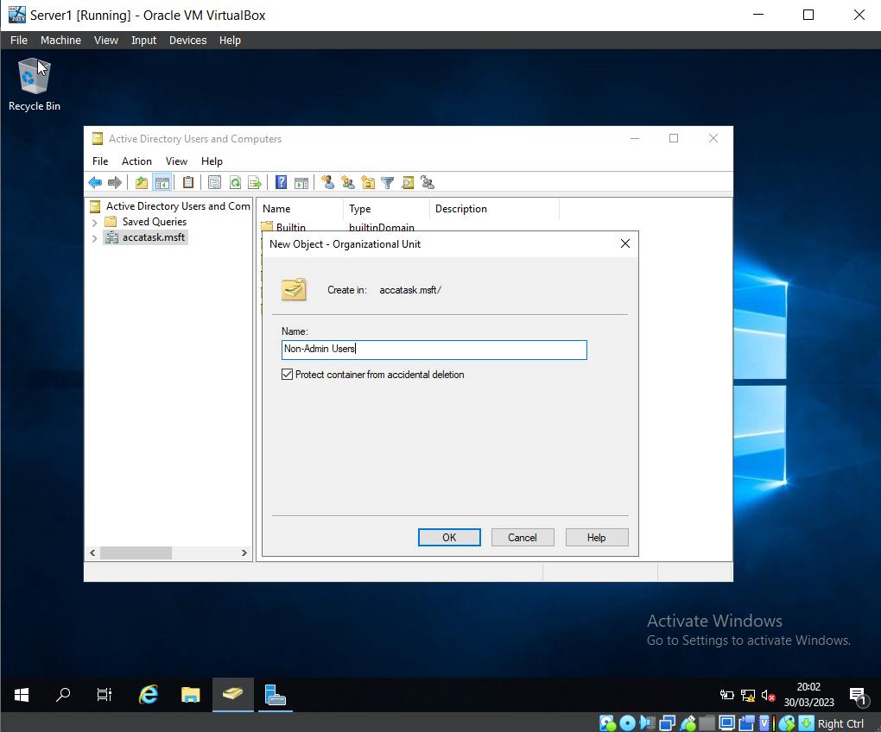

A new Organisation Unit has been created on Virtual Machine Server 1, named ‘Non-Admin Users’.

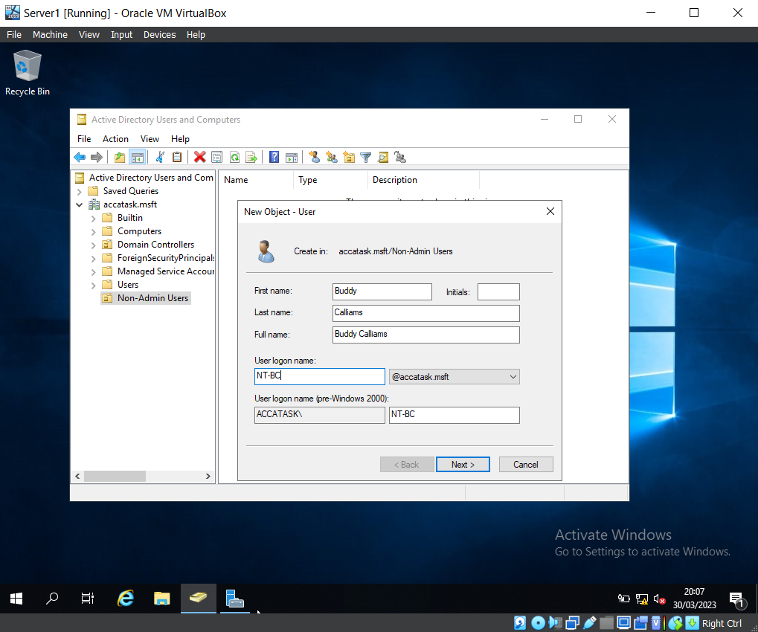

Using Active Directory Users and Computers, a new user has been created within the Non-Admin Users OU. (New user: ‘Buddy Cailliams’)

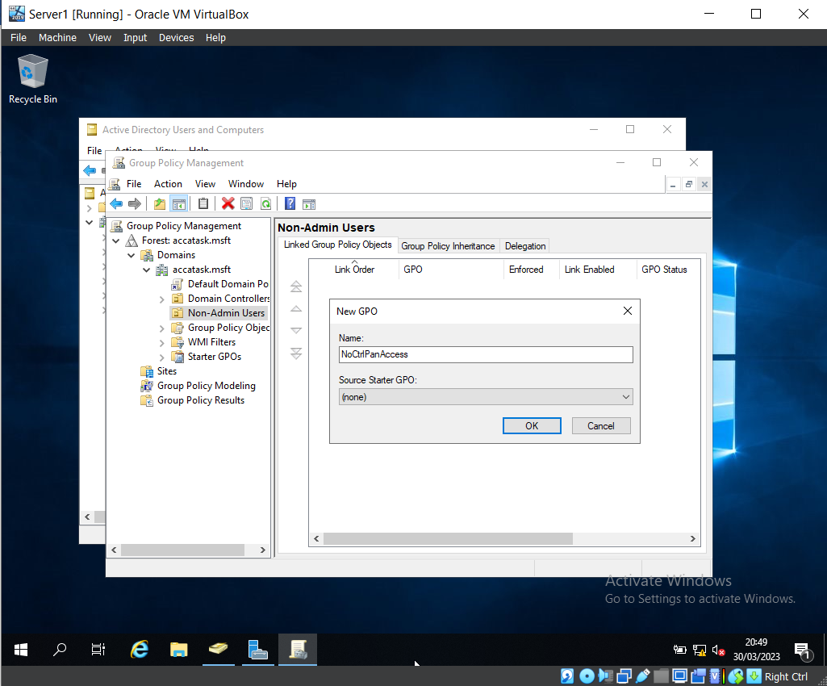

The Group Policy Management Console program was loaded to create a Group Policy Object (GPO). This GPO was named ‘NoCtrlPanAccess’.

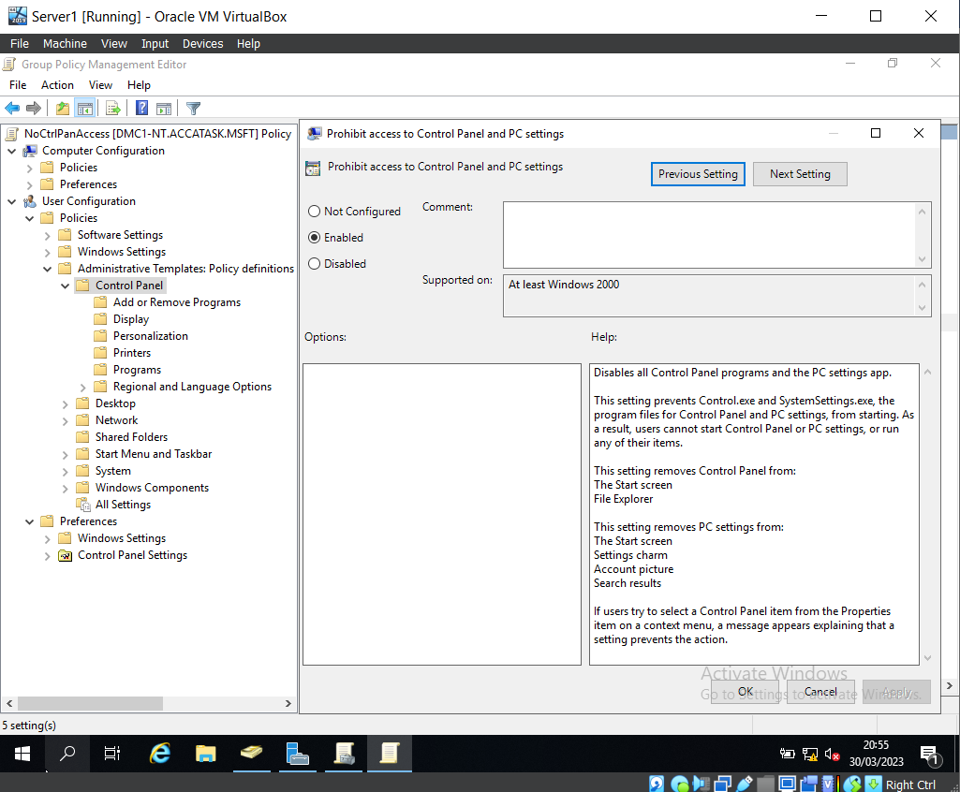

Here you can see that the ‘Prohibit access to Control Panel and PC settings’ policy has been enabled.

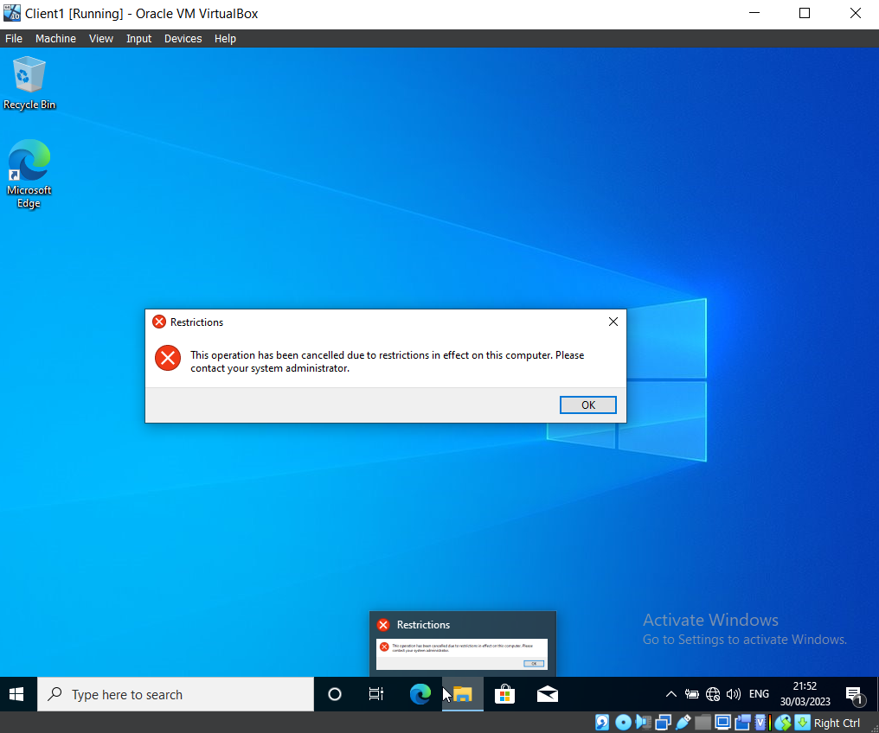

Once logged into Buddy Cailliams’ account (which was intentionally created with no access to the Control Panel), the group verified that the account could not access the Control Panel.

GPO 2: Removing Access to the Command Prompt

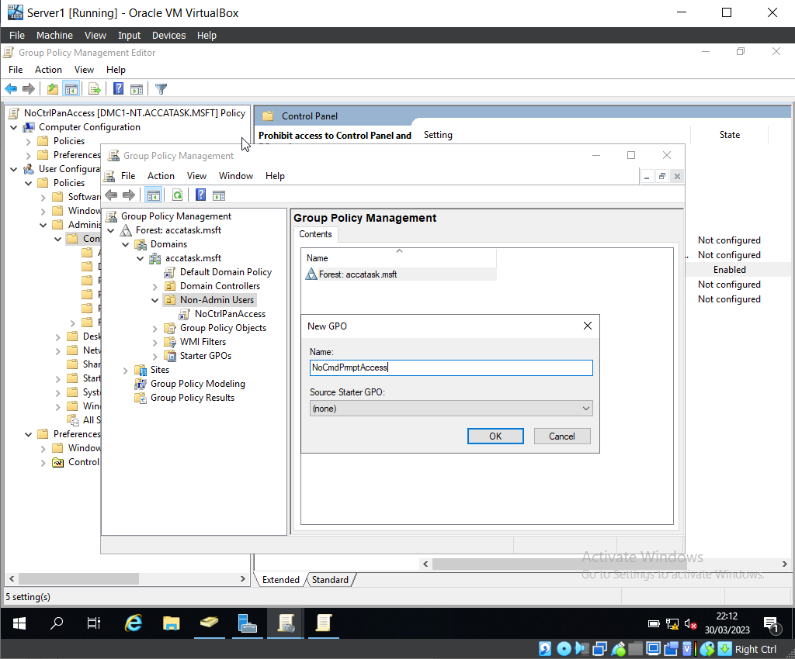

After loading the Group Policy Management Console program, expanding the domain, and finding the Non-Admin Users OU, the team created a new GPO named ‘NoCmdPromptAccess’.
The team then edited the GPO to prevent Buddy Cailliam’s from access to the Command Prompt.

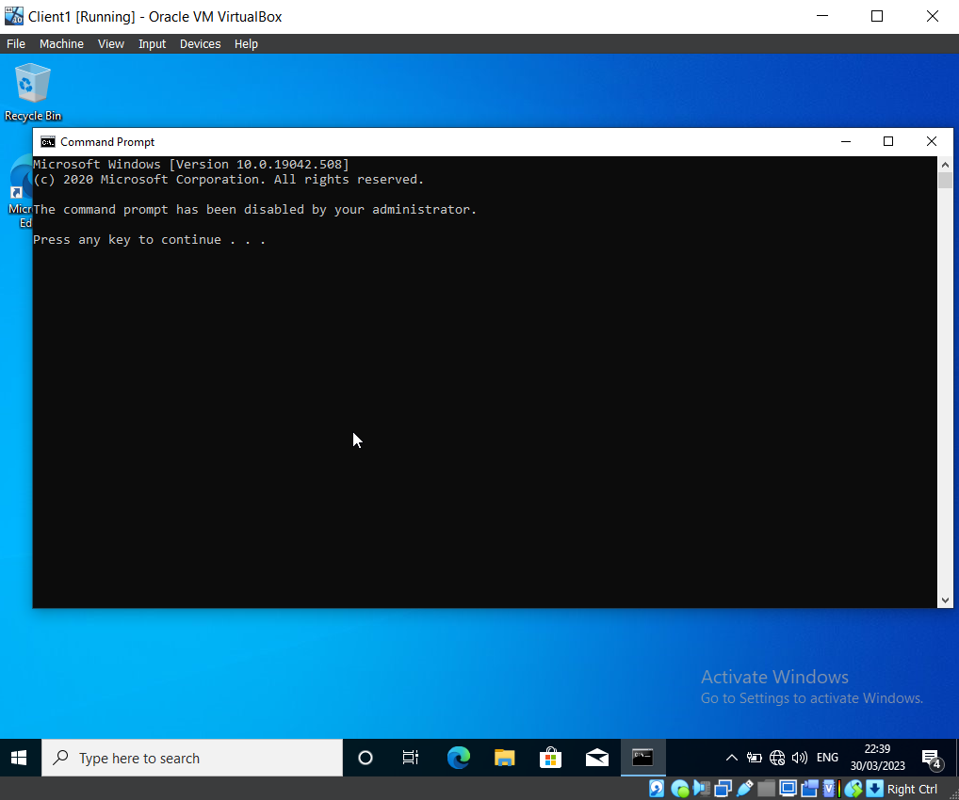

Using Buddy Cailliam’s account, the team tested that the Command Prompt could not be accessed. This screenshot confirms that the policy created in the GPO is working as expected.

GPO 3: Restricting Access to Removable Media Drives

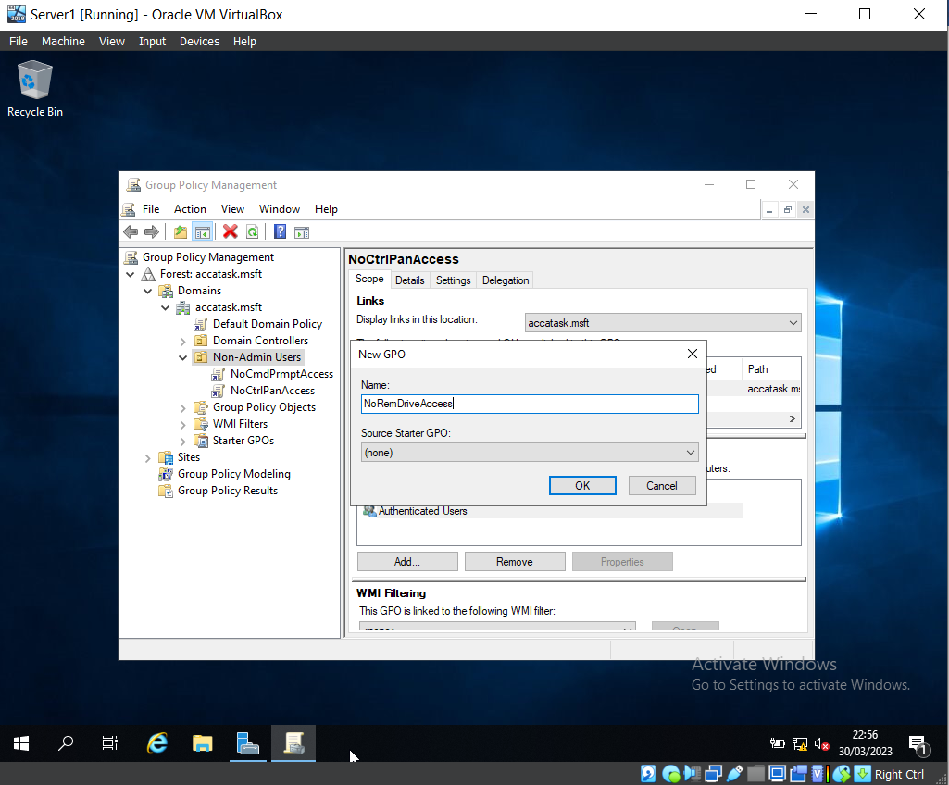

Another Group Policy Object has been created within the Non-Admin Users OU, named ‘NoRemDriveAccess’.

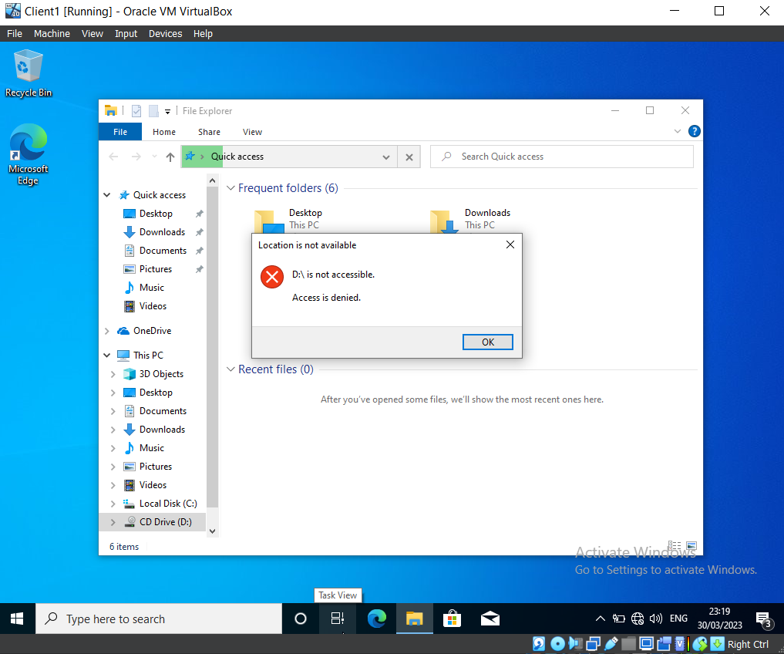

A USB has been attached to the Virtual Machine. This screenshot demonstrates that due to the policies now in place (i.e., access to Removable Storage is disabled), the USB is not accessible, and the error message is displayed to inform the user.

GPO 4: Restricting Software Installs

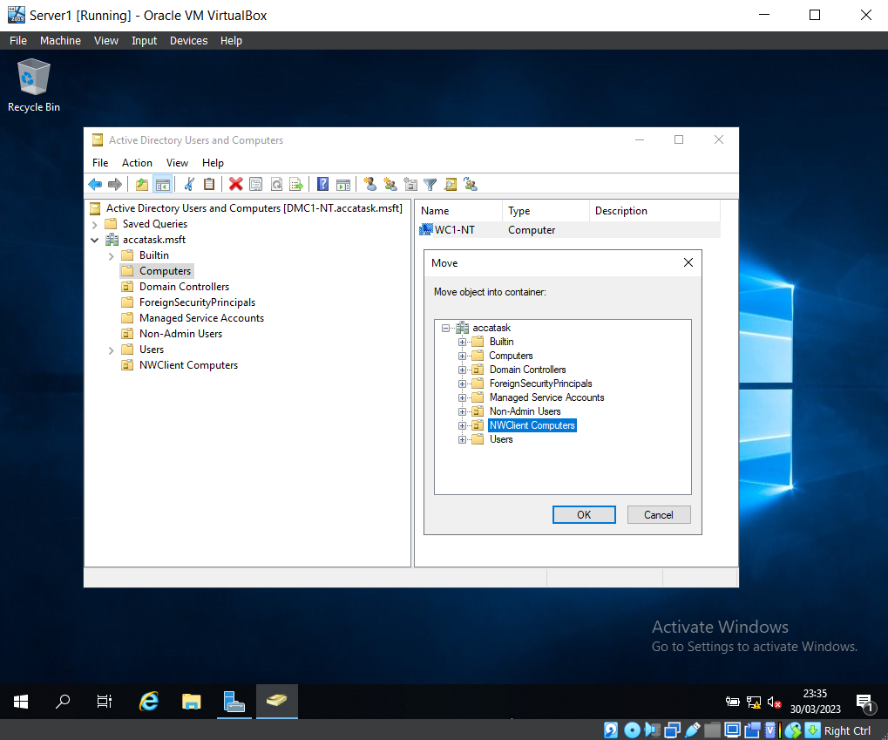

This screenshot displays the relocation of the client computer from the ‘Computers’ folder to ‘NWClient Computers’, enabling the policies specifically designed for computers within that particular Active Directory.

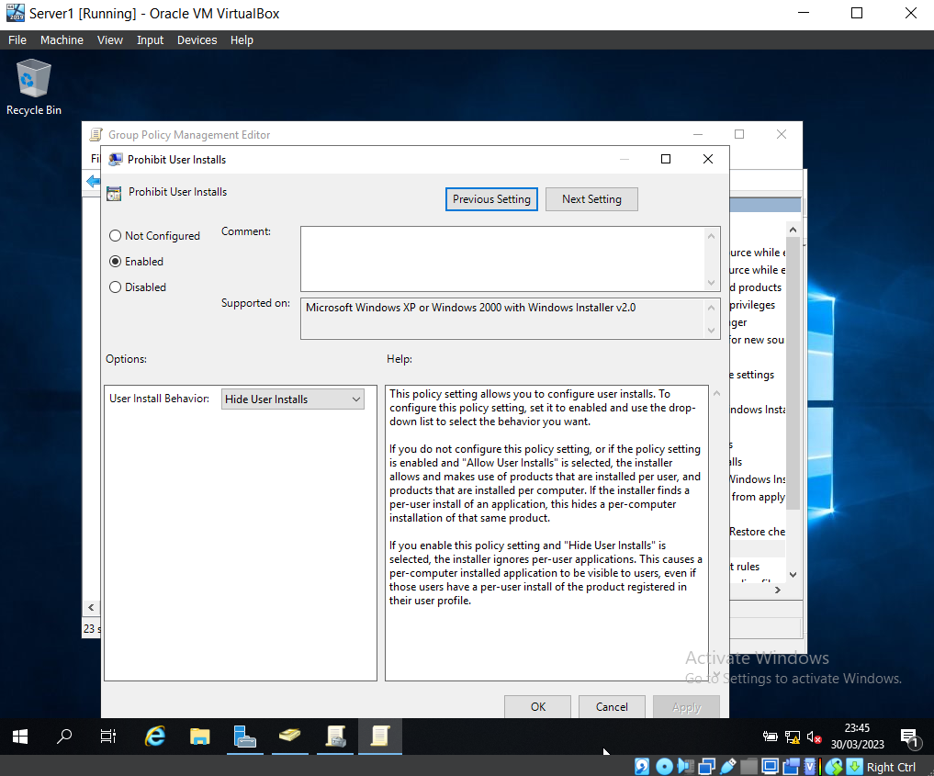

A policy has been created to stop users from performing installation on the client computer.

GPO 5: Enforcing Password Policy in the ‘accatask.msft’ domain

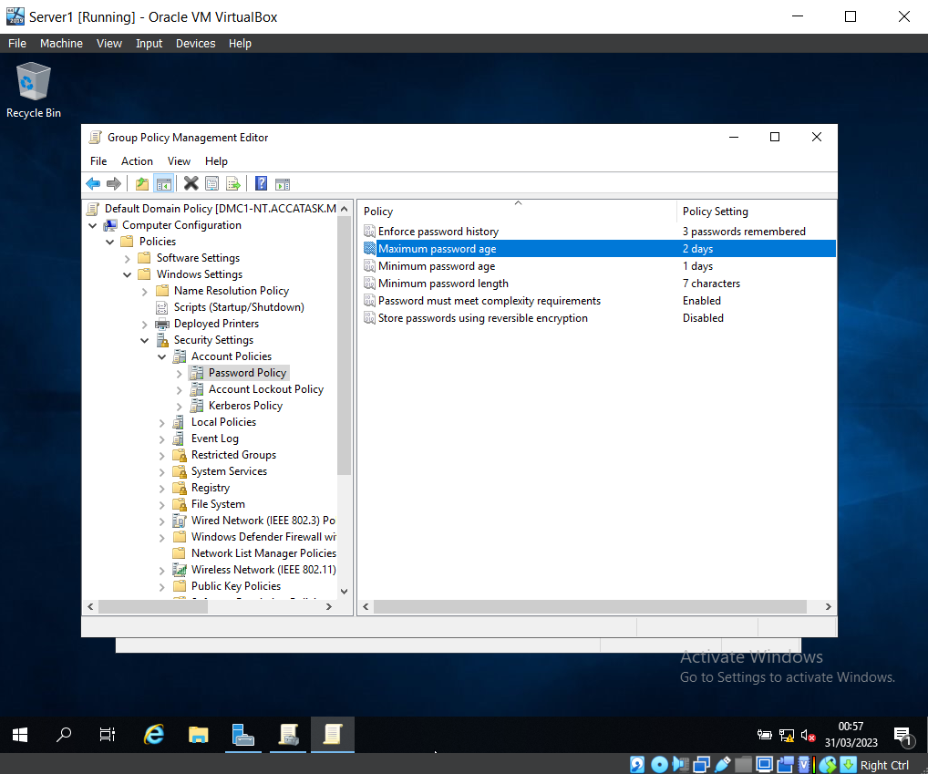

The password policy has been edited to fit the new requirements (e.g., the password must be a minimum of seven characters, and passwords using reversible encryption have been disabled).

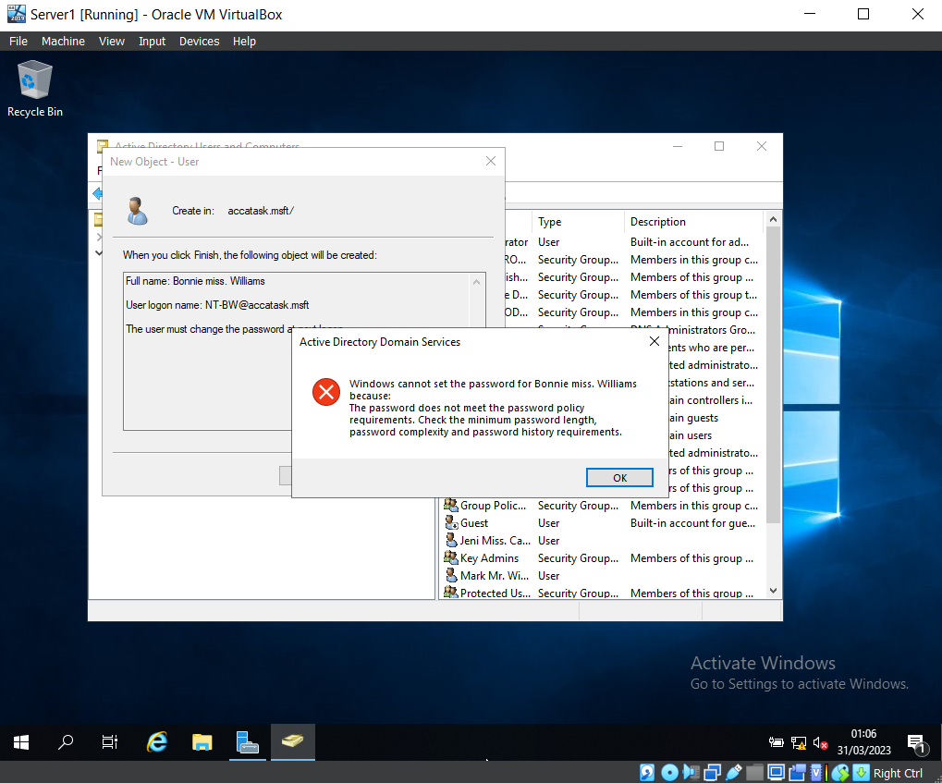

Here is evidence that the password policy is working as expected.
The team set a user’s password that was only four characters long, as this did not meet the criteria of the Password Policy, the password was not updated and an error message appeared.

Task 2: Routing and packet filtering within core TCP/IP services and critical failover/redundancy policies

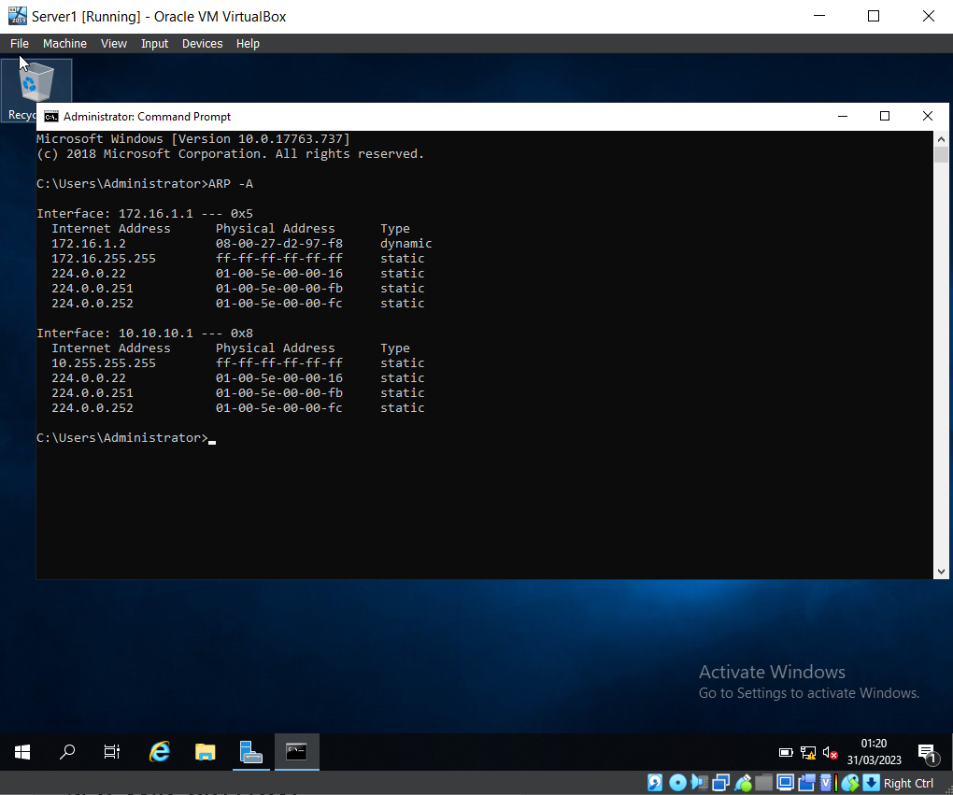

‘ARP – A’ has been entered into the Command Prompt, this shows the Interface (NIC’s), the Physical (MAC) address, and internet address of this NIC.

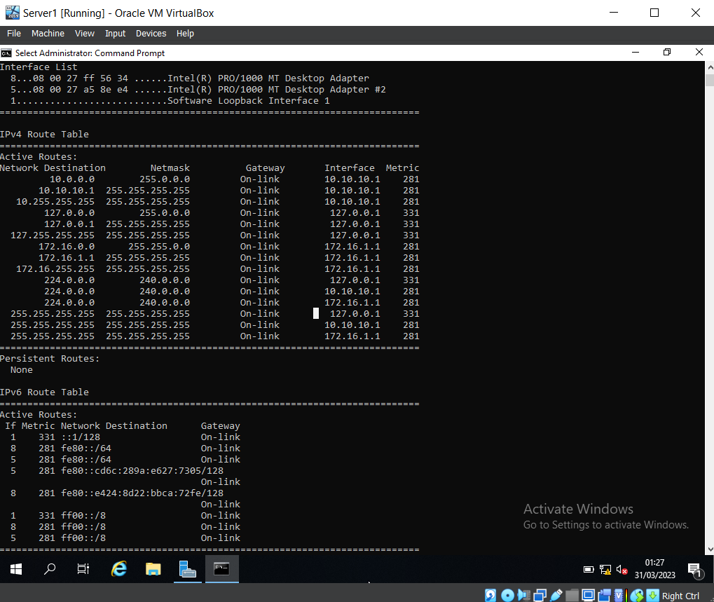

‘route print’ was entered into the Command Prompt to show the current IP routing table, which displays the following information: Netmask, Gateway, Interface, and Metric.

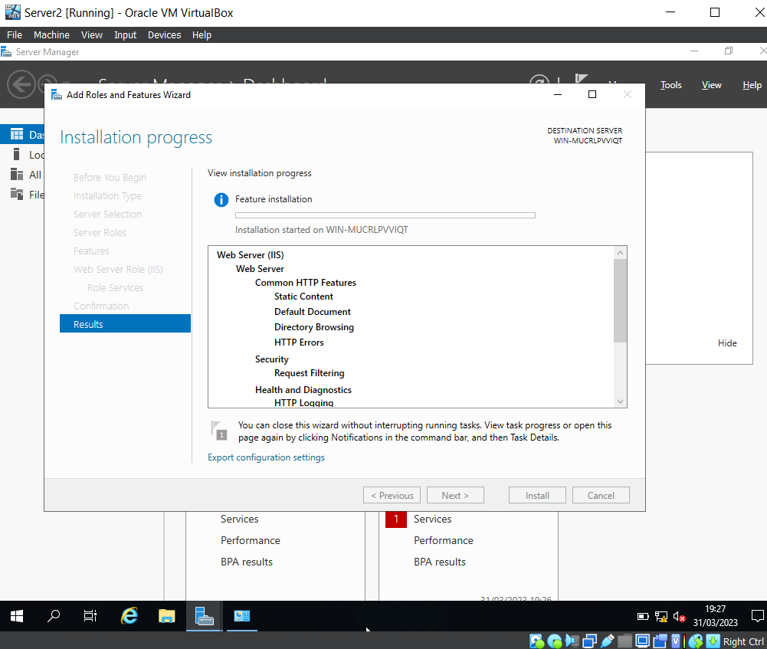

After launching the Server Manager, the FTP Server (IIS) Role has been configured and the FTP User Account has been created.

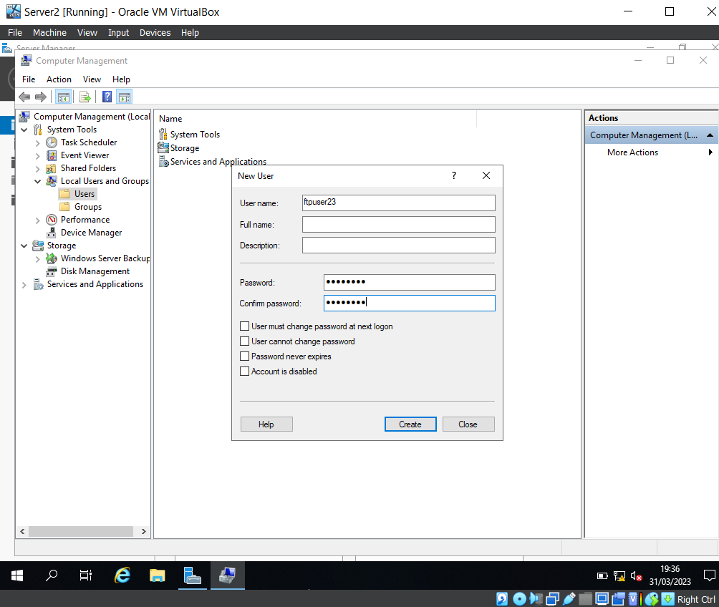

A new user was created, the username was set to ‘ftpuser23’ and the password ‘P@55word’.
The team manually unticked ‘User must change password at next logon’ before creating the user.

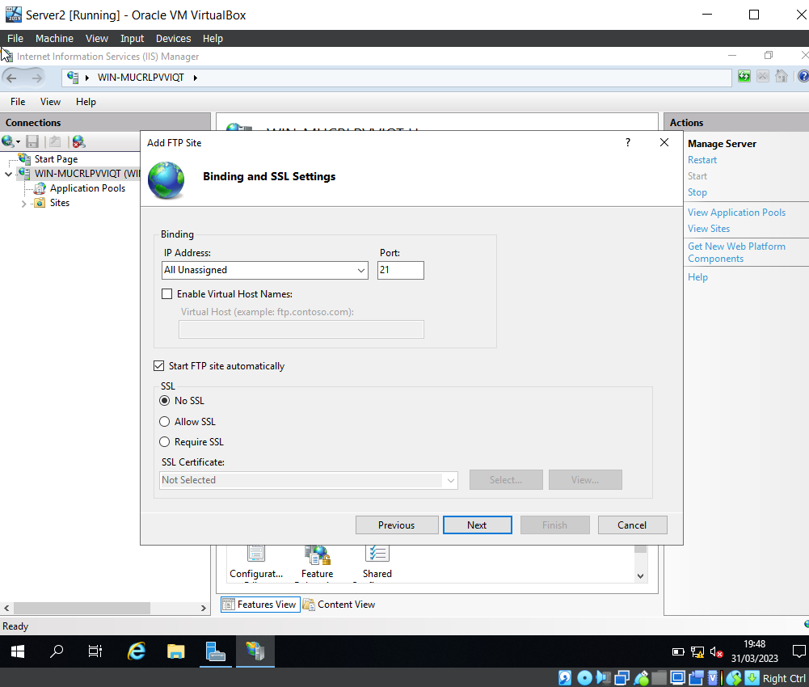
The team then opened the IIS Manager within the Sever Manager Tools and changed the binding and SSL settings to ‘No SSL’, and made a note of the Port Number (21), as this is the port used for FTP (File Transfer Protocol).

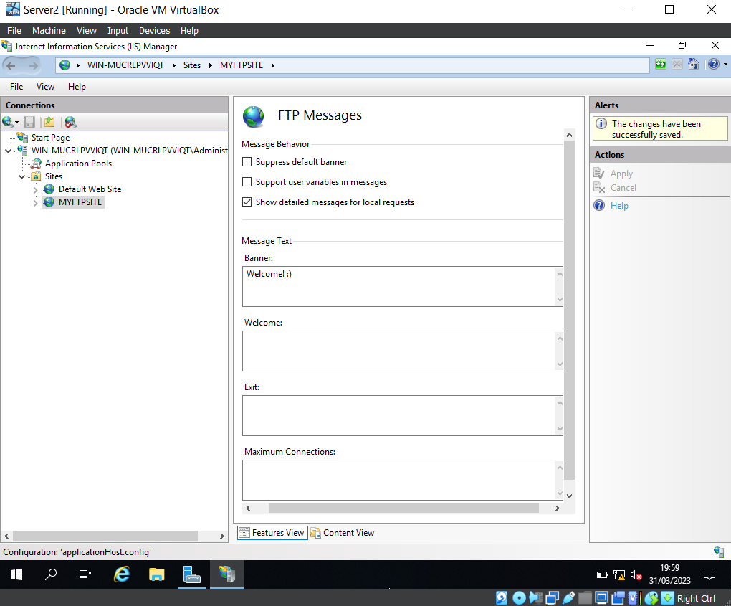
This screenshot displays the set-up of a banner message within the ‘MYFTPSITE’ site.

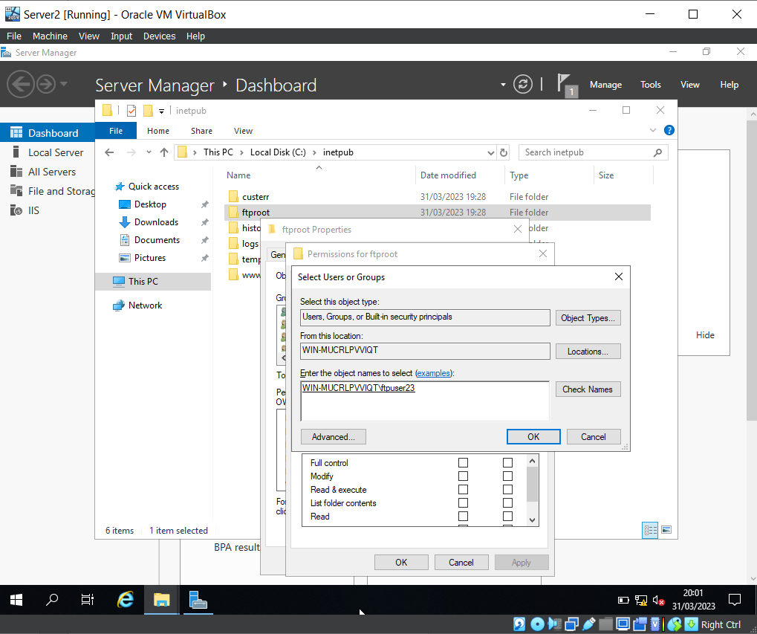

The newly created user, ‘ftpuser23’, has been added to ‘ftproot’ users group.
To confirm that the new user could be found, the team entered ‘ftpuser23’ and clicked ‘Check names’. The account is underlined, confirming that is has been found.

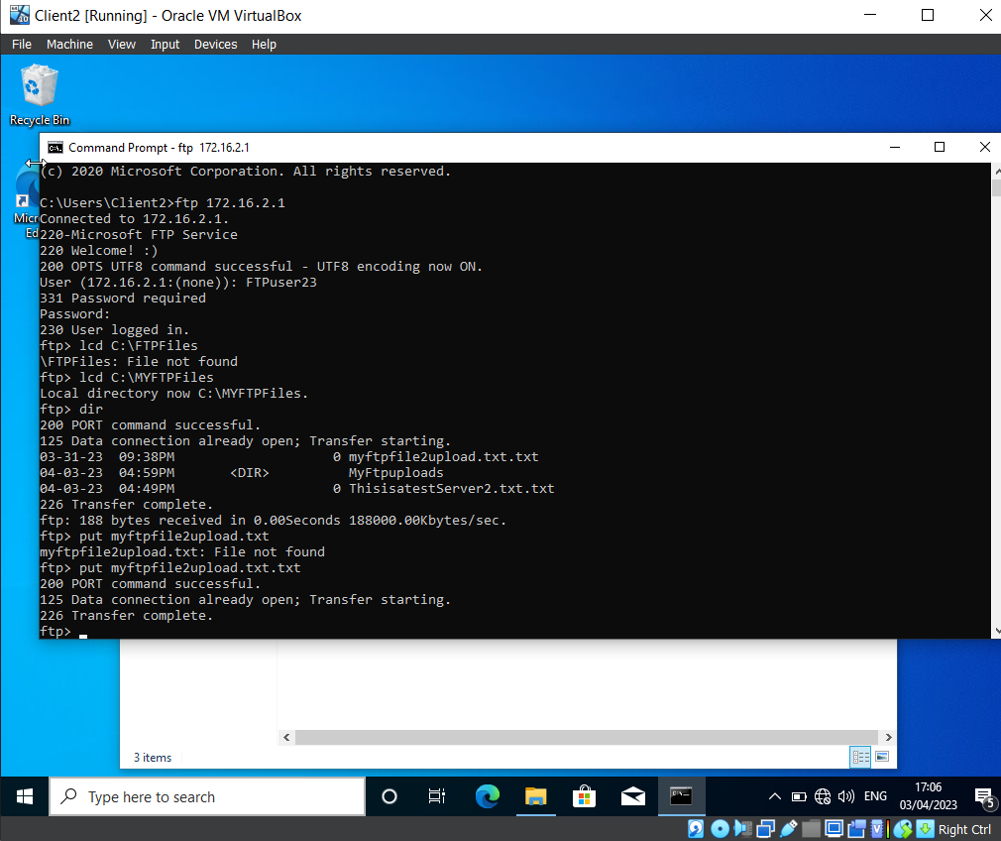

Using the command ‘ftp 172.16.2.1’ granted access to the FTP Service and prompted the ‘Welcome :)’ banner that was set up previously in the desk. This then prompted a login which was for the ‘Ftpuser23’ account. After the successful login, the command ‘lcd C:\MYFTPFiles’ proceeds to the directory of ‘C:\MYFTPFiles’. The command ‘dir’ brings up the files within the directory and the command ‘put myftpfile2upload.txt.txt’ transfers the document within ‘C:\MYFTPFiles’.

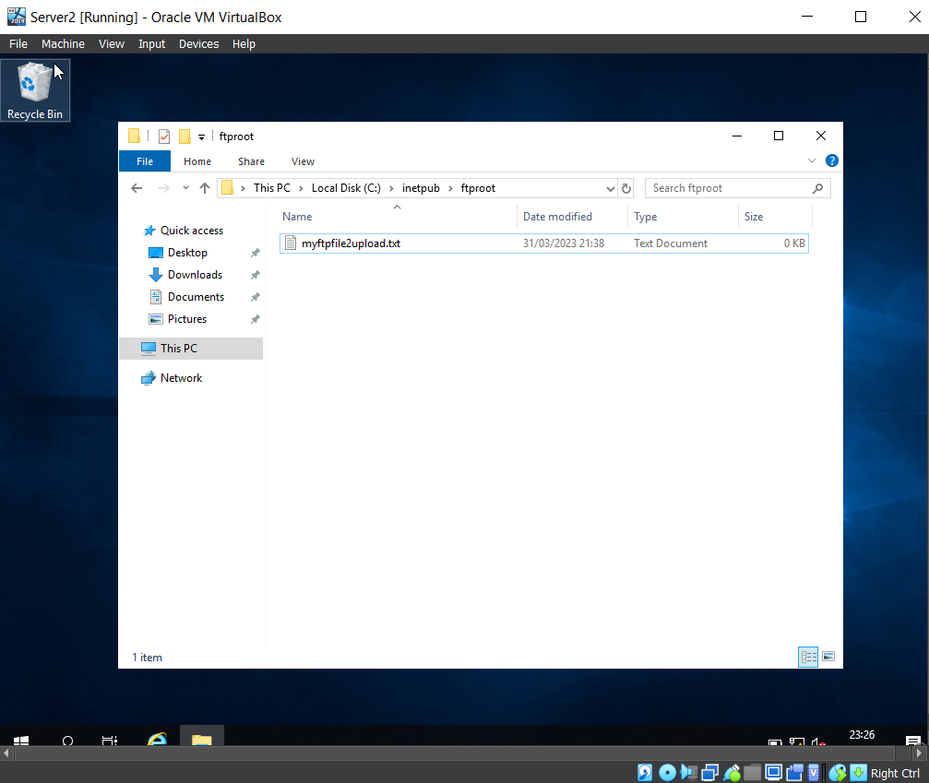
In the C:\directory of Client 2, the team created a new folder, and within this folder, a text file was created, named ‘myftpile2upload.txt’.
Prior to this, the team logged in as a domain administrator level account, and confirmed that the firewall on the Windows 10 client machine was disabled.

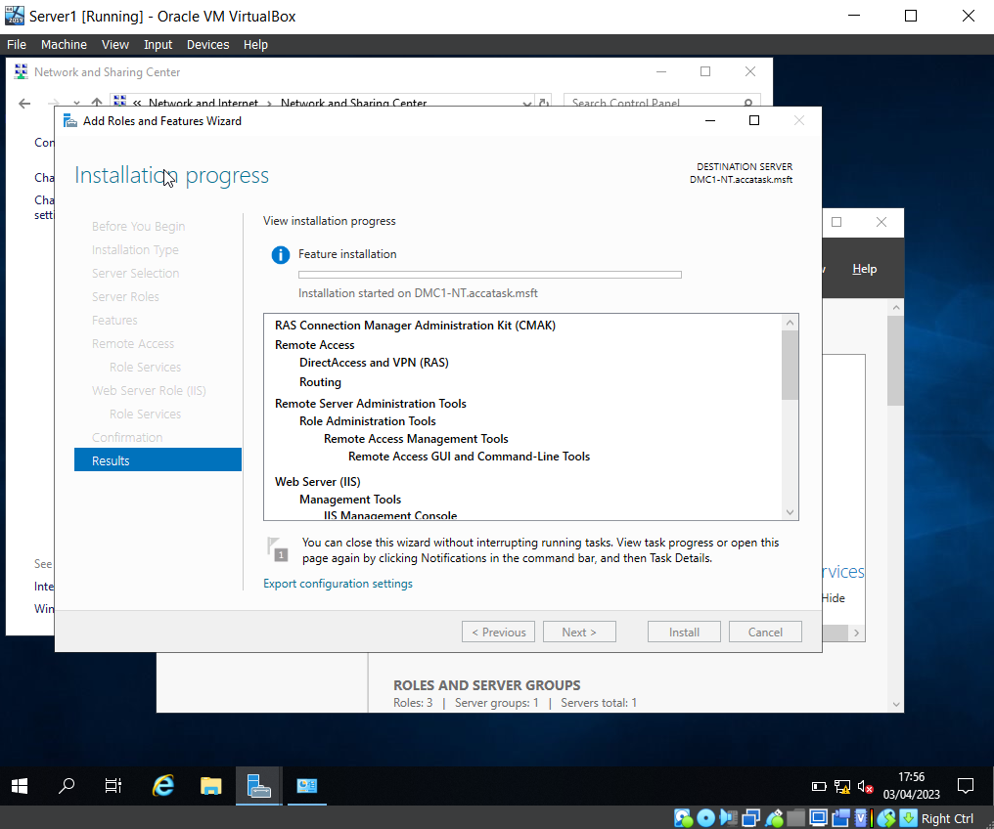

This screenshot displays the installation stage of adding roles and features for DirectAccess, VPN, and Routing Services.

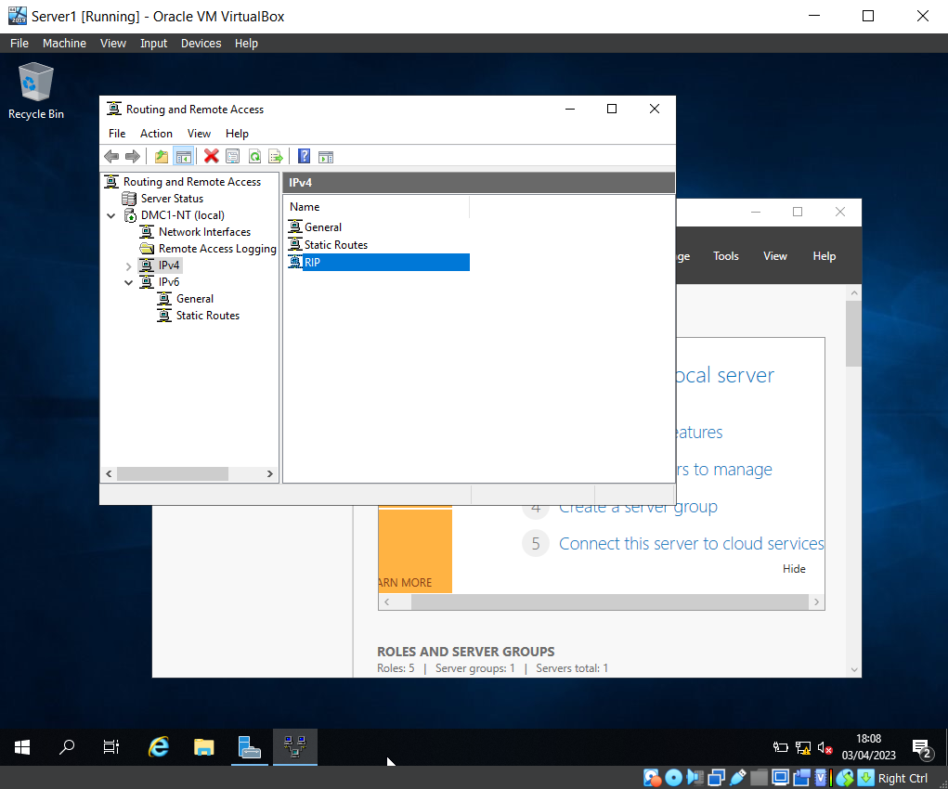

The team opened Routing and Remote Access and selected ‘RIP V2’ as the IPv4’s New Routing Protocol.
As you can see, ‘RIP’ is listed as an available protocol on the IPV4 stack.

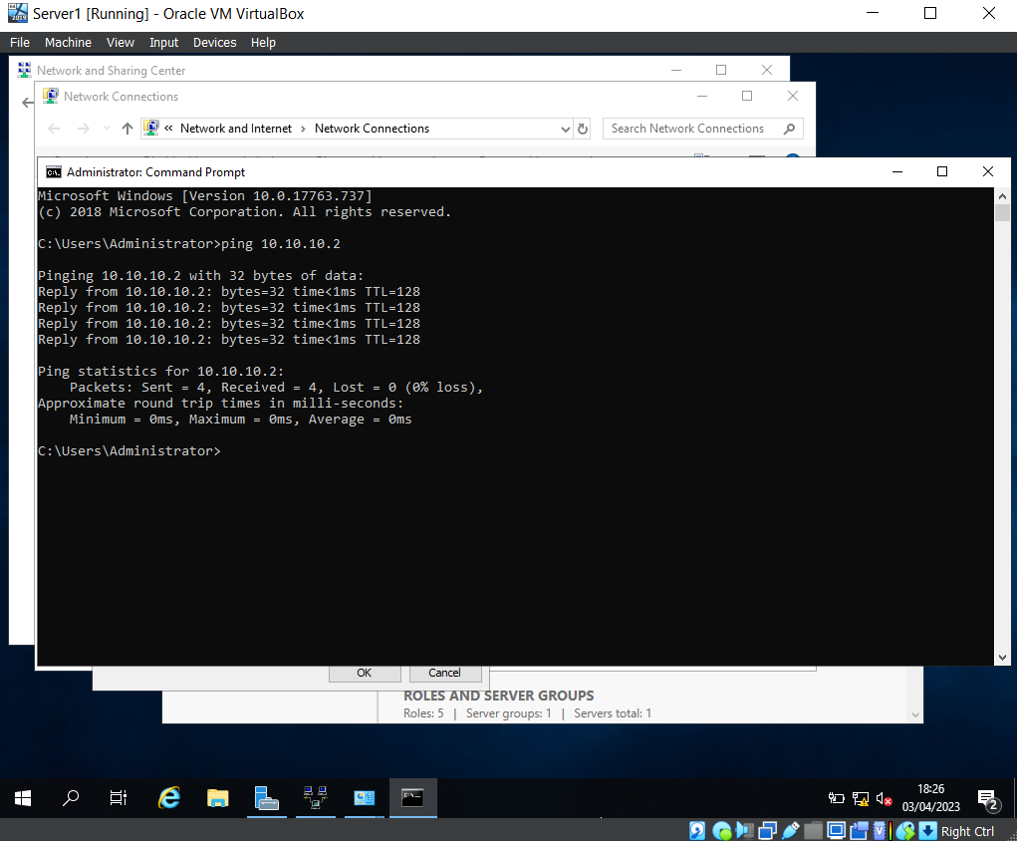
Pinging the PublicNet IP address for Server 2 from Server 1 and receiving a response.

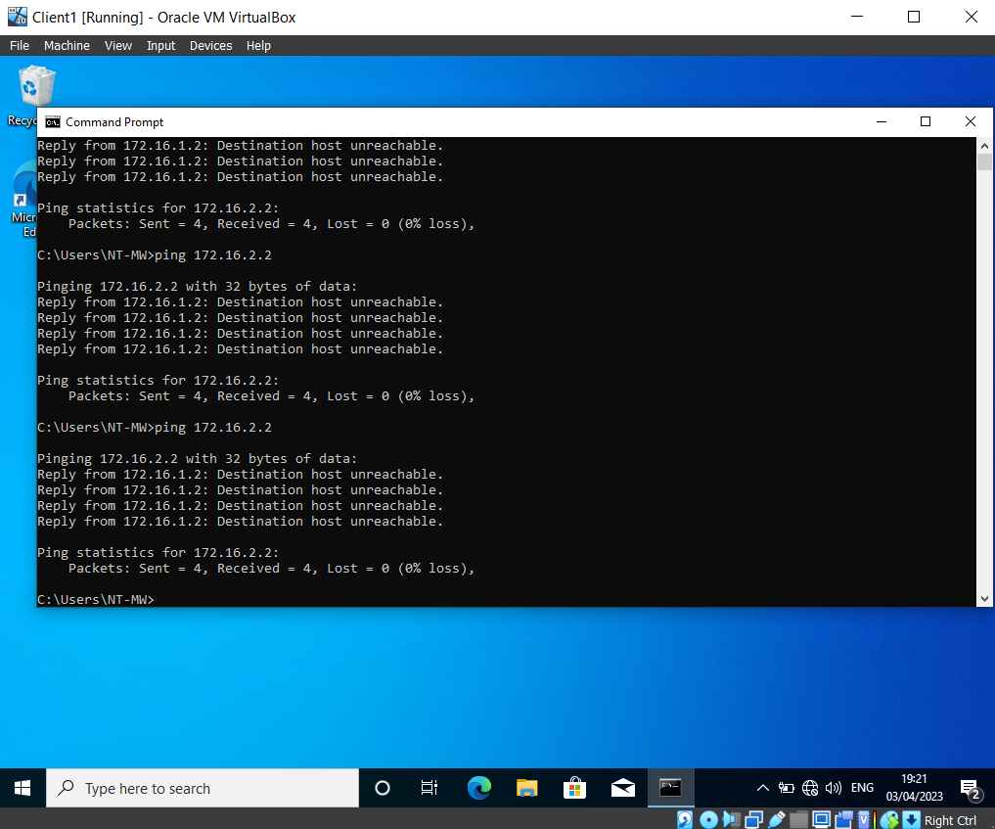

Here you can see the team are unable to ping Client 2 from Client 1.

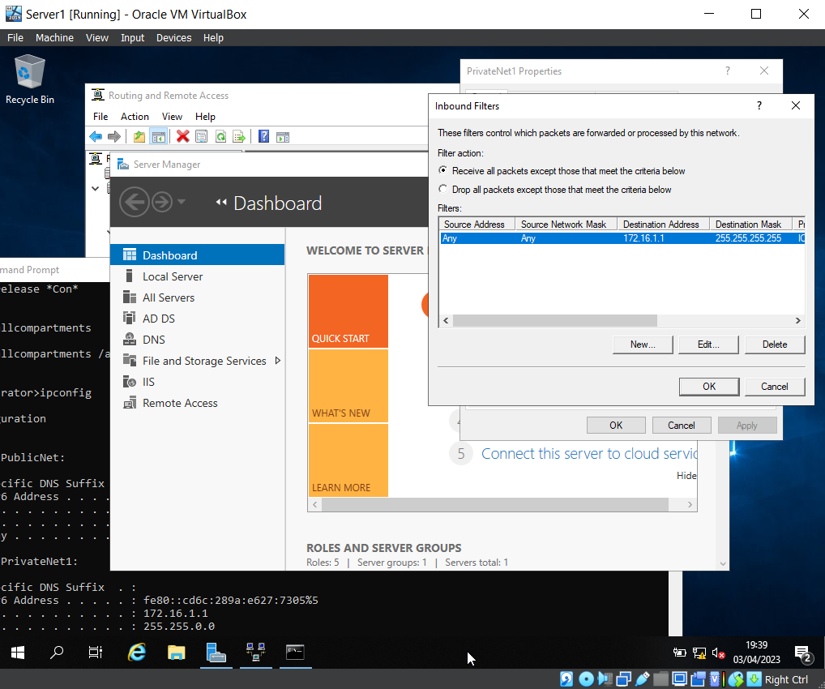

The Inbound filter for PrivateNet1 within Server1.

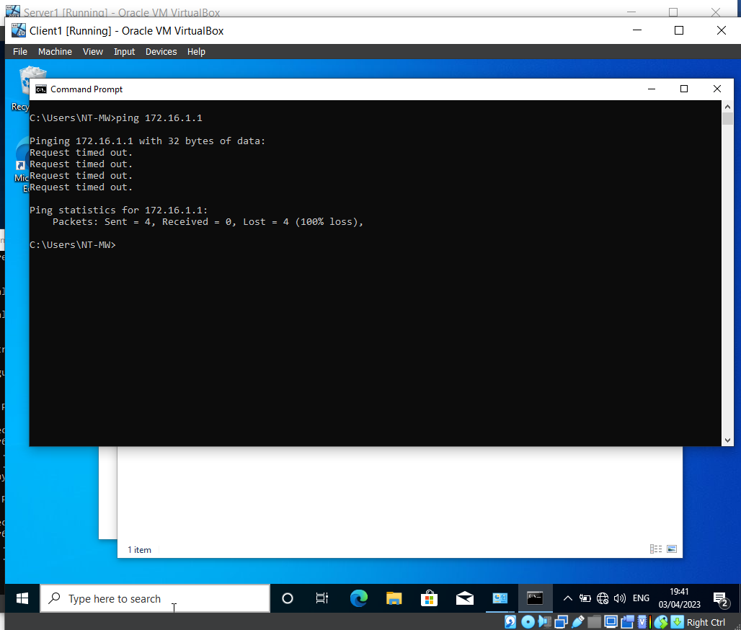

Here the team have attempted to send a ‘ping’ to PrivateNet1 from the Client, this currently results in a timeout error, as the new inbound filter is blocking ping requests.

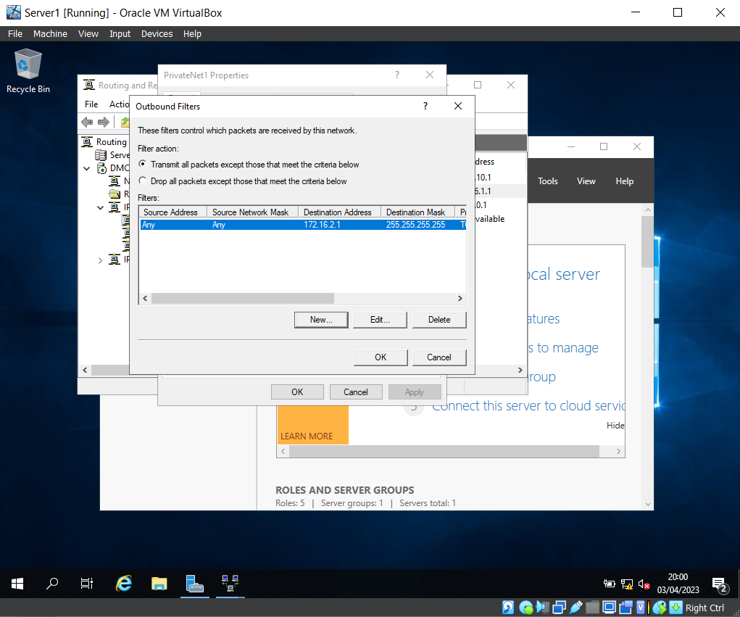

The outbound filter on Server 1 for PrivateNet1 is configured to restrict access from PrivateNet1 to the FTP running on Server 2.

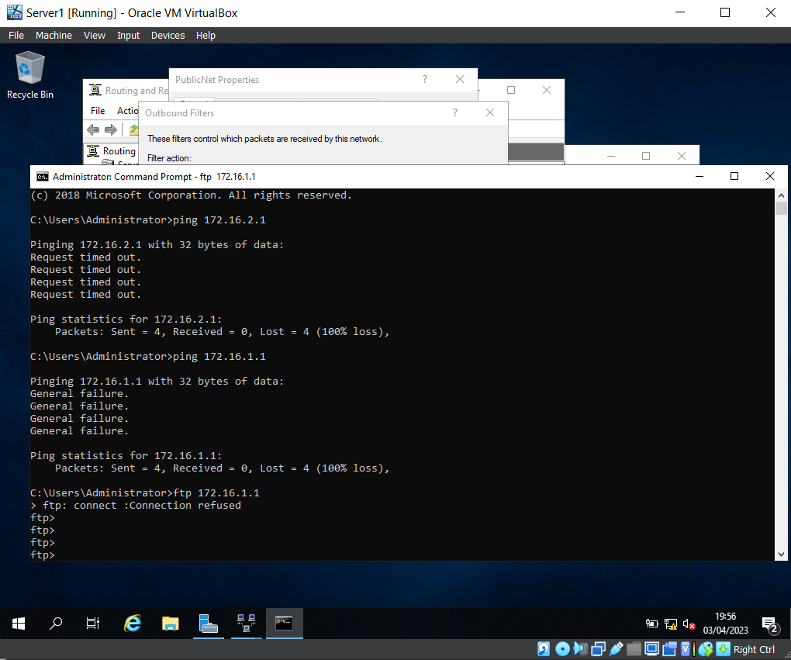

This screenshots shows the connection to ‘FTP 172.16.1.1’ has been blocked, due to the filter.

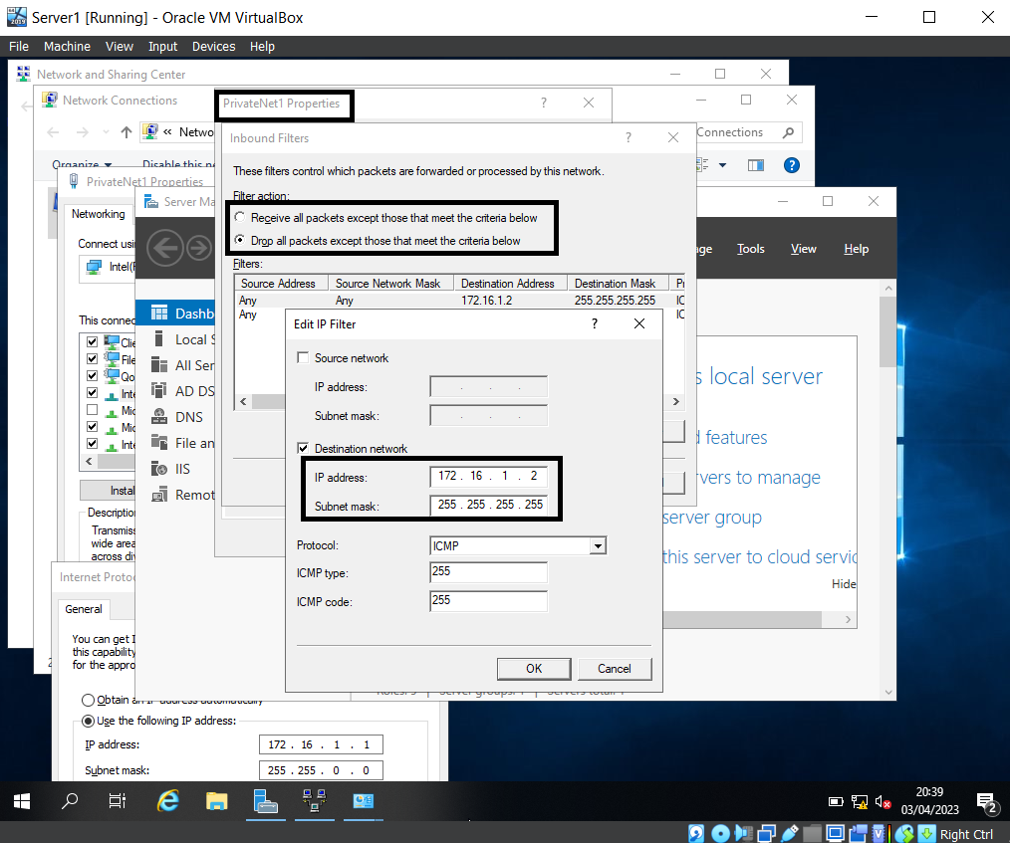

The set inbound rule above shows that the IP is set for Client1, and the middle box shows the filter action ‘Drop all packets except those that meet the criteria below’, which means Client 1 will have FTP access, but all other IP addresses will be denied access.

Task 3: Observational tasks

Small/home office security enhancements
Cyber-attacks have grown and become more advanced, below are some of the possible Cyber-attack’s small/home offices could face and ways to improve security:
Black Hole Attack – Places a malicious node within a network which is designed to make non malicious nodes believe that the malicious node is the best route to the destination, but then is intercepted by the malicious node which allows for further attacks[1].
Authentication prevents this type of attack by ensuring the identity of a node, which prevents further attacks on the network. It also stops non-authorised users from gaining access to the network through passwords as it acts as a secondary, more powerful password change the code every 30/60 seconds.
Password Attacks – Can be infiltrated through different attacks such as social engineering, which tricks a user into revealing their password by acting as an authorized use. Another example is brute force, this involves an automated software which bombards massive amounts of password attempts until it is able to access the account.
To prevent and counter this type of attack the use of password requirement policies ensures passwords contain certain characteristics, such as special symbols, capital letters and are over a minimum number of letters long[2]. Images below show the password policy requirements and just how effective the requirements are against attacks.

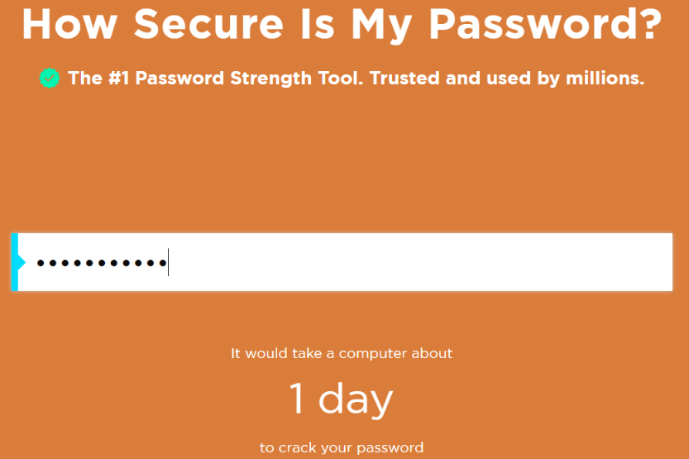

The password: “thisisatest” it would take a computer 1 day to crack the password.
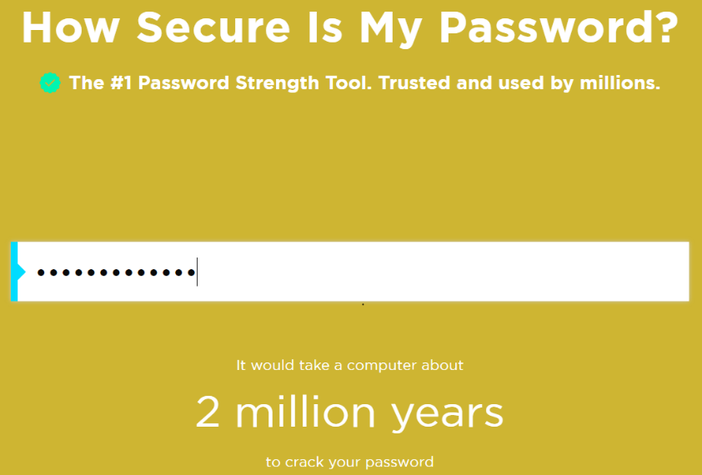

The password: “Thisisatest1!” would take the computer 2 million years to crack the password[3].

Malware – This covers a large range of attacks including Trojans which rely on the user to activate malicious software. This will spread viruses throughout the network, these types of attacks can be performed through Phishing attacks. Phishing is when a user receives an email which is designed to look professional and fool a user to click a link or attachment. The Journal of Cyber Security reported that Sony suffered from a malware attack which, “had an impact of close to $100 million[4].” Showing how vital good security is to keep a network safe.
The use of policies to prevent users from being able to install software and attachments would protect the network from phishing attempts or malicious items within USB’s. The below image shows a policy created within Routing and Remote Access Policies where non administration users are prevented from using any type of attachable USB to a networked device.
Another way to protect a network is through the use of Active Directory groups[5]. These place users within specific groups allowing and denying access to certain aspects within a network. For example, If a receptionist accidentally clicks a phishing email and infects the PC, the attack would only be able to access aspects of the network which the receptionist had access to. This allows time to remove the Malware before infecting further into the network.

Enterprise Network failover

what is a failover
A failover switches to a backup system, which immediately allows the network to stay continuously working If a problem has occurred. For example, if a networks server goes down, stopping all users from accessing the network. The failover will direct all actions from the main server to a back-up allowing users to access the network again. It also allows for the main server issues to be resolved in the background[6].
A failover must have the requirements to fit the business needs such as scalability and data synchronization, which allow the business to rely on the failover in the situation of a problem occurring.
Scalability – A failover must be able to continuously grow along-side the business. This includes the ability to modify aspects of the failover in terms of hardware by being able to upscale the components to allow it to keep up with the business growth and allow for the speed of which the failover can act[7].
Data synchronization -The ability to transfer data between the failover network and the main network is vital in allowing the business to maintain high or continuous availability. The vital data in keeping the network running on the main network must also be available on the failover. For example, information to allow users to login, policies to eliminate any further risks such as users accessing parts of the network they shouldn’t and data on what allows the business to continuously run.

Steps to create a Failover Cluster
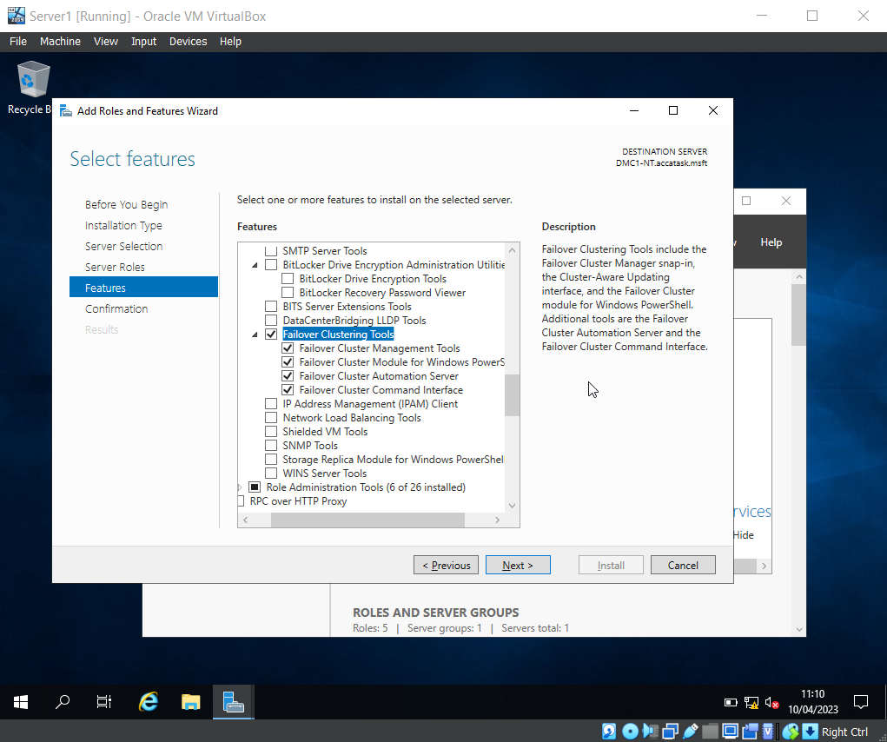The above image shows the features aspect of the wizard which shows the Failover Clustering Tools have been ticked. Presenting a list of the failover cluster tools which have also been ticked that allow for automation of the failover to take place in case of an emergency by automatically backing up everything that happens within the server. This tool works well with the failover cluster management tool as it allows for setting up what needs to be working in case of the first server going down.
Another tool is the Failover Cluster Command Interface, which allows network administration to create and edit the failover. Allowing for modification of the resources if needed while also making sure the failover is still active and there are no errors.
These tools work together and allow a network to have complete control over the failover if an unexpected event causes the servers to go down the network can continue to run keeping the network and the business continuously available.
An example of why a failover cluster is crucial for a network and business is Digital Health Care of Wales fix IT problems and requests for GP practices across Wales if their server crashes and there is no failover in place, they’re unable to help GP’s causing a rippled effect where patients could miss appointments, prescriptions and become ill. This is why the failover is so desperately needed by businesses that need to be high or continuously active[8].

Enterprise Network policy[9]

Overview
The enterprise network policy will cover critical business applications such as high/continuous availability, operating at multiple locations, architecture of the network, security teams and security policies. Along with security risks and any changes to security operations to mitigate violations.
Scope
Staff at all levels including, but not limited to security staff and administration must adhere to this policy.
Purpose
To maintain high/continuous availability throughout the network no matter the location and maintain a high level of security.
Assumptions
- The network is based in multiple locations using VPNs.
- Must operate at a high/continuous availability.
- The security team must follow set policies and adapt to changing risks.
- The networks topology and architecture is a hub-and-spoke model, where the main location of the office is the hub, and the multiple locations are the spoke[10].
Policy
Network architecture
- Must run at high/continuous availability.
- Failover cluster is in place to mitigate any down time.
- The use of Active Directory to store user data i.e. username, password, network access.
Security
- Must abide by the policies set.
- The ability to adapt to changing threats.
- The team must be trained and have qualifications linked to security.
Analysis of security risk
- Security team are in charge of analysing potential security risks.
- Must preform audits to predict and prevent attacks.
- Check all systems in place to ensure no attacks have or are taking place.

Security Changes
- Security team must be adaptable.
- Any changes within security must be agreed and documented.
- Any attacks or attempts must be documented and viewed.
Monitoring security operations
- Security must be active at all times to keep network highly/continuously active.
- All operations must be agreed and documented.
- Must follow all security policies.
Mitigating violations
- All violations must be reported to prevent future attacks.
- Security team must take action against threats/possible attacks.
- All staff must be trained on how to report security risks
Conclusion
This policy must be followed by all members of staff to protect themselves and the network and to understand what is required of them within a working environment. The policy with be checked and periodically changed when required.

Reflection
The team work helped with understanding harder aspects of the first task that would of otherwise more difficult to grasp. For example, the virtual machines wouldn’t load up, because one of the team members laptops didn’t have the hardware to run two virtual machines at the same time so one of the team reduced the ram and it solved the issue.
The individual based work lent a further opportunity to express what was learned through the team tasks and build upon it. This allowed for a deeper understanding of the overall subject. A particular part of the assignment that was interesting was the first question within the individual task which allowed for the knowledge already obtained from working form home to then be implemented into the assignment.

References
[1] Al-Shurman, M.; Yoo, S.M.; Park, S. Black Hole Attack in Mobile Ad Hoc Networks. In Proceedings of the ACMSE’04, Huntsville, AL, USA, 2–3 April 2014. Used for: How Black Hole attacks work, found on: file:///C:/Users/markw/Downloads/Black_hole_attack_in_mobile_Ad_Hoc_networks.pdf
[2] Sirapat Boonkrong, Arkalerk Kitthimon, Patchara Koksoungnoen, and Krissada Jenprakhon, “Password Strength Metre Application,” International journal of interactive mobile technologies, vol. 15, no. 15, pp. 59–73, 2021, doi: 10.3991/ijim.v15i15.22323. Used for: how to make the strength of password stronger, page 5, found on: file:///C:/Users/markw/Downloads/pkpadmin,+59_Password+Strength+Metre+Application.pdf.
[3] Website, “How secure is my password?”, Security.org, © Copyright 1995 - 2023 Security.org a Centerfield Media Company, used for information on password strength, found on: https://www.security.org/how-secure-is-my-password/
[4] F. Quader and V. P. Janeja, “Insights into Organizational Security Readiness: Lessons Learned from Cyber-Attack Case Studies,” Journal of Cybersecurity and Privacy, vol. 1, no. 4, pp. 638–659, 2021, doi: 10.3390/jcp1040032. Used for quote on Sony’s Malware attack, found on: https://mdpi-res.com/jcp/jcp-01-00032/article_deploy/jcp-01-00032-v3.pdf?version=1637742507
[5] B. I. Mokhtar, A. D. Jurcut, M. S. ElSayed, and M. A. Azer, “Active Directory Attacks—Steps, Types, and Signatures,” Electronics (Basel), vol. 11, no. 16, p. 2629–, 2022, doi: 10.3390/electronics11162629. Used for information on Active directory cyber-attacks and preventative actions, found on: https://mdpi-res.com/electronics/electronics-11-02629/article_deploy/electronics-11-02629-v2.pdf?version=1661254659
[6] L. Trombeta and N. Torrisi, “DHCP Hierarchical Failover (DHCP-HF) Servers over a VPN Interconnected Campus,” Big data and cognitive computing, vol. 3, no. 1, p. 18–, 2019, doi: 10.3390/bdcc3010018. Used for information on failovers, found on: https://mdpi-res.com/BDCC/BDCC-03-00018/article_deploy/BDCC-03-00018.pdf?version=1551776317
[7] Website, article, “Scalability and failover”, ProgressSitefinity, Copyright © 2016 Progress Software Corporation. All rights Reserved, Updated: 08/10/2016, used for information on failover scalability, found on: https://documentation.progress.com/output/sitefinity/cms/gs/index.html#page/sitefinity/scalability-and-failover.html
[8] Website, article, “What is a failover?”, Barracuda, © 2003 - 2022 Barracuda Networks, Inc. Used for information on why failovers are important, found on: https://www.barracuda.com/support/glossary/failover.
[9] Website, article, “Free policy template + examples to draw inspiration from”, mondayblog, March 4th 2022, All Rights Reserved © monday.com, used for information on how to create a policy, found on: https://monday.com/blog/task-management/policy-template/
[10] Website, article, “Hub-and-spoke network topology”, Microsoft, © Microsoft 2023, found on: https://learn.microsoft.com/en-us/azure/cloud-adoption-framework/ready/azure-best-practices/hub-spoke-network-topology

