BA (Hons) Business Management
Introduction to Leadership and Management
Christvit Luzeyiwo Kanga (2441744)
LCBB4015

Introduction
Leadership plays a fundamental role in shaping organisational culture, driving performance, and influencing employee engagement. As organisations confront increasing competition and rapid technological change, effective leadership has become more crucial than ever. Daniel Goleman, a prominent psychologist, identified six emotional-intelligence-based leadership styles that guide how leaders interact with others and influence outcomes. These styles offer valuable insights into the behaviours and approaches leaders can adopt to inspire, motivate, and support their teams. This essay focuses on three of Goleman’s leadership styles—authoritative, democratic, and coaching—exploring their characteristics, advantages, and limitations. Real-world business scenarios illustrate how each style can be applied effectively. The essay also identifies essential skills that contemporary leaders require to navigate complex environments, including emotional intelligence, adaptability, strategic thinking, and collaboration. Through understanding and applying these leadership styles and skills, leaders can foster innovation, resilience, and sustainable organisational success. Additionally, the essay will identify essential skills that contemporary leaders need to navigate complex challenges and drive sustainable growth, ensuring that organisations remain competitive in an ever-evolving landscape.

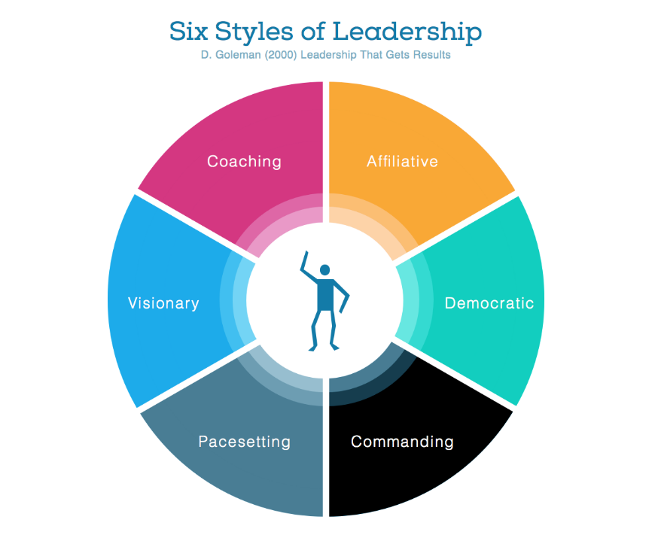

(Goleman, 2000)

1. Definition of Leadership
Leadership is often described as the ability to influence, motivate, and guide individuals or groups toward the achievement of shared objectives. Northouse (2018) defines leadership as a process in which an individual influences a group of people to reach a common goal. This definition emphasises leadership as an interactive and dynamic process rather than a static trait or position. Effective leadership requires strong communication skills, emotional intelligence, and the ability to adapt to shifting organisational or environmental conditions.
In contemporary organisations, leadership extends beyond directing tasks; it involves shaping vision, fostering relationships, and building a culture of trust and engagement. Leaders must therefore balance organisational demands with the personal and professional needs of their teams. Modern leadership theories increasingly highlight collaboration, empowerment, and shared decision-making, aligning closely with Goleman’s emphasis on emotional intelligence. Visionary (or authoritative) leadership, in particular, has garnered attention for its ability to provide clear direction in uncertain environments.
Visionary (Authoritative) Leadership
Visionary or authoritative leadership involves articulating a clear and compelling picture of the future while empowering team members to determine how best to achieve it. These leaders focus on long-term goals and inspire enthusiasm by linking individual contributions to the organisation’s broader mission. Visionary leaders excel at motivating teams during periods of change, as they provide clarity and reassurance without micromanaging. This approach is grounded in trust and confidence, enabling employees to innovate and take calculated risks. Visionary leadership, also known as authoritative leadership, is characterised by a leader who inspires and motivates people with a clear, compelling vision of the future. Visionary leaders articulate where the organisation is going but not necessarily how to get there, empowering their team to innovate and take risks.

2. Goleman’s Leadership Styles (Goleman, 2000)
a. Authoritative Leadership
Characteristics:
Authoritative leaders set a clear vision and direction while allowing autonomy in how tasks are performed. They communicate purpose effectively and encourage innovation by giving employees the freedom to explore solutions. Their confidence and clarity help create alignment within the team.
Advantages:
One of the main strengths of authoritative leadership is its ability to inspire and motivate. Employees often feel more engaged when they understand how their work contributes to a meaningful vision. This style also promotes adaptability, as team members can determine the best pathways to reach the desired outcomes. Research suggests that authoritative leadership can improve morale and performance, particularly in times of organisational transition. It fosters a sense of purpose and motivates employees by aligning their personal goals with the organisation's vision.

Disadvantages:
This style may be less effective in situations that require strict compliance or immediate action, such as crisis management or highly regulated environments where procedures must be followed precisely. Additionally, if a leader’s vision is unclear or lacks credibility, employees may become disengaged or confused. It may not be effective in situations requiring immediate compliance or in teams that require more guidance
Example:
During a significant organisational restructuring, an authoritative leader can effectively articulate the new direction and purpose, reducing uncertainty and rallying employees around shared goals. By encouraging staff to contribute ideas for implementing the changes, the leader fosters both ownership and innovation.

b. Democratic Leadership
Characteristics:
Democratic leaders place strong emphasis on participation, collaboration, and shared decision-making. They encourage team members to contribute ideas and opinions, fostering open communication and inclusive practices.
Advantages:
This leadership style enhances employee involvement and morale by giving individuals a sense of ownership over decisions. It often leads to higher creativity and innovation, as diverse perspectives are considered. Research indicates that democratic leadership can strengthen team cohesion and produce more effective problem-solving outcomes.
Disadvantages:
The collaborative nature of the style means decision-making processes can take longer, which may hinder productivity in situations requiring swift action. Additionally, differing viewpoints can lead to conflict or indecision if not managed carefully.
Example:
A democratic leader in a product development team might facilitate brainstorming sessions where all members contribute ideas. This inclusive approach can lead to more creative solutions and strengthens the team’s commitment to the final product.

c. Coaching Leadership
Characteristics:
Coaching leaders focus on developing individuals for long-term growth by providing guidance, mentorship, and constructive feedback. They help team members identify strengths and areas for development, aligning personal goals with organisational objectives.
Advantages:
This style significantly boosts employee engagement and retention, as individuals feel supported and valued. Coaching encourages continuous skill development, leading to improved performance and confidence. It is particularly effective in organisations that prioritise professional growth and learning.
Disadvantages:
Coaching requires considerable time and patience. It may not be effective for employees who are resistant to feedback or who prefer more direct, task-focused leadership. Additionally, in fast-paced environments, leaders may struggle to dedicate enough time to one-on-one development.
Example:
In a sales team, a coaching leader might work individually with employees to help them refine their techniques, set realistic goals, and build confidence. Over time, this personalised support contributes to higher overall performance and stronger team capability.

3. Key Skills for Contemporary Leaders
Modern leaders must possess diverse skills to navigate rapidly changing organisational landscapes. Among the most crucial are emotional intelligence, adaptability, strategic thinking, and collaboration.
Emotional Intelligence:
Emotional intelligence (EI) underpins Goleman’s leadership framework. Leaders with high EI can understand and regulate their emotions, empathise with others, and build strong interpersonal relationships. This enhances communication, reduces conflict, and supports a positive organisational climate. The ability to understand and manage one's emotions and those of others is crucial for effective communication and relationship-building.

Adaptability:
With constant technological and market changes, leaders must adjust strategies and approaches quickly. Adaptability enables leaders to respond effectively to uncertainty and make timely decisions that keep the organisation agile. The ability to understand and manage one's emotions and those of others is crucial for effective communication and relationship-building.

Strategic Thinking:
Strategic thinking involves analysing complex situations, anticipating future challenges, and aligning decisions with long-term goals. Leaders who excel in strategic thinking can position their organisations for sustained success and respond proactively to emerging trends. The ability to see the big picture and make informed decisions that align with long-term goals is essential for sustainable growth.

Collaboration:
Modern organisations thrive on teamwork. Leaders must foster collaboration by building trust, encouraging open communication, and creating environments where diverse perspectives are valued. Effective collaboration drives innovation and supports organisational objectives. Building strong relationships and fostering teamwork is vital for driving innovation and achieving organisational objectives.

Conclusion
In conclusion, Goleman’s leadership styles provide a valuable framework for understanding how leaders can effectively guide and motivate their teams. The authoritative, democratic, and coaching styles each offer unique strengths and limitations, making them suitable for different contexts within an organisation. By applying these styles appropriately, leaders can promote engagement, foster innovation, and support organisational resilience. At the same time, contemporary leaders must develop essential skills such as emotional intelligence, adaptability, strategic thinking, and collaboration to navigate the complexities of today’s business environment. Investing in personal development, encouraging open communication, and supporting the growth of team members are practical steps leaders can take to create a thriving workplace. Ultimately, effective leadership combines the right style with the right skills, enabling organisations to remain competitive and achieve sustainable success. The authoritative, democratic, and coaching styles each have unique characteristics, advantages, and disadvantages that can be leveraged in different business situations. As organisations continue to evolve, leaders must develop essential skills such as emotional intelligence, adaptability, strategic thinking, and collaboration to support growth and development. By embracing these styles and skills, leaders can create a positive organisational culture that fosters innovation, resilience, and success. Practical recommendations for leaders include investing in their emotional intelligence, encouraging open communication, and prioritising the development of their team members to ensure a thriving workplace.

