• Student: Magdalena Deneva Deneva
• ID: 2023975
• Topic: The Impact of Artificial Intelligence on Business operations in Tesla: An Analysis of Adoption and Performance Outcomes
• University: University of Wels Trinity Saint David
• Submission Date: 30.08.2023

Table of Contents
Introduction 2
Literature review 4
Research Methods and Methodology 5
Time prospects of the research (Gantt chart) 8
Conclusion 9
References 10

Introduction
- Introduction
In the wake of rapid advancements in technology, the rapid increase of artificial intelligence (AI) has emerged as a transformative force across numerous industries. In particular, the manufacturing sector stands at the forefront of this technological revolution, where AI has the potential to revolutionize traditional business operations. The integration of AI technologies into manufacturing processes offers promising opportunities to enhance productivity, optimize efficiency, and drive innovation.

Tesla is a leading company in that aspect. With integration of AI in their manufacturing part, they hold the promise of revolutionizing various aspects of their business operations. By leveraging machine learning algorithms, robotics, and data analytics, AI can enable manufacturers to automate and optimize processes, improve decision-making, and unlock new levels of operational efficiency. From predictive maintenance and supply chain optimization to quality control and demand forecasting, AI has the potential to reshape the manufacturing landscape.

Significance of topic: By investigating the impact of AI on business operations in Tesla is significant due to its potential to transform the rest of the industry, enhance operational efficiency, reduce costs, foster innovation, inform decision-making, influence industry policies, and contribute to knowledge advancement. By adopting the patterns and performance outcomes associated with AI integration is essential for other manufacturers to leverage the benefits of AI and navigate the evolving technological landscape effectively.

Purpose: The purpose of this research is to analyse the impact of artificial intelligence (AI) on business operations more specifically in Tesla. The research intends to provide valuable insights into how AI can enhance operational efficiency, optimize resource allocation, reduce costs, drive innovation, and improve decision-making in manufacturing organizations. Ultimately, the purpose is to contribute to the existing knowledge and guide other potential manufacturers in leveraging AI effectively for enhanced business operations.

Proposed aim, objective and potential questions.
The aim of this research is to examine the impact of artificial intelligence (AI) on business operations in Tesla. Specifically, it seeks to analyse the adoption patterns of AI technologies, assess the performance outcomes resulting from their implementation, and identify the factors influencing successful AI integration, so other companies may adapt the same technology in the future.

Proposed Objectives:

- To investigate the current state of AI adoption in business operations and understand the motivations and barriers faced by Tesla.
- To evaluate the performance outcomes associated with AI implementation in manufacturing operations, including improvements in productivity, efficiency, cost reduction, and quality control.
- To provide insights and recommendations for future manufacturers considering AI adoption to enhance their business operations.

Research Questions:
- What is the current level of AI adoption in Tesla, and what are the motivations and barriers faced by your organization in implementing AI technologies?
- What are some of the AI implementations which are currently used and what for.
- What are the performance outcomes resulting from the integration of AI in your operations, specifically in terms of productivity, efficiency, cost reduction, and quality control?
- Based on your knowledge and position, what insights and recommendations can you provided to future manufacturers for effectively adopting AI in their business operations?

Literature review
Studies such as (Dikmen & Burns, 2017) highlight Tesla's Autopilot system, which utilizes machine learning algorithms to enable semi-autonomous driving. This technology has not only improved safety features but also increased customer satisfaction.
In manufacturing and supply chain management, AI-driven predictive analytics have played a crucial role in optimizing production processes and inventory management (Sypko, 2022). Tesla's use of AI in predicting demand, supply chain disruptions, and optimizing production schedules has resulted in cost reductions and improved operational efficiency. AI's impact on Tesla's customer service has been studied by (Ajitha & Nagra, 2021), who emphasize the implementation of AI-powered chatbots for handling customer queries and providing personalized assistance.
Ethical Implications and Algorithmic Bias:
As AI plays an increasingly significant role in Tesla's operations, concerns about ethical implications and algorithmic bias have emerged. (Robinson & Martinez, 2019) highlight the potential biases that AI algorithms can inherit from historical data, leading to discriminatory outcomes. Understanding how Tesla addresses and mitigates such biases in its AI systems is crucial for ensuring fairness and equity in its business operations.
Human-Machine Collaboration and Workforce Dynamics:
AI adoption raises questions about the nature of human-machine collaboration and its impact on Tesla's workforce. (Nguyen et al., 2020) discuss the concept of "cobots" – collaborative robots – that work alongside human employees in Tesla's manufacturing plants. Exploring the dynamics of this collaboration, including skill development, job enrichment, and employee satisfaction, provides insights into how AI influences Tesla's work environment.

Performance Outcomes of AI Adoption in Tesla:
Enhanced Efficiency and Productivity: Research by (Cooke, 2020) reveals that AI-driven automation has significantly improved efficiency in Tesla's manufacturing processes.
Quality Improvement: AI-powered quality control systems have been instrumental in detecting defects and anomalies during the manufacturing process, as shown by (Ahmad & Khan, 2019).
Customer Experience Enhancement: Tesla's implementation of AI-powered chatbots and virtual assistants has positively impacted customer service, according to (Ullah, Aimin, & Ahmed, 2018). Elevating Customer Experience through AI: Tesla's innovative use of AI has transformed the customer experience within the automotive industry. The implementation of AI-driven chatbots and virtual assistants has provided customers with instant responses to inquiries and support requests. This not only reduces response times but also enhances customer satisfaction by providing personalized assistance around the clock. Moreover, the utilization of AI-powered data analytics has enabled Tesla to understand customer preferences and behaviours, leading to the design of vehicles that align better with consumer expectations.

Advancements in Autonomous Driving: Studies like (Perez Garcia & Saffon Lopez, 2018) highlight Tesla's Autopilot system as a significant breakthrough in autonomous driving technology.

While existing literature provides valuable insights into the adoption and performance outcomes of AI in Tesla's business operations, a notable gap exists in terms of the actual way of AI integration in your business. How exactly do they do it?

Research Methods and Methodology

RESEARCH PHYLOSOPHY -

Interpretivism: Interpretivism focuses on understanding the subjective meanings and interpretations individuals assign to their experiences. In the context of AI's impact on business operations, interpretivism can help explore the perspectives, motivations, and barriers of manufacturing organizations regarding AI adoption

Research paradigm: In the context of studying the impact of AI on Tesla’s business operations , pragmatism is best suitable. Pragmatism is a research paradigm that emphasizes the practicality and usefulness of research findings.

Research approach: By employing a qualitative research approach, you can gain a rich understanding of the subjective experiences, motivations, and barriers of Tesla’s adoption of AI in manufacturing.

Data Collection: Conducting structured, semi-structured, or open-ended interviews can be used to explore motivations, challenges, decision-making processes, and subjective experiences related to AI adoption.
Targets will be stakeholders, such as managers, executives, and employees involved in the decision-making and implementation of AI technologies in Tesla’s business operations.

Data Analysis: Analyse the semi-structured interviews and focus group data using qualitative analysis techniques, such as thematic analysis or content analysis. Identify emerging themes, patterns, and categories related to the motivations, barriers, and subjective experiences of organizations adopting AI in manufacturing

Research methodology: Case Study Methodology: This methodology involves an in-depth investigation of one or more organizations that have adopted AI technologies in their manufacturing operations. It allows for a detailed examination of the specific context, challenges, strategies, and outcomes related to AI adoption.

Netnographic Methodology: (online interview)Researchers can observe and engage with employees, collect data through interviews, observations, and document analysis. This methodology enables a deep understanding of the social and cultural factors influencing AI adoption and its impact on business operations.

Explanatory Research Strategy: An explanatory research strategy seeks to explain the causal relationships between variables and understand the underlying mechanisms behind the impact of AI on business operations in manufacturing.

Sampling method: Non-Probability Sampling: Snowball Sampling : is used as a sampling technique, whereby one interviewee provides the researcher with the name of at least one more possible interviewee. The sample expands like a rolling snowball if more than one recommendation per interviewee is given. That interviewee then gives the name of at least one more possible interviewee, and so on.

Data interpretation: Cross-Case Analysis: In case of multiple cases or interviews, compare and contrast the data across different cases to identify commonalities or differences. I will analyse how the themes and patterns vary across different organizations or contexts, providing a deeper understanding of the impact of AI on business operations.

Integration with Literature: Connect the findings from your qualitative data analysis with existing literature, theories, or conceptual frameworks. Consider how your interpretations align with or contribute to the current knowledge on AI adoption in manufacturing and its impact on business operations.

Ethical Considerations: When conducting research on the impact of artificial intelligence on business operations, including ethical considerations is crucial. Ethical considerations ensure that the research is conducted in a responsible and respectful manner, considering the potential impact on individuals, organizations, and society as a whole. Here are some ethical considerations to keep in mind:

- Informed Consent: It is essential to obtain informed consent from participants or stakeholders involved in the research.
- Data Privacy and Confidentiality: Researchers must handle data collected during the research process with care, ensuring that privacy and confidentiality are maintained.
- Transparency: Researchers should be transparent about their methodologies, data collection processes, and any potential conflicts of interest.

Time prospects of the research (Gantt chart)
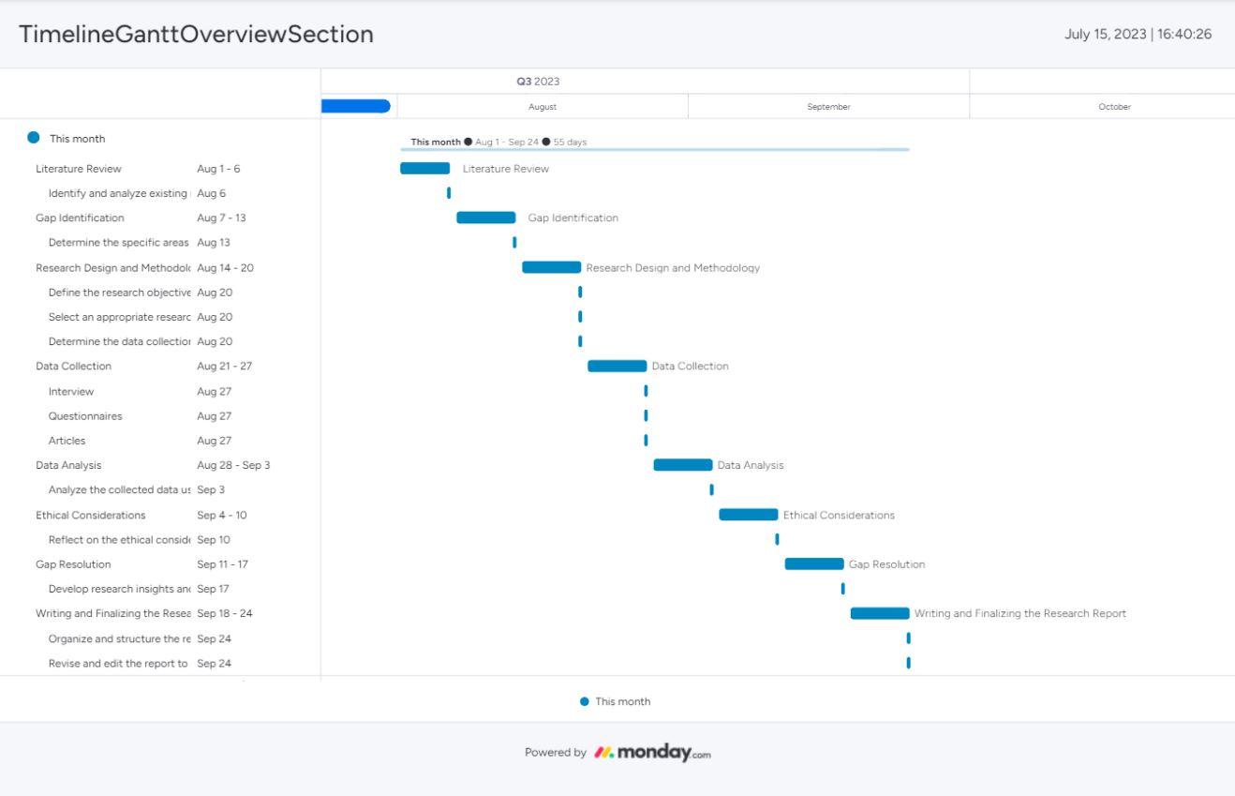

Conclusion
In conclusion, this dissertation proposal aims to investigate the impact of artificial intelligence (AI) on business operations in Tesla, focusing on the adoption and performance outcomes. The integration of AI technologies such as machine learning, computer vision, natural language processing, and predictive analytics has played a crucial role in achieving these outcomes.
By conducting this research, valuable insights can be gained to enhance our understanding of how AI adoption influences business operations in the automotive manufacturing industry, with Tesla serving as a prominent case study. The findings of this study will contribute to the academic literature on AI implementation, as well as provide practical implications for companies looking to leverage AI technologies effectively.

References
Ahmad, S. and Khan, M., 2019. Tesla: Disruptor or Sustaining Innovator. Journal of Case Research, 10(1).
Ajitha, P.V. and Nagra, A., 2021. An Overview of Artificial Intelligence in Automobile Industry–A Case Study on Tesla Cars. Solid State Technology, 64(2), pp.503-512.
Barbara A Schreiber, E. G. (2013, October 07). Tesla, Inc. Retrieved January 23, 2019, from Encyclopaedia Britannica: https://www.britannica.com/topic/Tesla-Motors
Christaininoa. (2016, June 17). Tesla’s Value Chain. Retrieved from wordpress: https://youareallwrongblog.wordpress.com/2016/06/17/teslas-value-chain/
Cooke, P., 2020. Gigafactory logistics in space and time: Tesla’s fourth gigafactory and its rivals. Sustainability, 12(5), p.2044.
Dikmen, M. and Burns, C., 2017, October. Trust in autonomous vehicles: The case of Tesla Autopilot and Summon. In 2017 IEEE International conference on systems, man, and cybernetics (SMC) (pp. 1093-1098). IEEE.
Inc, T., 2023. About Us. [Online]
Available at: https://www.tesla.com/en_gb/about
[Accessed 10 8 2023].
Perez Garcia, M. and Saffon Lopez, S., 2018, May. Building trust between users and telecommunications data driven virtual assistants. In IFIP International Conference on Artificial Intelligence Applications and Innovations (pp. 628-637). Cham: Springer International Publishing.
Sypko, D., 2022. Time-Based Competition in Tesla´ s Supply Chain in the Era of Industry 4.0.
Ullah, A., Aimin, W. and Ahmed, M., 2018. Smart automation, customer experience and customer engagement in electric vehicles. Sustainability, 10(5), p.1350.

