Student name: Zobia Riaz

Student ID: 2226851

Programme: MSc Public Health and Social Care in Practice

Module: Population Health and Digital Health Promotion

Module code: LCHS7009

Lecturer: Raheela

Assignment Title: Component 1 - 2 Blogs

Blog 1: Critically Discussing the Impact of an Existing Digital Technology Used for Health Promotion

Tackling Childhood Obesity in Black African Children Aged 10–15 Years Through Mobile Health Applications
Childhood obesity is a major public health concern in the United Kingdom and globally. Among children aged 10–15 years, obesity is associated with increased risks of type 2 diabetes, hypertension, cardiovascular disease, poor mental health and reduced quality of life (World Health Organization, 2024). Evidence from the National Child Measurement Programme shows that obesity prevalence remains disproportionately high among several ethnic minority groups, including Black African children, reflecting the influence of socioeconomic disadvantage, food environments and physical inactivity (NHS Digital, 2024). These inequalities make culturally responsive health promotion interventions essential.

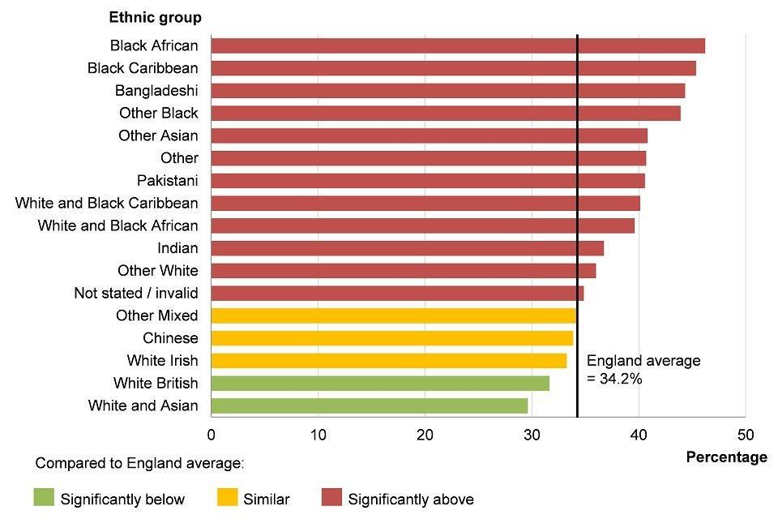
Image - NHS Digital (2024) - National Child Measurement Programme obesity statistics graph Childhood obesity prevalence varies across ethnic groups in England, highlighting the need for targeted interventions.
Existing Digital Technology: Mobile Health Applications
One existing digital technology used to address childhood obesity is the mobile health (mHealth) application. Examples include the NHS Better Health app and the Change4Life Food Scanner. These applications provide calorie tracking, nutrition education, physical activity monitoring and behavioural prompts through smartphones. They are based on behaviour change techniques such as self-monitoring, goal setting and feedback, which have been linked to improved health behaviours (Michie, Atkins and West, 2017).

How Health Apps Support Healthy Behaviour
Common features used in obesity prevention and health promotion programmes.

- Self-monitoring
- Children and parents can record food intake and physical activity.
- Goal setting
- Users receive personalised goals for steps, exercise or healthier eating.
- Reminders and prompts
- Notifications encourage regular activity and healthier choices.
- Gamification
- Rewards, badges and progress tracking help maintain motivation.
- Evidence of Effectiveness

Research indicates that digital interventions can improve dietary behaviours and physical activity in children and adolescents. Fedele et al. (2017) found that mHealth interventions were associated with increased engagement in health-promoting behaviours, while Rose et al. (2022) reported modest reductions in Body Mass Index (BMI) among young people participating in digital obesity programmes. Smartphone ownership is also widespread in the UK, making app-based interventions potentially accessible to many families (Ofcom, 2024).

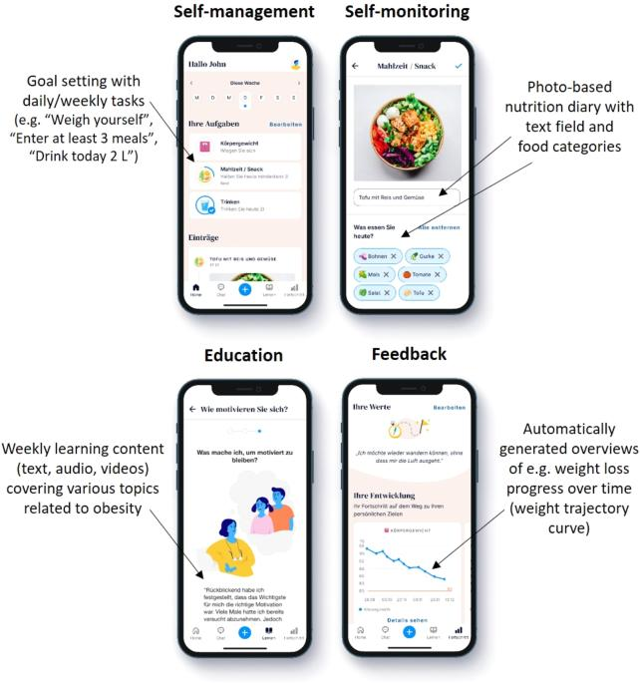
Image - Rose et al. (2022) - Digital obesity interventions have been associated with modest improvements in BMI and physical activity.
Critical Discussion
The main advantage of mHealth applications is accessibility. They can provide continuous support outside clinical settings and at relatively low cost. Interactive features such as reminders, progress tracking and rewards may enhance motivation and self-efficacy (Michie, Atkins and West, 2017).
However, significant limitations remain. Engagement often declines over time, reducing long-term effectiveness (Milne-Ives et al., 2020). Many apps are also not culturally tailored to Black African communities. Nutritional guidance may overlook traditional African foods, reducing relevance and trust. In addition, digital exclusion affects families with limited internet access, lower digital literacy or financial constraints. Privacy concerns regarding the collection and storage of children's health data are another important issue (Zhao et al., 2022).


Addressing the Shortfalls
To improve impact, developers should co-design applications with Black African families, schools and community organisations. Including culturally relevant dietary advice and physical activity options could increase engagement. Combining digital tools with school-based programmes and community support may also improve long-term adherence. Stronger data protection measures and digital literacy support are essential to ensure equitable access.

Conclusion
Mobile health applications offer a promising approach to reducing childhood obesity among Black African children aged 10–15 years. Evidence suggests they can support healthier eating and physical activity, but their effectiveness depends on sustained engagement, cultural relevance and equitable access. Addressing these limitations is crucial if digital health promotion is to reduce rather than widen existing health inequalities.

References - Blog 1
Fedele, D.A., Cushing, C.C., Fritz, A., Amaro, C.M. and Ortega, A. (2017) 'Mobile health interventions for improving health outcomes in youth: A meta-analysis', Journal of Pediatric Psychology, 42(7), pp. 701–717. Available at:https://doi.org/10.1093/jpepsy/jsx035 (Accessed: 16 June 2026).

Michie, S., Atkins, L. and West, R. (2017) The Behaviour Change Wheel: A Guide to Designing Interventions. London: Silverback Publishing.

Milne-Ives, M., Lam, C., De Cock, C., Van Velthoven, M.H., Meinert, E. and others (2020) 'The effectiveness of artificial intelligence conversational agents in health care: Systematic review', JMIR mHealth and uHealth, 8(6), e17046. Available at: https://doi.org/10.2196/17046 (Accessed: 16 June 2026).

NHS Digital (2024) National Child Measurement Programme, England 2023/24 School Year. Leeds: NHS Digital. Available at: https://digital.nhs.uk/ (Accessed: 22 June 2026).

NHS England (2024) Childhood Obesity Statistics Report. London: NHS England. Available at: https://www.england.nhs.uk/ (Accessed: 15 June 2026).

NICE (2023) Obesity Prevention: Clinical Guideline [CG43]. London: National Institute for Health and Care Excellence. Available at: https://www.nice.org.uk/ (Accessed: 18 June 2026).

Ofcom (2024) Online Nation 2024. London: Ofcom. Available at: https://www.ofcom.org.uk/ (Accessed: 20June 2026).

Public Health England (2023) Health Profile for England 2023. London: PHE. Available at:
https://www.gov.uk/government/organisations/public-health-england (Accessed: 17 June 2026).

Rose, T., Barker, M., Maria Jacob, C., Morrison, L., Lawrence, W., Strömmer, S. and others (2022) 'A systematic review of digital interventions for obesity prevention and treatment in children and adolescents', Obesity Reviews, 23(4), e13425. Available at:
https://doi.org/10.1111/obr.13425 (Accessed: 18 June 2026).

Royal College of Paediatrics and Child Health (2023) State of Child Health Report 2023. London: RCPCH. Available at: https://www.rcpch.ac.uk/ (Accessed: 22 June 2026).

UNICEF (2023) The State of the World's Children 2023: For Every Child, Nutrition. New York: UNICEF. Available at: https://www.unicef.org/ (Accessed: 11 June 2026).

World Health Organization (2024) Obesity and Overweight Fact Sheet. Geneva: WHO. Available at: https://www.who.int/news-room/fact-sheets/detail/obesity-and-overweight (Accessed: 17 June 2026).

WHO Europe (2023) Childhood Obesity Surveillance Initiative (COSI) Report. Copenhagen: WHO Regional Office for Europe. Available at: https://www.who.int/europe (Accessed: 15 June 2026).
World Obesity Federation (2024) World Obesity Atlas 2024. London: World Obesity Federation. Available at: https://www.worldobesity.org/ (Accessed: 24 June 2026).

Zhao, J., Freeman, B. and Li, M. (2022) 'Can mobile phone apps influence people's health behavior change? An evidence review', Digital Health, 8, pp. 1–14. Available at:
https://doi.org/10.1177/20552076221074423 (Accessed: 19 June 2026).

NHS Digital (2024) National Child Measurement Programme, England 2023/24 School Year. Leeds: NHS Digital. Available at: https://digital.nhs.uk (Accessed 13 June 2026).

Rose, T., Barker, M., Maria Jacob, C., Morrison, L., Lawrence, W., Strömmer, S. et al. (2022) 'A systematic review of digital interventions for obesity prevention and treatment in children and adolescents', Obesity Reviews, 23(4), e13425. Available at: https://doi.org/10.1111/obr.13425 (Accessed: 2026).

Blog 2: Critically Discussing the Impact of a Designed Digital Technology

AfriFit Kids: A Culturally Tailored Digital Health Platform for Black African Children Aged 10–15 Years
Childhood obesity among Black African children aged 10–15 years is a growing public health concern in the UK. Obesity increases the risk of chronic diseases, psychological distress and long-term health inequalities (World Health Organization, 2024). National data indicate that obesity prevalence remains higher among several ethnic minority groups than among White British children, highlighting the need for culturally appropriate interventions (NHS Digital, 2024). Existing digital programmes often lack representation of African foods, lifestyles and family practices, which can reduce engagement.

Image Unsplash (2025) - Culturally relevant healthy lifestyle promotion may improve engagement among Black African children and families.

Designed Digital Technology: AfriFit Kids
AfriFit Kids is a proposed digital health platform designed specifically for Black African children aged 10–15 years and their families. The platform combines a smartphone application, wearable-device integration and an online educational portal.

Core Features of AfriFit Kids
- Culturally relevant activity challenges (Dance, games and movement activities that reflect African cultural contexts)
- Nutrition education (Guidance that includes traditional African foods and healthier preparation methods)
- Family participation (Parents and carers can set goals, monitor progress and join challenges)
- AI-powered coaching (Personalised feedback based on activity levels, dietary patterns and goals)
- School and community engagement (Modules for teachers, youth groups and community organisations)



How the Technology Promotes Health
The platform is grounded in behaviour change theory. Self-monitoring, goal setting, rewards and social support are known to improve health behaviours (Bandura, 1986; Michie, Atkins and West, 2017). Children would receive personalised recommendations, while parents would access practical guidance on meal planning, portion sizes and physical activity. Community challenges and school partnerships could reinforce healthy behaviours across multiple settings.
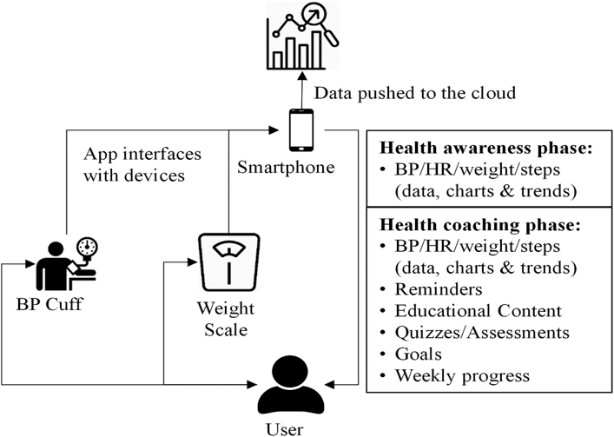
Figure 2. Example architecture of a culturally tailored mobile health platform integrating app, wearable and community components.

Critical Discussion
AfriFit Kids offers several potential advantages. First, cultural tailoring may increase relevance, trust and sustained engagement. Second, involving families recognises that children's eating and activity behaviours are strongly influenced by the home environment. Third, integration with schools and community organisations creates opportunities for population-level impact rather than individual-only behaviour change.
Nevertheless, important challenges exist. Developing and maintaining a sophisticated digital platform can be costly. AI-generated recommendations may introduce bias if training data do not adequately represent Black African populations (Zhao et al., 2022). There is also a risk that increased screen time could undermine physical activity goals if the app is not designed carefully. Digital inequalities remain another concern, as some families may lack access to smartphones, wearables or reliable internet connections.

Addressing the Shortfalls
Several strategies could reduce these limitations. Partnerships with schools, local authorities and public health agencies could provide subsidised devices or connectivity support. Inclusive data collection and regular algorithm audits could minimise bias. The app should prioritise brief interactions and activity-based tasks to avoid excessive screen use. Ongoing co-design with Black African families would help ensure cultural appropriateness and maintain user trust.

Conclusion - AfriFit Kids demonstrates how a culturally tailored digital health platform could strengthen obesity prevention among Black African children aged 10–15 years. By combining behavioural science, family engagement and community partnerships, the technology has the potential to improve diet, physical activity and health literacy. However, careful attention to equity, privacy, cost and algorithmic fairness is essential to ensure that digital innovation reduces rather than reinforces health inequalities.

References – Blog 2
Bandura, A. (1986) Social Foundations of Thought and Action: A Social Cognitive Theory. Englewood Cliffs, NJ: Prentice Hall.

Fedele, D.A., Cushing, C.C., Fritz, A., Amaro, C.M. and Ortega, A. (2017) 'Mobile health interventions for improving health outcomes in youth: A meta-analysis', Journal of Pediatric Psychology, 42(7), pp. 701–717. Available at: https://doi.org/10.1093/jpepsy/jsx035 (Accessed: 7 June 2026).

Michie, S., Atkins, L. and West, R. (2017) The Behaviour Change Wheel: A Guide to Designing Interventions. London: Silverback Publishing.

Milne-Ives, M., Lam, C., De Cock, C., Van Velthoven, M.H., Meinert, E. and others (2020) 'The effectiveness of artificial intelligence conversational agents in health care: Systematic review', JMIR mHealth and uHealth, 8(6), e17046. Available at:
https://doi.org/10.2196/17046 (Accessed: 17 June 2026).

NHS Digital (2024) National Child Measurement Programme, England 2023/24 School Year. Leeds: NHS Digital. Available at: https://digital.nhs.uk/ (Accessed: 22 June 2026).

NICE (2023) Obesity Prevention: Clinical Guideline [CG43]. London: National Institute for Health and Care Excellence. Available at: https://www.nice.org.uk/ (Accessed: 19 June 2026).

Ofcom (2024) Online Nation 2024. London: Ofcom. Available at: https://www.ofcom.org.uk/ (Accessed: 15 June 2026).

Public Health England (2023) Health Profile for England 2023. London: PHE. Available at:
https://www.gov.uk/government/organisations/public-health-england (Accessed: 13 June 2026).

Rose, T., Barker, M., Maria Jacob, C., Morrison, L., Lawrence, W., Strömmer, S. and others (2022) 'A systematic review of digital interventions for obesity prevention and treatment in children and adolescents', Obesity Reviews, 23(4), e13425. Available at:
https://doi.org/10.1111/obr.13425 (Accessed: 23 June 2026).

UNICEF (2023) The State of the World's Children 2023: For Every Child, Nutrition. New York: UNICEF. Available at: https://www.unicef.org/ (Accessed: 11 June 2026).

World Health Organization (2024) Obesity and Overweight Fact Sheet. Geneva: WHO. Available at: https://www.who.int/news-room/fact-sheets/detail/obesity-and-overweight (Accessed: 11 June 2026).

WHO Europe (2023) Childhood Obesity Surveillance Initiative (COSI) Report. Copenhagen: WHO Regional Office for Europe. Available at: https://www.who.int/europe (Accessed: 17 June 2026).

World Obesity Federation (2024) World Obesity Atlas 2024. London: World Obesity Federation. Available at: https://www.worldobesity.org/ (Accessed: 7 June 2026).

Zhao, J., Freeman, B. and Li, M. (2022) 'Can mobile phone apps influence people's health behavior change? An evidence review', Digital Health, 8, pp. 1–14. Available at:
https://doi.org/10.1177/20552076221074423 (Accessed: 16 June 2026).

Zheng, Y., Manson, J.E., Yuan, C., Liang, M.H., Grodstein, F., Stampfer, M.J. (2021) 'Associations of weight gain from early to middle adulthood with major health outcomes later in life', International Journal of Obesity, 45(6), pp. 1191–1203. Available at:
https://doi.org/10.1038/s41366-021-00795-7 (Accessed: 20 June 2026).

Unsplash (2025) Children participating in outdoor physical activity. Available at: https://unsplash.com (Accessed: 18 June 2026).

