E-Portfolio evidence of learning comprising of 2 separate artefact items
Student Name: Nnabuike Onyemauwa
Student Number: 2120203
Lecturer Name: Robert Nartowski
BMHP5014_BIRM
Changemakers: Creativity and Value Creation

Table of contents

Introduction 2
‘Mental health and illness’ campaign 3
Description 4
Elevator style pitch - ‘Mental health and illness’ 6
References 8

With huge vigor it is my team’s and my mission to educate and clarify people of the importance mental health has in our everyday lives and how it affects our professional careers too. Working in the line of coaching this profession finds much applications in many different ways such as performing better, acquiring skills, developing leadership qualities and growing more as a person. Applying human behaviour and feelings to coaching is also a remarkable way of making people realize their consciousness, meaning enhancing their self-awareness (Bachkirova and Clutterbuck, 2014). We mental health coaches limit ourselves in order to understand emotions towards yourself and get through you and as a result we are able to understand your psyche better and help you deal with it accordingly. I can say with great pleasure that it has been a career path I am following with a lot of passion and devotion for a considerable time now and what a time that was!
To start off, giving you an illustrated insight on this campaign to make you connect to my vision is what is first, followed by a prepared speech to deepen your understanding of the subject area in this campaign.

Introduction

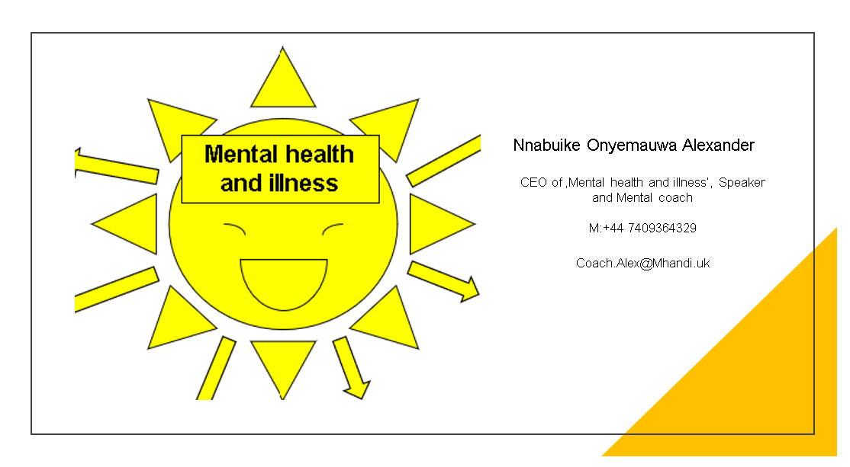

‘Mental health and illness’ campaign

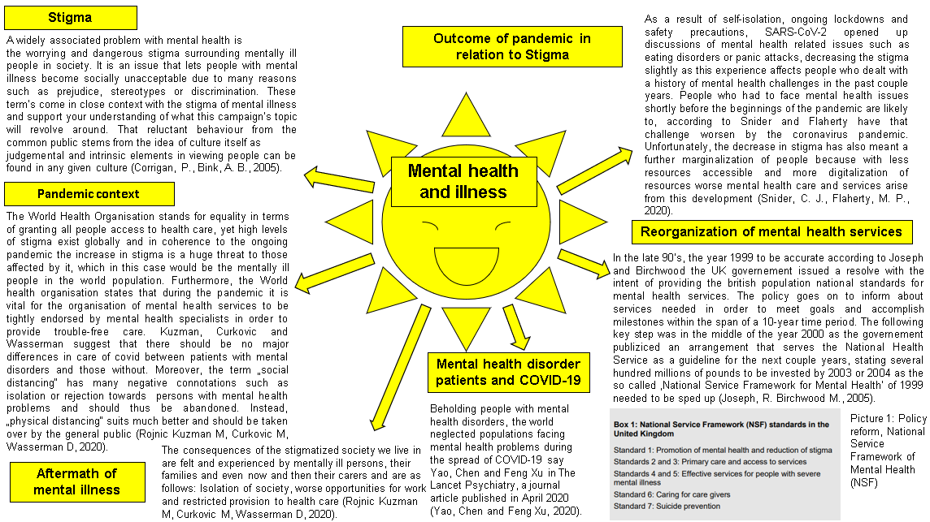

Description

Mental Health is an issue that is relatively, if not completely, abandoned by public health. In the largest parts of Europe mental health is a topic heavily suppressed to argue about yet is the same matter that simultaneously induces challenges in plenty public institutions or communities and especially affects people who suffer from pre-existing mental health problems or conditions. Stigma and a lot of with it associated discriminatory subject areas have wide reach and are well established in society. If these difficulties remain unaddressed, they can cause a hindrance in development towards a shift to positive and encouraging thinking about mental health and illnesses (Knapp, McDaid and Mossialos, 2006).
SARS-CoV-2, is a virus that has brought forth a severe negative impact on mental health according to Boden, et al. (2021) and caused nothing more than heavy stress, anxiety and depression in people around the globe.

‘The rule of thirds (RoT), in art and photography, refers to making use of the intersections of four imaginary lines that divide an image into thirds, horizontally and vertically, to alter the composition of an image’ (Koliska, 2021, p. 1)

This artistic rule lays the groundwork for the draft of my mind-map ‘Mental health and illness’ as the focus of attention, which is the bright yellow sun that serves the purpose to come over as particularly salient, is moved to roughly the first third from the far right arising thereby an accurate depiction of the most important information of the mind-map, leaving the viewer no room for possible misconception of grasping the illustration as a whole. Through the incorporation of that artistic rule into many people’s modern mobile device cameras a huge share of people in the general

public adopt the rule of thirds in their day-to-day lives without being aware of it, when taking a photo for example. Even though this highly valued composition rule has great status in paintings or artworks, according to experimental research findings of Amirshahi, et al. (2014), when applied or put into practice in considerable amounts of high-quality photographs and paintings the rule of thirds proves to play a significantly smaller role. Another auxiliary tool in the design of the mind-map was the finding of a catchy or memorable title. Since the title of an art piece represents the artistic ‘face’ of the work it is crucial to come up with a name people can sense and connect qualities with. If one takes the picture of a rose for instance with a name other than the one it possesses it perhaps smells different from a common red rose, speaking in an aesthetical sense (Levinson, 1985).

Elevator style pitch - ‘Mental health and illness’

Who am I? I am Nnabuike Alexander Onyemauwa! The ‘u’ is silent, but you can call me Alex. I am self-employed and work as a Speaker and Mental health Coach. As I have been around for almost a decade you can say I am an old hand in the industry. Why? Simple. Because I care about people. I care about YOU! I do mental health promotion. Spreading the message so you don’t forget to check on your mental wellbeing now and then. Even easier said, I run a campaign called ‘Mental health and illness’ trying to make mental health great again. Just joking! I am giving mental health a voice. Most people like saying how important mental health is but are suffering from plenty work stress. When you work a common 9-5 on a regular basis I am sure we are on the same page! We give mental health the importance it deserves, especially for people with pre-existing mental health problems. See, today in a world full of rush and a will to work we do our best to connect as many people to our cause as possible, particularly in these challenging COVID-19 shaped times. That feels gloomy, right? Well, that’s exactly why I am standing here in front of you. When I say we actually never really feel as good as we tell people every day, you agree? No, hold it. I’m sure we feel the same way. Ah! See? You are feeling better now. And that’s what I do. Alongside my fantastic team of four that is. As you just saw, we are successful in getting people to think differently about just another grim day at work. Our one goal is to have people like you and me challenge the view on your perspective and value your personal mental health more than ever before! In today’s society it is desired, we give people what they want! I organize meetings and events where people gather due to interest on their own mental health and once I am done talking they sign up with me for future workshops. Of course, I am making this a regular subscription, but only when customers are on board for at least half a month they are required to pay a fair monthly subscription fee. I am proud to say that our customer reviews tell us the vast majority of our clients is more than happy to pay our team and the work we do. We target young adults ranging from twenty-one to twenty-nine and older adults ranging between their late thirties and early forties. Signing up with our campaign ‘Mental health and illness’ means giving your mental health the value it needs. What distinguishes us from other competitors is our combined year-long experience in this line of business and that relentless vigour we put in

this work. It motivates not only our clients but ourselves too to strive for even greater results! Feel free to let me educate you and clarify you about your mental wellbeing. Have my business card! Call me whenever the positive feelings you had during this conversation come back! I am available during weekdays and on agreement Saturdays from eight to five!

References

Amirshahi, S. A., Hayn-Leichsenring, G. U., Denzler; C., Redies (2014) ’Evaluating the rule of thirds in photographs and paintings’, Art & Perception, 2(1-2), pp.163-182.
Corrigan, P. and Bink, A.B. (2005) On the stigma of mental illness (pp. 11-44), American Psychological Association.
Cox, Bachkirova, T., & Clutterbuck, D. (2014) The complete handbook of coaching (2nd ed.), SAGE.
Knapp, M., McDaid, D. and Mossialos, E. (2006) Mental health policy and practice across Europe, McGraw-Hill Education (UK).
Koliska, M. and Oh, K. (2021) ‘Guided by the grid: Raising attention with the rule of thirds’, Journalism Practice, pp.1-20.
Levinson, J. (1985) ‘Titles’, The Journal of Aesthetics and Art Criticism, 44(1), pp.29-39.
Boden, M., Zimmerman, L., Azevedo, K.J., Ruzek, J.I., Gala, S., Magid, H.S.A., Cohen, N., Walser, R., Mahtani, N.D., Hoggatt, K.J. and McLean, C.P. (2021) ‘Addressing the mental health impact of COVID-19 through population health’, Clinical psychology review, 85, p.102006.
Kuzman, M.R., Curkovic, M. and Wasserman, D. (2020) ‘Principles of mental health care during the COVID-19 pandemic’, European Psychiatry, 63(1), p.e45.
Joseph, R. and Birchwood, M. (2005) 'The national policy reforms for mental health services and the story of early intervention services in the United Kingdom', Journal of Psychiatry and Neuroscience, 30(5), pp.362-365.
Snider, C.J. and Flaherty, M.P. (2020) 'Stigma and mental health: The curious case of COVID-19', Mental Health: Global Challenges Journal, 3(1), pp.27-32.
Yao, H., Chen, J.H. and Xu, Y.F. (2020) ‘Patients with mental health disorders in the COVID-19 epidemic’.

