- Slide 1: BMSW 4002
Effective Team Working and Communication
Otilia Ghinet (1922158)
Rodica Geapana (1921535)
Mihai Mamele (1922123)
Lecturer’s: Saqib Shamim

- Slide 2: Table of Contents
- Introduction
- Teamwork
- Benefits of Teamworking
- Stages of Team Development(Tuckman)
- Team Roles (Belbin) -Leadership Roles (Hersey & Blanchard)
Managing conflict (Thomas and Kilmann) Successful Team Development
Conclusion
References

- Slide 3: Presented by
-
Mihai Mamele (1922123)

- Slide 4: Introduction – “Perfect Team Consulting”
“Perfect Team” is providing consulting services for companies
Teams will be helped with our strategies
Used strategies:
Teamwork development
Teamwork conflicts
Teamwork roles

- Slide 5: Team Work
- Team work is activating the integrity in a workplace
- Team work is bringing diversity and creativity
- Team work brings productivity and efficiency
- Team work stimulates learning
- Team work creates synergy in the work place
- (Wehbe, 2017).

- Slide 6: Benefits of Team Working
- The winner innovation comes from different perspectives
- Team work equals individual growth. (Middleton, 2019).
- Complementary strengths are blended together.
- Conflict Resolution will be a skill for everyone.
- Risk Taking is encouraged
- Builds trust. (Mattson, 2017).

- Slide 7: Stages of Team Development
Tuckman
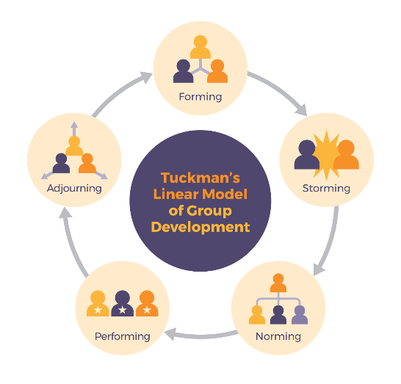
Source: (BCCampus, n.d.)- The Stages of the Tuckman model

- Slide 8: Stages of Team Development
Tuckman
- Forming
- Storming
- Norming
- Performing
- Adjourning (Toggl, 2020).

- Slide 9: Team Roles
Belbin
- The Team Roles of Belbin:
- Shaper
- Implementer
- Completer or Finnisher
- Coordinator (Merchant, 2019).

- Slide 10: Presented by
-
- Rodica Geapana (1921535)

- Slide 11: Team Roles
Belbin
- Team Worker
- Resource Investigator
- Monitor – Evaluator
- Specialist
- Plants (Merchant, 2019).

- Slide 12: Leadership Roles
Hersey and Blanchard
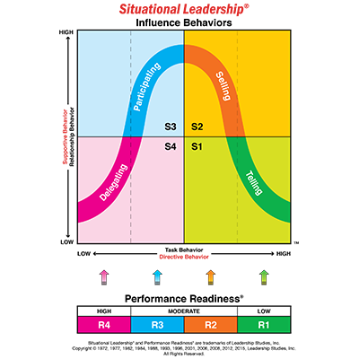
Source: (Situational, n.d.)- Situational Leadership

- Slide 13: Leadership Roles
Hersey and Blanchard
- Telling
- Selling
- Participating
- Delegating
- (Business to you, 2020).

- Slide 14: Managing conflict
Thomas and Kilmann
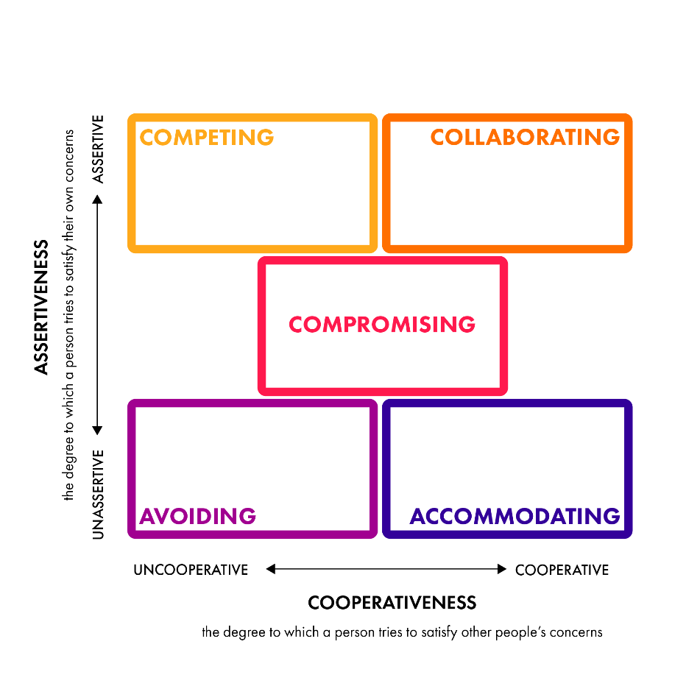
Source: (Psycho Metrics, n.d.) - THOMAS-KILMANN CONFLICT MODE INSTRUMENT
- Slide 15: Presented by
-
- Otilia Ghinet (1922158)

- Slide 16: Managing Conflict
Thomas and Kilmann
- Competing
- Accommodating
- Avoiding
- Collaborating
- Compromising (Harappa, 2020).

- Slide 17: Successful Team Development
- The hiring process is not enough
- A map should be created
- The Scoreboard (Bryant, n.d.)
- Communication is the key
- Focus on goals (Deering, 2020).
- Slide 18: Successful Team Development
- Contribution of fair share
- Giving support
- Members are diverse
- Excellent leadership
- Organizing (Deering, 2020).
- Slide 19: Conclusion
- Team work must go through all the processes
- Collaboration brings success
- Diversity is the key
- Every member should make efforts for the team
- Slide 20: References
- BCCampus, n.d.,- The Stages of The Tuckman Model - https://pressbooks.bccampus.ca/technicalwriting/chapter/understandingteamdynamics/ , Accessed on 16th of November 2020.
- (Bryant A., n.d., How to Build a Successful Team, Accessed on 16th of November 2020.
- Business to you, 2020, Hersey and Blanchard Situational Leadership Model: Adapting the Leadership Style to the Follower, Accessed on 16th of November 2020.
- Deering S., 2020, Top 7 Qualities of a Successful Team, Accessed on 16th of November 2020.
- Harappa, 2020, Dealing With Conflicts: The Thomas-Kilmann Way, Accessed on 16th of November 2020.
- Mattson D., 2017, 6 Benefits of Teamwork in the Workplace, Accessed on 16th of November 2020.
- Merchant P., 2019, What Are the Nine Types of Team Roles?, Accessed on 16th of November 2020.
- Middleton T., 2019, The importance of teamwork (as proven by science), Accessed on 16th of November 2020.
- Psycho Metrics, n.d., THOMAS-KILMANN CONFLICT MODE INSTRUMENT, Accessed on 16th of November 2020.
- Situational, n.d., Situational Leadership, - https://situational.com/situational-leadership/attachment/cls_situationalleadership_model_400x400/ Accessed on 16th of November 2020.
- Toggl, 2020, 5 Stages of Team Development, Understanding team development process, Accessed on 16th of November 2020.
- Wehbe S., 2017, 5 Important Reasons Why Teamwork Matters!, Accessed on 16th of November 2020.

