Shazia Cousear Ayub (2008734)
BMW4005 | Richmand LAMPTEY
Graduates’ Labour Market Outcome During the Coronavirus Pandemic: Occupational switches and Skills

CONTENTS
INTRODUCTION 2
UNEMPOLYMENT DURING CRISIS 3
PROBLEMS UNDERGRADUATE FACE: 3
ADVANTAGES OF GRADUATES 4
CONCLUTION 4
REFERENCES 5

INTRODUCTION
During the Coronavirus Pandemic, the UK and most of the world suffered a great deal. In January 2020 job retainment was a big issue as a lot of firms either went out of business or had to cut down in staff. “There were 1.51 million people who were unemployed in June-August 2021, which compared to 1.37 million in January-March 2020.” (Andy Powell, 2021)
During this time statistics show that graduate level workers were more able to change occupation than undergraduates, even if they are overqualified for the job.
Employers would rather employ overqualified candidates because “overeducation is oftentimes positioned by underemployed young people as involving affective and embodied adaptations that can be characterised as coping or survival strategies in the face of destabilising and overwhelmingly negative transitions into the labour market.” (Brendan Churchill, 2021)

UNEMPOLYMENT DURING CRISIS
Job retainment is a great cause for concern during the Coronavirus Pandemic with a lot of people unemployed, but graduates have faired better at obtaining and maintaining new jobs even if they do not have the required set of skills.
“The proportion of graduates in high-skilled occupations has increased during the pandemic
Distribution of graduates across occupations, from Quarter 2 (April to June) to Quarter 3 (July to September) 2020, UK” (Romiti, 2021)

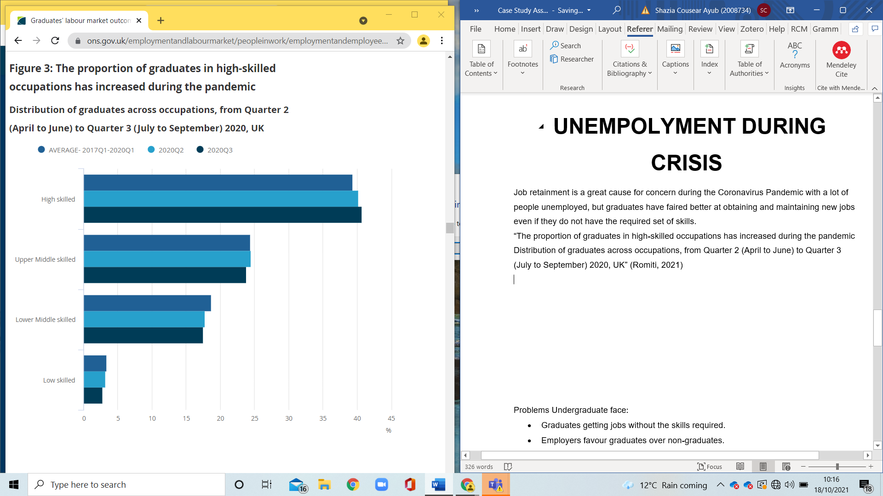

PROBLEMS UNDERGRADUATE FACE:
- Graduates getting jobs without the skills required.
- Employers favour graduates over non-graduates.
- These causes effect the kind of jobs available to undergraduates have lower paid jobs so will work harder longer hours to meet living costs.

ADVANTAGES OF GRADUATES
- Employers believe that they have a greater skill set and can adapt to new jobs.
- Graduates maintained jobs during the pandemic.
- They are able to work remotely given their educational requirements.

The above graph and statistics show that the Graduates gained and maintained jobs better than non-graduates. There are more graduates unemployed, so they are looking into less qualified jobs taking form the skilled and the non-graduates and employer’s favour. “Job loss was larger in occupations that require more interpersonal contact and that cannot be performed remotely”. (al, 2020)

CONCLUTION
These statistics and proof show that the graduates are better at getting retaining jobs have an advantage of the education they posses and have the skills academically to cope with the current crisis. To improve this situation the employers need to look into the qualified and better jobs need to be available for graduates so they don’t go into less skilled jobs taking work from undergraduates. Non-graduates can sign up to free placements show initiatives also have some sort of qualification to help get jobs get into internships. “Advantages included less time to obtain first position, increased monetary compensation, and greater overall job satisfaction.” (Jack Gault, 2000)

REFERENCES
al, L. M. e., 2020. Nationa Bureau of econic research, 2020. Determinants of dispairities in covid-19 job losses.
Andy Powell, B. F.-D., 2021. Coronavirus: Impact on the labour market. [Online]
Available at: https://commonslibrary.parliament.uk/research-briefings/cbp-8898/
[Accessed 17 10 2021].
Brendan Churchill, C. K., 2021. Sociology Compass. Youth underemployment: A review of research on young people and the problems of less(er) employment in an era of mass education, 15(10), p. 6.
Jack Gault, J. R. T. S., 2000. Journal of marketing education. Undergraduate Business Internships and Career Success: Are They Related?.
Romiti, m., 2021. Office for National Stistics. Graduates’ labour market outcomes during the coronavirus (COVID-19) pandemic: occupational switches and skill mismatch, 8 03.

