

Undergraduate Dissertation coversheet & feedback form

PLEASE COMPLETE THE TOP SECTION OF THIS FORM AND SUBMIT ONE COPY WITH YOUR DISSERTATION
For completion by student:
Student Name: Evan Fray

Student University Email: 1700724@student.uwtsd.ac.uk
Module code: HPAR6003 | Student ID number:  1700724 |  |  |  | Educational support needs:  No
Dissertation title: What are the new technologies that are available to archaeologists and what does this mean for the future?
Supervisor: Nigel Nayling |  |  | Word count: 9243
I confirm that this is my original work and that I have adhered to the University policy on plagiarism.
Signed Evan Fray
For completion by the first marker:
Comments:

First Marker’s Mark:  Signature: |  |  |  | Date:
For completion by the second marker (if appropriate):

Comments:

Second Marker’s Mark:  Signature: |  | Date:
NB. All marks are provisional until confirmed by the final examination board.

How agreed mark was decided upon—comments for External Examiner:

Proposed Mark:

Signature of External Examiner:

Final Agreed Mark:

Abstract

This dissertation explores the relationship between advancements in technology and archaeological research methodology. The research carried out was primarily based upon desk top studies with a limited amount of practical research. The study explores both historic and current methodologies in the field of Conservation, Excavation and Surveying and analyses the positives and negatives of these methods with particular focus on the impact new technologies have had on the field of archaeological research. I have also explored the potential impact of further technological advancements on the field of archaeology.
My analysis has shown there have been significant benefits to the field of archaeology as a result of technological advancements, both for the practitioners and the wider public. I have also identified the fact that there are some methodologies that technological advancements cannot replace and still require the human application of the methodology.

Table of Contents

Content

- Abstract
- Introduction
- Chapter 1 – What is an excavation?
What is a survey?
What is conservation?
- Chapter 2 - What new technologies are being used in archaeology?
- Chapter 3 - Is this technology viable and what does this mean for archaeology in the future?
- Chapter 4 – Conclusion
- Bibliography

Introduction
The field of archaeology is a discipline which has the aim of visually presenting the past and in order to achieve this goal archaeologists make extensive use of the many resources available to them. Prior to the advancements in technology, archaeology was presented through physical means, that being through journals, displays as well as drawings. As technology has advanced however, the ways in which archaeologists have presented this information has changed, such as through the use of virtual reality, as well as presenting this information via other media such as through video and photographs. With the advancements in the technologies available to archaeologists, it has meant the way that information is obtained from archaeological sites has experienced several significant changes as the technology available to them has improved. In order to find new ways in which to obtain archaeological information, archaeologists have used technology to change the methods of obtaining archaeological information. The aim is to go from a destructive and invasive method, to a more efficient method which helps preserve as much information as possible. Another area that has changed with the emergence of new technology is the way that the information is presented to the public, for example with the advancements of today’s technologies, archaeologists have tried to adopt non-invasive methods such as Ground penetrating Radar (GPR) as well as Light Detection and Ranging (LIDAR). These techniques are in addition to the use of photogrammetry with the purpose of using this information to digitally reconstruct archaeological sites, as well as the artefacts that are recovered into a three-dimensional image. By using these methods, archaeologists have been able to use this data to analyse the information in order to gain a greater understanding of the sites and artefacts being studied. Due to the impacts of these advancements in technologies, it leads many to ask how technology will further evolve and what that will mean for the future of archaeological research?
In this thesis I will be addressing the topic of what technologies are currently available for archaeologists to utilise, as well as how these new technologies are employed during the course of their investigations. In addition to this, I hope to address the potential areas that these technologies can be used in and what these uses could mean for the future of archaeological research. The primary focus of this paper is to analyse the impact of new technologies currently being utilised in archaeological research, the potential impact of further advancements in technologies, as well as the increase in accessibility for the general public to archaeological data as a result of greater use of these technologies.
Due to the variety of new technologies available to archaeologists, this thesis will focus on specific areas that new technology is being used such as in surveying, excavation and conservation. The reason for this is because in my opinion these areas are where I believe this technology has the highest potential for its use in archaeological practice, in addition to these areas having gone through the most changes. In order to understand the impact that technology has had on these areas of archaeology, I will be outlining the processes of each area of interest as well as their use in archaeological processes in Chapter One. In Chapter Two I will be identifying what new technologies are available to these areas of study, outlining the use of these technologies and how they are applied to archaeological research. I will also assess the benefits and shortcomings of these new techniques, using examples where these technologies have been used by archaeologists. In Chapter Three I will analyse whether or not these technologies are a viable resource, in addition to exploring what technologies may be used for in the future and what the potential impact could be on archaeological research. Throughout the course of my investigation, I expect to be able to explain the processes of how technology is utilised in archaeology, in addition to being able to provide a prediction as to how archaeologists will incorporate technology into archaeological research.

Chapter One
What is an excavation?

Archaeological excavation is defined as;
“the procedure by which archaeologists define, retrieve, and record cultural and biological remains found in the ground” (Carver, 2014)
Excavation has been used in order to gain an understanding of past societies and environments based upon the information obtained from this method. For an archaeologist, the information obtained through excavation is often used as the main source when conducting an investigation. Due to this archaeologists may excavate a variety of different sites in many different conditions, such as in fluvial environments as well as in mountainous environments. As a result of this the methodologies have changed depending on what kind of environment the site is in. However, despite excavation taking place in different environments, the overall method for conducting an excavation follows the same pattern as well as following the same processes throughout the course of the excavation, with the methodology changing slightly to suit the conditions presented to the excavation team.
Before an excavation takes place there is a process that must take place before the initial excavation can begin, this is called a desktop survey. This is conducted to assess the archaeological significance of the site in order to assess whether or not an excavation is a viable option for the site in question. The survey is conducted by looking at documents related to the site in order to gain as much information as possible about the site, which would include documents from organisations such as the Historic Environment Records (HER) and the National Record of Monuments and Places (NRMP) to see if there is any records of prior excavations taking place, in addition to identifying any documents relating to the nature of the site such as references made to the area in historic documents. This assessment is done in order to give archaeologists a clear understanding of the nature of the site. For example, if the site has been previously excavated or if there are documents outlining the use of the site, archaeologists can use this information in order to predict what kind of information might be recovered, as well as being able to assess where the best area is to excavate in order to obtain the most information about the site. If it is determined that the site is viable for excavation, then the excavation team would move on to the next stage in the excavation process. This would be to conduct a survey of the physical area (this described in greater detail in the survey section of this thesis), the basic outline of this process would be to survey the surrounding area marking out points of interest. This process would involve the use of technology primarily to record data. A point to note is that there is a possibility that artefacts may be recovered at this stage, if this occurs then the process of recording and storing the artefacts will begin (this process is described later on in this section). The information that is obtained throughout this stage in the excavation is used to determine the most ideal place to begin excavations. Once the survey has been completed the next stage of the excavation can begin, this is the excavation of the site itself. This would firstly be done by digging what is called test pits on the site, test pits are
“a small 1m sq trench dug in a series of layers to a depth of approximately 1m” (Morris, 2019)
These test pits are commonly used to assess the archaeological material present at the site due to this method being quick to set up, as well as being minimally intrusive (Test-pitting, n.d.). However, due to test pits being small in size they are also used to excavate sites where the land available for the archaeologists is limited, once enough information has been recovered to determine where the best place to start excavating. During the excavation archaeologists would start trenching the site, this is
“an excavation technique in which a site is penetrated with long, narrow trenches that reveal the vertical dimension of the area and to explore the horizontal dimension along one axis” (Archaeology Wordsmith, n.d.)
During this time archaeologists would dig trenches using a combination of machines and various hand tools. These tools would consist of trowels, shovels, mattocks and many others that would be implemented in the excavation process, depending on the aims and goals of the excavation team. The machines that would be implemented in an excavation will range in shape and size depending on what the aims of the excavation team are. For example, at the beginning of the excavation when the topsoil is being removed during deturfing an excavator like the one illustrated in figure one, this would allow archaeologists to quickly remove spoil and excavate to the desired level for archaeologists to begin their investigation.
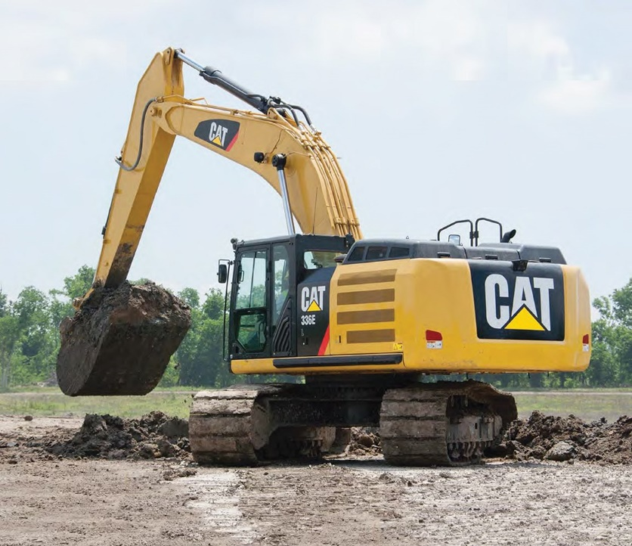
Figure one: Excavator

(https://www.equipmentworld.com/caterpillar-336e-l-excavator-review/ 03/05/20)
Other machines that are used in excavation are generally used during the post excavation process, or it is used in conjunction with the excavation process in order to find artefacts. An example of this would be, a soil sifter which is used to go through the spoil, which is “the soil, dirt and rubble that results from an excavation, and discarded off site on spoil heaps” (Spoil (archaeology), n.d.). This would be done by moving the spoil and processing it through the shaker screen, in order to recover any small artefacts that the excavators may have missed during the excavation process. These artefacts would then be recorded and processed alongside the other artefacts that were recovered during the excavation.

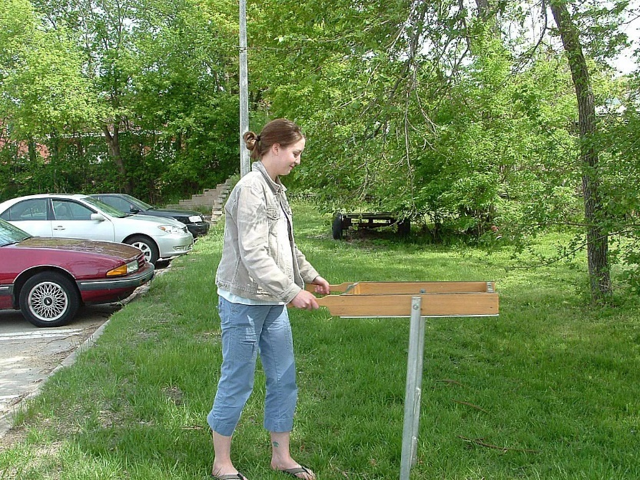
Figure two: soil sifter being used

(Archaeology Equipment: The Tools of the Trade, 2019)
During the excavation of the site itself, archaeologists would excavate the site in the most effective method possible. This would mean that they would excavate the site by digging the excavation site layer by layer through the use of mattocks, shovels and trowels. Archaeologists would use these tools due to the fact that they allow archaeologists to excavate while reducing the risk of damaging features that are revealed throughout the excavation process, as well as increasing the likelihood that artefacts can be discovered. Throughout this process each layer, feature and artefact is recorded in detail. In addition to this a field report is also created, in order to have a complete record of the events of the excavation process. Once the initial excavation has taken place, there is another stage in which the artefacts recovered are processed and curated (this process is covered in the curation section of this thesis) then the documents relating to the excavation are archived for later use.

What is a survey?
In order for archaeologists to effectively conduct an excavation, a thorough investigation on the site must take place this would occur in the form of an archaeological survey. An archaeological survey is “a specialized type of land surveying conducted to report the finds made in an archaeological site or to show the relationship of the archaeological site to the landscape” (Archaeological Land Surveying | Point to Point Surveyors, 2016) because surveying an area is a crucial part of the investigation process it is important that a detailed survey is carried out, in order to provide archaeologists with a clear understanding of what archaeological information is available to the excavators. Due to the nature of archaeological sites, the way that a survey is conducted depends on the conditions presented to the excavation team, the first thing that archaeologists would do before they survey the area would be to conduct a desktop survey as described in the excavation section of this thesis, this would be to obtain as much background information about the site as possible, once this has been done depending on the conditions present the next stage of surveying will take place, this can be done a number of ways for example if the excavation team knows about the existence of the site but is unclear as to the exact location of the site, then the method of surveying that the excavation team would use is aerial survey, or aerial reconnaissance, this method “involves the use of various types of aircraft or satellite to create images of the land which are then interpreted for archaeological information” (Archaeological Land Surveying | Point to Point Surveyors, 2016) this type of surveying relies on the visible alterations in the environment which is caused by human activity, these alterations could be changes in the topography of the landscape leaving shadow marks when oblique photographs are taken indicating the presence of archaeological material. Another way in which archaeological sites can be identified via aerial survey is through observing what is known as cropmarks, these are caused due to the presence of inorganic materials underneath the ground affecting the quality of the soil this in turn would result in a variation in the height and health of the vegetation that is growing above the areas where archaeological material is present often showing as being paler in colour as well as being shorter in height in comparison to the surrounding environment (Archaeological Land Surveying | Point to Point Surveyors, 2016), an example of these changes in the environment indicated the presence of archaeological material would be if in an area where a fort is present, in the area where a ditch may have been present the soil will be “rich with moisture and phosphates, as over a buried ditch where the earth has been disturbed in the past, plants tend to be taller, lusher, and more dense than the surrounding areas. Conversely, over a buried wall or stone feature, soil will be thinner, drier, and poorer, resulting in plants that are sparser, stunted, or otherwise different from the surrounding areas.” (Archaeological Land Surveying | Point to Point Surveyors, 2016). Another method of surveying is fieldwalking, this would be done by “A team of archaeologists walk across open areas of recently ploughed fields in a methodical gridded manner (known as collection units), gathering artefacts such as pottery or flint from the surface.” (Fieldwalking, n.d.) this method of surveying is very cost effective due to utilise the input of volunteers, in addition to this fieldwalking is also an effective way to rapidly assessing an area in order to determine the area’s archaeological potential whilst being one of the least intrusive methods of surveying an area of interest. Finally a method of surveying a site which is known as geophysical survey, this term is used to describe “the suite of detection methods used to map contrasts between the physical properties of buried archaeological remains and the surrounding soil.” (Geophysical Survey | Historic England, n.d.) this method has a greater reliance on technology, in addition to this these survey techniques are often used together in order to gain as much information about the site as possible. One of these methods is magnetometry is the “application of magnetometers to detect and trace archaeological features and structures that lie beneath the ground” (Fassbinder, 2016), this method of surveying involves the use of a magnetometer in order to sense differences in the Earth’s magnetic field when archaeological material is present it causes a change in the natural level of magnetism which is detected by the magnetometers, in the context of an archaeological survey this would mean that in an area where the surrounding magnetic field is weak if there is archaeology present such as a forging site there would be an anomaly in the readings showing an area of where the magnetic field is higher than the surrounding area, another example of this would be if the local area’s magnetic field was high if there is an area where the magnetic field is low it would come up in the survey as an anomaly where the magnetic field is lower than the average reading in the area. When conducting this type of survey a gradient must be set up within an established grid surrounding the area of interest in order to achieve an accurate reading, once this has been done a ‘zero point’ must be established, this is an area where the background reading of the magnetic field is zero nano-Teslas (nT) (Conducting A Magnetometry Survey, n.d.) this point is then used as a point of reference to ensure that the magnetometer is correctly calibrated throughout the surveying process. After the survey team has set up an appropriate area to conduct the survey and the magnetometer has been calibrated, the surveyors will then take readings of the established grid this would be done by taking constant readings over a transect and noting areas where an anomalous reading is present. Once a section of the grid has been surveyed the survey team will then move on and repeat the process until the area has been recorded, during this time any anomalous readings which appear during the survey will be marked on a grid and analysed to see if there is a pattern which may indicate the presence of archaeological material. Due to the sensitivity of this method of surveying relying on detecting changes in the magnetic field, modern features in the area such as metal piping as well as any metal objects that are on the surveyors themselves can often result in the readings being effected, however modern features have a much greater effect on the local area’s magnetic field sometimes ranging from one to two nT in comparison to how features which have a higher archaeological significance only affecting the local magnetic field by less than one nT meaning that these types of anomalies can be easily be identified and dismissed by the survey team. Through the use of magnetometry, it has allowed archaeologists to identify a multitude of sites, however geophysical surveying techniques are more effective when more than one technique is used in conjunction with each other, for example after using magnetometry to survey a site archaeologists may decide to use another form of geophysical survey such as a resistivity survey in order to gain as much information about the site as possible. A resistivity survey is a form of surveying which involves archaeologists measuring the response “to differences in the electrical conductivity of soils” (Weymouth and Huggins, n.d.) this is often done through the use of probes which measure the movement of an electrical current through the ground from two fixed points, the aim of this surveying method is to identify features which would have an unusually high or low resistivity than the surrounding area which would be measured through the difference in the voltage of the two points, this method relies on the amount of water residue present in the surrounding soil “and the contrast in porosity between a structure and its surrounding matrix” (Weymouth and Huggins, n.d.) this due to the fact that some archaeological features cause a water to accumulate in one area which would cause a low resistivity some of these features may include a ditch, whilst on the other hand some features such as a wall may result in the surrounding soil becoming highly porous and as a consequence of this will accumulate less water than the surrounding area, which would show on the survey to have a higher resistivity than the surrounding area, however there are some issues with this type of surveying mainly due to the fact that this form of surveying relies on the area of interest having water residue present, this means that depending on the conditions of the site it can result in a discrepancy in the readings taken by the surveyors, for example if there has been a period of heavy rainfall then it would result in the readings showing that the area has very little to no resistivity and by contrast if there has been a period of time where there had been little rainfall it would result in the readings showing the area having a high level of resistivity, because of this in order to obtain readings which accurately reflect the state of the site the conditions have to be right.

What is conservation?
Archaeological conservation is the process by which artefacts which have been recovered during an excavation are preserved through various methods, depending on the objects size, makeup and articulation. In addition to artefacts recovered during the excavation process, conservation also covers all aspects of the archaeological record which includes
“large-scale features such as sites, structures, and landscapes, as well as artifacts” (Archaeological Conservation - Wiki, 2011)
This process is arguably the most important stage of the archaeological process, due to the fact that whilst excavation provides archaeologists with valuable information about past societies, it is only through conservation can that information be preserved, be made presentable to the public, or to be put to use later by scholars in their research. Depending on what future excavations may discover, the information that has been preserved can be reinterpreted in light of new information. In addition to the duty of care that conservationists have to preserve archaeological information, they also have to follow a code of ethics, much like archaeologists would have to during the excavation process. This is due to conservationists having to handle sensitive materials such as human remains or artefacts, which may have a great religious value to modern day cultures. In order to ensure that this code of ethics is upheld, the methodologies used by conservationists are constantly improving to ensure that the practices are as ethically considerate as possible.
The first thing that conservationists would do when looking to preserve archaeological information, is to leave it in situ. This is when the archaeological material is left in the ground. This option is the most favourable due to the fact that it is the most cost effective method of conserving the information, in addition to the fact that this method also allows archaeologists to come back to the site at a later date when the technology that is available has advanced further. These potential advancements in the methodologies used by archaeologists could result in being less destructive and would allow for the recovery of the site with minimal risk of damaging the archaeological information available. However this method of conservation is often used for large standing structures such as buildings, alters and monuments, due to the fact the size of the structures would mean other methods of conservation would be both expensive as well as impractical. For smaller artefacts such as statues and coins, the preferred method of conservation is to move these artefacts to an off-site lab to go through the process of preserving the information available to archaeologists. This is done due to the fact that whilst large standing structures are able to withstand the exposure to the elements, smaller artefacts will not survive for very long. However because of this larger artefacts are also at risk of other factors such as vandalism as well as erosion, due to having a large number of visitors interacting with the site (Archaeological Conservation - Wiki, 2011). When preserving these smaller artefacts the methodology used to preserve the information is dependent on the type of artefact that is being preserved, for example if the artefact being preserved consisted of metal, the process of preservation would greatly differ than if the artefacts consisted of organic materials.
The process that conservationists would undergo when preserving metal artefacts, would firstly depend on the state in which the artefact is brought to the lab for example if the artefact was made of iron the condition of the artefact may be affected by the presence of iron oxide which may corrode the artefact. The action conservationists would take to conserve these types of artefacts would be to firstly clean the surface of the artefact through the use of soft tools such as brushes, after this the conservationists would then soak the artefacts in solvent in order to dehydrate the metal. In cases where the artefacts were made of a different metal such as a copper alloy the process will differ slightly, especially if the artefact has been effected by ‘bronze disease’. This is a
“progressive deterioration of ancient copper alloys, caused by the existence of cuprous chloride (nantokite) in close proximity to whatever metallic surface may remain. Cuprous chloride may lie dormant until reaction with moisture and oxygen causes this unstable compound to expand in volume on conversion to one of the copper trihydroxychlorides. This creates physical stress within the object affected, resulting in cracking or fragmentation.” (Oddy and Scott, 2002)
In order to prevent further damage to the artefacts, conservationists would undergo the one or more of the following steps to ensure that no further damage is done to the artefact:
“ (1) mechanical cleaning, usually aided by (2) water or solvents, (3) desalination through soaking in deionized water, (4) treatment with corrosion inhibitors such as benzotriazole, and (5) coating with synthetic resins to provide a barrier layer to protect the object from handling.” (Archaeological Conservation - Wiki, 2011)
In the past other methods have been used to treat this process, which have included other chemical, electrochemical and electrolytic methods, but they have resulted in damage to the artefact. However, the previous alternative methods can also cause damage to the artefact if the process is not controlled (Archaeological Conservation - Wiki, 2011). In terms of organic artefacts, when conservationists are preserving artefacts which are organic in nature such as wooden planks or logs, the method that conservationists would use when preserving these types of artefacts would be to firstly remove as much moisture from the material as possible. This could be done through the process of air drying, which would help remove most of the surface moisture from the artefacts, However, for artefacts where the removal of all moisture is essential for the preservation of material, for example if the artefact recovered from a shipwreck was a wooden plank, the method that would be used to extract the moisture would be freeze drying, This process involves drying the artefact in a low temperature environment, as well as being placed in a vacuum for an extended period of time (The Freeze Drying Theory and Process Things to Consider, 2018). The process would involve
“the water in the sample is first frozen to a solid and then removed directly by turning the ice into vapor. This is done under vacuum and without having to pass through the liquid phase. The unique advantage of Freeze Drying is that the samples are kept at low temperatures and remain frozen during the entire drying process, thereby preserving thermo labile components (proteins, flavours, colours), all while maintaining the original shape and size.” (The Freeze Drying Theory and Process Things to Consider, 2018).
However despite this process being highly effective it is also a very expensive process, in addition to this the process of freeze drying is a very time consuming process and depending on the size of the object, the time in which it would take to extract the moisture could range from a few weeks to potentially several months, in order for the process to be fully complete.
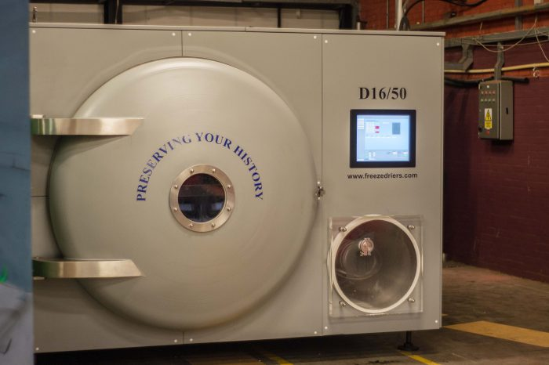
Figure three a freeze dryer

(Preservation & Storage - Friends of the Newport Ship, n.d.)

Chapter Two
What new technologies are being used in archaeology?

With technology being utilised more frequently by archaeologists, it has resulted in a change in the methodologies which are used throughout all areas of archaeological research. An example of this can be seen in the changes in the methodologies employed during the excavation process. As described in the previous chapter, the methodology excavation consists of conducting a survey of the surrounding area, looking at as many relevant sources in order to assess the archaeological potential of the site, as well as providing the excavation team with an idea as to what may be present at the site. Following on from this an excavation team would then excavate the site using various methods, in order to obtain as much physical evidence about the site as possible while recording as much information about the excavation, the artefacts recovered, as well as the overall outcome of the excavation in various documents such as a field report and finds records. Finally, any finds or artefacts which are recovered during the excavation process are then handed over to conservationists, wherein the artefacts undergo the process of preserving the objects for later use. Throughout this process archaeologists aim to maintain the integrity of the site, which is why archaeologists try to use methods which have the aim to reduce the amount of damage caused to the site to a minimum. With the advancements in technology, as well as the availability of new technologies, it has allowed archaeologists to improve their methodologies to get closer to the goal of reducing the damage caused to archaeological sites by excavational processes. The areas where the impact of new technologies can be seen most is in conservation efforts, as well as through the methodologies and equipment that are incorporated by survey teams through the course of a physical survey of the site.
The improvements in technology has had some effect on the processes which occur during the physical excavation of a site. This has included the use of machines to quickly excavate the site where appropriate in place of the use of hand tools such as shovels and mattocks. When considering the impact that new technologies have had on the methods which archaeologists have used when physically excavating the site there has been very little. However, with the improvements in the technologies used in scanning as well as in photography, it has resulted in a change in the way that archaeologists record the excavation site, in addition to the way that artefacts and other features that have been uncovered during the excavation are recorded, This is due to the fact that previously an excavation site would be recorded via a hand drawn picture, which would have been done throughout different points in the excavation process. Objects which were recovered were also recorded in this manner, in order to preserve as much detail as possible before the item was sent to storage. In addition to this when archaeologists are taking a level on the site it would be done manually through the use of a total station. However, with the advancements in technology it has allowed archaeologists to quickly take photographs of the site, which has greatly increased to efficiency of the recording of the site. This is especially evident in specialist areas of archaeology such as in maritime archaeology, where the use of underwater cameras has allowed the excavation teams to quickly record the site, as well as being able to conduct an impact assessment on how the excavation has effected the local wildlife. In addition to this, through the use of photogrammetry maritime, archaeologists are able create a three-dimensional image of the site. This is very important due to the nature of underwater excavations where the landscape around the site is constantly changing and by having a three-dimensional image of the site it can allow archaeologists to locate areas of interest, as the site has been recorded over consecutive excavations. Another benefit of this technology is that it can be used to quickly record features, this greatly benefits the excavation team due to them having to excavate under a short period of time. For excavations which take place on land the use of photography has been able to provide archaeologists with a way to quickly record large features, as well as being able to provide a visual record as to the progress of the site. In terms of recording the level on site during the excavation, as previously mentioned the level would be taken manually through the use of a total station, however with the advancement in technology archaeologists have been able to use Global Navigation Satellite Systems (GNSS) to create a three dimensional image of the excavation site (Understanding the Archaeology of Landscapes A Guide to Good Recording Practice (Second Edition), 2007). This has been an advantage to archaeologists due to the fact that this can be set up and the device will automatically begin taking levels of the site. This allows archaeologists to be able to focus more on other aspects of the excavation, due to the excavation team being able to have more personnel to deal with other issues which may come up. Another benefit to the use of these technologies is that the information recorded on these devices and the analysis of it can be easily distributed to other researchers. This is due to the fact that the information recorded is stored on an electronic system which can be easily stored in a server or has the possibility to be shared via the internet. This can allow archaeologists to quickly correspond to each other regarding information about the site, in addition to being able to easily organise and store important information and easily access it at a later date.
Unlike physical excavation the technological advancements in archaeology has had a major impact on the manner in which surveying is done. This is due to the fact the advancements in technology has provided archaeologists with new ways in which a survey can be undertaken. In addition to this it has allowed surveyors to be more accurate in their efforts to understand the nature of the site. This is due to archaeologists utilising Ground Penetrating Radar (GPR) to assist in the surveying efforts. Ground Penetrating Radar is utilised by archaeologists undergoing a survey by collecting data from radar waves, which are
“transmitted from a surface antenna into the ground and reflected off buried archaeological features and stratigraphic horizons. The reflected waves are recorded back at the surface and the transmission time is measured that can be converted to depth in the ground.” (Conyers, 2000)
This follows the principle that each of the waves transmitted into the ground move at a constant rate and as these waves reach a surface such as a rock or a change in the local geology, they will be reflected back towards the surface. During this process the survey team will have been monitoring the time it has taken for the wave to have returned, this means that if the stratigraphy was uniform with no inclusions the waves would return to the surface at the same time. However if the stratigraphy was uneven due to geological processes, or if there were features present, then this would result in the radar waves returning at different intervals or possibly even at different angles than would be expected, If the conditions were like the ones described earlier and the readings show this, it can be inferred that there may be archaeological material present in that area. In addition to this from the data collected over the course of this type of surveying, archaeologists are able to create a map with the general outline of the site. This has been advantageous for archaeologists due to the fact that through the ability to determine where the site is, how large the site may potentially be, coupled with the data collected from the survey, archaeologists can use this data to create a three dimensional image of the site. This can potentially be used to analyse the site in place of an excavation. This can provide archaeologists with the option to preserve the site in situ if it has been determined to not be under threat by development.
Maritime archaeology has also been able to benefit from the use of ground penetrating radar. Prior to this technology becoming available to archaeologists, this technology was mainly used for military applications such as minesweeping. This technology was also utilised in other industries such as offshore construction, deep-ocean exploration and seafloor mapping (Astley and Safadi, 2017). By accessing this technology, maritime archaeologists have been able to investigate areas wherein previously it would have been deemed too hazardous to excavate due to the conditions. However with the use of GPR maritime archaeologists are now able to survey areas and note the locations of archaeological interest, so that it can be determined if an excavation is viable.
Finally, the improvements in technology has arguably caused the most change is in the way that archaeologists choose to preserve archaeological information during the conservation process. This is due to the advancements in digital software which has provided conservationists with the ability to transfer data on numerous objects of archaeological significance onto a digital hard drive, which in theory could potentially store unlimited information on several artefacts, not only this but as mentioned earlier with archaeological features being recorded digitally as three dimensional images, it also caused a change in how conservationists process artifacts to be displayed for the public. This is in addition to how sites can be preserved in the long term due to advancements in scanning technology. This means that it is possible for archaeologists to scan an object or building to generate a three-dimensional image which a user can manipulate and interact with. This can allow archaeologists who are reconstructing objects with an accessible platform in which to do their work, an example of this would be the ongoing project involving the Newport ship, this project is focussed around the discovery of a fifteenth century merchant vessel which was unearthed in Newport in 2002 (What is the Newport Ship? - Friends of the Newport Ship, n.d.). The project aims to preserve and reconstruct the ship, as well as study the construction of the ship due to it being the most complete fifteenth century vessel ever found at the time of discovery. This means that it is imperative for nautical archaeologists that the construction of this ship was studied, in order to gain a greater understanding of how ships were constructed during this period of time. However, due to the nature of this site the ship itself had already been deconstructed, meaning that it would be difficult for archaeologists to fully understand the nature of the construction of the ship. It would also be difficult to reconstruct the ship using the timbers that were recovered during the excavation. In order to overcome this issue, the team of archaeologists decided to scan each of the individual timbers and from this data create a digital reconstruction of the ship in order to gain a greater understanding behind the methodology when the ship was constructed. This was achieved through the use of a FAROArm (Recording - Friends of the Newport Ship, n.d.), this is a device which is a coordinate measuring machine (CMM) which is used to record objects which have complex geometries at a high rate of rate of accuracy using a measurement bed, a probe, a computer and software to operate the probe (Understanding Portable Measurement Arms, n.d.). Through using this device they uploaded the recordings to a program called “Rhinoceros 3D, also known as “Rhino”, or “Rhino 3D”, is computer-aided design software” (Rhinoceros: CAD Software for Architecture & Industrial Design, n.d.) through the use of these technologies the archaeology team was able to record and upload the surviving timbers onto RHINO. From this a theoretical digital reconstruction of the ship was done, part of this reconstruction can be seen in figure four below.
Figure four part of the reconstructed hull of the Newport ship
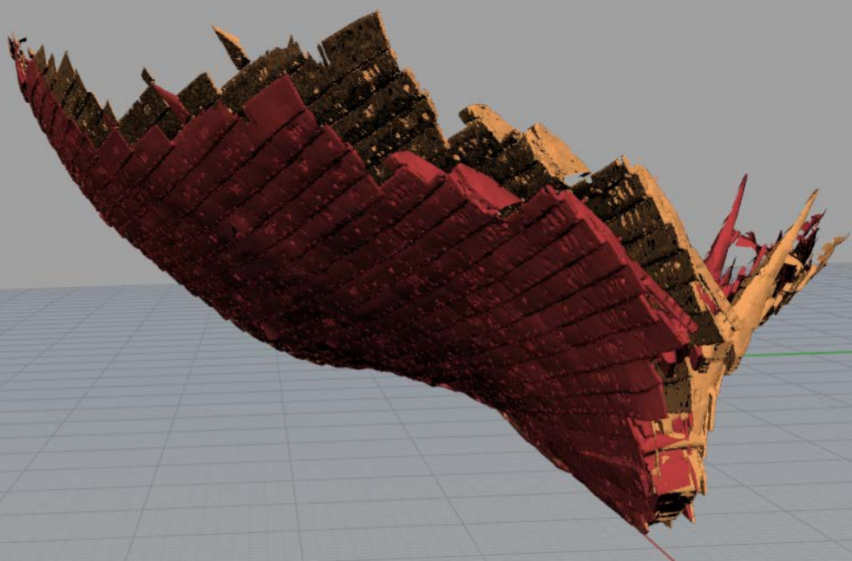
(Tanner, 2013)
From this, archaeologists who are investigating the Newport ship have been able to use this information to study the ship and produce a theoretical reconstruction of the whole ship. In addition to this the data that was used to reconstruct the ship was also used to create a program that displays the ship in virtual reality (South Wales Argus, 2018). Through the use of this technology, it is possible or archaeologists to create virtual environments that the public will be able to immerse themselves into and have a greater, more realistic experience. In terms of archaeological research, archaeologists are able to focus their studies on specific parts of the object, for example in the case of the Newport ship they were able to examine individual timbers to analyse the construction methodology used when constructing the ship.
In addition to enhancing the presentation of archaeological material to the public, conservationists are also able to use this technology as an additional method to standard preservation techniques, as it enables 3-D modelling to be created of the object, therefore minimising the need for the use of potentially harmful preservation methods in order for the artefacts to be exhibited. This technology also offers the potential for use in the restoration of archaeological materials, due to ability to replicate the material using a digital blueprint which can be obtained from a minute sample. An example of this can be seen in use following the recent fires at Notre Dame Cathedral (A closer look at the ravaged Notre Dame Cathedral, n.d.) where the roof and spire were extensively damaged in 2019. Archaeologists used data from a 3-D model used in the computer game ‘Assassin’s Creed’ to inform the restoration process, using the digital model as a reference point for reconstruction.
Prior to this technology being available the restoration of buildings such as Notre Dame Cathedral would have been heavily reliant on any available art work and physical plans. The risks to using information sources of this type include potential inaccuracies in proportion and scale, the potential of human error through misinterpretation of the methodologies used for measuring during that time period and a lack of specific site data available in order to accurately complete the restoration, with archaeologists having to rely upon sources which relate to buildings constructed in a similar manner during the same time period. A result of these potential errors could be an inaccurate restoration of the building, resulting in a structure that differs from the original. The use of 3-D modelling enables conservationists to have an accurate database in which to base their reconstruction plans upon and restore artefacts that have been subject to damage or deterioration. A further use of 3-D modelling in addition to restoration, is the use of the data to further analyse the nature and use of a site. An example of this type of research using 3-D modelling that is particularly beneficial is in the field of Maritime Archaeology. This is due to the fact when maritime archaeologists are investigating a submerged site they are subject to a limited timeframe in which they are able to explore to site due to restricted dive times. Through the use of 3-D modelling maritime archaeologists are able to analyse the site on shore and identify on areas of focused interest without having to restrict their exploration due to environmental factors.

Chapter Three
Is this technology viable and what does this mean for archaeology in the future?

Due to the fact the advances in technology have given archaeologists many advantages in all areas of archaeological research, we are now left with the question as to what this will mean for the future. We also need to consider how viable these technologies are in the longer term when put to use in archaeological methodologies. By analysing the current use of the available technology we can hypothesise as to what development and advances could be made in the future and what that would mean for the field of archaeology.
Based on the current uses of technology it is my hypothesis that in the future there will be a greater reliance on technology in areas related to conservation and surveying of archaeological sites and material. I believe this will be the case due to these technologies allowing for non-destructive methods for the studying of sites as well as providing a more accessible bank of date which can be utilised by researchers.
In terms of the areas conserving the surveying of archaeological sites I believe that the advances in technology there will be a greater use of technology to facilitate the surveying of larger scale archaeological features in a more efficient manner in terms of costs and time and with a higher degrees of accuracy than current technologies can provide. This is significant due to the finite financial resources available to archaeologists and the need to ensure accuracy is maximised whilst costs are controlled. I also believe that some of the current methods of surveying may become obsolete due to inefficiencies in terms of time and prohibitive costs, such as the use of Ground Penetrating Radar, as it currently used due to the fact that it can provide a general outline of the site’s archaeological features. However this method is not always accurate, due to the principal of this method relying on the stratigraphy of the geological layers being uniform as well as the geological characteristics being suitable for this methodology. An example of an area where this wouldn’t work, would be where there are high amounts of low tectonic activity due the fact the seismic activity would interfere with the radar waves being produced. Other geological features in the stratigraphy such as cavities in the ground may potentially cause inaccuracies in the data when using this method in isolation. Technological advancements could create an alternative to Ground Penetrating Radar, whereby alternative energy sources used to emit a pulse signal which would work on a similar principle to sonar but would be unaffected by geological features such as seismic activity.
Another methodology that I believe will become if not obsolete then significantly reduced in its usage is aerial surveying. This is due to the fact it is heavily reliant on archaeological features causing visible changes to the environment in which it exists that are visible when observed from the air. These same features can potentially occur due to natural competition between plant species, resulting in features which resemble crop marks that have not actually been caused by archaeological features. One method that I believe will replace the use of aerial surveying is the use of 3-D scanning in order to gain an accurate representation of the site. Another method that could also potentially replace aerial surveying would be if there were technological advancements in the method known as Coring. By developing a more technological application to this basic methodology, it would enable archaeologists to accurately analyse and identify where features have been changed due to natural factors rather than caused by archaeological features.
Upon review I do believe that some methodologies will remain in use in the future, however I propose that there will be some changes made in order to make them more accurate and more efficient, both in terms of cost and time taken to complete. One such method would be Field Walking, due to the fact there will always be a need to physically examine the area of interest to gain a basic understanding of the site. This methodology has already gone through some changes due to technological advancements including the use of GPS and can be further advanced for example through the use of hand held technology to record data such as images of discoveries in situ which can be immediately communicated anywhere across the world to other involved parties.
Another method that I believe will remain in use is a Magnetometry Survey, due to the fact it is a highly specialised method which makes extensive use of technology currently. This methodology has a high level of accuracy and is able to detect changes to the earth’s magnetic field to a range of >1nT. The only potential development that technological advancements could make to this methodology would be to reduce costs as this is a very expensive technique to implement.
Having reviewed the methodologies used in Conservation I believe it is this area that will experience the greatest level of change due to advancements in technology. These changes will not apply however in my view to the physical treatment of archaeological material due to there remaining a need to preserve the physical artefacts themselves. The only changes I perceive to be possible may relate to the type of chemicals used during the preservation process whereby developments would aim to reduce the damage caused to artefacts during the completion of the process.
The area I believe will be the most significantly affected by technological advances is in the field of Reconstruction. This is due to the fact physical reconstruction requires a significant amount of time to complete, particularly in relation to larger artefacts such as ships or building and is very cost heavy. By using technological advancements such as digital modelling this process can be completed in a much shorter time frame and with lower costs. In addition to this the finished product can also be taken apart and analysed thoroughly by researchers which would not be possible to do with the original artefact. The fact that the information can be gathered and stored electronically means it can be shared immediately across the internet to anywhere in the world. There are issues however with the level of technology required to complete this methodology of digital modelling as there is a requirement for specific software and hardware to be used which has cost implications in the current market. I do believe that advancements in this area will result in a reduction in costs as this type of technology becomes more commonplace and as a result this methodology will become a standard approach used by conservationists. The use of this approach also helps to overcome the ethical implications of handling certain types of archaeological materials such as human remains, through being able to interact with this material in a digital environment rather than to physically handle the material itself.
A key goal for conservationists is not only to preserve the artefacts but also to ensure they are accessible to the public whilst protecting the artefact itself. Advancements in technology has enabled archaeologists to explore new avenues of presenting artefacts which has significantly increased its accessibility to the public, both in terms of physical displays using 3-D imaging but also in terms of online platforms and virtual reality programmes. I believe further advancements in technology such as the use of holographic imagery will further enhance the work of conservationists and extend the accessibility of artefacts to the public.

Chapter Four
Conclusion

This dissertation has explored the many different ways that archaeologists have utilised technology within their field of study, as well as how technology has affected their methodologies. Throughout the process of an archaeological investigation, the aim of the archaeologists conducting this process is to obtain as much archaeologically significant information about the site. This process would be carried out by first undergoing a survey of the area in order to gain as much background information as possible about the site. As previously mentioned this process involves analysing the data recovered from the use of surveying methods in order to gain an understanding of the nature of the site. This would be done firstly by analysing any data that might be available about the site which was obtained during a desktop survey. Once this has been done the area will then be surveyed through the use of several methods such as fieldwalking, aerial surveying and geophysical surveying. The data recorded about this area will then be used to assess the archaeological significance of the area as well as assessing whether or not excavating the site is worth the time and resources required to complete this process. If the site has been deemed significant enough, archaeologists would then begin excavating the site which would be done by digging test pits first in order to further assess the archaeology present. Once this has been done and an area of interest has been established, trenches will then be dug with the excavation team excavating the site layer by layer until the area has been fully excavated. During this time the excavation team will be recording features and artefacts that have been discovered during this process, as well as keeping a record of the events of the excavation in a field report. Afterwards when the excavation process has been complete and the artefacts have been brought back to a laboratory, conservationists will undergo the process of preserving the artefacts found. Depending on what type of material the object consists of, as well as any damage the artefact may have had due to the method of recovery or due to the processes which occur during the object’s time in the archaeological record, it will result in the methodology used for the preservation of archaeological material to differ to suit each case. For example, this will be done through the use of chemical treatments to combat ‘bronze disease’ to prevent further damage to artefacts made from copper alloys. When dealing with organic artefacts the methods incorporated by conservationists to treat these artefacts may include methods such as freeze drying. With the advancements technology as well as its availability to archaeologists, it has resulted in the methodologies of these processes being altered as technology has been incorporated into these processes. For example, prior to the availability of heavy duty machinery to assist in excavating a site, archaeologists would have had to rely solely on hand tools in order to excavate a site. Another example would be in conservation, prior to the use of digital reconstruction, the process of reconstructing a large structure would have been cost heavy both financially as well as time, whereas now with the introduction of digital modelling software the costs of reconstruction has been reduced to be a more viable option in conservation when used on its own.
Throughout the course of my investigation, I have run into some issues which has had an impact on my ability to answer my question as thoroughly as I would have liked. Some of these issues have been the fact that due to the current Covid-19 restrictions I have been unable to physically test the different methodologies in order to thoroughly assess how the use of these technologies have had an impact on the original methodologies. In order to overcome this I have looked at case studies which relate to my field of interest, to assess how these technologies are used in an archaeological context in place of my own experience. One thing that has surprised me during this investigation, is how much technology is used not only in archaeology but in all aspects of everyday life and with the constant improvements in these technologies, as well as the increase in the availability of them, resulting in the methods that archaeologists have used to evolve and change just as quickly as these technologies are becoming available to them.
Overall, I believe that the new technologies that are in use in archaeological study have been able to greatly benefit the archaeologists which are incorporating them into their methodology. I believe that as technology advances and is made more available to archaeologists, it will result in the methods utilised by archaeologists to be more efficient, cost effective and ethically sound. However, I also believe that as technology improves there will be a greater reliance on digitally storing the information, as it allows large amounts of data to be stored that can be shared easily around the world. Though to predict accurately how exactly technology will advance in the future as well as how these technologies will be used is very difficult due to the rapid nature of development, however the answer to this question will show itself in time.

Bibliography
- 2018. The Freeze Drying Theory And Process Things To Consider. [ebook] Denmark: Ellab. Available at: <https://www.ellab.com/Files/Files/White-Papers/The-Freeze-Drying-Theory-and-Process_ellab-whitepaper.pdf> [Accessed 6 May 2020]
- Academic Dictionaries and Encyclopedias. n.d. Spoil (Archaeology). [online] Available at: <https://enacademic.com/dic.nsf/enwiki/3947136> [Accessed 3 May 2020]
- Archaeologywordsmith.com. n.d. Search Results | Archaeology Wordsmith. [online] Available at: <https://archaeologywordsmith.com/search.php?q=trench> [Accessed 1 May 2020]
- Astley, A. and Safadi, C., 2017. Geophysical Techniques For Maritime Archaeology. [online] FutureLearn. Available at: <https://www.futurelearn.com/courses/shipwrecks/0/steps/7950> [Accessed 8 May 2020]
- Carver M. (2014) Excavation Methods in Archaeology. In: Smith C. (eds) Encyclopedia of Global Archaeology. Springer, New York, NY
- Conservation-wiki.com. 2011. Archaeological Conservation - Wiki. [online] Available at: <https://www.conservation-wiki.com/wiki/Archaeological_Conservation> [Accessed 6 May 2020]
- Conyers, L., 2000. The use of ground-penetrating radar in archaeology. Radiation in Art and Archeometry, pp.1-14.
- Equipmentworld.com. 2017. [online] Available at: <https://www.equipmentworld.com/caterpillar-336e-l-excavator-review/> [Accessed 3 May 2020]
- Fassbinder, J., 2016. Magnetometry For Archaeology. [online] SpringerLink. Available at: <https://link.springer.com/referenceworkentry/10.1007/978-1-4020-4409-0_169> [Accessed 5 May 2020]
- Friends of the Newport Ship. n.d. Preservation & Storage - Friends Of The Newport Ship. [online] Available at: <https://www.newportship.org/archaeology-conservation/preservation-storage> [Accessed 7 May 2020]
- Friends of the Newport Ship. n.d. Recording - Friends Of The Newport Ship. [online] Available at: <https://www.newportship.org/archaeology-conservation/recording> [Accessed 8 May 2020]
- Friends of the Newport Ship. n.d. What Is The Newport Ship? - Friends Of The Newport Ship. [online] Available at: <https://www.newportship.org/discover-the-ship/what-is-the-newport-ship> [Accessed 8 May 2020]
- Historicengland.org.uk. 2007. Understanding The Archaeology Of Landscapes A Guide To Good Recording Practice (Second Edition). [online] Available at: <https://historicengland.org.uk/images-books/publications/understanding-archaeology-of-landscapes/heag142-understanding-archaeology-of-landscapes/> [Accessed 7 May 2020]
- Historicengland.org.uk. n.d. Geophysical Survey | Historic England. [online] Available at: <https://historicengland.org.uk/research/methods/terrestrial-remote-sensing/geophysical-survey/> [Accessed 5 May 2020]
- Insights.faro.com. n.d. Understanding Portable Measurement Arms. [online] Available at: <https://insights.faro.com/blog-articles/understanding-portable-measurement-arms> [Accessed 8 May 2020]
- Morris, M., 2019. Fieldwork Guide 3 – How To Dig An Archaeological Test-Pit. 1st ed. [ebook] University of Leicester. Available at: <http://leicsfieldworkers.co.uk/wp-content/uploads/2019/06/Leicestershire-Fieldworkers-Fieldwork-Guide-3-How-to-dig-an-archaeological-test-pit.pdf> [Accessed 1 May 2020]
- NBC News. n.d. A Closer Look At The Ravaged Notre Dame Cathedral. [online] Available at: <https://www.nbcnews.com/news/world/notre-dame-fire-what-was-damaged-n995371> [Accessed 10 May 2020]
- Oddy, A. and Scott, D., 2002. Copper and Bronze in Art: Corrosion, Colorants, Conservation. Studies in Conservation, 47(4), p.125.
- Point to Point Surveyors. 2016. Archaeological Land Surveying | Point To Point Surveyors. [online] Available at: <https://www.pointtopointsurvey.com/2016/07/archaeological-land-surveying/> [Accessed 3 May 2020]
- Sculpteo. n.d. Rhinoceros: CAD Software For Architecture & Industrial Design. [online] Available at: <https://www.sculpteo.com/en/glossary/rhinoceros-definition/> [Accessed 8 May 2020]
- South Wales Argus, 2018. Newport’s Medieval Ship benefits from virtual reality. [online] Available at: <https://www.southwalesargus.co.uk/news/16203898.newports-medieval-ship-benefits-from-virtual-reality/> [Accessed 8 May 2020]
- Sussexarch.org.uk. n.d. Conducting A Magnetometry Survey. [online] Available at: <http://www.sussexarch.org.uk/geophys/geomag.html> [Accessed 6 May 2020]
- Tanner, P., 2013. Digital Reconstruction and Analysis of the Newport Ship. [online] Available at: <https://www.academia.edu/4952684/Digital_Reconstruction_and_Analysis_of_the_Newport_Wales_Medieval_Ship_Phase_1_-_Minimum_Reconstruction_> [Accessed 8 May 2020]
- ThoughtCo. 2019. Archaeology Equipment: The Tools Of The Trade. [online] Available at: <https://www.thoughtco.com/archaeology-equipment-tools-of-the-trade-4122666> [Accessed 3 May 2020]
- Wessex Archaeology. n.d. Fieldwalking. [online] Available at: <https://www.wessexarch.co.uk/archaeological-services/fieldwalking#main-content> [Accessed 5 May 2020]
- Wessex Archaeology. n.d. Test-Pitting. [online] Available at: <https://www.wessexarch.co.uk/archaeological-services/test-pitting?gclid=Cj0KCQjwka_1BRCPARIsAMlUmEohgJjAQo7pZYHd9p6K9h6X3XZCrqmQRgLInJdf7gPt33I5ExQbXfgaAtI7EALw_wcB> [Accessed 1 May 2020]
- Weymouth, J. W and Huggins, R., n.d. Geophysical Surveying of Archaeological Sites.

