Introduction

Market research is super important for building a killer business since it helps entrepreneurs get the lowdown on what customers want, what's hot in the market, and how people behave before they drop a new product or service Market research is all about collecting, examining, and making sense of data about who we're selling to and who might buy our stuff, so we can make smart choices for our business (Best Digital Marketing, 2019) ([best-digitalmarketing.co.uk][ Knowing what your photography clients care about—like how much they're willing to pay, their preferred style, how they want their photos edited, or how easy it is to book—is key to creating services and marketing plans that really hit the mark

This project was all about creating a survey to get scoop on what people might like when it comes to snapping photos The survey results helped shape a photography business idea, design a two-page website, and make promotional stuff with Canva The analysis zeroes in on the main trends from the feedback and breaks down how these insights shaped our business approach, website layout, and SEO tactics

Questionnaire Design and Data Collection

We whipped up a Google Form questionnaire to snag some fresh insights from people who might buy our stuff Questionnaires are a go-to method for snagging firsthand info form customers since they let companies get straight to the point with their questions (Tutor2u, 2021) ([Tutor2u][2]) The survey had a variety of question types, like yes/no, rating, and free-form answers, to get both number-based and in-depth feedback

The questionnaire contained the following key questions:

1. What is your age group?
2. How often do you hire a photographer?.
3. What kind of photography gigs catch your eye?Are you into capturing weddings, snapping portraits, shooting events, or creating social media-worthy shots

4. What factors play a role in picking your go-to photographer?(cost, quality, feedback, vibe)

5. How much are you willing to shell out for a one-hour photo shoot

6. Where do you usually spot photographers?(Instagram, Google search, word-of-mouth)

7. How crucial is a pro website when picking a photographer

8. What kind of photography style do you lean towards

9. Would you rather book photography services online

10. What extra services are you thinking about?Maybe you're looking for editing, printing, album creation, or quick delivery

The questionnaire was distributed to classmates and social media contacts to collect responses. Survey research is a big deal in marketing since questionnaires let researchers gather tons of info from lots of people quickly (McQuarrie, 2016) ([SAGE Publications][3])

Data Analysis and Key Findings

Once we got all the answers, we crunched the numbers using the graphs Google Forms made for us Four key questions gave us the best ideas for planning our photography business strategy

1. Preferred Type of Photography Service

The findings revealed that portrait and event photography were the top picks, with social media photography coming in second Tihs shows that most people are mainly after photos for personal shots, special occasions, or their online businesses

This discovery shaped teh main services the company provides The business will zero in on three key photography services instead of trying to cover every niche

Portrait photography
Event photography
Social media content photography

Specializing helps small shops stand out better in a crowded market

2. Factors Influencing Choice of Photographer

When asked what factors influenced their decision when picking a photographer, most people picked

Portfolio quality
Price
Online reviews

This implies that showing your work and being trustworthy are super important in the photography biz Customers like to check out some of the work we've done before they decide to book

The website's design really puts a big focus on showcasing a huge collection of portfolios right on the homepage Marketing stuff also shows customer reviews and sample pics to win over future customers

3. Preferred Platform to Find Photographers

A good chunk of people say they usually spot photographers on Instagram or by Googling

This insight really shook up our marketing game Social media, especially Instagram, is super visual and perfect for showcasing photography services Plus, snagging a spot at teh top of Google's list can really draw in people looking for photography gigs

SEO strategies can boost a site's online presence by incorporating the right keywords and making the site easy to find in search results (Akram et al., 2010) ([arXiv][4])

Therefore, the website incorporates SEO strategies such as:.

A portrait photographer, an event photographer, and professional photography services

Optimised image descriptions
Location-based keywords to improve local search results.

4. Importance of Online Booking and Website

Most people liked photographers wih a pro site and simple ways to book

This shows that being easy to use really matters to how people shop today Customers are looking for fast info on prices, portfolio pics, and how to book

Audience Segmentation

Market segmentation lets businesses split up customers into groups that share similar traits and tastes The survey showed that the photography biz has two main groups it's aiming at

1. Young Adults (18–30)

A lot of people fell into this age range This part really focuses on

Portrait photography
Social media content photography
Affordable pricing

This crowd's really into social media, so Instagram adn TikTok are perfect for marketing

2. Event Clients

People are getting ready for stuff like birthdays, graduations, or just small get-togethers These customers prioritize

High-quality photos
Professional editing
Reliable service

Grasping these parts helps the company craft marketing strategies and services that really speak to each specific crowd

Marketing Materials

Marketing stuff for the photo biz was whipped up with Canva to get the word out on social media These materials were

Instagram promotional posts
Photography service advertisements
Promotional discount flyers

The design focused on eye-catching visuals and kept the text to a minimum to grab attention fast This research backs up the idea that eye-catching visuals really work well for creative fields, especially in photography

The marketing materials also included:

A consistent brand colour palette
Logo and brand name
Contact details and website link

Keeping the branding the same on all ads and the site makes the biz look pro and easy to spot

Conclusion

The survey we did with the questionnaire gave us some great info on what customers like when it comes to photo services The study showed that portrait and event photography are the top picks, high-quality portfolios really sway buyers, and Instagram's a big deal for finding photographers

References

Akram, M., Sohail, I., Hayat, S., Shafi, M. I., & Saeed, U. (2010) Organizations ar using search engine optimization methods. (arXiv, 4)

Top-notch digital marketing strategies. (2019) Check out tihs site for small biz market research: [best-digitalmarketing.co.uk](https://best-digitalmarketing.co.uk)

Ekinci, Y. (2015) Crafting survey questions for business and management students ([Sage Publications][5])

Kumar, S. (2018) Crafting solid survey questions for marketing research.(Source: ResearchGate, Reference 6)

McQuarrie, E. (2016) The market research toolbox includes survey research (published by SAGE Publications)

Tutor2u. (2021). Marketing research using questionnaires. ([Tutor2u][2])

Hillstrom, K., and Hillstrom, L. (2014) Encyclopedia of small business management. (Available at oldmis.kp.ac.rw)

Burns, A. (2003). Marketing research.

Saunders, M., Lewis, P., & Thornhill, A. (2012) Exploring research techniques for business students

Malhotra, N. (2010). Essentials of marketing research.

Website screenshot

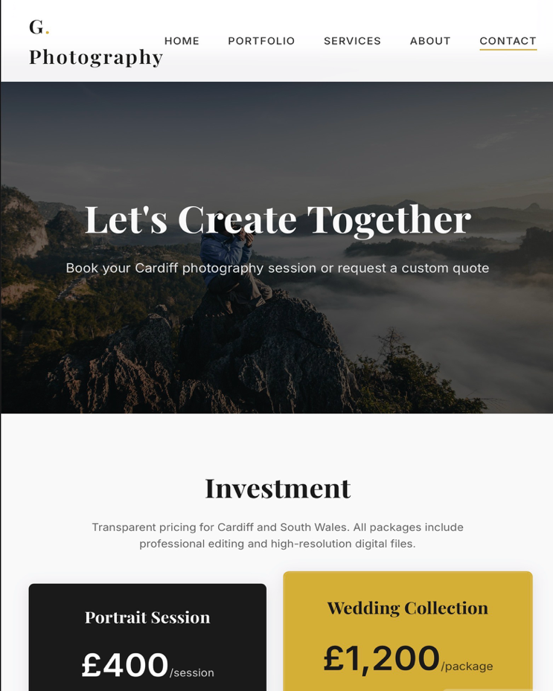
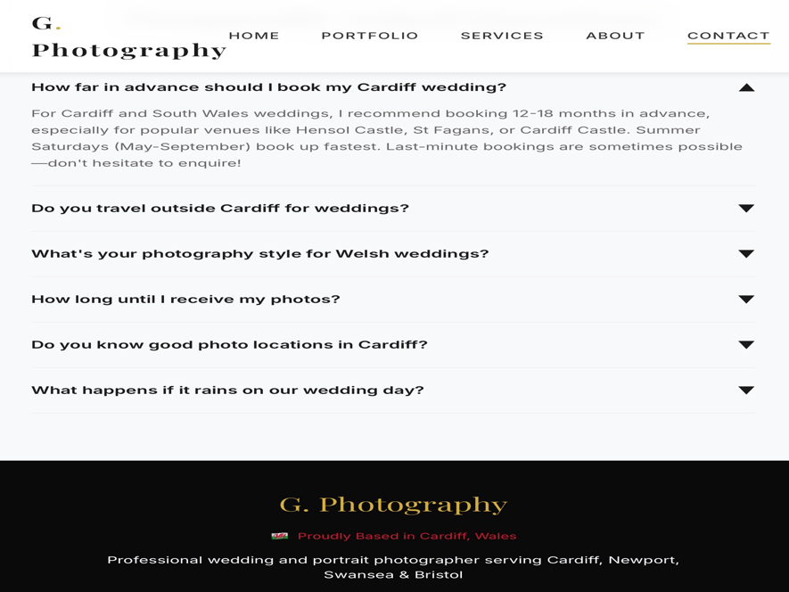
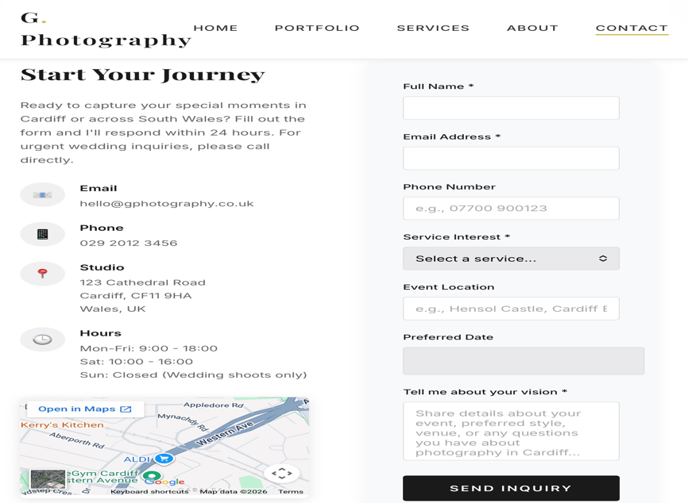
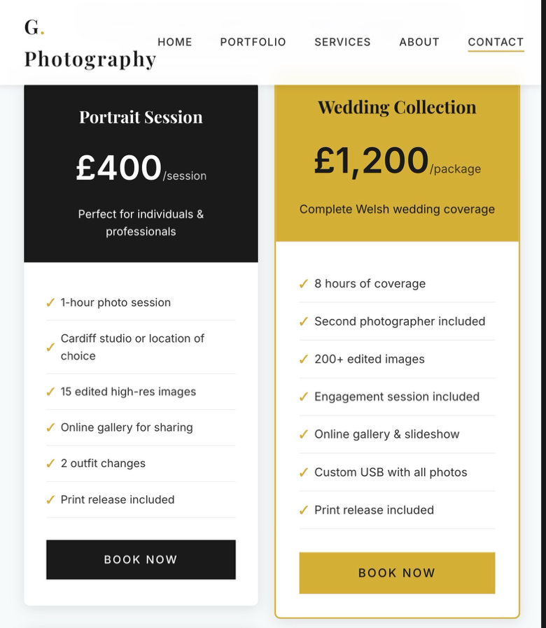

Category | Jan | Feb | Mar | Apr | May | Jun | Jul | Aug | Sep | Oct | Nov | Dec
Income
Photoshoot Bookings | 1500 | 1600 | 1800 | 2000 | 2200 | 2500 | 2700 | 2600 | 2300 | 2100 | 1900 | 2400
Photo Editing / Prints | 400 | 450 | 500 | 550 | 600 | 650 | 700 | 650 | 600 | 550 | 500 | 600
Total Income | 1900 | 2050 | 2300 | 2550 | 2800 | 3150 | 3400 | 3250 | 2900 | 2650 | 2400 | 3000
Expenses
Equipment Costs | 200 | 200 | 200 | 200 | 250 | 250 | 300 | 250 | 200 | 200 | 200 | 250
Marketing / Ads | 150 | 150 | 200 | 200 | 250 | 250 | 300 | 250 | 200 | 200 | 150 | 200
Travel Costs | 100 | 120 | 150 | 150 | 180 | 200 | 220 | 200 | 180 | 150 | 130 | 160
Software Subscriptions | 60 | 60 | 60 | 60 | 60 | 60 | 60 | 60 | 60 | 60 | 60 | 60
Insurance / Misc | 100 | 100 | 100 | 100 | 120 | 120 | 120 | 120 | 100 | 100 | 100 | 120
Total Expenses | 610 | 630 | 710 | 710 | 860 | 880 | 1000 | 880 | 740 | 710 | 640 | 790
Profit / Loss | 1290 | 1420 | 1590 | 1840 | 1940 | 2270 | 2400 | 2370 | 2160 | 1940 | 1760 | 2210

The Importance of Excel in the Digital Era.

Technology is super important for how companies run, handle data, and make choices these days Microsoft Excel is a super popular digital tool used by companies all over the globe Excel is a program that lets you sort data, do math, look at info, and show results in charts and graphs 'Cause businesses are all about data and tech, excel's a must-have for crunching numbers, analyzing data, and planning the biz
Excel rocks at handling and sorting through heaps of data without breaking a sweat Businesses gather info daily, like sales data, expense reports, customer details, and stock counts Excel lets yuo keep this info in neat spreadsheets with rows and columns, so you can get to it and break it down easier Excel is a no-frills, wallet-friendly option for small businesses to manage their finances without breaking the bank on pricey accounting programs
Excel rocks because it can do math stuff automatically wih formulas and functions Instead of crunching numbers by hand, people can use formulas that automatically adjust when fresh data comes in Everyday formulas like SUM, AVERAGE, and IF help businesses crunch numbers fast, check how they're doing, and spot patterns A business owner can use Excel to figure out their total earnings, total costs, and whether they made a profit or took a loss Saving time and cutting down on mistakes means we keep our money info on point and trustworthy
Excel is super handy for managing finances and predicting future trends Companies need to think ahead and figure out their money coming in and going out When companies make financial forecasts in Excel, they can see how their money might shift in the future A small photography biz might use excel to figure out how many shoots they'll do in a month and how much cash they'll make form them When business owners look at their projected earnings and compare them to expected costs like gear, ads, adn travel, they can figure out if their biz is going to make money Financial forecasting gives businesses an edge in making smart choices and getting ready for any curveballs
Excel rocks at making charts and graphs that show data in a way you can actually see and understand Data visualization is super key in the biz world since it helps make tricky info easy to get Excel lets you whip up bar charts, pie charts, and line graphs to show trends and comparisons A bar chart showing monthly income and expenses can help a business owner spot the most profitable months at a glance Visual aids can really make a difference when you're trying to get your point across to people like stakeholders, investors, or your team.They help break down complex data into something more digestible

Excel's big deal in today's world is how it helps us make sense of data and make smart choices Excel has some cool tools like pivot tables, sorting, filtering, and conditional formatting These tools let businesses sift through big data and spot trends or patterns Companies can check out which products are flying off the shelves, which months are raking in the cash, or where they're seeing their costs go up Managers can dig into this info to make smart choices that boost the biz
Plus, being good at excel is super important for jobs these days A lot of bosses want their team to know the basics of Excel since it's super common in places like banking, selling, health, teaching, and shopping Being able to use Excel effectively can improve productivity and help individuals perform tasks more efficiently. Learning Excel is super important for students and pros who want to nail it in the digital biz world
To wrap it up, Microsoft Excel is super important in our digital age.It helps companies sort out data, crunch numbers, dig into info, and plan ahead This tool's knack for doing math, making money forecasts, and showing data in a clear way makes it super important for any business For small businesses, like photography shops, Excel is a handy tool fro keeping track of money matters and keeping an eye on how things are doing As tech keeps advancing ad companies rely more on data, Excel's role is only getting bigger in today's digital landscape

References:Harvard Style References

Microsoft Support, 2024 Dive into the numbers in Excel Check out this link for Excel data analysis tips: https://support.microsoft.com/en-gb/office/analyze-data-in-excel
Microsoft Support, 2024 Dive into your data with PivotTables and other business intelligence tools for some insightful analysis Available at: https://support.microsoft.com/en-gb/office/use-pivottables.
GeeksforGeeks, 2025. The significance of Microsoft excel in the workplace Check out this link for why excel is super important in the workplace: https://www.geeksforgeeks.org/importance-of-microsoft-excel-in-workplace
School of Coding UK, 2024 Teh significance of Microsoft Excel in the business world Check out this blog post on why Microsoft Excel is super important for businesses
10XSheets, 2024. Excel plays a big role in the business world Check out this blog post on why Excel is super important for businesses
BSuite365, 2024. Here are some common ways businesses use Microsoft Excel Check out this blog post on excel's top uses in business: https://bsuite365.com/blog/excel/top-uses-of-microsoft-excel-in-business
Mathavan, P. (2023) Excel is still super important for data analysts Medium. Check out this article: https://medium.com
Noether, D. adn McKee, F. (2025) Alpha Excel Benchmark. arXiv You can find the paper at this link: https://arxiv.org/abs/2505.04110
Samar and Patni, in their 2008 study Managing data in spreadsheets. arXiv You can find the paper at this link: https://arxiv.org/abs/0803.2527

