Cross-Cultural Management Analyze

Course Code: SBUS6115
Course Name: Managing Internationally
Student Number: 1704338
Student Name: Siqi Li
Content

Excusive Summary………………………………………………………….…………3
1.0 Introduction…………………………………………………………….………….4
1.1 Hofstede’s Cultural Dimensions Theory……………………………………...4
2.0 Main Findings…………………………………………………………….……….4
2.1 Factors that influence negotiation and decision making………………………5
2.2 Differences in communication preferences between cultures…………………7
2.3 How culture affects leadership and motivation ……………………………….8
2.4 How culture affects the management of people internationally ……...……...10
3.0 Conclusion…………………………………………………………….………….12
4.0 Recommendations…………………………………………………….………….12
References……………………………………………………………………………13
Figure 1……………………….…………………………………………….…………6
Figure 2…………………………….………………………………………………….7
Figure 3…………………………….………………………………………………….8
Figure 4…………………………….………………………………………………….9
Figure 5…………………………….………………………………………….……....9
Figure 6…………………………….………………………………………………...11
Figure 7…………………………….………………………………………………...11

Excusive Summary

In international trade, there are many cultural differences between different countries and regions. With the development of global economic integration, it is more obvious that the influence of cultural differences on international trade. In addition, the influence of cultural differences on international trade has two aspects. On the one hand, organizations should use the cultural differences to promote economic development. On the other hand, cultural conflicts of different cultures should be avoided. This report will evaluate and analyze strategies and operations for companies that have entered different cultures / environments.

- Introduction
To start with, there is a definition to expression “culture” which can be defined as the ideas, customs and social behavior of a particular people or society (Murray, 1978). With the development of economic globalization, cultural communication between different countries and regions are becoming more frequent. As a multinational organization, it is very significant to find an effective way to do cross cultural management. According to Nancy Adler (2008), the cross cultural management is defined as the behavior of people in organizations around the world and shows people how to work in organizations with employees and client populations from many different cultures. Base on the current situation of international economic development, the report will analyze the strategies and operations of different companies according to Hofstede’s Cultural Dimension Theory (1980).
  - Hofstede’s Cultural Dimensions Theory
Geert Hofstede is a sociologist who studied employees working in a multi-national corporation (Reynolds and Valentine, 2011). From 1967 to 1973, Hofstede conducted a largescale cultural value survey in the famous multinational company IBM (International Business Machines Corp). His team issued more than 116,000 questionnaires to companies’ staff which worked in 72 different countries. The focus of the survey and analysis is the country differences between employees in terms of values.
Hofstede used the results of his research to produce a comparison between cultures on four and eventually five dimensions (Browaeys and Price, 2015):
- Power distance (high/low): attitudes to authority, the distance between individuals in a hierarchy.
- Uncertainty avoidance (high/low): the degree of tolerance for uncertainty or instability.
- Individual versus group orientation: independence and interdependence, the loyalty towards oneself and towards a group.
- Masculine versus feminine orientation: importance of work goals (earnings, advancement) compared with personal goals (co-operation, relationships).
- Short-term versus long-term orientation: fostering virtues related to the past and present or virtues related to the future.
- Main Findings
In this part, based on Hofstede’s cultural dimension and combine with some business cases, the report will analyze factors that influence negotiation and decision making; differences in communication preferences between cultures; how culture affects the management of people internationally and how culture affects leadership and motivation.
  - Factors that influence negotiation and decision making
A major claim made by culturalists is that ignoring culture is a principal cause of breakdown of negotiations (Faure and Rubin, 1993).
Case:
Martinez Construction is a well-established construction company in eastern Spain. The company want to acquire an existing company from the Thruhandanstalt (THA), a German company. Juan Sanchez, as the negotiator for the company to negate with the THA. The first meeting started at 9:00, but Juan did not arrive until 9:15 which made the Germans felt unhappy. At the beginning of meeting, the Spanish did not hurry to start the formal negotiations, but wanted to visit the surrounding environment. The request was rejected by the Germans. The Spaniards were surprised by the Germans’ contract which has covered everything. At the first meeting, the Spaniard just wanted to talk about the objectives of the contract without taking into account the details. The first meeting ended in a slightly awkward atmosphere. Fortunately, the negotiations went well. (Deresky, 2002)
Analyze:
According to this case, it is obvious that there are two factors that influence the negotiations. One is the thinking patterns and another one is time view.
There are two different thinking patterns, synthetic thinking and analytical thinking. Synthetic thinking builds concepts up into something greater. Analytical breaks a proposition down into its constituent concepts (Sarles, 2008).
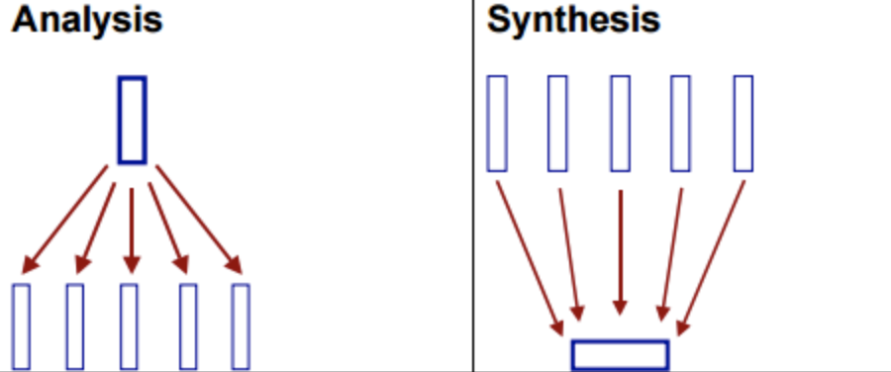
Figure 1: what is analysis and synthesis? (quora.com, 2018)
Although Spain and Germany are Western European countries, their thinking pattern is different. Germans tend to the analytical thinking, as in case they cover all details in the first meeting. In comparison, the Spaniard is more inclined to synthetic thinking. The first thing they care about is whether the two sides can reach agreement, and the details can be discussed later.
The more obvious factor in this case is the different time view between the two countries. Spaniards have a very flexible sense of time, and locals do not think punctuality is very significant. On the contrary, Germans have always been known for their punctual rigor, they attach great importance to time.
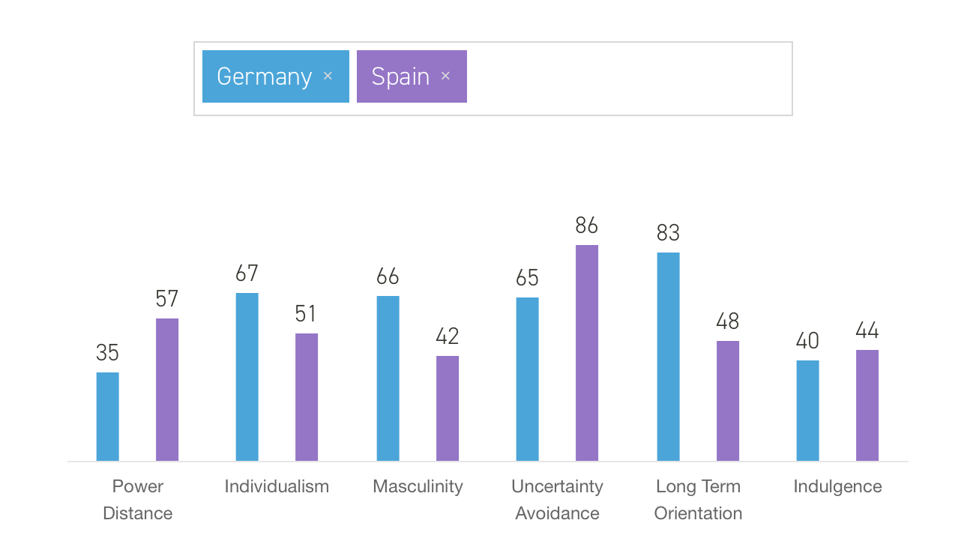
Figure 2: Compare the culture dimensions between Germany and Spain (Hofstede Insights, 2018)
According to Hofstede theory, there are some differences in masculine orientation between Germany and Spain. Germany is more inclined to masculine orientation than Spain, which leads the Germans to attach great importance to performance and from a rigorous style. By contrast, Spaniards are weaker in terms of masculine orientation, so they are more relaxed about time and style of work. This is also one of the reasons why Germany and Spain have so different ways of thinking and time.
  - Differences in communication preferences between cultures
Cultural barriers are greater than language barriers and they frequently provoke reactions that are both negative and emotional. What is considerate behavior in one country may be rude in another. (Novinger, 2018)
Case:
A 75 years old Chinese scholar was invited to the United States by a university in the eastern United States. His flight time was 21 hours and the American friend who came to pick up asked, “you must be very tired!” His answer is “yes”. The American friend was surprised by the old man’s answer. Americans from the same plane are complaining that I have never been so tired in my life. However, the fact is the old man is tired. In the scholar’s eyes, his age, long journey and his tired eyes can show the fact that he is very tired. (Varner and Beamer, 2011).
Analyze:
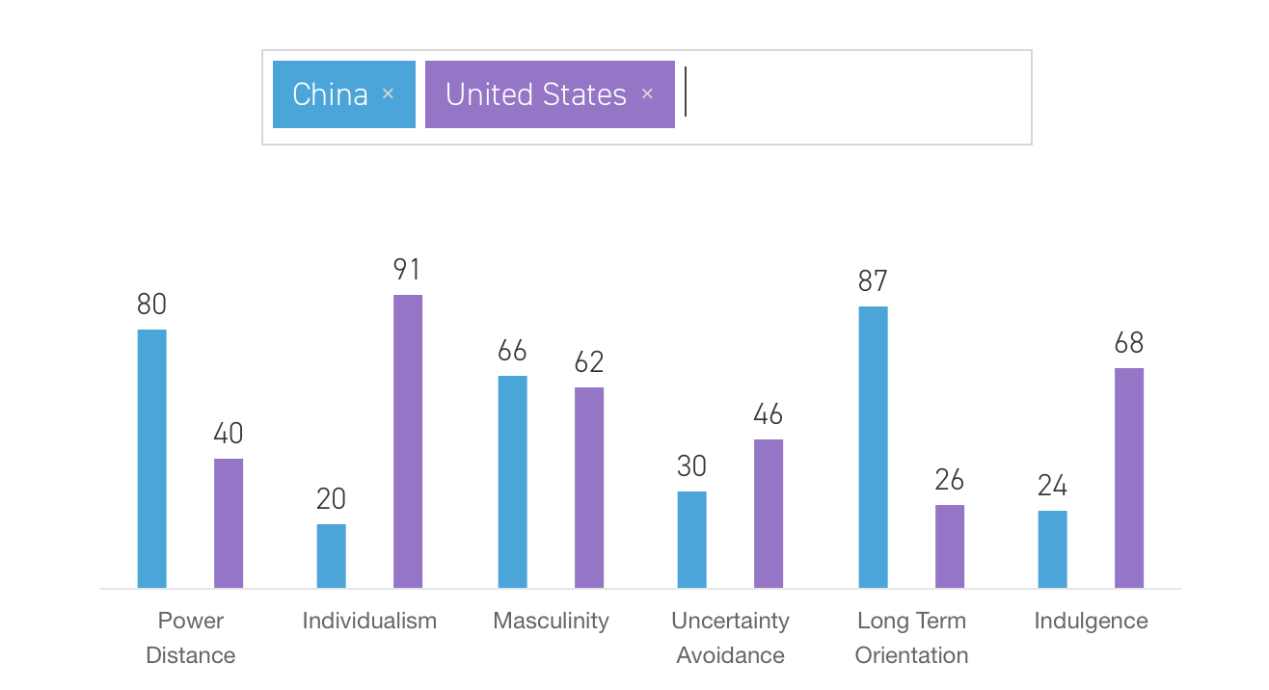
Figure 3: Compare the culture dimensions between China and the United States (Hofstede Insights, 2018)
According to Hofstede comparison graph, it is clear to show that American is a highly individualism country and China is a collectivism country. Toomey (1988) thinks that low context communication predominates in individualistic and high context communication predominates in collectivistic cultures.
According to Hall (1990), there are two context cultures and America is a high context country. On the contrary, China belongs to a low context country. The high context and low context can be defined as: A high context (HC) communication or message is one in which most of the information is already in the person, while very little is in the coded, explicit, transmitted part of the message. A low context communication (LC) is just the opposite; i.e., the mass of the information is vested in the explicit code. (Hall,1990)
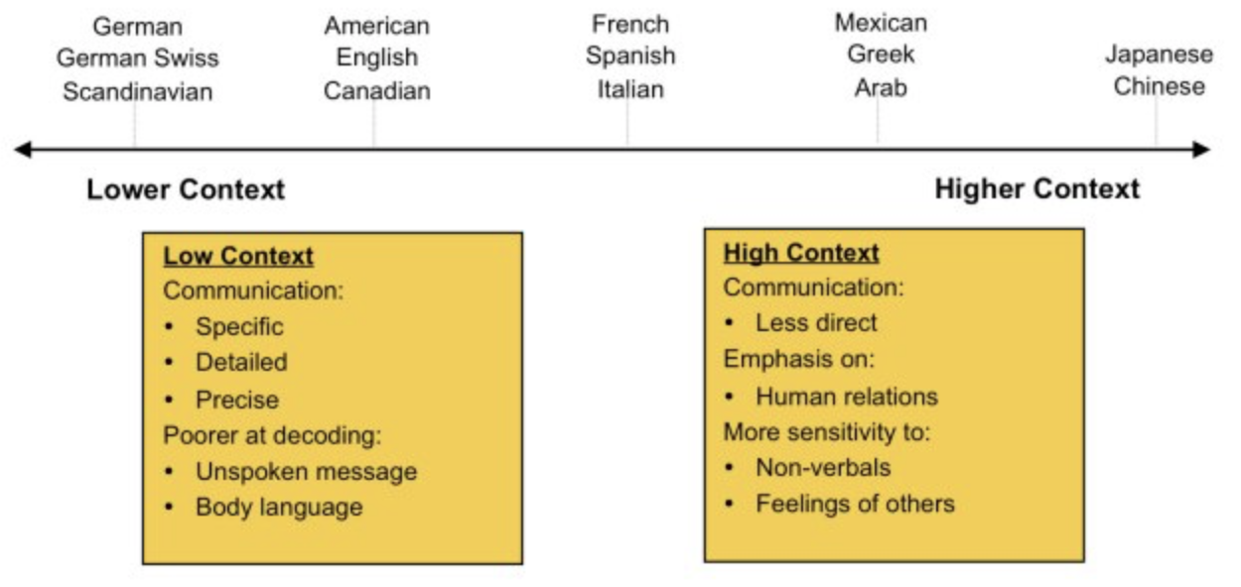
Figure 4: Country of high context and low context. (Lilly, 2018)
Based on these two differences cultures factors, Americans tend to speak directly and to show what they want to express. Generally, they have little connection with the environment and the situation of the speaker. However, in Chinese context culture, quite a part of information is transmitted through context the situation of the speaker himself. In this case, the scholar thought that his dusty appearance, age and the fact of a long journey can fully explain that he is tired and others should be able to judge this point according to the environmental factors of the time. However, the American pay more attention to the answer from the old man. Unless the other person expresses “yes, I am tired.” directly in language, otherwise they will not guess and understand the meaning of each other according to the environment. All in all, it is easy to cause problems and misunderstandings when people from different context cultures and they do not understand each other’s culture and expression ways.
  - How culture affects leadership and motivation.
“There is no hope for creating a better world without a deeper scientific insight into the function of leadership, of culture, and of the other essentials of group life. Social life will have to be managed much more consciously than before if man shall not destroy man.” (Lewin, 1943)
Case:
IKEA, a Swedish furniture retailer, entered the United Stated market in 1985. IKEA’s sales performance in the United States is promising, but that does not mean everything is going smoothly. IKEA encourages employees to work together, and the company does not give every employee a clear job direction. Instead, they ask their employees to discuss what to do next and who is responsible for the next step. American workers cannot accept this kind of work, so they quit their jobs.
IKEA was aware of the problem and made a change. In the United States, IKEA has a clear regulation and motivation system, and each employee decides his salary according to his sales volume. This not only reflects fairness, but also inspires the enthusiasm of employees, which greatly reduces the turnover rate. (White, 2003)
Analyze：
In this case, there are three main reasons lead to this situation. First, the different uncertainty avoidance. Secondly, the different work attitude. In addition, Sweden is a masculinity country which is very different with the United States.
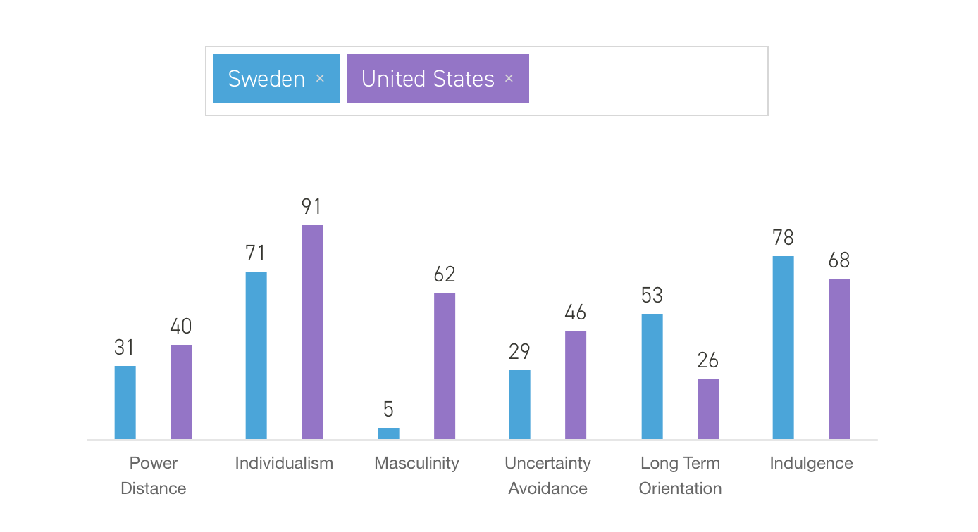
Figure 5: Compare the culture dimensions between Sweden and the United States (Hofstede Insights, 2018)
According to Hofstede’s cultural dimension theory, Sweden’s uncertainty avoidance has 29 points, while Americans have 46 points. By contrast, Americans are more nervous about unknown, so Americans tend to make a standard system and have a clear plan. At the same time, Swedes tend to focus on long- term career planning rather than short term work plans. Therefore, Americans working at IKEA will feel that leaders from Sweden are not professional enough and indecisive. Based on the data, Sweden is a feminine country and the United States is a typical masculine country, which attaches great importance to personal performance.
Therefore, Americans value the motivation system of the company very much. Enhance, in order to reduce employee turnover, IKEA’s leadership has changed its strategy to set up a more stringent incentive system for the United States employees.

  - How culture affects the management of people internationally
Intercultural competence is crucial to the internationalization of enterprises. It exists in business interaction and strategic decision making. According to the 2006 research, improve the intercultural competence can increase productivity 30% (Oracle.com, 2018).
Case:
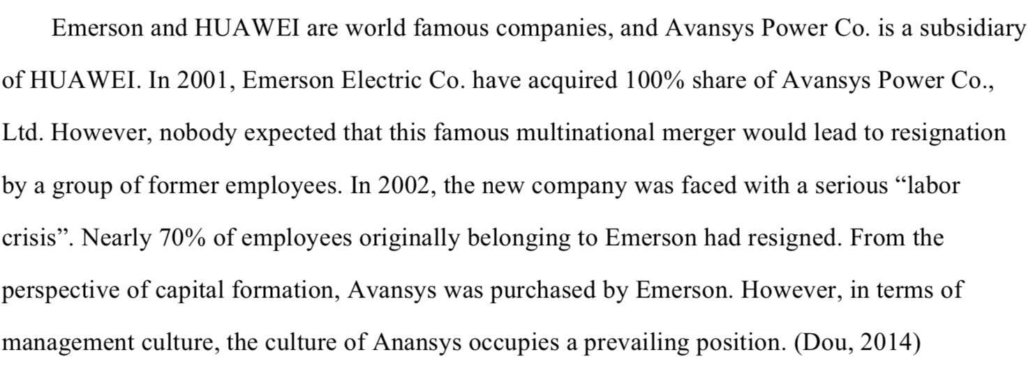Analyze:
Undoubtedly, this is a failed case of cross- cultural merger. Managers did not notice that management culture needs to be changed according to different national cultures. According to Hofstede’s research, it is easy to know that there are great cultural differences between China and the United States.
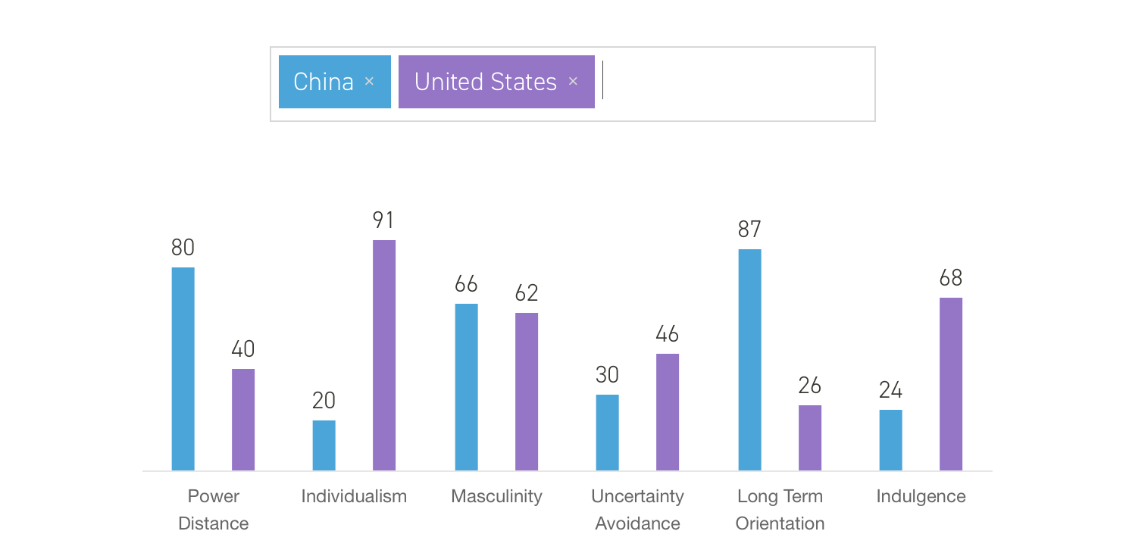
Figure 6: Compare the culture dimensions between China and the United States (Hofstede Insights, 2018)
In this case, a large number of former Emerson employees quit because they cannot accept the management of Anansys. This also shows the difference between Chinese culture and American Culture. According to figure one it is clear that China is a high power distance country and the United States is lower than China. Power distance refers to the way in which power is distributed and the extent to which the less powerful accept that power is distributed unequally. (The Articulate CEO, 2018). Enhance, in Chinses companies, there is a strict hierarchy between the superior and the lower level. In most cases, the lower level cannot disagree with the superior and should be fully subordinate to it. However, Americans prefer peaceful and democratic working atmosphere rather than power and rights. Here also is a picture to show the different power attitude between West and East.
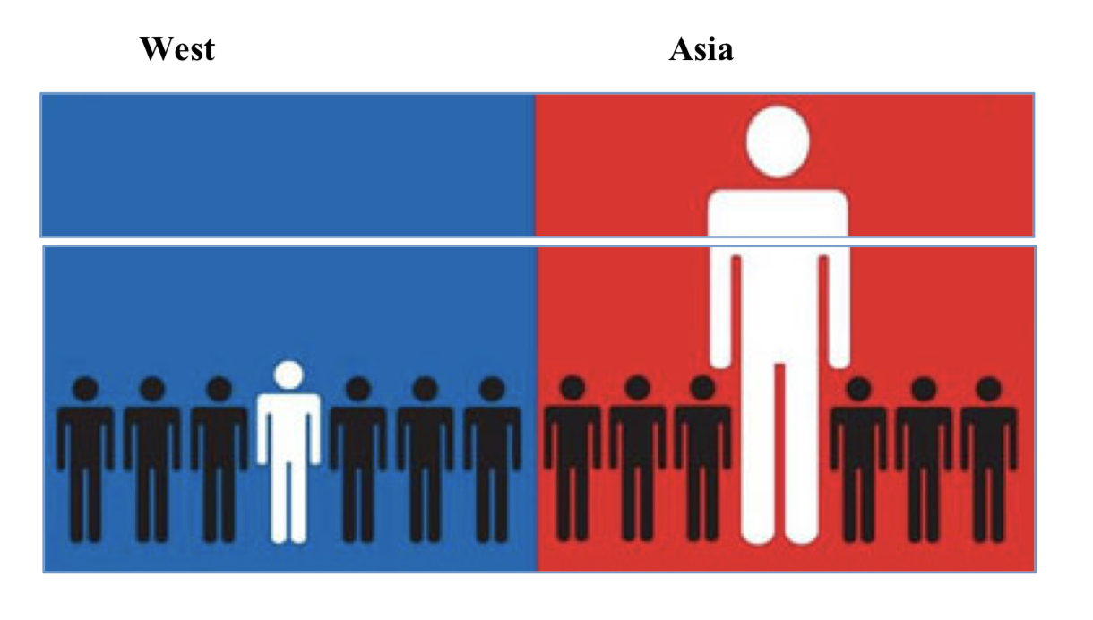
Figure 7: the different power attitude between West and Asia. (Mcgill, 2011)

- Conclusion
In conclusion, there are great differences between different countries and cultures, which has an impact on cross-cultural management and communication. With development of global economic integration, more and more companies are trading and managing in other countries. Whether company could avoid cultural conflicts and adjust different cultural habits in time will decide whether or not enterprises be succeeding.
In cross-cultural management, especially between West and East, the difference between them is very large. For example, American low context communication habits and Chinses high context communication habits. In addition, China and the United States have different views on power distance. Even in western countries, the degree of uncertainty avoidance is different, the tendency of the state to be masculinity or femininity also different.
It all needs to be paid attention to in cross cultural communication. Here are some recommendations that might be useful for future development.

- recommendations
- Understand the culture and habits of other countries and try to avoid cultural conflicts in negotiation or management.
- Do not be too rigid in your culture, be flexible and at the right time to make appropriate concessions or changes if it is necessary.

References
Adler, N. and Gundersen, A. (2008). International dimensions of organizational behavior. 5th ed. Mason (Ohio): Thomson/South-Western.
Browaeys, M. and Price, R. (2015). Understanding cross-cultural management. 3rd ed. Pearson Education UK.
Deresky, H. (2002). International Management. 4th ed. New Jersey: Prentice Hall.
Dou, W. (2014). Intercultural Business Communication: Cases and Analyses. Bei jing: University of International Business and Economics Press.
Faure, G. and Rubin, J. (1993). Culture and Negotiation: The Resolution of Water Disputes. London: SAGE, 1993.
Gudykunst, W., Ting-Toomey, S. and Chua, E. (1988). Culture and interpersonal communication. Newbury Park, Calif: Sage.
Hall, E. (1990). The silent language. New York: Anchor Books.
Hall, E. and Hall, M. (1990). Understanding cultural differences. Yarmouth: ME: Intercultural.
Hofstede Insights. (2018). Compare countries - Hofstede Insights. [online] Available at: https://www.hofstede-insights.com/product/compare-countries/ [Accessed 5 May 2018].
Hofstede Insights. (2018). Compare countries - Hofstede Insights. [online] Available at: https://www.hofstede-insights.com/product/compare-countries/ [Accessed 8 May 2018].
Lewin, K. (1943). Psychology and the Process of Group Living. The Journal of Social Psychology, 17(1), pp.113-131.
Lilly, D. (2018). Intercultural Communication – High and Low Context Cultures. [online] Working Voices. Available at: https://www.workingvoices.com/intercultural-communication-high-context-cultures/ [Accessed 6 May 2018].
Mcgill, M. (2011). La gestione degli aspetti culturali nei processi di internazionalizzazione. Fondazione Istud, pp.7-9.
Murray, J. (1978). Oxford English Dictionary. Oxford: Oxford University Press.
Novinger, T. (2018). How Culture Affects Communication. [online] Culturespan.blogspot.co.uk. Available at: http://culturespan.blogspot.co.uk/2008/01/how-culture-affects-communication.html [Accessed 8 May 2018].
Oracle.com. (2018). Understanding the Importance of Culture in Global Business. [online] Available at: http://www.oracle.com/us/corporate/profit/archives/opinion/050312-dhummel-1614961.html [Accessed 5 May 2018].
quora.com. (2018). What is the opposite of analytical thinking?. [online] Available at: https://www.quora.com/What-is-the-opposite-of-analytical-thinking [Accessed 5 May 2018].
Reynolds, S. and Valentine, D. (2011). Guide to Cross-cultural Communication. 2nd ed. New Jersey: Prentice Hall.
Sarles, S. (2008). Learn at Home for Great Shalom: Great Shalom at Home. Lulu.com.
The Articulate CEO. (2018). Cultural Differences - The Power Distance Relationship. [online] Available at: http://thearticulateceo.typepad.com/my-blog/2011/09/cultural-differences-the-power-distance-relationship.html [Accessed 5 May 2018].
Varner, I. and Beamer, L. (2011). Intercultural communication in the global workplace. Beijing: Tsinghua University Press.
White, M. (2003). A short course in international marketing blunders. Petaluma: World Trade Press.

