Changemakers Assessment 2
Portfolio of Work
Luke Rees - 2100784

Mind map:
MindMeister Mind Map
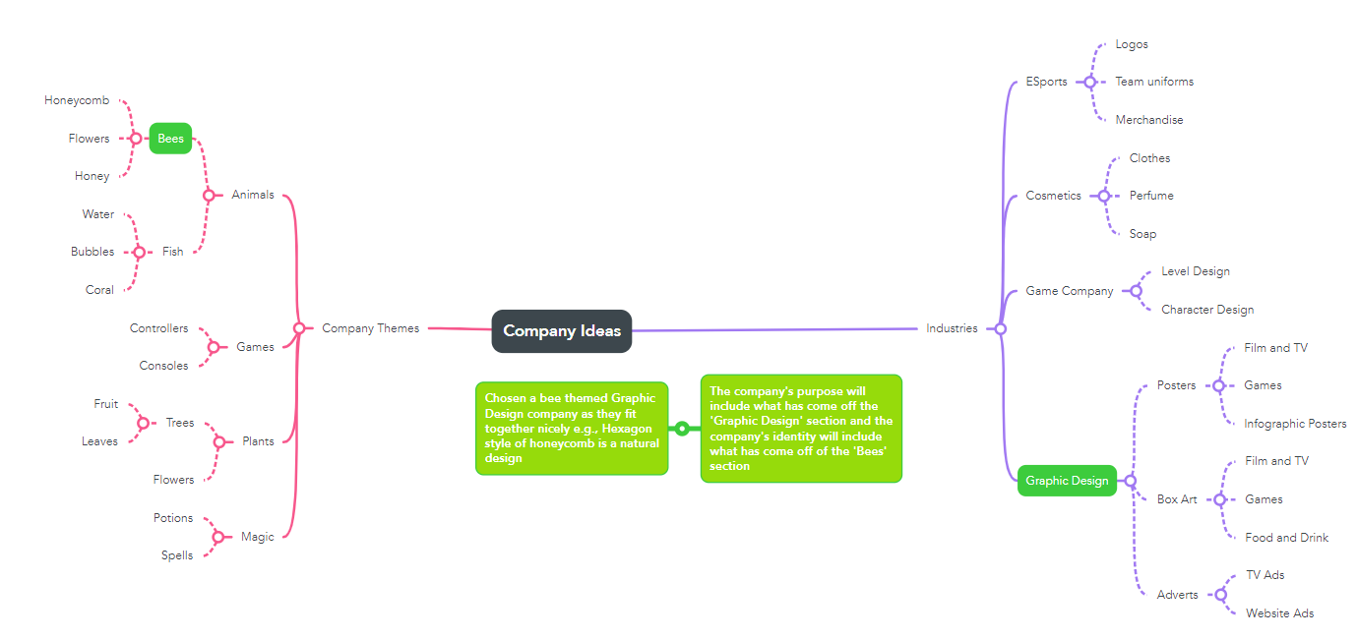
Logo and Banners:
OneDrive Folder with variations and final image .png files

‘Honeycomb Design’ Company Logo

Banner 300x250 Pixels

Banner 300x600 Pixels

Banner 320x50 Pixels

Banner 336x280 Pixels

Banner 728x90 Pixels

Video Graphic:
https://youtu.be/3HZ3TuzLU_A

