nick hinder

Web Development
ASP.NET WEB DEVELOPMENT

Contents
Introduction 2
Implementation 2
Evaluation 5
References 6

Introduction
This report outlines the aims and requirements of a simple board game library application, the methodology undertaken to provide the solution and an evaluation of the resultant product.

Implementation
The web application is aimed at providing a method of library tracking for those who play board games. The application will allow a user to add a game to their personal library and also to track gameplays; thereby providing the ability to assess how popular certain games are and what has not seen play in a while. This application will perform a function that is under represented with a target audience that report high occurrences of problems such as not playing games in too long, playing the same games repeatedly or simply not knowing exactly what is in their collection at a point in time.
The requirements of the application are that:
- Games must be able to be added to the system
  - whilst not much information will be required in early iterations of the application, a genre would be advantageous as that will provide users with information regarding a game that they might require.
- Games in the system must be able to be added to a users individual library
  - All games should be available to be added other than games that are already in the users library.
  - whilst it is possible to own multiple copies of a game, the primary purpose of the application is to track what is available to be played, not to track copies of a game.
- A user must be able to record a play of a game from within their library
  - There are no limits to how many plays can be recorded for a game, each separate play is logged against the copy of the game in the users library
- Listing screens should be searchable and sortable
  - Games should be searchable by name and genre
- Users should be restricted to accessing their libraries and plays, not those of others
  - If a user is not logged in, then they cannot access these areas
  - The user is automatically shown their own data for these pages
- Data must be stored securely
  - User data must be appropriately secured

The application has been created using .Net Core MVC and a code first approach. The
For user administration Microsoft’s Identity services were used to provide a secure, reliable user account feature. This means that there is an appropriate level of security provided by Microsoft’s own hashing of passwords, less time is required to develop such a feature and it means that a level of robustness is provided that a smaller development team could not provide.

Following are a number of screenshots detailing the functionality of the application.
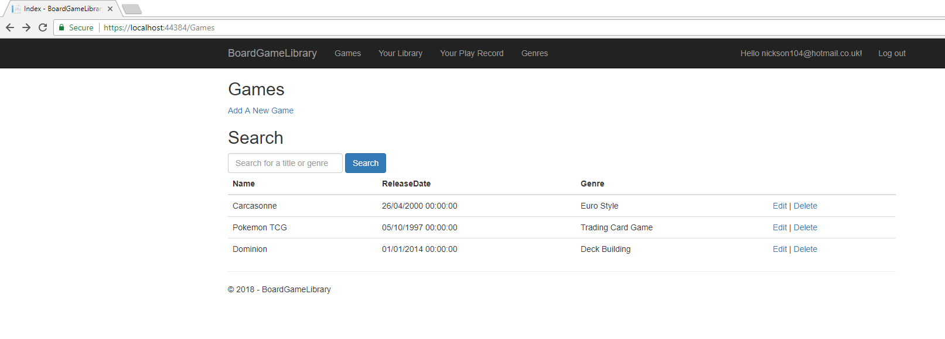
The above image shows the games page; this details all games that are currently installed on the system and provides the user with the means to manipulate the games in the system.
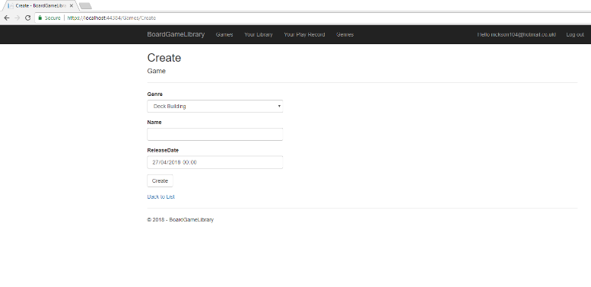
The create screen for this can be seen can be seen to the left; this screen allows the user to record all necessary details for a game when adding it to the system. The same screen is replicated for editing a game however the fields will be populated with the properties of the game currently being edited.

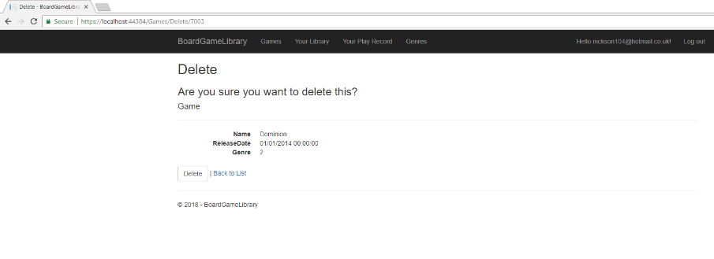
Below is the final game screen, delete; this is shown to the user when they request to delete a game. The screen shows the user the details regarding a specific game and requests confirmation of deletion prior to doing so in a bid to prevent erroneous loss of data.

Below is an image showing the genres screen, this allows the same usability as the game screens however the genres have not been provided a means of deletion; due to the early stages and targeted simplicity of the application, it is not appropriate to allow deletion of genres as this would ideally entail a method of reassigning dependant games to other genres.
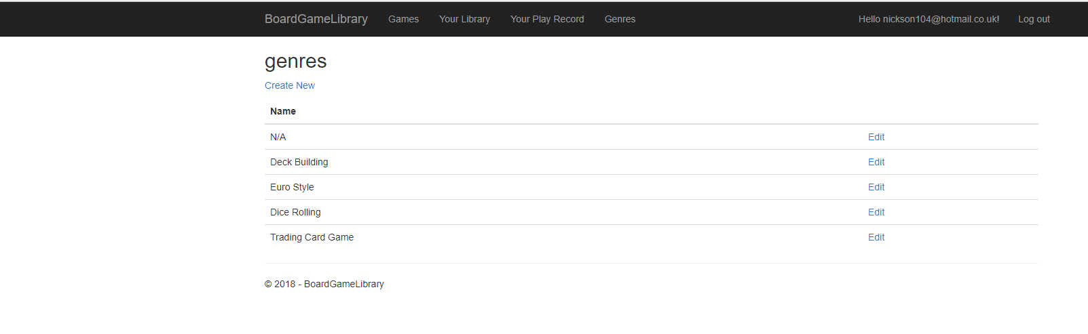
Below is the users library screen; this contains a listing of every game within a users collection and allows them the functionality of adding new games to their library, removing games from it or recording a play of a game within their collection.
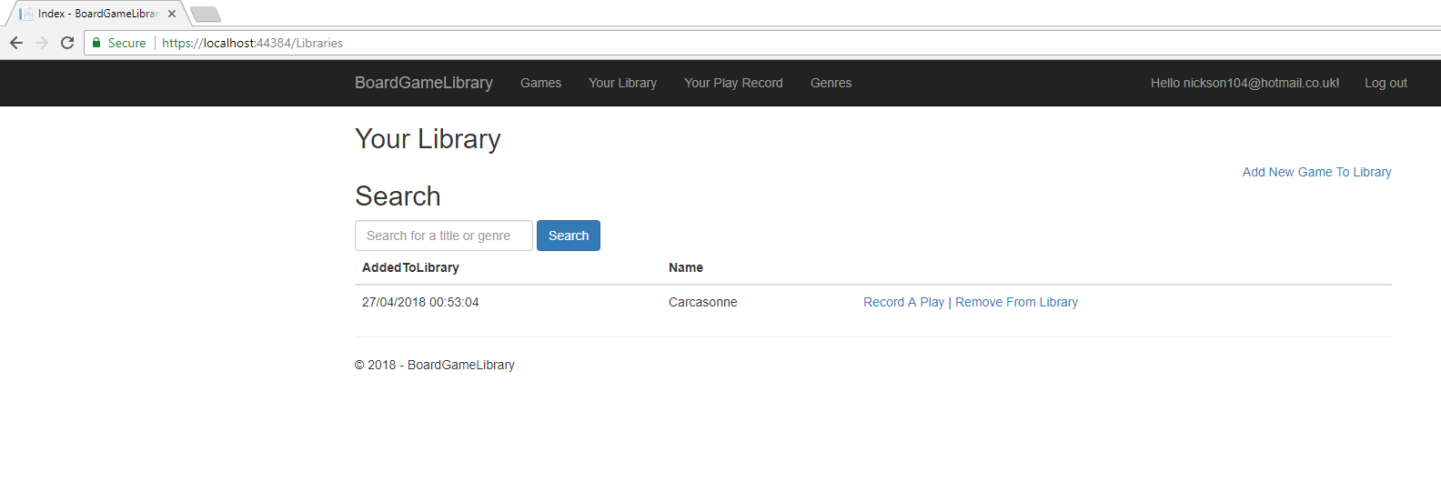
As can be seen in the image below, when adding a game to a users library, the user is only presented with a dropdown of games to be added to their collection. This dropdown is populated by games from within the system, however will not show games already in a users library.
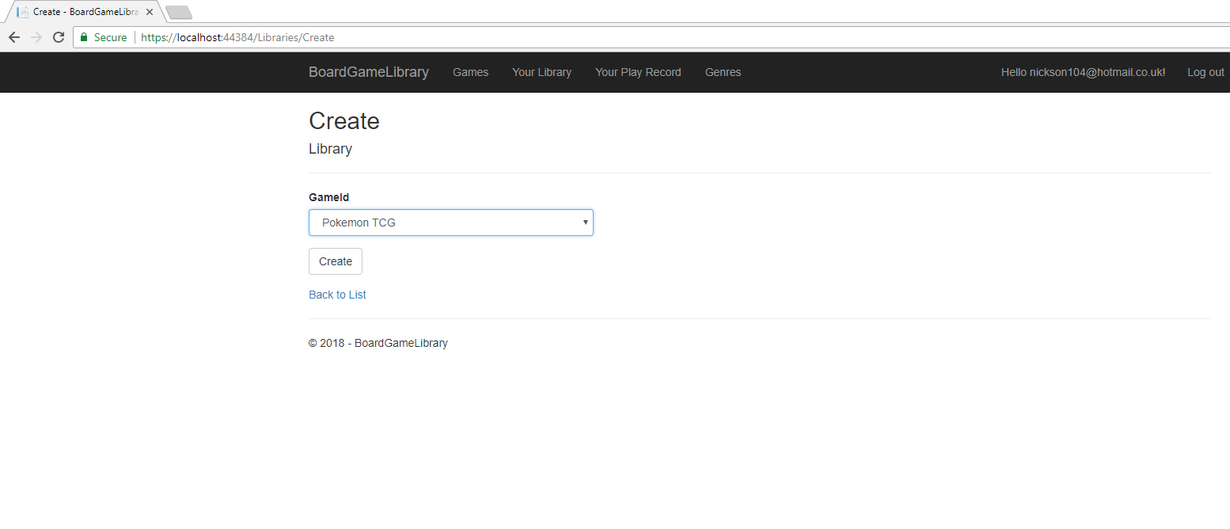
The following image shows the way a user can record a play against a game. The user has reached this screen from a game, therefore this does not need to be an option on the page, all that is required for a user to log is details about this specific play.
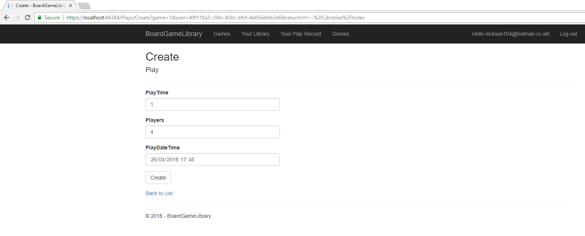
The next image shows the users play record; this shows a listing of game plays performed by the user and allows the ability to edit the details of these or delete the play altogether.

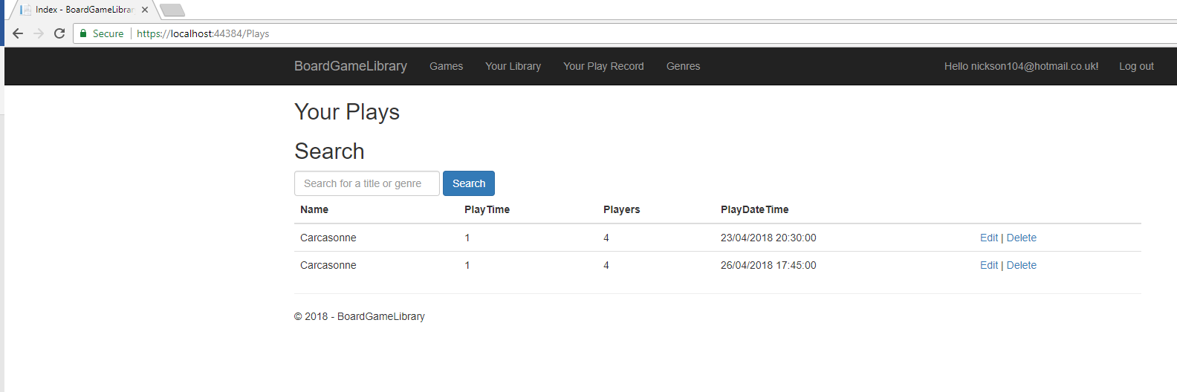
Both the library and play record pages are account locked; it would be illogical to provide these screens when a user is not logged in. When a user attempts to access these pages, they will instead be redirected to the log in page; upon successfully logging into the system, the user will be navigated to the screen they had intended on viewing. The login screen can be seen below.
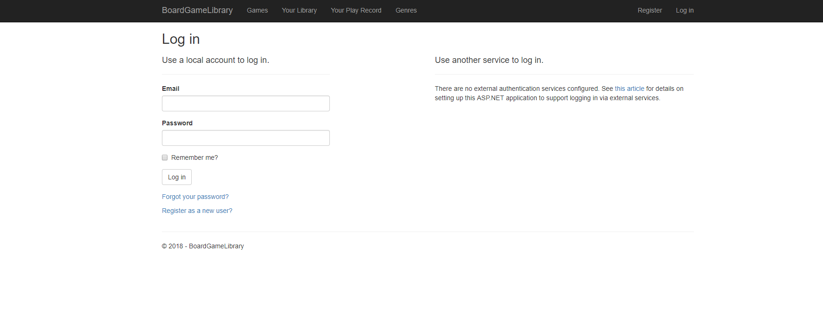

Evaluation
The code first approach theoretically provides development with more flexibility, however throughout the project this approach caused many issues that inhibited further development for significant periods of time.
The applications design is basic and unappealing; it is a functional design rather than an aesthetically pleasing one, this means that whilst it works, most users will not be impressed when shown the application. The design is also not very cohesive; it feels like an application with many sections as opposed to one application with a natural flow of operations.
Upon first looking at the application, a user will not immediately know what to do; in order to carry out actions they want to do, they must first look to the menus. This lack of immediate recognition highlights the bad design of the application.
Data in listing screens is unsorted and has no ability to add sorts, thereby failing to meet one of the ‘should-have’ requirements as this ability is intuitive and has become expected of the majority of applications; its absence would be noted and could lead to frustrations. In the same way, there has been no pagination of results added to the application, this could lead to difficulties in future and as would likely need to be addressed prior to initial shipping of the application.
There is some inconsistencies between pages in the application; not so much that the application loses continuity, but sufficient that a user may find it difficult to identify how to perform actions when navigating through the system.
The games and genres management pages require further work going forward; access to these should be restricted to administrators so as to avoid potential abuse and retain some integrity of data.
Going forward, the application would need a visual overhaul, perhaps even eliminating some screens and adding them to another as a partial. One example of this could be forming a partial from the plays screen, this would then allow for functionality such as a rollover popup of the plays of a game when mousing over a game in the users library; it could also allow for a new feature by doing the same thing for the games screen, but using general data from all users of the system to provide totals, averages and popularity of a game.
With stronger data protection rules being imposed by the Guide to the General Data Protection Regulation (GDPR) (1), it would be worth considering adding functionality for a user to remove both themselves and every piece of data relating to that user from the system in one request. Likewise, adding functionality to provide a user with all the above data could be advantageous as all users have the right to view this data on request.

References
1. Information Comissioners Office. Guide to the General Data Protection Regulation (GDPR). ICO. [Online] https://ico.org.uk/for-organisations/guide-to-the-general-data-protection-regulation-gdpr/.

