STUDENT NAME: kuljit kaur
STUDENT NUMBER: 2028451
MODULE CODE: BMSW 4001
MODULE TITLE: ACADEMIC AND EMPLOYABILITY SKILLS
LECTURER NAME: Dr Doreen Nyaa Amudam ASSIGNMENT TITLE: Reflective Review on Employablity Skills

Summary
The present report has shed light on the time management perspective from a given case study. The first question provides a general discussion regarding time management. Furthermore, issues related to time management have been elaborated on in the following section. Question 3 has been added to describe the 4D Model of time management used to improve time management skills. Furthermore, the application of a selected reflective model has been added, and the development of chosen skills has been explained in the following section. Finally, a personal development plan has been attached to improve basic employability skills.

Table of Contents
Summary 4
Time management skill 4
Critical Thinking skill 5
Planning and organisation ………………………………………………………………6

Application of a Reflective Model 6
Explanation of Development of Chosen Skills 8
Personal Development Plan 8
References 11

Time management skills
Time management could be referred to as a process for organizing and planning that can help an individual conduct specific activities within proper timings. Effective time management methods allow a person to work more intelligently and more complexly, and they can be used to complete a task within accurate timings. whenever work pressure is high, and a person fails to manage the effectiveness, they can complete several tasks within deadlines by proper time management skills. The highest level achievers focus on working their time correctly to improve their workability skills, and it is adequate for controlling pressures. However, practical time management skills are essential, and a person must focus on daily activities and results to achieve success.
Time management is also stated as organizing specific activities properly and assessing how long the activities will take to complete. It helps to develop productivity as well as efficiency for a vast professional reputation. Time management skills are essential to reduce stress and enhance further advancement in a career. Failing to manage time could result in less workflow as well as missed deadlines. It can help take control over a task properly to arrange it, and every job must be prioritized with proper scheduling techniques. Setting up personalized goals will be impactful in this stage that can be effective for discovering the motivational factors associated with a person.
It is necessary to ensure that a person has enough time to complete every project within reasonable deadlines. It also helps to enhance professional skills by increasing quality and developing a faster approach for meeting the deadlines associated with every project. Setting reminders could be helpful in this stage as it is necessary to set accurate reminders and develop a daily planner to arrange the tasks. As opined by Vasciuc (2020), dividing the schedule associated with every lesson according to individual perspectives will be effective for getting the job done within less time, and pressures are adequately high in this stage.

2) Critical thinking skill:-

Donna has several time management issues as she failed to complete her assignment within its associated deadline by Wednesday. Based on the given case, it can be said that Donna has less practical time management skills and faced several issues regarding the completion of her assignment (As per the case study). She faced massive problems, and some of the fundamental issues are discussed below;
- Firstly, Donna was looking for a pen and spent a while looking for a pen and could not find one. However, she managed to borrow a pencil and started the assignment. After that, she discovered that she required some notes, which she left at work. These issues were wasting vast amounts of time, Donna, which is not suitable for developing time management skills and could be referred to as less professional. She then began to start the textbooks and prepared herself to get the notes on Monday.
- Furthermore, her boyfriend Jason called her and spent half an hour on the phone; however, she decided to stay home on Saturday and complete her assignment within proper timings. It can be said from this situation Donna also wasted some time on the phone as well as shortened the deadline associated with her work for complet.
- Donna received a call from her friend Sharon for softball practice, and she agreed to meet them at 11.00. After winning the game by 2.00, Donna went to a pub to celebrate and got home late. However, she is too late studying as the situation represents Donna's lack of time management skills.
- On Sunday, she visited the church, saw her aunt and uncle in the afternoon, and forgot about the assignment until dinner. Donna also forgot that she did not have the notes for completing the work and found out different parts in the textbook that are difficult to understand, She then phoned her tutor, and the tutor did not answer her phone and left a message. Therefore, she was already late for completing her assignment as all the pressure was shifted to Monday and Tuesday.
- Finally, Donna woke up late on Monday and found out that she had forgotten to set the alarm clock. She ran to the bus stop as soon as possible, and it was already 8.45 as she was 15 minutes late.

3) Planning and Organisation
The 4D Model effectively elaborates practical time management skills as it will be beneficial for Donna to manage her tasks within reasonable deadlines. Effective time management strategies could be built by the application of the 4D Model for Donna.
Do
In this case, Donna must set her priorities and must develop a to-do list for tasks. She must arrange the lessons in a proper way to accomplish the prioritized functions properly. However, Donna should have focused on the job that required less time to complete in the first place and could help perform shorter tasks such as visiting Uncle and Aunt and talking with her boyfriend over the phone. Conducting these tasks would be beneficial for Donna to work on her assignment and develop a focus on completing each task (Osgerby et al., 2018).
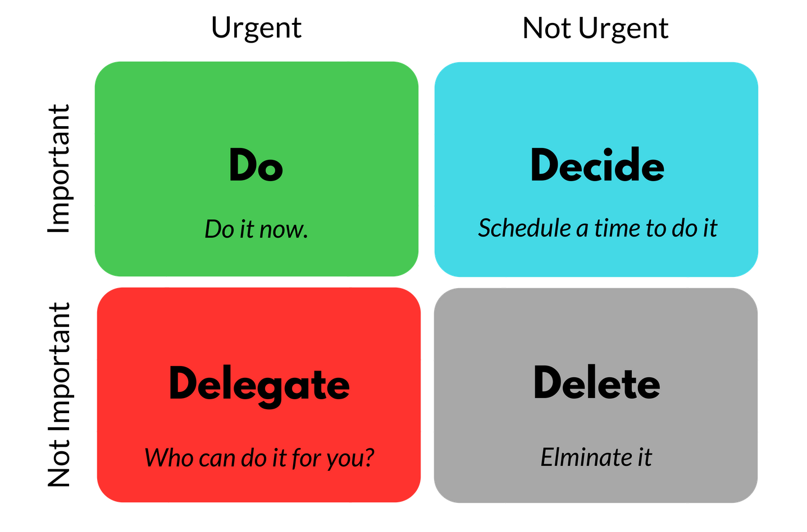
Figure 1: The 4D Model of Time Management
(Source: Marzban et al. 2017)
Dump
Removal of unnecessary tasks from the schedule is the central aspect of this stage, and Donna could have avoided such charges to complete her assignment. On Sunday, Donna visited her uncle and aunt, and this task could have been removed from the schedule, and she could have more time to complete her assignment.
Delay
It could be referred to as temporarily stopping a task that does not require to be handled at that time. The stage refers to properly prioritizing tasks based on their importance. According to the 4D Model, Donna could have avoided visiting the pub after winning the game. It could have developed a proper schedule for better availability over completing her assignment. It will be helpful for Donna to developmental delays in tasks other than her work.
Delegate
It could not be applied to Donna as it is referred to as reassigning tasks to other people. The descriptive functions in the case were associated with Donna and could not be completed by others.

Application of a Reflective Model
Firstly, the chosen skills are Time Management, Critical Thinking, Teamwork, and Planning and Organization. these skills are essential for me to develop personal and professional perspectives in the modern world, and adapting to these skills will help me achieve greater in life. Gibbs Reflective Model is selected in this stage which is helpful for me to assess the feedback and improve my specific areas.

Description
I want to develop several skills in me, such as time management, teamwork, critical thinking and planning, and organization, to become a better professional in the future. I think that developing these skills will be beneficial for me to analyze a situation differently, and I will be able to complete my tasks according to the given deadlines. I understand that working in a collaborative platform or team-based work culture will also enhance my communication and team management skills. Critical thinking will allow me to identify the core aspects of a situation as well as I will be able to prepare proper plans to achieve professional and personal success.
Feelings
Before this group assessment, I thought I had a lot of work to do by myself. However, I understood that result could be successfully achieved when the entire piece is divided between team members. When I realized that it would be impossible for me to submit the assessment on my own, I motivated myself to develop several skills to achieve success. I also consulted with my team members and took their precious time to conduct this assessment which led me to work harder in the evening, Looking back, I am now feeling satisfied to complete my work within the proper time.
Evaluation
I have faced several ups and downs during the completion of my targets. Firstly, I exp erienced multitasking for the assessment, which is not suitable for developing a practical time management skill. However, the other team members produced sufficient quality work, which motivated me to achieve the same level of success. I have focused on this particular task even in the evening and contributed towards planning and organization, including teamwork ethic.

Conclusion
I have improved my time management skill as well as planning and organization, and team management skills. However, critical thinking skills still need to be developed in me, which will be beneficial for me to understand the basics of a situation (Lejeune et al., 2021). I must think about what additional skills I will require to handle a case in a better way.
Action
I have to understand my strengths and weaknesses properly, which will help me achieve tremendous success. I must conduct a detailed personal SWOT analysis and prepare a personal development plan to sort out my key priorities (Pinn-Atkinson and Woolloff, 2018). I must communicate with my elders as well as my teachers to develop more professionalism in me.

Explanation of Development of Chosen Skills
Do  I must focus on developing my critical thinking skills, and on completing this achievement, I have to arrange my tasks. I must put the series of functions properly and identify which tasks I need to conduct in the first place (Bachik and Kitzman, 2020). It will be beneficial for me to accomplish smaller tasks, and I have to complete them within the proper timings. | Dump  I must remove unnecessary activities from my to-do list, and it will help me focus on key activities that will help me achieve better success. I must ignore unpredicted things and unnecessary time-wasters to improve my skills (Osgerby et al., 2018).
Delegate  It will not be suitable for me as I must not assign my task to others. However, I can associate my studies with my team members and focus more on team-based activities. I must reassign less critical duties to others (Bachik and Kitzman, 2020). | Delay  For this stage, I have to prepare a checklist and sort out the tasks in proper arrangement. I can temporarily pause a job that does not need to be handled right away. It will be suitable for me to assess my time management skills, and I will focus on other tasks (Chen et al., 2019).
Table 1: Application of the 4D Model
(Source: Self-Created)

Personal Development Plan
Skills | Development Areas | Actions | Timescale | Evidence
Critical Thinking | In-depth knowledge for completing a task and analyzing a decision | Use of different online sources for knowledge development | 3 Months | I have searched the internet regarding personal development of critical thinking skills as it helped me to train myself to generate a comprehensive knowledge
Planning and Organization | Accurate execution of ideas | By understanding the needs of a situation | 2 Months | Planned my assessments properly and arranged tasks within the proper schedule
Teamwork | Working in a collaborative platform | By developing accurate communication perspectives among the team members | 1-2 Weeks | Worked in a collaborative platform by completing an assessment, and it helped me to develop internal communication with my team members
Time Management | Inaccuracy in setting the time frame | Accurate planning and scheduling, as well as identification and allocation of resources | 1 Week | Set prioritize targets with practical time-bound goals, which helped me to conduct necessary tasks at the primary stage
Table 2: Personal Development Plan
(Source: Self-Created)

References
Bachik, A.K. and Kitzman, M.J., 2020. The case for including personal development in undergraduate psychology curricula. Scholarship of Teaching and Learning in Psychology, 6(2), p.150.
Chen, G. and Huang, S.S., 2017. Toward a theory of backpacker personal development: Cross-cultural of the BPD scale. Tourism Management, 59, pp.630-639.
Chen, G., Huang, S. and Hu, X., 2019. Backpacker personal development, generalized self-efficacy, self-esteem: Testing a structural model. Journal of Travel Research, 58(4), pp.680-694.
Ekaterine, G. and Natalia, K., 2017. Impact of Time Management on Personal Development of Master's Degree Students. European Journal of Social Science Education and Research, 4(6), pp.110-118.
Lancer, N. and Eatough, V., 2020. One‐to‐One Coaching as a Catalyst for Personal Development: An Interpretative Phenomenological Analysis of Coaching Undergraduates at a UK University. Coaching Researched: A Coaching Psychology Reader, pp.231-252.
Lejeune, C., Beausaert, S. and Raemdonck, I., 2021. The impact on employees' job performance of exercising self-directed learning within personal development plan practice. The International Journal of Human Resource Management, 32(5), pp.1086-1112.
Marzban, S., Hekmatyar, J., Nasrollahzade, K. and Rahimkarimi, H., 2017. Personal Skills and Organizational Skills; Time Management Among Managers of Zabol Medical Sciences University in 2015. Evidence-Based Health Policy, Management, and Economics, 1(2), pp.87-93.
Nair, P.K. and Fahimirad, M., 2019. A Qualitative Research Study on the Importance of Life Skills on Undergraduate Students' Personal and Social Competencies. International Journal of Higher Education, pp.71-83.
Neenan, M. and Dryden, W., 2020. Cognitive Behavioural Coaching: A Guide to Problem-solving and Personal Development. UK: Routledge.
Osgerby, J., Marriott, P. and Gee, M., 2018. Accounting students perceptions of using visual metaphor as part of personal development planning: an exploratory case study. Accounting Education, 27(6), pp.570-589.
Pinn-Atkinson, S. and Woolloff, J., 2018. Creative Themes for Groupwork and Personal Development. UK: Routledge.
Vasciuc, C.G., 2020. Reflection on Personal Development, Facts, and Rules to be Applied in the Management of Companies. HOLISTIC–Journal of Business and Public Administration, 11(2), pp.140-150.

