Q1. Examine Two key external factors likely to impact on BPE’s acquisition of Emrosu. (AC 1.1)
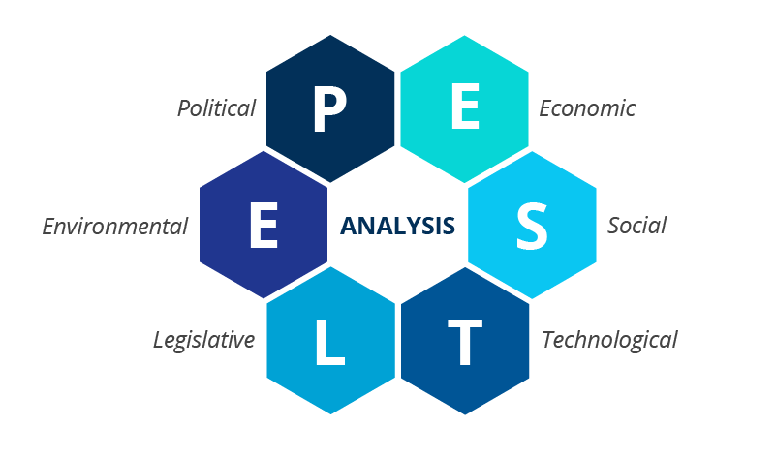 (Ormston, 2025)
There are many external factors that are likely to impact on BPE’s acquisition of Emrosu these are identified by using a PESTLE analysis. An analysis of these factors and staying connected with all these external factors can ensure an organisation keeps ahead of any curve that might be coming Waite et al (2021, pp 7-8).
Social
BPE currently supports a small area with a more personalised face to face approach to customers. As stated by Barton, Sturge and Harker (2024) the population is aging and growing, this creates more complex health concerns with more demand on pharmaceuticals for diseases that come with aging. As a smaller business, higher demand for services and increased demand in certain medications could be difficult to keep up with. Ensuring BPE has quick access and delivery of these medications is paramount to customers in the areas they serve. The acquisition will enable BPE to keep up with demand and change, Emrosu has a much larger operation which means they have a larger infrastructure of storage and delivery capacity for all their stores. Emrosu would be more capable of growth and adaptation to react to these additional pressures.
Technology
Emrosu is a large company spread out over a wider area, so they have a reliance on technology that is higher than with BPE. This would result in time efficiency and money saving as a benefit from less travel by using technology more to have meetings and to communicate with different sites. The technology currently in use by Emrosu to meet the needs of their online services will bring BPE up to date with current trends of online services. There is growing concern for the rate in which AI is advancing rapidly across business as stated by the world economic forum report 86% of people who responded believe that AI will have dramatically changed their business by the year 2030. This could result in potentially supporting the upskilling of the current workforce as a positive outcome, or as a negative there is also the risk that AI could replace new or typical employees World Economic Forum (2025). Some thought needs to be placed into ensuring that the face to face and personal nature of business by BPE is not lost during the transition keeping in mind that technological advances are not being taken by all ages of their customer base. With the aging population this is not the case so ensuring all services are provided both face to face and online ensures that all customers can continue with services they need.
Q2. Discuss two business goals that BPE might set once the acquisition has been completed, explaining the reasons why it is important that they plan to achieve these. (AC 1.2)
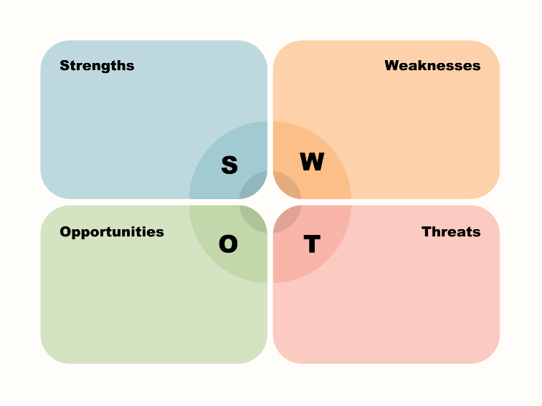 (BPI Global, 2023)
A SWOT analysis is used as a tool to look at what goals are needed within the organisation. With an adjustment period following the acquisition having direction in the form of goals would unite the companies into one.
To Increase online services available, Emrosu already has the technology, trained staff, and infrastructure in place to widen the number of services available. Increasing online services would advance the outreach of services to people and widen the customer base. Achieving this by BPE alone would not be as achievable with nothing currently in place to even begin the first online services. After the acquisition of Emrosu this would be achievable as some structure is in place. With demand for services at an all-time high and living in an age of technology this would certainly support BPE to stay current and relevant in today’s market and give BPE further outreach to more customers online. By adding one service per year for three years, this can be split into sub-goals, once each online service is completed each year, there is recognition and celebration at what has been achieved.
Increasing sales would reduce any confusion and misdirection with the acquisition with current customers. By having a goal of increasing sales can support the current customer base and keep loyalty and trust within your services whilst also gaining more. If the goal were to increase sales by 9% over three years this can be divided into sub-goals looking at a 3% increase per year is achievable in the growing demand of the market today. Increasing sales is relevant with the cost of the acquisition, the additional revenue will go some way to cover the costs incurred of the acquisition. Subgoals in-between can measure the success of the goal before the three years, adjustments and discussion can then determine why goals have not been met.
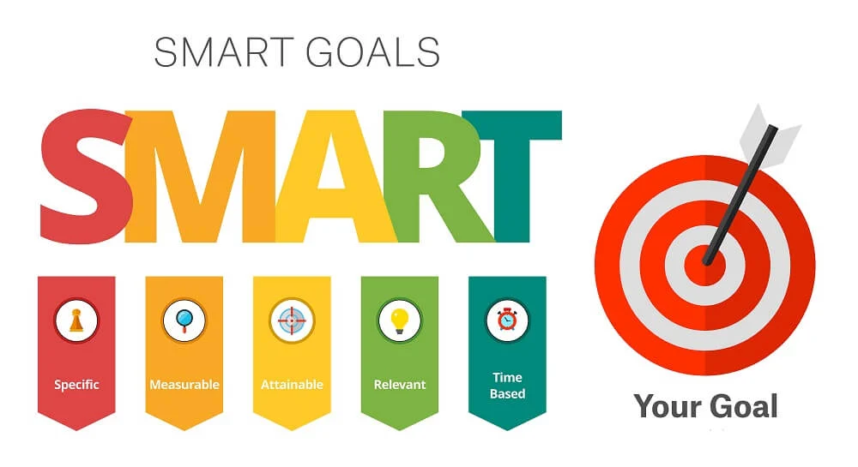 (Belyh, 2023)
As discussed by Waite et al (2021, p14) making goals is just an idea of something to achieve, a SMART structure makes them more successful.
As stated by Waite et al (2021) goal planning and execution is what sets the likelihood for success, ensuring employees are involved and understand the objectives fully and understand their role in achieving the goal is paramount to its success. Motivating employees to achieve gives a sense of purpose and belonging, striving for more, to further their skillset, broaden their training and develop new understanding of goals and objectives.
Q3. Discuss:
- The products and services that BPE and Emrosu deliver.
And
- Their main customers. (AC 1.3)
BPE is currently structured with all interaction being face to face with the services they provide from health and beauty products sales to consultations and pride themselves on this family culture environment. BPE have a loyal customer base for this reason. Emrosu have a much less personal feel to their organisational culture especially with the online prescription service which provides deliveries of medication to people on top of all the services that BPE provide. The in-person approach has the positives of people being in the store and waiting for prescriptions and are likely to browse products in store from makeup and basic health and medication items that they realise they need when there. The online prescription service provided by Emrosu eliminates this passing trade.
With regards to customers BPE stores are all local and supply local residents, only resulting in very little additional customer growth. They mostly have business to consumer relationships, if there are any business-to-business interactions then they are likely to be fewer and with local residential schools or residential homes within the smaller community. Emrosu as a larger company would have a larger percentage of business-to-business consumer relationships, they have a wider customer base and the infrastructure to meet the needs, to serve chains of residential homes with bigger contracts.
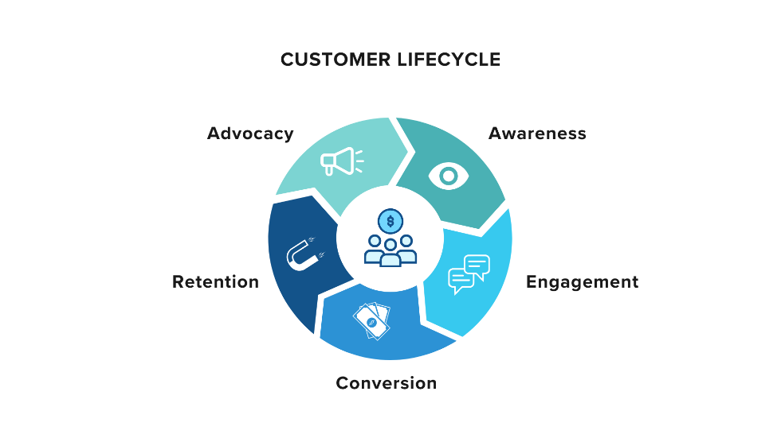 (Tyagi, 2023)
Taking a deeper look at the behaviour of customers and their satisfaction levels can make their loyalty more likely in future. Looking at more than just being a supplier of services and products, giving the customer a more enriching experience makes the difference in loyalty and engagement. Using this data to reach customers in meaningful ways will improve customers experiences and keep them coming back (Waite et al 2021)
Q4. Review the range of technology that could be available to the people professionals working at BPE and Emrosu and how these could be utilized to improve working practices and collaboration after the acquisition. (AC 1.4)

A core HR system which is used for the whole employee lifecycle would be available already by Emrosu. The system would ensure that all staff at the same level go through the full on-boarding process and essential training for their role. The HR system would also record all external training undertaken and record appraisals and disciplinary data. By keeping all this relevant data stored in one place it ensures all people professionals can access it, and it is kept up to date and private for GDPR purposes. This means only people professionals can review and access the data contained in the system. With accurate date logging and logging of who has made changes and edits to the data meaning changes are traceable. Systems are only as accurate as the people who use them though, so they can still hold inaccurate data if not kept up to date by staff.

Video conferencing facilities would work well to ensure the BPE and Emrosu teams can link together regularly and work together for the same goals. It ensures regular and timely communication as well as saving the costs of travel and time spent travelling. It is still preferable to have a mix of online and in person meetings, video conferencing does have an impact on individuals’ ability to join in with discussions, there is also a lack of non-verbal communication that is often missed using this style of communication.

Data sharing is a fantastic tool to work collaboratively work on documents. It supports GDPR guideline with access being given to only those who need it, securely hiding things that are not to be viewed by everyone. It is easy to use and is continually improving the way in which it works to be a streamlined and functional technology for companies to use in whichever way works for them.

In the collaboration of all these technologies it promotes an increase in engagement with easy to access contact and information with and between colleagues, it can reduce disputes and reduces a lack of communication within the organisation. It also promotes the ability for hybrid working and giving employees a better home/work life balance by doing so, this creates a more positive experience and supports better staff retainment.

Q5. Define what is meant by ‘organisational culture’ and why it will be important to foster an appropriate and effective workplace culture in BPE after the acquisition. (AC 2.1)

Organisational culture is the term used to describe the set of practices, patterns and behaviour in the way persons work together and alongside each other in the organisation Waite et al (2021, p28) Organisational culture can have different cultural rules based on departments where each can have its own set of unspoken ways and practices of working. Organisational culture has an influence over those who are within the organisation this happens over time and can slowly change how a person works and conducts themselves within a different culture Yukl et al (2020, p346).
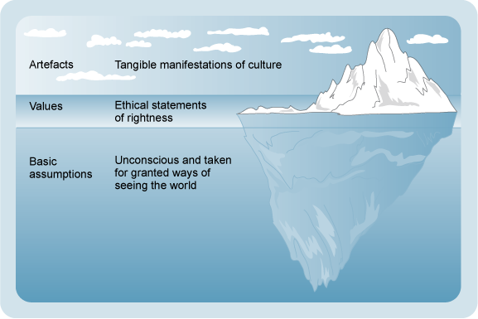 (Knell 2019)
Schein’s Model of culture explains that some aspects are seen and can be noticed while the underlying unseen aspect of culture is a mixture of attitudes, behaviours, assumptions, and beliefs. Together these make up the culture of a workplace Waite et al 2021.

A positive work culture can increase productivity and give healthier and happier employees who want to stay in the organisation. A positive culture can overtake the importance of their salary and the commute to work (Harvard University 2025). This shows how much a positive culture can make such a difference to someone’s work life. Having productive staff and less staff turnover can have a significant impact on profit margins. The time and money spent on recruiting and training is a large saving especially when this is dramatically reduced by staff retention.

Q6. Explain how organisations function as whole systems and how the work and actions of the people professionals at BPE, after the acquisition, could impact the organization. (AC 2.2)

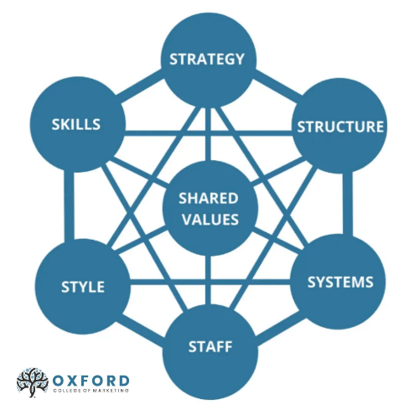 (Allen 2020)

McKinsey’s 7-S model shows how the seven aspects are linked and dependent on each other. Even in a small organisation the elements of each area come together to form the organisation, everything functions alongside and in tandem which each other. If one system is weaker then this can influence the organisation thus impacting the employee’s working experience and satisfaction within their role (Waite at al 2021). If a company can recognise this and take it into consideration for the management of the people, processes, and systems then they have a holistic view of the organisation which will become very important for the success, culture and environment for employees Waite et al 2021.

BPE has a flat structure while Emrosu has a hierarchical structure, with multiple levels of management. Each would have policies and procedures in place that support the values and structure of the organisation. After the acquisition there would be a merging of these practices and a re-alignment of the structure and policies. With unfamiliar staff coming together from different working environments, managing the acquisition with open communication is imperative to ensure everyone is working to the same values and policies. Training would need to be conducted to upskill staff going into a slightly different role they previously worked. People professionals need to foster a cheerful outlook with team building exercises, this can go someway to reduce disputes and create high productivity, increased revenue and an improved or maintained level of morale and motivation for employees.

Q7. Explain the main reasons why it is important that any changes made following the acquisition are planned and effectively managed. (AC 3.1)

Planning Change

Change is inevitable, even in business, staying as they are, is not an option, growth, success, and longevity of a business will need change (Waite et al 2021). Putting a plan together of what change needs to occur, how it is to be implemented and over what time the change is going to happen. Not all changes are able to be planned extensively with some change requiring a faster turnaround for example the Covid 19 Pandemic forced a lot of rapid changes for many organisations to function. There would have been a plan of how to do it, with a lot to organise and think about for the whole organisation change cannot occur without some level of planning. Thinking of the plan as steps can go someway to organise the change, thinking of the roles of different departments and employees within them and keeping open communication to ensure everyone is aware of the plan and the part they play in it (CIPD 2024).

Managing Change

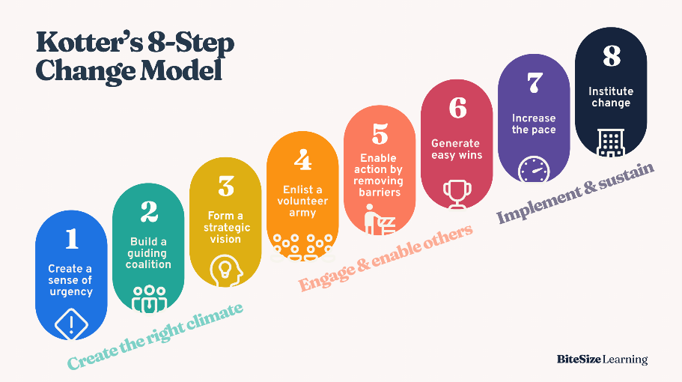 (BiteSize Learning 2024)

Managing a change is more about managing the people who play a part in the change, the process of managing changed has been supported successfully by Kotters 8 Step change model illustrated above (Waite et al 2021). Using Kotter’s model allows leaders to see the change, broken down into more manageable parts, this gives strategy on how to involve all employees. From involving them in the need for change to problem solving when a step is not going well and finding a way through with innovative ideas. This model makes employees feel as the they are part of the change and feel the motivation from this rather than the change just happening to them. By managing the change effectively through each step, it results in strong employee engagement and morale through the change, an increase in efficiency and productivity, and the change is likely to be more successful.

Q8. Consider the importance and role that the people professionals in BPE and Emrosu could play during the changes. (AC 3.2)

There are several distinct roles that people professionals can adopt during the change process, gate keeper, liaison person, driver of change, facilitator, or advisor. An organisation would benefit from more than one type of these roles, with one taking the lead and others being able to bring in various experiences to support (Waite et al 2021).
BPE and Emrosu working together from different angles will go a long way in supporting change and showing a united front to employees. With considerable planning together they can achieve the engagement and acceptance of employees without rushing the process and allowing for individuals to react but in a professional manner.

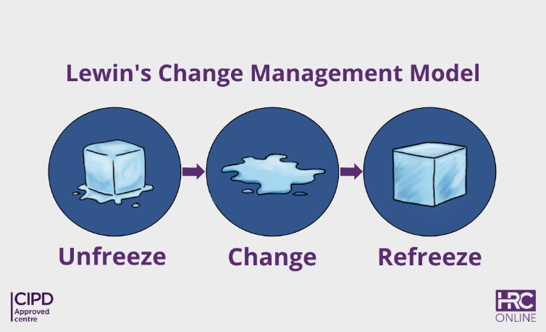 (HNC 2023)

Conducting assessments of what needs to be changed and communicating this need, while preparing the organisation for the change in unfreeze stage of the Lewins change process. The actual change is implemented in the change stage this can include new systems and procedures; HR is fundamental in ensuring training is conducted where needed and communicate continually through the change period. HR should also conduct periodic reviews of change engagement and responses to the change, amending attitudes and reactions as necessary (HNC 2023).

Q9. Discuss how the changes could impact people working at BPE and Emrosu. (AC 3.3)

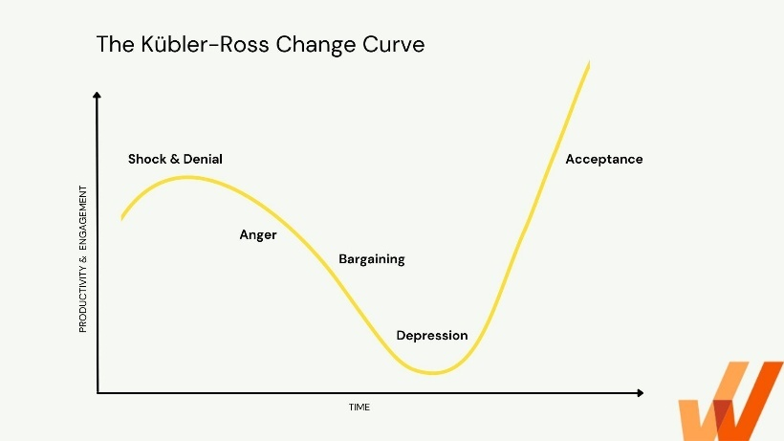 (Malik 2025)

It has been suggested by the Kubler-Ross change curve that there is a predicted process that employees go through when responding to change (Waite et al 2021). If people professionals can understand this process, they can assess how best to manage the people in each stage. Guiding and supporting through each stage is key to move forward, although the model does not allow for individuals who might back step into a previous stage. Paying more focus on the individual rather than the change and needs of the business will feel more beneficial to the individual. Since people and their personalities are unique based on life experiences, it means they may not fit into this model well and experience unexpected reactions to the change. (Roberts and Tracey 2024). The curve is a guide for people professionals and not a tick box exercise to get people through to the other side with accepting the change to be able to move forward, taken into consideration then it should benefit people professionals and enable them to support the people effectively.
Understanding the impact of the change on employees can close the gap to meet their concern and stressors around the change with answers which can ease those concerns.

Just as much as change is inevitable so is resistance to change, resistance can be from fear not just an unwillingness to change, fear of job losses, uncertainty, and abilities. It is important to pre-plan what resistance there might be to already have the support waiting to respond to any concerns (CIPD 2025).

References

Alicia, A. (2020). McKinsey’s 7S Model | Oxford College of Marketing. [online] Oxford College. Available at: https://blog.oxfordcollegeofmarketing.com/2020/12/16/aligning-an-organisation-for-success-with-mckinseys-7s/ (Accessed 31 October 2025).
Barton, C., Sturge, G. and Harker, R. (2024) The UK’s changing population, House of Commons Library. Available at: https://commonslibrary.parliament.uk/the-uks-changing-population/ (Accessed on: 22nd October 2025)
Belyh, A (2023) Smart-goals-definition-and-powerful-examples1 [online image]. Available at: https://www.founderjar.com/smart-goals/ (Accessed on: 29 October 2025).
BiteSize Learning (2024). Kotter’s 8-Step change model, explained. [online] BiteSize Learning. Available at: https://www.bitesizelearning.co.uk/resources/kotters-8-step-change-model (Accessed on 01 November 2025).
BPI Global (2023) Swot [online image]. Available at: https://www.bni.com/the-latest/blog-news/3-easy-steps-to-conduct-a-swot-analysis/ (Accessed on: 29 October 2025)
CIPD (2025). Change Management. [online] CIPD. Available at: https://www.cipd.org/uk/knowledge/factsheets/change-management-factsheet/ (Accessed 1 November 2025).
Harvard University (2025). Why Workplace Culture Matters. [online] Professional Development | Harvard DCE. Available at: https://professional.dce.harvard.edu/blog/why-workplace-culture-matters/ (Accessed 3 Nov. 2025).
HRC (2023). Lewin’s Change Management Model - HRC Online. [online] hrcoursesonline.com. Available at: https://hrcoursesonline.com/lewins-change-management-model/ (Accessed 2 November 2025)
Knell, L. (2019) Step up to leadership: 7 Developing an Effective team culture. Available at: https://www.open.edu/openlearn/money-business/leadership-management/step-leadership/content-section-8 (Accessed on 31 October 2025).
Malik, P. (2022). The Kübler Ross Change Curve in the Workplace. [online] The Whatfix Blog | Drive Digital Adoption. Available at: https://whatfix.com/blog/kubler-ross-change-curve/ (Accessed on: 2 November 2025).
Ormston, A. (2025) PESTLE-diagram [online image]. Available at https://www.b2binternational.com/2025/04/03/pestle-analysis/ (Accessed on: 29 October 2025)
Roberts, A. and Tracey, H. (2024). Change management: A guide for people professionals. [online] CIPD. Available at: https://www.cipd.org/uk/knowledge/guides/change-management/ (Accessed on: 2 November 2025).
Tyagi, A. (2023) Customer_lifecycle_management_stages [online image] Available at: https://www.sprinklr.com/cxm/customer-lifecycle-management/ (Accessed on: 31 October 2025)
Waite, K., Beevers, K., Small, N., Tomlinson, K. and Hussain, S. (2021) People Practice: A Complete Guide. London, United Kingdom: Kogan Page.
World Economic Forum (2025) Future of jobs report World Economic Forum. Available at: https://www.weforum.org/reports/the-future-ofjobs-report-2025/ (Accessed on: 29 October 2025)
Yukl, G., William, L., Gardiner III. (2020) Leaderships in Organisations. 9th ed. Essex, United Kingdom: Pearson Education Limited

