I confirm that I have not used any AI tools in the research and creation of this assignment. I confirm that I have not used any AI-generated materials as my own work. I confirm I have copies of my drafts, notes, and other resources I used, which I may be asked to provide in evidence.

Programme Rationale
The personal training programme designed for Nathan Chaplin was structured around his individual needs, goals, past exercise history, and physical assessment results. The goal of the programme was to develop muscular strength and lean mass while improving posture, hip mobility, and overall functional fitness. The training sessions also aimed to prepare him for participation in a mud run event, which requires a combination of cardiovascular endurance, muscular strength, and flexibility.

Client-Centred Design
From the beginning, Nathan demonstrated a positive attitude and readiness to commit to a structured training plan. He is 25 years old, works in a sedentary tech role, and enjoys a variety of sports such as bowls, golf, and dog walking. His lifestyle analysis revealed relatively low levels of current physical activity but a strong background in moderate to high-intensity sports, including judo, football, cricket, and half-marathon training. This history gave us a solid foundation to work from, allowing for the safe introduction of resistance training and high-intensity intervals without posing a high risk of injury.
Nathan’s PAR-Q indicated no contraindications to exercise, and physical testing results were largely within healthy ranges. He demonstrated a healthy BMI (21.2), normal blood pressure (120/80), and strong muscular potential. However, his sit-and-reach test showed limited hip mobility (4cm), and his postural assessment revealed mild kyphosis likely stemming from prolonged seated work. These factors were considered critical in the design of the programme to prevent injury and promote balanced muscular development.

Training Split and Periodisation
The programme followed a three-day training split: two upper body sessions and one lower body session each week. However, for the first period of the programme, this was reduced to one upper body session and one lower body session to allow gradual adaptation to the increase in physical activity. This structure was chosen for several reasons. First, research supports the use of split training for hypertrophy and strength gains, especially in recreationally trained individuals (Schoenfeld, 2010). By alternating muscle groups, the programme allows for optimal recovery between sessions while maximising training volume.
The 12-week programme employed a linear periodisation approach. This model progressively increases training intensity and volume over time to avoid plateaus and stimulate continued adaptations (Issurin, 2008). In Nathan’s case, initial sessions began with moderate loads and higher repetitions (10–12 reps) to focus on form, mobility, and muscular endurance. Over time, resistance and set volume were gradually increased, and rest periods were slightly reduced to increase time under tension and promote hypertrophy.

Exercise Selection and Programming

Warm-up and Mobility
Each session started with incline treadmill walking followed by mobility drills (leg swings, hip circles, and lunges). These were chosen to elevate the heart rate, activate the muscles, and target hip mobility. Incline walking helps engage the posterior chain and promotes hip extension, which is crucial for clients like Nathan who show limited hip flexibility (Behm & Chaouachi, 2011).
Mobility exercises also played a critical role in addressing kyphosis and sedentary posture. For instance, lunges promote dynamic flexibility and activate the hip flexors and glutes, helping counteract the effects of prolonged sitting (Page, 2012).

Resistance Training
A key focus of this programme was progressive resistance training, as it is the most effective method for increasing lean mass and strength (Kraemer & Ratamess, 2004). Each session included a mix of compound lifts and isolation movements, tailored to the upper or lower body focus.
Upper Body Sessions: Included exercises like deadlifts, bent-over rows, incline bench press, dips, and shoulder work (military press, lateral raises). Compound lifts were prioritised for their ability to stimulate large muscle groups and hormonal responses (Testosterone and Growth Hormone release), which are essential for hypertrophy (Schoenfeld, 2013).
To accommodate Nathan’s postural concerns, specific attention was given to strengthening the upper back and posterior deltoids through exercises such as reverse dumbbell fly and rows. These help correct the rounded shoulders and thoracic kyphosis by strengthening the rhomboids, traps, and rear deltoids (Kendall et al., 2005).
Lower Body Session: Focused on strength and functional stability, including squats, goblet squats, lunges, leg press, and calf raises. These exercises develop the glutes, quads, hamstrings, and calves, which are essential for injury prevention, stability, and preparation for running-based activities like a mud run (Comfort et al., 2012).
Goblet squats were chosen early in the programme for their lower technical demands and ability to teach proper squat mechanics. As Nathan progressed, more advanced variations (e.g., Romanian deadlifts or pistol squats) could be introduced to challenge balance and unilateral strength.

Cardiovascular Conditioning
Each session incorporated cardiovascular training. In upper body sessions, HIIT on a stationary bike was used (10s max effort/50s recovery x5). HIIT was selected due to its time efficiency and proven benefits in increasing VO₂ max, fat oxidation, and muscular endurance (Gibala et al., 2012).
In lower body sessions, a steady-state treadmill workout was used for active recovery while still promoting endurance. This balance between HIIT and steady-state cardio reflects ACSM guidelines for improving cardiovascular health in general populations (ACSM, 2018).

Core and Functional Work
Each session concluded with a bodyweight circuit (plank, shoulder taps, and mountain climbers). These exercises promote core strength, stability, and total body endurance. The inclusion of these movements helps bridge strength work with functional movement, particularly useful for obstacle races like a mud run.

Cool Down and Flexibility
Stretching was used to aid recovery and reduce muscle tightness, especially targeting the hip flexors, hamstrings, chest, and shoulders. Both maintenance (to sustain current ROM) and developmental stretching (to improve ROM) were prescribed based on session intensity.

Reflections
The process of designing and implementing a personal training programme for Nathan Chaplin was both rewarding and instructive. Throughout the 12-week period, I observed not only the client’s physical progression but also my own development as a personal trainer. Several key themes emerged from this experience: adaptability, client engagement, progressive overload, and the importance of communication.

Adapting the Programme
Though the original programme was well-structured, adjustments were necessary along the way. In early sessions, Nathan experienced mild DOMS in his lower back following deadlifts. To accommodate this, we temporarily replaced deadlifts with rack pulls to limit range of motion and reduce strain while still training posterior chain strength. This highlighted the importance of individual response and the need to modify exercises based on client feedback rather than rigidly following a pre-written plan.
Likewise, although Nathan had no contraindications to movement, his kyphosis required us to include extra focus on posture. I emphasised scapular retraction and thoracic extension during upper back exercises and adjusted cueing techniques accordingly. Over time, I noticed improvements in his posture during lifts and general standing posture.

Ensuring Progressive Overload
One of the core principles in the programme was progressive overload. I ensured consistent progression by tracking reps, weights, and rest periods. As Nathan adapted, we gradually increased weight loads and shortened rest times slightly to challenge him. For example, his incline dumbbell press progressed from 12 kg per arm to 20 kg over the course of the programme. He was motivated by measurable improvements, and this served as a strong driver of consistency.

Client Engagement and Enjoyment
Nathan was fully engaged in each session. His background in sports helped him appreciate the technical aspects of resistance training. He responded particularly well to the structure of each session and often asked questions about the purpose behind certain exercises. This opened opportunities for education, which strengthened our professional rapport and encouraged self-efficacy on his part.
Interestingly, the cardiovascular HIIT intervals were the most challenging for him in the early sessions, but he quickly adapted and began to enjoy pushing his limits. His confidence in those areas visibly grew, and by week 6, he voluntarily increased intensity without prompting.

Professional Growth
This process significantly enhanced my communication and coaching skills. I learned to provide clearer instructions, offer timely corrections, and recognise when to push and when to scale back. I also developed a better understanding of how to balance technical programme design with client psychology and motivation. Small moments, such as celebrating PRs or overcoming mental blocks, proved just as important as the physical training itself.
In summary, the programme successfully helped Nathan improve strength, build muscle, and prepare for his mud run while addressing his mobility and posture concerns. It also taught me valuable lessons in flexibility, communication, and the importance of evidence-based, client-centred training.

Word count:1382

• Schoenfeld, B.J. (2010) ‘The mechanisms of muscle hypertrophy and their application to resistance training’, Journal of Strength and Conditioning Research, 24(10), pp. 2857–2872.
Available at: https://doi.org/10.1519/JSC.0b013e3181e840f3
• Issurin, V.B. (2008) ‘Block periodization versus traditional training theory: a review’, Journal of Sports Medicine and Physical Fitness, 48(1), pp. 65–75.
• Kraemer, W.J. and Ratamess, N.A. (2004) ‘Fundamentals of resistance training: progression and exercise prescription’, Medicine & Science in Sports & Exercise, 36(4), pp. 674–688.
Available at: https://doi.org/10.1249/01.MSS.0000121945.36635.61
• Gibala, M.J., Little, J.P., Macdonald, M.J. and Hawley, J.A. (2012) ‘Physiological adaptations to low-volume, high-intensity interval training in health and disease’, The Journal of Physiology, 590(5), pp. 1077–1084.
Available at: https://doi.org/10.1113/jphysiol.2011.224725
• American College of Sports Medicine (ACSM) (2018) ACSM's Guidelines for Exercise Testing and Prescription. 10th edn. Philadelphia: Wolters Kluwer.
• Comfort, P., Bullock, N. and Pearson, S.J. (2012) ‘A comparison of maximal squat strength and 5-, 10-, and 20-meter sprint times, in athletes’, Journal of Strength and Conditioning Research, 26(1), pp. 258–265.
Available at: https://doi.org/10.1519/JSC.0b013e318218dd77

Appendix A
Lifestyle assessment and client profile
Page 1 of 6

Learner’s name: Zac Ashburner Date: 30/01/25

Client’s name |  |  |  | Age | Gender
Nathan Chaplin |  |  |  | 25 | Male
Description of lifestyle, to include: family, occupation, hobbies etc.
- Nathan lives with his partner and two dogs.
- Works as a VR tech specialist
- Enjoys playing bowls, gaming, golf, and cars
- Walks his dogs 2-3 times a week
Description of present exercise and physical activity levels (apply FITT where appropriate) |  | Description of past exercise and physical activity levels (apply FITT where appropriate)
- Nathan currently plays bowls and golf once a week for an hour each. He also walks his dogs 2-3 times a week, usually for 30 to 60 minutes. His current activities only demand a low level of physical activity
- Nathan has previously participated in activities which demand a moderate to high level of physical activity, such as Judo for an hour twice a week, football for an hour twice a week, and cricket for an hour twice a week. He also attended a gym regularly for six months with a focus on resistance training, and participated in a half marathon three years ago which involved a six week vigorous program to prepare for.

Clients activity likes and dislikes
Likes: |  |  | Dislikes:
Nathan is a fan of sport in general, and enjoys in participating in any sport given the opportunity. He also enjoys many other forms of physical activity as well as being outdoors. |  |  | Nathan has no known dislikes involving physical activity, and enjoys the opportunity to participate in any given sport or activity.
Client PAR-Q /PAR-Q + completed and informed consent explained: YES/NO |  |  | Did the client answer YES to any PAR-Q/par-q + questions? YES/NO
Analysis of PAR-Q/PAR-Q + response(s) and actions if applicable
NOT APPLICABLE
Results from tests (physical measurements/assessments (as appropriate to client and goals) –
examples only given – not prescriptive – appropriate to client needs and goals)
Test | Results
Blood pressure | 120/80
Anthropometrics (tick method): height and weight  BMI  waist circumference waist to hip ratio | 184.7cm/72.4kg  21.2  76  0.77

Body composition (tick method): callipers
bio-electrical impedance
Cardiovascular fitness (tick method):
Astrand bike test Rockport walking test step test
Cooper 12 min walk/run
other machine based time tests (please specify)
Range of movement (tick method): sit and reach test  visual assessment other (please specify) | 4cm
Muscular fitness (tick method): abdominal curl/sit-up test press-up test
estimation of 8-12 rep max other (please specify)
Balance tests:
(specify below)
Results analysis – list any considerations for the programme based on the above

Nathan has poor hip mobility based on his sit-and-reach test score. We will focus on improving this throughout his programme.

Functional ability – list any areas of functional fitness (relevant to client lifestyle and goals) that need applying to the programme
Hip mobility
Posture and alignment – list any postural/alignment issues your client might have and how these will be addressed in the programme (refer to postural analysis record)
Nathan has slight kyphosis in the upper back, potentially from sitting for long periods due to his work. We will aim to improve this through stretching and strengthening the upper back muscles.
Nathan has slight bow legs, which he is aware of. However, it has never caused any issues with his participation in physical activity and does not cause pain or discomfort. We will monitor this during training and make any adjustments if necessary.
Client’s needs
No needs for the client at present. Posture, alignment, and mobility will be monitored closely, and if any issues arise we will adjust the plan accordingly and make necessary arrangements.

Client’s readiness to participate (list the client’s general feelings towards starting a programme of
exercise and any possible obstacles)
Nathan is keen to start training and has no issues or objections to address.
SMART goals: Indicate below if another party other than the personal trainer and client is required for goal setting (please give a reason for their involvement)
Short-term (3 months) | Agreed review dates:
No requirement to involve another party to achieve the desired goal.
Aim is to gain muscle and strength to help achieve the clients’ goals of building an athletic, functional physique to assist with his goal of participating in a mud run.
S – Build strength and lean mass
M – measure increase in strength through progressive overload, and mass through weight and visual analysis and body measurements
A – Goals will be realistic and continuously measured to ensure the desired result can be achieved
R – The plan is relevant to the clients’ goals as it will build strength and endurance, giving a better foundation and reducing risk of injury
T – The program will be spread over a period of 12 weeks

Medium-term (6 months) | Agreed review dates:
Long-term (12 months) | Agreed review dates:
Barriers to achieving goals
Full time job
Strategies to overcome these barriers
Sign up to 24 hour gym
Identify any everyday activities the client incorporates into their lifestyle that could compliment a gym programme and assist them in achieving goals
Dog walking 2-3 times a week

Postural analysis record

Learner’s name: Zac Ashburner Date:30/01/25

Client name: Nathan Chaplin Date30/01/25

Postural assessment notes and screening (can include a copy of postural assessment records or photographs detailing client’s posture)
Area of the body | Observation (static/dynamic) | Comments/recommendations
Head / neck (cervical spine) | Slight kyphosis | Sitting for long periods frequently due to work may be causing postural issues.  This could be improved through strengthening the back muscles and stretching, and by also breaking up time spent sitting and to work on their feet when possible
Shoulders, scapulae and thoracic spine

Pelvis and lumbar spine
Knees, feet and ankles | Bow leg | The client has never had pain or discomfort during previous participation in sports or exercise.

Appendix B
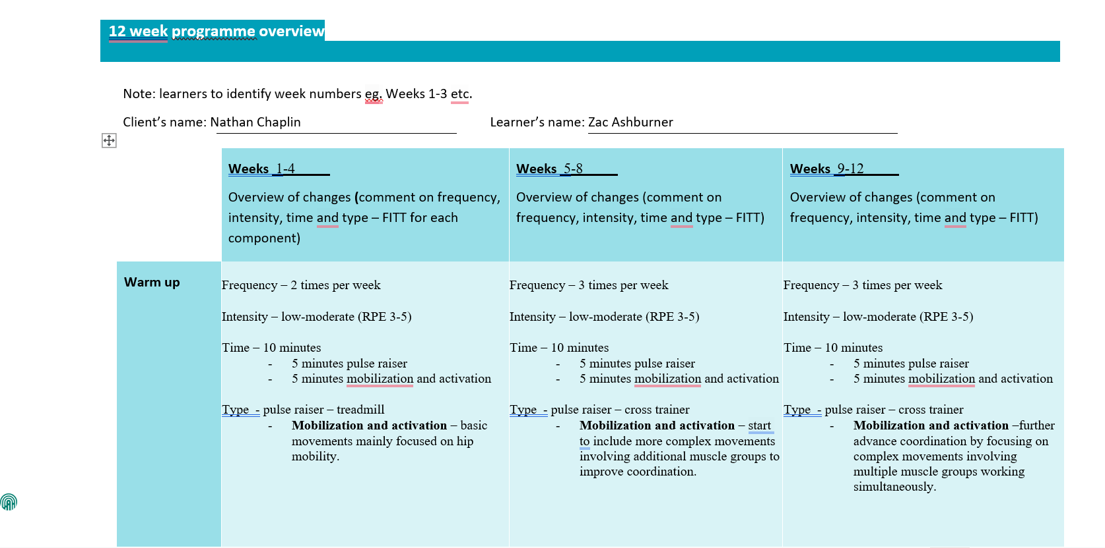

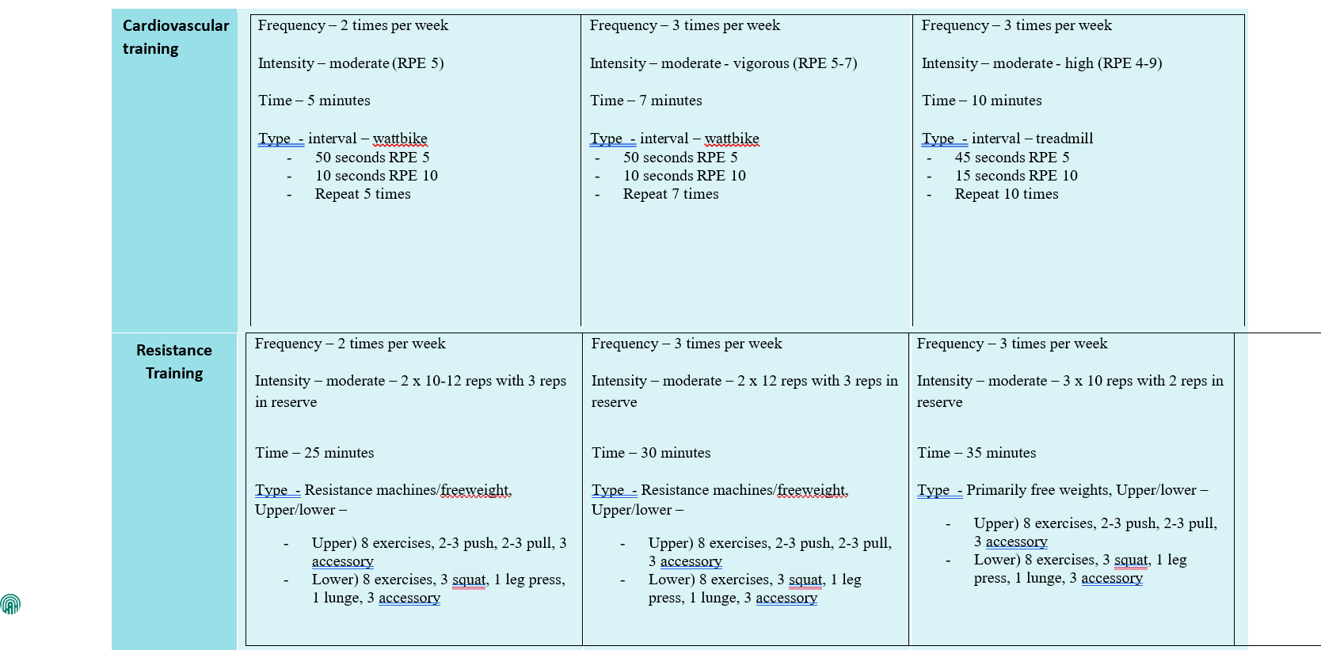

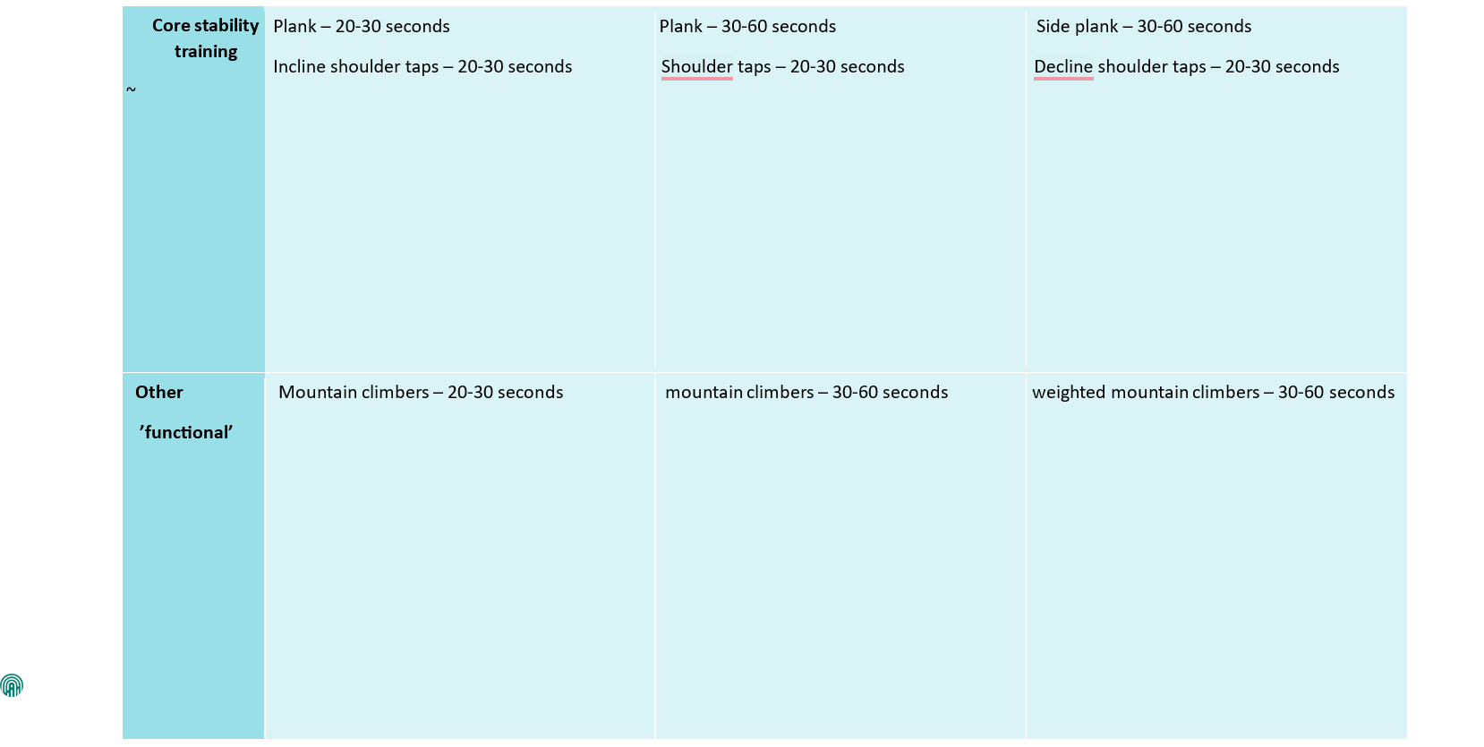
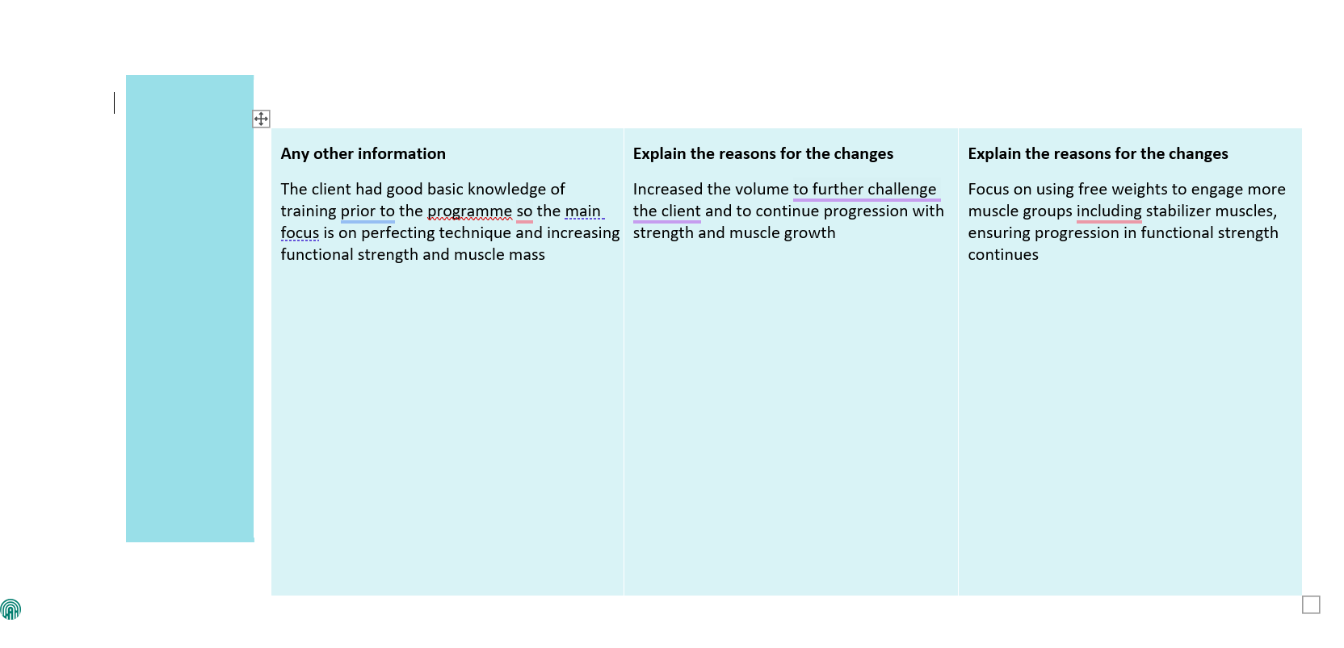

Appendix C
Session 1
Learner Name: Zachary Ashburner
Client Name: Nathan Chaplin
Session Objective: Upper body strength and hypertrophy
Warm up
Overview of content (including mobility, pulse raising (CV machine) | Equipment and duration | Level/speed | RPE (1-10) | Adaptation(s) or alternatives
Incline walking – steeper gradient promotes hip mobility | Treadmill – 5 minutes |  | 5 | Static bike – increases heart rate and promotes hip mobility while reducing strain on joints
Activation and Mobilisation Activities: Describe/draw activities in the space below
Leg Swings – using a wall or chair for support and standing side on, swing the outside leg forwards and backwards for 10-20 reps while keeping it straight and relaxed.

Hip circles – place hands on hips on and rotate in a circular motion for 10-20 reps both clockwise and anti-clockwise.

Lunges – with hands on hips, extend one leg forward and crouch until the rear knee touches the floor and push pelvis forward.

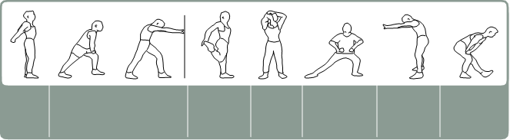
Cardiovascular training
Equipment and approach | Programme timings | Level/speed | RPE/HR | Adaptation(s) or alternatives
HIIT based static bike | 10 seconds maximum effort  50 seconds active recovery  Repeat x5 |  | 10/5 | Increase duration of maximum effort to increase difficulty
Resistance training
Exercise/machine | Resistance | Reps | Sets | Rest (seconds) | Adaptation(s) or alternatives
Deadlift |  | 10-12 | 2 | 60 | Can use rack pull to reduce range of motion and minimise lower body involvement
Barbell bent-over row |  | 10-12 | 2 | 60 | Increase the weight to increase the difficulty
Incline dumbbell bench press |  | 10-12 | 2 | 60 | Use incline machine press if preferred
Lat pull down |  | 10-12 | 2 | 60 | Swap for pull up to increase difficulty
Dips |  | 10-12 | 2 | 60 | Add weight to increase the difficulty
Barbell curl |  | 10-12 | 2 | 60 | Swap for dumbbells to improve unilateral movement
Overhead extension |  | 10-12 | 2 | 60 | Swap for cables if preferred
Hammer curl |  | 10-12 | 2 | 60 | Swap for cables if preferred
Body weight exercise |  |  | Sets/reps/rest
plank |  |  | 20 seconds/40 seconds rest x3
Shoulder taps |  |  | 20 seconds/40 seconds rest x3
Mountain climbers |  |  | 20 seconds/40 seconds rest x3
Cool down/flexibility
Cool down (if a re-warm or pulse lowering phase is required please detail in the space below)
CV machine | Time and intensity range
Treadmill or static bike | 5 minutes @ RPE of 5/10
Post-workout stretches (circle as applicable) - indicate which stretches are maintenance (M) and which are developmental (D)
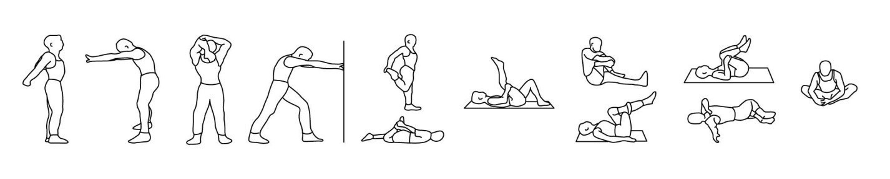
Notes

Session 2
Learner Name: Zachary Ashburner
Client Name: Nathan Chaplin
Session Objective: Lower body strength and hypertrophy
Warm up
Overview of content (including mobility, pulse raising (CV machine) | Equipment and duration | Level/speed | RPE (1-10) | Adaptation(s) or alternatives
Incline walking – steeper gradient promotes hip mobility | Treadmill – 5 minutes |  | 5 | Static bike – increases heart rate and promotes hip mobility while reducing strain on joints
Activation and Mobilisation Activities: Describe/draw activities in the space below
Leg Swings – using a wall or chair for support and standing side on, swing the outside leg forwards and backwards for 10-20 reps while keeping it straight and relaxed.

Hip circles – place hands on hips on and rotate in a circular motion for 10-20 reps both clockwise and anti-clockwise.

Lunges – with hands on hips, extend one leg forward and crouch until the rear knee touches the floor and push pelvis forward.

Cardiovascular training
Equipment and approach | Programme timings | Level/speed | RPE/HR | Adaptation(s) or alternatives
Treadmill steady state | 10 minutes continuous |  | 7 | Increase incline or speed to increase the difficulty

Resistance training
Exercise/machine | Resistance | Reps | Sets | Rest (seconds) | Adaptation(s) or alternatives
Squat |  | 10-12 | 2 | 60 | Can use front squat to engage different muscles
Leg press |  | 10-12 | 2 | 60 | Increase the weight to increase the difficulty
Squat press |  | 10-12 | 2 | 60 | Advance to RDL to incorporate additional weight
Goblet squat |  | 10-12 | 2 | 60 | Swap for pistol squat to incorporate balance
Lunges |  | 10-12 | 2 | 60 | Add weight to increase the difficulty
Leg extension |  | 10-12 | 2 | 60 | Increase the weight to increase the difficulty
Leg curl |  | 10-12 | 2 | 60 | Increase the weight to increase the difficulty
Standing calf press  (smith machine) |  | 10-12 | 2 | 60 | Use free weight to incorporate balance
Body weight exercise |  |  | Sets/reps/rest
plank |  |  | 20 seconds/40 seconds rest x3
Shoulder taps |  |  | 20 seconds/40 seconds rest x3
Mountain climbers |  |  | 20 seconds/40 seconds rest x3
Cool down/flexibility
Cool down (if a re-warm or pulse lowering phase is required please detail in the space below)
CV machine | Time and intensity range
Treadmill or static bike | 5 minutes @ RPE of 5/10
Post-workout stretches (circle as applicable) - indicate which stretches are maintenance (M) and which are developmental (D)
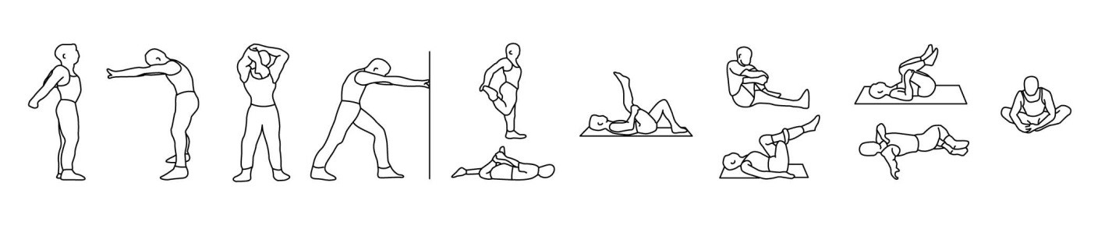
Notes

Session 3
Learner Name: Zachary Ashburner
Client Name: Nathan Chaplin
Session Objective: Upper body strength and hypertrophy
Warm up
Overview of content (including mobility, pulse raising (CV machine) | Equipment and duration | Level/speed | RPE (1-10) | Adaptation(s) or alternatives
Incline walking – steeper gradient promotes hip mobility | Treadmill – 5 minutes |  | 5 | Static bike – increases heart rate and promotes hip mobility while reducing strain on joints
Activation and Mobilisation Activities: Describe/draw activities in the space below
Leg Swings – using a wall or chair for support and standing side on, swing the outside leg forwards and backwards for 10-20 reps while keeping it straight and relaxed.

Hip circles – place hands on hips on and rotate in a circular motion for 10-20 reps both clockwise and anti-clockwise.

Lunges – with hands on hips, extend one leg forward and crouch until the rear knee touches the floor and push pelvis forward.

Cardiovascular training
Equipment and approach | Programme timings | Level/speed | RPE/HR | Adaptation(s) or alternatives
HIIT based static bike | 10 seconds maximum effort  50 seconds active recovery  Repeat x5 |  | 10/5 | Increase duration of maximum effort to increase difficulty

Resistance training
Exercise/machine | Resistance | Reps | Sets | Rest (seconds) | Adaptation(s) or alternatives
Bench press |  | 10-12 | 2 | 60 | Can use dumbbell bench press if preferred
Barbell bent over row |  | 10-12 | 2 | 60 | Increase the weight to increase the difficulty
Incline dumbbell bench press |  | 10-12 | 2 | 60 | Use incline machine press if preferred
Lat pull down |  | 10-12 | 2 | 60 | Swap for pull up to increase difficulty
Dips |  | 10-12 | 2 | 60 | Add weight to increase the difficulty
Military press |  | 10-12 | 2 | 60 | Swap for dumbbells to incorporate balance and coordination
Lat raise |  | 10-12 | 2 | 60 | Swap for cables if preferred
Reverse dumbbell fly |  | 10-12 | 2 | 60 | Swap for cables if preferred
Body weight exercise |  |  | Sets/reps/rest
plank |  |  | 20 seconds/40 seconds rest x3
Shoulder taps |  |  | 20 seconds/40 seconds rest x3
Mountain climbers |  |  | 20 seconds/40 seconds rest x3
Cool down/flexibility
Cool down (if a re-warm or pulse lowering phase is required please detail in the space below)
CV machine | Time and intensity range
Treadmill or static bike | 5 minutes @ RPE of 5/10
Post-workout stretches (circle as applicable) - indicate which stretches are maintenance (M) and which are developmental (D)
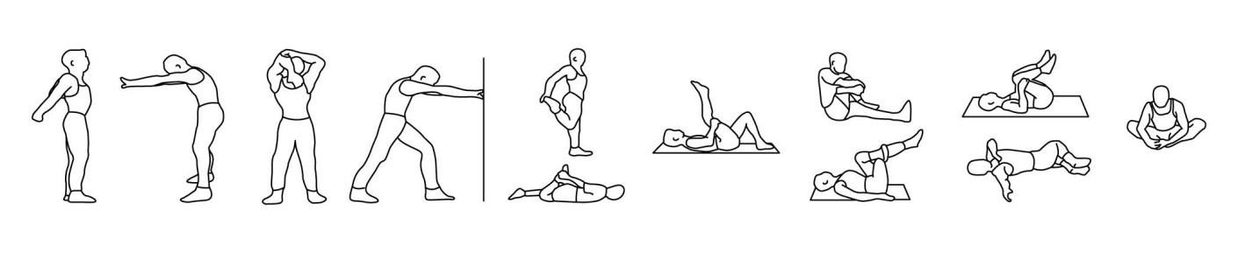
Notes

Appendix D

Session review (3 implemented sessions)

Learner’s name: Zac Ashburner

To be completed after each of the 3 implemented sessions.

Date | Session1: | Upper body 1 | Session 2: | Lower body | Session 3: | Upper body 2
After my sessions, I received the following feedback from the client:
Session 1
Nathan responded well to the session structure and appreciated the focus on form and controlled tempo, especially during compound lifts like the deadlift and incline dumbbell press. He mentioned slight fatigue during dips and barbell curls but managed to complete the reps with good technique. He enjoyed the activation/mobilisation phase, stating it helped him feel better prepared for the workout. He suggested incorporating more rest between sets next time for heavier lifts.

Session 2
Nathan found this session particularly challenging but rewarding. He noted tightness in his hamstrings during the RDL variation and showed some fatigue toward the end of the resistance circuit. The goblet squats were a highlight, as he appreciated the balance component. He liked the steady-state cardio as a way to pace into the session. He requested more calf-focused work in future sessions, and also asked if more glute activation exercises could be introduced during warm-ups.

Session 3
Nathan expressed increased confidence during this session, especially with exercises like the bench press and military press. He mentioned the HIIT section on the bike was intense but energising and liked how it was programmed at the start to “get him in the zone.” The shoulder work (lat raise, reverse fly) felt effective but taxing by the second set. He asked for form feedback during dips and lat pull-downs and appreciated the corrections. The session left him feeling accomplished and eager to keep progressing.

My sessions met the client’s needs in the following ways:
(comment on the effectiveness of your exercises, relationship with the client, how you communication style motivated the client and how well the programme matched the client’s needs and goals)
Session 1
This session was focused on upper body strength and hypertrophy. The exercises selected—such as deadlifts, incline dumbbell bench press, and bent-over rows—were effective in targeting the major upper body muscle groups. The client responded well to compound movements, and modifications like rack pulls allowed us to manage lower back stress while still building posterior chain strength. My communication style during this session was clear and encouraging, which helped establish trust and set the tone for future sessions. The client was motivated and engaged throughout, responding positively to structured progression and feedback.

Session 2
The lower body session was designed to build leg strength and improve functional movement. Exercises like squats, goblet squats, lunges, and leg press addressed both strength and mobility. I included variations to accommodate Nathan's slightly limited hip mobility, and focused on form to prevent aggravation of his mild postural imbalances. The steady-state cardio was well tolerated and complemented the strength component without over-fatiguing the client. My coaching remained supportive, offering corrections and praise as needed, which helped keep Nathan focused and confident.

Session 3
This session mirrored the upper-body focus of Session 1 but introduced different exercises to maintain variety and stimulate different muscle fibres. For instance, bench press and military press were added for more horizontal and vertical pushing work, while dumbbell flys and lateral raises refined shoulder and back development. Nathan showed improvement in movement control and strength since Session 1, which suggested the plan was progressing well. I used positive reinforcement and detailed cueing to help fine-tune his technique, particularly in pressing and rowing movements.

With the information gathered from your client and your own evaluation of the sessions within the programme, explain how you will review the Personal Training programme and develop your own skills
Session 1
Feedback from Nathan indicated that the session structure was clear and enjoyable. However, he did mention mild stiffness in his lower back post-session. Based on this, I reviewed the volume and intensity of deadlifts and introduced rack pulls as a modified alternative. This taught me the importance of responsive programming. I plan to improve my skills in early fatigue management and progressive exercise regression to better accommodate first-session intensity.

Session 2
This session confirmed that Nathan responded well to lower body training and could handle more volume than initially expected. From this, I learned to be slightly more aggressive in progressive overload for lower body work in future weeks. I also improved my ability to teach squat mechanics, as Nathan required more technical feedback on alignment and depth. I will continue refining my cueing techniques and learn more about teaching unilateral exercises to address minor mobility asymmetries.

Session 3
Session 3 demonstrated a noticeable improvement in Nathan’s strength and endurance. He mentioned feeling more confident in his upper body movements, which affirmed the effectiveness of our approach. I also experimented with new communication techniques—such as using visual demonstration alongside verbal cues—which seemed to increase his understanding and execution. This made me more aware of individual learning styles. Going forward, I aim to develop my ability to adapt communication and teaching methods to suit different clients.

I (the client) agree with the above changes to personal training sessions and agree that they are appropriate to my needs.

Client’s signature: Date:

Learner’s signature: Date:

Appendix E



