
University of Wales Trinity Saint David
School of Computing

18/01/2023/ACCA7002
Assignment 2

Database Systems

By Elanwy Evans (Student ID 1300155)

Abstract

This report will compare a traditional relational database management system (RDBMS) with different NoSQL database models and will provide use cases for each. It will aim to provide guidance to help Abertawe Entertainment decide which type of database is most suitable. Lastly, a demonstration of a NoSQL document database and a RDBMS PostgreSQL database will be provided to aid their decision.

Table of Contents
NoSQL vs Relational Databases 3
Different NoSQL Models 5
Key-value Database Model 5
Document Database Model 5
Graph Database Model 6
Wide Column Database Model 7
Choosing which Database to Use 7
Conclusion 9
Bibliography 10
Appendix 11

NoSQL vs Relational Databases

In the last three decades we have seen a huge shift towards the use of Web-based services which has and continues to involve the management of large amounts of data. At present, user data can scale to many terabytes daily, which need to be accessed at high speeds by millions of people across the world [1].

RDBMS have been used since the 1970s, however due to storage limitations within Web-oriented systems, researchers and companies have had to consider alternative ways of storing user data [1]. This is when NoSQL databases came into existence.

RDBMS are single-node systems which scale vertically, which means that they only have a limited storage capacity within a central server. To increase this capacity, more RAM or disk space must be added, however this can create performance issues as joins and transactions are costly and inefficient in a larger distributed system such as this [2]. Alternatively, the database can be transferred to a new server with upgraded hardware, however storage space would still be restricted, and performance would inevitably deteriorate as the database and associated queries expand [3]. Another limitation of vertical scaling is that the database only exists on a single server, so if it breaks down, you cannot access any of the data until its functionality is restored [1].

In contrast, NoSQL databases scale horizontally, so in theory, there is no limit to the amount of data you can store and query performance is generally faster [3]. Large datasets can be distributed across multiple different nodes (i.e. local and/or remote servers) using a method known as sharding/partitioning. Records are split into independent shards, meaning that each node is responsible for storing a different section of the database. A method called ‘replication’ can also be used, where data records from one server are replicated and the mirrored data gets stored in a separate server. This increases data availability i.e. in the event that a node goes down, but at the expense of data storage [1]. This can also be a disadvantage if the mirror image is updated synchronously, e.g. if a request is made to a mirrored server which doesn’t yet have all the up-to-date information, there will be a delay in response time. This can be performed asynchronously, but it increases the risk of data loss if the system crashes [4]. Though horizontal scalability may appear to be a solution to many problems, the CAP theorem demonstrates that when sharding takes place, designers must choose between higher availability or strict consistency. Prioritising availability over consistency is an approach known as BASE (Basically Available, Soft-state and Eventually Consistent), which is less desirable if data integrity is the company’s main concern [3].

RDBMS are schema-based (see figure 2), which means that the structure of the database along with relationships must be identified before it can be populated with data [3]. The schema design must be perfected at the beginning, as once the data is added, it becomes very difficult to change the structure retrospectively. The advantage of a structured, schema-based database is that, if normalized correctly, it ensures data integrity. Linking entities together via their primary and foreign keys enforces limitations on the type of data that can be entered and reduces the amount of redundant data and repetition i.e. if a change is made to a record that is referenced by another table, the data will also be updated there automatically. As each column can only accept a single datatype, it also reduces the likelihood of injection of irrelevant data. The downfall is that normalisation can be complicated and requires skilled personnel to ensure the database structure is appropriate. If done incorrectly, there is a risk that some data will become redundant and/or inaccessible [1]. It also becomes increasingly difficult and costly to maintain relationships when dealing with a large database containing many entities.

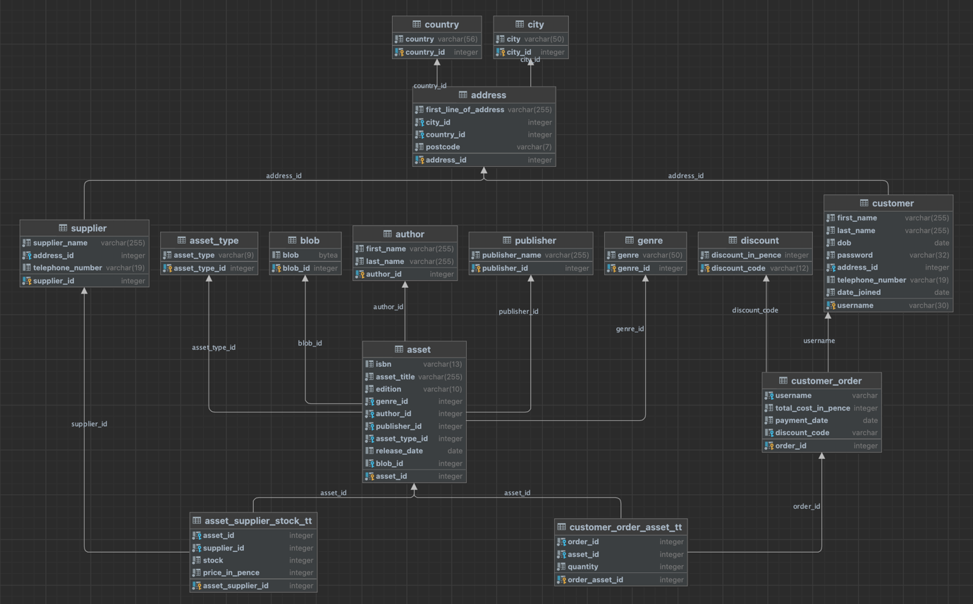
Figure 2: RDBMS Schema Designed for Abertawe Entertainment

NoSQL databases are much more flexible as they are mostly schema-less, meaning their structures are malleable and can easily be modified retrospectively. They are multi-model databases that support the use of many different datatypes simultaneously. As they are generally unstructured and denormalized, they are easier to navigate and developers can learn to use them relatively quickly. However, their denormalized structure increases data redundancies by data repetition, which inevitably reduces data integrity. [1]

RDBMS support the use of sophisticated queries which are arguably simpler to write as most developers have basic SQL skills. As opposed to some NoSQL models, it is possible to find data without specifying the primary key(s) e.g. ‘show all books with a price of less than £3’. However, the bigger the database and the more complex the query, the slower the response. In contrast to NoSQL databases, RDBMS support highly ACID (atomicity, consistency, isolation, durability) transactions, making it easier to manage concurrent access [4].

Lower-level NoSQL database commands and queries are often perceived to be more complicated to write as they must be written in a specific programming language. Some programmers would argue that this is more difficult than writing SQL queries, as many programmers have had some level of exposure to SQL, but may be less familiar with NoSQL query languages [4]. Though they have their limitations, they deliver results quickly when dealing with large datasets [3].

Different NoSQL Models

There are 4 main NoSQL data models which include document, graph, key-value and wide column. These different models can be used simultaneously within a single database, meaning you don’t have to create multiple databases which include the same data.

Key-value Database Model

This is the simplest type of NoSQL database which works similarly to a hash table (see figure 3), but the key-value pairs are distributed amongst different shards [1]. As opposed to relational databases, the values can be of multiple different types such as integers, JSON, lists, BLOB etc and can be stored as integers, strings, JSON or arrays. Key-value stores do not have a definitive query language and the values can only be accessed by querying the primary keys [5]. Despite these limitations, the queries are fast and effective. Key-value databases are generally used when an application is presented with continuous read and writes, as the data can be accessed quickly. It supports insert, delete and lookup operations and is often used to store basic information such as customer details or the contents of a shopping basket [4]. They can also be used to manage player sessions in large-scale online games, for large-scale session management, to cache data for fast response retrievals and for product recommendations. They are not suitable for applications that depend on complicated queries or need continuous updates [5].
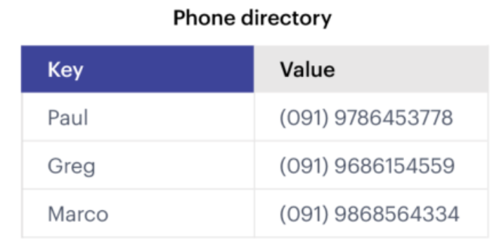
Figure 3: Example of a Key-Value Database [5]

Document Database Model

A document database is similar to a key-value database, but the key is the document ID and the value is the data within that document (in JSON/BSON format) (see figure 4). Key-value databases can only be queried via their keys, whereas document databases can be queried on multiple attribute value constraints [4]. However, a new index must be created for each type of query as elements are indexed by their document IDs [1]. In contrast to a relational database, a document database is commonly used for applications that don’t require data to be in a tabular format and when dealing with multiple different data types. It also differs to RDBMS as the number of fields do not need to be determined at the database design stage, thus allowing the creation of additional fields at any point. The equivalent method in RDBMS is significantly more complicated as it would involve changing the existing schema by creating new tables, managing new relationships between tables and changing all rows in the database [1]. It is best suited for applications that utilise CRUD (create, read, update, delete) operations and/or frequent reads and writes requiring fast in-memory access. Use cases include user profiles, electronic commerce and middleware that utilises JSON [6]. The drawback of document databases is their limited concurrency and atomicity when compared with traditional RDBMS that are ACID-compliant [4].

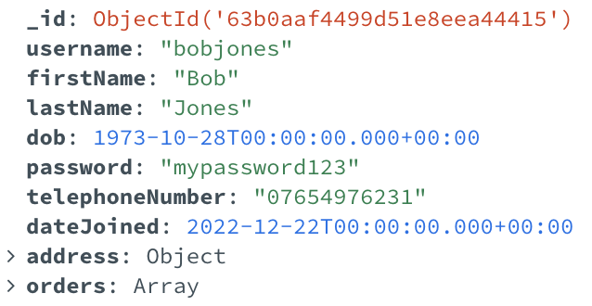
Figure 4: Layout of BSON Key-value Pairs within a Document Database (MongoDB) Designed for Abertawe Entertainment

Graph Database Model

A graph database stores data within nodes in a graphical structure (see figure 5), rather than using rows and columns in tables (as in RDBMS). They are multidimensional and relationships between data are depicted by connecting arrows between different nodes. They are the most ACID-compliant NoSQL database model [7]. Some argue that they are not true NoSQL databases [8] as they do not fully conform with the unstructured nature usually found in other NoSQL models. However, they are schema-less and can be modified much more easily than an RDBMS [1]. They are useful when you need to identify relationships between data, when dealing with many-to-many relationships and when low latency is required whilst dealing with large datasets. They are commonly used in applications that make suggestions or recommendations e.g. recommended friends on social media or suggested products based on previous purchases. Other use cases include fraud detection, network mapping, social networks and master data management [8]. A recent use case would be contact tracing and analysis of disease patterns, as data can be gathered on individuals who have tested positive for an illness, the locations they have visited & their close contacts. By identifying these connections, data analysts can pinpoint high-risk areas and prevent further outbreaks [9].

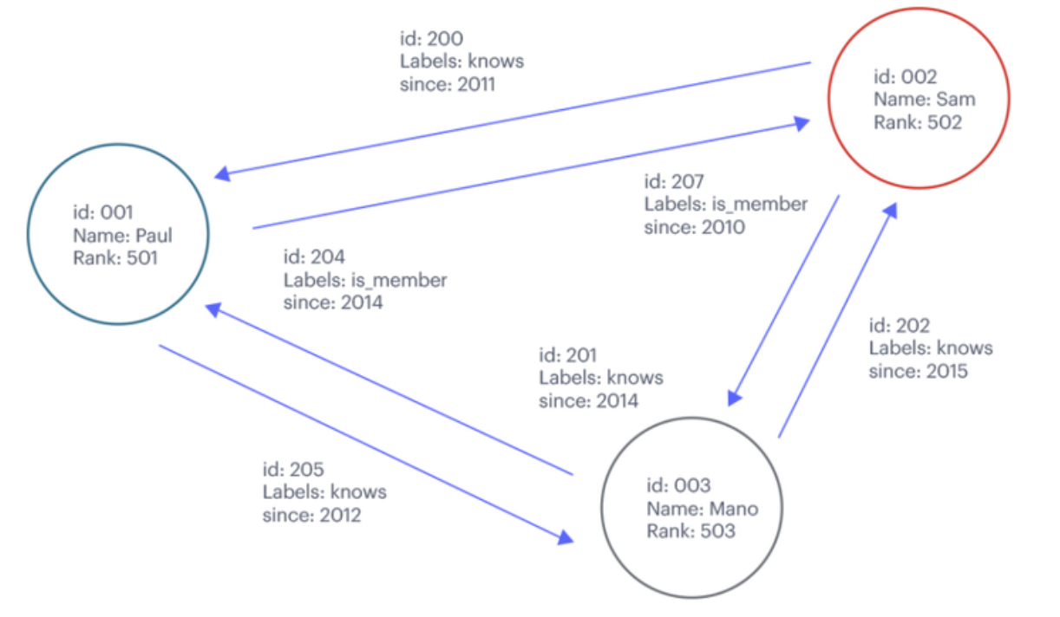
Figure 5: Example of a Graph Database [8]

Wide Column Database Model

Wide column databases save data by columns as opposed to rows seen in RDBMS (see figure 6). Both database types have similar schemas, however wide column database schemas are more dynamic and rows are not restricted. Columns that are unlikely to be queried together can be segregated and stored in separate nodes [1]. If the columns are related, they are grouped into column families which are physically segregated from other column families. Their column-oriented structure makes a wide column database easy to query and is optimised to retrieve data quickly from large datasets. They are also useful when there is a requirement for intensive and/or complex querying. As well as being infinitely scalable, they are effective at compressing data which saves storage [10]. Use cases include attribute-based data and analytical processing. It is less suitable for writing operations, such as adding a row of user data, since accessing multiple columns would be resource-intensive [11].

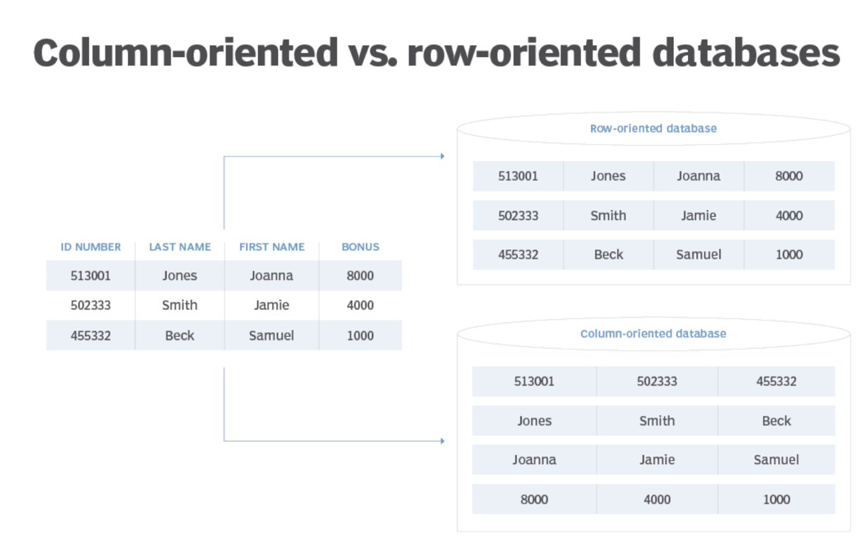
Figure 6: Comparison of Column-Oriented and Row-Oriented Databases [10]

Choosing which Database to Use

Before choosing which database to use, several factors must be considered:
- The size of the dataset
- The type and structure of the data
- The complexity and performance of queries
- The requirement for low latency and high availability
- The requirement for ACID compliance

This information can then be used to model the dataset and match it to the most appropriate database. NoSQL databases are difficult to model as they can exist in various different forms and have different characteristics, therefore there is no standardized method for the modelling process. RDBMS are easier to model, as standardized approaches such as ER (entity relationship) diagrams can be followed, however the normalization and dealing with many-to-many relationships introduce an additional layer of complexity [3].

- The Size of the Dataset
A NoSQL database might be more favourable if a company intends to handle huge masses of data that is likely to grow exponentially. Due to its horizontal scalability, storage space can be expanded when required and it is much cheaper to expand horizontally than vertically. A RDBMS can still handle large amounts of data, but should not be chosen if the company plans to scale up and/or anticipates frequent changes to the database in the near future [12]. As Abertawe Entertainment are looking to expand across Wales in the near future, a NoSQL database might be more suitable, especially if they are planning on expanding even further in the future.

- The Type and Structure of the Data
When dealing with large amounts of unstructured/qualitative data such as text files, multimedia, mobile data, surveys and sensor data, a NoSQL database is preferable [13]. Abertawe Entertainment are aiming to provide short stories in text, digital and audiobook format which are considered unstructured data. However, a significant proportion of the data is structured, such as title, author, genre, publisher, release date, price and stock amount, which would suit a RDBMS. NoSQL databases allow you to store an endless number of data types in the same location, providing flexibility for companies that may want to introduce different data types in the future [12]. If Abertawe Entertainment are looking to expand their digital footprint even further by offering more types of multimedia, a NoSQL database is likely to be most suitable.

- The Complexity and Performance of Queries
If a large number of simple queries are required, a horizontally scaled database is the best option as it’s fast and cost effective. However, as mentioned previously, developers tend to find NoSQL queries more difficult to write and must also understand a variety of different data structures [14]. If the queries are complex and involve joins between tables, it is better to use a RDBMS [15]. As Abertawe Entertainment want to be able to record transactions detailing a customer’s purchase(s), this would likely involve queries with joins to access asset, customer and stock information, making a RDBMS more suitable. However, due to its flexible nature, a document database could be structured in such a way that all the information required is stored within the same document collection, eliminating the requirement for joins. Either database would therefore be suitable.

- The Requirement for Low Latency and High Availability
NoSQL databases tend to achieve high availability and low latency but are less ACID-compliant as a result [7]. If low latency is preferable over ACID compliance, a NoSQL database is a better choice. Each record in a NoSQL database is independent and several queries can be run simultaneously regardless of the size of the dataset, but at the expense of data integrity. The data is also highly available as it gets distributed and replicated horizontally amongst several servers, allowing the data to be accessed if a node breaks down. As RDBMS utilise a single server, if it breaks, there is no way to access the data until it is fixed [3]. Latency should not be an issue for Abertawe Entertainment as it does not currently need to manage big data, but high availability would provide confidence that customer and asset information is always accessible. However, ACID-compliance is likely to be the top priority for the company, therefore an RDBMS would be a good choice [12].

- The Requirement for ACID Compliance
Some companies must prioritise atomicity to ensure that a transaction is considered either successful or unsuccessful, rather than partially complete e.g. if money is being transferred from account X to account Y, the amount should be taken from one account and added to the other. For the transaction to succeed, both operations must take place [12]. If unsuccessful, the expectation is that these isolated operations will consistently roll the data back to their previous state, preventing dirty reads. The durability aspect ensures that any changes made are permanent, even in the event that the system fails. ACID RDBMS are especially important when dealing with financial transactions, for example in online banking applications [7].
If ACID transactions are not a requirement and occasional inconsistencies are acceptable, a NoSQL database is likely to be the better option. However, as Abertawe Entertainment are going to be recording and updating stock levels and order details, transactions will need to be ACID-compliant to avoid the risk of partially completed orders/stock levels not being updated. Therefore, a RDBMS would be recommended to ensure better data integrity.

Conclusion

To conclude, based on Abertawe Entertainment’s requirements, ACID transactions should be considered their top priority. The customer order audit table created as part of the RDBMS example database gets populated automatically once an order has been placed, then the stock in the asset table also gets updated automatically. To ensure these details are captured correctly, the transactions need to be ACID, therefore a RDBMS would be the best choice. As the company is only looking to expand across Wales, a vertically scaled RDBMS would be sufficient to handle their data and simple queries. If a NoSQL database is preferred, a Graph database is likely to be the best option as it’s the most ACID-compliant.

Word count: 2853

Bibliography
[1] A. Corbellini, C. Mateos, A. Zunino, D. Godoy, and S. Schiaffino, “Persisting big-data: The NoSQL landscape,” Information Systems, vol. 63, pp. 1–23, Jan. 2017, doi: 10.1016/j.is.2016.07.009.

[2] M. Stonebraker and R. Cattell, “10 rules for scalable performance in ‘simple operation’ datastores,” Communications of the ACM, vol. 54, no. 6, pp. 72–80, Jun. 2011, doi: 10.1145/1953122.1953144.

[3] H. Vera-Olivera, R. Guo, R. C. Huacarpuma, A. P. B. Da Silva, A. M. Mariano, and M. Holanda, “Data Modeling and NoSQL Databases - A Systematic Mapping Review,” ACM Computing Surveys, vol. 54, no. 6, pp. 1–26, Jul. 2021, doi: 10.1145/3457608.

[4] R. Cattell, “Scalable SQL and NoSQL data stores,” ACM SIGMOD Record, vol. 39, no. 4, p. 12, May 2011, doi: 10.1145/1978915.1978919.

[5] Redis, What is a Key-Value Database? [Online]. Available: https://redis.com/nosql/key-value-databases/

[6] Redis, What is a Document Database? [Online]. Available: https://redis.com/nosql/document-databases/

[7] D. Ganesh Chandra, “BASE analysis of NoSQL database,” Future Generation Computer Systems, vol. 52, pp. 13–21, Nov. 2015, doi: 10.1016/j.future.2015.05.003.

[8] Redis, What is a Graph Database? [Online]. Available: https://redis.com/nosql/graph-databases/

[9] Oracle, (2021), 7 Use Cases for Graph Databases and Graph Analytics. [Online]. Available: https://www.oracle.com/a/ocom/docs/graph-database-use-cases-ebook.pdf

[10] A. Williams, (2021), 7 Use Cases for Graph Databases and Graph Analytics. [Online]. Available: https://www.techtarget.com/searchdatamanagement/tip/NoSQL-database-types-explained-Column-oriented-databases

[11] Shivang, Wide-column Database, Column Databases – A Deep Dive. [Online]. Available: https://scaleyourapp.com/wide-column-and-column-oriented-databases/

[12] D. Tobin, (2021), Which Modern Database Is Right for Your Use Case? [Online]. Available: https://www.integrate.io/blog/which-database/

[13] Mongo DB, Examples of Unstructured Data. [Online]. Available: https://www.mongodb.com/unstructured-data/examples

[14] R. Edwards, (2021), NoSQL Use Cases: When to Use a Non-Relational Database. [Online]. Available: https://datastax.medium.com/nosql-use-cases-when-to-use-a-non-relational-database-c05025aabd30

[15] N. Silnitsky, (2021), How to choose the right database for your service. [Online]. Available: https://medium.com/wix-engineering/how-to-choose-the-right-database-for-your-service-97b1670c5632

Appendix

As MongoDB does not permit comments, this appendix will describe and justify the design of the example MongoDB database. For the SQL database, comments have been added throughout the .sql file.

4 collections were created: asset, blob, customer & supplier. I created significantly fewer collections compared with the number of tables I created in the RDBMS as the data didn’t need to be normalized. Most details could therefore be recorded in the asset collection.

I created a separate blob collection as, in a real-life database, blobs take up a lot of storage space which could potentially slow down queries. Each asset within the asset collection references the unique object id of its corresponding blob in the blob collection (if applicable). FYI: no real blobs have been added to the blob collection as the brief states that this is not a real-world implementation scenario.

I placed supplier in a separate collection as each supplier has its own list of details which are independent from the assets. It is also more readable as it reduces the number of embedded objects within each document (as each document in the asset collection just references the supplier object id, rather than the name, address and phone number).

Each transaction is recorded within each customer’s ‘orders’ section. Each document within the customer collection contains the customer details, unique order ids and all the assets they have purchased.

