

Master of Business Administration

Human Capital Management (LCMB7023)

Assessment component 1: Individual report – HR strategy

Student Name - Deepa Sureshbhai Suthar

Student ID - 2523541

Lecturer Name - Dr. Lakshani Mendis

Word Count - 2410

Submission Date - 19 March 2026

Table of Contents
Introduction 3
Part 1: Re-Engineering Performance & Job Design 3
Performance appraisal and job design approaches 3
A modern, growth-focused system of performance appraisal 4
Job analysis 5
Proposed job descriptions and job specifications for key positions 6
Connection of the Two Systems to create a performance-driven culture 7
Part 2: Reflection 8
Reflection on learning journey using the Gibbs Reflective Cycle 8
Staying relevant in an AI-driven workplace 11
Conclusion 12
References 13

Introduction
Aether Innovations is a fast-growing technology company with about 300 employees but is having a number of organizational issues such as stagnant growth, high employee turnover and deteriorated customer satisfaction. Such problems tend to reflect a vulnerability of human resource management systems especially in performance management systems and job design. By focusing on the HR practices as parts of the strategic planning, organizations can greatly enhance the resilience and competitiveness (Yu et al., 2022, p. 508). Thus, the proposed report is an integrated human capital strategy of Aether innovation with the redesign of the performance appraisal and innovative job design to reconstruct the engagement, innovation, and customer value based on the contemporary practices of HR.

Part 1: Re-Engineering Performance & Job Design

Performance appraisal and job design approaches
Historically, the technology companies were accustomed to annual review-based performance appraisal system and manager-based performance appraisal system and traditional productivity measures such as output, speed of coding or project completion. Despite the systems being a structured to evaluate employees, it lacked dynamism and co-operative way of working in technology companies. Nastase et al. (2025, p. 23) admit the fact that businesses that survive in the digital era must discard the outdated appraisal strategies in favor of the flexible performance system of management that encourages continuous feedback and adaptability. Poljašević et al. (2025, p. 94) also add that a number of big technology firms such as Google and Microsoft were switching to the continuous performance talks that replaces the one-year performance review with the idea that in an innovate-driven culture, employee goals and business priorities should often be aligned.
Regarding job design, the traditional technology organization has traditionally adopted specialized roles in which employees work in the development, operations, or support team and have limited tasks they can perform. Although specialization can make workers more efficient, it can also lead to a loss of employee independence and innovativeness. Research by Wang et al. (2024, p.230) also reveals that the organizations that embrace high-performance work systems where emphasis is put on autonomy, the use of skills, and collaboration are more likely to achieve high levels of innovation. The trend of modern technology companies is to employ cross-functional teams, project-based positions, and flexible employment systems, which promote experimentation and exchange of knowledge. An example of these structures is the squad-based organizational structure of companies such as Spotify that enable employees to make independent decisions when carrying out projects that are aligned with the overall strategic plan.

A modern, growth-focused system of performance appraisal
A modern performance appraisal system is proposed to operate with the 360-degree feedback to handle the current performance issues of Aether Innovations. In this method, the performance feedback is gathered considering various sources as opposed to the managerial review alone (see Figure 1). In an organizational setting that is technology-based, collaborative and cross-functional team work is vital, then performance is best realized in terms of co-workers, supervisors, and stakeholders in which the employee works with on a daily basis. Chali and Lakatos (2024) explain that participatory evaluation systems enhance the level of engagement and organizational performance since they promote transparency, accountability, and ongoing improvement.
At Aether Innovations, 360-degree feedback would enable employees to obtain structured feedback provided by the supervisors, peers, subordinates, and even clients in case needed. This is because the method of evaluation is holistic and gives a better insight into the strengths that employees have, what they need to improve on, and their contribution to team innovations (Al-jaber et al., 2025). An illustrative example is a soft developer who could have feedback on deadline performance given by project manager, cooperation by other developers and quality of the code by product testers. Such a system stimulates the employees to enhance their communication and teamwork and problem-solving abilities, which are necessary in technology organizations.
Figure 1 360-degree feedback Performance Appraisal System for Aether Innovations
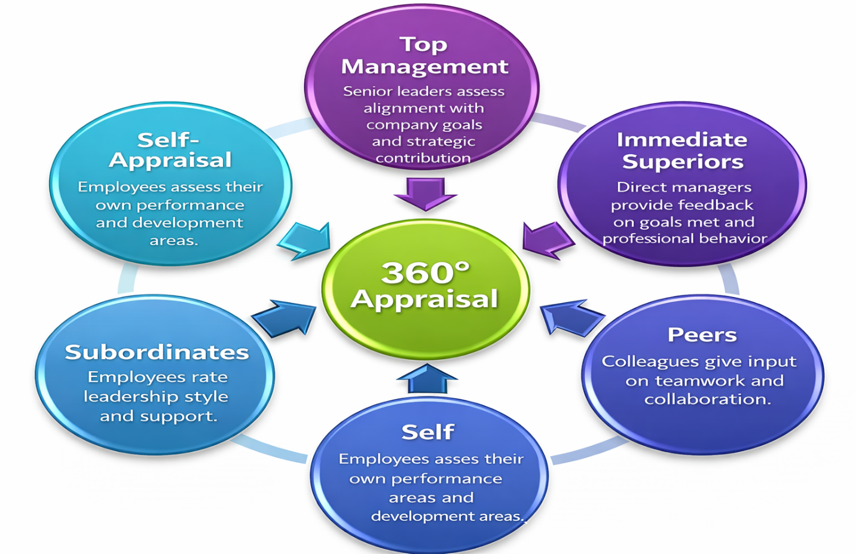
Source: Self-Made using Microsoft PowerPoint

Job analysis
Job analysis is a systematic process as it identifies tasks, work, expertise and abilities required in a job. In Aether Innovations, the analysis of the job needs to be conducted in detail to ensure that the roles contribute to creativity, teamwork, and technological development. According to Alrashedi (2024), proper job analysis is the foundation of successful HRM practices so that the capabilities of the employees could be aligned with the organizational goals (p. 5250). The job analysis of Aether innovations would involve the collection of information about the job through interviewing the employees, observing the work processes, and analyzing the available performance data. This will assist in establishing the most important skills such as digital literacy, innovation, teamwork, and problem-solving skills that should be in the technology-oriented organization. Re-engineering of jobs with more autonomy and skill variety would enable the company to improve employee engagement and motivation as well as promote innovation.

Proposed job descriptions and job specifications for key positions
The table below shows the suggested job description and job specification of six major leadership positions at Aether Innovations. These positions are designed based on the Job Characteristics Model that focuses on skill variety, task importance, autonomy, feedback, and creativity opportunities.
Table 2: Job Descriptions and Specifications
Position | Job Description | Job Specifications
CEO (Chief Executive Officer) | - Provides strategic leadership  - Drives company vision  - Ensures alignment between innovation and business strategy | - Extensive leadership experience  - Strategic decision-making ability  - Strong communication  - Innovation mindset
CFO (Chief Financial Officer) | - Manages financial strategy  - Budgeting  - Investment decisions  - Financial risk management | - Degree in finance/accounting  - Experience in technology industry finance  - Strong analytical skills
CTO (Chief Technology Officer) | - Oversees technological development  - Product architecture  - Engineering teams | - Advanced technical expertise  - Experience in software development leadership  - Knowledge of emerging technologies
CIO (Chief Innovation Officer) | - Leads innovation initiatives  - Identifies new technologies  - Promotes creative product development | - Expertise in innovation management  - Ability to lead cross-functional teams  - Research and development knowledge
HR Director | - Designs HR strategy  - Manages talent development  - Employee engagement  - Performance systems | - HRM qualification  - Leadership skills  - Expertise in talent management  - Organizational culture
Head of R&D | - Leads research projects  - Develops new products  - Coordinates experimental innovation initiatives | - Strong research background  - Technical expertise  - Ability to lead multidisciplinary teams

Connection of the Two Systems to create a performance-driven culture
A combination of performance appraisal systems and innovative job design provides a solid base of the performance-oriented organizational culture. Employees who are well aware of their duties and possess the freedom of choice in their job are more likely to produce significant results. The job design suggested will also give the employees a chance to apply various skills and make creative contributions towards organizational objectives. Meanwhile, the performance appraisal system will be used to make sure that such contributions are identified, quantified, and aligned to the company strategy.
It is established that those organizations in which strategic HR practices are combined with the performance management systems achieve higher results in terms of innovation and employee engagement. For example, Makumbe (2024) notes that the integrated HR systems enable the exchange of knowledge and innovation which ultimately result into improved performance within the organization. Similarly, Al Jaber et al. (2025, p. 8) emphasize that when the HR practices are in proper coordination, the well- being of the employees and future organizational development are achieved. The conglomeration of the existing appraisal techniques and the restructured jobs in the case of Aether Innovations will create the work environment wherein the employees will feel free to create, collaborate, and continuously advance the performance.

Part 2: Reflection

Reflection on learning journey using the Gibbs Reflective Cycle
The research on the strategic management of human resource in the context of this module has had a huge impact on my perception of how organizations can merge people management practices and business strategy. In modern-day organizations, especially technology companies like Aether innovations, HR has ceased to perform administrative duties and rather, it is a strategic entity in the pursuit of innovation, engagement of employees and organizational performance. Nastase et al. (2025) argue that strategic thinking and technological consciousness are the core attributes of HRM that needs professionals to keep up with the digital world. When I reflect upon my learning experience in terms of the Gibbs Reflective Cycle, I am able to evaluate critically how the information acquired in this module can be applied to my personal and professional growth.
Figure 2 Gibbs Reflective Cycle Applied to My Learning Journey
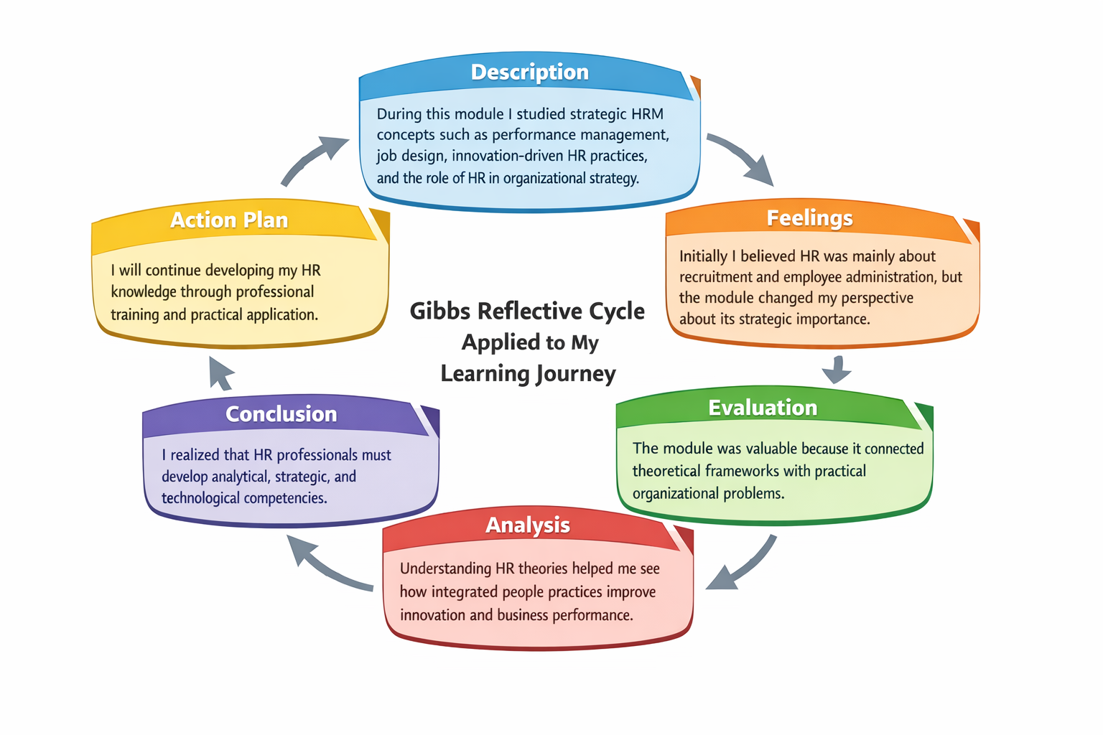
Source: Self-made using Canva
Description is the first step in the Gibbs cycle and entails finding the experience under reflection. In this module, I have studied some of the major concepts such as performance management systems, job design frameworks as well as the role of HR strategy in facilitating the growth of the organization. These issues made me realize that HR practices can affect innovation and engagement of employees. For instance, the analysis of high-performance work systems demonstrated the manner in which organizations can be able to increase employee motivation and productivity. Indeed, organizations that manage strategic HR systems are able to improve the performance of innovation considerably by boosting the intrinsic motivation of workers (Wang et al., 2024).
The second step is the assessing feelings connected with the experience. When I was starting the module, I perceived HR as a support activity dealing with recruitment and records of employees. However, later on in the module I started to value the strategic position of HR in determining the culture and performance of the organization. The studying of strategic HRM frameworks helped me to find out that HR professionals can help to make organizations become more competitive. This change in attitude made me more interested to acquire progressive HR skills and knowledge.
The third step in Gibbs cycle is evaluation, which entails good and bad aspects of learning. One of the most beneficial aspects of the module was an opportunity to look at the real-life organizational problems and apply the theory of HR to the real-life. One example is that the job design can be employed to motivate employees and through this learning, I came to realize that by redesigning job in relation to the company, Aether Innovations could improve innovation. However, one of the challenges was associated with the translation of the intricate HR theories into the practice management decision-making. Despite this obstacle, the learning experience helped me to develop my skills in the area of analysis and broaden my vision in terms of strategic HR management.
The fourth step is analysis, which entails searching on the reasons why the experience took place and the lessons that can be learned. I gained insights by reading research literature that I could enhance organizational resilience and long-term performance by becoming familiar with integrated HR systems. For example, Yu et al. (2022, p. 508) state that strategic HR practices contribute to the resilience of organizations as it helps companies to be adaptable to changes in the environment. This understanding made me realize the reason organizations invest in performance management systems, employee development programs and leadership training programs.
Gibbs cycle fifth stage is conclusion which aims at discovering what has been learnt through the experience. Through this module, I was informed that good HR management involves both theoretical and skills. HR professionals should have the capacity to ensure policies achieved the attainment of organizational goals and at the same time provided support to employees in terms of well-being and development. Teixeira (2025) points out that creative HR practices are needed by organizations in the quest to cope with the evolving economic and technological dynamics. This supports the need of constant learning among HR professionals.
The last will be the action plan which determines the way the learning experience will feed into future behavior. According to my reflection, I will continue to enhance my HR competence by participating in professional development programs like HR certification programs, workshops and network opportunities in the industry. I will also enhance my analytical and technological abilities in order to be able to participate in the process of decision-making that relies on data in HR. The ongoing learning process will enable me to enhance innovation and promote the growth mindset in myself and the organizations that I work.

Staying relevant in an AI-driven workplace
The fast development of artificial intelligence is changing numerous procedures of the contemporary work environment including human resource management. Organizational efficiency is being enhanced with technologies like automated recruiting systems, performance analytics systems, and AI-based learning systems becoming more and more popular. Although there are numerous benefits, the technologies also present the issue of job elimination and the future of human professionals. Singh et al. (2025, p. 3082) state that an organization that effectively uses emerging technologies to combine them with human expertise is in a better position to attain sustainable transformation.
Artificial intelligence is the supporting power that I will use in my future practice without eliminating human resource. For example, according to Bril et al. (2021), the HR can use AI to analyze huge data to identify the trends in employee performance, recruitment performance, and engagement. Such observations can guide the HR managers to adopt a superior decision on talent development and workforce planning. However, HR contains a significant number of elements that require human choice, emotionality, and moral judgment. The most significant components of the work of conflict resolution, acquiring leadership, and controlling the organizational culture, which the AI systems are unable to replicate, are the interpersonal skills that need humans.

Conclusion
Companies, which desire to innovate, be more engaged with the employees, and the overall performance of the company, need to engage in the development of integrated human capital. The present report suggested a combined HR strategy at Aether Innovations with a focus on the modern systems of performance appraisal and innovative job designs. The tools, such as the 360-degree feedback, and the development of new leadership positions based on the Job Characteristics Model help the company to create a working environment that promotes autonomy, collaboration, and creativity. The reflection subtopic revealed the manner in which the learning outcomes of this module can be applied in personal professional growth particularly in advancing the strategic role of the HR in the modern organizations. The issue of artificial intelligence also highlighted the importance of combining the strength of technology with human intelligence so as to remain competitive in the dynamic working environment. Altogether, strategic HR approach, lifelong learning and technological awareness will make people and companies survive in the highly competitive business environment.

References
Al-Jaber, A. et al. (2025) 'Integrating HRM strategies to achieve Sustainable development goals: the Mediating roles of Employee Well-Being and Corporate Governance,' Administrative Sciences, 15(12), p. 474. https://doi.org/10.3390/admsci15120474.
Alrashedi, A.K. (2024) 'The key Sustainable Strategies Criteria for Effective Human Resource Management Practices,' Sustainability, 16(12), p. 5250. https://doi.org/10.3390/su16125250.
Bril, A. et al. (2021) 'Improving personnel management by organizational Projects: Implications for Open Innovation,' Journal of Open Innovation Technology Market and Complexity, 7(2), p. 105. https://doi.org/10.3390/joitmc7020105.
Chali, B.D. and Lakatos, V. (2024) 'The impact of human resource management on financial performance: A Systematic review in cooperative enterprises,' Journal of Risk and Financial Management, 17(10), p. 439. https://doi.org/10.3390/jrfm17100439.
Makumbe, W. (2024) 'Green Human Resources Management and Green Performance: A Mediation–Moderation mechanism for green innovation and green Knowledge Sharing,' Sustainability, 16(24), p. 10849. https://doi.org/10.3390/su162410849.
Nastase, C., Adomnitei, A. and Apetri, A. (2025) 'Strategic Human Resource Management in the digital Era: Technology, transformation, and Sustainable advantage,' Merits, 5(4), p. 23. https://doi.org/10.3390/merits5040023.
Poljašević, B.Z., Gričnik, A.M. and Žižek, S.Š. (2025) 'Human resource management in public administration: the ongoing tension between reform requirements and resistance to change,' Administrative Sciences, 15(3), p. 94. https://doi.org/10.3390/admsci15030094.
Singh, R. et al. (2025) 'Integrating Industry 4.0, circular Economy, and green HRM: a framework for sustainable transformation,' Sustainability, 17(7), p. 3082. https://doi.org/10.3390/su17073082.
Teixeira, N. (2025) 'Innovative Human Resource Management Strategies for Circular Economy Transition: Comparative Insights from Portugal and Sweden,' Merits, 5(2), p. 8. https://doi.org/10.3390/merits5020008.
Wang, Y., Zhu, L. and Jin, X. (2024) 'The Effect of a High-Performance Work System on Organizational Innovation performance: the mediating effect of employees’ intrinsic motivation and the moderating effect of Person–Organization Fit,' Systems, 12(7), p. 230. https://doi.org/10.3390/systems12070230.
Yu, J. et al. (2022) 'A study of the impact of Strategic Human resource Management on organizational resilience,' Behavioral Sciences, 12(12), p. 508. https://doi.org/10.3390/bs12120508.

