

Student name: Jussara Coser
Student ID: 2024420731

Module name: Introduction to Health and Social Care

Module code: LCHS4003_LONDON

Lecturer name: Mark Kane
Table of Contents
Element 1 - A poster explains one healthcare service 3
Poster Link: 3
Element 2 – Origins of the National Health Service NHS 4
Element 3 - Conclusion 7
References 8

Element 1 - A poster explains one healthcare service
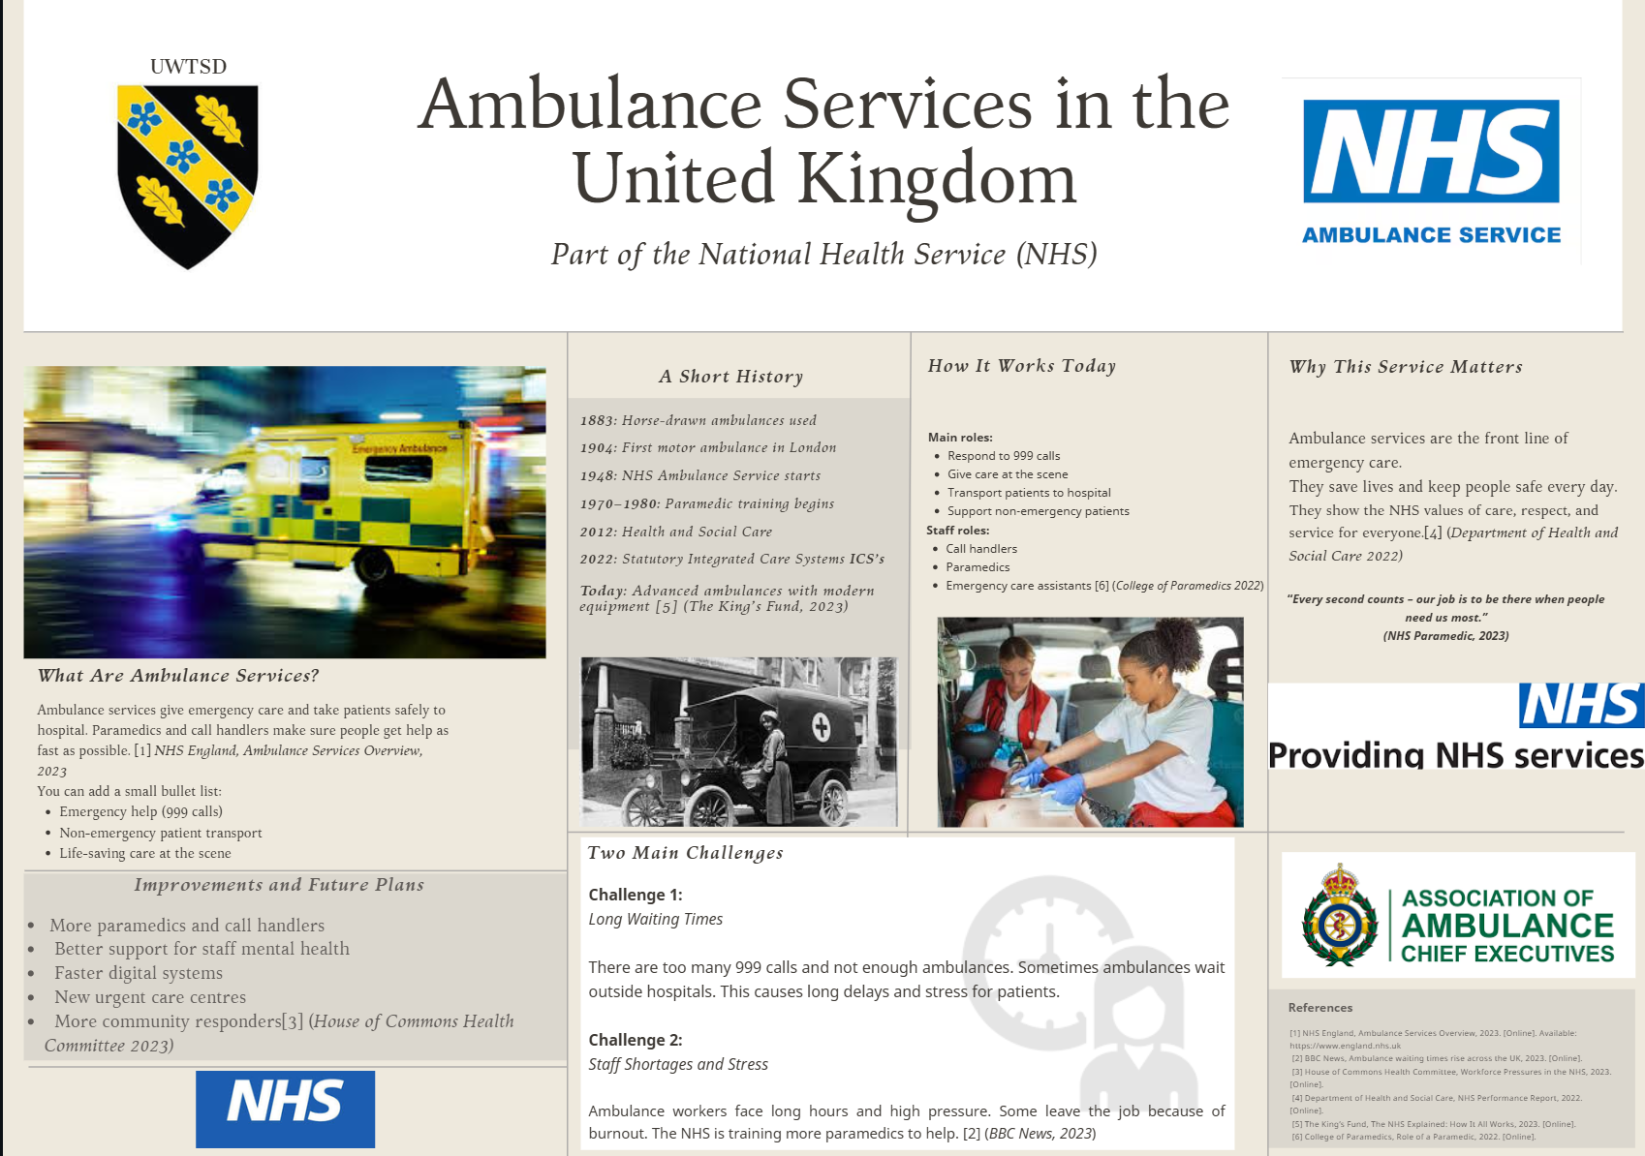
Poster Link: https://www.canva.com/design/DAG3qHr5ZJ4/znVYBf3N8hCu8NMBd54uFA/edit?utm_content=DAG3qHr5ZJ4&utm_campaign=designshare&utm_medium=link2&utm_source=sharebutton

Element 2 – Origins of the National Health Service NHS

The National Health Service (NHS) was established in 1948 and stands as one of the most influential social reforms in British history (Webster,2022). Its origins are rooted in the early twentieth century, when health provision in the UK was fragmented, unequal, and largely dependent on personal finances or charitable care (Ham, 2014). Before the NHS, a mixture of voluntary hospitals, private practitioners, Poor Law institutions, and limited municipal services created a system in which access to healthcare was inconsistent. Growing public awareness of poverty-related illness, high infant mortality rates, and industrial disease prompted increasing demands for a more coherent and equitable approach to healthcare (Rivett, 1998).
The experience of Second World War significantly accelerated this shift. The Emergency Medical Service (EMS) demonstrated that centralised planning could effectively coordinate hospitals, staff, and emergency services across the country (Beveridge,1942; Webster2002). This wartime model, combined with the publication of the Beveridge Report in 1942, helped establish the ideological foundations for the modern welfare state. William Beveridge identified “disease” as one of the five social evils and argued that all citizens should be protected from ill health through a comprehensive national system (Beveridge,1942). Aneurin Bevan, the Minister of Health in the post-war Labor government, translated these ideas into policy (Timmins,2017).
Bevan’s vision for the NHS rested on three core principles: the service would be universal, comprehensive, and free at the point of use, funded primarily through taxation rather than insurance or private payment (Ham,2014; Timmins,2017). These values reflected a political commitment to reducing inequality and promoting social solidarity.
While these founding principles remain widely supported, the structure of the NHS has evolved significantly. The UK health and social care system now faces major challenges including rising demand from ageing populations, increasing prevalence of chronic conditions, founding pressures, and workforce shortages (NHS England,2019). These pressures have influenced repeated reforms, such as the Health and Social Care Act 2012, which introduced clinical commissioning groups (CCGs) and expanded competition among providers (Department of Health,2012). Although intended to improve efficiency and patient choice, the reforms were criticised for creating fragmentation, complex accountability arrangements, and a competitive environment that hindered collaboration between health and social care providers (Ham et al.,2015)
More recent reforms reflect a shift away from market-style competition towards partnership-based integration. The introduction of Integrated Care Systems (ICSs) in 2022 marked a significant structural change (NHS England,2022). Each ICS is composed of an Integrated Care Board (ICB) responsible for commissioning and overseeing NHS services-and an Integrated Care Partnership (ICP), which brings together local authorities, voluntary organisations, and social care providers to develop long-term strategies 9NHS Engalnd,2022). This structural model recognises that health outcomes are shaped by wider determinants, including housing, employment, education, and social care, and therefore requires integrated responses (Care Act,2014).
Partnership working is now a central feature of the UK health and social care landscape.
Effective communication between hospitals, GPs, social workers, mental health services, and community organisations is essential for ensuring continuity of care, safeguarding vulnerable service users, and reducing duplication (Lloyd &Wait, 2005). Good record-keeping underpins this collaborative approach by enabling information sharing, supporting patient safety, and maintaining legal and professional accountability (NMC,2018).
Key legislation continues to play a significant role in shaping contemporary practice within the health and social care sector. In addition to the Health and Social Care Act 2012, several major policy frameworks provide essential guidance for professionals and organisations. The Care Act 2014 places a strong emphasis on promoting integrated models of care. The NHS Long Term Plan further reinforces these priorities by highlighting prevention, personalised care, and system-wide collaboration (NHS England, 2019). Alongside these, the Equality Act 2010 establishes a statutory duty to ensure fairness and protect citizens from discrimination. Collectively, these frameworks inform decision-making, uphold professional standards, and clarify organisational responsibilities across the sector (Health and Social Care Act 2012; Care Act 2014; Equality Act 2010; NHS England, 2019).

Element 3 - Conclusion

The NHS was founded on principles of universality, comprehensiveness, and equity, shaped by the historical context of wartime experience and post-war welfare reform. Its current structure, particularly the development of ICSs and ICBs, reflects ongoing attempts to address contemporary challenges through collaboration, integration, and improved population health management. Ensuring the sustainability of the NHS will depend on effective partnership working, clear communication, robust record-keeping, and policies that remain aligned with its founding values.

References
BBC News (2023) Ambulance waiting times across the UK. Available at: https://feeds.bbci.co.uk/news/uk-wales-64331612 (Accessed: 04 Nov 2025).
Beveridge, W. (1942) Social Insurance and Allied Services (The Beveridge Report). Available at: https://www.innertemplelibrary.org.uk/timeline/history-of-the-nhs/ (Accessed: 14 November 2025).
College of Paramedics (2022) Role of a Paramedic. Available at: https://www.collegeofparamedics.co.uk/(Accessed: 04 Nov 2025).
Corrigan, O. (2024) ‘Integrated care systems in England: the significance of community assets’, Frontiers in Sociology. Available at: https://www.frontiersin.org/journals/sociology/articles/10.3389/fsoc.2024.1355215/full?utm_source (Accessed: 7 Nov 2025).
Department of Health and Social Care (2022) NHS Performance Report. Available at: https://www.gov.uk/government/publications/performance-of-the-health-service-in-england-secretary-of-state-for-health-and-social-care-annual-report-2022-to-2023?utm_source=chatgpt.com (Accessed: 04 Nov 2025).
Equality Act 2010. (2010) Equality Act 2010. Available at: https://www.england.nhs.uk/publication/the-nhs-long-term-plan/ Accessed 14 Nov 2025)
Full PDF of the Long Term Plan: Available at: https://www.longtermplan.nhs.uk/wp-content/uploads/2019/01/nhs-long-term-plan-june-2019.pdf (Accessed: 10 Nov 2025)
Goddard, M. (2023) ‘Integrated care systems and equity: prospects and plans’, Journal of Integrated Care. Available at: https://www.emerald.com/jica/article/31/5/29/215313/Integrated-care-systems-and-equity-prospects-an(Accessed: 28 Oct 2025).
Ham, C. (2014) Reforming the NHS from within: beyond hierarchy, inspection and markets. London: The King’s Fund. Available at: www.kingsfund.org.uk/publications/reforming-nhs-within (Accessed: 14 November 2025).
Health and Social Care Act 2012 – legislation.gov.uk: Available at: https://www.legislation.gov.uk/ukpga/2012/7 (Accessed 14 Nov 2025)
House of Commons Health Committee (2023) Workforce Pressures in the NHS. Available at: https://publications.parliament.uk/pa/cm5803/cmselect/cmhealth/115/report.html? (Accessed: 04 Nov 2025).
Limb, M. (2022) ‘Integrated care systems face challenges fulfilling hopes of better services, says watchdog’. Available at: https://committees.parliament.uk/writtenevidence/117716/html/ (Accessed: 14 Nov 2025).

Lloyd, L. & Wait, S. (2005) NMC (2018) The Code: Professional standards of practice and behaviour for nurses, midwives and nursing associates. Available at: https://www.nmc.org.uk/standards/code/ (Accessed: 14 November 2025).
NHS England (2023) Ambulance Services Overview. Available at: https://www.england.nhs.uk (Accessed: 04 Nov 2025).
Page, B., Sugavanam, T., Hogan, H., Fitzpatrick, R. and Lalani, M. (2024) ‘Floundering or flourishing? Early Insights from the Integrated care Systems in England’, International Journal of Integrated Care. Available at: https://ijic.org/articles/7738/files/6683e4430471c.pdf (Accessed: 28 Oct 2025).
Rivett, G. (n.d.) The history of the NHS. Nuffield Trust. Available at: https://www.nuffieldtrust.org.uk/health-and-social-care-explained/the-history-of-the-nhs (Accessed: 16 November 2025).
Timmins, N. (2017) The Five Giants: A Biography of the Welfare State. London: HarperCollins. Available at: https://www.instituteforgovernment.org.uk/sites/default/files/publications/World%27s%20Biggest%20Quango%20NHS%20England%20web.pdf?utm_source=chatgpt.com (Accessed 16 Nov 2025)
The NHS Long Term Plan (2019) – NHS England. Available at: https://www.england.nhs.uk/publication/the-nhs-long-term-plan/ (Accessed: 10 Nov 2015).

