University of Wales Trinity Saint David

Wales Institute of Science & Art


Modelling Automotive Control Systems in MATLAB
Energy Storage and Control Systems (ACHA7007)
Your Name – Shaikh Mohammad Sabir Mohammad Mohid
Your Student Number - 2508908
Date (29/03/2026)

Contents
Contents 2
1. Introduction 3
2. System Description 3
3. Signal Encoding and Resolution 4
4. Controller Design 5
5. Simulation Results 6
5.1 1-Bit Signal Performance 6
5.2 7-Bit Signal Performance 7
5.3 16-Bit Signal Performance 8
6. Discussion 8
7. Effect of Sampling Time 9
8. Effect of Communication Delay 9
9. Trade-off Analysis 9
10. Conclusion 10
11. References 10

1. Introduction
The need to develop advanced automotive control systems has become vital in achieving better performance, efficiency, and safety in vehicles. Out of the various advanced automotive control systems, the cruise control system is considered to be one of the most important applications of feedback control systems, in which the objective is to maintain the speed of the vehicle despite the disturbance caused by the environment, such as the gradient of the road or the effect of air resistance.

This report is aimed at providing an overview of the modeling and analysis of the digital cruise control system, which has been developed using the MATLAB tool. The system has been developed using a closed-loop feedback control system in which the controller will change the input to the actuator in proportion to the difference between the desired speed and the actual speed of the vehicle. A Proportional-Integral-Derivative (PID) controller is considered in this regard, as it is quite robust and has been applied in various fields of industry.

Unlike the continuous system, in which the variables are continuous in nature, in the case of the actual automotive control system, it has been observed that the system is developed in a digital environment in which the signals have to be sampled, quantized, and transmitted using communication channels. However, certain non-ideal phenomena occur in this regard, and they have to be critically analyzed in the context of the performance of the system. This report will critically analyze the effect of the resolution of the signals, the time interval, and communication delays in the context of the performance of the system.

2. System Description
The major components of the cruise control system are the velocity sensor, driver demand input, controller, and actuator.
The velocity sensor is used for measuring the velocity of the car. The range of the velocity sensor is from 0 to 150 mph. However, this analogue input is converted into a digital form, keeping in mind a realistic scenario where analogue to digital conversion is a must.
The driver demand input gives the desired velocity of the car, which is then used by the system. The range of this input is from 30 mph to 110 mph, with a step increment of 5 mph. This input is considered a discrete input, keeping in mind a realistic scenario where a driver drives a car.
The controller generates a control signal by determining the difference between desired and actual velocities.
The actuator takes actions by executing a desired task. This component has a significant effect on the system, as it introduces a delay effect.
The system is considered a discrete time system, with a sampling time denoted by $T_{s}$. This implies that the system takes regular intervals of time to update itself. This is a realistic scenario, as it is considered that all embedded systems are discrete time systems (Ogata, 2010).

3. Signal Encoding and Resolution
Encoding of the signal is another important aspect for the precise representation of physical variables in the digital domain. During the conversion of an analog signal to a digital signal, a quantisation error is introduced, which is one of the limitations of digital control.
For an $n$-bit system, the encoding equation is:
$$V_{\text{raw}}=\text{round}\left(\frac{2^{n}-1}{V_{\text{max}}} ⋅ V_{\text{real}}\right)$$
The decoding process is given by:
$$V_{real}=\frac{V_{raw}}{2^{n}-1}⋅V_{max}$$

These equations define the relationship between continuous physical values and their discrete binary representations. In MATLAB, this process is implemented using functions such as dec2bin and bin2dec, enabling realistic simulation of digital communication within the control loop.
Impact of Bit Resolution
The number of bits directly determines the system’s resolution:
- 1-bit system: It offers only two states and thus extreme quantisation is present. This leads to a similar situation as the bang-bang controller and oscillations and instability occur.
- 7-bit system: It offers 128 discrete levels and thus quantisation is present but to a lesser extent. It is closer to the ideal continuous signal and oscillations are present but to a lesser extent than the 1-bit system.
- 16-bit system: It offers 65,536 discrete levels and thus smooth control is present as quantisation is negligible.
There is an inherent error associated with Quantisation too. The error is more visible when the resolution level is low. There is a chance for chatter in the control signal, i.e., the signal may change rapidly due to inadequate resolution levels. The problem can be minimised by increasing the resolution level, but the effects of discretisation cannot be eliminated completely (Nise, 2020).

4. Controller Design
The system employs a Proportional-Integral-Derivative (PID) controller, which is widely used due to its simplicity and effectiveness in a wide range of applications.
The PID control law is defined as:
$$u(t)=K_{p}e(t)+K_{i}∫e(t) dt+K_{d}\frac{de(t)}{dt}$$
where:
- $e(t)=V_{\text{demand}}-V_{\text{actual}}$
- $K_{p}$controls the proportional response
- $K_{i}$eliminates steady-state error
- $K_{d}$improves system stability and damping
The proportional term gives immediate correction in proportion to the amount of error. The integral term gives correction for the accumulation of previous errors and also provides zero steady-state error. The derivative term predicts the future trends of the errors and gives better damping.
The gains of the PID controller used in the present study were adjusted empirically to achieve the best compromise for the response speed of the system, the amount of overshoot, and stability of the system. The response speed of the system can be increased by increasing the proportional gain, Kp. The amount of overshoot also increases when the proportional gain is increased. The steady-state error is also eliminated by increasing the integral gain, Ki. The response becomes unstable when the gain is increased beyond a certain level. The damping of the response is also improved.
However, the derivative term is also more susceptible to noise when the resolution of the system is low.
The best compromise is required to achieve the best performance for the control system. The performance of the control system is considered to be the best when the control system is designed to meet the performance objectives such as response speed, stability, and robustness (Franklin et al., 2019).

5. Simulation Results

5.1 1-Bit Signal Performance
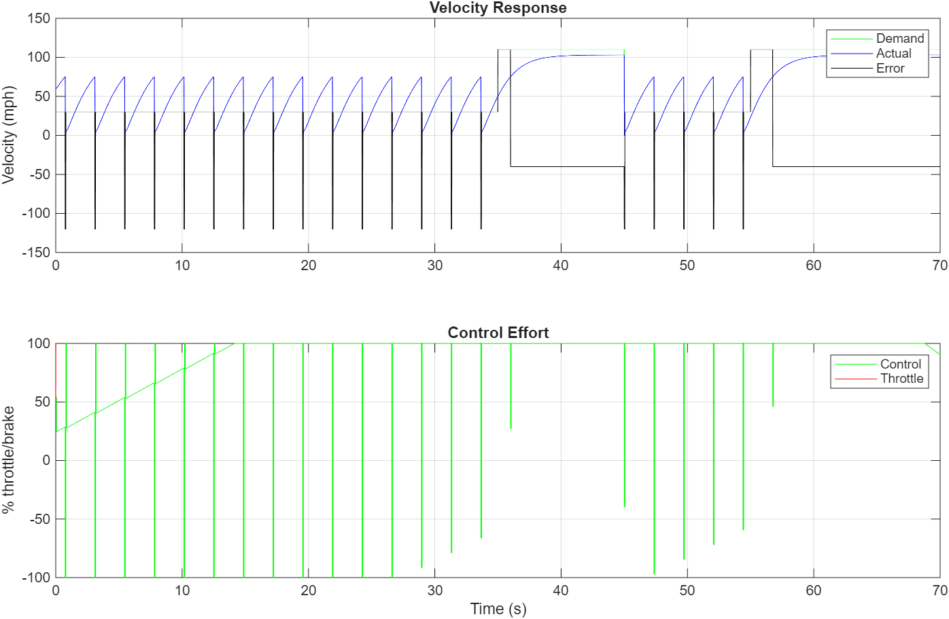
Figure 1: Vehicle velocity response using 1-bit signal
The performance of the 1-bit system is poor.
The reason why the performance of the system is poor is that the system has only two levels of output.
This is the reason why the performance of the system is poor.
This is so because the system is operating as a bang-bang controller.
From an engineering point of view, it is essential to note that the resolution of a system is such that the system is ineffective due to the high quantisation error.

5.2 7-Bit Signal Performance
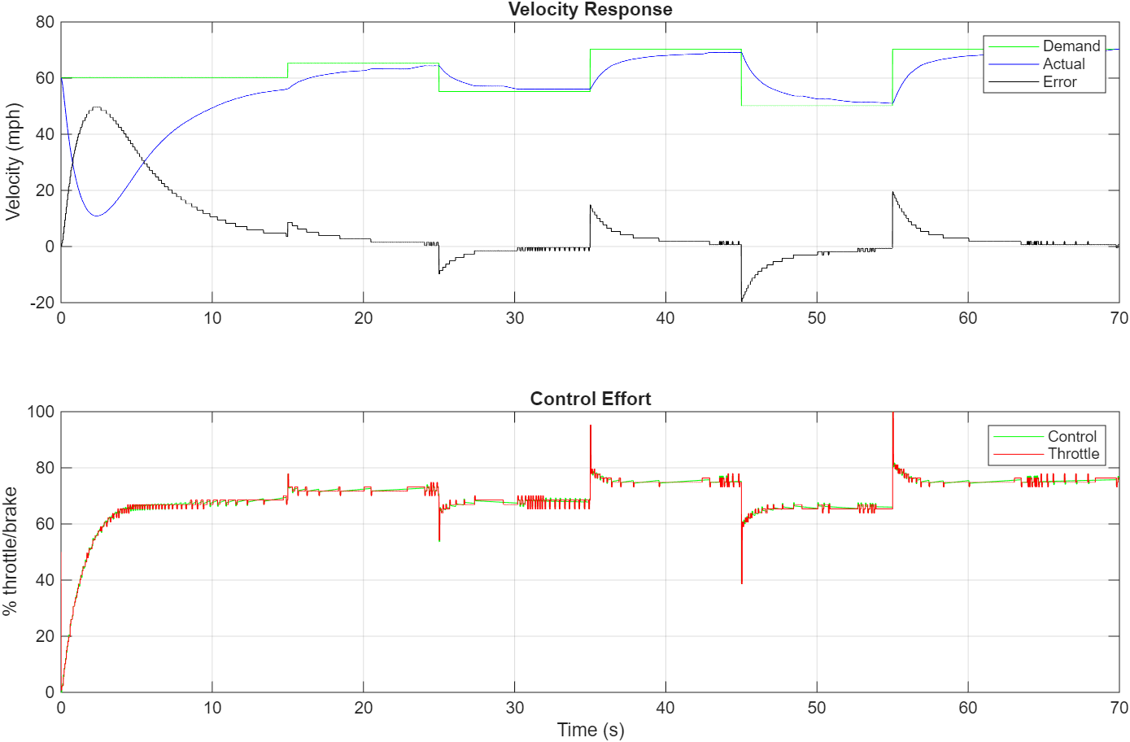
Figure 2: Vehicle velocity response using 7-bit signal
The 7-bit system demonstrates an improvement in performance with a significant reduction of oscillations and a better tracking of the desired velocity.
However, there are some oscillations that are a result of the quantization effects. This proves that there are limitations to the performance of a system regardless of the resolution.
This system is a compromise between performance and computational efficiency.

5.3 16-Bit Signal Performance
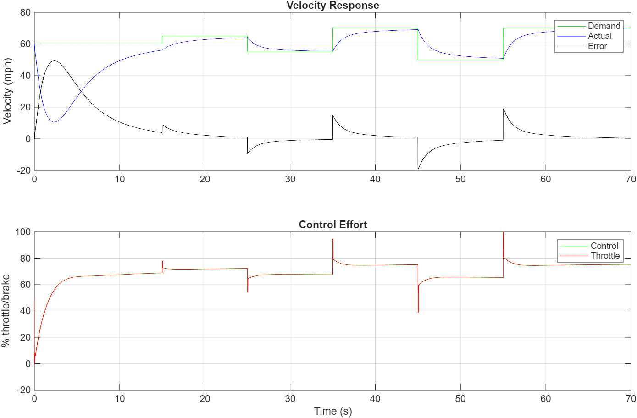
Figure 3: Vehicle velocity response using 16-bit signal
The best performance is offered by the 16-bit system, with the velocity curve closely matching the desired demand and few oscillations.
The high resolution helps in accurate control, and quantisation error is reduced, allowing for an approximation of continuous systems.
But this comes at a cost, namely, memory and computational complexity are increased.
In actual systems, it may not be possible to achieve such high resolution, as it may not be feasible for embedded systems because of hardware constraints, power consumption, and processing capabilities.

6. Discussion
The results have clearly shown that the resolution of the signal has a direct impact on the performance of the control system. The higher the resolution of the signal, the more precise the signal becomes, thus minimizing the quantization error.
However, it needs to be stated here that the higher the resolution of the signal, it also has some disadvantages. The higher the resolution of the bits, the more memory and computational power will be required, thus creating more latency.
From the above discussion, it needs to be stated here that one of the fundamental concepts in the field of engineering is that for the optimal design of the system, trade-offs have to be made so that the system can be optimally designed, achieving the required balance for the accomplishment of the different objectives. In the case of the control system, the resolution of the signal depends on the application, hardware, etc. (Ogata, 2010).

7. Effect of Sampling Time
The impact of the sampling time $T_{s}$ on the performance of the system is also significant. In case the value of the sampling time $T_{s}$is reduced, it is possible to enable the controller to perform well in response to the changes in the behavior of the system. However, it is also possible for the computation burden of the controller to increase. This might also lead to sensitivity in the performance of the controller. On the contrary, in case the value of the sampling time $T_{s}$is increased, it is possible to reduce the computation burden of the controller. However, it is also possible for the performance of the controller to lag. This might also lead to instability in the performance of the system. Therefore, it is essential to choose an appropriate value of the sampling time $T_{s}$to ensure the performance of the system is balanced (Franklin et al, 2019).

8. Effect of Communication Delay
The communication delay will lead to time delay in the response of the signal and the actuator. Time delay, when present in the system, will lead to phase lag in the system. The phase lag in the system will lead to instability in the system. The effect of the delay is less when the time delay is less. But when the time delay is more, it will lead to instability in the system. The large time delay will be handled by the use of the PID controller. But the large time delay cannot be handled, and it will lead to instability in the system. The low values of time delay have to be present in the system. This is because the system is critical, as mentioned in the article by Åström and Murray (2010).

9. Trade-off Analysis
The system has several major trade-offs, including the following:
- Resolution and performance
- Sampling time and responsiveness
- Delay and stability
- Control effort and accuracy
These trade-offs form the basis for control systems, and they have to be balanced in accordance with the needs.

10. Conclusion
In this report, the design and analysis of the MATLAB-based cruise control system, specifically in terms of its dependence on signal resolution, have been discussed.
The results obtained from the analysis conducted in this report are as follows:
- Low resolution systems have high quantization errors and instability issues
- Medium resolution systems have the right balance between performance and efficiency
- High resolution systems have the right performance; however, there is a price to be paid for the same
In conclusion, it can be stated that though the performance of the system is enhanced as the resolution of the signal is enhanced, other factors also come into play.

11. References
Books:
- Franklin, G.F., Powell, J.D. and Emami-Naeini, A. (2019) Feedback Control of Dynamic Systems. 8th edn. Pearson.
- Nise, N.S. (2020) Control Systems Engineering. 8th edn. Wiley.
- Åström, K.J. and Wittenmark, B. (2021) Computer-Controlled Systems. 3rd edn. Dover.
- Rajamani, R. (2021) Vehicle Dynamics and Control. 3rd edn. Springer.
- Kiencke, U. and Nielsen, L. (2020) Automotive Control Systems. Springer.
Journals / Reports:
- IEEE (2021) Digital Control Systems in Automotive Applications. IEEE Transactions on Control Systems Technology.
- Richard, J.P. (2020) ‘Time-delay systems: an overview’, Automatica, 39(10), pp. 1667–1694.
- Camacho, E.F. and Bordons, C. (2020) Model Predictive Control. Springer.

