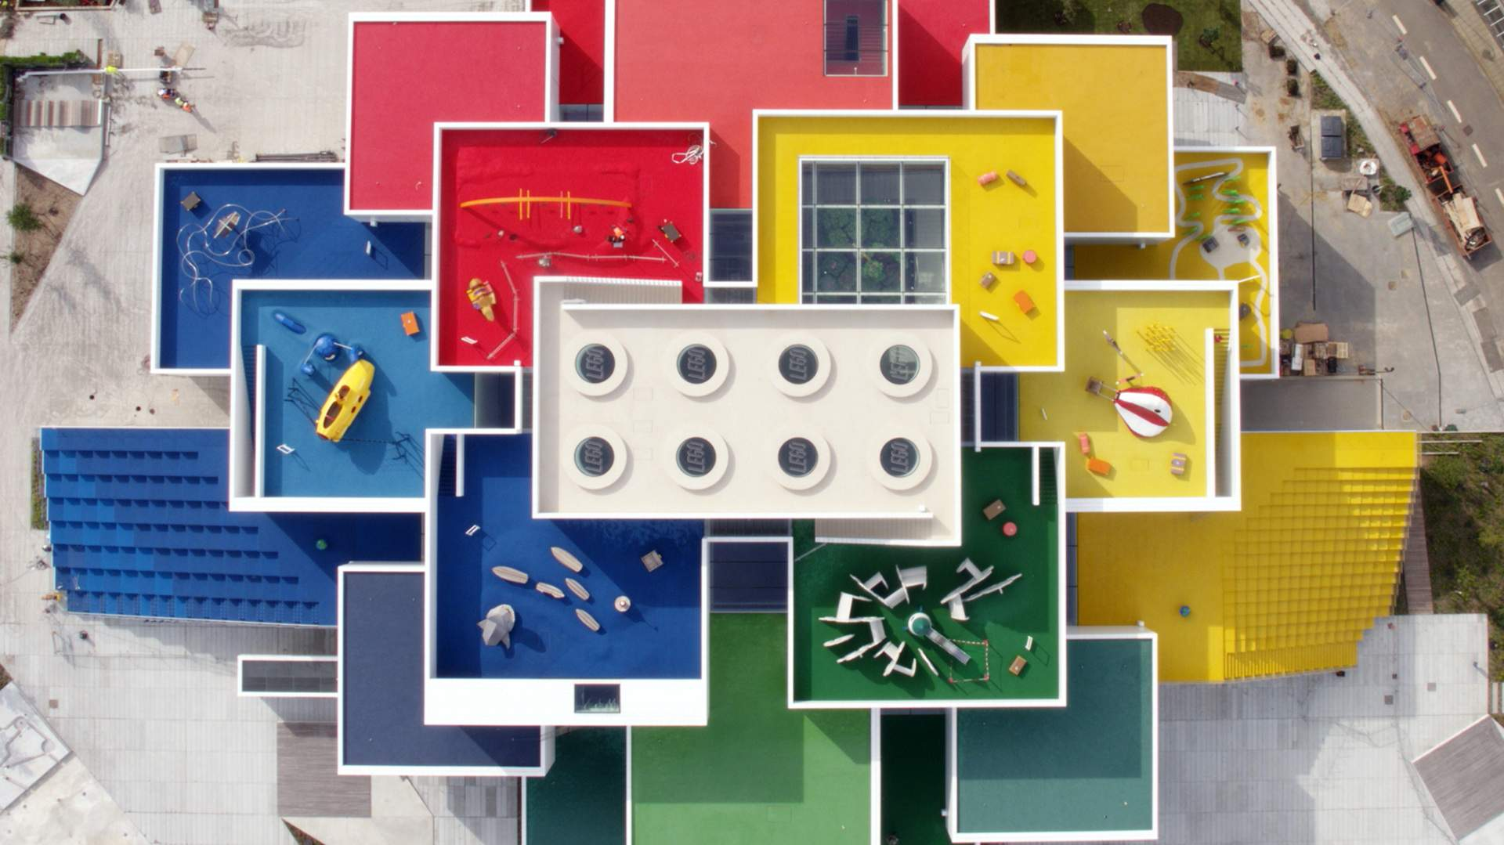

ACBA4003
https://concreteplayground.com/sydney/news-2/life-sized-lego-house-opened-denmark

Why I Joined the Construction Industry
  - And what inspired me

Luke Nicholas 27th October 2022

When I first joined the construction industry, it was merely a means to an end. A physical, labour intensive and not very thought provoking. It wasn’t glamorous and certainly didn’t appeal to me on a wider scale beyond necessity of requiring a job and an income. Whether it was fortune or chance, I was put onto a multi-skilled site and required to drive a tipper from day one. Both of which were completely alien to me beyond some DIY with my grandfather.
This chance encounter quickly evolved into something of a secret passion, sort of a spark emerged. Showing some willing and aptitude to learn and pick up things quickly, I was entrusted with tiling and refinishing a whole bar. Daunting task to even an experienced carpenter but I soldiered on, wanting to learn, and prove myself wrong and any doubt soon started to leave.
This original experience left me working away, seven days a week almost 12 hours a day sometimes and the money wasn’t compensation enough. So, what was keeping me eager and willing?

Something had given me some clarity on a very possible future, which certainly wasn’t there before. But I believe I was always interested in construction from a very early age.

But when you are interested in castles, structures, bridges and Lego. This doesn’t feel like a direct or obvious link until you find a passion when doing it at scale as an adult.
Page - 1 -

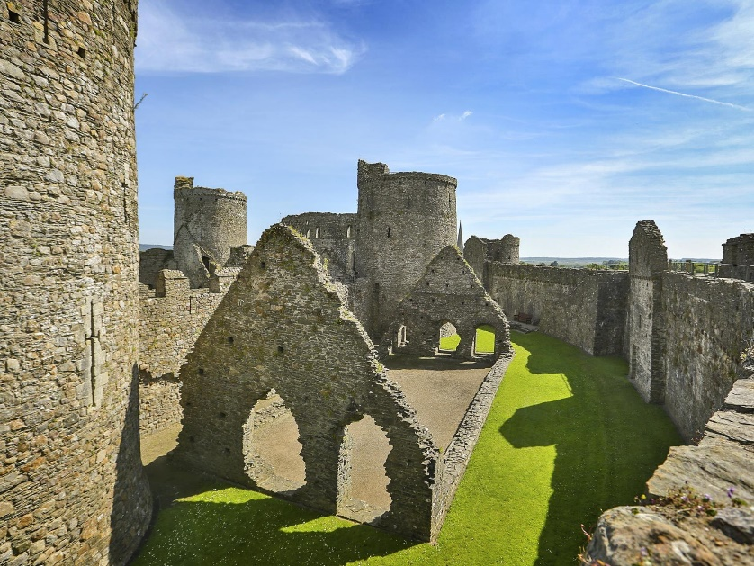
Page - 2 -

Joining Construction

  - The Journey to now
03  Working and experiences within the construction industry.  Future possibilities and what aspects of construction to pursue.  The capabilities of Lego, and my past that were inspirational catalysts.  01  02 | 01 My Inspiration  Just as Disney is a whole world of dream and wonder for children to adults, Lego has the same ethos and possibly even more so. Dreaming, creating and inspiring is what all construction is about?  All which Walt Disney built his whole vision from. Which always resonated with me, just wasn’t aware on what level architecture appealed to me. This Vision was further accomplished with the construction of the Lego house. (Lego,2022). It is literally what I dreamt of when I was a child, building an entire structure out of Lego, or to mimic Lego blocks and utilize Lego as set pieces throughout.  This rings true from where I grew up, seeing Kidwelly Castle almost everyday of my life. Being one of the most impressive structures I have ever seen to this day. Until I got older and started to learn about structures. I didn’t understand the magnitude of such construction.  For a building to have stood the test of time, dating back to 1280s. (Visit Wales, 2022). It is the most impressive structure and to have remnants across the town even to this day is inspiring for a legacy structure. I feel is the most impressive construction accomplishment in human history. Next to the pyramids and the great wall.  https://www.visitwales.com/attraction/castle/kidwelly-castle-cadw-516104
02 Working & Experience
Through various opportunities and different levels of projects. I have been fortunate enough to have experienced a variety of trades, both vocational and managerial levels. Which has given me a broad range and outlook of the industry from a varied perspective.
This has been extremely beneficial in giving me insight to such and expansive and diverse industry that is changing, for the better but also to keep up with ever evolving industry needs and advances in technologies, but also being forced to change for climate and ever looming stricter restrictions in both building regulations and cost implications.
A project I was heavily involved with as my introduction to construction was a restoration on this pub in Aberystwyth.

I’ve been lucky enough to be part of various organizations as a student in the last year or so and have even attended the CABE conference recently. In which I chose to apply as a student member following joining other recognized awarding bodies. Of whom are huge in the industry as a level of quality and prestige in their given fields. Following the conference which was hugely insightful regarding embodied carbon and constructions pledge to be net zero by 2050. (CABE, 2022).
Another big part of wanting to be so inclusive of these awarding bodies is their recent push for mental health awareness among the workforce especially in construction. As a long-term sufferer and knowing the percentages of suicide among construction workers, thanks to the CIOB and their work with improving it. (CIOB, 2020).

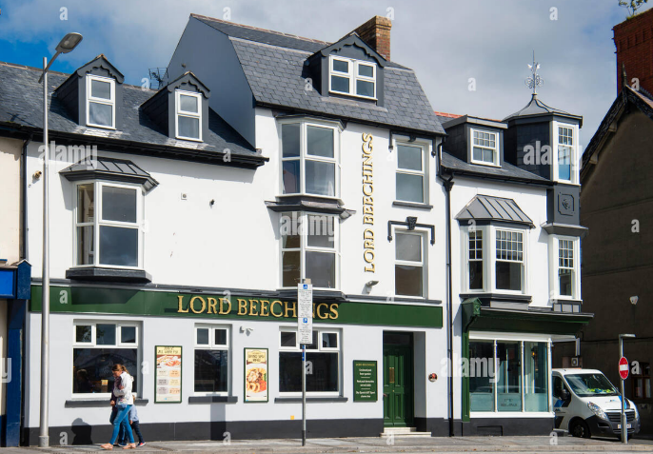
https://www.alamy.com/stock-photo-exterior-the-lord-beechings-pub-owned-by-the-brains-brewery-company-111329849.html

Page 3

Page - 3 -

03 The Future
The entire process so far has led me to this point. And no matter what roadblocks I have had to encounter and overcome. Be them career or health I am here, and in better standing than I have ever been. Thanks to my student status I’ve been given the opportunity to network and establish a connection with a multitude of these awarding bodies at a communicative level to prepare for when I achieve my degree, I can become an affiliate of these and be recognized professionally. Also being a member of the groups on LinkedIn is also an invaluable foothold in the current and future climate with the power LinkedIn has brought to businesses and the professional industry itself. (Linkedin,2022).

Summary
The construction industry is currently having a huge economic shift, with the industry needing more work force than it has ever required. And the lack of tradesmen is an industry low. With a lot of established companies, especially in the last 5 years have all started to fold due to new financial difficulties and unable to shift with the culture. (CITB, 2022). This makes going into this as a profession daunting but also challenges can be exciting. Obviously, a dream job would be a Lego master builder, at any caliber the constructive and creative nature of that job really does appeal to me. But the historic and renovation side of modern restoration building does truly inspire me, and I have looked at this side of the industry more and more. (IHBC,2022). This is not just inspiration, but I am actively searching for a circa 1700 – 1800 building, preferably a chapel for restoration and renovation to live in. Conservation can be the right solution not just for the future of building but certainly for Wales and their housing stock and gives me a long and busy career.

References

- The Construction Institute Training Board, (2021) Addressing skills shortages in the trades, Available at: https://www.citb.co.uk/about-citb/partnerships-and-initiatives/addressing-skills-shortage-in-the-trades/
(Accessed: 3rd November 2022)

- The Chartered Association of Building Engineers, (2022) Association News, Available at:
https://cbuilde.com/news/619455/CABE-Announces-the-Winners-of-the-Built-Environment-Awards-2022.htm
(Accessed: 3rd November 2022)

- The Chartered Institute of Building, Rees-Evans, D. (2020)
Anxiety UK
[CIOB Report]
Available at: https://www.anxietyuk.org.uk/wp-content/uploads/2020/05/CIOB-Understanding-Mental-Health-in-the-Built-Environment-Report.pdf
(Accessed: 3rd November 2022)

Page - 4 -

- The Institute of Historic Building Conservation, (2022)
Available at: https://newsblogsnew.ihbc.org.uk/
(Accessed: 3rd November 2022)

- Lego, (2022) The Lego House
Available at: https://concreteplayground.com/sydney/news-2/life-sized-lego-house-opened-denmark
(Accessed: 3rd November 2022)

- Lego, (2022) The Lego House
Available at: https://legohouse.com/en-gb/plan-your-visit/faq/
(Accessed: 3rd November 2022)

- Visit Wales, (2022) Kidwelly Castle
Available at: https://www.visitwales.com/attraction/castle/kidwelly-castle-cadw-516104
(Accessed: 3rd November 2022)

Page - 5 -

