

MA (Education) Teach First
Module: Research Methods in Education
Module Code: M7X01494
Module Handbook

Module Leader: Sharon James
Email: sharon.james@uwtsd.ac.uk

Programme Director: Junnine Thomas-Walters
Email: junnine.thomas-walters@uwtsd.ac.uk

MA (Ed) Administrator: Lesley Morgan
Email: lesley.morgan@uwtsd.ac.uk
Phone:01792 482070

Research Methods in Education (Teach First)
Semester One: Starting October 2018

MODULE AIM(S)

- To engage critically with current debates and literature surrounding educational research.

- To develop knowledge and understanding of how research can contribute to improvements in practice and raising of standards in educational settings.

- To promote reflective practice through critical analysis of different research tools approaches.

MODULE LEARNING OUTCOMES

Upon the successful completion of this module, the student should be able to:

- critically assess information from various educational sources

- critically reflect on the process of gathering data with due regard to ethical considerations associated with educational research

- develop a comprehensive understanding of how theory links with research and practice

Timetable
Date | Session details
Prep for session 1 | Google Books Research Methods in Education Cohen, Manion, and Morrison: Read Chapters 1 and 2– Nature of Inquiry and understand the different theoretical perspectives. Also delve into chapters relevant to Session 1 on qualitative research.
SESSION 1  Saturday 6th October  10.30-4.30 | Module aims, learning outcomes, assessment criteria & assignment, including structuring research report  Research basics (aims, questions, designs, processes, paradigms & nature of data)  Research Briefings and Literature reviews: purpose, types, search parameters, abstracts, access  Qualitative research techniques 1; interviews & focus groups, analysing spoken data, coding  Qualitative research techniques 2: observations, audio-visual methods  Ethics |  |  | SLJ
Session discussion points | Theme: Research ethics and qualitative methods  What is research for? Why do it? What is a research question? What does a good one look like?  What is a research paradigm? What needs to be considered when undertaking a literature review?  How do you structure a research project? What are the core values and ethical dimensions of practitioner research?  What is the nature of data? Why use interviews and focus groups? What are the different kinds of observation?  How do you analyse and code spoken words? What ‘other methods’ can be used for qualitative research?  Useful readings/refs researched - http://www.workingoutwhatworks.com/  http://www.workingoutwhatworks.com/en-GB/Resource-library/Presentations/rED-p-jude-enright-camb-2015  On interviews see also: http://www.history.ucsb.edu/faculty/marcuse/projects/oralhistory/2006MEBrennerInter viewInEducResearchOCR.pdf  http://www.leeds.ac.uk/educol/documents/000001172.htm
Prep for session 2 | Chapters 4,6,9 and 24 from Cohen
SESSION 2  Saturday Oct- Dec tbc  10.30-4.30 | Overview of quantitative approaches incl. RCTs  Designing questionnaires  Types of quantitative data and descriptive statistics  Analysis of data  Mixed methodologies  Writing up research: reports, posters, conferences, peer-review |  | SLJ
Theme: Research ethics and quantitative methods
What is quantitative research and possible research applications in your setting?
What is the role of measurement in research? What do you know about reliability and validity?
What types of variables are there? How do you control them?
What are the range, mean and standard deviation? What is statistical inference?
How can software such as SPSS help you and where can you learn more?
What are the principles of mixed method research?
What do you need to know about writing up and presenting your research findings?

Useful readings/refs
http://www.unesco.org/iiep/PDF/TR_Mods/Qu_Mod1.pdf - useful introduction to different kinds of research questions

DOING quantitative research IN EDUCATION:
http://www.modares.ac.ir/uploads/Agr.Oth.Lib.23.pdf (upload available via an Iranian University!)

SESSION 3  Saturday Feb – March tbc  10.30-4.30 | Review  Tutorials
SESSION 4  Individual tutorials via Skype to be arranged | As necessary

KEY READINGS: Suggested references from the e-books in the library:
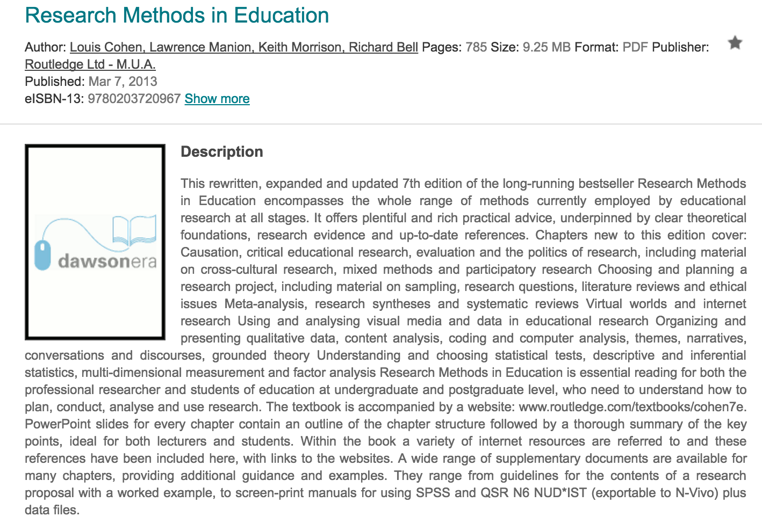
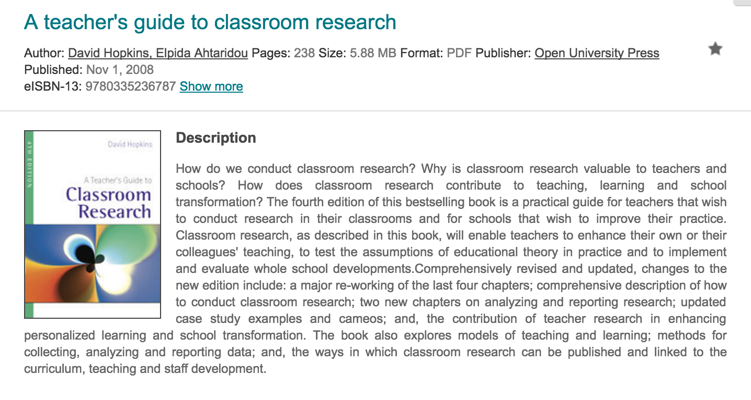
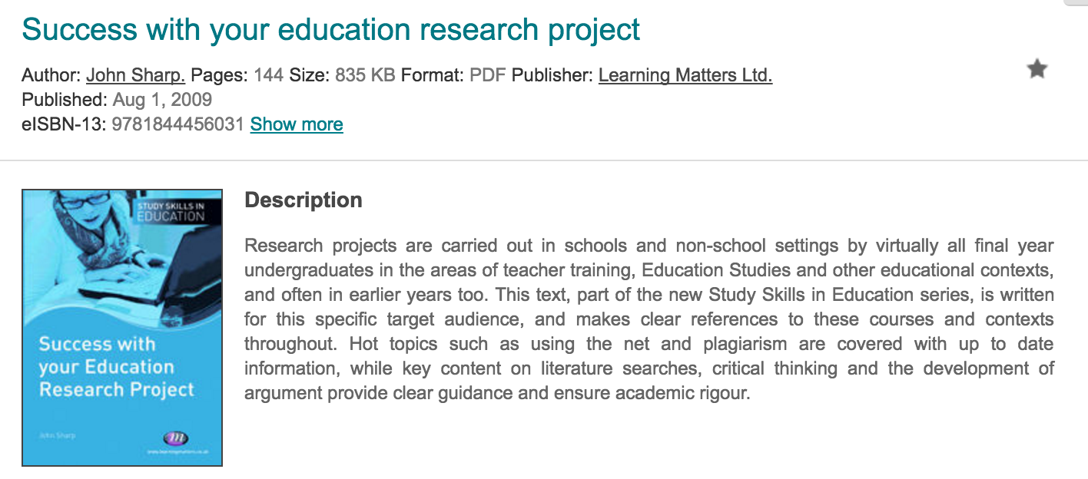
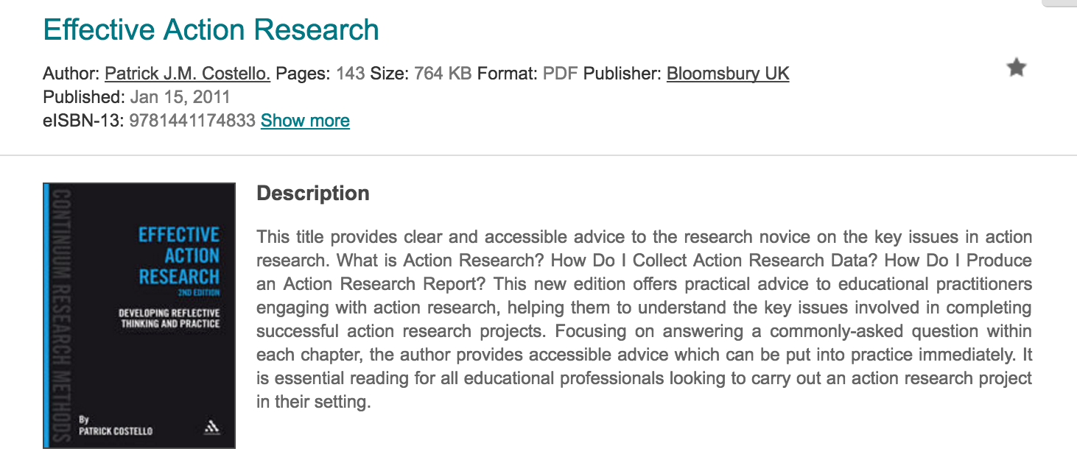

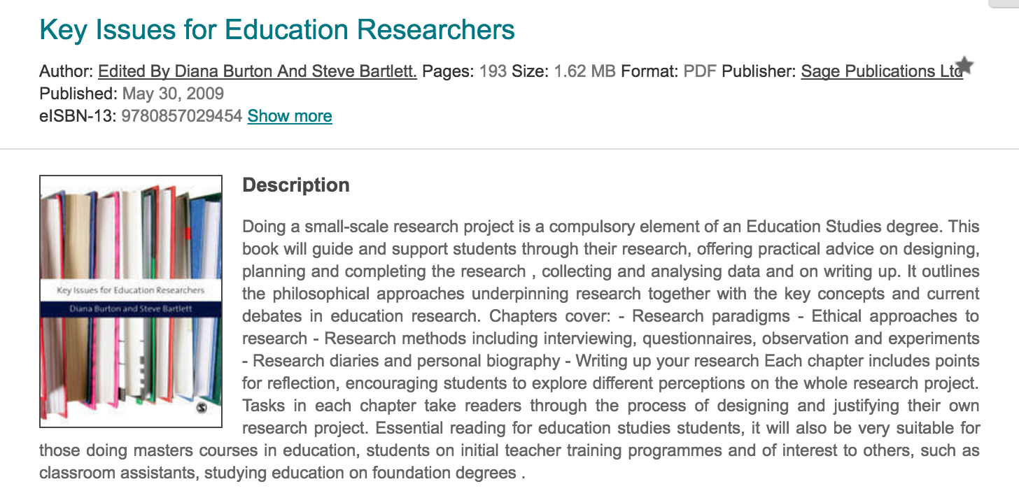

You also need to look at this publication from the Welsh Government:

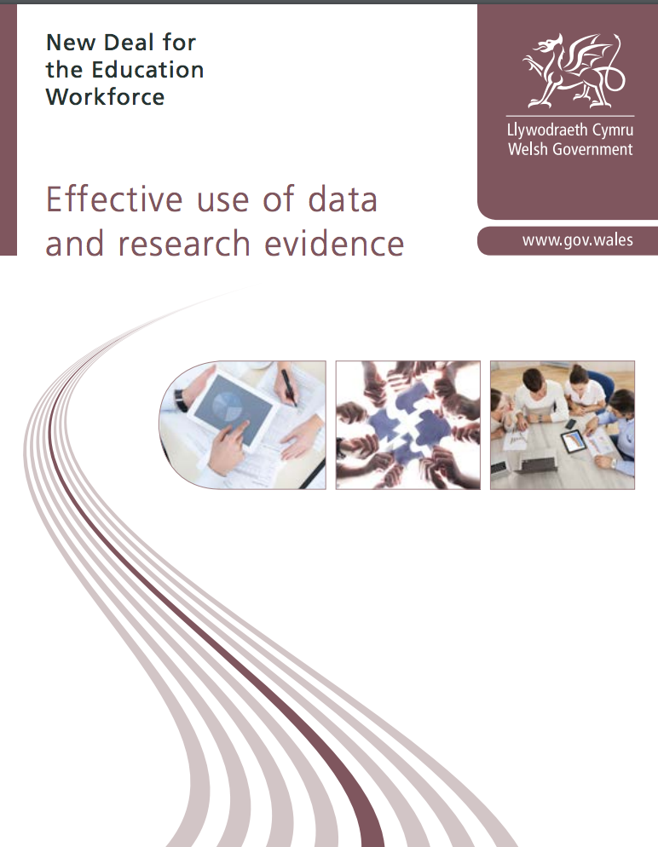
http://learning.gov.wales/docs/learningwales/publications/150814-effective-use-of-data-en.pdf

BIBLIOGRAPHY

Essential
British Educational Research Guidelines (BERA, 2011) http://content.yudu.com/Library/A1t9gr/BERAEthicalGuideline/resources/index.htm?referrerUrl=

Fictman-Dana, N. & Ydndol-Hoppey, D. (2008) (2nd Ed) The Reflective Educator's Guide to Classroom Research: Learning to Teach and Teaching to Learn Through Practitioner. Corwin Press.

Opie, C. (2004) Doing educational research: a guide to first-time researchers. London: Sage.

Welsh Government (2015) Effective Use of Data and Research Evidence, Cardiff: Welsh Government.

Zeni, J. (1998) A guide to ethical issues and action research, Educational Action Research, 6:1, 9-19

Recommended

Aubusson, P., Ewing, R., & Hoban, G (2009) Action Learning in Schools. London: Routledge.

Boog, B., Preece, J., & Slagter, M. (Eds) (2008) Towards Quality Improvement of Action Research Sense Publishers

Burnaford, G. E., Fischer, J., & Hobson, D. (2001) Teachers doing research: the power of action through inquiry. Mahwah, NJ: Lawrence Erlbaum

Campbell, A. & Groundwater-Smith, S. (Ed) (2009) Connecting Inquiry and Professional Learning in Education. London: Routledge.Cochran-Smith, M., & Lytle, S. L (2009) Inquiry as Stance: Practitioner Research in the Next Generation. Teachers’ College Press.

Cochran-Smith, M. & Lytle, S.L. (2009) Inquiry as Stance: Practitioner Research in the next generation. New York: Teachers’ College Press

Cohen, L. & Manion, L. (2011) Research Methods in Education 7th edition. London: Routledge.
See: http://www.sfu.ca/media-lab/DCM/Backups/March%202015/Comps%20research/Methodology%20books/%5BLouis_Cohen.pdf

Dadds, M. (1995) Passionate Enquiry and School Development. London: Falmer Press

Denscome, M. (2010) (4th ed) The Good Research Guide: for small-scale social research projects. Buckingham: Open University Press

Drever, E. (1995) Using semi-structured interviews in small-scale research: a Teacher's Guide. Glasgow: The Scottish Council for Research in Education

Gordon, S. P. (2008) Collaborative Action Research: Developing Professional Learning Communities Teachers' College Press

Henning, J. E., Stone, J. M. & Kelly, J. L. (2009) Using Action Research to Improve Instruction. London: Routledge.

Herr, K. J. & Anderson, G. L. (Eds) (2005) The Action Research Dissertation: A Guide for Students and Faculty. Sage Publications.

Lassonde, C. A. & Israel, S. E. (Eds) (2008) Teachers Taking Action: A Comprehensive Guide to Teacher Research. International Reading Association

Lewis, I., & Munn, P. (2004) So You Want to Do Research? A Guide for Teacher's on How to Formulate Research Questions The SCRE Centre

MacNaugthton, G. & Hughes, P. (2008) Doing Action Research in Early Childhood Studies: a step-by-step guide. Open University Press

Mertler, C. (2008) Action Research: Teachers as Researchers in the Classroom. London: Sage

McKernan, J. (1996) Curriculum Action Research: A handbook of methods and resources for the reflective practitioner. 2nd Edition. London: Kogan Page
McNiff, J. & Whitehead, J. (2009) Doing and Writing Action Research. Sage Publications

Mertler, C. (2008) Action Research: Teachers as Researchers in the Classroom. London: Sage.

Pollard, A. (2008) Reflective Teaching. London: Continuum

Sagor, R. (2000) Guiding school improvement with Action Research. Association for Supervision and Curriculum

Journals

Action Research
Educational Action Research

Websites

BERA: https://www.bera.ac.uk

Estyn: http://www.estyn.gov.uk
Learning Wales: http://learning.wales.gov.uk/resources/improvementareas/professional-learning/effective-use-of-data/?lang=en

Research in Education: http://www.edu.plymouth.ac.uk/resined/

ActionResearch.Net provides introductory materials on action research: http://www.actionresearch.net/

Jean McNiff’s website includes examples of masters and doctoral these which follow an action research approach: http://www.jeanmcniff.com/reports.html

Action Research Network allows teachers to track current research projects: http://actionresearch.altec.org
ERIC: Educational Resources Information Centre, a national information system designed to provide users with ready access to an extensive body of education-related literature: http://www.eric.ed.gov/

The Research Informed Practice Site (TRIPS) hosted by DCSF provides essential research findings for teachers, governors, and parents: http://www.standards.dfes.gov.uk/research/

Department of Education for Northern Ireland has annual research reports: http://www.deni.gov.uk/index.htm

The British Education Research Association website provides an overview of some of the activities and aims of BERA: http://www.bera.ac.uk/

The Association for the Study of Primary Education emphasizes reflective study and on collaborative activity: http://www.aspe-uk.eu/

The Collaborative Action Research Network is an international network covering professionals in education, health, social care, commerce and public services: http://www.did.stu.mmu.ac.uk/carnnew/

National Centre for Social Research has guidelines on assessing the quality of research:

The Nuffield Foundation, set up in 1943, funds research in many areas: http://www.nuffieldfoundation.org/

The UK National Statistics Online website has statistics across the public sector. The Children, Education and Skills section has data on topics such as early years education and child safety: http://www.statistics.gov.uk/hub/index.html

National Foundation for Educational Research carries out around 200 research projects each year across all sectors of education: http://www.nfer.ac.uk/index.cfm
Esmee-Fairbairn Foundation occasionally funds research: http://www.esmeefairbairn.org.uk/

Economic and Social Research Council is the UK's leading agency for research funding and training in economic and social sciences: http://www.esrc.ac.uk/ESRCInfoCentre/index.aspx

Scottish Education Research Association promotes debate about the contribution research can make to enhanced practice:http://www.sera.ac.uk/

The Sutton Trust: http://www.suttontrust.com/about-us/us/education/

Access to Research Resources for Teachers Space (ARRT Space) is part of the website of the General Teaching Council for Northern Ireland: http://arrts.gtcni.org.uk/gtcni/

The Evidence for Policy and Practice Information and Co-ordinating Centre (EPPI-Centre) leads systematic reviews and aims to makes research findings accessible to those who need them. It is part of the Social Science Research Unit at the Institute of Education, University of London: http://eppi.ioe.ac.uk/cms/

The Intute website is a key reference, containing reviews by experts on the best web resources – see the education and research methods section. It also includes Internet free tutorials on using the Web for education and research: http://www.intute.ac.uk/
Genamics JournalSeek is the largest completely categorized database of freely available journal information available on the internet. The database contains around 9,500 titles: http://journalseek.net/

Centre for the Use of Research and Evidence in Education sets out to connect academic research and professional practice: http://www.curee-paccts.com/

UK Teaching and Learning Research Programme includes research summaries: http://www.tlrp.org/

George Mason Graduate School of Education has useful introductory materials on teacher research: http://gse.gmu.edu/research/tr/

Assignment Brief

Assessment Component 1 – 100%

The learning outcomes will be assessed through a coursework assignment (6000 words). Exemplar: Submit a research proposal with due regard to ethical considerations

The requirement is to propose a research project that is concerned with a significant issue that is relevant to your setting. This should fit into the general theme of addressing the impact of poverty on education.

Assessment Summary
Activity type | Percentage
Written exam | 0%
Coursework | 100%
Practical | 0%
TOTAL | 100%

Guidance

- The research proposal should be concerned with a significant issue relevant to your setting and fit within the general theme of addressing the impact of poverty on education
- Write a clear, concise and engaging title – no more than 30 words
- Set out in the background and context your own experience, motives and setting, along with what has already been written about the subject and any gaps that you hope to fill; or how it adds to, develops (or challenges) existing literature in the field
- Under Aims and Objectives, be clear about the difference between the two. Write SMART research questions. You should include a clear rationale and comment on intended impact
- Under proposed plan of work, set out how you will approach answering your research questions. You might include a table with an indicative timeframe and milestones. It is the project management element of the proposal.
- The proposed methodology section is very important because it sets out the framework, methods, sample e.g. qualitative, quantitative or mixed methods; pilot study? You need to say why you have chosen the particular methodologies. Who will you talk to? What data will you collect? How will you analyse and report upon this? You should devote between 3000-3500 words to this section
- The introductory bibliography should include all the key readings around the subject including peer-reviewed articles. It is important that your references are up-to-date. Ensure that you follow the Harvard style.
- Appendices: you can include additional materials that you think are important about the context of your research

Throughout you need to demonstrate ethical awareness e.g. getting permission to access data and note if there are any particular aspects

Don’t look upon the proposal as the definitive document. It is normal to refine original proposals considering detailed literature reviews, further consideration of research approaches and feedback from the supervisors (and other academic staff).

Most research proposals follow this structure:
Title

Abstract

1. Introduction
Brief contextual background to your study
Aims
The research questions, issues, problems
2. Literature review
3. Proposed Methodology
Research design
Data sources
Collection techniques
Issues relating to reliability and validity
Definition of any key terms
Ethics
4. Work plan
5. Appendices
6. References

List of intended sources

This postgraduate website provides useful guidance
https://www.postgrad.com/advice/exams/dissertations_and_theses/research_project/

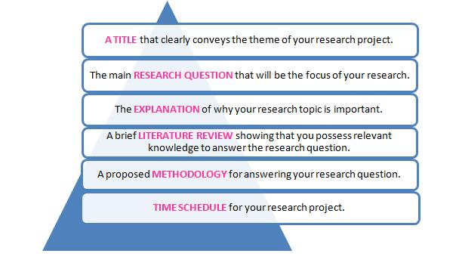

You can find guidance on what constitutes a research proposal and how to put one together on many University websites across different disciplines and at different levels e.g. http://www.birmingham.ac.uk/schools/law/courses/research/research-proposal.aspx
http://libguides.usc.edu/writingguide/researchproposal
https://www.abdn.ac.uk/education/documents/Guidelines_for_Research_Proposal.pdf

Assignments should be submitted via Turnitin by 23:59 on Wednesday 10th April 2019. Turnitin will be available for submissions two weeks prior to this date. There is also a draft Turnitin submission which you can access to check your Turnitin score before you hand in your assignment. It is recommended that you do this.

You also need to hand – in two hard copies of your assignment to Lesley Morgan (Dylan Thomas Centre, 1 Somerset Place, Swansea SA1 1RR) by NOON the following day Thursday 11th April. Please be advised that you can hand in this work up to one week earlier.

- Please note that your Turnitin electronic submission is your official submission. Any late assignments will be penalized.

You are strongly advised to check you have access to your student account at least two weeks before your electronic submission is due. If you do not have access to your student account then you will be unable to submit your assignment electronically.

* Please ensure that you use the coloured front cover provided at the back of this handbook to preface your assignment. A module assessment form should also be included with the hard copy of your assignment. This form will be made available via Moodle

University of Wales MA (Education) Teach First

Research Methods in Education ( Teach First)
M7X01494

Student Number: ……………………………………………………………….

Level: MA(Ed)
7

Assignment Number: 1 2 3 4

Tutor: S L James

