NAME: CHERELLE WHITBREAD
STUDENT ID:2513414
MODULE: EMPLOYABILITY AND CAREER DEVELOPMENT
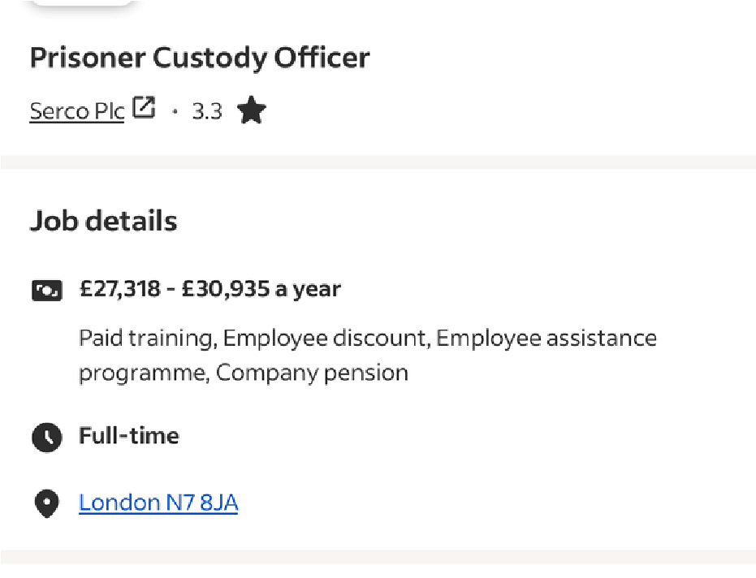
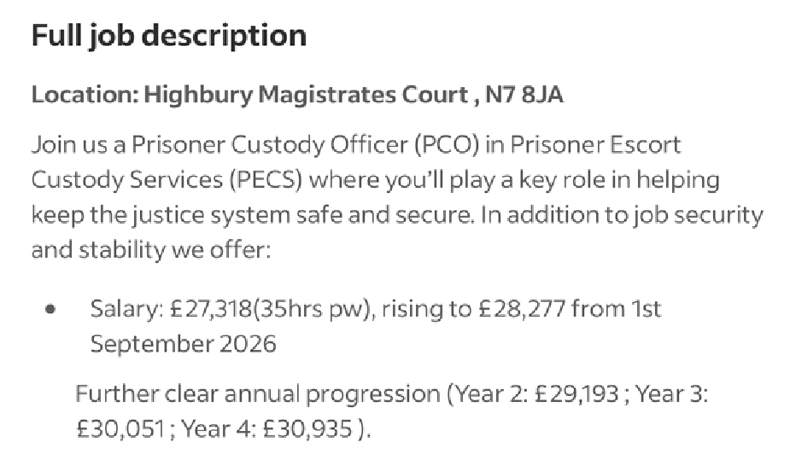
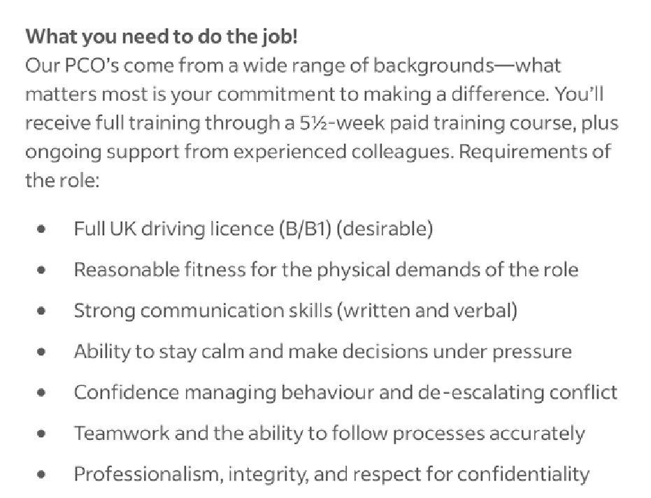
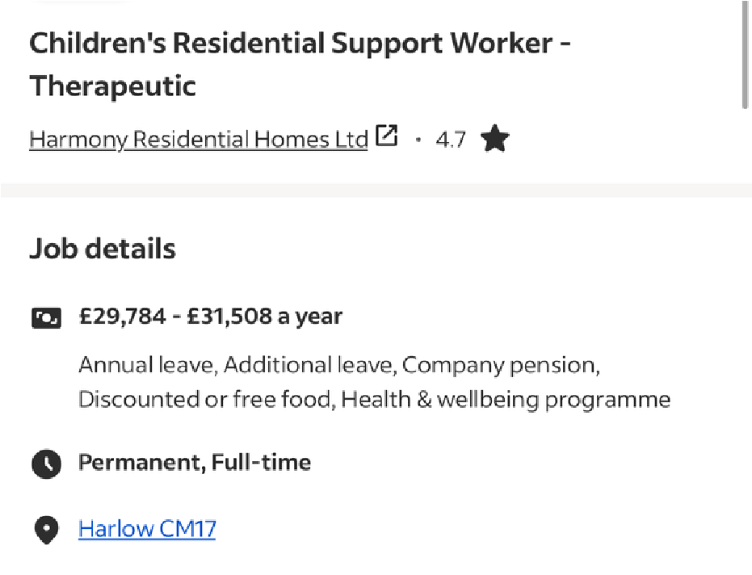
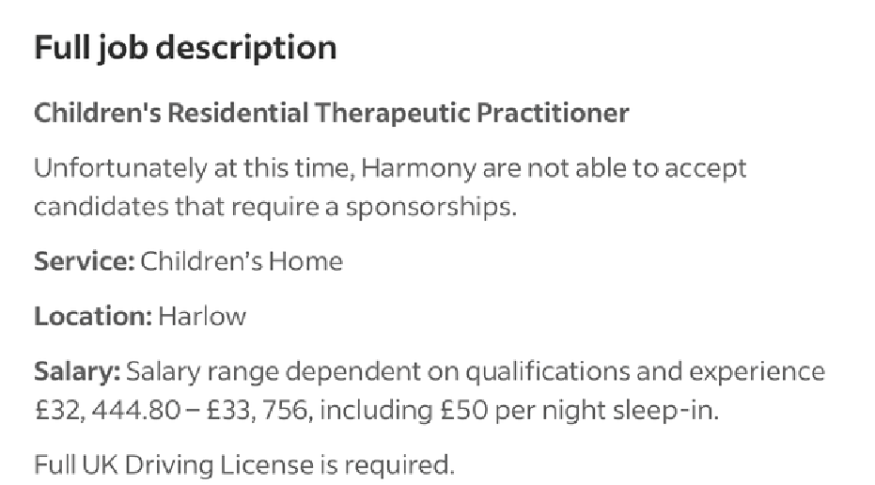
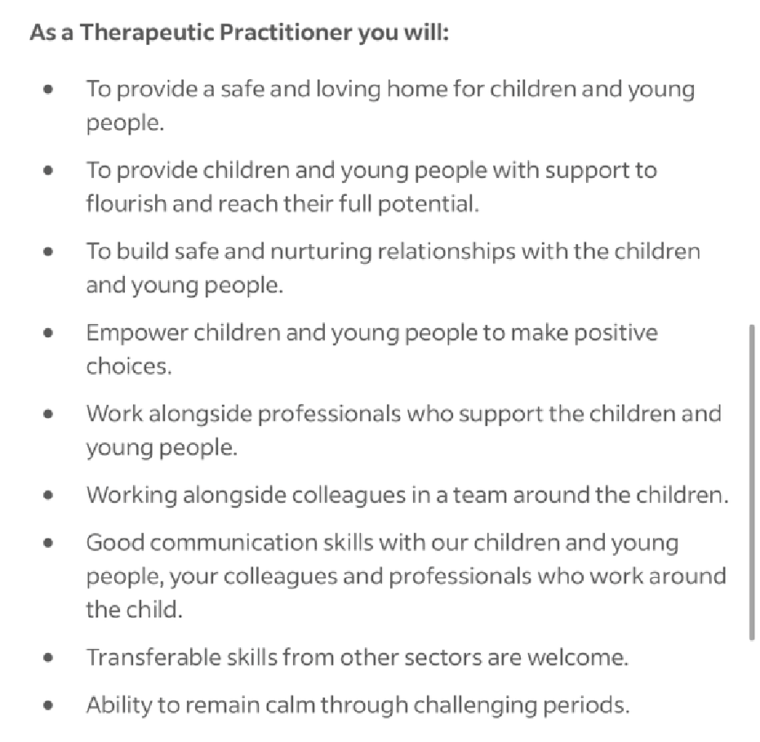
MODULE CODE: LCLM4005
JOB 1
JOB 2

Job number one is job advertisement for a Prisoner Custody Officer, and the second job is for a Support worker at a children’s residential home. Both jobs are different setting but require similar skills to apply.
Between these two jobs they both need an applicant that has;
- Good communication skills
- Ability to stay calm under pressure/through challenging periods.

Why is the having the ability to stay calm under pressure through challenging periods important?
- Make good decisions – you can think clearly instead of reacting emotionally.
- Handle difficult situations – staying calm helps you deal with challenging customers, colleagues or situations professionally.
- Communicate effectively – you are more likely to listen and explain things clearly. Work well with others – remaining calm can prevent disagreements from becoming bigger problems.
- Reduce stress – keeping calm can help you manage pressure and avoid feeling overwhelmed.
- Stay professional – employers expect staff to behave appropriately, even when situations are difficult.
- Keep others calm – your calm behaviour can reassure colleagues, customers or people you are supporting.
Staying calm is important for a Prison Custody Officer because officers may have to deal with challenging, confrontational or aggressive behaviour. Remaining calm allows the officer to communicate clearly, make appropriate decisions and use de-escalation techniques rather than allowing the situation to become more serious. HMPPS states that how staff respond to challenging behaviour is critical and that officers are expected to remain professional, fair and respectful when dealing with prisoners (HMPPS, 2025).

For a support worker working with children, staying calm is equally important because a child’s behaviour may be a way of communicating distress, frustration or difficult experiences. Remaining calm can help the worker understand the child’s triggers and respond appropriately rather than reacting emotionally. Government guidance recommends that staff understand children’s needs and triggers and use positive behaviour support and de-escalation to help defuse difficult situations (Ofsted, 2021).
Staying calm in a work setting is important because it helps employees think clearly, make appropriate decisions and communicate professionally, particularly when dealing with pressure or challenging situations. The Health and Safety Executive (HSE, 2024) explains that stress can affect the way people think and behave, including causing indecisiveness and difficulty concentrating.
Remaining calm can also help to reduce conflict and maintain positive working relationships. When employees manage pressure effectively, they are more likely to respond to colleagues and customers in a professional and respectful way. Workplace stress can negatively affect behaviour and performance, which is why managing stress is important for both employees and organisations (CIPD, 2026).

Reflective self-assessment
Strength
- Good communication skills
- Able to remain calm in difficult situations
- Good teamwork Skills
- Reliable and responsible
- Willing to learn new skills
Weakness
- Lack of confidence when public speaking
- Can lack confidence when presenting an idea
- Can become nervous
- Sometimes overthink a situation
- Literary

Opportunities
- Practise public speaking through presentations and group discussions.
- Take part in training and development opportunities.
- Ask for feedback from my tutors and colleagues.
- Use my strengths to take on new responsibilities.

Threats
- Fear of making mistakes could affect my confidence.
- Stress or pressure could affect my performance.
- Avoiding public speaking could prevent me from improving.
- Comparing myself to more confident people could lower my confidence.
- Lack of confidence could limit future opportunities
My SWOT analysis has helped me identify my personal strengths and areas that I need to improve. One of my main strengths is that I can remain calm when dealing with difficult situations and I work well with others. However, public speaking is one of my weaknesses because I can become nervous due to lack of confidence when speaking in front of a group. I recognise that this is an important skill to develop because having more confidence can help me in both education and employment. Another important skill I lack in is literature.
Good literature skills are important in a work setting because they help with reading, understanding, communicating and use information effectively. I may need to read emails, policies, instructions, health and safety information, reports and forms. Good literacy skills can therefore help me work safely, complete tasks correctly and communicate professionally with colleagues and customers.
However, people with learning disabilities or learning difficulties like me, may experience challenges with reading, writing, spelling, processing information or remembering instructions. This does not mean I cannot be successful at work as I use reasonable adjustments and different learning aids to support myself.

According to the VARK model, different learning abilities are based on four main learning preferences: visual, auditory, reading/writing and kinaesthetic. Each learner may prefer how they receive and understand information. Visual learners learn through images and diagrams, auditory learners prefer listening and discussion, reading/writing learners learn through written information, and kinaesthetic learners prefer practical, hands-on activities. Understanding these different preferences can help teachers and employers use a variety of methods to support learning and development (Fleming, 2001)
One of my learning strengths is that I am a practical and visual learner. I learn more effectively when I can watch a task being demonstrated and then practise it myself. However, I sometimes struggle when I must read large amounts of information. I therefore find it helpful to use visual demonstrations, videos, diagrams, audio support and information broken down into smaller sections.
The British Dyslexia Association (2026) recommends using different formats, such as audio, video, drawings, diagrams and flowcharts, as well as assistive technology such as screen readers and speech-to-text software, to support people who experience difficulties with reading and writing. These strategies can help me understand and remember information more effectively.
In a work or education setting, having appropriate support can help me overcome difficulties with reading and allow me to demonstrate my abilities. Employers have a responsibility to make reasonable adjustments where appropriate so that disabled workers are not substantially disadvantaged at work (GOV.UK, 2026)

Evidence of Readiness: I believe I am ready to take the next step in my career development because I have identified my strengths, weaknesses and areas for improvement through self-assessment and reflection. I recognise that public speaking and confidence are areas I need to develop. I am willing to improve these skills, and I have already acted as I had the opportunity to take part in a mock job interview that I overthought prior and felt I would not give me best due to my lack of confidence but I received good feedback from my lecture which then led me to take part in my second challenge and that was presenting my wok in front of my collages and again I was overwhelmed by the good feedback I received.
I have realised that my nervousness does not mean that I lack knowledge or ability; it is mainly my confidence that I need to develop. This has helped me identify public speaking as an area for personal development.
My learning style does not affect my ability to work or my capability of being successful in employment. I have learned throughout my life how I learn best and have developed strategies that help me understand and complete tasks effectively. I learn particularly well through hands-on activities, visual demonstrations and watching someone complete a task before practising it myself.
Having used these strategies throughout my life has helped me become adaptable, independent and confident in recognising how I learn best. Therefore, I do not see my learning needs as preventing me from working. Instead, I understand my strengths and know how to use appropriate strategies to overcome challenges. This demonstrates my readiness for employment and my ability to continue learning and developing in the workplace.

Employment Goals

My short-term employment goal is to secure a job where I can develop my communication, teamwork, leadership and confidence skills. I want to gain more workplace experience and continue developing my ability to work with different people. I also want to improve my reading and written communication skills by using the learning strategies and aids that work best for me.
My long-term employment goal is to develop a career as a keynote speaker. I want to use my personal experiences, knowledge and communication skills to inspire and motivate other people. To achieve this, I need to continue developing my public speaking, presentation, leadership and networking skills.
SMART | My employment goal
Specific | I want to improve my public-speaking and presentation skills so that I can become more confident speaking in front of groups and eventually work towards becoming a keynote speaker.
Measurable | I will practise and deliver at least one presentation or public-speaking activity each month and ask for feedback to identify areas for improvement.
Achievable | I will start with small groups and gradually work towards speaking in front of larger audiences. I will use college presentations, group discussions and relevant events to gain experience.
Relevant | Improving my confidence, communication and public-speaking skills directly supports my long-term goal of becoming a keynote speaker at conferences and events about mental health.
Time-bound | Over the next 12 months, I will regularly practise public speaking, build my confidence and gain relevant experience. I will review my progress every three months.

These employment goals align with my career aspirations because gaining workplace experience will help me build confidence and transferable skills that I can use when speaking to larger audiences. I also understand that becoming a successful keynote speaker will require continued learning, practice and professional development. My goal is therefore to use my current strengths while working on my weaknesses so that I can progress towards my long-term career ambition.

Over the next 12 months, I will improve my public-speaking and communication skills by completing at least one speaking or presentation activity each month and seeking feedback after each activity. I will gradually increase the size of my audience as my confidence develops. This goal will help me overcome my weakness in public speaking and prepare me for my long-term career aspiration of becoming a keynote speaker at conferences and events about mental health.

Harvard References
British Dyslexia Association (2026) Reasonable adjustments in the workplace. Available at: [British Dyslexia Association website] (Accessed: 18 August 2026).
CIPD (2026) Stress in the workplace. Available at: [CIPD website] (Accessed: 13 August 2026).
Fleming, N.D. (2001) Teaching and Learning Styles: VARK Strategies. Christchurch: Neil Fleming.
GOV.UK (2026) Reasonable adjustments for workers with disabilities or health conditions. Available at: [GOV.UK website] (Accessed: 18 August 2026).
Health and Safety Executive (HSE) (2024) What are the Management Standards? Available at: [HSE website] (Accessed: 13 August 2026).
Health and Safety Executive (HSE) (2024) Work-related stress and how to manage it. Available at: [HSE website] (Accessed: 13 August 2026).
HM Prison and Probation Service (HMPPS) (2025) Spotlight on Professional Standards and Behaviour at Insights25. Available at: [GOV.UK website] (Accessed: 13 August 2026).
Ofsted (2021) Positive environments where children can flourish. Available at: [GOV.UK website] (Accessed: 13 August 2026).

