University of Wales Trinity Saint David

Wales Institute of Science & Art



Fatigue Analysis of a Connecting Rod using ANSYS Mechanical
Structural Component Analysis (ACHA7030)

Ewan Evans
2200899
12/12/2025
Contents
1. Introduction 2
2. Boundary Conditions 3
2.1. Geometry 3
2.2. Mesh validation 3
2.2.1. Mixed dimensional coupling test 3
2.2.2. Bimetalic strip 6
2.3. Loads applied 7
2.4. Thermal conditions 10
2.5. Material selection 11
3. Component analysis 12
3.1. Stress and deformation analysis 12
3.2. Factor of safety and life cycle analysis 14
3.3. Implementation of thermal loading on fatigue analysis 16
4. Improvement in con rod quality 18
5. Conclusion 1
6. References 1

Introduction
FEA (Finite element analysis) is a key analysis tool used in the modern engineering world, allowing engineers to calculate complex analytical results, such as stress. These models need to have boundary conditions applied to achieve as accurate results as possible, reducing margin for error. For this report an in-depth critical analysis on the con rod located within an engine cylinder will be investigated throughout this document.
To do this study the FEA solver chosen in ANSYS FEA using various component system to improve accuracy. Information such as the geometry, pressure in the cylinder and further information were provided through various external sources. Information such as thermal loads were gathered from research and engineering understanding of what loads would be realistic. Also it needs to be stated that certain limitations of the connecting rod will be mentioned throughout the report to identify reasons for differences in results.
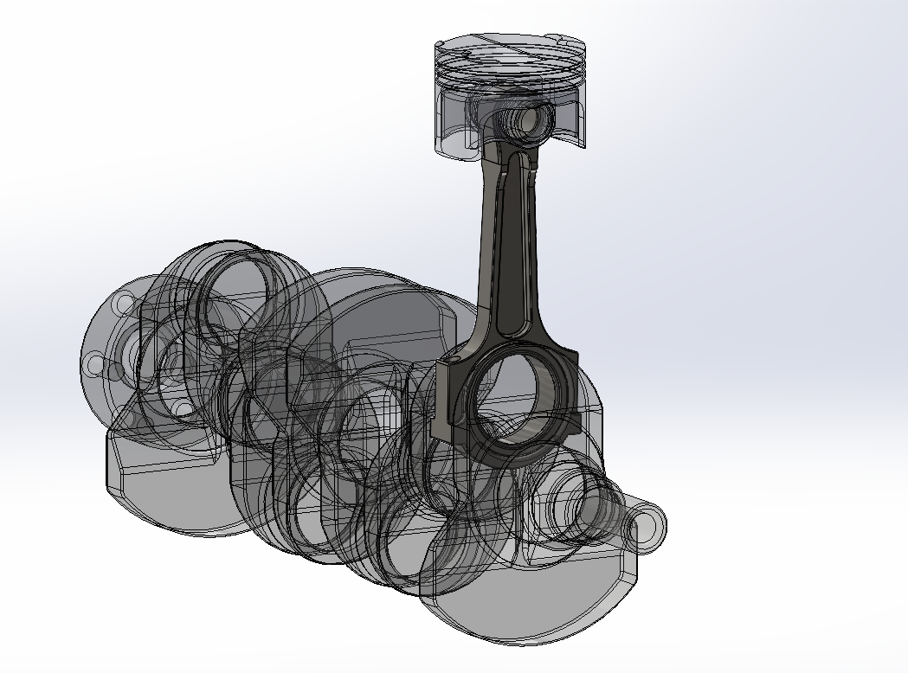
Figure 1 - Connecting rod in the engine configuration

Boundary Conditions

Geometry
It needs to be stated that having a strong set of boundary conditions that give the most relatable conditions to the real world scenario is key. A common overlooked boundary condition is the geometry of the component. This is due to stress concentrations being a common occurrence in the FEA process that would not occur in the real world, leading as to why the connecting rod has several of the edges filleted to improve the accuracy of the results.
One area that is not considered in the geometry is the implementation of the con rod bolts and the effect of which these have on the connecting rod, as well as this in the real world these con rod bolts would combine the con rod and con rod cap, which this does not take into account.

Mesh validation
As well as this, the geometry needs to be able to allow a mesh to replicate the component investigated accurately to understand the results as accurately as possible. An improved mesh results in an increased level in accuracy of results. Therefore, a mesh study is a key aspect that should be analysed beforehand to validate the software being used. As shown below these mesh results are carried out to compare them against the analytical results.

Mixed dimensional coupling test
A strong and well recognised testing method is the cantilever beam. However, to make this more applicable to the scenarios that a connecting rod will see, a mixed dimensional coupling test that has too loads acting alternative directions is carried out.
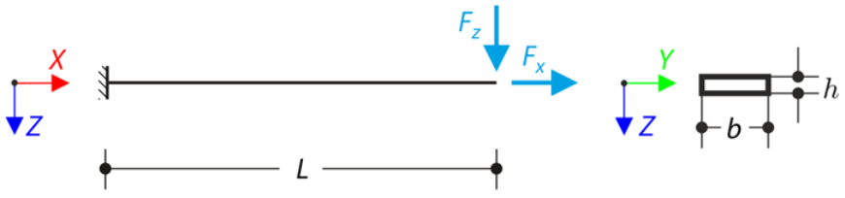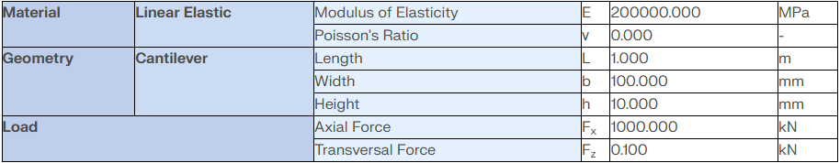
Figure 2 - Diagram and constraints applied in the mixed dimensional coupling (Dlubal, 2025)

Equation 1 - Analytical calculations for axial deformation
$$u_{x}=\frac{F_{xL}}{Ebh}$$
$$u_{x}=\frac{1x{10}^{6}*1}{200x{10}^{9}*0.1*0.01}=5.00mm$$

Equation 2 - Analytical calculations for transverse deflection
$$u_{z}=\frac{4F_{z}L^{3}}{Ebh^{3}}+β\frac{2F_{z}L}{Ebh}$$
$$u_{z}= \frac{4*100*1^{3}}{200x{10}^{9}*0.1*{0.01}^{3}}+β\frac{2*100*1}{200x{10}^{9}*0.1*0.001}=20.001mm$$

Equation 3 - Analytical calculations for total deflection
$$u= \sqrt{u_{x}^{2}+u_{z}^{2}}$$
$$u= \sqrt{5^{2}+{20}^{2}}=20.617mm$$

When comparing the FEA results to the analytical results in there is a small difference, however as shown in the mesh study the deformation is not changing significantly between the varying mesh sizes. Therefore suggesting that as long as the mesh size reaches a point at which the deformation does not change significantly the mesh chosen can become valid.

Figure 3 - Mesh study for the mixed dimensional coupling

Bimetalic strip
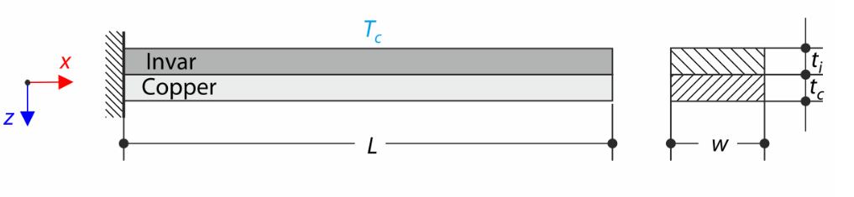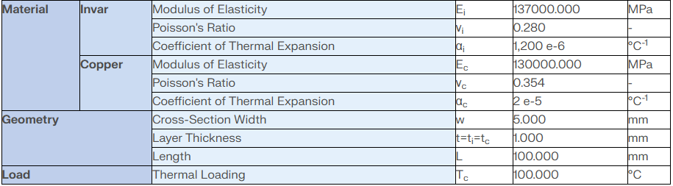
Figure 4 - Diagram and constraints applied in the Bimetalic strip (Dlubal, 2025)

Equation 4 - Analytical calculations for dimensionless coefficient of equivalent stress
$$K1=4+6 \frac{t_{c}}{t_{i}}+4{ (\frac{t_{c}}{t_{i}})}^{2}+ \frac{E_{c}}{E_{i}} {\left(\frac{t_{c}}{t_{i}}\right)}^{3}+ \frac{E_{i}t_{i}}{E_{c}t_{c}}$$
$$u_{z}\max{=\frac{6\left(α_{i}-α_{c}\right)\left(t_{i}+t_{c}\right)T_{c}}{t_{s}^{2}K_{1}}} \frac{L^{2}}{2}$$
$$u_{z}\max{= 7.049 mm}$$

When looking first hand at the results there seems to be a significant difference, however when looking at the numerical difference between the results the overall difference is minute.

Figure 5 - Mesh study for the bimetallic strip mesh study

It should be stated that the mesh size used for the con rod was at 1mm with a smaller mesh size applied to the small end bearing due to the pressure loads being applied at this point.

Loads applied
Loads being applied to the system undoubtably have a significant influence on the results taking place. To replicate the loads as accurately as possible the rigid dynamic system is utilised to apply a rotational velocity to the crankshaft. The motion load for both the small and big end bearings are recorded at max tensile and compressive loads in the X and Y direction. These loads are applied as bearing loads in the static structural to simulate the loads being applied through eh crankshaft and gudgeoned pin.

Table 1 - Loads applied to the connecting rod
 | Loads being applied to the connecting rod | Tensile Load | Compressive Load
Small end bearing | X Force (N) | -7829.6 | 4511.4
Small end bearing | Y Force (N) | 910.34 | -1070.1
Small end bearing | Force from the gas pressure (N) | 28545.8 | 264.882
Big end bearing | X Force (N) | -15962 | 11719
Big end bearing | Y Force (N) | -1070.1 | -535.92
Big end bearing | Force from the gas pressure (N) | 28545.8 | -381.603

The gas pressure needs to be taken into consideration as this will drastically effect the loads applied to the system. Due to no direct pressure being able to be applied to the system a force is calculated and applied once again as a bearing load through the small end bearing. The tensile load was chosen at max pressure due to the force levels the combustion applies whereas the max compressive load is when system sees max X forces as this is the largest force in this scenario.

Equation 5 - Equation for force of the gas pressure at peak combustion
$$F=P*A$$
$$F=72.631x{10}^{5}N/m^{2}*4.902x{10}^{-3}m$$
$$F=35601.32N$$
To simulate the angle at which the rod sees the loads are applied to it the global coordinate system for the specific load is shifted to represent the rod angle in relation to what the crank angle is, as shown below.

Equation 6 – Rod angle for varying points at which loads are taken
$$Rod angle=\frac{\sin^{-1}((Crank radius*\sin\left(Crank angle\right))}{Rod length}$$

$$Rod angle@{Tensile both big and small end bearing}= \frac{\sin^{-1}((0.041m*\sin\left({14}^{o}\right))}{0.135m}$$
$$Rod angle@{Tensile both big and small end bearing}={4.179}^{o}$$

$$Rod angle@{Compressive small end bearing}= \frac{\sin^{-1}((0.041m*\sin\left({146}^{o}\right))}{0.135m}$$
$$Rod angle @{Compressive small end bearing}={9.700}^{o}$$

$$Rod angle @{Compressive big end bearing}= \frac{\sin^{-1}((0.041m*\sin\left({175}^{o}\right))}{0.135m}$$
$$Rod angle @{Compressive big end bearing}={1.504}^{o}$$

Validation of the rigid dynamic can be proven through the analytical vs FEA motion loads as shown below. There is a small discrepancy, but is likely due to the moving components within FEA simulating motion loads to a higher level of accuracy than the hand calculations.
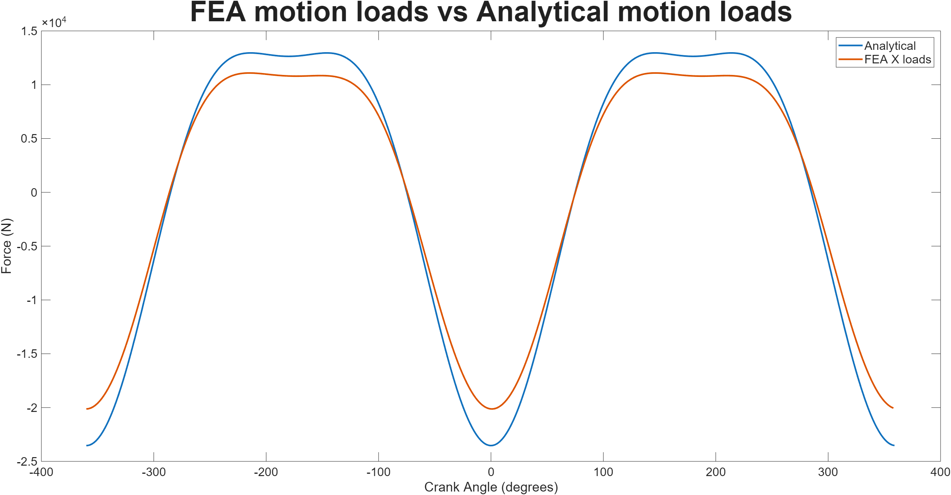
Figure 6 - Analytical vs FEA motion load study
One limitation to how the loads are being applied in the simulation is that loads are not being applied simultaneously at both ends of the bearing and that only the small end bearing or the big end bearing is being looked into.

Thermal conditions
Thermal aspect is an aspect that is generally always taken into consideration during FEA process for engine components. Therefore, implementation of these through a steady state thermal could be utilised. The connecting rod does not see drastic thermal loads and therefore only 120 to 100 degrees Celsius (small end bearing to big end bearing) will be implemented suing a thermal film coefficient of 162 W/m^2 Degrees will be used (Kumar, date unknown). However as will be addressed later on in the report for connecting rod analysis it is common for the thermal loads not to be taken into account when doing connecting rod analysis (MAHLE 2016).
Throughout the fatigue study the thermal is assumed to not be applied unless specified and will become clear as to why further on.

Material selection
Material choice needs to be carried out to accurately represent how the boundary conditions will affect the stresses, strains and other analysis details that are altered due to the material properties selected. The material chosen for the baseline analysis is an annealed Carbon Steel 1141 (S.Change, James.Hoffman,1989), due to various sources suggesting the use of steel alloys (Dr Galewski , date unknown).

Component analysis
Once these boundary conditions are applied analysis of various different results can be conducted, to gain an understanding of how the different boundary conditions affect the component.

Stress and deformation analysis
When comparing the analytical to the FEA stresses seen on the component there is some limitations of this analysis. One of these limitations is the geometry of the component. This is due to the analytical methods using the same cross-sectional area as a selected point within the con rod. However, the physical geometry used in the simulation is an unsymmetrical bar in this region as well as the edges having fillets to control the stress concentrations. Furthermore, other stress concentrations can propagate into the region, increasing the overall stress in this area.
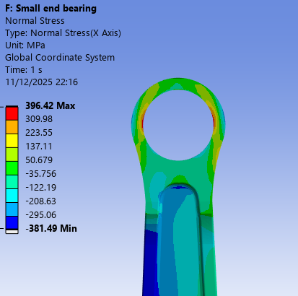
CSA location

Figure 7 - Normal stress (Mpa) when small end bearing loads applied
Above shows the distribution of the load being applied to the con rod deviates laterally across the rod where the CSA (cross sectional area) is located. Therefore, when comparing it to the analytical results calculated using the formulas below it shows that the calculated is around where the minimum stress in this area and that the additional stress occurs due to the geometry.
Equation 7 - Inertia force calculation
$$Inertia force=Recipricating mass*Angular acceleration$$
$$Recipricating mass=Pin mass+Piston mass+\frac{1}{3} Rod mass$$
$$Recipricating mass=0.0768Kg+0.7436Kg+ \frac{1}{3}0.4156Kg$$
$$Recipricating mass=0.959 Kg$$
$$Inertia force @ peak pressure=0.959* {23312}^{o}/s$$
$$Inertia force @ peak pressure=22356N$$

Equation 8 – Force Compressive calculation
$$Force_{Compressive}= Inertia_{Compressive}-Force_{gas}$$
$$Force_{Compressive}=22356N-35601.32 N$$
$$Force_{Compressive}=-123245N$$

Equation 9 – Stress compressive
$$Stress_{Compressive}=\frac{Force_{Compressive}}{Cross sectional area}$$
$$Stress_{Compressive}= \frac{-123245N}{140{mm}^{2}}$$
$$Stress_{Compressive}= -93Mpa$$

When looking at the deformation of the component, the big end bearing exceeds a higher small end bearing values. A significant influence on these results stems from the motion loads being differing significantly more in scale between the big end bearing compared to the small end bearing.
Table 2 - Small and big end bearing stresses and deformation
 | Minimum Stress (Mpa) | Maximum Stress (Mpa) | Total deformation (mm)
Small end bearing | -405.38 | 403.82 | 0.765
Big end bearing | -411.74 | 521.56 | 1.734

Factor of safety and life cycle analysis
Factor of safety and life cycle analysis is key to understand the longevity of a component amongst its application. Therefore, analysing this area is key to removing any chance of failure in the real world. It is understood that within industry a factor of safety between 1.25 and 1.5 is expected depending upon the components scenario, whilst the life cycle in this case is for an infinite life cycle (1e8 in the case of ANSYS FEA).
Table 3 - Small and big end bearing showing life cycles and Factor of Safety
 | Minimum life cycle | Minimum Factor of safety
Small end bearing | 1.596e7 | 0.935
Big end bearing | 1e8 | 1.0136

The main culprit for the low factor of safety is the material being used is not at a high enough tensile strength. Therefore, when thermal loads are applied the loads are significantly worse and would almost instantaneously fail due to the FOS being less than one. An improvement in the material being used or the finishing/ curing process can enhance the FOS and fatigue life of the component.
A reason for the significant deviance in the analytical compared to the FEA is through the FEA study having a small region of lower life cycle (in red) compared to the surrounding region (yellow/blue) as shown in the figure below.
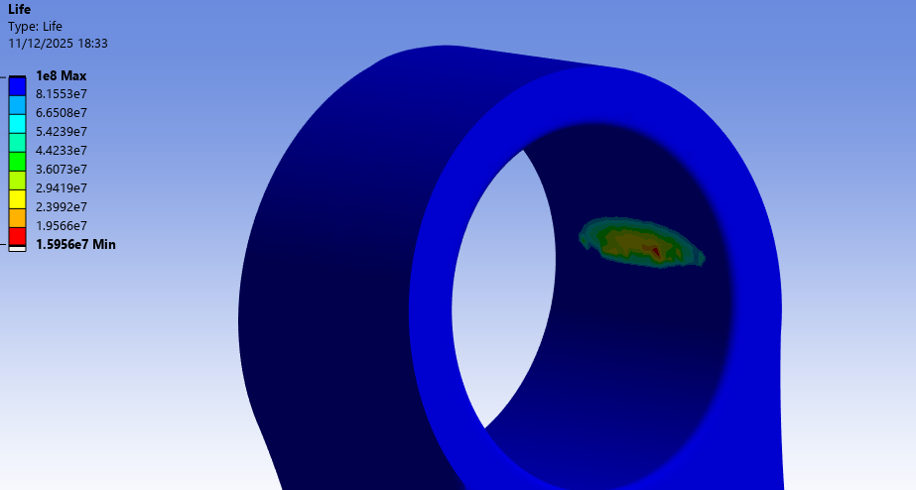
Figure 8 - Deviation in accuracy of life cycle accuracy on the small end bearing
Even though the big end bearing has a higher FOS (factor of safety) this stems from the component having a larger amount of material there, resulting in an increase in compensation of the larger loads it sees in comparison to the small end bearing. However, this difference between the small and big end bearing is minute and therefore should not be investigated to critically.
Table 4 – Analytical vs FEA for factor of safety
 | Analytical results | FEA factor of safety output
FOS (factor of safety) | 1.845 | 0.935

When comparing the analytical to the calculated factor of safety, there is clear differences in results. This stems from the nock on effect of small differences throughout the analytical methods stacking up as well as more importantly no stress concentrations or the geometry itself is considered.

Implementation of thermal loading on fatigue analysis
As mentioned earlier due to other studies not considering the thermal loading of the rod it was decided not to implement the thermal conditions until this point. However, after implementing the loads, it became clear as to why industry does not apply thermal loadings. The thermal loadings did not have a significant influence on the fatigue results and ultimately changed some values in unrealistic trends as shown below.
Table 5 – Thermal loading implementation and its impact on fatigue
 | Minimum life cycle | Minimum Factor of safety
Small end bearing (no thermal load) | 1.596e7 | 0.935
Big end bearing (no thermal load) | 1e8 | 1.0136
Small end bearing (thermal loading) | 1e8 | 1.005
Big end bearing (thermal loading) | 6.212e6 | 0.930

As well as this the distribution of the factor of safety changes significantly, giving an increased level of uncertainty to the results. This can therefore lead to a clear issue in the accuracy of the results due to this issue and is an area that needs to be analysed fully.
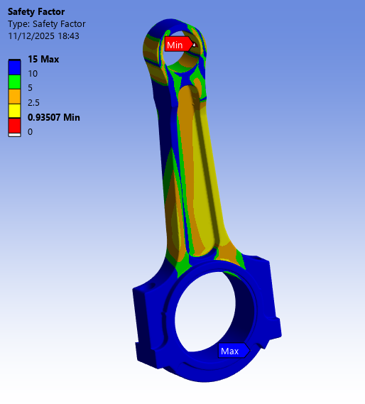  Figure 9 - Factor of safety for the con rod without thermal loads to the small end bearing test | 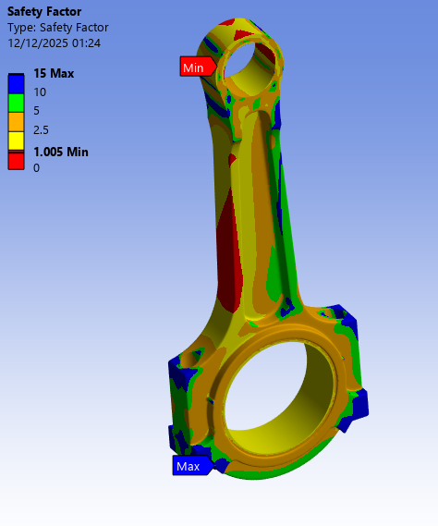  Figure 10 - Factor of safety for the con rod with thermal loads applied to the small end bearing test

Improvement in con rod quality
To improve the reliability of the con rods factor of safety and life cycle analysis of this component various boundary conditions identified earlier can be analysed and improved upon. One key fundamental aspect is the material the component is made from as this will affect the loads being applied. As well as the endurance limit and UTS being used in the calculation of the factor safety and life cycle of the component. To do an improvement of the component’s quality is by quenching the component to improve the tensile strength of the material.
When looking into the results, the small end bearing shows an improvement, whilst the big end bearing shows a significant decrease in results. This is due to some stress concentrations appearing and therefore in the real world this is likely to not exist. Meaning when looking at figure____, the rest of the component achieves a value greater than previously and proves the improvement in the material.
 | Minimum life cycle | Minimum Factor of safety
Small end bearing (not quenched) | 1.596e7 | 0.935
Big end bearing (not quenched) | 1e8 | 1.0136
Small end bearing (quenched) | 1e8 | 1.010
Big end bearing (quenched) | 1e8 | 0.948

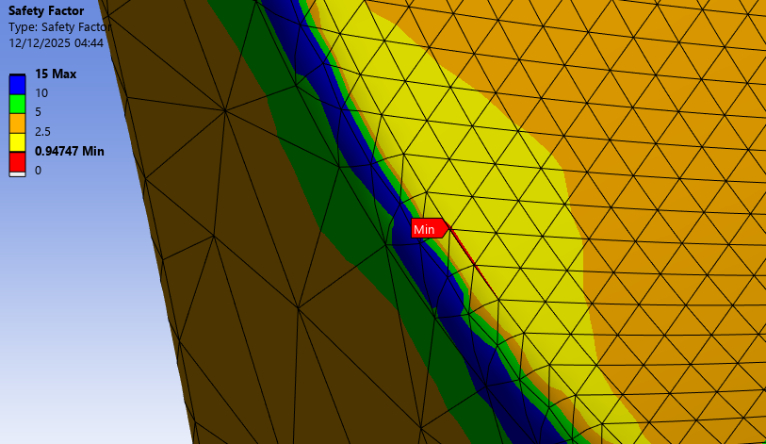
Figure 11 - Factor of safety for the connecting rod in the big end bearing test

Conclusion
FEA is highly intricate tool that if the boundary conditions are applied correctly can give accurate results. When comparing results that are given out it needs to be considered the difference between the raw number and the actual distribution of the loads as shown in the change in material of the connecting rod. To continue having a material that has a higher tensile strength ultimately results in an increase in factor of safety and enhances the components performance going forwards. As well as this the thermal loading being applied to the con rod is complex to complete accurately and removing the thermal influence can increase the accuracy of results.

References
MAHLE GmbH, editor. (2016). Cylinder components : properties, applications, materials (2nd edition.). Springer Vieweg. (accessed 11/12/2025)
Finite lement analysis of connecting rod and correlation with test2009. SAE MOBILUS. (accessed 9/12/2025)
DLUBAL, 2025a. VE0035 - Mixed dimensional coupling. DLUBAL. (accessed 9/12/2025)
DLUBAL, 2025b. VE0078 | Bimetallic Strip. (accessed 9/12/2025)
DLUBAL, 2015. 0004 - Stability of a Beam Subjected to the Combined Loading. DLUBAL. (accessed 12/12/2025)
DR GALEWSKI, Connecting rod basics. (accessed 9/12/2025)
KUMAR, M., A Finite Element Thermo-Mechanical Stress Analysis of IC Engine Piston. IRJET. (accessed 10/12/2025)
NAM S.&NBSP, CHANG, AND&NBSP, JAMES H.&NBSP and HOFFMANN, 1989. Evaluation of control cooled, NB-treated SAE 1141 steel connecting rod. SAE MOBILUS. (accessed 9/12/2025)

