https://www.retailgazette.co.uk/blog/2014/12/42101-john-lewis-ranked-as-best-retailer-to-work-for-in-the-uk/

John Lewis ranked as best retailer to work for in the UK
By
Veebs Sabharwal
-
December 10, 2014
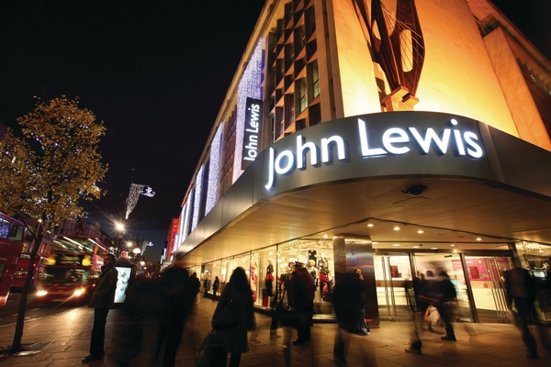
Career community Glassdoor has announced the winners of its seventh annual Employees‘ Choice Awards which honours the Best Places to Work in 2015 across the UK and the U.S.
Unlike other workplace awards, the Employees‘ Choice Awards are based entirely on the anonymous and voluntary input of employees who provide feedback, via a review survey, about their job, work environment and company.
Winners were ranked based on their overall company rating achieved during the past year, with ratings based on a 5-point scale:
1.0 very dissatisfied, 3.0 – OK and 5.0 – very satisfied.
Google came in at no.1 as the top company to work for in the UK but British retailer John Lewis ranked at a very close no.2
John Lewis, which this year celebrated its 150th anniversary, is an employee owned company made up of ‘partners‘. These partners “share the responsibilities of ownership as well as its rewards of profit, knowledge and power”, one advantage of which includes the annual bonus, where a proportion of profits is distributed equally as a percentage of partners‘ salary.
The department store chain, which has previously won awards for being the ‘nation‘s favourite retailer‘ also offers a non-contributory final salary pension scheme, one of the companies left that does. Retired partners who have completed 10 years‘ service are entitled to identical benefits as working partners, which includes a 25% discount off products (12.5% on electrical goods) and a 15% discount at Waitrose. These discounts are on top of in-store promotions, for example during ‘Price Match‘ campaigns.
As well as half price theatre and concert tickets and subsidies for selective educational and leisure course, there are also sabbatical and extended leave opportunities.
25 years‘ service at John Lewis grants partners six months paid holiday.

