The importance of effective communication for young children’s learning and development during transitions.
By Rory Butterfield
(2312708)

(Image 1)

Contents

- Transitions: Pages 1-3

- The needs of the child: Page 4

- The role of the adult: Page 5

- Partnerships: Page 6

- Interventions: Page 7

- Proposed outcomes: Page 8

- References: Pages 8-9

(Image 2)
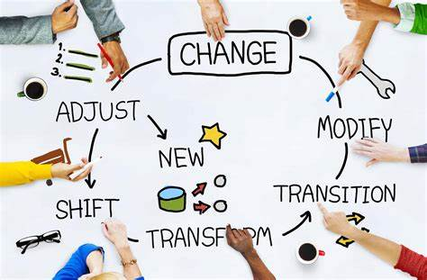

Transitions
What are transitions?
Transitions are something that everyone goes through on a regular basis from birth all the way through to adult life. Some people thrive on transitions whilst others find them incredibly challenging and stressful. Education Scotland (2023) define transitions as the moves young people make from home to an early learning or childcare setting, onwards from there to primary school, from stage to stage, primary to secondary, between schools and from secondary possibly onto further education or the working world. They go on to note that transitions and changes are part of everyone’s lives, as previously mentioned, and that the vast majority of young people look forward to moving on. However, they admit that some transitions can be challenging and support from staff and parents is key in allowing transitions to be as smooth as possible.
Why are transitions important and how do we know this?
Supporting Positive Transitions in the Early Years: Guidance for Practitioners Guidance and documents to help Early Years staff support successful transitions for children into, within and from their setting Early Years Educational Effectiveness Team and SEND Team, (2023) suggest that transitions are a point in which a child makes a significant move from one part of their education journey to another. Within the setting of early years transitions can include starting in a setting, changing rooms within that setting, moving from one setting to another before eventually moving up to school. During my practice in a junior school setting, I have seen many children transition from year group to year and eventually from junior school to comprehensive school. This shows that even into young adulthood transitions play a key role in that person’s life and are incredibly important.
Supporting Positive Transitions in the Early Years: Guidance for Practitioners Guidance and documents to help Early Years staff support successful transitions for children into, within and from their setting Early Years Educational Effectiveness Team and SEND Team, (2023) continue to say that positive transitions are so important as they support the child’s emotional wellbeing and development, the quality of the transition can impact on the child’s ability to play, learn and feel safe in the setting they are in. The manner in which the first transitions in a child’s life are handled can have a significant effect on that child’s capacity to deal with change in both the long and short term, so if their initial transition into starting a setting is a negative one this could then have a detrimental effect on future transitions such as starting school or moving on from primary education to secondary education.
McLeod (2023) looks at Maslow’s theory of hierarchical needs (1943). He states that Maslow believed that human needs should be arranged in a hierarchy, with physiological needs at the bottom and the more intellectual and creative self-actualisation needs at the top. He goes on to say that Maslow argued that for an individual to satisfy the higher needs they must first satisfy the physiological or survival needs. The survival needs Maslow notes are things such as food, drink, shelter and warmth. These are requirements that all early years settings need to provide in order to achieve a positive first transition for a child in to their first settings. Physical survival is a humans most basic need and will ultimately motivate the behaviour of a child in a setting, the human body cannot function optimally if those initial needs are not met, McLeod (2023) goes on to say that Maslow considered physiological needs the most important as all other needs become secondary until they are met.
Further up the hierarchy are two more needs that a positive transition can also satisfy, safety needs and love and belongingness needs. McCleod (2023) goes on to say that humans want to experience order, control and predictability in their lives, and this is something that early years settings can provide during a transition. By communicating clearly with both the child and their parents during a transition will allow them to feel in control of the situation and predict what is going to happen which can only be beneficial for a positive transition.
Finally, McLeod (2023) states that Maslow was of the belief that when both physiological and safety needs are met the third level of human needs is social and involves the feeling of belongingness. This refers to the human emotional need for interpersonal relationships, connectedness, affiliating and being part of a group. Welcoming a child into a setting and meeting both their physiological and safety needs will help to nurture the relationship of the child and the professional and also help the child build friendships with their peers and feel a part of the group. This will have an incredibly positive effect on the transition the child goes through, however this can also be a contributing factor on why transitions can be incredibly challenging for some children as they have to leave those relationships and connections behind to begin the hierarchy once again, this is why positive transitions are incredibly important not just in early years but throughout a person’s life.
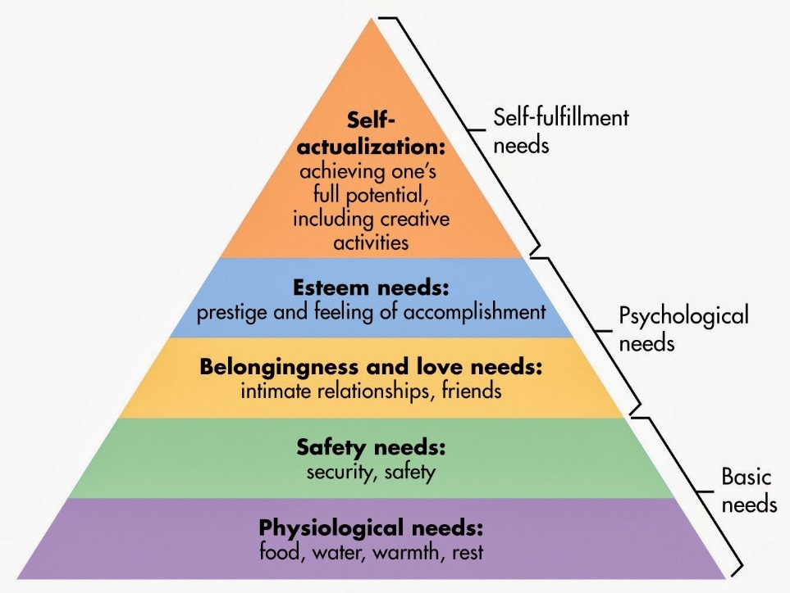
(Image 3)

How can smooth transitions benefit children and their families?
A best practice guide on the transition from the home into the early years setting from Norfolk County Council (no date) states that to ensure a transition is good and positive the parent or guardian of the child has to be valued as the first educator of the child. The parent or guardian plays a pivotal role in the very early development of a child. Linking back to Maslow’s hierarchal theory it’s down to the parent or guardian to provide those physiological, safety and belongingness and love needs the child depends on from the day they are born. If they meet these needs, it will give the child the best possible chance of transitioning well into an early years setting. If this is the case, then the early years setting then take on the responsibility of ensuring those needs are met. If they can ensure that the transition is smooth and they do meet the needs of the child then it will benefit the parent child exponentially, as according to Maslow’s hierarchal theory they will eventually achieve self-actualization and reach their full potential which can only be a positive in the eyes of both the parent and child.
According to a handbook on good practice in transitions within early years by Oxfordshire County Council (2019), involving a parent/carer in the transition process can reduce anxiety greatly not only for them but for the child too. They go on to say that sending a child to a setting for the first time can be an extremely daunting experience not only for the children but the adult also. If the adult had negative experiences within education, they may seek reassurance from the professionals working in the setting that their children are going into that the same is not going to happen to them. By letting the adult know that their children are going to be safe, that the setting will value the learning from the home, responding to and respecting the child’s cultural values and responding to the child’s uniqueness will help ease the stresses both the adult and child feel about the transition process.
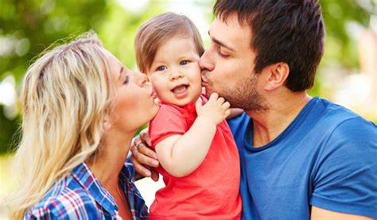
(Image 4)

What does the evidence tell us about what children need in times of transition?
Many theorists believe that the needs of the child are the focal point of any transitions and as a result have compiled evidence over many years to support this claim. If we look at Erickson’s stages of development (1958) he breaks the human life down into 7 stages of development or transition and clearly lays out the consequences of what can happen to the child if they do not receive what they need in times of transition. He begins by saying that the first stage is infancy, which he categorises as birth to 18 month. He notes the key event at this stage to be feeding, he believes that children being fed even at such an early age helps build trust with their givers and consequently a lack of this will lead to mistrust from the child to the caregiver which will have a detrimental effect on transitions going forward.
He then moves on to the second stage of development, early childhood. He believes the biggest challenge that the 2- and 3-year-olds in this stage face is the battle of autonomy vs shame and doubt. A transition most children in this age bracket face is that of toilet training. They need to form a sense of control over personal skills and also independence. Being successful in this transition will encourage autonomy however, failure will result in the child feeling ashamed and then have a negative effect on further transitions in their lives. Encouraging the child and reassuring them as a practitioner in a setting will allow them to feel less shame and doubt, with them persevering and eventually achieving autonomy. As Maslow (1943) stated the child needs to feel safe and secure in the setting they are in if they are going to transition well and develop. If the setting can encourage them to persevere and not feel shame and doubt this will in turn allow them to feel safe and secure, which is essential.
Attachment issues can be one of the biggest stumbling blocks when it comes to a child experiencing a positive transition. Bowlby (1997), defines attachment as a clinical term that is used to describe “a lasting psychological connectedness between human beings.” According to Bowlby (1997) a child is born with innate tendencies to seek direct contact with an adult, usually their mother. According to NSPCC learning (2021), attachment theory highlights the importance of the emotional bond between a child and their primary care givers. They go on to say that disruption to or loss of this bond can affect a child emotionally and psychologically to such an extent that it will have a detrimental effect on their adult lives and as a result damage relationships in the future.
Bowlby (1997) states that children can form attachments with more than one caregiver however, the bond they build with the people who have provided close care from a young age often proves to be the most enduring and important. This clearly shows that the role of professional is pivotal as the way they care for and interact with the child not only benefits their transition in the short term in their setting but also goes on to benefit that child’s life as a whole. If they key people in the child’s life can all work together, then the child has the best possible chance of going through smooth transitions which is not only going to stand them in good stead at a young age but throughout the rest of their lives.
Role of the adult
The role that the adult plays in transitions cannot be underestimated. Both the parents/guardians of the child and the professionals working in the setting have a great responsibility in assuring that the child has the best experience possible when in the transition period. The Educator (2017) believes that the principle of well-planned transitions alongside working with parents to ensure that the child’s needs are met is embedded in Early Years practice. They go on to list a large number of tips that practitioners should consider when coming up with transition policies and procedures. They believe that the parent/guardian should be central to the transition process including things such as, offering a welcome pack to caregiver containing pictures of staff in the setting and the provision itself. This will allow the caregiver and child to become accustomed to who they’re going to be coming into contact with and will allow familiarity to develop as soon as possible. Furthermore, they believe that the practitioner should be made aware by the caregiver for as much information as possible about the child prior to them joining the setting. Things such as their feeding, changing and sleeping routine for example being made as clear as possible will have a positive effect on how the transition develops over time.
McLeod (2023) looks at Vygotsky’s social development theory (1934,1978) as a clear indication as to why the role of the adult is so important in a child’s life in general and not only in transitions. He goes on to say that Vygotsky believed that developing cognitively is intrinsically linked to cultural and social factors. Vygotsky (1934,1978) really put emphasis on the role of social interaction in developing mental abilities such as speech and reasoning in children. McLeod (2023) goes on to note that Vygotsky (1934,1978) believed that cognitive development is a socially mediated process where children acquire and develop beliefs, cultural values and problem-solving skills through more knowledgeable members of society. So, in the case of Early Years transitions, the practitioner plays a key role as the more knowledgeable member of society in ensuring the children in their setting develop those skills previously mentioned, as well as ensuring that the children are safe, happy and nurtured.
Finally, McLeod (2023) states that Vygotsky’s theory can be linked to two educational strategies, scaffolding and reciprocal teaching. He goes on to say that as Vygotsky’s theory encourages cooperative and collaborative learning between children and their teachers. Scaffolding involves the teacher or adult in the setting providing support structures to encourage mastery of skills just beyond the child’s capabilities, whilst reciprocal learning has a greater emphasise on teachers or adults taking turns with the child on leading discussions and strategies. In an Early Years transition is most likely that the scaffolding technique will be used more often as developing mastery of skills encourages confidence and as a result will allow the child to feel more settled in the setting they are transitioning into.

Partnerships
Practitioners building strong partnerships with caregivers, external agencies and other stakeholders is essential for a child to experience positive transitions in Early Years. Wilson (2016) states that the development of partnership with caregivers is not only beneficial for the children in that setting but also has a value to wider society. Developing that trusting relationship offers opportunities to receive support and information, which in turn can lead to more intensive support for the child in question if necessary. If there is not a strong partnership between the professional and the caregiver, then the professional may find it more challenging to identify areas in which the child needs help with. The support of the child’s caregiver and a strong partnership with them will enable the professional to provide support to the child when they need it most. Furthermore, building that supportive relationship and strong partnership with the child’s caregiver can increase trust and as a result enable parents to share anxieties and concerns more readily.
Wilson (2016) continues by saying that referrals to other agencies that you have strong partnerships with is also key to the child’s development. By identifying emerging behavioural or cognitive problems, through building the partnership with the child’s caregiver, it is possible to share ideas with parents to modify behaviour patterns and if necessary, redress potential problems at the earliest stage possible. Without building the initial partnership with caregivers the partnership with other external agencies cannot follow. The trust of the child’s caregiver will enable the practitioner to approach them with concerns about their children and possibly refer them on to other agencies such as educational phycologists or different therapists. Moreover, developing the partnerships with those external agencies will allow positive and important conversations to be had which will have a great benefit on the children who need their support throughout their lives.

(Image 5)
Early Education (2021) state that working in partnership can have long term benefits such as working together to help children who attend more than on setting. Building a partnership with the other settings they or their siblings attend will provide an opportunities for a more consistent approach and will allow more advice and support. This will encourage families to be supported in a more holistic manner. For example, if a child’s attendance is poor and they have siblings in another setting where they have identified a similar issue then a common approach across the two settings can be trialled and if necessary, an external agency such as social services can be brought in if necessary.

Interventions
During my practice working with children aged 10 and 11 I have experienced many children going through the challenging transition of leaving the primary school setting and moving on to the comprehensive school setting, one that can be incredibly trying for the children. During this time of change and uncertainty other practitioners in my setting and I provide a number of transition interventions in the hope of making the transition as smooth and positive as possible. We take the children on a number of transition days to their chosen comprehensive school as well as running weekly transition support groups in school time.
The transition days at their chosen comprehensive school links back to Maslow’s theory of hierarchal needs (1943). By allowing the child to experience the setting they are going to be transitioning into will allow them to meet the safety needs that Maslow specifies. By getting to know the layout of the school including entrances, exits and the rooms of the key people who are going to be in their new setting will allow them to feel safer and more secure in that setting, which Maslow deems as important. Furthermore, the children meeting some of their new teachers and peers from other primary schools will allow them to start building relationships with them prior to the transition itself. Thus, meeting the belongingness and love needs that Maslow states is required for a child to develop.
Finally achieving tasks set by the comprehensive teacher on the transition days will allow the child to feel a great sense of accomplishment and achievement which will fulfil the self esteem needs that Maslow notes on his hierarchal theory. Even if the task is pitched at a level suited to a primary school child rather than a comprehensive school child, just completing it within the comprehensive school setting will build the child’s confidence which will in turn aid their transition when the eventually make the move from the primary setting to secondary setting. In my years of practice working with children aged 10 and 11, it has been clear to me that children who have partaken in the most transition days make the smoothest transition into their new setting.
(Image 6)
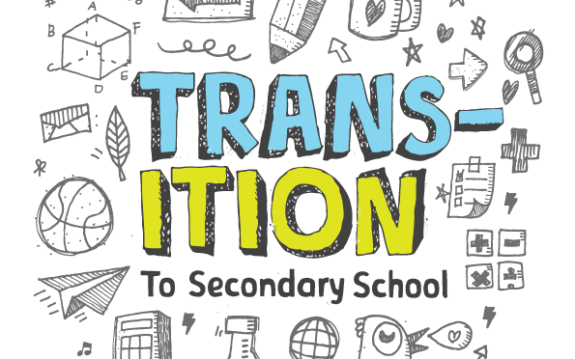

Proposed Outcomes
To conclude, many theorists over many years have compiled evidence pointing to the facts that it is not just the professionals in the setting the child is in that determine how transitions in that child’s life are going to manifest. It is down to the child’s caregivers, professionals within the settings they are in, as well as other external agencies that will determine how transitions in that child’s life will go. Finally, linking back to Maslow (1943) once more, there are a wide range of needs that a child needs meeting to develop and reach their full potential and it is down to all the adults in that child’s life to ensure that happens.

References
admin (n.d.). Managing Transitions in Early Years – The Educator Magazine UK. [online] Available at: https://www.the-educator.org/managing-transitions-early-years/. (Accessed 28th November 2023)
Anon, (2021). Working in partnership – Early Education. [online] Available at: https://early-education.org.uk/working-in-partnership/. (Accessed 28th November 2023)
Ayoola, A. (n.d.). MASLOW HIERARCHY OF NEEDS. www.academia.edu. [online] Available at: https://www.academia.edu/50258320/MASLOW_HIERARCHY_OF_NEEDS. (Accessed 21st November 2023)
‌Image 6: blogs.glowscotland.org.uk. (2019). Primary-Secondary Transition | 2019 Primary 7. [online] Available at: https://blogs.glowscotland.org.uk/ea/onthankp7/2019/11/29/primary-secondary-transition/ (Accessed 28th November 2023)
Bowlby, J. (1969). Attachment and loss. London: Pimlico.
Education Scotland (2023) What are transitions? Available at https://education.gov.scot/parentzone/my-child/transitions/what-are-transitions (Accessed 8th November 2023)
McLeod, S. (2023). Maslow’s Hierarchy of Needs. [online] Simply Psychology. Available at: https://www.simplypsychology.org/maslow.html. (Accessed 21st November 2023)
Mcleod, S. (2023). Vygotsky’s Sociocultural Theory of Cognitive Development. [online] Simply Psychology. Available at: https://www.simplypsychology.org/vygotsky.html. (Accessed 28th November 2023)
‌NSPCC (2021). Attachment and child development. [online] NSPCC Learning. Available at: https://learning.nspcc.org.uk/child-health-development/attachment-early-years. (Accessed 28th November 2023)
‌Psychological Health Care. (n.d.). Child Psychologists Perth | Parent Child Counselling. [online] Available at: https://www.psychologicalhealthcare.com.au/services/child-psychologist/. (Accessed 21st November 2023)
Image 1: Shelley F Knight (2021) Transitioning from primary school to secondary school. Available at https://shelleyfknight.com/blog/transitioning-from-primary-to-secondary-school/ (Accessed 8th November 2023)
Smooth Transitions in the Early Years: A Good Practice Guide. (n.d.). Available at: https://www.oxfordshire.gov.uk/sites/default/files/file/early-years-childcare/smoothtransitionsintheearlyyearsagoodpracticeguide.pdf. (Accessed 28th November 2023)
Supporting Positive Transitions in the Early Years: Guidance for Practitioners Guidance and documents to help Early Years staff support successful transitions for children into, within and from their setting Early Years Educational Effectiveness Team and SEND Team. (2023). Available at: https://www.surreylocaloffer.org.uk/__data/assets/pdf_file/0004/325741/supporting-transitions-guidance.pdf. (Accessed 14th November 2023)
Image 2: The education hub (2020) The transition to secondary school. Available at https://theeducationhub.org.nz/the-transition-to-secondary-school/ (Accessed 8th November 2023)
‌Transition from home into an Early Years Setting A Best Practice Guide 1 2 3 4 5 6 7. (n.d.). Available at: https://www.schools.norfolk.gov.uk/-/media/schools/files/early-years-education/quality-ey-ed/ey-transitions-leaflet-2-from-home-into-early-years-settings.pdf#:~:text=On-going%2C%20smooth%20transitions%20support%20the%20personal%2C%20social%20 (Accessed 21st November 2023)
Image 3: Unknown (2014). Dr. Phelan, I Presume?: Applying Maslow’s Hierarchy of Needs Theory to Botswana. [online] Dr. Phelan, I Presume? Available at: http://drphelanipresume.blogspot.com/2014/03/applying-maslows-hierarchy-of-needs.html. (Accessed 14th November 2023)
Vygotsky, L. (1934,1978.) Vygotsky’s Sociocultural Theory of Cognitive Development. [online] Simply Psychology. Available at: https://www.simplypsychology.org/ vygotsky.html. (Accessed 28th November 2023)
Image 5: www.oup.com.au. (n.d.). Partnerships in the Early Years. [online] Available at: https://www.oup.com.au/books/higher-education/education/9780190306823-partnerships-in-the-early-years. (Accessed 28th November 2023)
‌ Wilson, T. (2016) Working with parents, carers and families in the early years: the essential guide. New York: Routledge.

‌

