FamilyFit24

Business Planning
Student ID: 2515581
Word Count: 1,649

Table of Contents

Executive summary
Acknowledgement
Mission Statement
Industry at a glance (Projected Industry growth)
Key External Drivers (PESTEL Analysis)
SWOT analysis
Marketing (7 Ps)
Market Analysis
Competition analysis
Start Up Costs
AI Declaration
Management (Year 1 Personnel Forecast)
Financial Highlights (Financial Indicators, Break even analysis, Proforma Revenue Forecast, Year 1 Profit and Loss, Proforma Cash Flow -, Proforma Balance Sheet, Stress Analysis)
Sales Summary
References
Appendix

Executive summary
FamilyFit24 is a new emerging local business. The gym will provide 24-hour access to all its clients. Also, during the daytime, I will be offering childcare assistants for clients with young children. I believe this is a major gap in the market as clients with young children and unusual working hours miss out on going to the gym. By appealing to these clients as well as the usual client base I will be able to increase the membership with higher client numbers. My passion has always been in the fitness industry. I have a BSc Hons Degree is Sport and Physical Education gained 14 years ago, and I have been a Personal Trainer for 5 years. I now believe that it is time to branch out with my own business and fulfil my lifelong dream. I, Nikki Rusby will be the company’s owner, and it will be a sole trader company.

Acknowledgement
The development of this business plan for FamilyFit24 would not have been possible without the support, guidance, and encouragement of several individuals and organizations. First, I would like to express my gratitude to my family and friends for their steady support, patience, and belief in my vision. Their encouragement has been the root of my motivation to bring my fitness dream to life. Special thanks to my mentors, whose expertise and constructive feedback helped shape the financial direction of this plan. Your insights into business development and customer service excellence have been extremely valuable. Finally, to everyone who contributed time, knowledge, or inspiration to this project—thank you for helping make the vision of FamilyFit24 a reality.

Business Mission
The Business will be client focused which will ensure previously extremely restricted clients such as, parents of young children and clients that have jobs that restrict access to the normal opening times of other gyms, will all be catered for. This allows more clients to stay fit and healthy, no matter what their personal circumstances.

Industry at a glance (Projected Industry growth)
UK Health and Fitness Market 2024

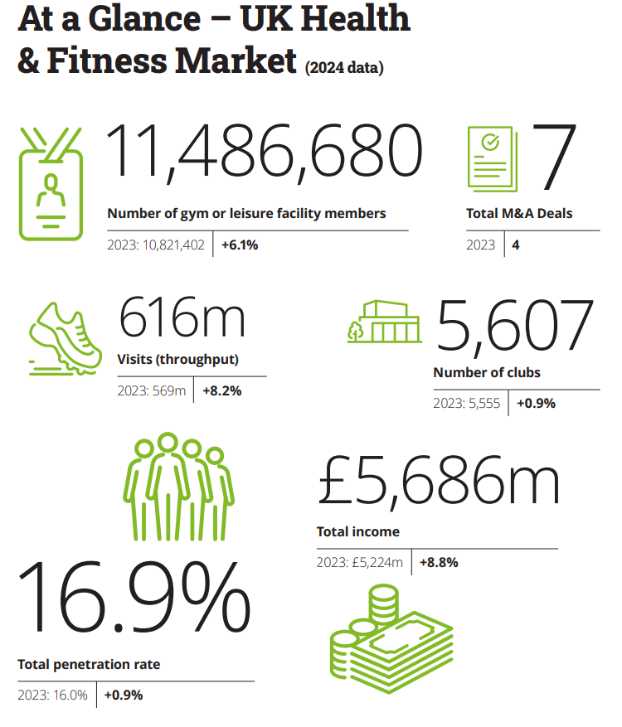
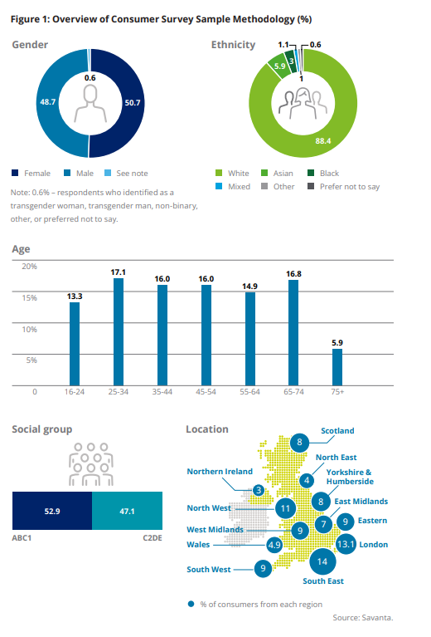
UK-Health-and-Fitness-Market-Report-2025.pdf
As evidenced in the above statistics the number of clients ages between 35 – 64 has a decrease in participation. This shows that there is a gap in the market to try and improve these numbers. This age range is usually the age when people have a young growing family. As can be seen in the graph above 13.3% of children aged 16-24 attend the gym. This is another area I am trying to target, by advertising activities throughout the day that young adults would be interested in to join while their parents are training in the gym. In the UK it states that only 4.9% of all gyms are based in Wales. This number is very low and shows that Wales has areas to grow and develop gyms across the country. This might be because Wales has large rural areas, and some businesses may feel that the potential for growth is not enough. However, for an individual that has grown up in these rural areas I can see the need and potential.
Overall, from the information gained from the UK Health and Fitness report it shows that there is a gap in the market that are currently not being targeted, especially in Wales.

Key External Drivers (PESTEL Analysis)
To analysis my key drivers I will be using Pestel analysis, as explained in the graph below by Makos, (2024):

The following points will go into detail of how my business will follow these points.

Political Factors

Government health initiatives:

National and local governments increasingly promote physical fitness and active lifestyles to reduce healthcare costs. As evidenced by (Local government Association (2023 viewed on 11/11/25) The Government’s new strategy “Get Active: sets new targets to get 2.5 million more adults and one million more children active by 2030. This includes specific targets for the least active groups”. This means it will help to create opportunities for FamilyFit24 gyms, as I am also targeting the groups of clients that have family’s and unusual working hours.
Public funding & grants:

Availability of small business or health promotion grants may support gym startups or community fitness centres.
Regulations & policies:

Health and safety regulations and licensing requirements will all affect my business, and it is essential to have in place before startup.

Economic Factors

Inflation & interest rates:

Affect startup costs such as equipment and leases. This then will affect the membership pricing strategies that I apply to the business.

Social Factors

Health and wellness awareness:
Increased awareness of the importance of fitness, nutrition, and mental health will help drive demand for FamilyFit24.

Technological Factors

AI & data analytics:
Enable personalized workout plans and customer retention analysis. This will be an advantage within the gym as customers will feel more involved in their fitness plans. As evidenced by Irwin., (2024, viewed on 18/11/25) “By combining the precision and efficiency of AI with the empathy, motivation, and personalised attention that only humans can provide. Fitness professionals can offer a holistic and superior fitness experience”. This evidences that AI programs will enhance my gym.
Digital marketing tools:
Online booking, virtual classes, and social media marketing will expand my brand to reach the community.

Environmental Factors

Sustainability expectations:
Consumers favour eco-friendly gyms with energy-efficient equipment, waste reduction policies, and green design. Energym (2025, viewed on 18/11/25) states that “61% aged 18-24 said sustainability is important when choosing a gym… despite rising cost of living concerns, consumers are willing to spend 9.7% more on sustainable goods”. Due to this I will try and adapt these into the gym as much as possible.

Legal Factors:

Health & safety compliance:
Gyms must meet strict standards for equipment safety, cleanliness, and emergency procedures, these will all be covered in my licences that I will have completed before the gym opens.
Data protection laws:
Compliance with GDPR and data privacy rules is critical for gyms as we will store not only clients’ names, addresses, contact details and bank details. We will also have health details, biometrics and lifestyle data. GDPR., (2025, viewed on18/11/25) indicates the consequences of breaching GDPR “Failure to comply can result in a hefty fine, with penalties reaching 4% of annual turnover. For the fitness industry, GDPR compliance isn’t just about avoiding fines. It represents an opportunity to improve operational standards and strengthen the trust of gym-goers”. This means that following the correct guidelines is absolutely crucial for the success of my gym.

SWOT Analysis

Strength | Weaknesses
I can be more flexible in how much I charge clients. As other businesses are fixed. If I have loyal long serving clients, I can suggest cheaper rates as a reward.  I can find out what clients would like for sessions and produce them.  People might be more willing to be involved in a smaller business which is more personal instead of a larger chain business. | There are businesses that are already established.  I will not have some facilities that other gyms can offer such as – swimming pool and spa facilities.
Opportunities | Threats
Give opportunities to a wider range of potential clients.  Word of mouth through my surrounding town can go a long way.  Have a better opportunity to build a strong relationship with clients and their families.  Lack of competition with the same use of facilities. | Other businesses can afford / have better equipment / newer machines.  For a new undeveloped business, the seasonal barrier must be considered. Such as Christmas and the summer holidays.

Marketing Strategies (7 Ps)
Products of the club
The gym will offer the standard gymnasium workout equipment with a daycare centre attached to the gym. The standard gym equipment will be accessible 24 hours – members being allowed access via their fob that is connected to their personal account.
- Standard gym facility
- Dance Studio / Yoga / Aerobics / Spin / Pilates
- Day care / soft play area
Pricing
Majority of clients will be on a monthly contract that they are fixed for the year. Some clients can pay for the membership upfront for the year, this eliminating monthly instalments. I will also have pricing for drop-in sessions, as not everyone wants to be locked into a contract as they cannot commit to attend the gym. This allows FamilyFit24 to regain some clients that have very busy lifestyles. However, drop-in sessions clients will not be able to access the gym 24 hours as the receptionist will not be on site 24hours.
Annual one-off membership – £700
24-hour monthly membership - £65
Dailey membership - £50
Drop ins - £6 per drop in.
Promotion
Family Fitness 24 will primarily rely on the Internet, Leaflets and word of mouth to maximise the number of clients and enhance the use of the gym. The advertisements will be via social media like Facebook and Instagram. As the gym is in a rural area and is currently going to be one building, I will produce leaflets and posters that will be disputed around the town and adjoining areas that are within the catchment area. In time, I would set up a website that will be developed to bring the gym into the next stages of recruitment for members.
Place
The location will be Usk, which is in Monmouthshire. As there is a building available and the area in which I live and seeing the potential for a gym.
People
There will be six staff members which will include Personal Trainers Level 3, front desk, day care level 2 staff and myself, also Level 3 PT. Additional staff members will be required in year three to help expand and grow the business.
Process
The main process for the gym will be the membership sign-up process and this needs to be as simple and fast as possible, as clients do not want to feel flustered during this process. I want them to be happy to spend their money with me. This then would lead to a fast and effective booking system for all classes. The way we handle complaints needs to be responsive and customer centred, this will then increase the satisfaction rates and reduce negative feedback.
Physical Evidence
To ensure that clients will want to join and maintain their membership I will have to make sure I maintain a certain standard, such as:
- Facility appearance: clean, modern, organized, well-lit
- Equipment: updated, good quality, variety of machines
- Staff uniforms: professional and identifiable

Market analysis

Population
Usk: 3,100
Pontypool: 36,000
Monmouth: 12,250
Target Market
Age: 18 – 70
Income Level: Middle to high income
Lifestyle: Active individuals, professionals, students and families
Market Need
Modern, clean, and safe facilities
High-quality group classes (HIIT, strength, yoga, cycling, functional training)
Personal training and coaching
A sense of community to increase motivation and retention
Customer Segments
Busy professionals: Seeking efficient workouts and extended hours
Fitness enthusiasts: Interested in specialized equipment and advanced classes
Beginners: Need coaching, simple routines, and confidence-building
Older adults: Want safe, low-impact programs supervised by professionals
Youth athletes: Strength/conditioning training opportunities

Competition analysis
Primary Competition
Pontypool Leisure Centre - 8 miles from Usk
Cwmbran Leisure Centre - 11 miles from Usk.
Monmouth Leisure Centre - 13 miles from Usk
Nufield Health - 10 miles from Usk
Secondary Competition
PT Pilates Usk – offer 4 classes a day with two trainers Tuesday – Sunday. Each session is £6 a class, classes of 8 people.
The table below goes into more detail about the size of my competitor gyms, its profit margines and its pricing.
Competitors Name | Sales | Profits (£) | Year Started | Primary / Secondary | Size Of Corporation | Pricing
Nuffield Health | £1453.1m | Non-Profit Company. Charity Run | 1957 | Primary | 110 Gyms across UK | Yearly -£750  Monthly - £73
Pontypool & Cwmbran Leisure | £5.26m | Non-Profit Company.  Run by council | 2013 | Primary | 2 facilities linked with 2 councils | Monthly - £36  Drop ins - £5.00
Fitness First | £38.4m | £2.9m | 1993 | Primary | 26 Gyms across UK | Monthly - £73
Monmouth Leisure | Unavailable | Non-Profit Company  Run by council | N/A | Primary | 2 facilities linked with 2 councils | Monthly - £26
PT Pilates | Unavailable | Unavailable | 2023 | Secondary | One Business in Usk | Per Session:  £6

The table evidence that 3 out of five of my competitors are a non-profit organization. The only primary competition is based in Cwmbran and has a £2.9 million profit. This indicates that by owning a gym there is money to be made, especially if I focus on a wider range of clients. Also, the client base will range from Cwmbran to Monmouth.

Start Up Costs
FamilyFit24 will have a high cost to start up. However, over the years I have managed to save £50,000 in which I invest into the business. I have also been able to earn a grant from the government of £10,000. Both payments will make it feasible to open the gym. I then managed to gain a loan from the bank for the remaining amount of £20,000. This loan will be paid back over ten years at £264 per month. Regarding the gym equipment I did have two choices of one of payment of £50,000 or a two-year monthly payment of £2,000 with a £2,000 direct payment. Due to the savings in my account, I have chosen the one-off payment as I believe this will benefit the business in the future. The other major payment that is needed to start the gym is insurance and costs of licenses, which will total £2,800. Below you will find the full breakdown of the start- up cost for the business.
Start Up Cost | Proposed Amount
Rent | £2,600 – One month deposit
Gym Equipment | £50,000 – one of payment then monthly payments
Insurance | £2,000 annual
Furniture and Fixtures | £12,600
Daycare Fixtures | £6,000
Licenses  Fire Risk Assessment  Health and Safety Consultant  Childcare | £500 – Annual  £200 – Annual  £100 – Annual
Marketing and Branding (Uniform and signs) | £500
Total Cost | £74,500

Investment | Proposed Amount
Cash Deposit – own money | £50,000
Grant | £10,000
Bank Loan | £20,000
Total | £80,000

AI Declaration
FamilyFtness24 recognizes the growing role of artificial intelligence (AI) in improving business efficiency, customer experience, and data-driven decision-making. The following outlines how AI technologies will be utilized within my business operations.
- Member Management: AI-driven software to analyse attendance, preferences, and engagement to personalize fitness programs and retention strategies.
- Marketing & Communication: AI tools for targeted digital marketing, for social media optimization.
- Operations & Scheduling: Predictive analytics for class scheduling and trainer availability.
- Financial Planning: AI-assisted forecasting for budgeting and expense management.
O’connell (2024, Viewed on 12/11/25) states that the role of AI in “The Role in health and fitness are as follows:
- “AI in Personalized Training Programs
- AI-Driven Nutrition and Diet Planning
- The Future of AI in Fitness: Predictive Analytics and Virtual Coaching
- Enhanced Wearable Fitness Technology”.
This suggests that AI makes information easier to gain and knowledge better to understand. Therefore, individuals have more direct use and availability such as smart watches and AI driven health plans, allowing them to see and understand their own personal health and fitness needs.

Management (Year 1 Personnel Forecast)

To start the gym up I will be employing five members of staff. These include three-day care staff and two trainers as I will be the third trainer. All Personal Trainers will have a Level 3 PT qualification, and all Childcare staff will have a Level 3 Health and Social Care qualification. Once the gym has been established, I will look to employ two more staff in year three to make daily running’s easier and smoother with the growing numbers of clients. The table below shows the figures for my staff, wages and my drawings from the business for the next three years.
Personal Count | Year 1 | Year 2 | Year 3
Director | 1 | 1 | 1
Operations | 5 | 5 | 7
Total Personal | 6 | 6 | 8
Wages | £124,992 | £131,992 | £181,992
Drawings | £24,000 | £26,000 | £28,000
Total Payroll | £148,992 | £157,992 | £209,992

Break-Evan Analysis

To breakeven every month I must earn £13,775. As shown in my table and graph below.
Assumptions | Amount
Average revenue | £17,175
Average Fixed Costs | £13,517
Variable costs | £3,086
Break-Evan | £13,774 (17.65 member)

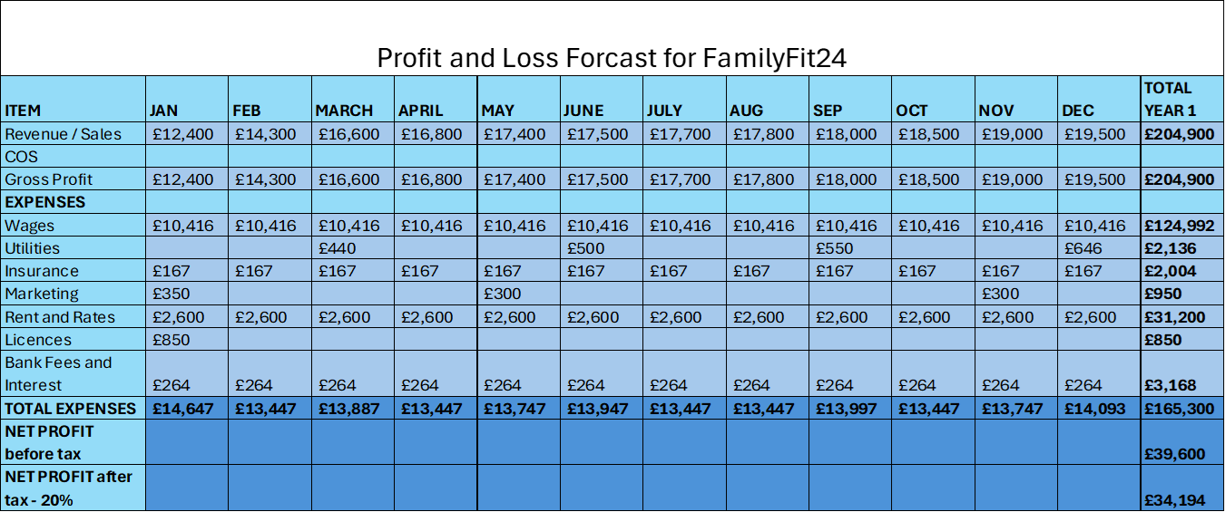
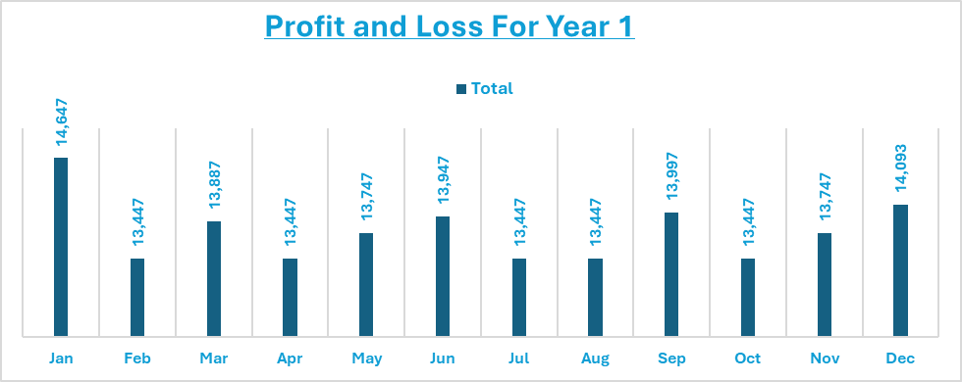

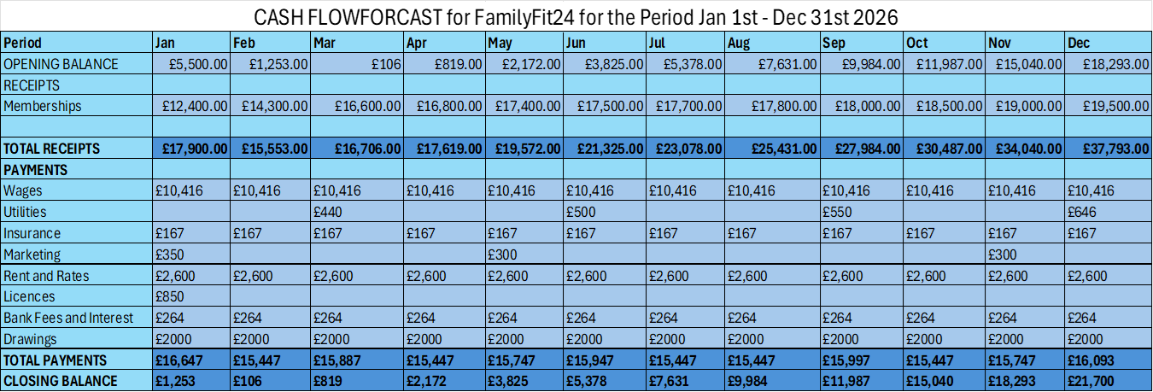

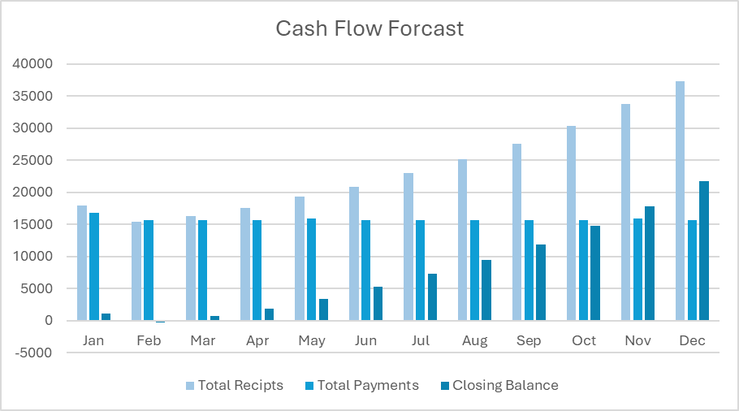

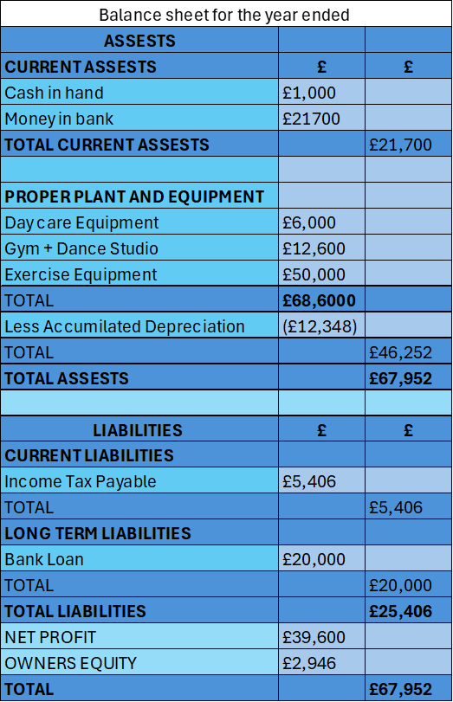
Utilities bills will be a variable price and paid quarterly over the 12 months – Utilities are water, gas and electric
Licenses – covers personal injury and public liability and internal fixtures. Not external as that will be covered by the landlord.
Marketing will also be a variable cost – leaflet printing – rest will be advertised on social media and viral marketing etc.
Rent and rates - £600 a week rent and £200 business rates.
In year 3 my profit will decrease as I will be employing two more members of staff.
In year four my rent goes up as my three-year lease will come up for renewal.
You will find extra graphs in the appendix for a 5-year plan for profit and loss, predictions for my cash and workings out for my financial indicators.

Financial Indicators
Revenue Indicators | Amount
Monthly Recurring Revenue (MRR) | £17,075
Average Revenue per member (ARPM) | £782
Profitability Indicators
Gross Profit Margin | 31.38%
Net Profit Margin | 16.43%
Membership Indicator
Lifetime Value (LTV) | £2,346
Cost and Efficiency Indicators
Operating Expense Ratio | 80.67%
Payroll-to-revenue ratio | 61%

Stress Analysis Year 1

 | Mild | Moderate | Severe | Business Impact | Improvement
Member decline  My Total  £204,900 | -10%  -£20,490  New: £184,410 | -25%  -£51,225  New: £153,675 | -40%  -£81,960  New: £122,940 | Cash Flow issues | Marketing push, retention programs
Price Reduction  My Total  £65 monthly | -5%  -£3.25  New: £61.75 | -10%  -£6.50  New: £58.50 | -15%  -£9.75  New: £55.25 | Lower margines | Marketing push, retention programs
Rent  My Total  £2,600 | +5%  +£130  New: £2,730 | +10%  +£260  New: £2,860 | +15%  +£390  New: £2990 | Higher Expenses | Negotiate Terms
Utilities  My Total  £2,136 | +5%  +£106  New: £2,242 | +10%  +£213  New: £2,349 | +15%  +£320  New: £2,456 | High Expenses | Negotiate Terms
Extra training | +£100 per person | +£250 per person | +£400 per person | Extra Expenses | From final profit
Staffing | Small turnover | Slight Turnover | High Turnover | Lower class quality and times | Salary negotiations
Equipment repairs | +£60 per machine | +£150 per machine | +£300 per machine | Extra Expenses | Maintenance plan
Equipment replacement | +£500 per machine | +£1,500 per machine | +£2,500 per machine | Extra Expenses | Maintenance plan
Competition | New small studio | New gym in close radius | Low-cost chain | Price / Market Pressure | Offer better services

Operations
I will not have to work with any operations as I will not be buying or selling goods. My clients will be coming to use my equipment.
Facility Design: Ground floor – Gym, changing rooms and Daycare facilities
Second floor – Dance studio, Spin Class Studio, Aerobics Studio

Sales Summary
In conclusion, I am looking to open a 24 hour fully inclusive gym. By allowing clients to train at a time that suits themselves, the entire community benefits. My gym would be supporting young families who are currently disadvantaged by lack of opportunity as they currently have minimum access to adequate levels of fitness / wellbeing care. In turn, this should result in improvements in both physical health as well as improved mental health of a section of the community who have been largely ignored in the past due to lack of availability.

References

Energym,. (2025) Sustainability in Fitness: Shaping the Gyms of 2025 and Beyond – Energym. Gymshark accelerated (Viewed on 18/11/25)
www.ukactive.com., (2025) - UK-Health-and-Fitness-Market-Report-2025.pdf (Viewed on 4/11/25)
GDPR Advisor., (2025) GDPR in the Fitness Industry: Managing Gym Member Data - GDPR Advisor. (Viewed on 18/11/25)
Irwin, S., (2024), - AI in Fitness: The Future of Personalized Workouts and Nutrition Plans | Australian Institute of Fitness (Viewed on 18/11/25)
Local Government Association., (2023) Sport and leisure: promoting health and wellbeing through public services | Local Government Association – (Viewed on 11/11/25).
Makos, M., (2024) - What is PESTLE Analysis? (Free Template) - (Viewed on 11/11/25)
O'Connell, B., (2024) The Top 4 Ways AI Has Impacted The Fitness Industry - TrueCoach. FRSA CSM. (Viewed on 12/11/25)
Torfaen Count Council (2024) Funding for leisure trust. -Report calls for extra funding for leisure trust | Torfaen County Borough Council. (Viewed on 22//10/2025)

Appendix

First Month Forecast
Income per month | Number of Clients | Proposed Amount
Full Membership – 24-hour access | 120 at £65 | £7,800
Day membership – Normal hours | 80 at £50 | £4,000
Pay as you go | 50 x 2 times a week | £600
Total Coat |  | £12,400

Profit and Loss

Cash Flow Predictions after first year

Above is a graph that will show you the cash flow forecast with predictions of upper and lower confidence bond. This graph factors in the gyms ability to become extremely successful and if the gym runs into any sort of financial problems.

Financial Indicators
Revenue Indicators | Amount
Monthly Recurring Revenue (MRR)  204900 / 12 | £17,075
Average Revenue per member (ARPM)  204900 / 262 | £782
Profitability Indicators

Gross Profit Margin  (204900 – 165300) / 204900 x 100 | 31.38%
Net Profit Margin  39600 / 204900 x 100 | 16.43%
Membership Indicator
Lifetime Value (LTV)  £782 x 3 on basis they will stay for three years | £2,346
Cost and Efficiency Indicators
Operating Expense Ratio  165300 / 204900 x 100 | 80.67%
Payroll-to-revenue ratio  124992 / 204900 x 100 | 61%

