4/11/2022
Sean Leach (2004817)

A Report Discussing Professionalism, Ethics, Leadership, Teamwork and How They Play a Part in the Construction Industry, Along with Some Personal Thoughts and Experiences.

Contents
1 Introduction 3
2 Professionalism and Ethics 3
2.1 Professionalism 3
2.2 Ethics 4
2.3 Professionalism and Ethics within the Construction Industry 5
3 Professional Development 6
3.1 Organisational Behaviour 6
3.2 Summary of Writers Career 8
3.3 Personal Development Appendices 9
4 Leadership 9
4.1 Understanding Leadership 9
4.2 Leadership Theories 10
4.2.1 Behaviour Theory 10
4.2.2 Contingency Theory 10
4.2.3 Great Man Theory of Leadership 10
4.2.4 Transformational Theory 10
4.2.5 Transactional Theory 11
4.2.6 Situational Leadership Theory 11
4.3 Leadership Styles 11
4.3.1 Authoritarian Leadership (Autocratic) 11
4.3.2 Participative Leadership (Democratic) 11
4.3.3 Delegative Leadership (Laisses-Faire) 11
4.3.4 Transactional Leadership 11
4.3.5 Transformational Leadership 12
4.4 Personal Leaderships Experience and Analysis 12
4.5 My Leadership Style 12
5 Teamwork 13
5.1 Teamwork Theory 14
6 Summary 15
7 Appendices 15
8 References 19

1 Introduction

This report aims to cover multiple aspects of the Construction Industry and expand vital aspects under their own sub-headings. It aims to discuss how personal attributes and ethics can impact the industry. It shall include personal details and experiences of the writer, covering professional development and experiences that have led to better understanding and practices. It will discuss leadership and draw on experiences of the writer.

2 Professionalism and Ethics

Professionalism and ethics shape the way humans work, think and behave. They can define the standards of a company or organisation. Within the Construction Industry there are many potentially dangerous hazards and decisions to be made on every site or project that can lead to devastating disasters if short cuts are taken or the level of work and knowledge is inadequate as to what is required. This requires the Construction Industry to uphold and ensure the highest level of professionalism and ethics are carried out by all professional workers within the industry. With many decisions within the industry leading to major consequences if not correct, it is important to understand how professionalism and ethics play a major role in decision making within the industry.

2.1 Professionalism

A saying within the industry states that, ‘professionalism is not the job you do, but is in fact how you do the job’. Many individuals within all industries can often mistake being a professional with high levels of professionalism. Being a professional accounts for any person who earns a living from a specified professional activity. Within the Construction Industry that accounts for many roles such as, Quantity Surveyor, Construction Manager, Architect, Project Manager and many others, (Anon, 2018).
The Construction Industry has many challenging and fast paced decisions that need to be made on a regular basis by various professionals. As HSe (2020) highlights, within the construction industry, 61000 non-fatal accidents took place in 2020 and 39 fatal injuries occurred. According to statistics taken from 2015 -2020, the construction industry was the most dangerous industry to work in based on deaths occurred (R&B, 2020). These worrying statistics show the seriousness of decisions, and the consequences bad decisions can lead to. This also highlights the extreme need for high levels of professionalism.
Professionalism is defined by Cambridge dictionary (2019) as, “the combination of all the qualities that are connected with trained and skilled people”. Within construction good professionalism can be used as a tool to build trust between clients and contractors.
One way that professionalism can be measured in the industry is by the governing bodies which offer chartership. To become chartered within a professional body you must meet the criteria which is available for all members of the industry to see. This enables the whole industry to see the minimum standard a person must adhere to, to gain chartership. These requirements vary from professional body to body, but all have major similarities such as, required levels of education or equivalent experience and a minimum amount of Continuous Professional Development (CPD). CPD is one way professional bodies ensure all members remain current and competent in their relevant fields of the industry. Employers and clients can hire professionals who are accredited through professional bodies such as RICS, CIOB, CABE and ICE and be aware of the minimum standard of professionalism they must maintain. Professional bodies such as the ones listed will often have rules and regulations that define how members must conduct themselves to maintain professionalism, an example of this can be found at (CIOB, 2022) .
Characteristics of professionalism include high levels of competence, knowledge, integrity, respect, emotional Intelligence, appropriateness and confidence, (Mind tools, 2022). These are expected from all professionals and contribute to the reputation of professional companies.
When it comes to decision making within the industry, the professional with the higher level of professionalism, regardless of role, will generally make the better-informed decision because they are current and competent in their role due to the CPD they have continued to undertake which has been verified. Although not being a member of a professional body does not discredit the professionalism of an individual, it is a way of verifying one’s professionalism by a respectable governed body.

2.2 Ethics

Although heavily linked with professionalism, ethics has major differences in its meaning and interpretation. As highlighted above, professionalism is about skills, competencies and knowledge of one’s profession. Whereas ethics refers to the moral decisions like, was it good or bad? Ethics is often seen as the language of is it right or wrong, (Anon, 2022). Although originally derived from religion, philosophies and cultures, ethics now create debates on various important topics including professional conduct, (BBC, 2014). Ethical behaviour is often measured by the degree of trustworthiness and integrity in which organisations and individuals conduct their business.
Ethics plays a large part within the construction industry as it affects decisions made at organisational level that cascade down throughout the industry. Ethics is a key part of companies’ corporate social responsibility (CSR). Ethical corporate social responsibility aims to ensure that all stakeholders within a business are treated fairly, from customers to employees, (Jackson, 2021). At organisational level, ethical responsibilities are often self-imposed by the companies to ensure they are undertaking the morally correct way of doing things and not only because of obligations. A company’s ethics must be instilled by its culture and strong leadership at each level.
Personal ethics tend to derive from a person’s values, beliefs, environment and personality. A report written by the Society of Construction Law (CSL) stated that the principles of ethics in construction are,
- Honesty – You are to act with honesty and avoid conduct that can lead to deception.
- Fairness – Do not seek benefit which arises from unfair treatment of others.
- Fair Reward – Avoid depriving other parties of fair reward for their work.
- Reliability – Only offer services within your skills.
- Integrity – Ensuring you account for the interests of the public.
- Objectivity – Identify and report conflicts of interest.
- Accountability – Apply warnings to the public where necessary to avoid determent.
Companies can produce their own tailored principles that they deem morally correct and these will apply to all persons as individuals.
(CSL, 2003) was a good source of information for this.

2.3 Professionalism and Ethics within the Construction Industry

The construction industry has fallen foul to some of the worst tragedies seen in recent years within the UK. Grenfell Tower is a prime example where 72 people sadly died on the 14th of June 2017, (BBC, 2019). After an industry wide analysis into what went wrong to learn for the future, it was evident that during the refurbishment of the tower in 2013 the contractor who won the project came into financial difficulties. After Rydon submitted a lowest cost tender under budget, they identified they needed to make one million pounds in savings. This was to be acheived through ‘Value engineering’. Value engineering is known in the industry as changing specified products for cheaper alternatives without compromising overall quality. However, when changing the original cladding design of a zinc composite to a newer cheaper aluminium cladding, which would bring £500,000 pounds worth of savings, it has been identified very little consideration was given to fire protection and fire safety. Although a safety certificate had been given out by the supplier Arconic, it was not thoroughly checked by any parties involved in the decision making, (Apps, 2019). Another cost saving decision was signed off by a site manager working for Rydon. This involved swapping the polyisocyanurate Celotex phenolic foam made by Kingspan. A decision that should have been approved by Kensington and Chelsea Management Organisation as per the contract, (Apps, 2019).
If high levels of professionalism and ethics had been implemented throughout each decision, cost savings should have never been at the forefront of a project’s priorities. Ethical decisions should have ensured safety was the prime factor when deciding on materials used as this is in the interest of the stakeholders and most importantly the residents.
As highlighted previously, professionalism within the industry dictates that professionals are current, competent, knowledgeable, trained and qualified to make decisions within their role. Yet when choosing the cladding during the Grenfell towers refurbishment, a total lack of professionalism led to a cheaper alternative being used that enabled cost savings but failed to reach an adequate fire-resistant standard. A decision that was approved at multiple levels. Ethically, decisions should always be made with the stakeholder and, most importantly, residents of Grenfell towers safety in mind. A cost saving change is not ethically wrong providing it does not cause harm or loss to the stakeholders and is aligned with their interests. However, in this case the decision was made with cost savings as a priority, followed by a blame game of various parties.
The case of Grenfell Tower highlights the seriousness of decisions within the construction industry. The highest levels of professionalism and ethics are required to ensure safety to everyone involved. Lessons learned from Grenfell include, decisions needing to be informed and considered with absolute professionalism by all industry professionals. Decisions must also be ethical and consider stakeholders before profits, as well as the safety of the project over the project’s aesthetics. This will help mitigate any more major failings in the industry moving forward.

3 Professional Development

3.1 Organisational behaviour

Organisational Behaviour (OB) is the study of human behaviour in organisational settings, it’s the interface between human behaviour and the organisation itself, (Moorhead et al, 1995). People behave differently in different situations. The behaviour of one person at work can be entirely different to their behaviour at home, so understanding organisational behaviour will help managers and leaders within organisations get the full potential from their subordinates or employees. OB is extremely important within management in all industries. It can be used as a tool to help managers understand and predict the way that their employees will behave in an organisation. Studies into organisational behaviour were first recorded during the Industrial Revolution as early as 1760's. However, it wasn’t until the 1920's that the Hawthorne studies began.
The Hawthorne studies takes its name from the location where the studies took place, the Western Electric factory in Chicago called the Hawthorne Works. Elton Mayo originally tested to see if the workers would be more productive working with higher levels of lighting or lower levels of lighting. The workers’ productivity improved when changes were made, but after the studies had been completed the level of productivity returned to pre-study levels. What these results suggested is that the workers were not being more productive because of the differences in lighting, but because of increased motivation due to an interest was being shown in them, (Cherry, 2020). The Hawthorne studies gave us a better understanding of what motivates individuals within their workplace. It highlighted that there are other factors apart from personal economic needs that influence the way we shape our attitudes and behaviours towards work related activities, (British Library, 2012).
Following Elton Mayo's conclusion on the Hawthorne studies, the focus of organisational behaviour became motivation and throughout the 1950's and 1960's, a range of theories developed which underlined employee’s motivation, work performance and job satisfaction. It wasn’t until the 1970's that organisational behaviour became a legitimate field of academic study, (Aplitude, 2022).
It is well known within big organisations that understanding organisational behaviour is one of the essential ingredients to business success, regardless of which industry you are in. The aim of organisational behaviour is to take knowledge gained from individuals, employees and groups on behaviour and use it to make the organisation work more efficiently, (Anon, 2017). The study of organisational behaviour concentrates on:
- Improving job satisfaction for employees
- Enhancing employees’ performance and efficiency
- Promoting innovation
- Instilling good leadership qualities
With an emphasis on these key areas, it helps organisations in a variety of ways. It gives organisations a better understanding between them and their employees. This gives the organisation a chance to improve their human resources strategies and create a better environment which in turn should increase their employee loyalty. As a better understanding of motivation can be learned, it will give managers and leaders within the organisation the tools to better motivate their employees and individuals, thus improving the performance of the organisation. Managers with good knowledge of organisational behaviour will be able to better predict the human behaviour of their employees. This will help them keep the organisation effective during difficult times, (Devasia, 2018).
In terms of personal development, the benefit of understanding organisational behaviour is massive. As for any manager or leader it is vital to drive high levels of productivity and performance from your team to bring success to the organisation. Keeping employees motivated to carry out a task is critical and the job of ensuring the team is motivated falls to the manager of that team. Understanding that people are different and methods of motivation for individuals can vary drastically is key for driving high levels of motivation. Considering some employees are motivated by a simple thank you, and yet others need the thought of a big financial bonus, understanding how to satisfy the individual needs of employees so they can come together and operate as a team is a hugely desirable attribute for any organisation looking to employ effective managers.
The construction industry often poses more issues than others when it comes to organisational behaviour. One reason for this is, teams are thrown together for short term periods to complete a project, unlike traditional industries where individuals in teams work closely together for sustained periods, (Futurelearn, 2022). This problem requires managers within construction to have a greater understanding of organisational behaviours and be able to identify traits in their subordinates in a shorter time frame with co-workers they are not so familiar with.
Another common issue the construction industry has unfortunately become well known for is delivering projects late and over budget. Although many projects are delayed by adverse weather conditions or other uncontrollable variables, there are occasions that the cause of this has been poor leadership and management of a project. With the ambition to join the industry as a future construction manager, understanding organisational behaviour management will enable me as a leader to manage subordinates effectively and bring co-workers together as a team to achieve the overall goal, (Futurelearn, 2022).

3.2 Summary of Writers Career

The writer, ‘Sean Leach’, joined the British Army as a recruit in 2014 where he served as a recruit for six months. Throughout his time in training, he learned valuable skills that would enable him to thrive throughout a career in the infantry.
In 2014, he was posted to Germany to carry out his role of a professional soldier, working in various teams and becoming an effective team member. In 2017 he was selected to go on a promotional course where he learnt many first-hand leadership skills and was tested on implementing those. Following a successful first promotion and successful deployment overseas, he was selected to attend the infantry battle school to compete for his next promotion against the best in the Infantry. During this course, he completed courses in coaching and mentoring, instruction and training, leadership and management and section and platoon level tactics. Following success on that course he became the youngest serving Corporal in his Unit.
He then got the opportunity to implement all new skills and knowledge learnt overseas on exercises and operations. After deciding to pursue further education, he left the British Army in Sep 2020 to study towards a degree in Construction Management.
During his career he learnt invaluable skills that he looks forward to transferring over into a new industry. Alongside his studies he works part time in a school helping children with behavioural difficulties improve on their interpersonal skills with the aim to get them back to their mainstream school.

3.3 Personal Development Appendices

- CV has been attached under Appendix 1.
- Professional development plan has been attached under Appendix 2

4 Leadership

4.1 Understanding Leadership
Leadership has been around for centuries, as far back as history shows, all the greatest and most memorable leaders have been remembered throughout history. There is often a misconception when it comes to leadership, and it can be analysed wrong. Many people believe that leadership is popularity, showmanship, power or even just long-term planning. The misconception comes because many great leaders have these traits and implement them while successfully leading. However, Prentice (2014) highlights that although these traits can help leaders, leadership is in fact the accomplishment of a goal through human assistance.
It is noted that a good leader need not be powerful or even popular. They do not need to be able to plan at great length and can even just carry out the plans of another human. However it is vital to be able to understand his fellow workers or subordinates and understand their individual goals and how they can attribute into the overall team goal, (Prentice, 2014).
It is important for all professionals in all industries to have a good understanding of leadership, whether they are working within a small close-knit team or a large-scale complex organisation. Understanding the theories behind leadership will improve current leaders’ effectiveness. It will give them a better idea of their own style and help them identify areas that can be improved on for self-development. For employees who don’t find themselves in a leadership role, understanding characteristics of different leadership theories will help them understand their leader better and should improve communication between leader and their subordinates. This will have a knock-on effect and should improve the effectiveness of a team. Dr Luthra et al (2015) highlights in their article on leadership that managers spend between 70-90% of their time communicating, so understanding your team and the team understanding their leader is a huge advantage for any team in any organisation

4.2 Leadership Theories

Western Governors University (2020) state that leadership theories are just explanations of how and why certain people become leaders. This highlights that for the theory to exist a well-documented leader has been studied. A look at history gives some of the most famous leaders to have ever lived. You can identify different styles and the effectiveness of their leadership. Below is a breakdown of some of the most renowned leadership theories that have been studied in great depth.

4.2.1 Behaviour Theory
The Behaviour Theory states that qualities and traits of a good leader can be learned. It states that leaders do not need to possess natural leadership traits, but from watching other leaders, can learn and take on these skills. This theory has some great advantages, one being that leaders can decide the traits and qualities they want to take on and implement, so they can choose the type of leader they want to become. This allows leaders to adapt new styles and remain flexible. Another advantage of this theory is that it enables anyone to become a leader which can boost people’s confidence within their work setting. However, being flexible doesn’t always work as an advantage because this theory doesn’t have the answer for every situation. (Simplilearn, 2020) and (Western Governors University, 2020) were good sources of information for this theory.

4.2.2 Contingency Theory
This theory suggests that there is no right or applicable style of leadership for each and every situation and that variables affect the decisions that leaders have to make. This theory states that a good leader will be able to choose the right choice based on the variables. It is noted under this theory that the best leaders not only have the right traits, but can assess the needs of their followers and make the correct decisions accordingly, (Moniz Jr, 2020).

4.2.3 Great Man Theory of Leadership
Often well known as one of the oldest leadership theories. According to this theory, a person is born with all the correct traits for a leader such as, high levels of intellect, charm, good levels of social aptitude and great communication skills. The great man theory states that you are either born with the ability to be a leader or not. However, many scientists and theorists have discredited this theory and no longer count it relevant, (Wester Governors University, 2020).

4.2.4 Transformational Theory
Transformational leadership is also a style of leadership as well as a theory about a type of leadership. This theory of leadership accounts for leaders who inspire their followers to share their vison. They then enounce and empower their followers to help achieve the shared goals and vision. The leader in this theory is often seen as a role model for the vision, (IMD, 2021).

4.2.5 Transactional Theory
This theory states that transactional leaders rely on the role of supervision, organisation and teamwork. A tool often used by these leaders is the use of reward and discipline. This theory can be a great tool to motivate employees and is often used, (Wester Governors University, 2020).

4.2.6 Situational Leadership Theory
This theory shares many similarities with the contingency leadership theory. It also believes that no one style of leadership is right for every situation. However, it differs from the theory of contingency because it considers the maturity level of the followers. It breaks followers’ maturity in to four levels, as well as the leadership style of the leader. It then matches up the correct maturity level with the leadership style for the best effect. But like contingency, it believes leaders must make decisions based on their judgement of the situation they are in, (Cherry, K -B, 2020).

4.3 Leadership Styles
Whereas leadership theories focus on how finding out what makes leaders excel and become so successful in what they do, leadership styles are classifications of how a person behaves while leading a group, (Cherry, 2021). Below are a few of the most common seen leadership styles and a short description.

4.3.1 Authoritarian Leadership (Autocratic)
Commonly this style of leadership is known as a one-person show, where the leader makes most of the decisions with very little input from the team. It can be efficient and time saving and very successful if the leader is the most knowledgeable in the team. However, it can lack creativity and kill innovation, (IMD, 2021).

4.3.2 Participative Leadership (Democratic)
Psychologist Kurt Lewin identified this style of leadership to be the most effective style. All members of the team often participate in this style and have a much greater input. Information flows in both directions, from leader to team, but also from the team back up to the leader. Although everyone participates in the group and gets to feel involved, it is the leader who makes the final decision.

4.3.3 Delegative Leadership (Laisses-Faire)
Leaders who have this style tend to have more trust and reliance on their employees. Employees are often not micromanaged or given to much instruction or guidance. They trust their employees’ judgement and allow them to use their experience, resources, and creativity to meet the teams’ goals.

4.3.4 Transactional Leadership
This style comes from the transactional theory highlighted above. Leaders set out clear goals and objectives for each member in the team. The leader then clearly outlines rewards for good achievement and punishments for poor performance.

4.3.5 Transformational Leadership
This style has emerged from study into this theory. Transformational leaders inspire members of their team and act as role models. It brings the team on to the shared vision and keeps the team very motivated.

4.4 Personal Leaderships Experience and Analysis

Having been fortunate enough to serve in HM Forces, this has enabled me to work alongside some of the best leaders in the world in some of the most challenging circumstances. Working in a male only environment stereotyped the kind of leader you would expect within the Infantry, but personal experience of witnessing different styles of leadership having different effects really helps identify how leadership theory and styles play their part in leadership.
Due to the nature of the job and the situations soldiers often find themselves in, every leader must be highly adaptable, as the landscape and situation is forever changing. One experience of poor leadership stands out and through learning the theories of leadership and the different styles of leadership I am able to identify why. A mid-level manager was in charge while I was overseas on operations. This leader had a very strong Authoritarian leadership style. The leader very rarely asked for the opinion of the lower-level commanders and believed his way of doing tasks was the best and only way of doing things. This very quickly led to low morale of soldiers working under this leader as easier and more effective ways of working had been identified and he had dismissed them. The low morale led to soldiers losing their discipline which had a knock on effect to the output of the whole team. Reflecting on the situation, it is understandable for a leader in such a dangerous profession to take an authoritarian leadership style, as the job demands tasks are done in a certain way with great efficiency. However, as the job can be very complex and forever changing, a leader who doesn’t listen to his subordinates lacks innovation, and although there are more effective ways of doing tasks, they can dismiss them unfairly or without proper consideration.
With this particular leader, if he was aware of the contingency theory, he may have been more open to taking a different approach for certain situations and understood that using an authoritarian style works great in high pressure situations when tasks need to be done quickly without question, but in more relaxed situations a participative leadership style would of helped him understand the needs of his team and the individuals which would have helped the overall efficiency of the team and boosted morale.

4.5 My Leadership Style

Being empowered at a young age by military law to be a leader enforces a steep learning curve. Having led many teams in a variety of situations, this has enabled me to make some very good leadership decisions, but has also highlighted that when leading a team, you don’t always get it right. Mistakes can happen from a lapse of judgement. In my experience making mistakes has been the best lesson of all. Providing leaders reflect on their performance whether good or bad, it will always enable the chance for self-improvement.
I found myself in the situation of being a leader before understanding the theories and different styles that were recognised. Reflecting now on my own style I find it very difficult to place myself in one style of leadership and believe this comes from the complexity of the role I was undertaking while building leadership experience. Witnessing many different styles whilst being a team member, I became aware I did not agree with an authoritarian style of leadership, I found this very de motivating at times and it did not enhance the team’s communication or confidence. So, when becoming a leader myself, I found a participative leadership style worked very effectively for me. It increased confidence in my team and enhanced the output. Trust between team leaders and team members is vital as without trust it can be extremely difficult to take on other opinions.
This is where the contingency leadership theory stands out to me, as I agree and have found through experience that one type of leadership does not suit every situation and the best leaders are able to adapt to the needs of their team. I believe this works better than the team trying to adapt to the style of leadership that a firm leader can come in with.

5 Teamwork

Through ample experience of working in a variety of teams, I’ve proven myself as an effective team player and team leader. I enjoy sharing a common goal and working with others to achieve this. I bring effective communication to the team. Strong individuals will not make a good team if they cannot communicate. As a team leader I ensure all members of my team are provided with all information required in efficient, timely manner and ensure feedback is given. A well-known saying is ‘A team is only as good as its weakest member’. Having found great truth in this saying during my time as a team member and team leader, I look to invest time to understand my fellow team members so that we can bring the best out of each other. Understanding to have a good team you must all bring your own strengths and weaknesses; the success of the team comes on how well you can mitigate each other’s weaknesses and improve on everyone’s strengths.
The transformational theory covers much of how I perform when in a team. I take the shared goal of success and work towards this with strong commitment. As a team leader I look to inspire my team and encourage them to perform to their best without fear of failure. As a team member and leader, I would never expect another team member to do a task, job, or role that I would not do myself or have done myself. This can be very inspiring and when a team falls on difficult times, team members with selfless commitment will ensure moral stays high and the task is completed by all team members.

5.1 Teamwork Theory

Like leadership, teamwork has had extensive studies into how teams work well together and what makes a good team. Notably one study is Tuckmans study into the life cycle of a team. Below is a diagram showing Tuckmans model of team development.
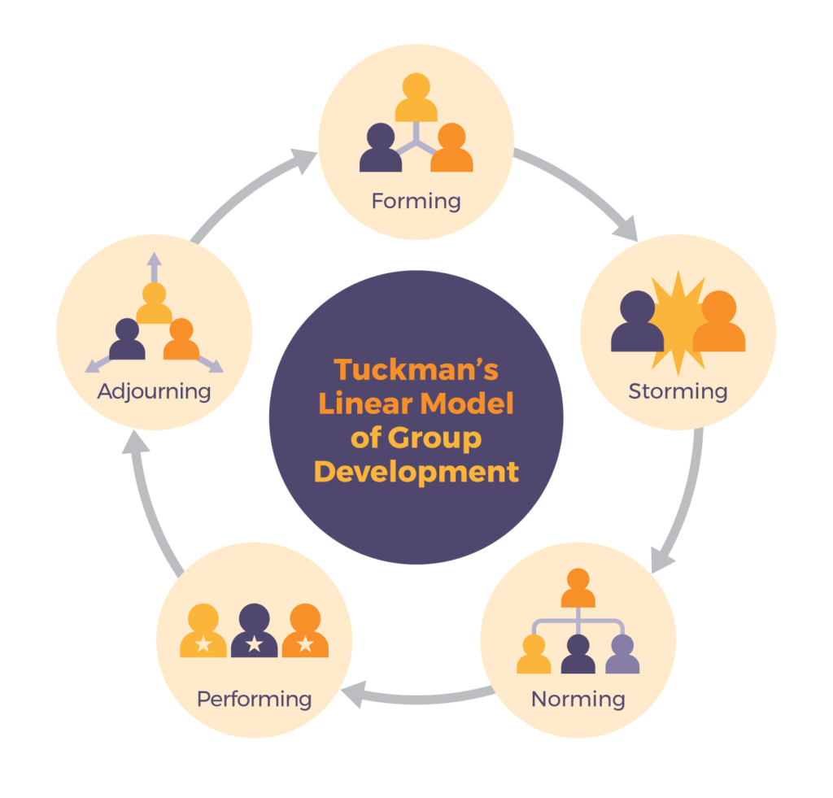
Image taken from (last, 2019)
As Tuckman highlights, each team that is newly formed must go through these stages to become effective. Tuckman highlights that to move from stage to stage, communication is key. From my experience, the storming stage can be very difficult. It occurs when multiple personalities clash, usually trying to assert dominance. Once a team has passed through this stage they become used to the structure and start to work more efficiently. Once the team is performing the task is executed to a high standard and once the task or project is complete the team moves on.
In the construction industry teams are put together for huge projects, but very often have never met each other or worked together. This can be very risky as there are no guarantees that a team will work well together. However, the DISC theory developed by William Marston helps understand conflict management by analysing personality types. The four categories are, Dominance, Influence, Steadiness and Conscientiousness (DISC). This theory promotes self-awareness of traits and can be used by employers to ensure a new team members’ personality will fit the team. This enables construction teams to be carefully chosen to give maximum efficiency and get through the storming stage of Tuckman’s theory much quicker as clashes are mitigated by the chosen personality types, (discinsignts, 2022).
After taking the DISC assessment, my results pointed out my strongest trait was a driver, full results can be seen in appendix 3. It’s an advantage to understand your own traits to be able to work as efficiently as possible in a team.

6 Summary

This module has been of great benefit and enhanced my understanding of myself and how attributes I possess can be suited to the Construction Industry. Below is a list of points learned throughout this module,
- The importance of professionalism and ethics in Construction and the devastating effects that not implementing the highest levels of both can have.
- How leadership theories came about. How they play a part in analysing the leaders of the past and present and help future leaders analyse their style.
- How organisational behaviour studies have improved team efficiency.
- Teamwork theories and how teams can be chosen based on personality traits to enhance their performance.
- How teamwork models can be used to predict the outcomes of teams and the cycles all teams must go through.
- How the construction industry differs from many industries with teamwork. Putting together new teams for short projects time and time over. How studies into teamwork and leadership can help these start more efficiently.
- How different leadership styles can have different effects on their subordinates and how different styles can be suited to certain situations.

I look forward to taking the theories learned throughout this module forward into my construction career.

7 Appendices

Appendix 1 CV.

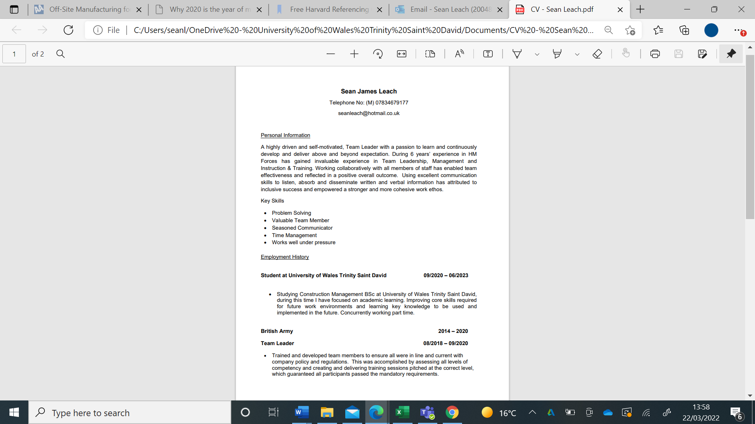

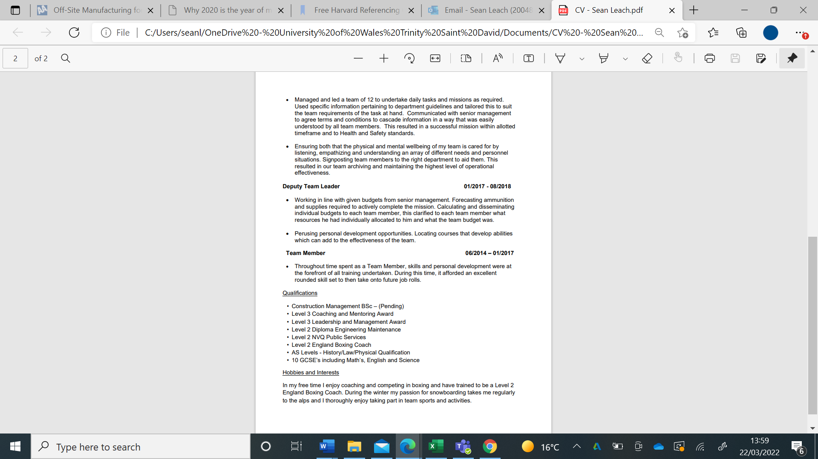

Appendix 2, Professional development plan
Name: Sean Leach Date: 23/03/2022
Current Situation | What professional development activities are you already undertaking?  Currently I am studying BSc Construction Management full time at the University of Wales Trinity Saint David.  I undertake CPD events on the CIOB website to improve my knowledge of construction.
Current Goals | What is your 12-month career goal?  My goal is to complete my degree with a 1st class honour and secure a job within the construction industry that is related to my degree.  I also have the ambition to work towards chartership for CIOB.
Skills Gap | What skills, knowledge or resources do you need to achieve the career goal(s)?  I need to improve my understanding of BIM to further enhance my chances of securing a job.  I need to speak to local companies and ensure I gain real like experience to prepare me for the industry.
Actions | What actions will you take to address the skills gaps?  I shall undertake CPD on relevant subject that I need to improve my knowledge.  I shall reach out to companies in the local area and secure work placements to give me experience doing various roles in the industry.
Evaluation | How often will this plan be reviewed?  This plan shall be reviewed every 12 months. Or when a major milestone has been completed so a new objective can be added.

Appendix 3 – DISC personality test results.
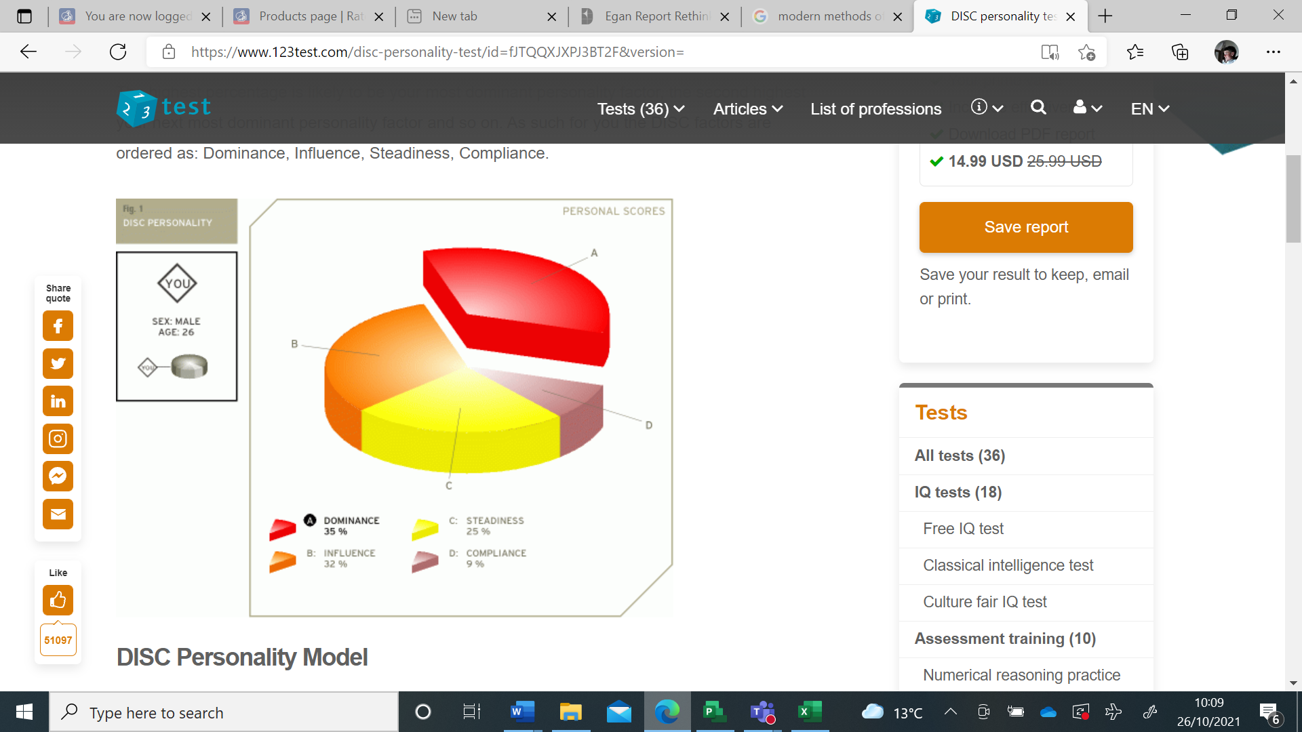

8 References

‌
(CSL). The Society of Construction Law. (2003). SCL Ethics Group | Society of Construction Law UK. [online] Available at: https://www.scl.org.uk/resources/ethics.

(R&B) Refurb & Developer Update. (2021). Dangerous Occupations Report 2021: Construction is revealed as the riskiest industry @Im_Insured. [online] Available at: https://developer-update.co.uk/2021/09/15/dangerous-occupations-report-2021-construction-is-revealed-as-the-riskiest-industry-im_insured/ [Accessed 5 Apr. 2022].
.
Anon. (2017). Why Study Organizational Behavior. [online] Available at: https://www.iedunote.com/why-study-organizational-behavior.
Anon. (2018). Professionalism in the Construction Industry. [online] Available at: https://www.ukessays.com/essays/construction/the-professionals-of-construction-industry-construction-essay.php.

Anon. (2022). Difference Between Ethics and Professionalism. [online] Available at: https://www.differencebetween.com/difference-between-ethics-and-vs-professionalism/#:~:text=Ethics%20refers%20to%20the%20guidelines [Accessed 5 Apr. 2022].

Apps, P. (2019). Six key factors in the failure of the Grenfell Tower refurbishment. [online] Available at: https://www.insidehousing.co.uk/insight/insight/six-key-factors-in-the-failure-of-the-grenfell-tower-refurbishment-67309.

BBC (2014). BBC - Ethics - Introduction to ethics: Ethics: a general introduction. [online] www.bbc.co.uk. Available at: https://www.bbc.co.uk/ethics/introduction/intro_1.shtml.

BBC (2019). Grenfell Tower: What happened. BBC News. [online] 18 Jun. Available at: https://www.bbc.co.uk/news/uk-40301289.

British Library (2012). Elton Mayo: The Hawthorne Experiments Thinker. The British Library. [online] Available at: https://www.bl.uk/people/elton-mayo.
Cambridge Dictionary (2019). PROFESSIONALISM | meaning in the Cambridge English Dictionary. [online] Cambridge.org. Available at: https://dictionary.cambridge.org/dictionary/english/professionalism.

Cherry, K -B. (2020). Situational Theory of Leadership. [online] Verywell Mind. Available at: https://www.verywellmind.com/what-is-the-situational-theory-of-leadership-2795321.

Cherry, K. (2020). The Hawthorne Effect and Behavioral Studies. [online] Verywell Mind. Available at: https://www.verywellmind.com/what-is-the-hawthorne-effect-2795234
Cherry, K. (2021). Leadership styles and frameworks you should know. [online] Verywell Mind. Available at: https://www.verywellmind.com/leadership-styles-2795312.
CIOB (2022). Search Results | CIOB. [online] Available at: https://www.ciob.org/sites/default/files/Rules%20and%20Regulations%20of%20Professional%20Competence%20and%20Conduct_0.pdf [Accessed 5 Apr. 2022].

Discinsights. (2022). DISC Theory and DISC Personality Traits - DISC Insights. [online] Available at: https://discinsights.com/disc-theory#:~:text=DISC%20is%20an%20acronym%20for.

Fernando, J. (2022). Corporate Social Responsibility (CSR). [online] Investopedia. Available at: https://www.investopedia.com/terms/c/corp-social-responsibility.asp.
‌
FutureLearn. (2022). Why is organisational behaviour important in construction? [online] Available at: https://www.futurelearn.com/info/courses/organisational-behaviour-in-construction-an-introduction/0/steps/75259.
HSE (2020). Health and Safety Executive. [online] Available at: https://www.hse.gov.uk/Statistics/industry/construction.pdf.
‌
IMD (2021). The 5 Leadership Styles you can use & How to implement each. [online] IMD business school. Available at: https://www.imd.org/imd-reflections/reflection-page/leadership-styles/.

Jackson, R. (2021). Corporate Social Responsibility - A Simple Guide. [online] TheGivingMachine. Available at: https://www.thegivingmachine.co.uk/blog/posts/corporate-social-responsibility-a-simple-guide/.

Last, S. (2019). 4.2 Five Models for Understanding Team Dynamics. pressbooks.bccampus.ca. [online] Available at: https://pressbooks.bccampus.ca/technicalwriting/chapter/understandingteamdynamics/#:~:text=The%20Tuckman%20Team%20Model.

Luthra, A. and Dahiya, R. (2015). Effective leadership is all about communicating effectively: Connecting leadership and communication 1. International Journal of Management and Business Studies, [online] 5(3), pp.43–48. Available at: https://www.mcgill.ca/engage/files/engage/effective_leadership_is_all_about_communicating_effectively_luthra_dahiya_2015.pdf.

Management, A. (2022). Organisational Behaviour Theories and its Role in Management. [online] Aptitude Management PTY LTD. Available at: https://aptitudemanagement.com.au/organisational-behaviour-theories-and-its-role-in-management/.
Mind tools (2009). Professionalism Developing This Vital Characteristic. [online] Mindtools.com. Available at: https://www.mindtools.com/pages/article/professionalism.htm.
Moorhead, G., & Griffin, R. W. (1995) Organizational behavior: Managing people and organizations (5th edition) Boston: Houghton Mifflin
Prentice, W.C.H. (2014). Understanding leadership. [online] Harvard Business Review. Available at: https://hbr.org/2004/01/understanding-leadership.
Pugh, D. (1971) Organisation Theory: Selected Readings, Harmonwords
Rahman, M. (2016). Organisational behaviour - definition and importance. [online] howandwhat. Available at: https://howandwhat.net/organisational-behaviour/.
Richard J. Moniz Jr. (2022). Contingency Theory - an overview | ScienceDirect Topics. [online] Available at: https://www.sciencedirect.com/topics/economics-econometrics-and-finance/contingency-theory.

Rics.org. (2022). [online] Available at: https://www.rics.org/uk/surveying-profession/join-rics/#:~:text=Relevant%20experience%20and%20an%20RICS [Accessed 5 Apr. 2022].
‌
Sahil Devasia (2018). Organisational Behaviour and its Importance in Management - Robert Kennedy College Blog. [online] Robert Kennedy College Blog. Available at: https://blog.college.ch/robert-kennedy-college/organisational-behaviour-and-its-importance-in-management/.
Simplilearn (2020). Top Leadership Theories Every Manager Should Know. [online] Simplilearn.com. Available at: https://www.simplilearn.com/top-leadership-theories-every-manager-should-know-article.

Western Governors University (2020). Leadership Theories and Styles. [online] Western Governors University. Available at: https://www.wgu.edu/blog/leadership-theories-styles2004.html#close.
‌

‌

