Part 1:

What do I know already: I have studied child development/ early years play, care and development through my GCSE’s and level 2 and 3 in college.
What have I learnt so far: studying Early years development for a few years has given me a range of knowledge in this area, developing my confidence and comprehension when learning new things now coming to university.
What do I want to develop: I want to develop my skills and knowledge regarding Early years development to enable me to graduate and have a profession working with children

Objective | Actions | Resources | Target Date for achieving objective | Success criteria
Organisation skills | I plan to make use of different methods, applications and routines to overall give myself better organisational skills. This will benefit not only with my studies but with my life in general. I plan to use the reminders app on my phone for smaller and quicker tasks that I’m more likely to forget about. I will also be using a written out weekly plan in a table format to visualise my week and maximise time and efficiency. I will also allocate a minimum and maximum time to complete task to ensure they are completed but to ease the workload to avoid stress. | A year planner or a calendar will help me create a weekly plan to ensure the placing this in room where i will see it often will ensure i am on top of future plans and planning in general also using my phone to take a photo and maybe having a digital format to constantly reference and update it. The reminders app on my phone i will check as part of routine to ensure I haven’t missed anything and to add any tasks to have a reminder to complete it. I will also ask friends, family and tutors for feedback on my organisation if it needs to be improved and if its good enough | In the next academic year I would like to be applying myself in the correct way to be able to achieve this goal | The main way i will observe if my organisational skills have improved is by making a direct comparison of my free time and work that’s completed, and the quality of my assignments and such to see if by being more organised has provided a boost in quality and quantity. As previously stated I believe feedback from my friends, family and tutors is great way to have some idea if what i am doing is working and helping me achieve my goals efficiently. The planner I will be using can be used to check off tasks and assignments and looking back to see how much has been completed will indicate if i am organised and being efficient but can directly show me where i need to maybe change certain aspects of my planned tasks.
Level 1 first aid training | I plan to Via the first aid UK website i will enrol on the course and with studies and research within my own time and further complete the required tasks, tests and assessments to meet the criteria to be successful in achieving the qualification. | I will use the first aid UK website for research, i will also be using my university library for any documents and texts the can provide useful and adequate information that will benefit me. I will ask for advice and information from people who have the qualification and also do my own research online. | I aim to achieve this once I have graduated university, therefore my training will still be in date when I aim to get a job | Upon successful completion of the level 1 health and safety qualification i will be given a certificate of completion which i can provide as proof of the qualification and will be able to apply this to my CV.
Level 1 safeguarding | my university course in it self is very useful in regards to gathering useful information to learn about safeguarding. To complete the course i will enrol directly through my university on the government website and use the gained knowledge through my tutoring to complete the course | I will be completing the course to gain the qualification on the government website. To ensure being successful i will reference my university lectures and course work to achieve the level 1 qualification. If needed i can ask for support from my tutors and people who already have this qualification. |  | Becoming qualified in this course will result in certification which will be widely recognised and useful for my career, i will be provided with either a digital or hard copy of the certificate which will help with my CV and future job prospects.

Part 2:
According to Pacey(2016) the meaning of reflective practice is the process of thinking about adapting, challenging and improving your practice to better the outcome. This could be the analysis of teaching methods, interactions, and choices to strengthen their professional practice, ensuring to have a non-bias view on your own personal practice and aiming to develop all areas where possible to become certain within your practice. However, being a reflective practitioner means understanding that there is always room for improvement and to not become too reliant on old practice. Reflective practice allows individuals to develop their problem-solving skills, and critical thinking, it will allow practitioners to begin a cycle of self-awareness, action and apply to practice. Taking theory and applying into practice is a vital skill to have when working with children, understanding that when working with children being able to have a variation of methods to different scenarios will be beneficial as each child is unique in their own way. Brock(2014) has suggested that practitioners should approach reflective practice in a way that looks at all areas meaning that reflective practice should be a thorough process and Brock(2014) also suggests that ideas and suggestions from different individuals to gain a wider view and will help identify areas for improvement.

Reflection plays a key role in professional practice as practitioners need to nurture self-awareness, continuous improvement finalising a verdict with reasoning. When making constant self-evaluations professionals can pinpoint areas of development which will inevitably lead to developing personal skills and effectiveness. Reflection is also a way of learning how to apply theory to practice, learning from real life situations will give practitioner a realistic view on how to look at how to approach the next step with the childs needs at the forefront of all decisions. Reflective practice is not only important for personal development and children, but it is also a way of parents/ carers to build a trust with the people they are leaving their children with. Parents/ carers will be able to see the high level of care you are providing which is important as it reassures parents/ carers about the well being and begins to create collaborative relationships with parents/ carers. It helps build communicative relationships which can then encourage parents/ carers to engage and be involved within their child’s learning.

Moreover, reflective practice is important in the early years as it ensures that practitioners frequently assessing their strategies to teaching methods and interactions, leading to improved results each time for children during a pivotal stage of their development. Furthermore, reflective practice involves regularly self- assessing actions, decisions, and their impacts on children's learning and well-being. This is all very important for the child as it ensures the practitioner are staying responsive to children’s development, understanding and sometimes the children’s setbacks. It opens an area where the practitioner can amend the environment to meet the child’s needs and allow children to explore, experiment and develop in a way that will always be complimentary to their needs. Reflective practice is a good way to gain understanding of why we do certain things in our practice, assessing whether it is necessary or can be developed on the approach. It creates sense in what we are doing

Moving on, Gibbs's developed the reflective cycle by Graham Gibbs (1988). Gibbs developed a form a cycle structure through learning from experiences. Also, Gibbs developed this cycle to allow professionals to repeat experiences to see the strengths and weaknesses (Reflection toolkit). In other words, these experiences can be one-time experiences or a frequent experience you go through. When approaching Gibbs's reflective cycle, it can be viewed as a good way of reflecting on practice because it has a form of questions to support practitioners to examine their weakness and strengths, when providing the best possible start for children in early years According to this source Gibbs's reflective cycle askes questions such as to look at the strengths and weaknesses of the situation, this allows practitioners to look at both sides of the situation. Gibbs and Kolb's theory both use a reflective learning cycle that support practitioners to evaluate their practice. That Kolb's learning cycle looks at professional personal learning styles and holistic assessment as he believes this allows practitioners to learn about good leadership skills. Both reflective cycle's continuities look at how practitioners can experiment, reflect, and learn through these experiences to improve . Another similarity is that both reflective cycles look at a new situation or situations that keep recurring and to find a solution in these situations. An advantage that Kolb's theory states, that Gibbs's does not is that Kolb's four stages of his reflective cycle only work if practitioners go through these stages step by step, to allow the practitioner to really examine the importance of this situation.

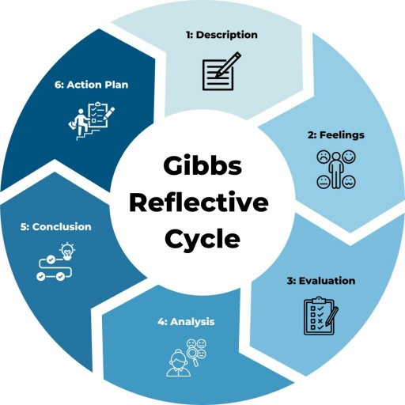
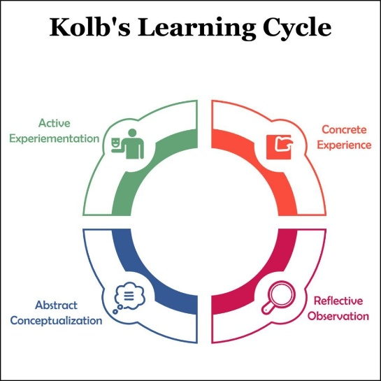

Part 3:

Professional practice is the way and method of carrying out your role with a level of professionalism within your sector. For example an early years practitioner would have to have a confident, modest and mature mindset. This would result in the way they work with this age group, they understand the importance of emotions, respect and individuality as their core values. This is integral to maintaining a professional level of work as well as respect from work colleagues and the children, this further provides a greater level of care and would ultimately lead you to be considered a professional with your role. Key values for a professional practitioner would consist of respect, understanding, confidence, patience, emotional intelligence and cooperation. These are essential to provide the highest level and quality care and assistance for early years who will depend on these values due to their many needs at such an age, the level of support is a must for a healthy development of behaviour, independence and education. The relationship and communication with a child in early year’s development is vital to remain consistent, clear and compassionate.
Children’s needs and wants must be understood to provide strong support, a practitioner must be able to listen carefully with encouragement to get the child to ask questions and talk about how they feel so they have the confidence to talk about things they may be scared to say or ask. This level of communication will go alongside clear explanations and approachable body language to ensure the child has the confidence and understanding of what maybe need to be explained to them and allowing them take on board the information and recognise what had been said. If a practitioner has built a good relationship with child within the early years the child gathers a level of trust and reliability as well as confidence, which allows for more interest and comprehension of care and education. A deep level of knowledge is is significant for professional practice as this knowledge is particular to the role which will help them in all aspects of the job, they will be able to pick up smaller details and solve problems that may not have been handled or tackled properly without such a level of knowledge. For example, safeguarding children may seem straightforward but with hindsight and a great level of ability, a practitioner can safeguard much more effectively by identifying vulnerable children sooner to prevent danger and risks and to protect these children. It is extremely important for partnerships and multi-agency working for the aspect of professional practice due to the importance of safeguarding a child can take more than one practitioner to provide the best level of security and protection for a child, having more than one agency or practitioner involved in the care education or safeguarding of a child will result in communication of different opinions of how to make the best informed decision about all aspects of the child’s care.
Discussing with colleagues and partners about the child’s behaviour and wellbeing can make it easier for when a child changes care from practitioner to practitioner, this allows for the best transition for both the child and professional this acknowledgment of information will help with the future of the child’s development and welfare. The cycle of observation and planning allows for practitioners provide the best quality of care and fulfil the needs of the children to fullest extent by ensuring the children have been observed in many different ways and aspects including play, everyday activities and the parent's own observations of what the child does at home. This is an extensive way of understanding exactly how the child behaves and learns which allows for a practitioner to tailor the way they educate and care for the child. This leads to the assessment of their observations and findings to then later plan how to progress with the child’s development and learning, this may include the balance of children’s playing time balancing with their class work, being in enabling environments to see the child’s strengths as well as areas for improvements and to see how well their skills develop overall. Many professionals and practitioners will use this information to shape their way of caring and the year curriculum. This becomes very useful and valuable to the practitioner who can fulfil the needs and contentment of the children that have been observed and assessed for their own benefit. This allows for them also to become a well respected and professional level childcare practitioner.
The UNCRC principles are fundamental for both young children and the childcare practitioners and professionals, there are four general principles that are most valued and essential to professional practice of childcare. CPYCS (n.d) Articles: 2, 3, 6 and 12 generalise how the UNCRC should be interpreted, article 2 suggests that children should never be discriminated against as something so serious will ensure a lack of respect and trust between the professional and child. Article 3 proposes the practitioner should have the child’s best interests accounted for as a primary consideration this will provide a great level of care and devotion the child and their emotions and feelings. CPYCS (n.d) Article 6 states the child has the right to survive and develop which a practitioner can attend to in every form, its crucial they can provide assistance to allow a child to develop extensively and adequately. CPYCS (n.d) Article 12 advocates the child’s right to have their views heard and taken seriously, this is intrinsic that a practitioner can show compassion for a what child believes and thinks and can take on board the opinions to give the child the best quality of understanding, education and aid this shows a high level of professionalism within their role and an outstanding level of empathy.

Overall professional practise with the field of working with early years developing children comes down to a number of factors which include a level of compassion and dedication, patience and understanding, teamwork and communication as well as a great care for ethics and morals when it comes the the care and education of these children. Professionals will have to undertake task which maybe demanding challenging, but the dedication of professionalism will reflect in the multitude of skills that are used when providing such amounts of support. Higher levels of knowledge is key and having an endearing and supportive mindset will set you apart in terms being able to meet the expectations of such roles. Working collectively and effectively with other professionals will allow for improvements for both the children and practitioners alike this results in development both ways. Communication becomes a massive part building strong relationships with children, agencies and childcare providers collectively. All in all this shows professional practice is key to giving outstanding aid care and fulfilment to young children.

refer

Fact Sheet title (pacey.org.uk)

Brock, A (2014) The early years reflective practice handbook. London: Routledge

Birth to 5 Matter (No Date) Learning and Development, Observation, Assessments and Planning. Available at: Explaining-the-OAP-Cycle.pdf (birthtoSmatters.org.uk) (Accessed: 18 May 2024),

Gibbs' Reflective Cycle | The University of Edinburgh

BERA (2016) Professionalism and the early years practitioner. Available at: https://www.bera.ac.uk/blog/professionalism-and-the-early-years-practitioner#:~:text=My%20research%20demonstrates%20that%20practitioners,the%20value%20of%20collaborative%2C%20cooperative (Accessed at: 27 jun 2024)

WJEC (2019) Professional Practice as a Childcare Worker. Available at: http://resource.download.wjec.co.uk.s3-eu-west-1.amazonaws.com/vtc/2018-19/hsc18-19_3-3/_multi-lang/unit02/03-developing-good-relationships-working-in-ways-that-build-trust.html#:~:text=Developing%20effective%20relationships%20allows%20everybody,gain%20the%20trust%20of%20others. (Accessed at: 27 jun 2024)

Skills for health (2023) Why is safeguarding so important in health care? Available at: https://www.skillsforhealth.org.uk/article/why-is-safeguarding-so-important-in-health-care/#:~:text=Serious%20issues%20can%20only%20be,to%20identify%20and%20tackle%20concerns. (Accessed at: 27 jun 2024)

NSPCC Learning (2023) Multi-Agency working. Available at: https://learning.nspcc.org.uk/child-protection-system/multi-agency-working-child-protection#article-top (Accessed at: 27 jun 2024)

Birth to 5 Matters (n.d) Observation, assessment and planning. Available at: https://birthto5matters.org.uk/observation-assessment-and-planning/ (Accessed at: 27 jun 2024)

Children and young peoples commissioner scotland [CYPCS] (n.d) What are the general principles of the UNCRC? Available at: https://www.cypcs.org.uk/faq/what-are-the-general-principles-of-the-uncrc/ (Accessed at: 27 jun 2024)

Implementing Kolb´s Experiential Learning Cycle by Linking Real Experience, Case-Based Discussion and Simulation - PMC (nih.gov)

