Appendix 1
Observation of engagement

Name of Child: Name of observer:

Date: Time:

Level | Engagement | Signals | Observed (Tick):
1 | Extremely low | The child does not respond to the environment, avoids contact and is withdrawn. They may look bored or be distracted by things surrounding them. The child may also act upon something not related to classroom discussion and as a result, distract others around them.
2 | Low | The posture, facial expression and actions indicate that the child is not fully engaged. However, the signals are less explicit than under level 1.
3 | Moderate | The child has a neutral posture. Facial expression and posture show little or no engagement. The child looks engaged but does not voluntarily contribute to group discussion.
4 | High | The child shows obvious signs of understanding and engagement (as listed under level 5). However, these signals are not constantly present with the same intensity.
5 | Extremely high | The child looks happy and cheerful, nods their head and is eager to participate- showing a sense of understanding. The child appears focussed and does not show any signs of stress or tension. He/she is open and accessible to the environment.
Comments:

Level of engagement:

Appendix 2
Interviewer: Abigail Maggs
Interviewee: 6 children
Interview structure: Semi-structured

*Make sure to have chilled conversation so that the participant is relaxed.

Questions

- Do you like school?
- What is your favourite subject in school?
- Do you like getting involved with classroom discussions?
- If not, why not?
- If you were a Mr Men character, which one would you be? [cards]
- How does it make you feel when Mrs Phillips uses the pegs with your names on?
- Why do you think Mrs Phillips uses the pegs with your names on?
- Do you think she should keep using these in class?

Appendix 3
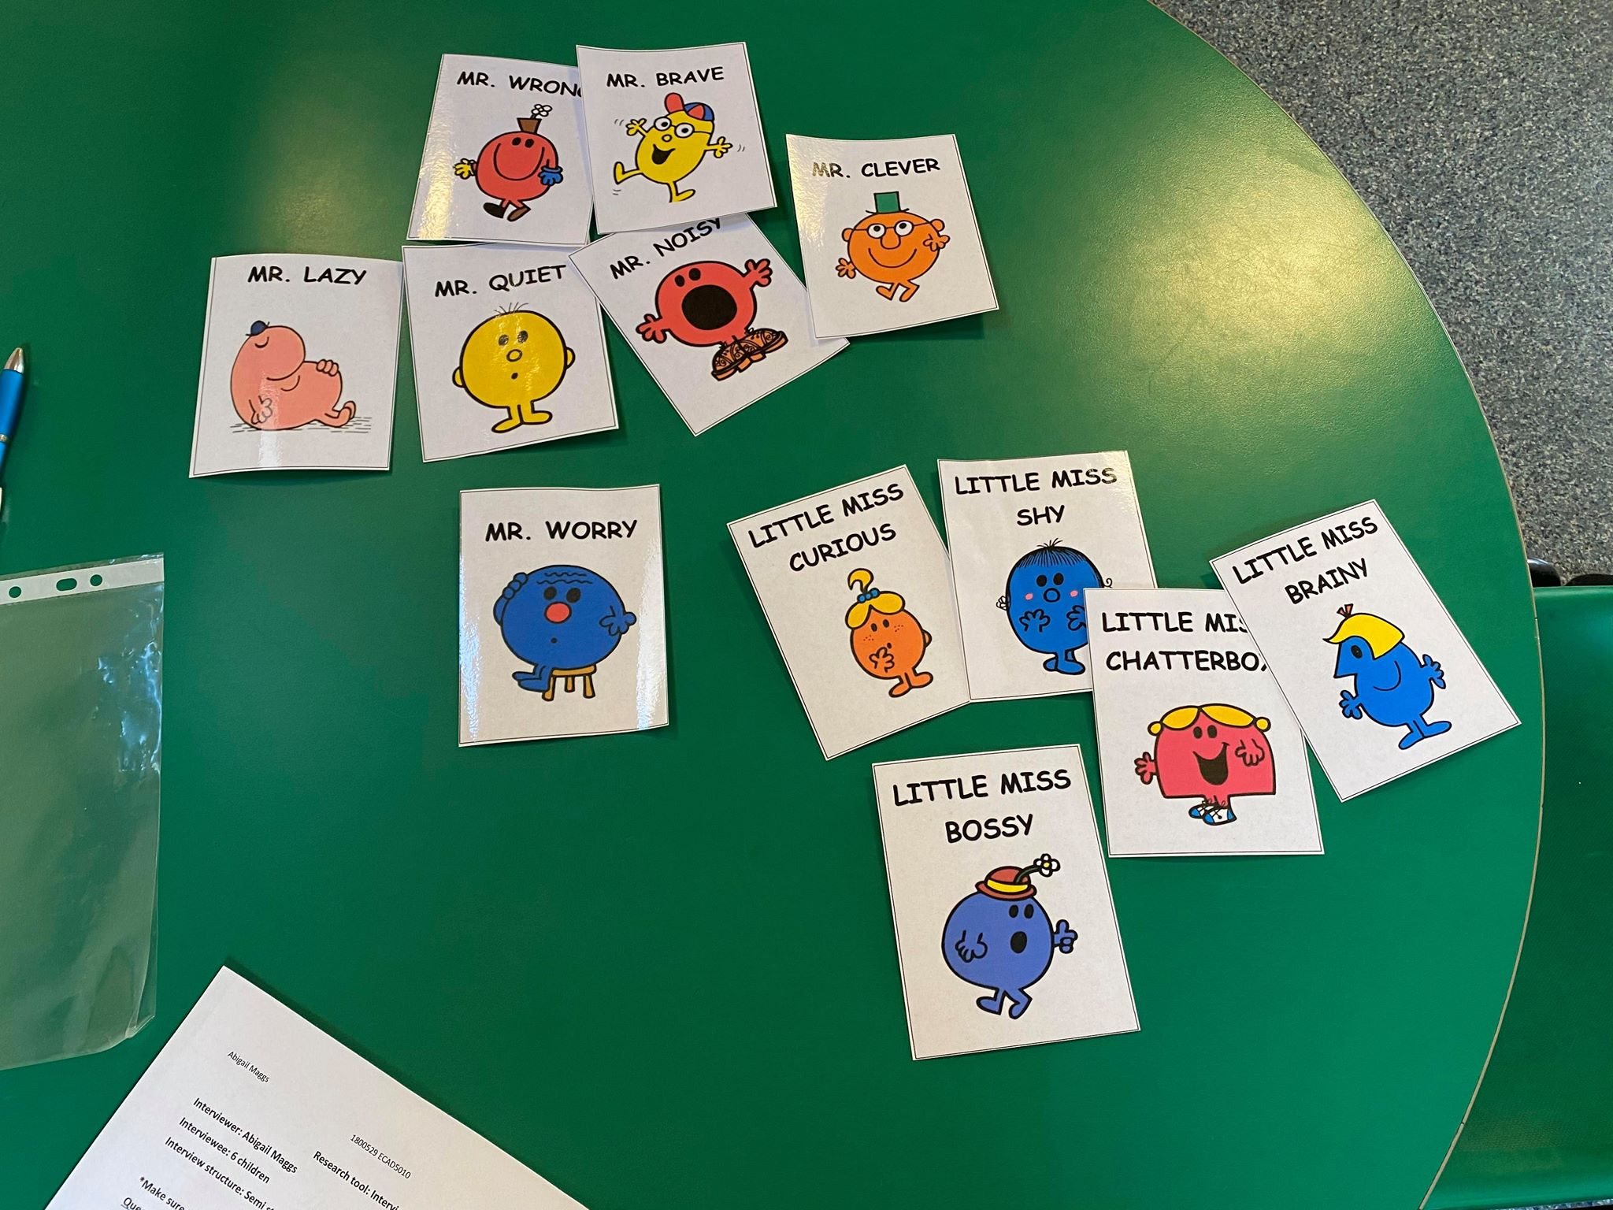

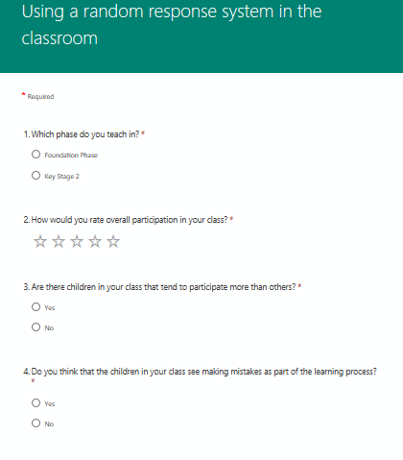
Appendix 4

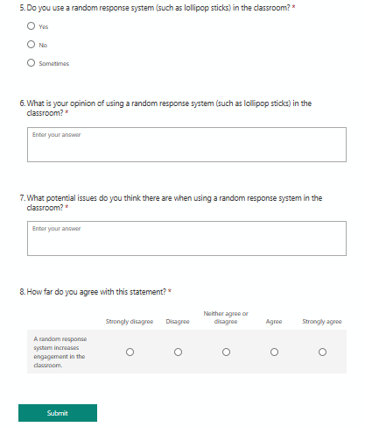
Appendix 5
APPLICATION FOR ETHICAL APPROVAL

In order for research to result in benefit and minimise risk of harm, it must be conducted ethically. A researcher may not be covered by the University’s insurance if ethical approval has not been obtained prior to commencement.

The University follows the OECD Frascati manual definition of research activity: “creative work undertaken on a systematic basis in order to increase the stock of knowledge, including knowledge of man, culture and society, and the use of this stock of knowledge to devise new applications”. As such this covers activities undertaken by members of staff, postgraduate research students, and both taught postgraduate and undergraduate students working on dissertations/projects.

The individual undertaking the research activity is known as the “principal researcher”.

Ethical approval is not required for routine audits, performance reviews, quality assurance studies, testing within normal educational requirements, and literary or artistic criticism.

Please read the notes for guidance before completing ALL sections of the form.

This form must be completed and approved prior to undertaking any research activity. Please see Checklist for details of process for different categories of application.

Delete the Guidance Notes at the end of the form BEFORE submitting your application

SECTION A: About You (Principal Researcher)
Full Name: |  | Abigail Anne Maggs
Tick all boxes which apply: |  | Member of staff: | ☐ | Honorary research fellow: | ☐
Undergraduate Student | ☒ | Taught Postgraduate Student | ☐ | Postgraduate Research Student | ☐

Faculty/School/Centre: | Initial Teacher Education, Yr Athrofa
Campus: | Carmarthen
E-mail address: | 1800529@student.uwtsd.ac.uk
Contact Telephone Number: | 07854475019
For students:
Student Number: | 1800529
Programme of Study: | BA Primary Education with QTS
Director of Studies/Supervisor: | Dr. Sioned V. Hughes

SECTION B: Approval for Research Activity
Has the research activity received approval in principle?  (please check the Guidance Notes as to the appropriate approval process for different levels of research by different categories of individual) |  | YES | ☒ | NO | ☐
 |  |  |  | Date
If Yes, please indicate source of approval (and date where known): Approval in principle must be obtained from the relevant source prior to seeking ethical approval | Research Degrees Committee |  | ☐
 | Faculty Research Committee |  | ☐
 | Other (write in) ECAD5010 Module Lead |  | ☒ | 27.02.20

SECTION C: Internal and External Ethical Guidance Materials
Please list the core ethical guidance documents that have been referred to during the completion of this form (including any discipline-specific codes of research ethics, and also any specific ethical guidance relating to the proposed methodology). Please tick to confirm that your research proposal adheres to these codes and guidelines.
UWTSD Research Ethics & Integrity Code of Practice | ☐
UWTSD Research Data Management Policy | ☐
British Educational Research Guidelines (Bera, 2018)  https://www.bera.ac.uk/researchers-resources/publications/ethical-guidelines-foreducational-research-2018 | ☐

SECTION D: External Collaborative Research Activity
Does the research activity involve collaborators outside of the University? |  | YES | ☐ | NO | ☒
If Yes, please provide the name of the external organisation and name and contact details for the main contact person and confirmation this person has consented to their personal data being shared.as part of this collaboration.
Institution
Contact person name
Contact person e-mail address

Has this individual consented to sharing their details on this form? |  | YES | ☐ | NO |  |  | ☐
Are you in receipt of a KESS scholarship? |  | YES | ☐ | NO |  |  | ☐
Is your research externally funded |  | YES | ☐ | NO |  |  | ☐
Are you specifically employed to undertake this research in either a paid or voluntary capacity? | Voluntary | YES | ☐ | NO |  | ☐
 | Employed | YES | ☐ | NO |  | ☐
Is the research being undertaken within an existing UWTSD Athrofa Professional Learning Partnership (APLP) | If YES then the permission question below does not need to be answered. | YES | ☒ | NO |  |  | ☐
Permission to undertake the research has been provided by the partner organisation | (If YES attach copy)  If NO the application cannot continue | YES | ☐ | NO |  |  | ☐

Where research activity is carried out in collaboration with an external organisation
Does this organisation have its own ethics approval system? | YES | ☐ | NO | ☒
If Yes, please attach a copy of any final approval (or interim approval) from the organisation

SECTION E: Details of Research Activity
Indicative title: | Using a random response system in the classroom
Proposed start date: | 02.03.20 | Proposed end date: | 01.04.20
Introduction to the Research (maximum 300 words)
Ensure that you write for a Non-Specialist Audience when outlining your response to the three points below:
- Purpose of Research Activity
- Proposed Research Question
- Aims of Research Activity
- Objectives of Research Activity
Demonstrate, briefly, how Existing Research has informed the proposed activity and explain
- What the research activity will add to the body of knowledge
- How it addresses an area of importance.
Purpose of Research Activity

- To explore how a random response system affects engagement in the classroom.
- To trial different research tools in practice.
- To use the data collected to improve my own practise.

Research Question

Does a random response system increase engagement in the classroom?

Aims of Research Activity

- To explore staff and learners’ perceptions of using a random response system.
- To critically evaluate the different research tools chosen.
- To further develop personal knowledge and understanding of feedback within AfL.
- To improve professional practice.

Objectives of Research Activity

- To explore the use of a random response system used by staff through a questionnaire.
- To use the Mosaic Approach to collect data.
- To interview 3-11-year-olds learners to capture their views/feelings on using random response systems.
- To observe a lesson with/without using a random response system and measure children’s engagement.
- To critically reflect on the process of using different research tools to collect data.

Proposed methods (maximum 600 words)
Provide a brief summary of all the methods that may be used in the research activity, making it clear what specific techniques may be used. If methods other than those listed in this section are deemed appropriate later, additional ethical approval for those methods will be needed.
Interviews: A group of 6 children from a Year 3 class will be involved in a semi-structured interview where they will be invited to respond to key questions. For example, how do you feel when [class teacher] uses the pegs with your names on? Do you know why she uses them? Do you think she should keep using them? These interviews will be conducted in an informal setting and I will make notes and audio record their responses. The children chosen will be randomly selected from each ability group and will not be forced to participate. They will also be made aware that they do not have to answer any questions and that they can opt-out at any time. Children will have access to a thumbs up thumbs down as a signal to demonstrate that they are happy to continue. I will check on the children’s feelings regularly. No names will be recorded.

Questionnaire: Class teachers from both Foundation Phase and Key Stage 2 will complete a questionnaire where they will be asked questions on their opinion and feelings on using a random response system in the classroom. For example, do you use a random response system in your classroom (such as lollipop sticks)? What potential issues do you think there are when using a random response system in the classroom? These questionnaires will be completed when classroom teachers have spare time (possibly break time and lunch time). The teachers chosen will be random- making sure there are some from both phases and will not be forced to participate. Teachers asked to take part will sign a consent form indicating that they have agreed to take part and have been informed of the aims of my research, they will also be made aware that they can opt-out at any time. No names will be recorded.

Observations: A group of 6 children in a Year 3 class will be observed, I have already been in this class as part of my PTE2 therefore I must maintain my teacher-pupil relationship so that it does not jeopardise my research findings. The observational schedule being used is a modified version of the Leuven Scale which measures the engagement from being extremely low to extremely high. The schedule also includes a ‘comments’ section where I can expand on my observation and record any comments that I think contributes to my research study. The children chosen will be random from each ability group and will not be forced to participate. They will also be made aware that they do not have to answer any questions and that they can opt-out at any time. Children will have access to a thumbs up thumbs down as a signal to demonstrate that they are happy to continue. I will check on the children’s feelings regularly. No names will be recorded.

Location of research activity
Identify all locations where research activity will take place.
The research activity will take place in a large urban school in the Rhondda Cynon Taff with approximately 400 pupils aged between the ages of 3-11. The school has two classes for each year group.

Research activity outside of the UK
If research activity will take place overseas, you are responsible for ensuring that local ethical considerations are complied with and that the relevant permissions are sought. Specify any local guidelines (e.g. from local professional associations/learned societies/universities) that exist and whether these involve any ethical stipulations beyond those usual in the UK (provide details of any licenses or permissions required). Also specify whether there are any specific ethical issues raised by the local context in which the research activity is taking place, for example, particular cultural and/or legal sensitivities or vulnerabilities of participants.
N/A

Use of documentation not in the public domain: Are any documents NOT publicly available? | NO | ☒
 | YES | ☐
If Yes, please provide details here of how you will gain access to specific documentation that is not in the public domain and that this is in accordance with prevailing data protection law of the country in question and England and Wales.

SECTION F: Scope of Research Activity
Will the research activity include? | YES | NO
Use of a questionnaire or similar research instrument? | ☒ | ☐
Use of interviews? | ☒ | ☐
Use of diaries? | ☐ | ☒
Participant observation with their knowledge? | ☒ | ☐
Participant observation without their knowledge? | ☐ | ☒
Use of video or audio recording? | ☒ | ☐
Access to personal or confidential information without the participants’ specific consent? | ☐ | ☒
Administration of any questions, test stimuli, presentation that may be experienced as physically, mentally or emotionally harmful / offensive? | ☐ | ☒
Performance of any acts which may cause embarrassment or affect self-esteem? | ☐ | ☒
Investigation of participants involved in illegal activities? | ☐ | ☒
Use of procedures that involve deception? | ☐ | ☒
Administration of any substance, agent or placebo? | ☐ | ☒
Working with live vertebrate animals? | ☐ | ☒
Other primary data collection methods, please explain in this box  For example, ‘focus groups. Please indicate the type of data collection method(s) in this box and tick the accompany box. | ☐ | ☒
Details of any other primary data collection method:  (this box should expand as you type) | ☐ | ☒
If NO to every question, then the research activity is (ethically) low risk and may be exempt from some of the following sections (please refer to Guidance Notes).

If YES to any question, then no research activity should be undertaken until full ethical approval has been obtained.

SECTION G: Intended Participants
Who are the intended participants? | YES | NO
Students or staff at the University? | ☐ | ☒
Adults (over the age of 18 and competent to give consent)? | ☒ | ☐
Vulnerable adults? | ☐ | ☒
Children and Young People under the age of 8? (Consent from Parent, Carer or Guardian will be required) | ☐ | ☒
Prisoners? | ☐ | ☒
Young offenders? | ☐ | ☒
Those who could be considered to have a particularly dependent relationship with the investigator or a gatekeeper? | ☐ | ☒
People engaged in illegal activities? | ☐ | ☒
Others (please identify specifically any group who may be unable to give consent) please indicate here and tick the appropriate box. | ☐ | ☒
Other – please indicate here: | ☐ | ☒

Participant numbers and source
How will you identify participants and how will they be recruited?
How many participants are expected? | 12 participants
Who will the participants be? | 6 teachers and the same 6 pupils (2 from each ability) being both observed and interviewed.
How will you identify the participants? | I have already been in this class as part of my PTE2 therefore I must maintain my teacher-pupil relationship and not jeopardise my research findings. The children chosen will be random from the different abilities.

Information for participants: | YES | NO | N/A
Will you describe the main research procedures to participants in advance, so that they are informed about what to expect? | ☒ | ☐ | ☐
Will you tell participants that their participation is voluntary? | ☒ | ☐ | ☐
Will you obtain written consent for participation? | ☐ | ☐ | ☒
Will you explain to participants that refusal to participate in the research will not affect their treatment or education (if relevant)? | ☒ | ☐ | ☐
If the research is observational, will you ask participants for their consent to being observed? | ☒ | ☐ | ☐
Will you tell participants that they may withdraw from the research at any time and for any reason? | ☒ | ☐ | ☐
With questionnaires, will you give participants the option of omitting questions they do not want to answer? | ☒ | ☐ | ☐
Will you tell participants that their data will be treated with full confidentiality and that, if published, it will not be identifiable as theirs? | ☒ | ☐ | ☐
Will you debrief participants at the end of their participation, in a way appropriate to the type of research undertaken? | ☐ | ☐ | ☒
If NO to any of above questions, please give an explanation

Information for participants: | YES | NO | N/A
Will participants be paid? | ☐ | ☒ | ☐
Is specialist electrical or other equipment to be used with participants? | ☐ | ☒ | ☐
Are there any financial or other interests to the investigator or University arising from this study? | ☐ | ☒ | ☐
Will the research activity involve deliberately misleading participants in any way, or the partial or full concealment of the specific study aims? | ☐ | ☒ | ☐
If YES to any question, please provide full details

SECTION H: Anticipated Risks

Outline any anticipated risks that may adversely affect any of the participants, the researchers and/or the University, and the steps that will be taken to address them.

If you have completed a full risk assessment (for example as required by a laboratory, or external research collaborator) you may append that to this form.
Full risk assessment completed and appended? |  | Yes | ☐
 |  | No | ☒
Risks to participants
For example: emotional distress, financial disclosure, physical harm, transfer of personal data, sensitive organisational information
Risk to Participant:  - Pupils may feel under pressured to give the correct answer to the questions.  - Pupils may feel pressured to give the right answer because they know me.  - Teachers may feel pressured to give the correct answers to show sound pedagogy.  - Children may encounter physical harm.  - Personal data can be misused. | How will you mitigate the Risk to Participant?  - Pupils will be told that there is no consequence for anything they say. I will make it clear that I want open and honest answers. I will make it clear that the answers they give will affect their education in no way and there will be no repercussions for their actions and answers in regard to the research.  - I have already been in this class as part of my PTE2 therefore I must maintain my teacher-pupil relationship so that it does not jeopardise my research findings.  - I will ask the teachers to give honest answers when completing the questionnaire and I will make it clear that the answers they give are confidential.  - There will be another researcher present while interviewing is taking place.  - I will make sure to anonymise both children and teachers in my notes, referring to children as (Child A) and teachers as (Teacher A) etc. I will also not name the school.
If research activity may include sensitive, embarrassing or upsetting topics (e.g. sexual activity, drug use) or issues likely to disclose information requiring further action (e.g. criminal activity), give details of the procedures to deal with these issues, including any support/advice (e.g. helpline numbers) to be offered to participants. Note that where applicable, consent procedures should make it clear that if something potentially or actually illegal is discovered in the course of a project, it may need to be disclosed to the proper authorities
N/A

Risks to investigator
For example: personal safety, physical harm, emotional distress, risk of accusation of harm/impropriety, conflict of interest

Risk to Investigator:  - Allegations from pupils in the classroom while completing the research.  - Children might not want to co-operate.  - Investigator may encounter physical harm.  - Investigator may experience emotional distress.  - Investigator may commit unethical actions or go against the BERA guidelines. | How will you mitigate the Risk to Investigator?  - The majority of the research will be during a normal activity in the classroom. There will be another researcher present while interviewing is taking place.  - The children who decide not to co-operate can have the option to op-out. Check on these children regularly and respect their choice if they choose to withdraw at any time.  - Make sure that there is another adult present in the room to prevent harm to the investigator.  - I am going to make sure that I stay on top of my notes by making use of break times/lunch times to record any notes to avoid getting stressed. I will also keep my notes private and safe.  - I will make sure I am aware of the BERA guidelines before carrying out my research study.
University/institutional risks
For example: adverse publicity, financial loss, data protection
Risk to University:  - Not behaving in a way that could impact the relationship between school and university.  - Not protecting data | How will you mitigate the Risk to University?  - I will behave in a professional manner, at all times.  - I will make sure not to disclose participants names or the school to withhold my professional status.

Disclosure and Barring Service
If the research activity involves children or vulnerable adults, a Disclosure and Barring Service (DBS) certificate must be obtained before any contact with such participants. | YES | NO | N/A
Does your research require you to hold a current DBS Certificate? | ☒ | ☐ | ☐

SECTION I: Feedback, Consent and Confidentiality
Feedback
What de-briefing and feedback will be provided to participants, how will this be done and when?
N/A

Informed consent
Describe the arrangements to inform potential participants, before providing consent, of what is involved in participating. Describe the arrangements for participants to provide full consent before data collection begins. If gaining consent in this way is inappropriate, explain how consent will be obtained and recorded in accordance with prevailing data protection legislation.
I will converse with my class teacher and participants and inform them of the research that I will be undertaking, providing reason and rationale behind the research. I have written a consent letter that the teachers can read and also have a copy if they wish. These consent letters have a consent form attached to which the teachers should sign, so I have their recorded agreement.

However, in terms of assent, I will verbally ask children identified to participate whether they wish to participate by using the thumbs up thumbs down approach. I must check on the children regularly and make sure they are comfortable. Children will also be informed that they can approach me at any time to ask questions and discuss their contribution to the project.

Confidentiality / Anonymity
Set out how anonymity of participants and confidentiality will be ensured in any outputs. If anonymity is not being offered, explain why this is the case.
The consent forms that are to be completed by the teachers before completing the questionnaire include a variety of statements which ensure the participant that their identity is anonymous. No names will be recorded, I must refer to teachers as (Teacher A) for example, throughout my notes and research study to disclose names. I will ensure that no individual data is made available to schools/parents etc.

SECTION J: Data Protection and Storage NO NEED TO COMPLETE SECTION J
In completing this section refer to the University’s Research Data Management Policy and the extensive resources on the University’s Research Data Management web pages (http://uwtsd.ac.uk/library/research-data-management/).
Does the research activity involve personal data (as defined by the General Data Protection Regulation 2016 “GDPR” and the Data Protection Act 2018 “DPA”)? | YES | NO
“Personal data” means any information relating to an identified or identifiable natural person (‘data subject’). An identifiable natural person is one who can be identified, directly or indirectly, in particular by reference to an identifier such as a name, an identification number, location data, an online identifier or to one or more factors specific to the physical, physiological, genetic, mental, economic, cultural or social identity of that natural person. | ☐ | ☐
If YES, provide a description of the data and explain why this data needs to be collected:
Does it involve special category data (as defined by the GDPR)? | YES | NO
“Special category data” means sensitive personal data consisting of information as to the data subjects’ –  (a) racial or ethnic origin,  (b) political opinions,  (c ) religious beliefs or other beliefs of a similar nature,  (d) membership of a trade union (within the meaning of the Trade Union and Labour Relations (Consolidation) Act 1992),  (e) physical or mental health or condition,  (f) sexual life,  (g) genetics,  (h) biometric data (as used for ID purposes), | ☐ | ☐
If YES, provide a description of the special category data and explain why this data needs to be collected:
Will the research activity involve storing personal data and/or special category data on one of the following: | YES | NO
Manual files (i.e. in paper form)? | ☐ | ☐
University computers? | ☐ | ☐
Private company computers? | ☐ | ☐
Home or other personal computers? | ☐ | ☐
Laptop computers/ CDs/ Portable disk-drives/ memory sticks? | ☐ | ☐
“Cloud” storage or websites? | ☐ | ☐
Other – specify: | ☐ | ☐
For all stored data, explain the measures in place to ensure the security of the data collected, data confidentiality, including details of password protection, encryption, anonymisation and pseudonymisation:
(this box should expand as you type)
All Data Storage
Will the research activity involve any of the following activities: | YES | NO
Electronic transfer of data in any form? | ☐ | ☐
Sharing of data with others at the University? | ☐ | ☐
Sharing of data with other organisations? | ☐ | ☐
Export of data outside the European Union or importing of data from outside the UK? | ☐ | ☐
Use of personal addresses, postcodes, faxes, emails or telephone numbers? | ☐ | ☐
Publication of data that might allow identification of individuals? | ☐ | ☐
Use of data management system? | ☐ | ☐
Data archiving? | ☐ | ☐
If YES to any question, please provide full details, explaining how this will be conducted in accordance with the GDPR and DPA (and/or any international equivalent):
(this box should expand as you type)
List all who will have access to the data generated by the research activity:
(this box should expand as you type)
List who will have control of, and act as custodian(s) for, data generated by the research activity:
(this box should expand as you type)
Give details of data storage arrangements, including security measures in place to protect the data, where data will be stored, how long for, and in what form. Will data be archived – if so how and if not why not.
(this box should expand as you type)
Please indicate if your data will be stored in the UWTSD Research Data Repository (see https://researchdata.uwtsd.ac.uk/ ). If so please explain. (Most relevant to academic staff)
(this box should expand as you type)
Confirm that you have read the UWTSD guidance on data management (see https://www.uwtsd.ac.uk/library/research-data-management/) | YES | ☐
 | NO | ☐
Confirm that you are aware that you need to keep all data until after your research has completed or the end of your funding | YES | ☐
 | NO | ☐

SECTION K: Declaration
The information which I have provided is correct and complete to the best of my knowledge. I have attempted to identify any risks and issues related to the research activity and acknowledge my obligations and the rights of the participants.

In submitting this application I hereby confirm that I undertake to ensure that the above named research activity will meet the University’s Research Ethics and Integrity Code of Practice
Signature of applicant: | - Maggs | Date:  27.02.20

For STUDENT Submissions:
Director of Studies/Supervisor: | Dr. Sioned V. Hughes | Date:  27.02.20
Signature: | S.V.Hughes | Date:  27.02.20

For STAFF Submissions:
Head of School/Assistant Dean: |  | Date:
Signature: |  | Date:

Checklist: Please complete the checklist below to ensure that you have completed the form according to the guidelines and attached any required documentation:
☒ | I have read the guidance notes supplied before completing the form.
☒ | I have completed ALL RELEVANT sections of the form in full.
☒ | I confirm that the research activity has received approval in principle
☒ | I have attached a copy of final/interim approval from external organisation (where appropriate)
☐ | I have attached a full risk assessment (and have NOT completed Section H of this form) (where appropriate) ONLY TICK IF YOU HAVE ATTACHED A FULL RISK ASSESSMENT
☒ | I understand that it is my responsibility to ensure that the above named research activity will meet the University’s Research Ethics and Integrity Code of Practice.
☒ | I understand that before commencing data collection all documents aimed at respondents (including information sheets, consent forms, questionnaires, interview schedules etc.) must be confirmed by the DoS/Supervisor, module tutor or Head of School.
☒ | I have deleted the guidance notes before submitting the PG2 for consideration

Appendix 6
Participant Identification Number: 1800529
Project title: Using a random response system in the classroom.

Dear Participant:
My name is Abigail Maggs and I am a student on the BA Primary Education (QTS) course at the University of Wales Trinity Saint David, Carmarthen.
I would like to invite you to participate in my research project. This focuses on classroom engagement and aims to discover whether a random response system increases engagement in the classroom. Through your participation in the questionnaire and observation, I hope to ascertain different views on engagement in education.
All questionnaires will be kept strictly confidential to the researchers involved and at NO time will individual questionnaires be released to the general public. Your participation in this study is completely voluntary so you can withdraw from the questionnaire/interview at any stage.
My questionnaire should take about 3 minutes to complete, but there is no time constraint. There are also no right or wrong answers. Attached to this letter is a consent form. I understand that your time is at a premium, but your opinions are very valuable to me.
After careful and precise analysis of the data obtained from this questionnaire, I will be happy to provide you with a copy of the findings at your request. The results of this questionnaire will hopefully enhance my understanding of whether a random response system increases engagement in the classroom.
I thank you in advance for your time and participation. If any questions do arise, feel free to contact me at your convenience. If you are happy to take part in this study, please sign the consent sheet attached.

Abigail Maggs
University of Wales Trinity Saint David
Carmarthen
Dyfed
SA31 3EP

Using a random response system in the classroom
Abigail Maggs
University of Wales Trinity Saint David
CONSENT FORM

PARTICIPATION IN THIS RESEARCH STUDY IS VOLUNTARY

I have read and understood the study information dated [02/03/20], or it has been read to me. I have been able to ask questions about the study and my questions have been answered to my satisfaction. | YES / NO
I consent voluntarily to be a participant in this study and understand that I can refuse to answer questions and that I can withdraw from the study at any time without having to give a reason. | YES / NO
I understand that the information I provide will be used for a research study handed in to the University and may be used in future reports, articles or presentations by the research team. | YES / NO
When completing the questionnaire or taking part in observation, I agree that my (anonymised) information can be quoted in research outputs. | YES / NO
If written information is provided by the myself (e.g. diary), I agree to joint copyright of the data to Abigail Maggs. | YES / NO
I understand that any personal information that can identify me – such as my name, address, will be kept confidential and not shared with anyone other than myself or beyond the study team. | YES / NO
I give permission for the (anonymised) information I provide to be deposited in a data archive so that it may be used for future research. | YES / NO

Please retain a copy of this consent form.

Participant name:

Signature: ________________________________ Date ________________

Interviewer name:
Signature: ________________________________ Date ________________
For information please contact Abigail Maggs, 1800529@student.uwtsd.ac.uk

Appendix 7
Interviewer: Abigail Maggs
Interviewee: Child A
Transcribed: March 2nd, 2020
___________________________________________________________________________

Interviewer: So, just a few quick questions this won’t take long. My first question is do you like school?
Interviewee: I do like it because I have lots of friends in school
Interviewer: Yeah, it’s nice to see your friends everyday isn’t it. What about your favourite subject? Do you have a favourite subject?
Interviewee: I like science.
Interviewer: I like Science too. Do you know when Miss is on the carpet, do you think you answer a lot of questions? Like do you think you talk a lot.
Interviewee: Sometimes. But if I don’t really get it, I don’t.
Interviewer: Yeah, just sometimes? … I have lots of cards here. Do you know what Mr Men or Little Miss is?
Interviewee: Yeah.
Interviewer: So, like, Mr Clever, Mr Brave and I have some girly ones like Little Miss Shy, Little Miss Chatter box… If you had to describe yourself as one of these what would you say?
Interviewee: I would say I’m kind of two. Little Miss Chatterbox and Mr Lazy.
Interviewer: Interesting! Next one, do you know the pegs that Mrs Phillips uses with your initials on? How do you feel when she uses them? Do you like them?
Interviewee: I feel normal. Sometimes I don’t like it because sometimes you’re stuck and don’t know what to do, but when she don’t use them you can put your hand up when you know.
Interviewer: You feel normal? They don’t bother you do, they? Do you think she should keep using them then?
Interviewee: Yes, I like them
Interviewer: Thank you for participating that’s it now.

Interviewer: Abigail Maggs
Interviewee: Child B
Transcribed: March 2nd, 2020
___________________________________________________________________________

Interviewer: So, my first question… do you like school?
Interviewee: Yes
Interviewer: Yes? Why do you like school?
Interviewee: My most favourite thing about school is learning maths.
Interviewer: I like maths too! That was going to be my next question what your favourite subject is. Anyway, my next question is do you like getting involved in classroom discussion? Do you know when we’re on the carpet talking, do you think you put your hand up much?
Interviewee: Sometimes. I think that the smarter people always put their hands up because they always know the answer.
Interviewer: You don’t have to be smart to know an answer to a question! So, I have here lots of cards with Mr. Men and Little Miss characters, do you know what Mr. Men is?
Interviewee: Yes
Interviewer: Well I have some of them here, Mr Lazy, Mr Clever, I have some girls as well … Little Miss Chatterbox, Little Miss Bossy. If I was to ask you to describe yourself as one of these, which one would it be? You can choose male or female its up to you.
Interviewee: Probably Little Miss Chatterbox or Mr Noisy for a boy.
Interviewer: Always the talkative one it seems! Next one, do you know the pegs that Mrs Phillips uses with your initials on? How do you feel when she uses them?
Interviewee: I think its fair and sometimes not. Because Miss picks on people and then they don’t want to have a go and plus it’s a fair way to answer because for example if you picked someone without the pegs then the other person might be sad.
Interviewer: Interesting! Why do you think Mrs Phillips uses them do you know?
Interviewee: Because it’s fair.
Interviewer: Do you think she should keep using them in class?
Interviewee: Yes
Interviewer: Why? Why do you think she should keep using them?
Interviewer: Because it’s fair.

Interviewer: Abigail Maggs
Interviewee: Child C
Transcribed: March 2nd, 2020
___________________________________________________________________________

Interviewer: So, just a few quick questions it wont take long. Nice and easy, do you like school?
Interviewee: Sometimes.
Interviewer: Sometimes? Why sometimes?
Interviewee: Because sometimes when there’s something afterschool and I want to prepare it gets in the way. Like I got my brownie promise straight after school today.
Interviewer: Wow! Good luck! What about subjects, do you have a favourite subject?
Interviewee: I like literacy.
Interviewer: OK so fun activity, do you know the Mr Men and Little Miss Characters?
Interviewee: Yeah.
Interviewer: Well I have lots of them here, I have Mr Lazy, Mr Quiet, Mr Worry, Mr Brave, I have some girls as well… Little Miss Bossy, Little Miss Chatterbox, if you was going to describe yourself as one of these which one would it be? You can choose male or female.
Interviewee: Probably Mr Clever, sometimes Little Miss Shy when I meet new people.
Interviewer: Me too! My next question is, so do you know when the whole class is on the carpet, do you feel like you put your hand up a lot? Do you get involved in classroom discussion?
Interviewee: I put my hands up a lot, so I do think I get involved and I want to answer a lot of questions.
Interviewer: Do you think she should keep using them? What would you do if you was Mrs Phillips?
Interviewee: It depends. I think you should only use them in some subjects.
Interviewer: Really? Which subjects?
Interviewee: Maybe maths.
Interviewer: What subjects shouldn’t she use them in?
Interviewee: Maybe literacy because people like to put their hand up and tell miss what they think. Most people can do maths, but some people find literacy hard. And if you don’t know the answer for the peg and then it picks you, then you won’t know what to do.
Interviewer: Interesting! Thank you.

Interviewer: Abigail Maggs
Interviewee: Child D
Transcribed: March 2nd, 2020
___________________________________________________________________________

Interviewer: Do you like school? You can be honest your answers stay with me.
Interviewee: Yes, I like school. I like to see my friends every day.
Interviewer: Do you have a favourite subject in school?
Interviewee: Probably maths.
Interviewer: You’re good at maths aren’t you! My next question is do you get involved in classroom discussion? Do you think you talk on the carpet much?
Interviewee: Sometimes.
Interviewer: So, little fun activity, do you know the Mr Men characters?
Interviewee: Yeah.
Interviewer: Well I have lots of them here, I have Mr Lazy, Mr Quiet, Mr Worry, Mr Brave, I have some girls as well… Little Miss Bossy, Little Miss Chatterbox, if you was going to describe yourself as one of these which one would it be? You can choose male or female.
Interviewee: Mr Clever.
Interviewer: Definitely Mr Clever! I’m going to discuss now the pegs that Mrs Phillips uses, know the pegs with your initials on?
Interviewee: Yeah.
Interviewer: Well how do you feel when she uses these? Do you like them?
Interviewee: A bit worried because I might not know the answer.
Interviewer: Do you know why she uses these?
Interviewee: Because its fair everyone gets a chance to talk.
Interviewer: Do you think she should keep using these?
Interviewee: Yes, because it’s fair.

Interviewer: Abigail Maggs
Interviewee: Child E
Transcribed: March 2nd, 2020
___________________________________________________________________________

Interviewer: Do you like school?
Interviewee: No.
Interviewer: Oh no why?
Interviewee: I just don’t. I don’t like work much only like doing PE outside.
Interviewer: So, PE is your favourite subject?
Interviewee: Probably.
Interviewer: So, my next question is, know when the class is on the carpet, do you think you get involved with classroom discussion much? Do you put your hands up?
Interviewee: No.
Interviewer: Oh, why not?
Interviewee: I don’t know the answers. I think everyone would laugh if I don’t know the answer.
Interviewer: Nobody should laugh! It’s OK to be wrong sometimes. Anyway, fun little activity… do you know the Mr Men characters?
Interviewee: Yeah
Interviewer: Well I have cards here with Mr Men characters, also Little Miss Characters… if I was to ask you to describe yourself as one of these, which would you be?
Interviewee: Mr Quiet or Mr Lazy I would be on weekends.
Interviewer: Next one, do you know the pegs that Mrs Phillips uses with your initials on? And she pulls one out at a time after she asks a question?
Interviewee: Yeah.
Interviewer: How do you feel when she uses them? Do you like them?
Interviewee: I don’t like them that much I think that if you want to talk you should just talk or put your hand up to tell Miss the answer.
Interviewer: Do you know why she uses them?
Interviewee: Yeah, I think it’s to ask people questions instead of people putting their hands up.
Interviewer: Yes, that’s right. So, do you think she should keep using these?
Interviewer: No, I like putting my hand up if I know what to say.

Interviewer: Abigail Maggs
Interviewee: Child F
Transcribed: March 2nd, 2020
___________________________________________________________________________

Interviewer: OK so just a few quick questions, they won’t take long. You can be as honest as you like these answers are only staying with me. My first question… do you like school?
Interviewee: Yes.
Interviewer: Good! What about subjects, do you have a favourite subject?
Interviewee: Maths
Interviewer: A lot of people have said maths this morning! My next question is do you like getting involved in classroom discussion? When on the carpet, do you think you put your hand up much?
Interviewee: Not really.
Interviewer: Why not?
Interviewee: Because I don’t know the answers.
Interviewer: That is fair enough. So, I have here lots of cards with Mr. Men and Little Miss characters, do you know what Mr. Men is?
Interviewee: Yes
Interviewer: Well I have some of them here, Mr Lazy, Mr Clever, I have some girls as well … Little Miss Chatterbox, Little Miss Bossy. If I was to ask you to describe yourself as one of these, which one would it be? You can choose male or female it’s up to you.
Interviewee: Little Miss Shy.
Interviewer: We’re going to talk about now the pegs that Mrs Phillips uses, do you know the ones with your initials on?
Interviewee: Yes
Interviewer: Well how do you feel when she uses these? Do you like them?
Interviewee: Good.
Interviewer: Why do you think she uses these?
Interviewee: To see how you feel about stuff.
Interviewer: Do you think she should keep using these?
Interviewee: Yes.

Appendix 8

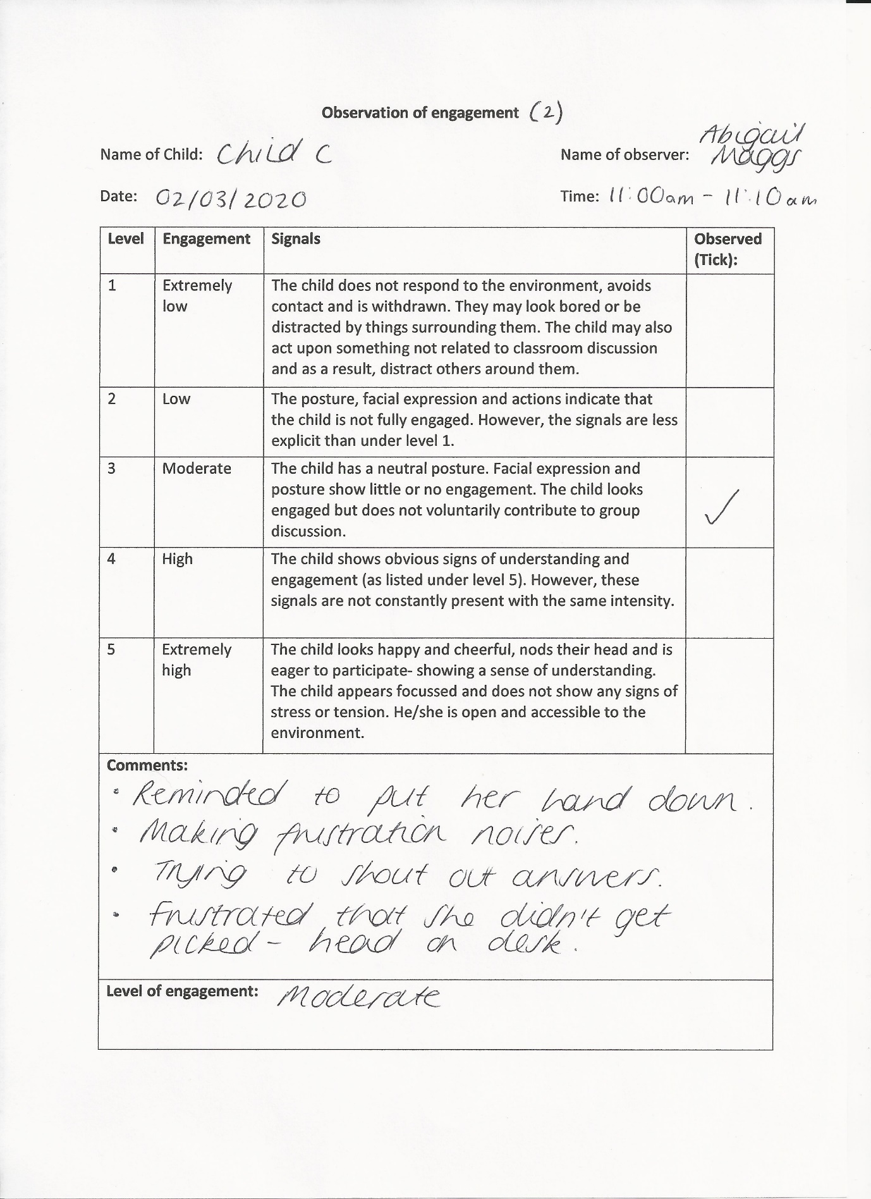
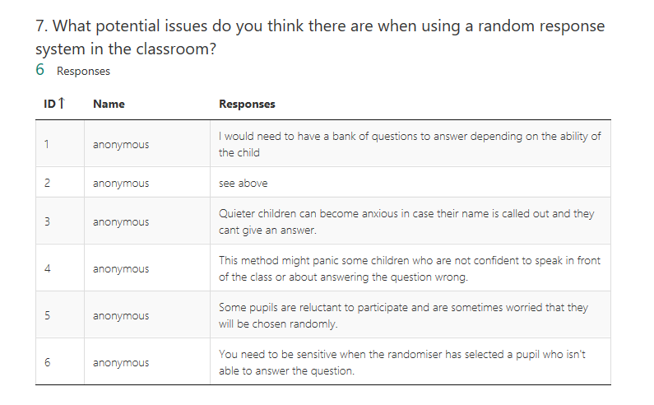
Appendix 9

Appendix 10


