
Project Proposal:
Resilient Video Transmission in a Degraded Electromagnetic Environment

Embedded Electronic Systems, Year 4
Jack Lonsdale
Student No: 2114210
Word Count: 1,550
Similarity: 11%

Contents
Introducing the problem 2
Background Research 5
Degraded EM environment: 5
DVB-S2 5
Different parts of the radio spectrum 5
Free-space losses 7
Research already conducted 7
Project Design 7
Development method 7
Tools 8
Data analysis approach 9
Resources and Planning 9
Resources 9
Work Breakdown Structure 9
Schedule 11
Critical path 11
Deliverables 12
References 12

Introducing the problem

The importance of DVB:
Video Broadcasting is an important part of society. It allows information to rapidly be spread to a wide audience, and provides multiple services, including:
- Entertainment
- Education and awareness to topics that would otherwise remain undiscovered
- Shaping of public opinion and policy
- Real-time connectivity to a large audience

How does DVB work?
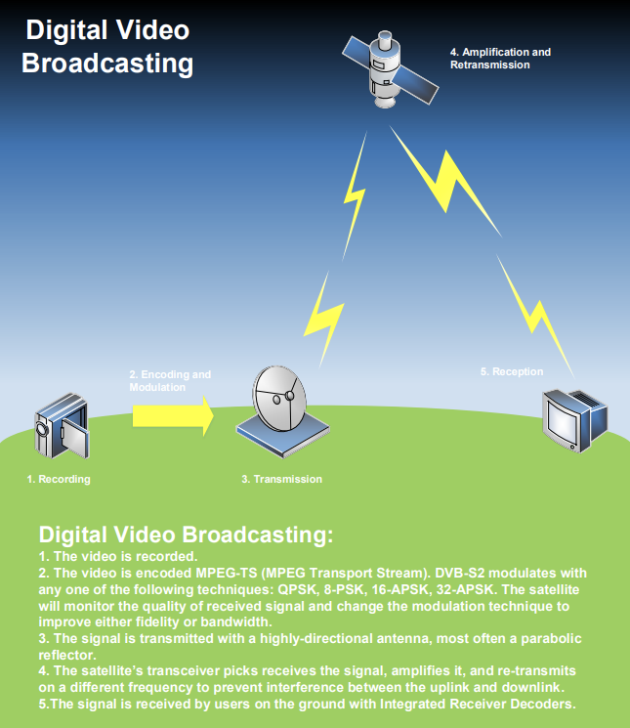
Figure 1. Operation of DVB-S2 protocol [1].

Susceptibility of DVB-S2:
Since most video broadcasting systems rely on satellite communication to function, they are vulnerable in many ways to “degraded electromagnetic environments”:
- Coronal mass ejection: large clouds of ionised particles launched by the sun that can severely damage or destroy satellites.
- Solar winds: ionised solar radiation that has the potential to damage satellites. Although the earth’s ionisation field is strong enough to protect from all solar winds on the surface of the earth, this is not the case for all satellites in orbit.
- High altitude nuclear event: when nuclear weapons are detonated in space, they generate an electromagnetic pulse that can easily destroy nearby satellites, even if they are not within the blast radius.
- Anti-Satellite (kinetic) weapons: shooting down satellites used for relaying the DVB broadcast.
- Jamming: Actors seeking to disrupt satellite broadcasting can do so with little technical requirements. This makes the medium susceptible to not just state actors, but also activist groups, militias, or terrorist organisations. Jamming is possible on the uplink and downlink.

Proposed Project:
This project seeks to mitigate the risk to video broadcasting in a degraded electromagnetic environment, and will:
- Evaluate the use of alternative technologies for video broadcasting, such as:
  - Use of different transmission protocols
  - Use of different satellite constellations
  - Use of different bands of the spectrum
- Develop a redundant video transmission system. This system will act as a relay to a DVB transmitter in a different geographic location.
This project will improve the integrity of mass communication is a disaster, allowing emergency instructions to be spread to a large audience, and enabling journalism to continue.
Project Aim
The aim of this project is to improve the resiliency of video broadcasting in a degraded electromagnetic environment. This means that it must have a measurable improvement in the level of white (Gaussian) noise resistance compared to standard DVB-S2 broadcasting. Because the disasters listed above vary in strength and functionality, this project will treat any noticeable improvement in noise resistance as a success (with the goal of improving noise resistance to the highest level possible). The deadline for this is 6th May 2025.
Deliverables:
This project will produce:
- A report on possible techniques to improve video transmission performance in a degraded electromagnetic environment.
- A “relay station” that will move the video broadcast outside of the area of disaster such that conventional broadcasting can resume
- A full design pack for the relay station, including: circuit schematics, PCB design files, block overview diagram, bill of materials, software design document, copies of all code used, and any other relevant design files.

Background Research

Degraded EM environment:

Coronal mass ejection
Coronal mass ejections are large bursts of plasma that erupt from the sun. This plasma generates large magnetic fields and have the possibility of damaging sensitive electronics (such as satellites). Typically, the earth’s ionosphere protects from these events, but if they are large enough that is not the case. Satellites are at increased risk due to their position high above the earth (further up in the ionosphere). [2]

Solar winds
Solar winds are constant streams of charged particles that travel through the solar system. They have the potential to cause damage to electronics by causing bit-flips (a software error where a stored value has been changed, potentially changing how software runs). [3]

DVB-S2
DVB-S2 (Digital Video Broadcasting, Version 2) is the primary protocol for digital video broadcasting. It uniquely utilises adaptive coding and modulation (ACM) techniques, meaning the modulation scheme and level of coding is adapted naturally to find the optimal trade-off between data integrity and transmission speed, improving bandwidth by up to 30% when compared to DVB-S1 [4]. This means that DVB-S2 has much better resistance to degraded EM environments than most satellite protocols. However, degraded electromagnetic environments will slow down transmission with the possibility of stopping successful reception entirely.

Different parts of the radio spectrum
Band: | Frequency: |  | Use:
Band: | Range: | Unit: | Use:
Extremely low frequency | 3-30 | Hz | Not enough bandwidth for video transmission
Very Low Frequency | 30-3000 | Hz | Not enough bandwidth for video transmission
Low Frequency | 30-300 | kHz | Not enough bandwidth for video transmission
Medium Frequency | 0.3-3 | MHz | Not enough bandwidth for video transmission
High Frequency | 3-30 | MHz | Not enough bandwidth for video transmission
Very High frequency | 30-300 | MHz | Possibly enough bandwidth for incredibly low fidelity video transmission, potentially useful for intelligence gathering purposes, not good enough for newscasting.
Ultra-High Frequency | 0.3-3 | GHz | Contains enough bandwidth for standard video transmission, but maintains transmission strength, Useful in areas of worse atmospheric weather.
Super High frequency | 3-30 | GHz | Significant bandwidth allows for transmission of multiple high-fidelity streams. DVB-S2 typically works within this band.
Extremely High Frequency | 30-300 | GHz | Atmospheric absorption and cost are both too high to feasibly operate here
Table 1. Bands of the Radio spectrum [5].

Free-space losses
The Friis Transmission equation provides a ratio of the transmitted and received power for a transmission system (loss). The loss is calculated with the directivity of both antennae, the wavelength, and the distance between the transmitter and receiver. Given below:
$$\frac{P_{r}}{P_{t}}= D_{t}D_{r}{(\frac{λ}{4πd})}^{2}$$
Equation 1. Friis transmission Equation. [6]
This equation is used to calculate the power lost from the transmitting to receiving antenna. It’s important to note that the receiving antenna must be in the far field of the transmitting antenna for this equation to work.
It will be important to consider free-space path losses when designing the relay station, as it determines the effective range. The equation shows that gain is directly proportional to the square of the wavelength. It can therefore be derived that the loss is directly proportional to the square of the frequency.

Research already conducted
Related research already conducted includes:
- DVB-S2 ACM: The Adaptive Coding and Modulation of digital video broadcasting, allowing data rate to be changed depending on received signal strength. [7]
- DVB-NGH: The “next generation handheld” variation of DVB includes advanced Forward Error Correction (FEC) codes to allow the receiver to correct and transmission errors without further transmission requirements [7]
- Cognitive Radio: [8] monitors the spectrum and can select the clearest frequency with the least noise. This can work well against narrow-band jamming where the issue only lies on certain frequencies

Project Design

Development method
The primary development method used for this project will be the scrum. This method breaks work down into short “sprints” of intensive work and rapid progress. Each sprint has a review at the end to provide feedback and ensure project is on task. Sprints naturally improve focus as they provide clear, near-term deadlines, and clear near-term definitions of success and failure.
This method was selected for the following reasons:
- The short timeline of the project requires advanced to be made quickly
- Since the solution to the problem is not defined (finding the best solution is part of the project), development needs to be adaptable to whatever direction works best
- Regular sprints provide accountability with project supervisor, ensuring the project stays within the planned schedule and scope
- Working primarily by myself (with direction and support provided by PTA), it is easier to manage the intensive time costs during sprints.
It will be important to schedule working time primarily for the project as “sprints” require the majority of my time when active. Other work and university projects will need to be scheduled into free spaces.

Tools

Development tools
- KiCad PCB designer: PCB designer available at UWTSD and on corporate Dstl systems
- Proteus circuit simulation: license already provided by UWTSD, with appropriate skills and experience already obtained from previous projects
- Matlab’s Simulink: will possibly be used to simulate RF transmission and reception with the presence of a AWGN (Additive White Gaussian Noise) channel.

Compatibility tools
- Microsoft teams: available on Dstl corporate systems and university IT. This will be used to regularly chat with project supervisors
- Cisco Jabber: used to contact other Dstl project stakeholders such as my line manager, the project manager, and project technical authority.

Testing tools
- Anechoic chamber: to test experimental RF transmission in a safe, legal environment
- Spectrum Analyser: to test the frequency and power of transmitted signals
- Signal analyser (if resource permits): to analyse any protocols being used (e.g. DVB-S2)
- Multi-meter: for conducting power-draw calculations
- Oscilloscope: for verifying PCB functionality

Data analysis approach
- Transmitted and Received power: will be collected using a spectrum analyser and multi-meter. This will be used to estimate and effective range for the system, this range will be compared to probable sizes of different disasters to determine if it can move the broadcast outside of the disaster zone.
- Power draw: Will be analysed with multi-meter to determine the power requirements (and therefore expected lifespan if on batteries, or infrastructure requirements if being powered)
- Frequency Envelope: Collected with spectrum analyser to determine if frequencies used are within the allowed power envelope, and their potential interference from neighbouring frequencies.

Resources and Planning

Resources
- Anechoic chamber
- Spectrum analyser (appropriate for chosen frequency)
- Signal analyser (if resource permits, not strictly essential)
- Multi-meter and other basic hand tools
- External PCB production
- Components budget ~£250
- Computer
- CAD software for PCB and circuit design

Work Breakdown Structure
Project work areas and task breakdown:

W1 – Project Planning
T1.1 – Statement of Requirements
T1.2 – Bill of materials
T1.3 – Project Schedule adjustment
T1.4 – Meeting with project supervisor and Project Technical Lead
T1.5 Project reporting:
T1.5.1 Project Proposal writing
T1.5.2 Interim viva preparation
T1.5.3 Final Viva Presentation
T1.5.4 Final Report Creation
T1.5.5 Poster creation

W2 – Research and Design
T2.1 – Analysis of COTS solutions
T2.2 – Development of own solution
T2.2.1 – Spectrum selection (band and frequency)
T2.2.2 – Chip Selection
T2.2.3 – Circuit Design
T2.2.3 – PCB Design
T.2.2.4 – Antenna Design

W3 – Construction
T3.1 – Component ordering
T3.2 – Delivery Confirmation
T3.3 – Component Inspection
T3.4 – Purchasing/production of antenna
T3.5 – Assembly of Components

W4 – Software development
T4.1 – Protocol testing
T4.2 – Algorithm design
T4.3 – Programming of chip

W5 – Test and Analysis
T5.1 – Develop testing process
T5.2 – Test radio hardware
T5.3 – Testing of software
T5.4 – Combination of hardware and software testing

W6 – Evaluation and Re-design
T6.1 – Performance evaluation of radio
T6.2 – Modification of radio

Schedule
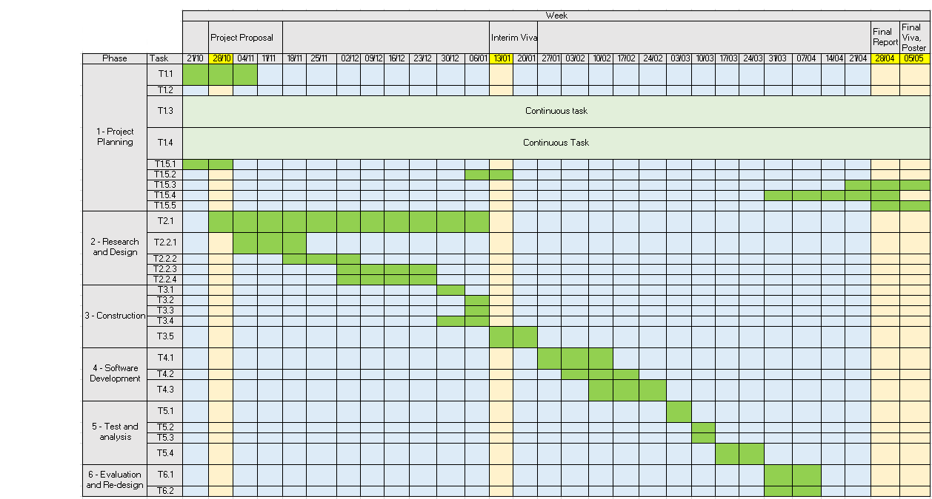
Figure 2. Project Schedule

Critical path
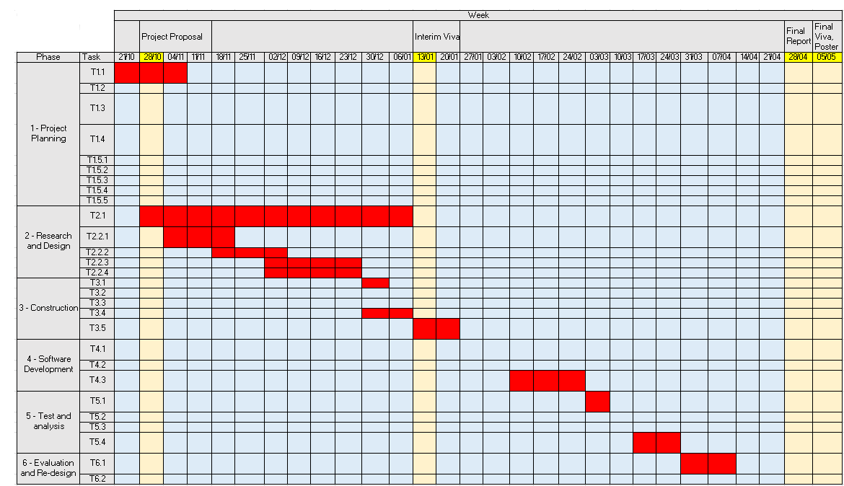
Figure 3. Critical Path
Tasks in red are considered “critical tasks”, which other tasks require the completion of before they can begin. Please see “work breakdown structure” section for a description of different tasks.

Deliverables
- Report of viability of different techniques to improve performance in a degraded EM environment (e.g. different frequencies, increasing transmission power, increased antenna directionality, using different constellations, using a relay station)
- Physical Video Relay station
- Relay station documentation pack

References
[1] J Lonsdale. DSTL, "Digital Video Broadcasting" unpublished.
[2] Attrill, G.D.R, “Low coronal signatures of coronal mass ejections: coronal “waves” and dimmings”, University College London, 2009.
[3] The HESPERIA HORIZON 2020 Project and Beyond, “Solar Particle Radiation Storms Forecasting and Analysis”, 1st ed. Springer, 2018
[4] Digital Video Broadcasting (DVB); Second generation framing structure, channel coding and modulation systems for Broadcasting, Interactive Services, News Gathering and other broadband satellite applications; Part 1: DVB-S2, ETSI EN 302 307-1 V1.4.1, European Telecommunications Standards Institute, Oct. 2014.
[5] H. Mazar, “Radio Spectrum management: policies, regulations, and techniques”, 1st ed. Wiley, 2016
[6] J A. Edminster, “Schaum’s outline of theory and problems of electromagnetics”, 2nd ed. McGraw-Hill, 1995.
[7] Digital Video Broadcasting (DVB); Second generation framing structure, channel coding and modulation systems for Broadcasting, Interactive Services, News Gathering and other broadband satellite applications; Part 2: DVB-S2 Extensions (DVB-S2X), ETSI EN 302 307-2 V1.1.1, European Telecommunications Standards Institute, Feb. 2015.
[8] Tonu Trump. (2017). Cognitive radio (T. Trump, Ed.). IntechOpen.

