Kian Harper-Evans (2204995)
2204995@student.uwtsd.ac.uk
Course Title: Computing- Computer Networks and Cybersecurity
Module Title: Introduction to Web and Database Concepts
HTML and CSS Web Development Assignment
Word Count: 2286 Words
Date: 14/05/2023

Contents
1.0 Introduction 2
2.0 Requirements 3
3.0 Implementation 4
4.0 Validation 8
5.0 Evaluation 11
6.0 References 13
7.0 Appendices 14

Introduction

This document contains the content required for the assignment HTML and CSS Web Development assignment for the introduction to web and database concepts module. For this assignment I was tasked with planning and creating a website with content for either a fictional company or idea of my design or create a website based on a hobby that I could create an appropriate number of pages for. For this assignment I decided to create a website that is based on a fictional company I made up and designed a web page for. This document will contain evidence of my work hand coding this website, containing a minimum of 5 pages using HTML and CSS coding methods and techniques. The finished web page will be submitted separately from this document in a zip file containing all the files required to make the website. This document will contain the requirements I set for the final product, a page on the implementation of my ideas containing screenshots of all the completed web pages, a validation section where I validate the HTML code of the Home Page of the Website and the websites main CSS file and finally and evaluation section where I give an overall conclusion of the project and evaluate what I believe I did correctly and what I believe needs to be improved upon in the future.

For context for the rest of this document I choose to base my website around a fictional company that specializes in running gym locations. All pages on the site are related to the fictional gym and the services they would provide.

2.0 Requirements

What was the purpose of the website?
I created this website for the purpose of advertising the services that the fictional company Gym World offers. The website contains all the relevant information a customer would need to know when signing up for the company’s service. Such as available classes, the gym’s schedule, products that are available to be purchased at the locations, the companies contact information and a page that gives the user information about what they will find on the web page.

What are some of the required features that should be present?
For this website there are some features that a necessary for the page to be of the required quality. These include at least 5 separate pages that all contain content, a method to navigate the pages of the webpage (for example a navigation bar or next/previous page buttons), titles for each of the pages, images to make the pages more aesthetically pleasing to viewers, colored backgrounds to make the website more aesthetically pleasing and finally a mixture of different text writing techniques to help users distinguish between different types of information.

What content should be present on the website?
As this website’s purpose is to advertise a line of gyms and inform users about what can be found at these locations the pages of the site need to contain specific types of information. This includes a home page that gives a description of what users will find on the site, contents list/page, gym timetable/hours list, page dedicated to giving information on services and facilities provided, a page dedicated to products sold on site and finally a page that contains the contact information and social media links for the brand/company.

3.0 Implementation

In this section I will be displaying the implementation of the ideas and requirements stated above onto my actual web pages. I will be doing this by taking screen grabs of each of the completed pages using the snipping tool and then giving a brief description of what each page is and what each page contains. I will not be including any screen grabs of the code in this section, only the completed final products.

Page 1 – Home Page:
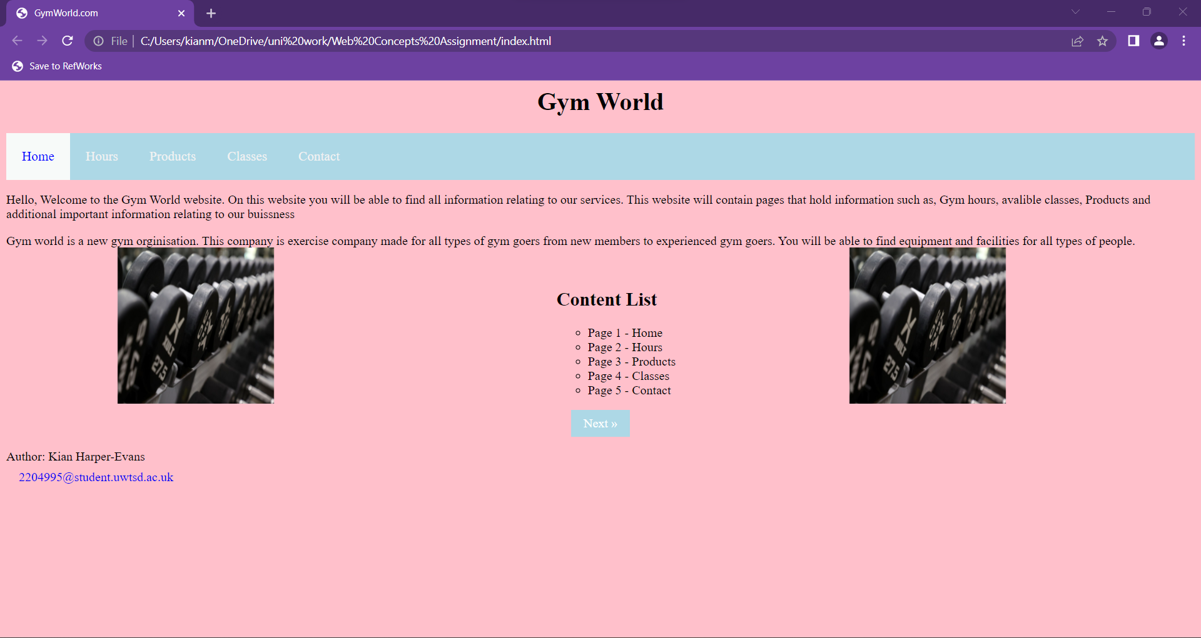
This first page is the site’s home page which contains a navigation bar, next page button, images, content list/context page, titles, footer with authors credit, use of different text styles/colors and a changed background color. This page’s purpose is to give a brief description of what content can be found on the site and direct the users to those relevant pages.

Page 2 - Hours Page:
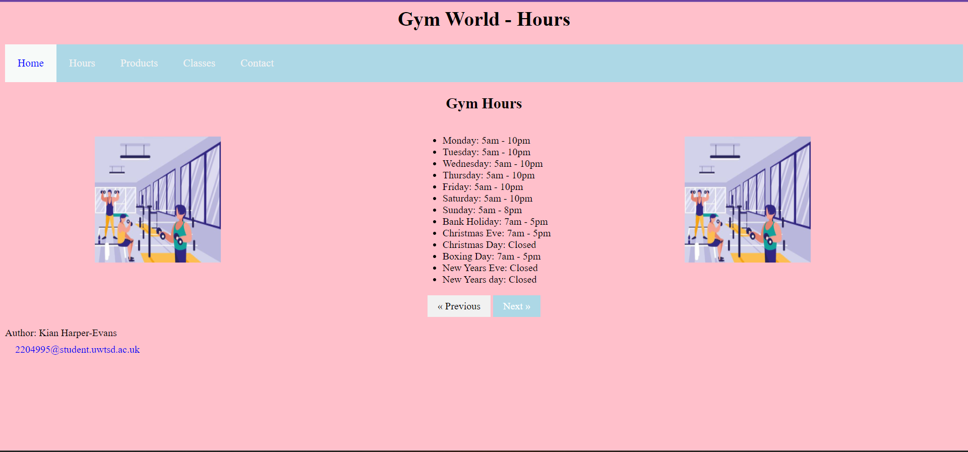
The second page is the site’s hours page. This page contains features such as a navigation bar, images, colored backgrounds, text list, next/previous page buttons, two titles and a footer like the home page. This page’s purpose is to give the user information of when the gym locations under this company will be open. So, for this page I used a list that displays when the gyns are open Monday to Sunday and included information for changing times due to holidays such as Christmas, new year’s, boxing day and bank holidays.

Page 3 – Products Page:
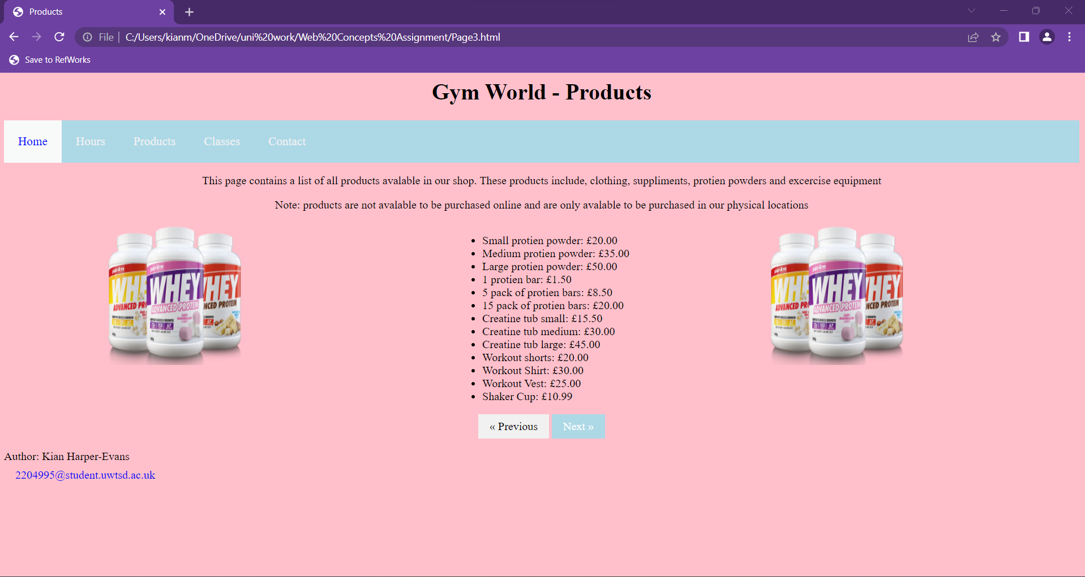
The third page featured on the site is the products page. Like the previous two pages this page contains the use of a list, navigation bar, images, next/previous page buttons, titles, colored backgrounds, and different text styles. The purpose of this page is to give the user a list of the products sold at the gym locations and give them a list of the prices as well. This is done using the list method.

Page 4 – Classes Page:
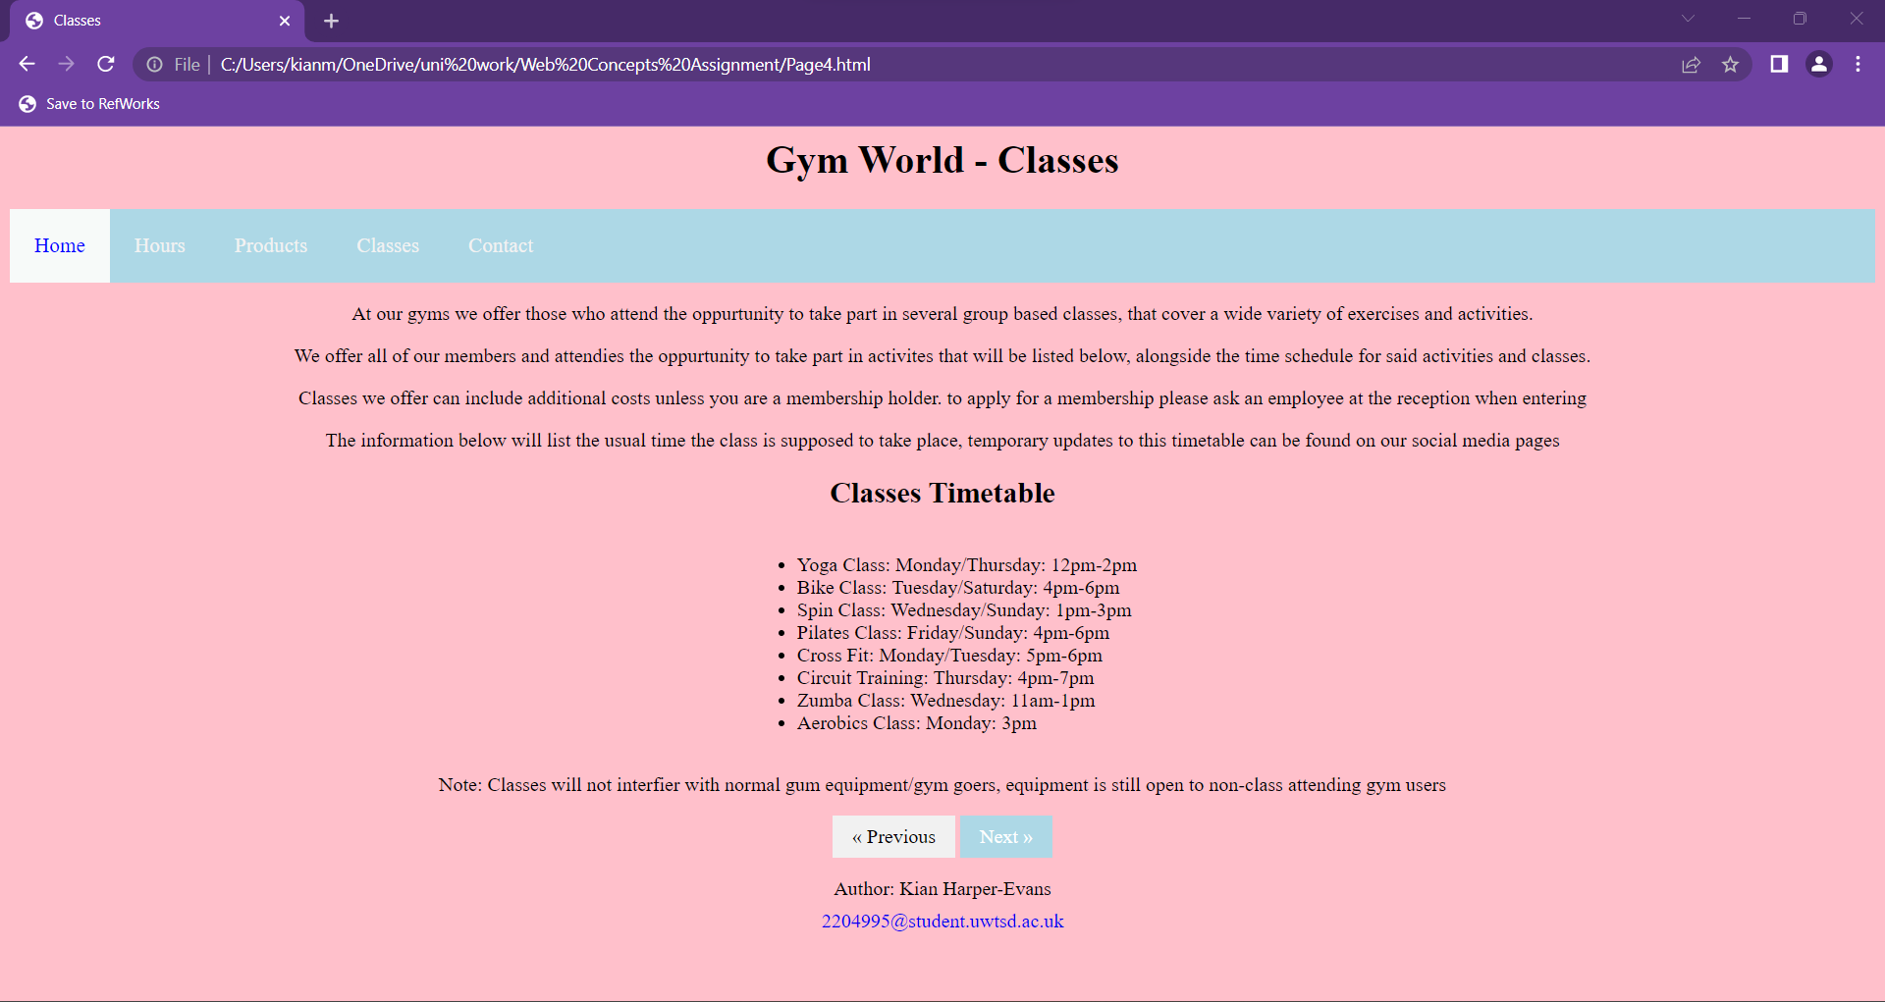
The fourth page of the site is the classes page. This page contains features like colored backgrounds, titles, a navigation bar, different text styles and a footer. The purpose of this page is to display what classes are available to members of the gym and what times these classes are held at on what days.

Page 5 – Contact Page:
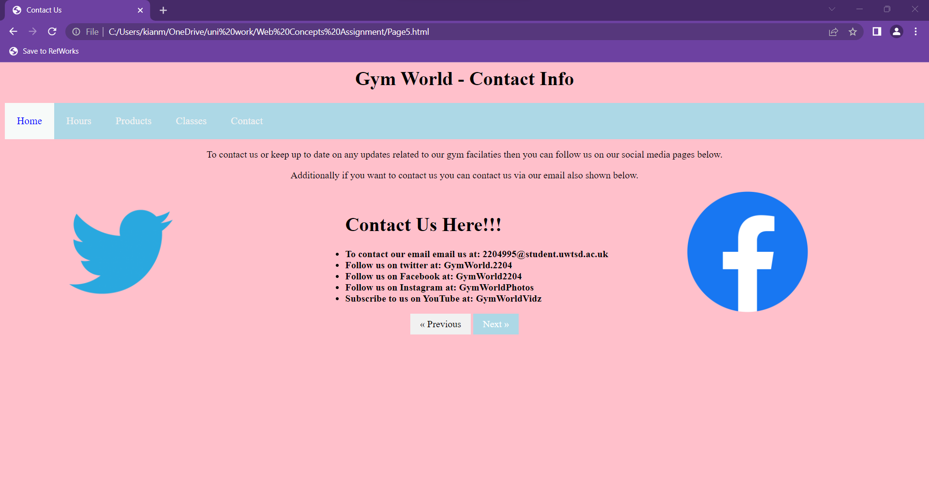
The fifth and final page of the site is the contact information page. This page, like the previous pages contains a navigation bar, titles, different text styles (bold text), lists, next/previous page buttons, images, and colored backgrounds. The purpose of this page is to display the contact information associated with the company I created. However, all the contact information and social media information is fictional and are not linked with any real accounts that exist associated with this project, excluding the email which is just my student email.

Note: all pages also contain a change in the title in the tab area. So each page has a different name in the tab (different page title).

4.0 Validation

In this section I will be validating the HTML and CSS code for my website. I will be doing this by running the files containing the code through the validator websites linked in the assignment brief. In this section I will only be validating the HTML code for the main home page of my site and the main CSS file for the site. I will not show screen grabs of the code as it will be submitted separately alongside this document.

Home Page HTML Validation
After running the HTML through the validator, it turned up a result of six apparent errors in the code. Below will be the listed errors and an explanation of how I corrected these errors. If I was unable to correct any errors, I will explain why.

Error 1:
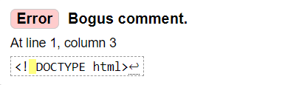
Solution: After this error was pointed out by the validator, I went back to the code to correct the error believing it to be an easy fix by just removing the space. After removing the space, however this fix didn’t fix any issues but instead created new ones. After removing the space several of the elements featured on the page proceeded to break and the CSS linked to the page stopped working. After attempting to find the reason for this, I was unable to find a fix and decided to leave the error in the code as the page still worked as intended before the error was fixed.

Error 2:
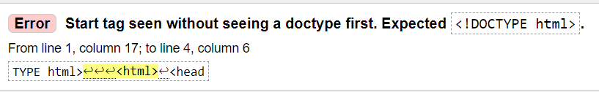
Error 2 is flagged for the same reason as error 1 so nothing was done to correct this error due to the reason stated above.

Error3:
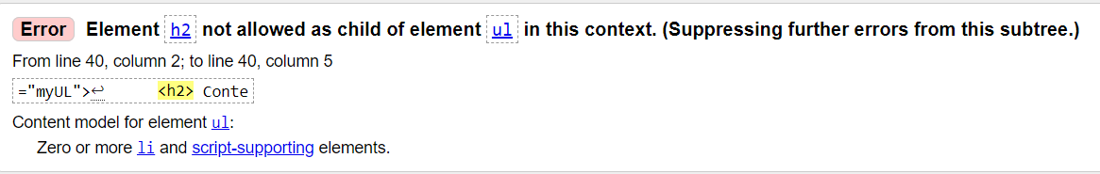
Solution: to fix the error shown above I decided to swap the positions of the heading’s tags and the UL lists tag. This results in the supposed error being fixed and the heading for the list being moved up a couple of pixels on the screen.

Error 4:
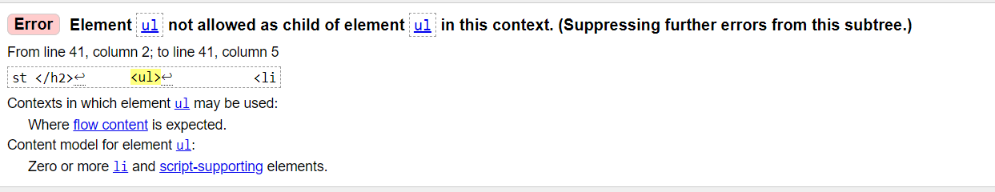
Error 4 originates from the same cause for the previous error, error 3 so the fixed used was the same fixed that was used for the previous error.

Error 5:
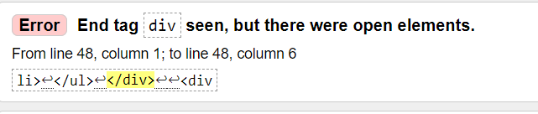
Solution: After looking at the area of the code where the error was reported to be I found that for the list in this segment I had two list tags open for the same list. To fix this issue I decided to remove the one list tag that didn’t contain the class function. This can be seen on line 40 of this page. Before the fix there was an additional unclosed, unnecessary list tag.

Error 6:
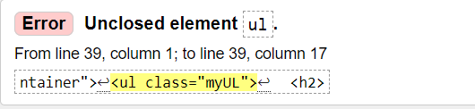
This error originates from the error that was fixed above so no further action was taken to fix this error.

CSS Validation
When coding my website, I made the decision to only make use of one CSS file for the whole website. This means all the pages are linked to the same CSS file called StyleSheet. So, when running this file through the validator it checks for errors in the CSS for the entire site. After running the CSS file through the validator site, the validator returned a possible 9 errors in the code.

Error 1:
Solution: after going to this area in the code I found that I entered a value without putting a unit of measurement after the number. To fix this I added PX for pixels after value to fix the error.

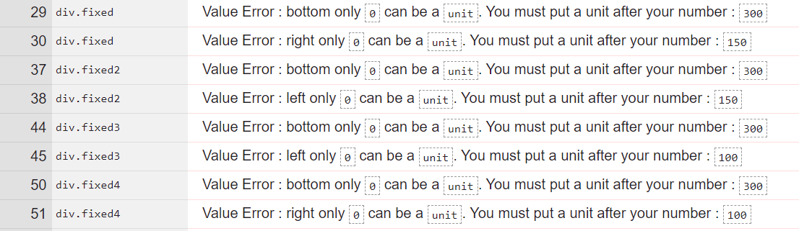
8 out of the 9 errors present in the CSS file were related to the issue seen in the first error. This issue being no unit of measurement present after values added. To fix this I went through and added all units to the end of the values.

Error 2:
Solution: This error occurred due to a missing hashtag before the hex code for the color. To fix this I went through the code and found where any missing hashtags should be and then readded them after they were found.

5.0 Evaluation

In this section I will be evaluating my final completed website. I will be evaluating the site based on factors like usefulness/useability, search engine optimization (SEO) and Accessibility. I will evaluate my site based on these factors and backup my claims using references I have sourced using my own research.
Firstly, I will give a detailed description of what each feature I will be evaluating my website on means. This will be backed up with references collected from my own research.

- Usefulness (Useability/Utility)

First how do we define a website’s useability? According to [1], Web useability can be defined as, “Web usability of a website are broad goals of usability and presentation of information and choices in a clear and concise way, a lack of ambiguity and the placement of important items in appropriate areas as well as ensuring that the content works on various devices and browsers.”. So, Useability refers to how easy a website is to use, if I can be used on multiple platforms and devices and if the information on the site is arranged effectively to display it to a user.

- Search Engine Optimization (SEO)

What is search engine optimization? Well, [2], says SEO can be defined as “Search engine optimization (SEO) is the practice of orienting your website to rank higher on a search engine results page (SERP) so that you receive more traffic. The aim is typically to rank on the first page of Google results for search terms that mean the most to your Target audience”. According to, [3], you can use this list of methods to help with SEO, “
- Learn from your competitors.
- Prioritize low-difficulty topics.
- Update old content.
- Fill content gaps.
- Create content hubs.
- Get more backlinks.
- Optimize internal links.
- Fix broken links.
“.

- Accessibility
Firstly, when talking about websites what is meant by accessibility? Simply it refers to how accessible your site is to different people. For example, does your website cater to those who are color blind, speak a different language or that are attempting to run the site on different software or hardware. According to, [4], “Web accessibility means that websites, tools, and technologies are designed and developed so that people with disabilities can use them. More specifically, people can: perceive, understand, navigate, and interact with the Web. contribute to the Web.”.

In this next section I will be evaluating the content of my completed website based on the features listed above.

- Usefulness and Useability:

When looking at my website I believe that it meets the requirements for being usable, however it could use many improvements. When talking about the website’s useability I believe my sites are up to standards as all buttons and links work as intended and all information on the page can be viewed easily. However, when looking at the look of the website I believe it could use some improvements. In future I believe my site would benefit from having more content to fill the pages and that the content on the page is laid out with more thought to make the site look more professional. My webpages, however, are extremely easy to use and understand.

- Search Engine Optimization:

My final website makes use of some SEO techniques. These include fixing broken links to other pages and fixing broken buttons and prioritizing a low difficulty topic, as a gym company is a simple easy to understand idea. To improve I could make use of looking at how competitors in the same field design their web pages. I could also fill content gaps present on the page and make use of more links to external content like videos and articles to help with SEO.

- Accessibility

My site is accessible to many people; however, it could use many improvements. Firstly, my site is accessible to most people using windows computers and the webpage doesn’t make use of sound in any areas, so the site is fully accessible to deaf people. However, the site could be improved to cater to those who speak different languages or sound could be used to help cater to blind people, by using sound to navigate pages. My color scheme is appropriate for most viewers as the foreground text doesn’t blend in with the background. I would say even though the site requires some improvement stylistically, the site is still perceivable, operable, and understandable to most users. However, the content of my site could be more robust as the use of assistive technology for those with disability wasn’t taken into consideration during the initial design of this site.

6.0 References

[1] | N/A, "Web usability," Wikipedia, N/A N/A N/A. [Online]. Available: https://en.wikipedia.org/wiki/Web_usability. [Accessed 13 May 2023].
[2] | N/A, "Search Engine Optimization (SEO)," INTUIT MAILCHIMP, N/A N/A N/A. [Online]. Available: https://mailchimp.com/marketing-glossary/seo/#:~:text=Search%20engine%20optimization%20(SEO)%20is,most%20to%20your%20target%20audience.. [Accessed 13 May 2023].
[3] | J. Hardwick, "10 SEO Techniques for More Traffic," Ahrefs Pte Ltd., 22 September 2022. [Online]. Available: https://ahrefs.com/blog/seo-techniques/. [Accessed 14 May 2023].
[4] | W3C, "Introduction to Web Accessibility," W3C, N/A N/A N/A. [Online]. Available: https://www.w3.org/WAI/fundamentals/accessibility-intro/#:~:text=products%20and%20services.-,What%20is%20Web%20Accessibility,contribute%20to%20the%20Web. [Accessed 14 May 2023].
[5] | [Online]. Available: https://en.wikipedia.org/wiki/Web_usability. [Accessed May 2023].
[6] | 2022. [Online]. Available: https://ahrefs.com/blog/seo-techniques/. [Accessed 14 May 2023].

7.0 Appendices

- Page 1 HTML:
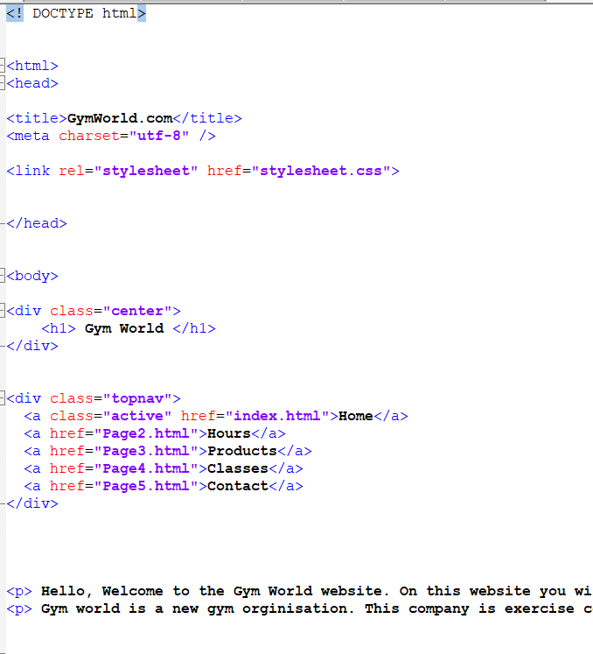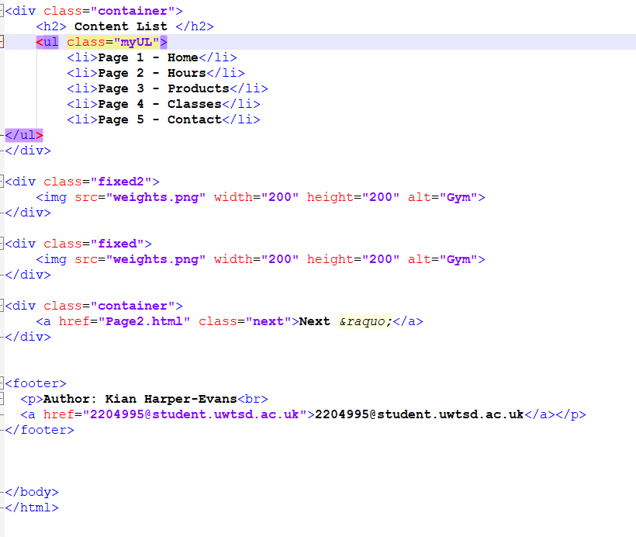

- CSS:

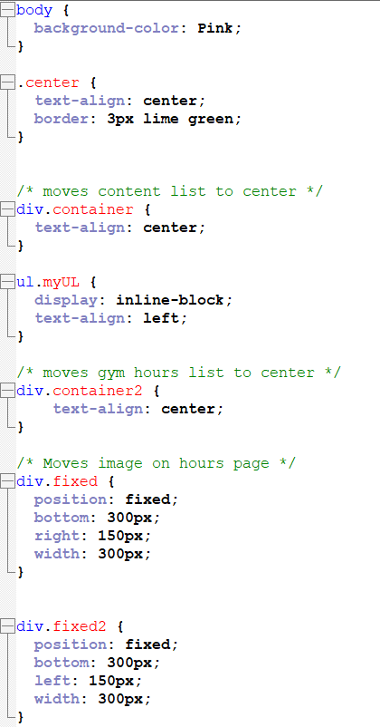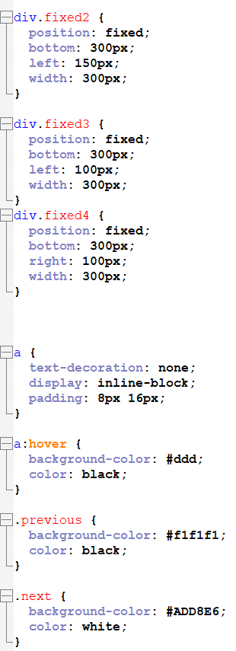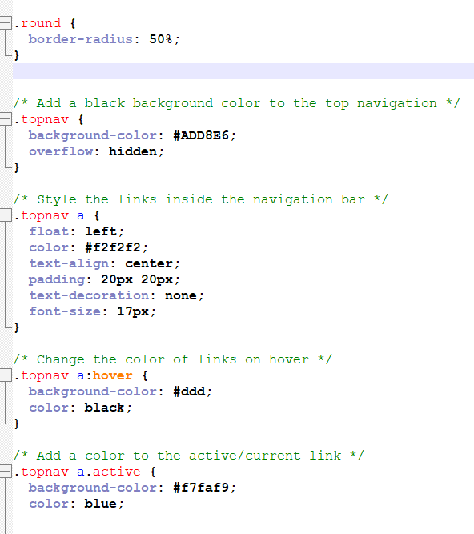

- Page 2 HTML:
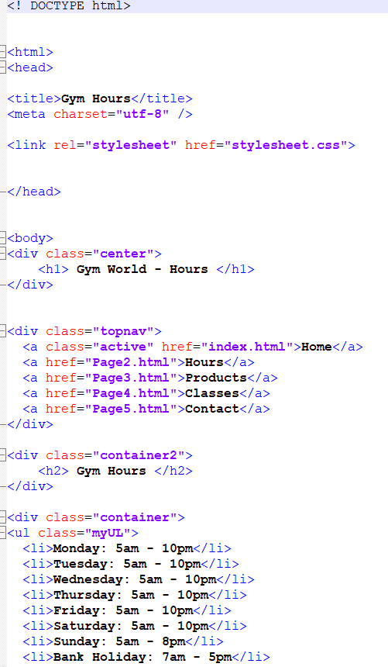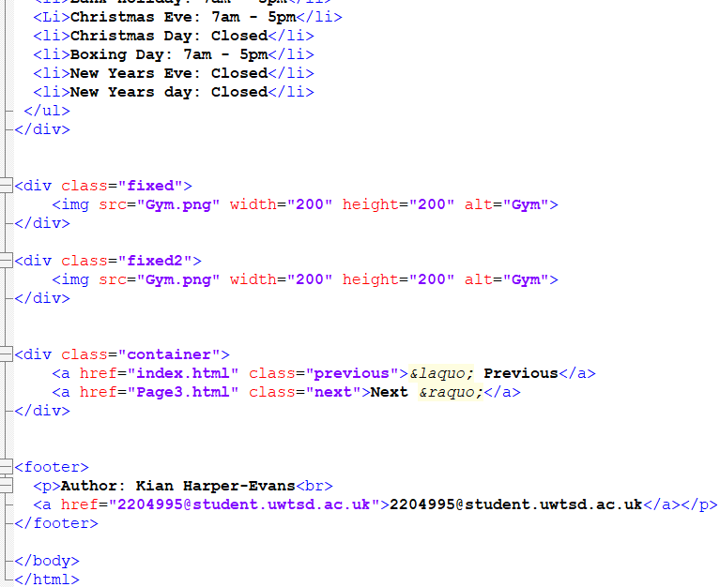

- Page 3 HTML:

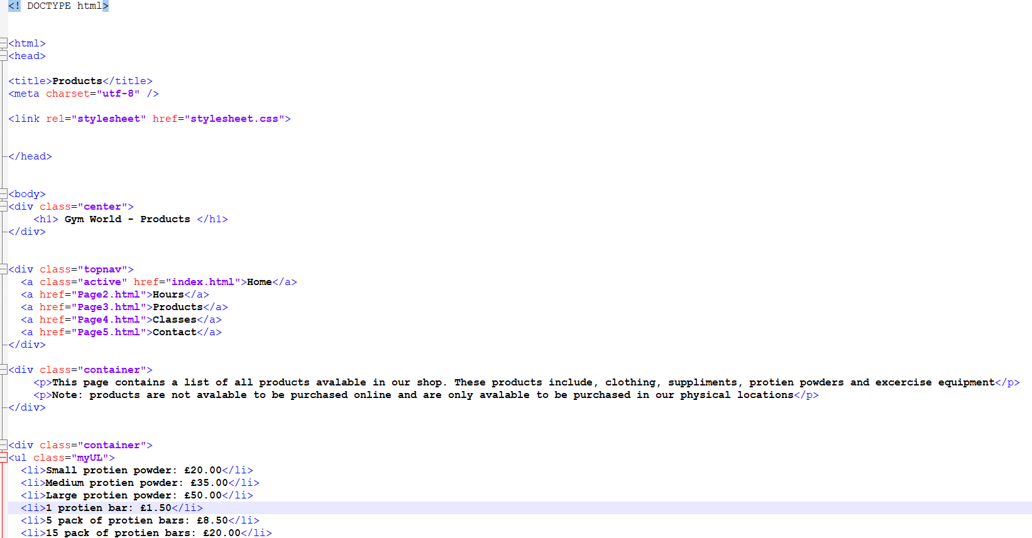
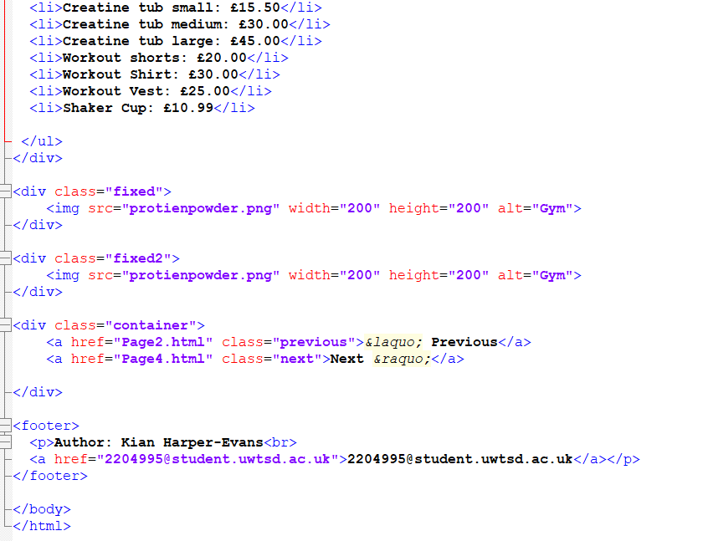

- Page 4 HTML:

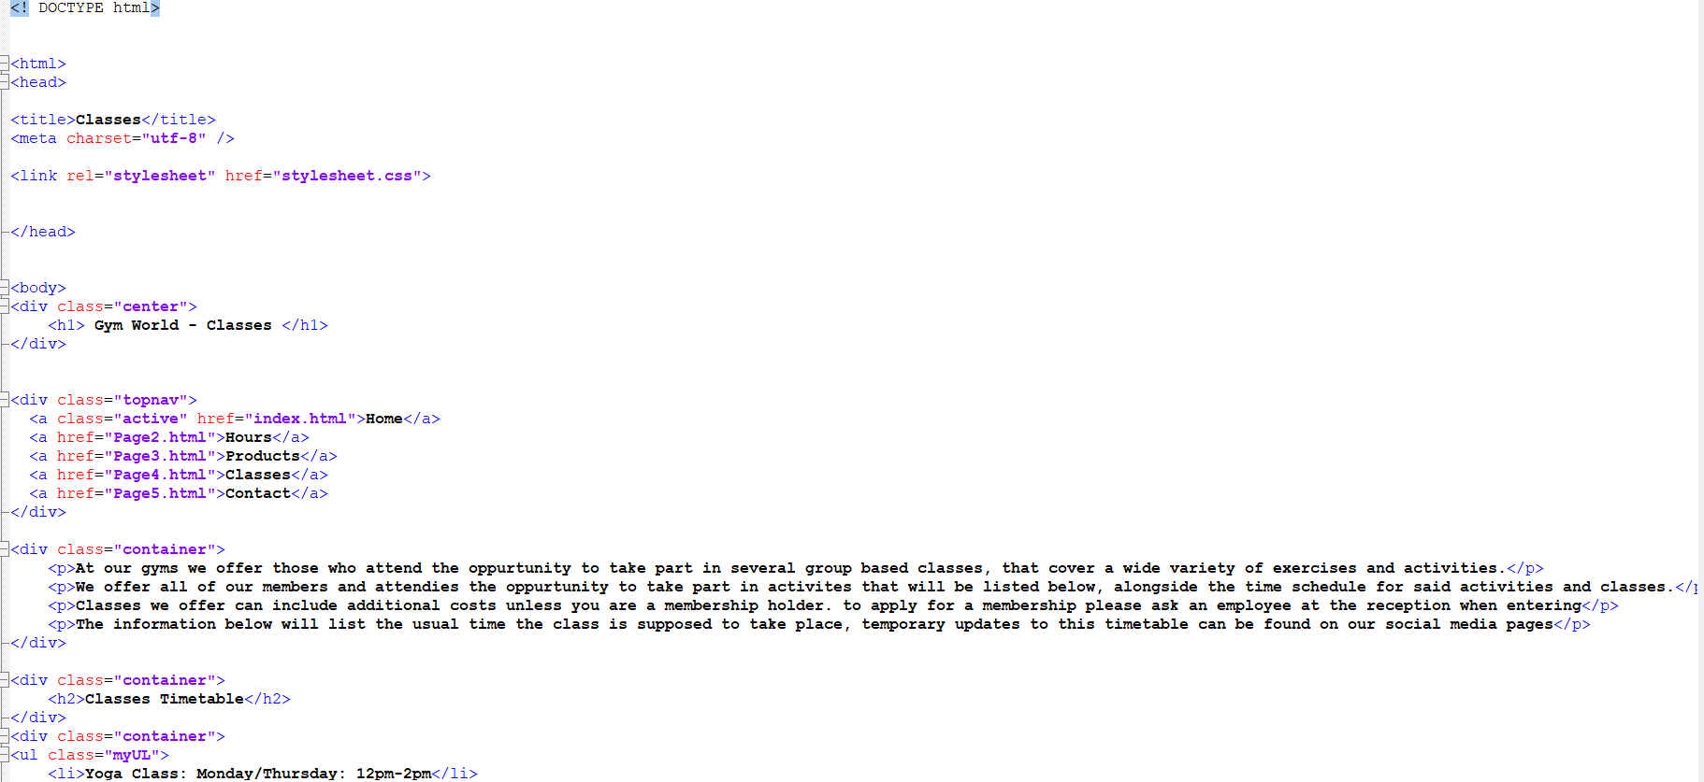
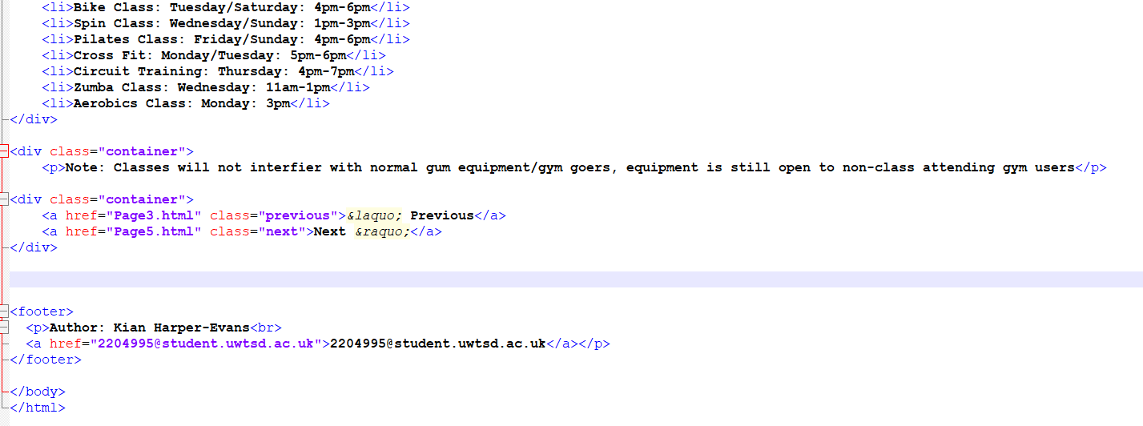

- Page 5 HTML:



