Essay based on a Sky Journal
‘Be clearly aware of the stars and infinity on high. Then life seems almost enchanted after all.’ Discuss this quote by Vincent Van Gogh as it relates to your sky journal observations.
Introduction
On August 11, 1888, Van Gogh wrote to his brother, Theo, primarily of his desire to articulate himself through his paintings by being ‘an obstinate colourist’, as opposed to replicating his subjects realistically. Embedded within the text, he inserts that one should ‘be clearly aware of the stars and infinity on high. Then life seems almost enchanted after all.’ It is interesting to note that Van Gogh does not introduce this assertion amid his musings on self-expression; instead, he places this line within a segment on his health. Van Gogh ends his letter by assuring Theo of his returning strength due to the Parisian heat, he then theorises that a vigorous manual labourer is able to sustain themself on ‘a piece of bread while doing a full day’s work…’. By ending this particular paragraph with a remark on the sky’s ability to enchant life, Van Gogh implies that astronomical experiences are able to nourish and fortify one just as food and drink.
This essay aims to cover the findings of a 30-day experiment where, from October 19th to November 18th, I resolved to monitor the daily changes of the moon alone, yet as the days progressed, I found myself compelled to incorporate my survey of other celestial features, such as visible planets, the surrounding landscape, and the rising or setting sun. From these results, I will present three themes that arose: disenchantment, enchantment, and the link between them, and will then place them within the context of Van Gogh’s quote. I recorded these daily perceptions in a sky journal and attempted to capture how these observations affected me subjectively. In addition to journal entries, I utilized visual imagery using an iPhone 18 and have included several photographs and excerpts to illustrate their impact as supporting evidence for the claims I will propose in relation to Van Gogh’s statement.
While acquiring my data, the varied nature of the moon’s rising and setting time required a fluctuation in observation times, and I must also note that I often observed the moon and sky at multiple locations throughout the North Texas, Dallas-Fort Worth area. Finally, due to my attentiveness to the inner experience, the moon and sky’s effect on my consciousness, and, at times, their ability to stimulate memories in my life history, this experiment falls under the umbrella of qualitative research. Educators Bell and Waters support this declaration by stating that the primary benefits of qualitative research methods are that they ‘can provide data about emotions, beliefs and personality characteristics’ as well as ‘[allowing the researcher] to reflect on [their] own experiences…as part of the process’ itself.
Disenchantment
‘Be clearly aware of the stars and infinity on high…’, instructs Van Gogh to his brother, Theo, over a century ago. Yet, from the outset of this investigation, I doubted that a consistent experience of enchantment could be found in the skies over Dallas-Fort Worth. In fact, I often found myself reluctant to begin research because how was I, a resident of the concrete jungle, to be ‘clearly aware of the stars’ when my view was chronically occulted by a thick layer of atmospheric pollution? I was troubled by a profound awareness of the modern dilemma that is light pollution because, while North Texas is renowned for its impressive cityscapes, its class 8-9 skies (on a scale of 1, being extremely dark rural skies, to 9, indicating the presence of bright inner city level light pollution) are less than ideal for stargazing. Before the research officially began I found myself considering that Van Gogh existed in a somewhat idyllic time when electric lighting was not yet wide spread, and those historic nights have been immortalized in many of his paintings, such as The Night Café, which are illuminated only by the golden glow of lamp light. While Van Gogh inspires one to stargaze, from a contemporary perspective, his instruction does not take into account the absence of visible stars.
On the first morning of observation, October 19th, I shook the sleep from my eyes and arose before the sun in hopes of seeing venus, however, I kept in mind that venus may be obscured by unsightly infrastructure and then promptly washed out in the sun’s rays by the time it was released into my view. Still guarding my heart from the seemingly inevitable disappointment, I stepped outside and witnessed the sky as a lavender gradient with a soft glow growing in the east, suggesting that the sun was beginning to set sail over the horizon. To my astonishment, between a vignette of oak trees, I met a thin, silver crescent hanging feebly in the lilac sky while only three degrees away was a twinkling star, venus, as the moon’s brief companion (fig.1). Breathing deeply in the dim light of celestial beauty, I wrote in my first journal entry that ‘[presently] the moon is only a sliver of light. It is not begging to be noticed but the opportunity is here for those who have the desire to be enchanted.’
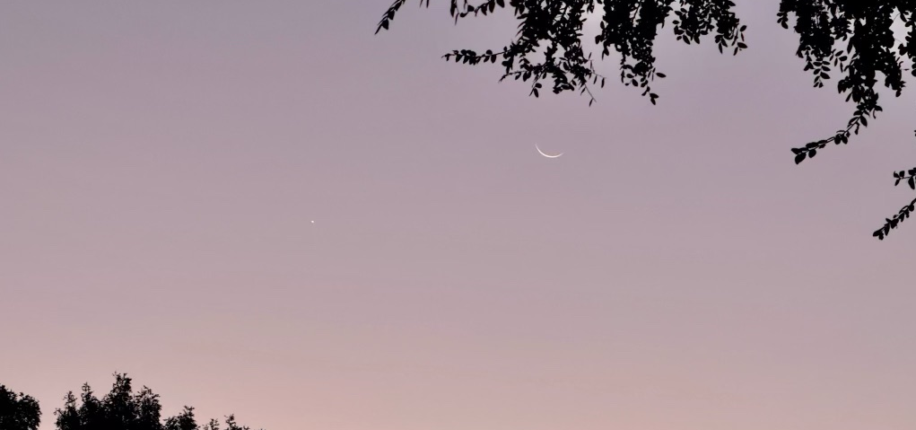

Figure 1. Venus and crescent moon at dawn. October 19, 2025. 07:18 am. Image: Raine Richard.
The wonderful serendipity of sighting a moon-venus conjunction, that same coupling that is present in Van Gogh’s Starry Night, on day one of my 30 day inquiry felt so meaningful that, for the rest of the study, my fear of being disenchanted by the polluted sky was laid to rest. This inner transformation reminded me of Richard Tarnas’ essay on modern disenchantment, where Tarnas informs the reader that psychologist Carl Jung often ‘used hints from the world to correct the one-sided blindness of his conscious attitude.’ Just as Jesus promised his disciples to ‘ask, and it will be given to you; seek, and you will find; knock, and it will be opened to you’, this attitudinal shift, acquired by the sky itself, demonstrated that accessibility to enchanting experiences of heaven could be attained if I would only find myself ‘aware of the stars’, regardless of their quantity or magnitude in the sky.
The Bridge
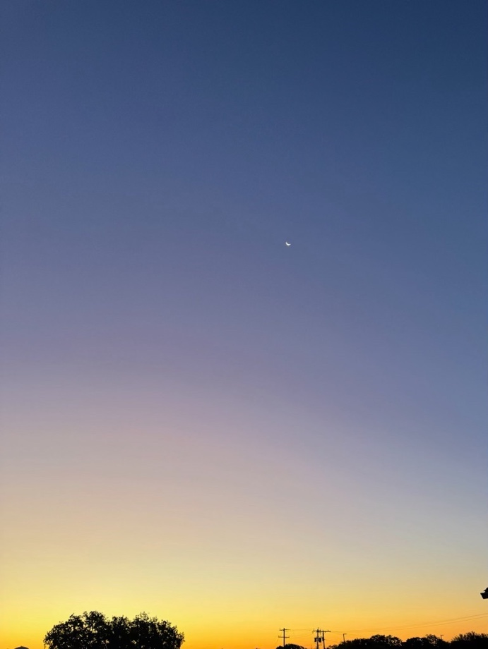
Attempting to be ‘clearly aware of the stars’, many days I opted to view the moon from atop a pedestrian overpass. One mid-November morning, at sunrise, I stood at this point outlooking a vast, unclouded sky, noting the ever-shrinking moon while simultaneously confronting how immensely small I was within the greater cosmos (fig.2). As I reviewed my photographs and entries, I discovered that this location consistently stimulated feelings of wonder and later found this point explicitly reiterated in Awe and the Experience of the Sublime:
‘Huge and steep mountains, starry night skies, waterfalls, grand canyons, deserts, [and] thunderstorms are all examples of grand stimuli triggering experiences of the sublime. This type of experience arises when we are confronted with an overwhelming vastness or power...’
Additionally, these impressions also lead me to a realization that hidden within Van Gogh’s quote was an understanding that, just as the overbridge stimulated a deeper connection to the sky, the celestial world bridges the onlooker to experiences of enchantment. I have chosen the word “bridge” here deliberately, for The Archive for Research in Archetypal Symbolism has found bridges to represent pathways which connect two opposing natures and bring them into relationship with one another. With the understanding that expansive scenes, such as mountains, oceans, and deserts, can bridge one to awe-inspiring experiences, Van Gogh’s advice carries more truth because, unlike other landscape views, the sky, and thus enchantment, is readily available wherever on earth we find ourselves.
Figure 2. Sunrise and moon. November 15, 2025. 06:41 a.m. Image: Raine Richard.
Enchantment
Midway through the experiment, I found myself particularly struck by the sight of a nearly full moon at sunset (fig.3). Perched with my sky journal atop the bridge, I observed ‘the night grow swiftly up over the horizon and hit the zenith before darkness came crashing down over us in its pursuit of the sun’. Strangely, I also noted the beauty of the fading streetlights, which I usually viewed as unsightly, protruding into the sky ‘as if they [were] reaching or pointing up like church steeples’, while simultaneously imagining that ‘all the people down below [were] enjoying the same ‘stellar show’’ as I. ‘Enchantment is relational. It happens as an encounter with an enchanting other, across a gap of difference which it instantly bridges’, informs Patrick Curry. Curry’s definition addresses my encounter with the full moon, where I felt a pervading sense of relatedness or interconnection with not only the sky and moon, but also the surrounding area. Under the glow of ‘golden hour’ (the last hour before sunset), the sky linked me, psychologically, to the drivers engaged in their journeys below because here we were, all together, under one sky.
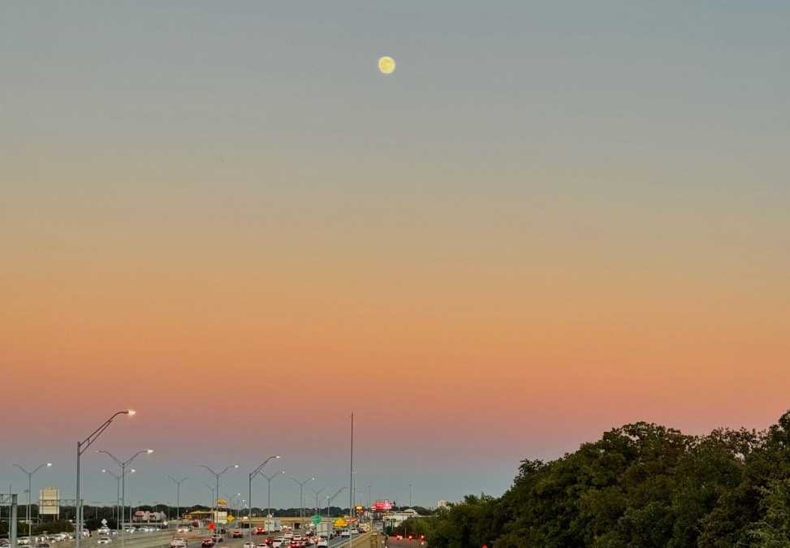
Figure 3. Full moon and sunset. November 3, 2025. 05:38 p.m. Image: Raine Richard.
While exploring various writer’s definitions of awe and wonder, Nicholas Campion summarizes Tolkien’s understanding of enchantment as a ‘state of mind in which one is perfectly, and perhaps ecstatically, integrated with cosmos’ and continues by citing him directly:
‘Faërie contains many things besides elves and fays, and besides dwarfs, witches, trolls, giants, or dragons: it holds the seas, the sun, the moon, the sky; and the earth, and all things that are in it: tree and bird, water and stone, wine and bread, and ourselves, mortal men, when we are enchanted…’
Admittedly, Tolkien’s outlook has occupied my mind since long before this project, however, its resonance burrowed deeper into my heart on the final morning of observation when I, by chance, happened to step out under a burnt orange horizon and caught sight of a menacing cloud, which appeared to me to be shaped like a dragon’s head passing silently over the dying moon (fig.4). From my subjective viewpoint, the sky again offered a moment of wonder and connection, this time calling up imagery I’ve associated with Smaug, that fantastical denizen of Tolkien’s land of Faërie, which, for a fleeting moment, I too felt I inhabited.
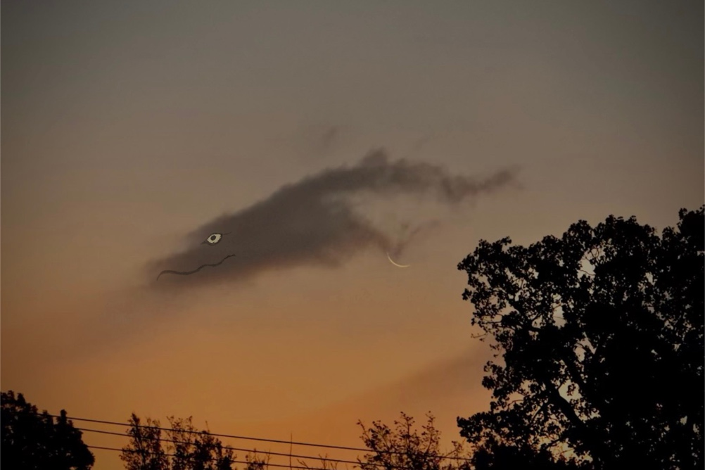
Figure 4. Moon and cloud. November 18, 2025. 06:35 a.m. Image and illustration: Raine Richard.
Tolkien’s stance that Faërie, or the spirit of enchantment, lives not only in imaginal realms, but often brushes up against earthly life is echoed from another perspective, by the astronaut Edgar Mitchell. In an essay predominantly considering the aesthetic quality of the cosmos and mathematics, Holmes Rolston assesses aesthetic appreciation from above earth’s atmosphere and illustrates this point with a quote of Mitchell’s, perhaps, altered state of consciousness as he beheld an earthrise from the moon:
‘Suddenly from behind the rim of the moon, in long, slow-motion moments of immense majesty, there emerges a sparkling blue and white jewel, a light, delicate sky-blue sphere laced with slowly swirling veils of white, rising gradually like a small pearl in a thick sea of black mystery.’
This extract, as well as the personal material I have shared throughout this paper, appear to support Van Gogh’s proposition that when one is present and aware of the heavens, life itself, not exclusively the stars, but the entirety of existence, including the people, sounds, local environment, clouds, and earth itself, does in fact seem ‘almost enchanted after all’.
Conclusion
This paper has examined the relationship between the sky and feelings of awe within the context of Van Gogh’s guidance to ‘be clearly aware of the stars and infinity on high. Then life seems almost enchanted after all.’ Through a 30-day qualitative experiment documenting the sky, moon, and landscape, I analysed the effect celestial phenomena had on my internal experience, and in investigating the evidence, this essay found three core themes arise. The first theme looked at the sky’s ability to dissolve a disenchanted attitude which, in this case, arose from the assumption that the heavens had been tainted by light pollution. Secondly, I considered the vast sky as the only consistent bridge to awe-inspiring experiences. Finally, I investigated the definition of enchantment as spontaneous ecstasy coupled with a profound sense of interrelation with the cosmos, including one’s fellow humans and local environment, organic or otherwise. Overall, this essay has found Van Gogh’s assertion to be true; despite even suboptimal conditions, when one looks heavenward, they find its grandiosity to connect them to a state of awe, wonder, and oneness which, in Van Gogh’s view, sustains one just as their daily bread does.

Bibliography
Primary Sources
Gogh, Vincent Van, and Ronald de Leeuw. The Letters of Vincent Van Gogh. London: Penguin Books, 1997
Gogh, Vincent Van.1888 “‘The Night Café’ by Vincent van Gogh.” Vincent van Gogh, https://www.vincentvangogh.org/the-night-cafe.jsp.

Gogh, Vincent Van. 1889. “‘The Starry Night’ by Vincent van Gogh.” www.moma.org/collection/works/79802
Tolkien, J.R.R. 2012. The Hobbit (HarperCollins)

Secondary Sources
Arcangeli, Margherita & Sperduti, Marco & Jacquot, Amelie & Piolino, Pascale & Dokic, Jérôme. (2020). Awe and the Experience of the Sublime: A Complex Relationship. Frontiers in Psychology. 11. 1340. 10.3389/fpsyg.2020.01340.

Bell, Judith, and Stephen Waters. 2018. Doing Your Research Project: A Guide for First-time Researchers (McGraw-Hill Education (UK))

Campion, Nicholas. “Enchantment and the Awe of the Heavens.” The Inspiration of Astronomical Phenomena VI, 2011.

Campion, Nicholas, and Patrick Curry. 2006. Sky and Psyche. Floris Books.

Curry, Patrick. 2021. ‘Understanding Enchantment’ http://www.patrickcurry.co.uk/papers/Enchantment%20for%20SMN.pdf

Nelson, Thomas. 2005. NKJV, Holy Bible (Thomas Nelson)

Rolston III, Holmes. “Celestial Aesthetics: Over Our Heads and/or in Our Heads.” Theology and Science, Informa UK Limited, 2011.

Symbolism, Archive for Research in Archetypal. 2017. The Book of Symbols. Taschen

Texas, Darksky. ‘LightPollution Map’. sqm.darkskytexas.org/sqm-map-staging/#sky-quality-across-the-world

Gogh, Vincent van, and Ronald de Leeuw. The Letters of Vincent Van Gogh. London: Penguin Books, 1997. pp391
Gogh, Vincent van, and Ronald de Leeuw. Letters. pp. 392.
Gogh, Vincent van, and Ronald de Leeuw. Letters. pp. 392.
Bell, Judith, and Stephen Waters. 2018. Doing Your Research Project: A Guide for First-time Researchers (McGraw-Hill Education (UK)) pp. 26
Texas, Darksky. ‘Light Pollution Map’. sqm.darkskytexas.org/sqm-map-staging/#sky-quality-across-the-world
Gogh, Vincent Van.1888 “The Night Café” by Vincent van Gogh.” Vincent van Gogh, https://www.vincentvangogh.org/the-night-cafe.jsp
Gogh, Vincent Van. 1889. “The Starry Night” www.moma.org/collection/works/79802
Campion, Nicholas, and Patrick Curry. 2006. Sky and Psyche. Floris Books. Pp187
Nelson, Thomas. 2005. NKJV, Holy Bible (Thomas Nelson), pp. Matthew 7:7
Arcangeli, Margherita & Sperduti, Marco & Jacquot, Amelie & Piolino, Pascale & Dokic, Jérôme. (2020). Awe and the Experience of the Sublime: A Complex Relationship. Frontiers in Psychology. 11. 1340. 10.3389/fpsyg.2020.01340. pp. 2
Symbolism, Archive for Research in Archetypal. 2017. The Book of Symbols. Taschen. pp. 626
Curry, Patrick. 2021. ‘Understanding Enchantment’ http://www.patrickcurry.co.uk/papers/Enchantment%20for%20SMN.pdf pp. 2
Campion, Nicholas. “Enchantment and the Awe of the Heavens.” The Inspiration of Astronomical Phenomena VI, 2011. Pp. 5
Tolkien, J.R.R. 2012. The Hobbit (HarperCollins)
Rolston III, Holmes. “Celestial Aesthetics: Over Our Heads and/or in Our Heads.” Theology and Science, Informa UK Limited, 2011. Pp. 282
Gogh, Vincent van, and Ronald de Leeuw. The Letters of Vincent Van Gogh. London: Penguin Books, 1997, pp.392.

