Module Code: BMHP6030.
Module: Health, Wellbeing and Sustainable Development.
Assignment Title: Component 2 Written Assignment (Report)
SDG 3 and SDG 11
Student Name: Felicia Tejuoso
Student ID: 2311756
Lecturer Name: Junaid Shaikh.

Table of Contents
Introduction 3
Overview 3
Global Policies and Initiatives 4
National (UK) Policies and Initiatives 4
Local (London) Policies and Initiatives 5
Theory 1: Health Belief Model 5
Model 1: Social Ecological Model 6
Recommendations 7
Section 2: SDG 11- Sustainable Development Goal 8
Overview 8
Global Policies and Initiatives 8
National (UK) Policies and Initiatives 9
Local (London) Policies and Initiatives 9
Theory 1: Social Cognitive Theory 10
Model 1: Dahlgren and Whitehead Model 10
Recommendations 11
Conclusion 12
References 13

Introduction
The Sustainable Development Goals (SDGs) can be used as a universal blueprint for tackling complex health-related issues, for tackling inequality, and for urban sustainability. The purpose of this report is to critique SDG 3 (Good Health and Wellbeing) and SDG 11 (Sustainable Cities and Communities) on how they affect health outcome and living conditions. The report looks at the main policies and initiatives in place globally and in theUK, considers their effectiveness using appropriate theories and models and explores the application of these in practice. It consists of two parts focusing on two SDGs, both of which involve a critical examination of aspects of the SDG and then a set of evidence-based recommendations to determine the impact of each SDG on sustainable and equitable development outcomes.
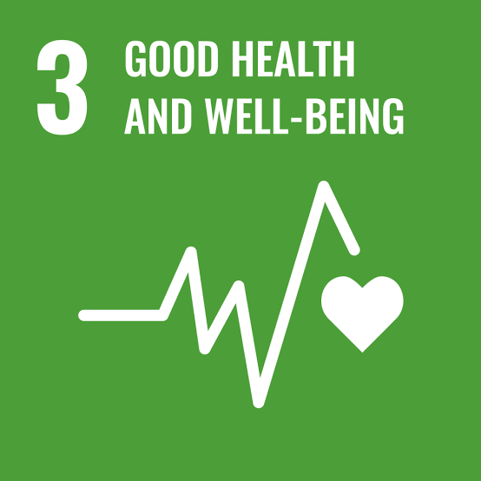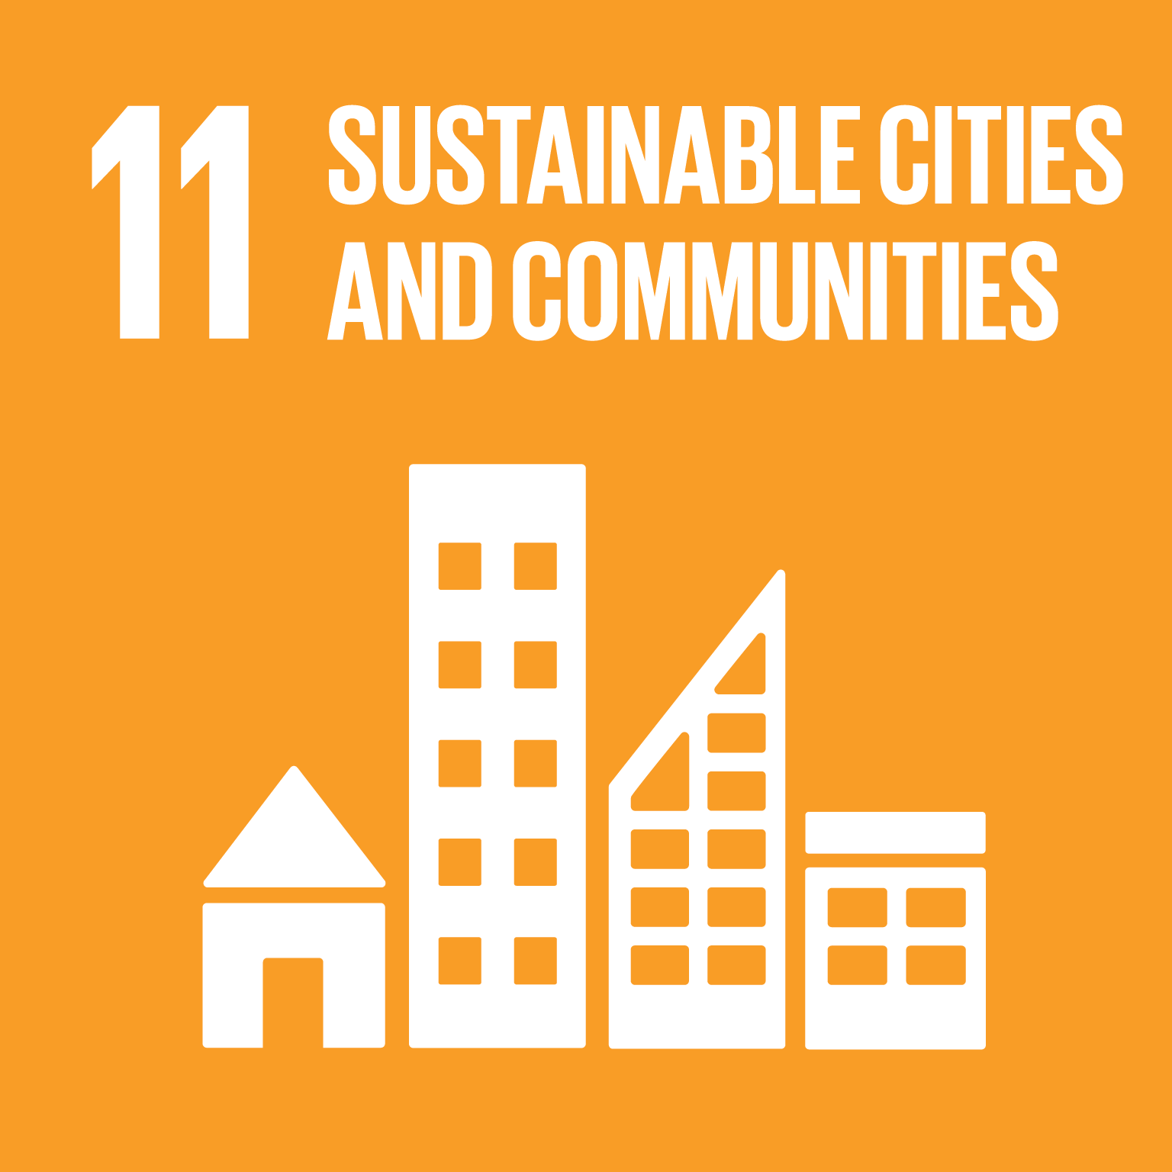
(University College Cork, Ireland)
Section 1: SDG 3 - Good Health and Wellbeing

Overview
SDG 3 puts emphasis on enhancing and protecting the health and wellbeing of mothers, children and the population at large: Communicable and non-communicable diseases, maternal and child health and access to healthcare (EC.Europa.eu, 2026). It contains targets like "Reduce maternal mortality by less than 70 deaths per 100 000 live births" and "End preventable deaths of new-borns and children (SDGs.UN.org, 2025). Consolandi et al. (2020) claim that SDG 3 is more than just health care provision, as governance structures, inequality, and resource allocation has an impact on the outcomes. Similarly, environmental exposure, inequalities in lifestyle and access are shown to have a huge impact on outcomes, as highlighted by EC.Europa.eu (2026), meaning that SDG 3 effectiveness is not only reliant on integrated, multi-level interventions, but also on individual health interventions.

Global Policies and Initiatives
SDG 3 is being implemented at the global level in the WHO Universal Health Coverage initiative and the UN Global Health Strategy, respectively, to increase access and to reduce mortality. Progress is evident as the maternal mortality rate has decreased 14% and under-5 mortality rate has decreased 16% from 2015 to 2023 (SDGs.UN.org, 2025). Moreover, EC.Europa.eu (2026) reports that the life expectancy at birth has risen to 81.4 years and healthy life expectancy in that same period to 75.3 years. Avoidable mortality is still high at 237.7/100,000, however, this is due to inefficiencies. As per the Health Belief Model, policies increase perceived benefits, however systemic barriers like weak infrastructure, and funding inequalities constrain behaviour change (Kam and Lee, 2024). Similarly, Consolandi et al., (2020) make the argument that global gains conceal inequality. Thus, whilst there are improved results at the global level, effectiveness is not even as a result of the structural differences.

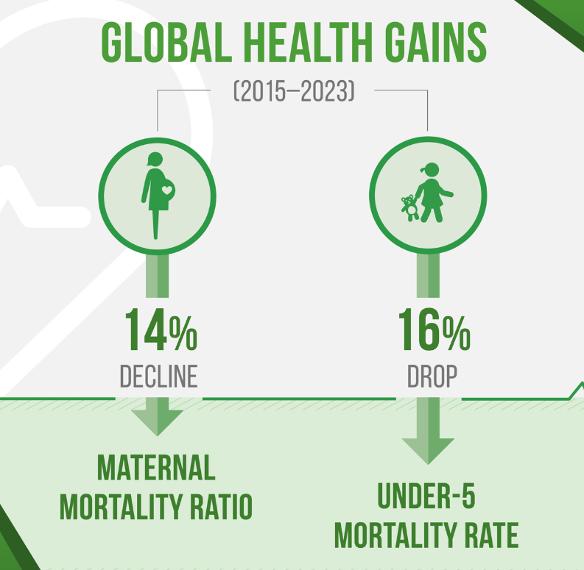
Figure 1: Global Health Gains
Source: (SDGs.UN.org, 2025).

National (UK) Policies and Initiatives
The UK Government's commitment to SDG3 is via the NHS Long Term Plan and the Office for Health Improvement and Disparities, which include work on prevention and tackling inequalities. Systematic monitoring is emphasised which is a good sign of good governance (SDG Data.gov.uk, 2023). These policies have enhanced access to intervention and services for the earliest learners as well as greater access to services. But there are 2.5% who have unmet health care needs as a result of waiting times and costs (indication of strain) (EU.Europa.eu, 2026). Social Ecological Model suggests that policies need to be directed mainly towards policy delivery of health care and ignore other factors that affect health, for example socioeconomic inequalities. Similarly, Consolandi et al. (2020) report structural constraints. So, whilst the design of policies is good, capacities and differential access to resources limit the effectiveness of the policies in the real world.

Local (London) Policies and Initiatives
NHS Integrated Care Systems (ICS) and borough-level prevention programmes are amongst examples of local work which seeks to enhance access and reduce health inequalities. These are holistic programs that improve childhood and early intervention services in the community. Like the country, though, there are inequalities in access between the poorest boroughs. Eriksson et al. (2025) state that the local health environment and social factors, such as housing and income, have a strong influence on local health outcomes. Thus, although local policies can enhance service delivery, these policies do not provide sufficient attention to determinants upstream. However, efforts at the community level have the potential to decrease inequalities, suggesting that effectiveness is determined by locally tailored approaches that involve multiple sectors, not by a one-size-fits-all approach.

Theory 1: Health Belief Model
One of the models that explains health behaviour is the Health Belief Model developed in 1950s by Hochbaum and Rosenstock which is based on the perceived susceptibility, severity, benefits and barriers (Kam and Lee, 2024).
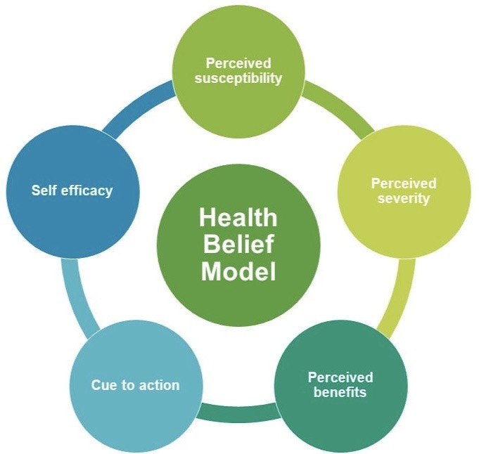
Figure 2: Health Belief Model
Source: (Kam and Lee, 2024).

SDG 3 takes an international and UK approach to making people aware and benefitting from their actions, which leads to behaviour that prevents issues. But whilst there has been perceived growth, uptake is not uniform – for a range of reasons including access delays and cost. Likewise, Consolandi et al. (2020) report that structural inequalities have a negative impact on behavioural outcomes. As a result, the model accounts well for individual decision making, but when considering its application, an SDG 3 policy will not work if there are system constraints that are more important than individual behaviour and reduce the likelihood of achieving sustained improvements in health.

Model 1: Social Ecological Model
Bronfenbrenner in 1977 suggested that the Social Ecological Model of health outcomes recognises a variety of factors that impact health at the individual, interpersonal, community and policy levels (CRP.TRB.org, 2016).
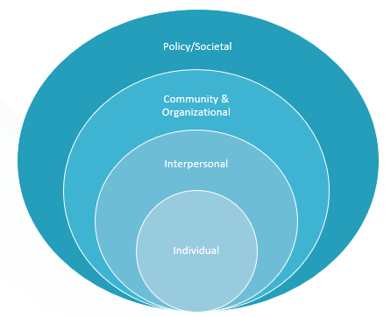
Figure 3: Social Ecological Model
Source: (CRP.TRB.org, 2016).

Policies in SDG 3 enhance health systems, but it is important to note that other determinants like income and environment are contributing factors to the change in behaviour, as argued by Eriksson et al. (2025). Likewise, the absence of equalities over time indicates that interventions fail to sufficiently take into account factors upstream. Thus, whilst healthcare delivery improves, limited multi-level integration fails to make them effective, suggesting that interventions at multiple levels is necessary for sustainable healthcare outcomes to be realised, including structural and environmental determinants.

Recommendations
Table 1: Recommendations Source: Self-made
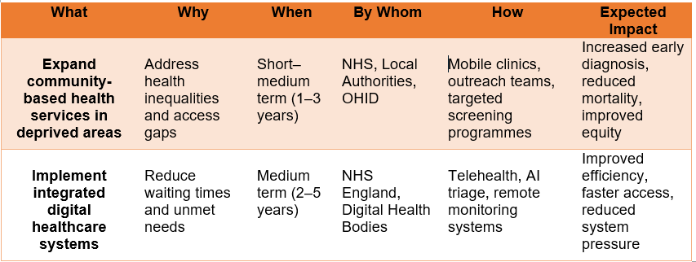
Office for Health Improvement and Disparities (OHID)
Expanding community-based healthcare directly addresses inequalities identified by Consolandi et al. (2020), as it targets structural determinants influencing access. This is supported by Eriksson et al. (2025) who found that behaviour and early diagnosis could be improved more at a community-level. But there are factors that might restrict scalability, such as a lack of workforce and funds.

Similarly, digital health care systems improve efficiency and shorten waiting times, which promotes engagement in line with the Health Belief Model which states that reducing barriers to elements increases engagement (Kam and Lee, 2024). In this respect EC.Europa.eu (2026) points to unmet needs that are a result of delays. Digital exclusion can, however, be a reinforcing force for inequalities.

Both strategies are effective, but it was found that they could only be effective if there was integration of structural, behavioural and technological solutions.

Section 2: SDG 11- Sustainable Development Goal

Overview
The Sustainable Development Goal (SDG) 11, make cities and human settlements inclusive, safe, resilient and sustainable, and can be achieved by tackling housing, transport and urban planning and improving environmental quality (SDGs.UN.org, 2025). The SDG 11 is significant because urbanisation is crucial to the growth of the economy, but also contributes to inequalities and stress on the environment (Küfeoğlu 2022). Similarly, Berisha et al. (2022) point out that SDG 11 has infrastructure, housing and climate resilience as dimensions which are hard to implement. But much of this is hampered by the effects of rapid urbanisation and poor governance. SDG 11 is a comprehensive policy, but it is important that policies across multiple sectors be coordinated to tackle both structural inequality and environmental sustainability.

Global Policies and Initiatives
SDG 11 is promoted at the global level through the UN New Urban Agenda (2016) and Sendai Framework for Disaster Risk Reduction (2015-2030) with the concepts of sustainable planning, resilience, and inclusive housing. As seen in Figure 4, there is significant inequality as up to 3 billion people have difficulty obtaining housing, whilst 1.12 billion people live in slums (SDGs.UN.org, 2025). Moreover, there is an increased demand for infrastructure due to fast urbanisation. But, Berisha et al. (2022) has noted that a non-standardised indicator makes evaluation difficult whilst Küfeoğlu (2022) has pointed out that non-national implementation means that there is not uniformity in the outcome. The Social Cognitive Theory view is that there are weak environments that restrict behaviours. Hence, frameworks have been designed to guide the development but the inequalities of governance and funding are limiting the effectiveness of such frameworks on the global level.
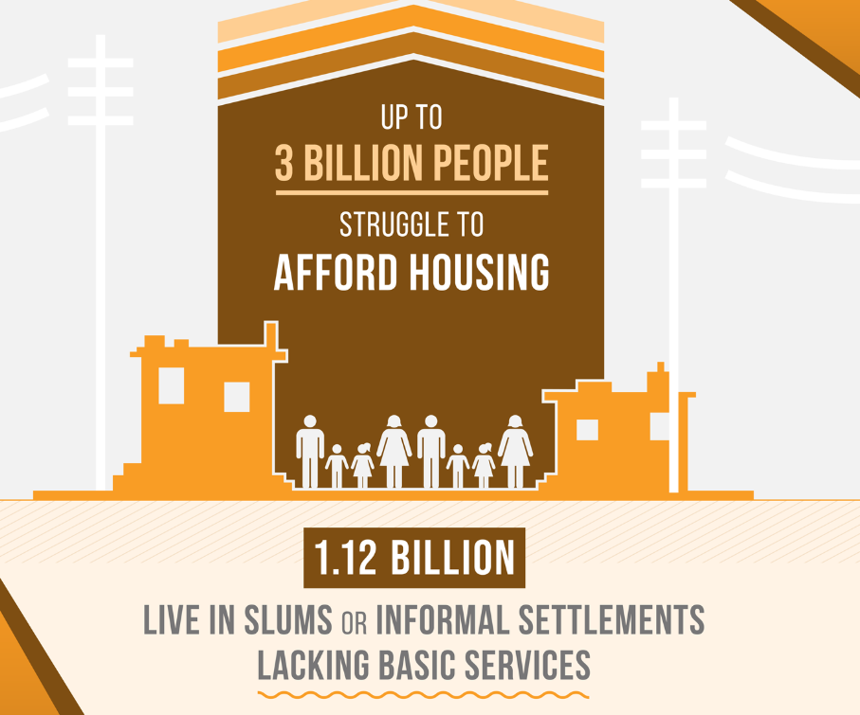
Figure 4: Statistics Related to SDG 11
Source: (SDGs.UN.org, 2025).

National (UK) Policies and Initiatives
In the UK, SDG 11 is taken forward in the context of national urban strategies, and through DFID's Infrastructure and Cities for Economic Development Programme and the Cities and Infrastructure for Growth Programme. The strong commitment to these investments is evidenced by the fact that the investment is said to be £1.2 billion which was made by UK as mentioned by Bond.org.uk (2023). The programmes enhance the facilities and boost economic activities. But Bond.org.uk (2023) notes that there is a lack of policies that focus on vulnerable groups whilst the emphasis is on economic growth. Similarly, Berisha et al. (2022) maintains that there is a need for targeted inclusion, as missing it would perpetuate inequality. Structural determinants are ignored from a Dahlgren and Whitehead view. However, the effectiveness of UK policies is limited by not being well funded, as well as the inequities in the way they are implemented and the lack of an equity focus.

Local (London) Policies and Initiatives
A number of policies at the local level are attempting to make things more accessible, sustainable and enhance quality of life, including London's Affordable Housing Programme and the Healthy Streets policy. These initiatives contribute to the improvement of transport systems and are about inclusive urban design. As in the rest of the country, though, affordability and accessibility of housing is not consistent between boroughs. Islam et al. (2023) suggests that the behaviour is highly shaped by the environmental constraints and that provision of less infrastructure will confine sustainable living practices. Conversely when adapted to the need of the community, targeted local programmes have the potential to show promise. Thus, local efforts can make improvements but can only be effective if they are tackling structural inequalities, as well as infrastructure.

Theory 1: Social Cognitive Theory
Albert Bandura in 1986 developed an explanation of behaviour called the Social Cognitive Theory which states that behaviour is an interaction between personal factors, environment and behaviour (IA Computinged.org, 2023).
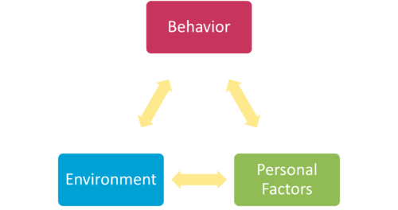
Figure 5: Social Cognitive Theory
Source: (IA Computinged.org, 2023).

As part of SDG 11, cities affect behaviours like transportation and housing. Yet, Islam et al. (2023) believes that the environment plays an important role in restraining behavioral changes whilst Küfeoğlu (2022) points to the lack of policy implementation as a reason for the weak impact. In other words, theory shows how environments affect behaviour but application of it to SDG 11 shows that the SDG does not occur if the urban system is not providing supportive conditions which inhibit sustainable behaviour and erode the effectiveness of policies.

Model 1: Dahlgren and Whitehead Model
Dahlgren and Whitehead's Model of 1991 focuses on socioeconomic, environmental and structural factors influencing health (Dahlgren and Whitehead, 2021).

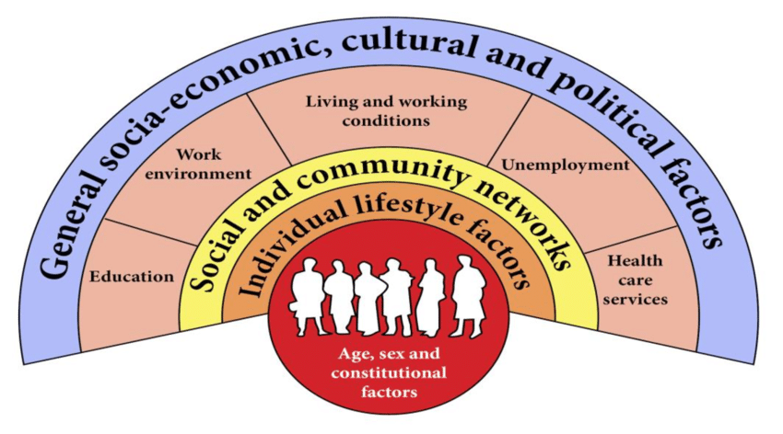
Figure 6: Dahlgren and Whitehead Model
Source: (Dahlgren and Whitehead, 2021).

Housing, employment and infrastructure are directly related to wellbeing in SDG11. But, Bond.org.uk (2023) notes that vulnerable groups are most negatively impacted by lack of inclusive infrastructure whilst Berisha et al. (2022) state that inequality is structurally entrenched. So, even if SDG 11 policies enhance the infrastructure, they cannot ensure equity if they do not tackle the social, economic and environmental determinants, showing that effective SDG 11 requires a combination of social, economic and environmental policies.

Recommendations
Table 2: Recommendations Source: Self-made
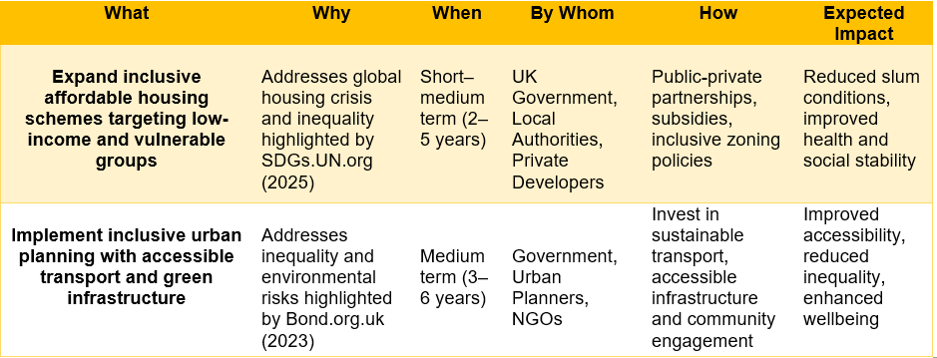

Expanding affordable housing directly addresses global inequalities identified by SDGs.UN.org (2025), whilst Bond.org.uk (2023) links housing to improved health and economic stability. Nevertheless, Küfeoğlu (2022) notes difficulties that may hinder implementation, such as financing and regulation.

Likewise, inclusive urban planning enhances accessibility and sustainability as per the Dahlgren and Whitehead Model which focuses on the structural determinants (Dahlgren and Whitehead, 2021). Gajatekar et al. (2023) also confirms that better environment is conducive to behaviour change. But there can be governance and coordination issues which may limit effectiveness.

So, whilst both are evidence based, integrated, inclusive and funded policies are necessary to ensure they are a successful strategy.
Conclusion
The report shows that SDG 3 and SDG 11 are closely linked and both the health care system and urban environment have an impact on health and wellbeing. Progress has been made through global and national policies, but structural inequalities and lack of implementation is a challenge. But the analysis identifies that whilst healthcare will only improve the health of people if urban determinants, like housing, infrastructure and environmental conditions, also improve. Hence, policy frameworks are a means of strategic guidance, but require multi-levelled and integrated approaches to be effective. To achieve sustainable development the action needs to be coordinated across sectors and policies must be effective, inclusive, equitable and responsive to real world social and environmental complexities.

References

Bambra, C. and Marmot, M. (2024) “Restructuring of the Office for Health Improvement and Disparities is a further step in the wrong direction for tackling health inequalities.”
Berisha, E., Caprioli, C. and Cotella, G., ( 2022). Unpacking SDG target 11. a: What is it about and how to measure its progress?. City and Environment Interactions, 14, p.100080. https://www.sciencedirect.com/science/article/pii/S2590252022000022
Bond.org.uk (2023). SDG 11: Progress, gaps and recommendations for the UK. [online] Bond.org.uk. Available at: https://www.bond.org.uk/wp-content/uploads/2023/03/sdg11_progress_gaps_and_recommendations_for_the_uk.pdf [Accessed: 1st Jul 2026].
Consolandi, C., Phadke, H., Hawley, J. and Eccles, R.G., 2020. Material ESG outcomes and SDG externalities: Evaluating the health care sector’s contribution to the SDGs. Organization & environment, 33(4), pp.511-533. https://journals.sagepub.com/doi/abs/10.1177/1086026619899795?__cf_chl_f_tk=hJFoYxQdcb2_I2JFiFnvj_miQTA65rozWbOtw8v2UyA-1783186675-1.0.1.1-h2ST_OSJV8TU7tYLTqOr53uZEP.2RlmooPyr2u8XiXo
CRP.TRB.org (2016). Social-Ecological Model. [online] Trb.org. Available at: https://crp.trb.org/btscrpwebresource2/mitigation-tools/socioecological-levels/ [Accessed: 1st Jul 2026].
Dahlgren, G. and Whitehead, M., 2021. The Dahlgren-Whitehead model of health determinants: 30 years on and still chasing rainbows. Public health, 199, pp.20-24. https://www.sciencedirect.com/science/article/abs/pii/S003335062100336X
EC.Europa.eu (2026). SDG 3 - Good Health and well-being. [online] ec.europa.eu. Available at: https://ec.europa.eu/eurostat/statistics-explained/index.php?title=SDG_3_-_Good_Health_and_well-being [Accessed: 1st Jul 2026].
Eriksson, M., Sundberg, L.R., Santosa, A., Lindgren, H., Ng, N. and Lindvall, K., 2025. Health behavioural change–the influence of social-ecological factors and health identity. International journal of qualitative studies on health and well-being, 20(1), p.2458309. https://www.tandfonline.com/doi/full/10.1080/17482631.2025.2458309
IA Computinged.org (2023). Social Cognitive Theory - Institute for Advancing Computing Education. [online] Institute for Advancing Computing Education. Available at: https://iacomputinged.org/social-cognitive-theory/ [Accessed: 1st Jul 2026].
Islam, K.F., Awal, A., Mazumder, H., Munni, U.R., Majumder, K., Afroz, K., Tabassum, M.N. and Hossain, M.M., 2023. Social cognitive theory-based health promotion in primary care practice: A scoping review. Heliyon, 9(4). https://www.cell.com/heliyon/fulltext/S2405-8440(23)02096-0
Kam, B.S. and Lee, S.Y., 2024. Integrating the health belief model into health education programs in a clinical setting. World Journal of Clinical Cases, 12(33), p.6660. Available at: https://pmc.ncbi.nlm.nih.gov/articles/PMC11514333/
Küfeoğlu, S., 2022. SDG-11: Sustainable cities and communities. In Emerging technologies: Value creation for sustainable development (pp. 385-408). Cham: Springer International Publishing. https://link.springer.com/chapter/10.1007/978-3-031-07127-0_13
SDG Data.gov.uk (2023). Goal 3 - Good health and well-being - U.K. Indicators For The Sustainable Development Goals. [online] sdgdata.gov.uk. Available at: https://sdgdata.gov.uk/3/ [Accessed: 1st Jul 2026].
SDGs.UN.org (2025). Goal 11 | Make cities and human settlements inclusive, safe, resilient and sustainable. [online] United Nations. Available at: https://sdgs.un.org/goals/goal11 [Accessed: 1st Jul 2026].
SDGs.UN.org (2025). Goal 3: Ensure healthy lives and promote well-being for all at all ages. [online] United Nations. Available at: https://sdgs.un.org/goals/goal3 [Accessed: 1st Jul 2026].

