Assessment 2

Introduction of new Restaurant concept to Hotel Trinity chain and Ala cart Menu

Student’s name : Diana Vukov
Sudent’s ID : 2234549
Food & Beverage Operations (BMIH4002)
Tutor : Jaliya de Silva
Word Count : 446

Table of Contents
Part 1: Restaurant concept 3
Restaurant concept 3
Target audience 3
Reasoning behind menu choices 3
Part 2: Menu Design 5
References 6

Part 1: Restaurant concept

Restaurant concept
The development of a feasible business idea within the food and beverages industry is required to ensure business success (Jabeen, 2019). The feasibility of a food and beverages product delivery firm is in done based on the preferences of appetite among the target customers within the target market (Gnjidić, 2018). Establishing a restaurant offering food and beverage items from popular cuisines creates possibilities for the restaurant owner to attain adequate customer footfall (Durane, 2019). This restaurant will be an Italian restaurant with an Ala Cart Menu. The restaurant will include both food items from Italian cuisine and beverages of Italian origin such as Cappuccino. Furthermore, the restaurant under the brand umbrella of the Trinity Hotel chain will include both dine-out and takeaway offerings along with an open-air sitting arrangement.

Target audience
Identification of the target audience of a business creates possibilities for the business to ensure business success (Lessmann, et al., 2021). It supports attracting and engaging customer demographic that is capable of generating higher revenue. In addition, product position especially in the food and beverages organisations is done based on the preferences of the target customers (Chih, 2020). Italian food and beverages are popular among people in the UK (Ricci, et al., 2019).
Around 58% of people from 16 to 24 years of age prefer buying Italian food. Alongside, 56% of people from 25 to 39 years of age prefer buying Italian food (You Gov. UK, 2023). Hence, the key target customer segment will be people from young age which is from 16 to 39 years.

Reasoning behind menu choices
In order to ensure higher business success rationale choice of the products to be selected as business deliverables is required (Seo, 2020). The selection of products to be included in the business offerings needed to be in line with the preferences of the target customers. The choice of the inclusion of Italian food and beverage dishes is rational as there is a high demand for Italian food items in the UK.
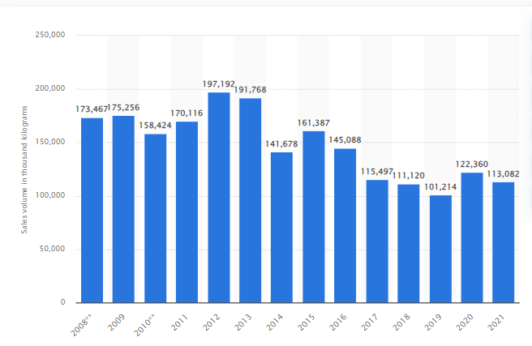
Figure 1: Sales of Readymade Pasta in the UK, Source: (Statista, 2023)
For example, the demand for readymade pasta dishes was 113,082 thousand kilograms in 2021, which shows the high demand. In addition, the Pizza takeaway industry generated revenue of 3.7 billion GBP in 2021, which shows the high demand. Hence, the selection of the menu items has been rational (Ibis World, 2023).

Part 2: Menu Design
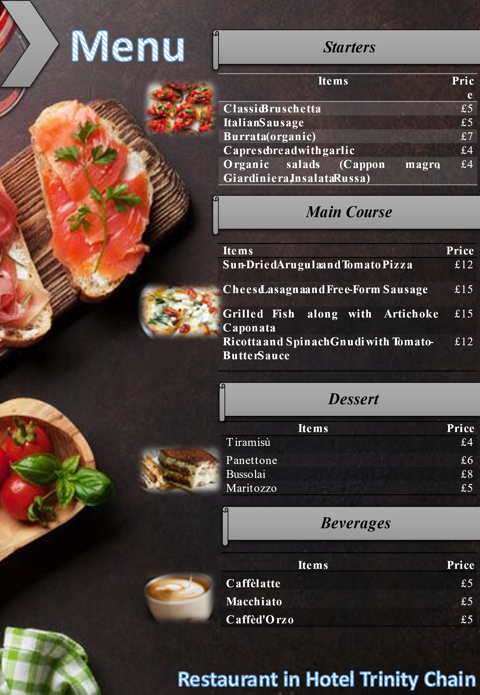

References
Chih, Y. (2020). Project benefit management: A conceptual framework of target benefit formulation. International Journal of Project Management, 33(3), 352-362; DOI: 10.1245.3265.1154.98958-47.
Durane, R. (2019). The intersection of entrepreneurship and strategic management research. The Blackwell handbook of entrepreneurship, 12(5), 45-63,DOI: 10.1016/j.sbspro.2015.06.290.
Gnjidić, V. (2018). Interdependence of company’s industrial competitive position and its strategic orientation: A dynamic theoretical model. Management. Journal of Contemporary Management Issues, 23(2), 103-122; DOI: 10.30924/mjcmi/2018.23.2.103.
Ibis World. (2023). Pizza Delivery & Takeaway in the UK - Market Size 2011–2029. Retrieved June 08, 2023, from Ibis World: https://www.ibisworld.com/united-kingdom/market-size/pizza-delivery-takeaway/#:~:text=Questions%20Clients%20Ask%20About%20This%20Industry&text=The%20market%20size%2C%20measured%20by,in%20the%20UK%20in%202022%3F
Jabeen, F. (2019). Entrepreneurial mindset and the role of universities as strategic drivers of entrepreneurship: Evidence from the United Arab Emirates. Journal of Small Business and Enterprise Development, 11(4), 11-78, DOI: 10.1201.1335.65862.9787-7.
Lessmann, S., Haupt, J., Coussement, K., and De Bock, K. (2021). Targeting customers for profit: An ensemble learning framework to support marketing decision-making. Information Sciences, 55(7), 286-301; DOI: 10.1016/j.ins.2019.05.027.
Ricci, E., Stranieri, S., Casetta, C., and Soregaroli, C. (2019). Consumer preferences for Made in Italy food products: The role of ethnocentrism and product knowledge. AIMS Agriculture and Food, 4(1), 88-110.
Seo, H. (2020). Sensory nudges: The influences of environmental contexts on consumers’ sensory perception, emotional responses, and behaviors toward foods and beverages. Foods, 9(4), 509; DOI: 10.3390/foods9040509.
Statista. (2023). Sales volume of prepared pasta dishes* manufactured in the United Kingdom (UK) from 2008 to 2021. Retrieved June 08, 2023, from Statista: https://www.statista.com/statistics/485618/prepared-pasta-dishes-volume-sales-in-the-united-kingdom-uk/
You Gov. UK. (2023). Part Three: Favourite cuisines and junk food. Retrieved June 08, 2023, from You Gov. UK: https://yougov.co.uk/topics/society/articles-reports/2022/04/20/part-three-favourite-cuisines-and-junk-food

