Chloe Duggan 2305558
Ways Of Thinking ADDA4022

What is Causing a Resurgence of the Arts and Crafts Movement in Contemporary Society?

Introduction

With a growing appreciation for handmade goods, a desire for sustainability, and the effects of digital culture on creativity, a revival of the arts and crafts movement feels more imminent than ever. By examining the similarities between the original movement and contemporary trends, insight can be gained into how our rebellion against dehumanising practises continues to shape the relationship with craftsmanship and the ongoing preference for quality over quantity. Throughout time, creatives have been utilising their voice to advocate for the arts, and as society tackles with the repercussions of consumerism and over 250 years of industrial revolution, they seek inspiration from historical periods.

History

The Arts and Craft Movement began in the late 19th century which came as a response to the industrialisation of Britain and the technological innovation of the country’s economy. Although a positive breakthrough for some aspects, members of this art movement rejected the mass production of products and the minimal human connection with them. The goal of the movement was to fight for artisans and the decorative arts, focusing on furniture, architecture, textiles, and objects with function, while also protesting the use of factory-made products, and the dehumanizing way things were made. As the Industrialisation was meaning less work was needed from skilled workers in trades, the result was products that lacked soul and beauty, and had little contact with the makers. (Victoria and Albert Museum, n.d.)

William Morris

A key figure of this movement was William Morris, who was extremely passionate about leading the future towards a creative direction. Not only was he a craftsman but also a social activist, conservationist, writer, and poet and dedicated his rebellious mind towards bringing this movement to life. His design company ‘Morris and Co’ still appears in many households on everyday objects, textiles, and walls. This lasting effect of bringing nature and crafts into society shows how people instinctively yearn for the authenticity of handmade and the beauty of traditional techniques with medieval influences. Morris led the movement not completely against machines and factories, but with a strong emphasis on making work with integrity and cared for the wellbeing of the working class. He believed that the repetition of working in a factory was a dehumanizing way to live and wanted to ensure workers had the opportunity to experience the positive effects of engaging with your work and unleashing creativity.

“He wanted to free the working classes from the frustration of a working day focused solely on repetitive tasks and allow them the pleasure of craft-based production in which they would engage directly with the creative process from beginning to end.” (Victoria and Albert Museum, n.d).

John Ruskin

Morris was influenced by the past and the medieval styles of art, in particular gothic architecture. He believed it was “an ideal template for both good design and good living,” (Victoria and Albert Museum, n.d). This stemmed from his fascination with the book “The Stones of Venice” (1853) written by philosopher and art historian, John Ruskin, who had a great influence on the movement. Ruskin believed that art should be “true to nature” and wanted to return to the art styles and values from the medieval age. This idealism paired with Morris’s rebellious ways led to the progression of the movement. (Bain, 2019, p. 12)

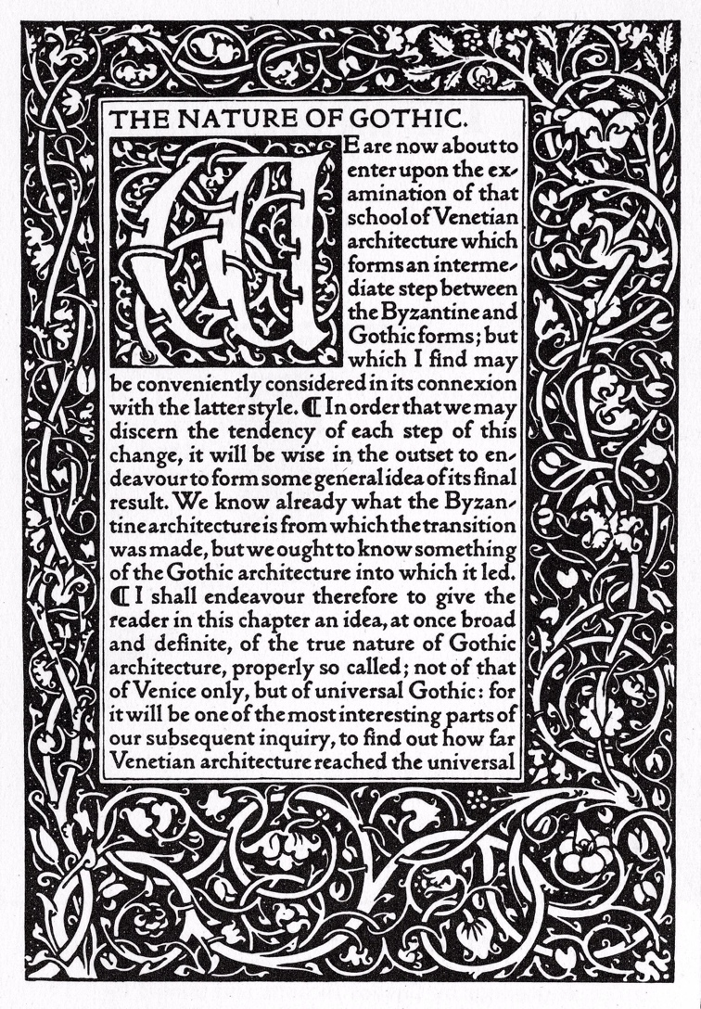
Fig 1: Text by John Ruskin; decorated and printed by William Morris; published by Kelmscott Press, Hammersmith (1892)

In the book, Ruskin sets out a manifesto for the ideal qualities and rules of gothic architecture, with “naturalism” being the third most important element. Ruskin also discusses and admires the gothic builders and questions what attributes effect their architecture.

“What characters, we have to discover, did the gothic builders love, or instinctively express in their work, as distinguished from all other builders?” (Ruskin, 2001, p.133)

This is suggesting that Ruskin admires this expressive style of work and looks to the maker rather than their tools and materials, with emphasis on the builders being the key to the outcome. It can be noted how Morris has taken influence from this way of thinking and his attitude towards skilled workers, and their expressiveness in their work. Morris also co-founded the ‘Pre-Raphaelite Brotherhood’ which fought for conservation, and preserving the gothic architecture, stating that “We are only trustees for those that come after us.” This is a similar view to Ruskin in the belief of longevity and preservation, protecting the beauty in the world to pass down to those after them. (Ruskin, 1877)

Semiotics and Materials

These visual signs remind society of their connection to nature and the organic shapes around them. The details present in the gothic architecture also act as a symbol of the time, effort, and creative imagination required to make exquisite work. If society sees beauty in their everyday lives, they are more inclined to want to protect it for future generations. By using the natural motifs as images in their work, Morris and Ruskin have captured the splendour to remind people of what they could lose if they were to give in to the industrialisation. Hand-crafted products were also symbols in themselves due to the materials they used and the natural, sustainability of them, acting as an icon for artisans and representing the strength of craftsmanship. The use of natural materials and the rejection of pollution caused from the industrialisation is a driving force of the movement, and endeavours to encourage that craftsmen not only make work reflecting nature but also using it. Techniques such as wood carving, weaving and metal work alongside materials like stone, cotton, and wood all represent the simple and sustainable ways of making crafts while keeping the connection to nature through the creation of functional objects.

Contemporary Trends

It can be said that the world is closer now more than ever towards another uprising of the Arts and Crafts Movement.

“A Crafts Council survey, the Market for Craft report, reveals 73% of UK adults
bought craft in 2019, snapping up almost 25 million handmade objects.” (Smith, 2020).

The 21st century is in a digital age and the economy is gradually becoming a paperless world, making things more efficiently to require less time and higher yield. This is mirroring the goals of the industrialisation in the 19th century with different tools. On the one hand, the digital age is promoting the revival of homemade goods due to social media giving platforms to sell and promote crafted goods to people all around the world. There are also online communities where creatives can collaborate, almost like the historical period when there would be society meetings for discussions to make change. Another positive is that there are many online classes and tutorials to stay connected with skills and learn new trades. These are opportunities that would not have been accessible to someone from the 19th century, meaning that art is accessible to a wider selection of people, and now more than ever due to technology. Today’s artisans may have only decided to begin their trade later in life, from the abundance of opportunity society offers.

“Industrial innovations are informing a new creative movement- the result of the maturing of a new industrial revolution brought about by digital technologies” (Johnston, 2017 p.7).

The same tool that gives opportunities to skilled workers, is also the driving force for the longing for arts and crafts, due to the over stimulation of technology and screen times. With much of the population owning a form of technology, it is refreshing to feel handmade products and have physical beauty around their homes rather than digital. Current consumerism trends like ‘fast fashion’ are also a trigger for a resurgence of crafts as society is bored, as well as disappointed in the meaningless, cheap fabrics that are bought daily, and are looking back to traditional methods for handmade techniques such as knitting, crochet, weaving and embroidery, very much like Morris taking his inspiration from the past. The use of these damaging materials also makes society stop and think about their personal effect on the environmental damage that is a constant issue of today, with people turning to these traditional materials and techniques, celebrating nature, and preserving our world by choosing not to have products made by a machine. (Smith, 2020).
Lastly, mental health has played a crucial role in the longing for craftsmanship. “1 in 4 people will experience a mental health problem of some kind.” (Mind, 2020) It can be said that individuals are looking to art as a therapy, relating back to Morris’s beliefs that it is in our human nature to want to create and bring creativity to life. With both men and women expected to work long hours in jobs that subdue their creative side, with little gain and satisfaction in their lives, they could be turning to the arts to make a change and live a fulfilling life, searching out traditional methods and finding the beauty that is being lost in the world.

Conclusion

In conclusion, the resurgence of the Arts and Crafts Movement reflects the yearning for authenticity in a world that feels disconnected. As more people gravitate towards handmade and personalized creations, they not only revive traditional skills, but also encourage the standards that Morris and Ruskin fought to uphold. This movement highlights the true value of craftsmanship and the need to keep creativity alive, more than ever in a digital age which is forever changing. As time moves on it will be interesting to explore how emerging technologies might further influence the future of Arts and Crafts.

Bibliography

Bain, R., (2019) William Morris’s Flowers, published by Victoria and Albert Museum, London Design, Thames & Hudson Ltd, London.

Fig 1: Text by John Ruskin; decorated and printed by William Morris, (1892) The Nature of Gothic published by Kelmscott Press, Hammersmith (1892) Available at: JSTOR, https://jstor.org/stable/community.14380848. Accessed 27 Nov. 2024.

Johnston, L., (2017) Digital Handmade, published by Thames & Hudson Ltd, London.

Mind. (2020) Mental Health Facts and Statistics. Available at: [https://www.mind.org.uk/information-support/types-of-mental-health-problems/mental-health-facts-and-statistics/] (Accessed: 2 December 2024).

Ruskin, J., & Links, J. G. (2001). The stones of Venice, published by Penguin, London.

Ruskin, J., (1877) The SPAB Manifesto. Available at: [https://www.spab.org.uk/about-us/spab-manifesto] (Accessed 2 December 2024).

Smith, I. (2020) The Rise and Rise of Craft. Available at: [https://theartssociety.org/arts-news-features/rise-and-rise-craft] (Accessed: 27 November 2024).

Victoria and Albert Museum. (n.d) The Arts and Crafts Movement. Available at: [https://www.vam.ac.uk/articles/arts-and-crafts-an-introduction?srsltid=AfmBOore38lIyoR_vjOT7c2h51NMDFwtm7dQBO2Y69dRjPtmbUuoF_nI] (Accessed: 20 November 2024).

Essay word count: 1600
Bibliography word count: 138

