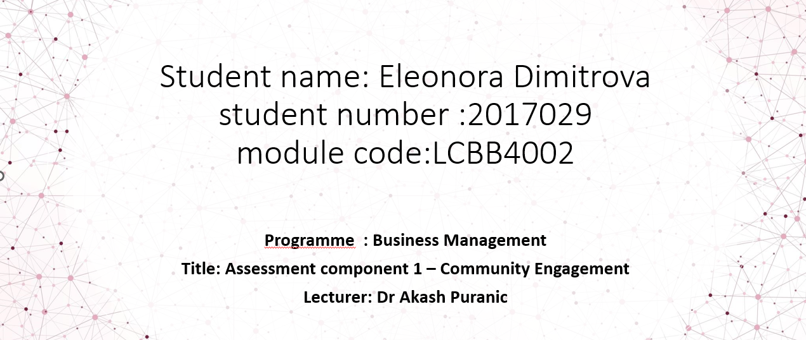

Birmingham and Solihull Mental Health NHS Foundation Trust

Contents
INTRODUCTION 3
THE PROJECT 4
COMMUNITY ENGAGEMENT PRINCIPLES 5
1.Person-centered care 5
2.Accessibility and inclusivity 5
4. Continuous learning 5
5.Flexibility and adaptability 5
STRENGTHS 6
1. Holistic approach 6
2.Proactive care 6
3. Partnership & collaboration 6
4. Evidence-based practice 6
TOOLS USED 7
Internal Communications 7
Patient satisfaction surveys and feedbacks 7
Webpage and phone line 7
WEAKNESSES 7
RECOMMENDATIONS 7
Reduce wait times 7
Cultural sensitivity 7
Management training 7
IMPACT OF THE PROJECT 8
CONCLUSION 9
REFERENCES 10

INTRODUCTION

This individual report is intended to provide insight into the NHS Foundation Trust for Mental Health in Birmingham and Solihull, an organization dedicated to providing high-quality mental health services to people living in poverty.
Trusts operate on a set of guiding principles that shape their approach to care delivery, these are patient-centred, inclusive, and holistic. By following these principles, they strive to provide high-quality mental health services to meet the needs of the diverse community they serve, and to support people on their journey to mental health and recovery.
The report covers an overview of the Trust, followed by the community engagement principles they follow with examples of it. An analysis of their strengths and weaknesses, and recommendations on how to overcome those weaknesses.
Finally the impact of the Trust is assessed and a conclusion on the findings is given.

THE PROJECT

Birmingham and Solihull mental health NHS foundation trust is a trust based on Birmingham and Solihull with a strong reputation in service excellence. Their purpose is to provide comprehensive health care for residents with mental health problems.
They were established in 2008 and serve over a million of people with a workforce of over 4000 staff and over 40 locations, most of which are in environments with high levels of deprivation, low income and unemployment. These factors tend to be associated with mental health issues, Araya et al. (2003) say ‘less education, a recent income decrease, and poor housing remain significantly associated with an increased prevalence of common mental disorders’.
However they also make it harder for proper mental health to be given, which is why the project keeps finding innovative ways of engaging people from the most affected places.
The trust also has its own charity, Caring Minds, which directly raises money for the services provided, including staff and patients. Caring Minds helps to provide extras that normal NHS funding does not include.
If living in Birmingham or Solihull and struggling with mental health issues, the foundation wants to help. They offer a wide range of mental healthcare services, from inpatient and community to specialised care. They understand the needs of the people they serve and work hard to make sure they get the help they need as their mission is to help people recover and achieve better mental health outcomes.

COMMUNITY ENGAGEMENT PRINCIPLES

The trust is set up with a set of key principles to make sure people with mental health issues get the help they need. These are principles that are followed to effectively engage communities, as they help build positive relationships, promote collaboration and empower the community.
These principles go together with the mission of the trust to provide high quality mental health care to the communities it serves. These principles include person-centered care, accessibility, inclusivity, respect and empathy, continuous learning, flexibility and adaptability.

1.Person-centered care
This is all about putting the person at the heart of the process and making sure they get the care they need. This means understanding the individual’s unique needs and wants, and including them in the decision-making process for the treatment and care they need. This could be culturally sensitive services for example.

2.Accessibility and inclusivity
This is about making sure everyone has access to mental health services, no matter who they are, or how old. Equal access to care is key, and the trust works to make sure everyone has the chance to access it with things such as online sessions for the disabled or handicapped-friendly facilities for example.
3.Respect, dignity and non-discrimination
These are at the core of the trust’s approach as it is in line with their policy of safeguarding the wellbeing of individuals. Through celebrating diversity and providing an environment free of stigma and prejudice, they ensure that everyone is treated with the highest level of respect and dignity during their care, so that they may feel comfortable and in safe hands.

4. Continuous learning
The trust is committed to continuous learning and improvement, it regularly evaluates its services, listens to service users’ feedback through surveys, and makes the necessary changes to improve the quality and efficacy of its care on a regular basis.

5.Flexibility and adaptability
Recognizing that each community member is different and may have different needs and pose unique challenges, requiring the trust to be flexible in their approach. Parkes and Gilbert (2010) point out that ‘many service users say their spiritual beliefs are key to their recovery’, which is why tailored services and innovative approaches are necessary for example in the form of collaboration with faith communities.

STRENGTHS

The trust aims to have a positive impact on society as a whole, their benefits range from improving mental health outcomes, reducing stigma, improving social inclusion, creating collaborative partnerships, bringing economic benefits, improving community education, and contributing to research, all of which help create a better environment.
The strengths of Birmingham & Solihull NHS Foundation Trust’s project are as follows:

1. Holistic approach
The trust takes a holistic approach to mental health, recognising the multi-faceted nature of the condition and many factors that can affect the lives of their patients.
This means that the approach considers biological, psychological, and social factors when dealing with mental health issues.

2.Proactive care
The trust encourages people to take the lead in managing their own mental health and achieve personal goals, so that they may become self-reliable over time. This type of care emphasizes the importance of hope and self-determination, helping people regain control over their own lives and reach their goals. It is very vital that they do this type of care as ‘participants’ expectations about treatment are interwoven with their personal aims for the future’, says Biringer et al. (2016). This means that patients specifically want help to achieve their own goals.

3. Partnership & collaboration
The trust values collaboration and partnership, which fosters a network of support. They have partnerships with many services that range from gardening projects, musical projects, photography, drama therapy, therapy kitchens and business projects. They also work with families and carers to accommodate where they can and make the process transparent to ease the mind of loved ones and to co-ordinate with carers.
The trust also encourages research on mental health topics and collaborates with other similar institutions which leads to better research outcomes as ‘community engagement demonstrates the production of research that is more relevant to the community’, said by Holzer, Ellis and Merritt (2014). This way both the trust and the collaborators mutually benefit from their shared activities, and patients get to have more benefits.

4. Evidence-based practice
The trust believes that interventions and treatments should be based on scientific evidence, and that best practices for mental health care should be followed. This belief in evidence-based practice helps to ensure that people receive the best and most effective treatments available, as it recognizes that ‘health care is individualized and involves uncertainties and probabilities’ as said by McKibbon (1998), letting health providers suit the treatment to the patient.

TOOLS USED

Internal Communications
The trust uses a variety of internal communication channels, including email newsletters, staff meetings, etc., to ensure that employees are aware of the principles and are aligned with them, as well as get updated on any important topics. This helps to create a consistent and unified approach to providing mental health care services where every staff member is on the same page.

Patient satisfaction surveys and feedbacks
Feedback forms ask about things like how was the access to care, how well they communicated, if the patients feel better about their mental health, and how satisfied they are with the services they receive.

Webpage and phone line
The trust has both an online webpage and phone line to provide help to those in need, via webchat or answering calls on a help line number. The web shows all their services and information about what they do and who they are, so that prospective patients may get an understanding of what they can be offered.
The help line is vital in time of crisis, Paterson, Reniers and Vollm (2009) say ‘helplines have been recognised to provide an effective way to reach individuals in crisis’. This is because of the benefits that being an anonymous form of contact brings, making people feel less judged and more likely to use them if necessary.

WEAKNESSES
An inspection report by the care quality commission (2023) shows that the ‘safety, effectiveness, and management of the trust require improvement’. Specifically they point out that mental health crisis services, and management are the major weaknesses of the trust.

RECOMMENDATIONS

Reduce wait times
Reducing wait times for mental health services is essential to ensure timely and effective care delivery, specially for crisis services where a quick response is essential.

Cultural sensitivity
To meet the needs of people from different backgrounds and communities, it is important for mental health services to be culturally sensitive and diverse. The trust has to consider training and improving cultural competency among staff members.

Management training
Lack of efficient management is one of their major weaknesses, as said by Hamel (2008) ‘too many companies are held back by impoverished management models’, so staff training should take place to ensure managers are knowledgeable on how to lead the different centres to make efficient use of the resources they have.

IMPACT OF THE PROJECT
The Birmingham & Solihull NHS Foundation Trust's project is having a positive effect on society. It's helping to improve mental health outcomes, reduce stigma and discrimination, and create a more accepting and inclusive environment which is all part of the trust's mission to make the world a better place.
The trust is all about making sure people with mental health issues have access to the services they need to get back on their feet. They strive to make sure everyone has the same chance to participate in society by getting a job or an education, and stay connected with their loved ones. This is important because mental health is a vicious cycle that makes it harder to find a job, as said by Thorne (2018) whose research found ‘1 in 3 people with a long-term mental health condition experienced difficulties with their employment as a result’.
For this reason mental health care has a huge impact on the economy, and people who get better mental health care are more likely to stay on track with their work, stay away less, and don't need to go to the hospital as much. This can mean lower healthcare costs, more productive workers, and a better economy for the whole community.
The trust also works to raise awareness and education about mental health issues in the community. It provides information and resources to help people understand mental health and to encourage people to reach out if they need it, it also helps to create evidence-based practices and best practices for mental health care, which not only helps the trust's services but also the wider field of mental health.

CONCLUSION

The trust is committed to providing evidence-based interventions and treatments and adheres to best practices in the field of mental health care such as proactive care accessibility, adaptability, and continuous learning.
By doing so, the trust ensures that individuals are receiving the most effective and current treatments available. The trust regularly evaluates its services, listens to service users’ feedback, and makes necessary changes to improve the quality and efficacy of its care.
Continuous improvement is what keeps the trust delivering comprehensive mental health services to meet the diverse needs of the community.
However they seem to have a problem with management where resources are not used effectively, meaning services could be better such as their crisis response which requires improvement.
They need to better train their staff and think about the use of their resources to reach as much people as possible, one such way could be increased social media presence to get more exposure.
The aim is to further improve the wellbeing and recovery outcomes of people living with mental health problems in Birmingham and the Solihull area.

REFERENCES

Araya, R., Lewis, G., Rojas, G., & Fritsch, R. (2003). Education and income: which is more important for mental health?. Journal of Epidemiology & Community Health, 57(7), 501-505. Available at: https://jech.bmj.com/content/57/7/501.short (Accessed: 29 June 2023).
Biringer, E., Davidson, L., Sundfør, B., Ruud, T., & Borg, M. (2017). Service users’ expectations of treatment and support at the Community Mental Health Centre in their recovery. Scandinavian journal of caring sciences, 31(3), 505-513. Available at: https://onlinelibrary.wiley.com/doi/abs/10.1111/scs.12364 (Accessed: 29 June 2023).
Care Quality Comission (2023). Birmingham and Solihull Mental Health NHS Foundation Trust. Available at: https://www.cqc.org.uk/provider/RXT?referer=widget3 (Accessed: 29 June 2023).
Hamel, G. (2008). The future of management. Human resource management international digest, 16(6). Available at: https://www.emerald.com/insight/content/doi/10.1108/hrmid.2008.04416fae.001/full/html?journalCode=hrmid (Accessed: 29 June 2023).
Holzer, J. K., Ellis, L., & Merritt, M. W. (2014). Why we need community engagement in medical research. Journal of Investigative Medicine, 62(6), 851-855. Available at: https://journals.sagepub.com/doi/abs/10.1097/JIM.0000000000000097 (Accessed: 29 June 2023).
McKibbon, K. A. (1998). Evidence-based practice. Bulletin of the medical library association, 86(3), 396. Available at: https://www.ncbi.nlm.nih.gov/pmc/articles/PMC226388/ (Accessed: 29 June 2023).
Parkes, M., & Gilbert, P. (2010). Gods and gurdwaras: The spiritual care programme at the Birmingham and Solihull mental health foundation NHS trust. Mental Health, Religion & Culture, 13(6), 569-583. Available at: https://www.tandfonline.com/doi/abs/10.1080/13674676.2010.488437 (Accessed: 29 June 2023).
Paterson, H., Reniers, R., & Völlm, B. (2009). Personality types and mental health experiences of those who volunteer for helplines. British Journal of Guidance & Counselling, 37(4), 459-471. Available at: https://www.tandfonline.com/doi/abs/10.1080/03069880903161419 (Accessed: 29 June 2023).

