

Module Code: LCMB7023
Module Title: Human Capital Management
Assessment Component 1: Individual Report – HR Strategy

Student Name: Md Naeem Rezwan
Student ID: 2522417

Lecturer: Dr Nerys Dosseh

Word Count: 2733

Table of Contents
1. Introduction 3
2. OPTION 1: Re-Engineering Performance & Job Design 4
2.1 Understanding HR Practices in the Technology Sector 4
2.1.1 Evolution of Performance Management in Tech Companies 4
2.1.2 Job Design Trends in Technology Organisations 5
2.2 Proposed Performance Management Framework for Aether Innovations 5
2.2.1 Goal Alignment through OKRs Framework 5
2.2.2 360-Degree Feedback for Comprehensive Evaluation 6
2.2.3 Continuous Performance Reviews 7
2.2.4 Expected Benefits of the New Performance System 7
2.3 Designing Leadership Roles through Job Analysis 8
2.3.1 Conducting Job Analysis 8
2.3.2 Executive Job Descriptions 8
2.3.3 Leadership Job Specifications. 9
2.3.4 Applying the Job Characteristics Model 10
2.4 Connecting Job Design with Performance Management 12
3. Part 2 - Reflection 12
3.1 Human Capital Management Learning (Application of Gibbs Reflective Cycle) 12
3.2 Future Career in the AI Era 15
4. Conclusion 17
5. References 18

1. Introduction
Human Capital Management is a strategic way of managing the knowledge, skills and abilities of employees with the aim of enhancing organizational performance and competitiveness in the long term (Boxall, and Purcell, 2016). It pays attention to performance management practices, job design, leadership development, and employee engagement to make sure that human resources can play their part in the organizational objectives. This report discusses the application of human capital practices in enhancing organizational effectiveness in Aether Innovations. It examines recent performance management strategies, job design, and motivational systems that facilitate innovation and productivity. In addition, the report makes a reflection on personal learning during the module and talks about how people can stay relevant in a more AI-driven work environment.

2. OPTION 1: Re-Engineering Performance & Job Design

2.1 Understanding HR Practices in the Technology Sector

2.1.1 Evolution of Performance Management in Tech Companies
Technology organizations are dynamic, and the rate of innovation is extremely high; product development needs continual learning. Due to such circumstances, not all firms are using the conventional appraisal methods where employees are only assessed once every year. They would rather concentrate on the adaptable performance management methods that promote teamwork, openness and continuous feedback.
Digital tools are also common in modern technology companies to monitor the performance of their employees and their progress towards organizational goals (Burnett and Lisk, 2021). For example, Spotify motivates teams to frequently deliberate on the progress of performance by organizing team meetings and team feedback meetings. This enables staff to easily reallocate their operations in case of a change in project needs.
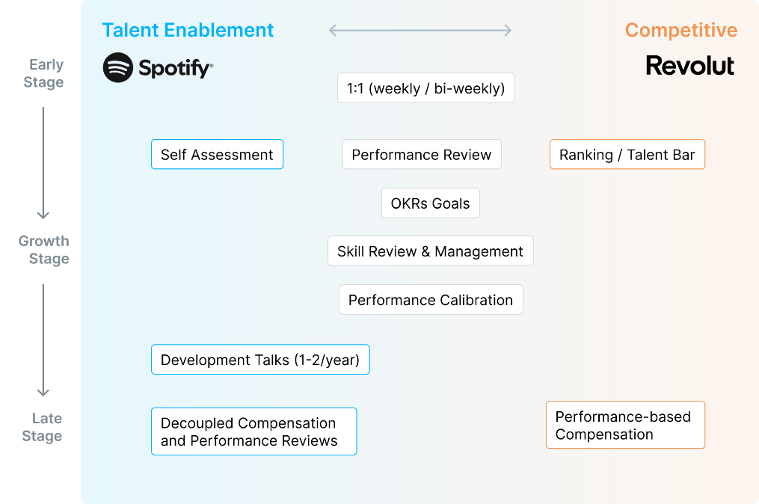
Figure 1: Performance Management at Spotify
Source: (Cottel, 2025)
Likewise, LinkedIn focuses on constant monitoring of goals and active communication between employees and managers. Employees get feedback regarding their performance and how to work better through the regular check-ins. The care about employee development is another significant trend in the technology sector. Learning opportunities are usually identified through performance discussions to enhance leadership skills and career growth (Leskiw and Singh, 2023). Indicatively, Intel also incorporates development planning in its performance management.

2.1.2 Job Design Trends in Technology Organizations
The job design practices have also changed alongside the changes in performance management in technology firms (Brannick Levine and Morgeson, 2019). Knowledge work needs flexibility, teamwork and creativity; hence, jobs should enable employees to provide ideas and use a variety of skills.
A lot of technology companies structure their work in teams and not in strict hierarchical units. For example, Slack Technologies promotes collaboration between engineering, design and marketing teams in developing products. This method will enhance interdepartmental communication and problem-solving.
There are also technology organizations which formulate roles that enable employees to get involved in various projects. Dropbox also allows employees to work on innovation projects and research projects inside the company that are not part of their core duties (Dropbox, 2025).

2.2 Proposed Performance Management Framework for Aether Innovations
Aether Innovations must use a modern performance management system to overcome the challenges of low growth, high turnover of staff and decreasing customer satisfaction. The proposed performance management framework for the company is following:

2.2.1 Goal Alignment through OKRs Framework
Objectives and Key Results (OKRs) are a formal method of converting organizational strategy into specific employee objectives (Irikefe, 2024). In this context, top management sets general organizational goals, and teams and individuals work out measurable key outcomes that reflect the progress toward these goals.

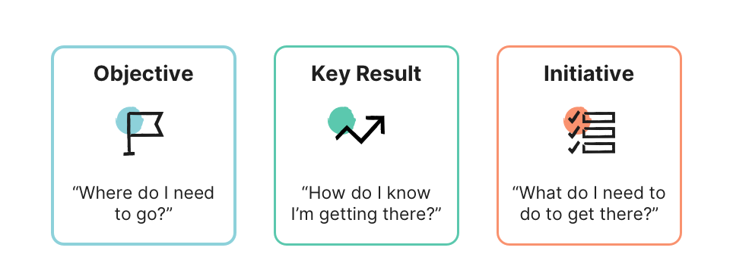
Figure 2: Application of OKRs Framework
Source: (Zahra Currimbhoy, 2025)
In the case of Aether Innovations, the company-wide goals may be based on product innovation, customer experience, and operational efficiency. Departments would then set certain goals, like enhancing product release schedules or customer retention. Clarity of OKRs is one of its most important benefits (Silva and Santos, 2024). The employees are able to see how their own contribution can affect organizational performance. This openness would bring motivation and make teams work together to reach common objectives.

2.2.2 360-Degree Feedback for Comprehensive Evaluation
Although goal tracking is used to check performance results, leadership behavior and teamwork should also be assessed. A 360-degree feedback system is a holistic approach as it gathers the views of supervisors, peers and subordinates (Pollack and Pollack, 2022).
It is effective in higher leadership positions where interdepartmental cooperation will be necessary. For example, project team feedback can identify strengths in communication or leadership issues that would not be evident during traditional performance appraisal (Scott and Einstein, 2023).
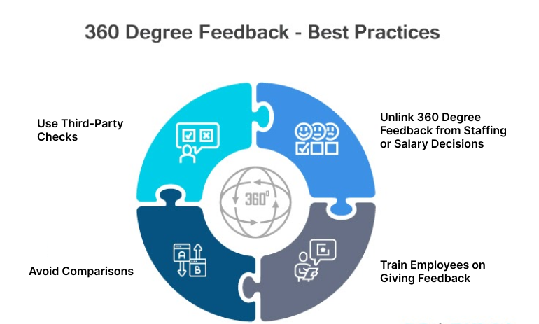
Figure 3: 360 Degree Feedback System
Source: (Nantham, 2020)
Having various perspectives can help Aether Innovations develop a more precise and well-balanced performance review procedure. The employees will also feel more engaged in the organizational development as their opinions are used to enhance leadership.

2.2.3 Continuous Performance Reviews
The annual appraisal systems, which are traditional, tend to lack prompt guidance (Payne et al., 2023). To solve this problem, Aether Innovations must introduce a continuous performance review, where managers meet employees on a regular basis to monitor progress and development. Such meetings may be held four times or once significant project milestones have been achieved. Managers will be able to see the progress of the OKR targets achieved, where performance may be hindered and give feedback where needed. Ongoing reviews are particularly useful in technology contexts since the priorities of projects are subject to constant alterations.

2.2.4 Expected Benefits of the New Performance System
OKRs, along with 360-degree feedback and ongoing performance conversations, will foster a transparent and growth-oriented performance culture at Aether Innovations. The employees will be more aware of their tasks and get constructive criticism that will help them improve. Meanwhile, leadership will have a greater understanding of organizational capabilities and development requirements (Dawson, 2021). This integrated performance management system will ultimately increase employee engagement, innovativeness and overall organizational performance.

2.3 Designing Leadership Roles through Job Analysis

2.3.1 Conducting Job Analysis
Job analysis is a scientific approach employed in order to identify the tasks, duties and skills needed in a specific position (Singh, 2008). The information aids organizations to come up with clear job descriptions and hire the right people with the right skills. In the case of Aether Innovations, the job analysis can imply the analysis of the strategic objectives, meetings with senior managers, and operational workflow analysis. It is through this that the organization is able to know the qualities that it would need in a leadership position that would drive innovation and organizational development.
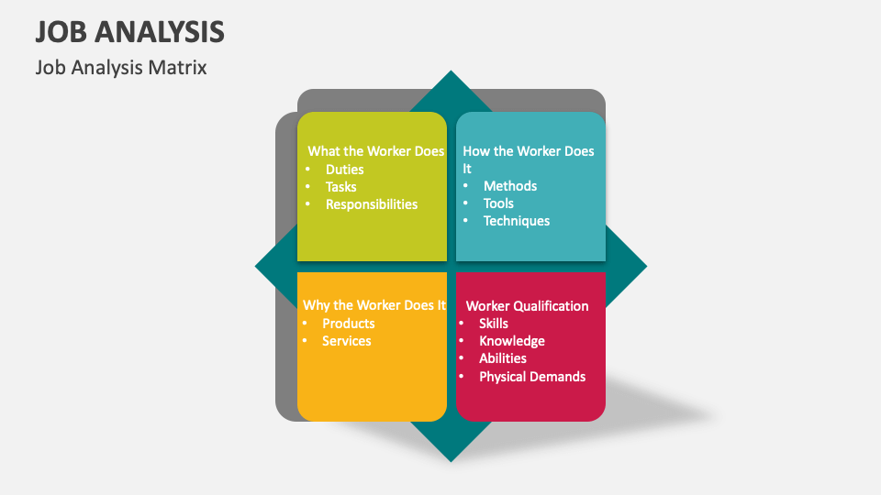
Figure 4: Job Analysis Matrix
Source: (Collidu, 2024)

2.3.2 Executive Job Descriptions
Job descriptions outline the role of every leadership position, the duties, as well as the reporting relationships in the organization (Martin, 2021).
Position | Primary Role | Key Responsibilities | Decision Authority | Reporting Line
CEO | Provide strategic direction | Establish long-term strategy, coordinate executive leadership | Final corporate decisions | Board of Directors
CFO | Manage financial performance | Oversee budgeting, financial planning and investment | Financial strategy decisions | CEO
CTO | Direct technology strategy | Manage engineering teams and digital infrastructure | Technology architecture decisions | CEO
CIO (Chief Innovation Officer) | Promote organizational innovation | Explore emerging technologies and develop innovation programmed | Approval of innovation initiatives | CEO
HR Director | Lead workforce strategy | Talent recruitment, leadership development, and employee engagement | HR policy and workforce planning | CEO
Head of R&D | Guide product research | Coordinate research teams and develop prototypes | R&D project prioritization | CTO

2.3.3 Leadership Job Specifications.
Job specifications are defined as the qualifications and competencies that people must possess to be effective in every job (Vernau and Maloney, 2024).

Position | Education | Experience | Key Skills | Leadership Competence
CEO | MBA or Business Strategy degree | 15+ years of executive leadership | Strategic decision-making | Visionary leadership
CFO | Finance or Accounting degree | 12+ years of finance management | Risk analysis and budgeting | Financial governance
CTO | Computer Science or Engineering | 12+ years of technology leadership | System architecture | Technical innovation
CIO | Innovation Management degree | 10+ years of product leadership | Creative problem solving | Change leadership
HR Director | HRM or Business degree | 10+ years HR experience | Talent development | Organisational leadership
Head of R&D | Engineering or Technology degree | 10+ years of research leadership | Product experimentation | Collaborative leadership

2.3.4 Applying the Job Characteristics Model
The Job Characteristics Model is used to describe the impact that certain aspects of job design have on employee motivation and performance (Denis, 2023).
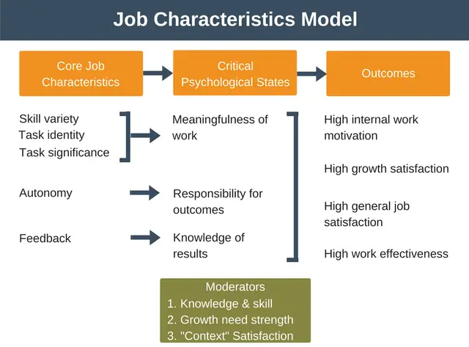
Figure 5: Job Characteristics Model
Source: (Denis, 2023)
Skill Variety: The jobs in Aether Innovations must demand application of various competencies such as strategic planning, technological knowledge and organizational alignment. Involvement of leaders in various activities promotes resourcefulness and effective decision-making.
Task Identity: Executives are expected to manage entire projects to their full extent. The lifecycle management of strategic initiatives enhances ownership and responsibility towards the organizational outcomes (Jørgensen, 2022).
Task Significance: Senior leader decisions affect the organizational success, employee health and customer satisfaction. Knowing the bigger picture of their work is more motivational and commitment-enhancing.
Autonomy: Allowing executives to make decisions gives them a chance to test new ideas and react swiftly to technological changes (Denis, 2023).
Feedback: Frequent performance reviews and data-based assessments will inform leaders about the efficiency of their strategies and allow them to improve constantly.

2.4 Connecting Job Design with Performance Management
The performance management systems and job design practices should work in conjunction to produce a high-performing organization (Boxall, 2020). With a well-defined role and alignment with organizational goals, employees get to know what is expected of them and the role their work plays in the success of the company. The offered performance management system at Aether Innovations gives the employees clear goals, frequent feedback, and development opportunities. Meanwhile, the restructured leaders' functions adopt independence, the use of skills and accountability for strategic results. A combination of these two aspects allows the organization to build a culture that promotes innovation, teamwork and responsibility.

3. Part 2 - Reflection

3.1 Human Capital Management Learning (Application of Gibbs Reflective Cycle)
The Reflective Model of Gibbs (1988) is a systematic model of a method to make people reflect on any experience in order to be clear and systematic in the process (BiteSize Learning, 2024). The application of this model is following:
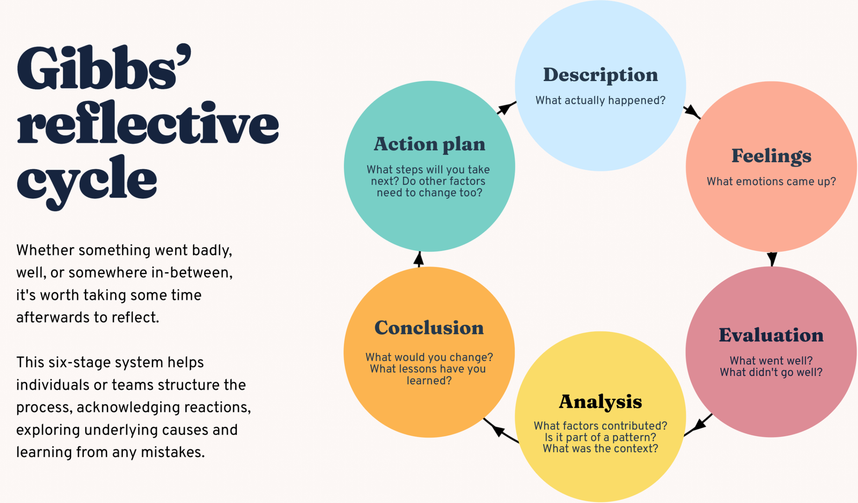
Figure 6: Gibbs' Reflective Model
Source: (BiteSize Learning, 2024)
1. Description:
During this Human Capital Management module, I learned many things about how people management practices affect organizational performance, innovation, and employee engagement. The module taught performance management systems, job design strategies, talent development, and leadership practices. Specifically, working on the Aether Innovations case study has enabled me to put theoretical models into practice in a situation in an organization.
Through the study of problems in staff turnover and deteriorating customer satisfaction, I was able to understand the impact of sound HR practices on solving business challenges. The steps of suggesting a performance appraisal system based on OKRs, 360-degree feedback and continuous reviews made me realize how performance management can synchronize individual objectives with the organizational strategy. Also, the use of the Job Characteristics Model assisted me in understanding the role of job design in motivating employees by enhancing autonomy, skill variety, and task significance.
2. Feelings:
I was confused early in the module about how HR theories can be applied in practical organizational scenarios. There are numerous theories, like models of performance appraisal and job design, that appear to be too abstract. Nevertheless, my deeper insight into their practical relevance gradually happened as I went through the learning activities and assignments.
The case study of Aether Innovations made me more confident in my ability to analyse organizational issues and provide HR solutions. I was especially intrigued to learn how tech firms are handling employee performance and innovation. This experience helped me understand that human capital management is not solely the administrative HR functions but also strategic decision-making that has a direct impact on organizational success.
3. Evaluation:
The module gave me a number of good learning experiences. The possibility of using theoretical models in practice was one of the most positive elements. The discussion of the issues of Aether Innovations allowed me to comprehend the way HR practices can affect employee motivation, productivity and innovation.
The analytical skills were also improved because of the use of frameworks like OKRs and the Job Characteristics Model. These aids helped me to assess the organizational issues in a systematic manner and to formulate structured solutions. Moreover, the reflection process helped me to reflect critically upon my own learning and discover what I need to develop.
Nevertheless, the issue that I had to go through during the module was the difficulty of integrating various HR practices in one organizational strategy. In the beginning, performance management, job design, and employee engagement were hard to imagine as connected.
4. Analysis:
The experience acquired during this module teaches that human capital management is a key factor in the success of any organization. Employees are viewed as the main source of competitive advantage in modern organizations, particularly in the technology industries.
To illustrate, performance management systems like OKRs can assist organizations in aligning the efforts of employees with the strategic goals. Employees will probably be highly motivated and productive when their objectives are transparent, and they are given feedback often. Equally, job design models such as the Job Characteristics Model have indicated that employees do an excellent job when their jobs give them autonomy, purposeful work and chances to use all kinds of skills.
Personally, these lessons can be taken as a reminder of the need to learn continuously and develop specific skills. To be effective in innovative organizations, they should develop a growth mindset and be willing to learn new things and technologies.
5. Conclusion:
The reflection on this module has assisted me in acknowledging the strategic role of human capital management in contemporary organizations. I have learned that efficient HR practices are the key to enhancing employee engagement, fostering innovation and long-term business success. The experience I learnt in this module will enable me to grow my professional skills, especially in the fields of strategic thought, problem-solving and organizational analysis. Nevertheless, I also understand that I need more development to become a stronger leader and analyst.
6. Action Plan:
The following development actions I will apply to apply the knowledge acquired during this module and develop a growth mindset include:
Development Area | Action Steps | Timeframe | Expected Outcome
HR Knowledge | Read academic literature on strategic HRM and performance management | Next 6 months | Stronger theoretical understanding
Analytical Skills | Practice analyzing business case studies related to HR strategy | Ongoing | Improved problem-solving abilities
Leadership Skills | Participate in leadership training programmed or workshops | Within 1 year | Enhanced leadership capability
Digital Skills | Learn HR analytics and digital HR tools | Next 12 months | Ability to apply data-driven HR decisions
Innovation Mindset | Engage in collaborative projects and brainstorming activities | Continuous | Development of creative thinking

3.2 Future Career in the AI Era
The high rate of artificial intelligence (AI) development is changing what work is in most industries. AI technologies can now do the things that people used to do, such as analyzing data, administration, and making default decisions. This means that many traditional job positions are shifting, forcing workers to acquire new skills so as to stay afloat in the labor market.
I am aware that in my future profession, I will have to adjust to technological change. As opposed to perceiving AI as a threat, I will consider it as a supportive tool that can improve my productivity and decision-making potential. AI technologies can help to analyze big data, find trends and produce insights that might be used in strategic planning. Through this application of AI, humans will be able to dedicate more time to solving intricate problems, creativity, and leadership tasks that are not easily automated by machines.
I will constantly advance in digital literacy and analytical skills to stay relevant in an AI-driven workplace. Being able to apply AI-powered tools responsibly will enable me to become more efficient and retain human judgment in decision-making. Moreover, I would like to enhance the distinctly human aspects of critical thinking, emotional intelligence, and communication skills.

4. Conclusion
This report discussed the role of integrated human capital practices in enhancing organizational performance in Aether Innovations. This analysis has shown that current performance management systems, such as OKRs, 360-degree feedback and continuous reviews, can align employee goals with organizational strategy. Also, a well-designed job according to the Job Characteristics Model could lead to increased motivation, innovation and engagement of the employees. The reflection section also brought up the significance of constant learning and self-improvement towards the creation of professional competencies.

5. References
BiteSize Learning (2024). The Gibbs Reflective Cycle, Explained. [online] BiteSize Learning. Available at: https://www.bitesizelearning.co.uk/resources/gibbs-reflective-cycle-explained-diagram-examples [Accessed 15 Mar. 2026].
Boxall, P. (2020). High-performance work systems: what, why, how and for whom? Asia Pacific Journal of Human Resources, 50(2), pp.169–186. doi:https://doi.org/10.1111/j.1744-7941.2011.00012.x.
Boxall, P. and Purcell, J., (2016). Strategy and Human Resource Management. 4th ed. London: Palgrave.
Brannick, M. T., Levine, E. L., and Morgeson, F. P. (2019). 'Job and Work Analysis' (3rd ed.). SAGE Publications.
Burnett, J.R. and Lisk, T.C. (2021). The Future of Employee Engagement: Real-Time Monitoring and Digital Tools for Engaging a Workforce. Routledge eBooks, [online] 1(1), pp.117–128. doi:https://doi.org/10.4324/9781003142492-9.
Collidu (2024). Job Analysis. [online] Collidu.com. Available at: https://www.collidu.com/presentation-job-analysis [Accessed 15 Mar. 2026].
Cottel, G. (2025). Playbook: Spotify’s / Revolut’s Performance Managamement. [online] Sprad.io. Available at: https://sprad.io/talent-management/playbook [Accessed 15 Mar. 2026].
Dawson, R. (2021). Knowledge capabilities as the focus of organisational development and strategy. Journal of Knowledge Management, 4(4), pp.320–327. doi:https://doi.org/10.1108/13673270010379876.
Denis (2023). Job Characteristics Model. [online] Expert Program Management. Available at: https://expertprogrammanagement.com/2017/09/job-characteristics-model/ [Accessed 15 Mar. 2026].
Dropbox (2025). Building a Strong Team Culture in Remote Settings - Dropbox. [online] Dropbox.com. Available at: https://www.dropbox.com/resources/team-culture [Accessed 15 Mar. 2026].
Irikefe, O. (2024). Effect of Objectives and Key Results (OKR) on Organisational Performance in the Hospitality Industry. SSRN Electronic Journal, [online] 7(3). doi:https://doi.org/10.47119/10.47119/IJRP1009111220212596.
Jørgensen, T.H. (2022). Towards more sustainable management systems: through life cycle management and integration. Journal of Cleaner Production, 16(10), pp.1071–1080. doi:https://doi.org/10.1016/j.jclepro.2007.06.006.
Leskiw, S. and Singh, P. (2023). Leadership development: Learning from Best Practices. Leadership & Organization Development Journal, [online] 28(5), pp.444–464. doi:https://doi.org/10.1108/01437730710761742.
Martin, J. (2021). The Manager and the Managerial Tools: Job Description. Revista de Management Comparat Internațional, [online] 16(5), pp.603–614. Available at: https://www.ceeol.com/search/article-detail?id=730142 [Accessed 15 Mar. 2026].
Nantham, S. (2020). What is 360 Degree Feedback & Why is it so Important? [online] Best OKR Software by Profit.co. Available at: https://www.profit.co/blog/performance-management/360-degree-feedback-how-to-make-it-work/ [Accessed 14 Mar. 2026].
Payne, S.C., Horner, M.T., Boswell, W.R., Schroeder, A.N. and Stine‐Cheyne, K.J. (2023). Comparison of online and traditional performance appraisal systems. Journal of Managerial Psychology, 24(6), pp.526–544. doi:https://doi.org/10.1108/02683940910974116.
Pollack, D.M. and Pollack, L.J. (2022). Using 360° Feedback in Performance Appraisal. Public Personnel Management, 25(4), pp.507–528. doi:https://doi.org/10.1177/009102609602500410.
Scott, S.G. and Einstein, W.O. (2023). Strategic performance appraisal in team-based organizations: One size does not fit all. Academy of Management Perspectives, 15(2), pp.107–116. doi:https://doi.org/10.5465/ame.2001.4614990.
Silva, R. and Santos, G. (2024). Surveying the Academic Literature on the Use of OKR (Objectives and Key Results) – An Update. iSys - Brazilian Journal of Information Systems, [online] 17(1), pp.4:1–4:26. doi:https://doi.org/10.5753/isys.2024.3885.
Singh, P. (2008). Job Analysis for a Changing Workplace. Human Resource Management Review, 18(2), pp.87–99. doi:https://doi.org/10.1016/j.hrmr.2008.03.004.
Vernau, J. and Maloney, S. (2024). An analysis of job description and person specifications to define the requirements for obtaining employment within strength & conditioning. Professional Strength and Conditioning, [online] 3(2), pp.07-17. Available at: https://repository.vtc.edu.hk/thei-fac-man-hos-sp/175/ [Accessed 15 Mar. 2026].
Zahra Currimbhoy (2025). The Objectives and Key Results (OKR) crash course. [online] Perdoo.com. Available at: https://www.perdoo.com/resources/blog/okr-crash-course [Accessed 15 Mar. 2026].

