

Student name: Tresy tiamuna
Student ID:2527552

Module name: Introduction to Health and Social Care
Module code:LHS4003
Lecturer name:Umma Suleiman

Table of Contents
Element 1: Community Antenatal Midwifery Services in the UK 3
Element 2: Residential Care Homes in England 4

Element 1: Community Antenatal Midwifery Services in the UK

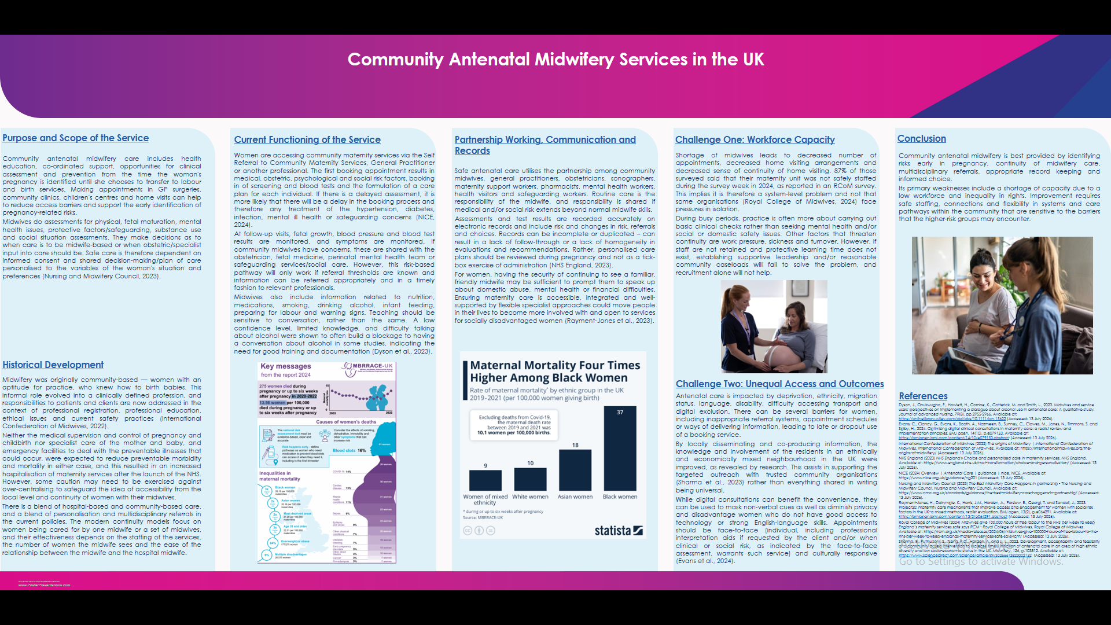

Element 2: Residential Care Homes in England
Introduction
Residential care is the provision of support and supervision to adults who are not able to live independently in a safe and secure environment; they live in accommodation with access to personal care services. They should not be judged by the way and the frequency with which they are used, or by their cost-reduction capability, but rather by their ability to maintain rights, autonomy and attain an acceptable quality of life as a care.
Origins and Historical Development
Early efforts to deal with "uncontrollable" children were in almshouses, which were later replaced by Poor Law care, or Poors' and workhouses, for which the level of care was limited to conditions and was focused on institutional control. (There was a tendency to limit care when a child became “uncontrollable”). The 20th century saw a shift in the focus of welfare to public agencies and welfare-oriented providers. Current vision is not on containment, but dignity, choice, independence and participation. From a rights-based point of view, however, a transition remains incomplete due to its disconnections in funding. However, parliamentary research indicates that adult social care is not as “politically salient” as healthcare, and so has not been reformed or invested in as consistently (Adult Social Care Committee, 2022).
Current Functioning and Critical Evaluation
Access is usually via a needs assessment or a hospital discharge process and/or family decision and privately arranged placement. Plans for providers are made, including plans for care and support with personal hygiene, moving around, eating and drinking, medicine, communication, protecting and promoting the individual from harm and helping them to be more part of society. Plans need to be, and can be, effective. Plans must be, and can be, effective – with residents! Despite Government reform policy pledges of care based on personalised and integrated care, this would need joint working by councils, health professionals and the NHS at a local level that could also involve working together across different aspects and funding (Department of Health and Social Care, 2023).
The Care Quality Commission ensures services are safe, effective, caring, responsive and well-led. Regulation sets out the accountability, but if the management or staffing is not stable, then inspection will not ensure that the quality is sustained day to day. In 2023/24, 45% of the delays to people in acute hospitals for 14 days or longer were delays to access to care-home or home-based care. This translates to the NHS and wards being hampered and its people with unnecessary hospital admissions because of a lack of capacity in social care (Care Quality Commission, 2024).
Continuity & safety are directly related to workforce conditions. In 2024/25, the vacancy rate for residential care was 4.4% – lower than all major adult social-care settings, although the point should not be overlooked that the amount of vacancies is a way of understating turnover, sickness, levels of skill mix and the use of overseas recruitment (Skills for Care, 2025). Research in English care homes has also determined that more staff does not equal better care, unless the roles, competence and deployment of these staff are appropriate for the care homes' residents (Charlwood et al., 2024).
Contribution to Quality of Life
Residential care will make residential care of the resident safer, provide better nutritional care, better drug management and better access to professionals. Its more powerful effect is relational, reduces isolation, and saves identities through knowing familiar staff, having meaningful activities and having supported choices. Entry into the facility can also result in grieving, a feeling of helplessness, and loss of control if residents are not directly involved in any decision-making processes. Lastly, evidence from transitioning to residential care contributes to preparing and engaging families and making the transition to residential care, but it doesn't assume that when someone enters care, their vulnerability is solved. (Scott et al., 2024).
Conclusion
Residential care does not provide for high-quality care of individuals, and for many with more extensive support needs, this is necessary. This is based on good staffing levels, effective management, involved leadership and real choice, which focus on promoting residents' autonomy and health and wellbeing through a focus on their health and everyday life.
References
Adult Social Care Committee (2022) Ordered to be printed 21 November 2022 and published 8 December 2022, House of Lords Adult Social Care Committee. Available at: https://committees.parliament.uk/publications/31917/documents/193737/default/ (Accessed: 13 July 2026).
Care Quality Commission (2024) State of Health and Adult Social Care in england: 2023 to 2024 - gov.uk, GOV.UK. Available at: https://www.gov.uk/government/publications/state-of-health-and-adult-social-care-in-england-2023-to-2024 (Accessed: 13 July 2026).
Charlwood, A., Valizade, D., Schreuders, L.W., Thompson, C., Glover, M., Gage, H., Alldred, D., Pearson, C., Kerry, J. and Spilsbury, K., 2024. Workforce thresholds and the non-linear association between registered nurse staffing and care quality in long-term residential care: A retrospective longitudinal study of English care homes with nursing. International journal of nursing studies, 157, p.104815. Available at: https://www.sciencedirect.com/science/article/abs/pii/S0020748924001275 (Accessed: 13 July 2026).
Department of Health and Social Care (2023) Next steps to put people at the heart of care - gov.uk, GOV.UK. Available at: https://www.gov.uk/government/publications/adult-social-care-system-reform-next-steps-to-put-people-at-the-heart-of-care/next-steps-to-put-people-at-the-heart-of-care (Accessed: 13 July 2026).
Skills for Care (2025) The state of the adult social care sector and workforce in England, Skills for Care. Available at: https://www.skillsforcare.org.uk/Adult-Social-Care-Workforce-Data/workforceintelligence/resources/Reports/National/The-state-of-the-adult-social-care-sector-and-workforce-in-England-2025-Executive-Summary.pdf (Accessed: 13 July 2026).

