Self-Actualization
Self-actualization is being the best version of yourself (Maslow, 1968). This means giving it your all, trying new things, and doing what you like. Children are not all good at the same things. One child might be good at music, another at art, and another at problem solving. Children at this stage of life like gaining new knowledge, engaging in creative activities, and challenging themselves.
Maslow (1943) suggested that self-actualization involves essential motivation rather than reliance solely on external incentives or praise. Other psychologists, such Rogers (1961), asserted that children achieve optimal development when they are provided with encouragement, support, and the ability to express their opinions. Practitioners and teachers support children in early year settings and schools by letting them choose what to do, giving them creative activities, and allowing them to figure out what they want. Self-actualization can only happen when most of the basic wants, such safety, belonging, and respect, are met (Maslow, 1954). When children feel comfortable, loved, and sure of themselves, they could start working on their needs, aims, and skills.

Esteem
Esteem is all about feeling good about yourself, being able to do things, and being respected (Maslow, 1943). This happens when children are proud of what they have done. children also want practitioners and teachers to acknowledge what they have done. This can be done by verbally or even by giving a sticker. These rewards make the children feel good about themselves and a great sense of achievement (Maslow, 1954). Children who lack a lot of self-esteem may not try new activities because they are too frightened, ashamed, or unsure of themselves. Bandura (1997) and other psychologists have suggested that children feel more certain of themselves when they do well. Practitioners and teachers can help with this by praising children for their hard work and celebrating their achievements (Dweck, 2017). When children feel good about themselves, they are eager to learn and do new things. But if these needs are not met, they could give up quickly or avoid challenges because they fear failure.

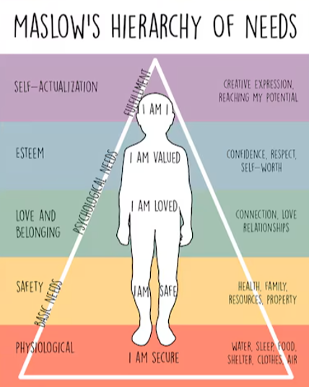
Love and Belonging
Love and belonging, includes feeling close to others, such as our friends, family, classmates, and teachers (Maslow, 1954). To be happy and mentally healthy, children need to have friends and feel like they belong, feel like they are important and are supported emotionally and physically. This could mean having a close friend with other children or carrying out an activity within a group.
If these requirements are not fulfilled, children may feel lonely or left out, which can make them feel miserable and lower their self-esteem (Bee and Boyd, 2019). Practitioner's help children feel like they belong at early year and school by encouraging teamwork, kindness, and good friendships (Lindon and Trodd, 2016). Children feel like they belong when they do things like circle time and play games with other children. Children need to feel like they belong because it helps them trust people and feel safe emotionally. It also helps them grow socially, which is essential for healthy growth (OECD, 2020). Maslow suggests that children need to feel liked and like they belong before they can start to feel good about themselves.

Safety
Safety needs are all about feeling safe, protected, and secure (Maslow, 1943). This means having a safe place to live, adults they can trust, and routines that make life easy to understand. Children cannot relax or learn when they feel unsafe because their brains are always on high alert (Maslow, 1954).
Safety for children is not just about being safe physically, it is also about being safe emotionally. A big part of feeling safe is knowing that they can talk to trusted adult and tell them what is bothering them. In early years settings and schools, practitioners work hard to keep children safe by carrying out regular safeguarding training, putting rules in place, continuous supervision, and setting clear routines (CIW, 2023). Fire drills and rules against bullying are some of the things that help children feel safe (HSE, 2022).
Children may not feel safe, if they are going through a difficult time at home for example, separation of parents or if they are being bullied, may have a challenging time moving forward because their body and minds are too busy worrying about what is going on in their young lives. (Maslow, 1954). Children are more likely to make friends and learn new things when they feel safe and secure.

Physiological Needs
Physiological needs are a crucial part of survival in Maslow’s Hierarchy of Needs because these are the basic things humans need to survive. These needs include water, sleep, food, air, shelter, and clothes. If a human does not have these basics, they cannot really focus and think about anything else. For example, if a person is hungry, they are unable to think about anything else until they have eaten some food. According to Maslow (date) if a person does not have these basic needs met, the human body enters survival mode. That means a person's body focuses only on staying alive instead of learning, playing, or solving problems. This can happen in school, too. If a child goes to school hungry, worn out, or unwell, they will not be able to concentrate on the tasks given to them. Schools often help with these basic needs by providing breakfast clubs and free school meals to all primary-aged children, warm spaces, quiet time, or support to the children. Once a baby or young child has their physiological needs met, this can help build a strong foundation for their development needs.

