GDC Cleaning-Business plan

Prepared by Cristian-Marin Pena
Student number: 1908795

Prepared for
Managing Enterprise in the 21st Century Module
BMSW4006
University of Wales Trinity Saint Davies

July 3rd, 2020

Executive Summary

The aim of the Business Plan is to create the foundation of a business based on protecting both people’s health and environment, bringing these two concepts in the 21st Century by using environmentally friendly chemicals whilst maintaining as a high priority people’s allergic reactions to factors such as chlorine and detergents.
Through the action plan and operating hours, based on Primary Research, the business will show a good understanding of the value of time, saving future customers time to do what is important for them.

Contents List

1.0 Overview of Business………………………………………..5
1.1 Company name………………………………………………………………………………..5
1.2 Mission Statement…………………………………………………………...................5
1.3 Aims and Objectives of the Organisation………………………………………….5
1.3.1 Aims of the Organisation……………………………………………………………….5
1.3.2 Objectives of the Organisation………………………………………………………5
1.4 Legal identity……………………………………………………………………………………5
1.5 Products and Services………………………………………………………………………6
1.5.1 Pricing…………………………………………………………………………………………..6
1.5.2 Location……………………………………………………………………………………….6
1.5.3 Products or Services not offered by competition ………………………...7
1.5.4 The influence on customers in buying products/using services…….7
2.0 OPERATIONS…………………………………………………….7 2.1 How Product or Service will be delivered…………………………………………….7
2.2 Human Resources Management……………………………………………………..7
2.3 Use of Physical and Human Resources to ensure Quality of products/Service/Delivery/ After Sales customer care……………………………..10
3.0 Marketing and Promotions………………………………10
3.1 Marketing Activities……………………………………………………………………….10
3.2 Summary of the Market Research………………………………………………….14
4.0 Market Research……………………………………………..16
4.1 Target Market based on Primary and Secondary Research…………….15
4.2 Segmenting the customers…………………………………………………………….15
5.0 Promotion Activities…………………………………………16
5.1 Advertising …………………………………………………………………………………..16
5.2 Promoting…………………………………………………………………………………….17
6.0 Financial Resources…………………………………………18
6.1 Sources of Finance………………………………………………………………………..18
6.2 Cash Flow for a 12 Month period………………………………………………….19
7.0 Conclusion……………………………………………………..20
8.0 Appendices…………………………………………………….21
9.0 References..…………………………………………………..23

1.0 Overview of Business

1.1 Company name
I have chosen the name of the company using the initials of the three people developing and financing the company: Gabriel, Dana and Cristian. The name of the company will be: GDC Cleaning.

1.2 Mission Statement
Cleaning with environmentally friendly chemicals whilst supporting a healthy life and valuing out customers’ time.

1.3 Aims and Objectives of the Organisation
1.3.1 Aims of the Organisation
Our company aims to offer a large variety of services, including residential, commercial and car cleaning with a removal service available seven days a week.
1.3.2 Objectives of the Organisation
Our company’s objectives will be:
- Recruiting experienced cleaning candidates with an eye for detail
- Using and promote environmentally friendly cleaning products
- Selling and supporting Environmentally friendly products
- Running projects that support a healthy environment and life

1.4 Legal identity:
Based on the research related to the Legal Identity of businesses, I have been able to identify the following: Sole Trader, Partnership, Limited Liability Partnership, Limited Company, Social Enterprise, Co-operative, Charity.
As a result of the research, the Legal Identity that has been chosen for the company is Limited Liability Partnership. Through this identity, the business will be subject to the following:
a) Partners will share risks and loses
b) Partners will bring a variety of skills
c) The business can not be taken over by other companies
d) Increased capital for investment
e) Shared management responsibilities.

1.5 Products and Services
1.5.1 Pricing
According to Robert M. Schindler in “Pricing Strategy: A Marketing Approach”, ‘price’ represents what must be provided by the customers in return for a product of service.
Through a detailed investigation of the Market, our company will provide competitive prices and offers complimented by an outstanding cleaning service according to the demand of the audience identified in the Primary Research represented by a Questionnaire and ensuring the profit needed for a continuous development of the business.
1.5.2 Location
Aiming for the lowest investment in the location of the business, ensuring enough money to cover all the necessarily and unexpected expenses, I have decided to start with a website. This strategy will provide both time and money, allowing me to find the best location at the best price.
When the business will grow enough to afford to have a physical location, I will find a place with a courtyard large enough for a Car Wash to be built. The idea behind this step is that while people will have their cars washed, the staff can discus with them about potential cleaning services that they may be interested in, or they didn’t know about.

1.5.3 Products and Services
When it comes to Product and Services, our company will provide consistency, training employees at all levels in showing a great interest in the customers needs and environmental protection.
Future customers will be able to try and purchase environmentally friendly cleaning products, GDC Cleaning being able to provide training in using the chemicals, all according to the Health and Safety Procedures.
1.5.4 The influence on customers in buying products/using services
Future customers will notice a positive energy, an eye for detail and their time being valued by every member of staff that they will meet. They will be able to test and purchase environmentally friendly chemicals, the company being able to provide training in the use of the chemicals and the Health and Safety Procedures related to the use of the chemicals along with all the Personal Protective Equipment at competitive prices.

2.0 OPERATIONS

2.1 How Product or Service will be delivered
The future customers will be able to contact the company 7 days a week using the telephone number or/and the email address that can be found on the company’s website, services being available between 09:00am and 18:00pm. The services available will be residential, commercial and car cleaning with a removal service available seven days a week, complemented by a range of environmentally friendly cleaning products and Personal Protective Equipment available at competitive prices.

2.2 Human Resources Management:
2.2.1 Recruiting
We will start by contacting people that he previously worked with in the cleaning industry. The vacancies will be advertised using social media, social networking platform or poster, depending on the financial resources and the research in terms of promoting.
We will need someone who’s skills and experience match the business’s needs, someone with the ability to recruit and interview, someone reliable as the working hours may change according to the business needs, someone with the ability to work under pressure, someone who work in the industry before and can train future employees.
We will also need a person who will start as a regular worker and depending on their willingness to learn and develop both themselves and the business, giving them the possibility of being promoted to Team Leaders, Supervisors and even Managers with the payment increasing for each level.

2.2.2 Training
The training will start with a one-to-one meeting that will provide valuable information about the candidate’s previous employment, the level of experience and commitment, and very important: the candidate’s learning style.
An introduction to the business and owner will follow, the aim and potential of the business, the views and the expectations.

2.2.3 Payment
Our business aims at recruiting one person to help cleaning, as the owners of the business will help with every task in first 12 months in order to save money.
The successful candidate will start with the minimum wage and the possibility of being promoted in time. The Human Resource manager and the Marketing manager will also be paid with the minimum wage as along with the researcher they are the three owners of the business.

2.2.4 Duties
The employee’s duties will be written in the contract that they must read and sign. Some of the duties will be:
- To wear the Personal Protective Equipment provided by the employers
- To follow the Health & Safety Procedures during their shifts
- To maintain a good personal hygiene
- To be respectful to both customers and colleagues
- To build a good knowledge about the products used in cleaning, to be able to sell them in case the customers are interested those products, as well as the Health & Safety procedures related to the products, as the business will also sell environmentally friendly cleaning products
- To build a good knowledge about the prices and offers available, helping the business to upsell, maintaining a continuous development.

2.2.5 Organisational Chart

-CEO, Finance Manager (who will also be a Legal Advisor) and Marketing Manager (who will also be the IT Specialist)
-One employee to help with delivering the services the customers pay for.
Having only one employ will allow the researcher to save a considerable amount of money in the first 12 months.

2.2.6 Equipment
The equipment that the researcher will start with will consist in:
- Cleaning Tools
- Cleaning Chemical
- Personal Protective Equipment for House cleaning
- Personal Protective Equipment for Car cleaning
- Two Laptops
- One Telephone
- One Van

2.3 Use of Physical and Human Resources
In the first 12 months I will ensure that every member of the staff, regardless of their position, will be well trained and always able to deliver the services the customers will pay for, ensuring:
-the quality of the products by pricing, using and promoting them.
-the quality of the service by showing a good knowledge in using the products and the Health & Safety procedures.
-the quality of delivery, including both the services and the cleaning products order.
-an excellent After Sales Customer Care, valuing the needs of the customers and the feedback received.

3.0 Marketing and Promotions

3.1 Marketing Activities
Willing to identify the audience and the demands related to the Business plan created, factors that will re-shape the plan, the Marketing Activities that I have undertaken have been:
a) Accessing cleaning services websites, where I have identified the following:
- A&R Cleaning Services: Clean website, Easy to find both Telephone number and how to get a Quote, light Blue colour which looks clean and relaxing, Short description of what they do and why it is important, short description of why choosing them (https://www.arcs-cleaning.co.uk/).
- Red Dragon Group: Black, Gray and Red colours, very complex website, I thought I’m on a Law oriented website at the beginning, easy to find their contact details, easy to find the services they provide (https://www.reddragongroup.co.uk/).
- Fast Klean: Very complex website, contact details easy to find, they are selling ECO-Friendly products, easy to find the prices and purchase the products (https://www.fastklean.co.uk/).
b) Creating an online questionnaire that has considerably shaped the Business Plan, identifying the audience, the products and services they are interested in and conducting a SWOT Analysis (See Appendices, Fig1).
Aiming for an accurate research of the market, I have developed a questionnaire that will provide valuable information in creating a business plan.
Shaping the business plan, five questions have been chosen and discussed as following:


In the attempt of finding the audience that the business plan will be created around, the individuals age interested in the business is between 26 and 44 years old. The result will influence the business on both Marketing and Promotional plan. The business will not only be promoted on social networking sites such as Facebook, Twitter or Instagram. The business will also be promoted using social media such as newspapers, Websites and Radio.
A full analysis will be done related to both the cost and the process aiming to find the most effective contracts at the lowest cost. The amount of money that will cover this cost will be influenced by the Financial Resources in order to ensure that there will be enough founding to cover the remaining costs such as equipment, legal procedures, price and services.
As one person will be hired, I will have to ensure that the remaining money will cover the employee salary and the personal protective equipment required by the Health and Safety procedures.
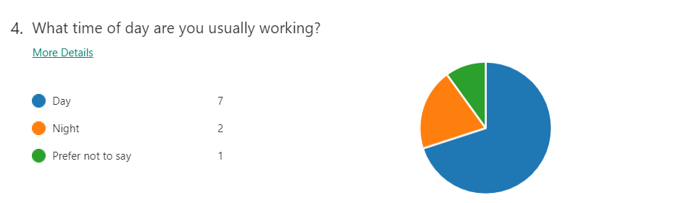
According to the questionnaire, the time of the day that most future customers are working is daytime, which means that will be the time of the day that the business will be the most active. As one person will be hired, a full rota will be created, agreed and sent to each individual working within the company.
The results of the questionnaire also provided the information that a small percentage of future customers are working night shifts, which will lead to the idea of having a part-time team for the night contracts that i will try to bring into the business.
The idea behind a part-time team instead of a full-time team is that in terms of salary the night rate is higher than the day rate. In the first 12 months the income provided by the Financial Sources will have to ensure the cover of unexpected expenses as well which means that a night pay rate for a part-time team will not be a priority.
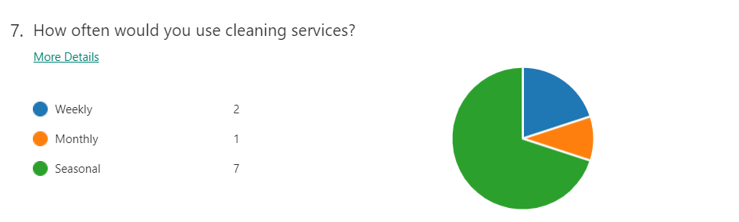

In the attempt of finding how often the future customers use cleaning services, having to choose between ‘weekly’, ‘monthly’ and ‘seasonal’ answers, the information provided has highlighted the use of seasonal cleaning services, showing me that the Market Research for the business plan currently in development is crucial.
In the same time, the result shows that a Market Research must be done on a regular basis, targeting the Pricing Strategy and Segmenting the customers. Offers will have to be created aiming to bring the future customers into business as often as possible and having an eye for detail will make the difference.
However, having a good balance Price-Service is not an easy task, as there will be a profit that the business will have to achieve, as I aim to maintain a continuous developing process. Feedback will be analysed in detail to ensure that every service will be better than the one before.
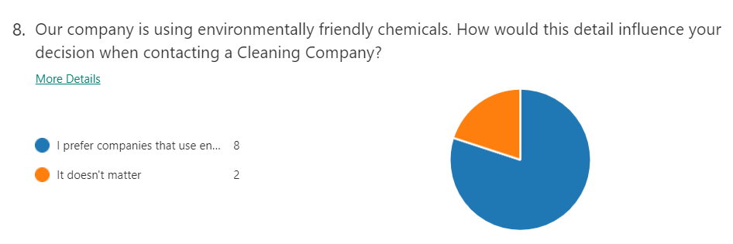
The business plan aims for using environmentally friendly chemical. Based on the research, 80% of the audience prefers environmentally friendly chemicals which shows me that supporting a healthy environment will bring customers into the business. A full research regarding the costs of the products and promotion must be done so the business can use and sell these products.
Along with using and selling environmentally friendly chemicals, I will investigate the process of running annual community environmental projects, which will increase the popularity of the business and they will gain the future customer’s trust.
The annual projects will be promoted using mass media, meaning that the popularity will come with a cost. I will have to prioritize the steps being in the first 12 months of development, meaning that the environmental projects will be an important step to consider in the future.

Aiming for the best income, as the first 12 months will be the foundation of the business, along with the house cleaning, I will implement a car cleaning service as well.
As the results show, the future customers are interested in their car to be washed, highlighting the importance of organising the jobs. Future cleaning candidates with experience in cleaning houses may need training in washing cars which will have to be organized by the management. The Personal Protective Equipment and the chemicals used for this job will be different, showing the importance of the Financial aspect of the business, spending money wisely.

3.2 Summary of the Market Research
When developing a business plan (Gratton C., Jones I., 2004), Primary Research is important as it consists in the collection of original data specific to that particular project, through questionnaires or interviews.
A Secondary research should follow, consisting in sources of data that already exist. I will bring the Legal and Market procedures up to date, the researcher being able to shape the business plan according to the present demand, taking advantage of the Financial Resources in the best way (Blackwell E., 2008).
As the results of the five questions discussed, Ihave been able to better understand the Market, the audience and the Legal and Health and Safety procedures, allowing him to invest wisely, avoiding unnecessarily expenses.
The questionnaire result have highlighted new opportunities for me to generate additional income through washing cars, considering creating a part-time night team in the future covering the contracts from people who work night shifts and selling environmentally friendly products, which the audience shows a great interest for (Thomas B., Tobe J., 2012).
The business plan, along with the opportunities that have been identified through Primary Research have shown the use of large number of chemical, helping me understand the importance of a detailed research related to the Health and Safety procedures.
Using different types of Personal Protective Equipment, as House Cleaning and Car Cleaning requires, show the importance of a good Investment plan and Pricing Strategy of the business in the first 12 months, helping me to ensure the best income.

4.0 Market Research

4.1 Target Market based on Primary and Secondary Research:
The Primary Research, consisting in a questionnaire, has generated valuable information related to the potential customers, as following:
- The age of the audience, 26-44, influencing the advertising methods, the messages used for promotions and the prices that will be available.
- The audience’s interest in cleaning products and services available, which will generate a slight income but will help the business’s popularity to grow.
- The audience’s interest in the Car Cleaning service available, which will generate a significant income.

4.2 Segmenting the customers
Customer segmentation (https://www.shopify.co.uk/) in the process of separating the customers into smaller groups based on similar characteristics, so businesses can market each group effectively.
In our business, the potential customers will be divided in groups based on how often they will use the cleaning services, the type of services and offers they are usually interested in, the time of the day when they will use the services and their location.

5.0 Promotion Activities

5.1 Advertising
Advertising in a crucial step in starting and developing a business. As a result, I have identified several affordable methods, such as:
a) Radio - approximately £2 per thousand listeners, the number of listeners depending on the show and the time of the day
(https://www.workspace.co.uk/).
b) Magazines - the cost varies between £500 - £20,000, depending on the publication, the size of the ad or colour
(https://www.entrepreneur.com/).
c) Local Television Advertising – consisting in:
- The cost of making a Tv ad, sometimes not exceeding £10,000
- The cost of placing it on Tv, varying for reasons such as: time of the day, time of the year, region and channel
(https://tvadvertising.co.uk/).
d) Local Movie Theatre – for four weeks ad, the price varies between:
- £1,000 - £2,000 for a 15-second spot.
- £2,000 - £3,000 for a 30-second spot.
- £3,000 - £4,000 for a 60 second spot
(https://smallbusiness.chron.com/).
e) Setting up a Google Business Page – starting at £5 per month and after 12 months the cost drops to £50 per user, per year
(https://www.smartz.com/).
However, aiming for the lowest cost possible, I have found a few advertising methods that are free of charge, such as:
- Using social networking platforms: Instagram, Twitter, Facebook, Facebook Messenger
- Joining relevant online communities and contributing
- Creating a blog
- Distributing creative promotional videos on YouTube
(https://www.americanexpress.com/)
In my opinion, simplicity is one of the most complex things to achieve. However, the advertisings will be kept short and simple, highlighting:
a) the Name of the business
b) the Products and Services that can be delivered, trying to match the potential customer’s needs, highlighting the ‘environmentally friendly cleaning products
c) the Prices and Offers available at that time, maintaining competitive options
d) a Reason why the potential customers should choose these services
e) the Contact details, the working hours and the potential flexibility of the business at that time.

5.2 Promoting
The promotional activities will be aimed at individuals with ages between 26 and 44, meaning that not every member of the audience will use Social Networking applications.
The advertising will be made not only using the online and mass media options (See 5.1 Advertising), as I have also created a poster, aiming to attract all the audience:


6.0 Financial Resources

6.1 Sources of Finance
Through research, I been able to identify several sources of finance, ensuring a good start of the business, such as: Bank Loans, Business Credit Cards, Business Cash Advances, Crowd Funding, Government Funding, Personal Investment, Venture Capital, from which the most relevant and realistic would be:
- Bank Loans – the first step will be to the reason and the amount of money are required. The second step will be to check the eligibility, by visit HDFC Bank, Personal Loan Eligibility Calculator online. Step 3 will be to calculate the monthly instalments. Step 4 will be to approach the bank. Step 5 will be to submit the documents (https://www.hdfcbank.com).
- Government Funding – each loan program having its own application process.
- Personal Investment
- Donations: equipment, advice or/and money.

6.2 Cash Flow for a 12 Month period
Our business’ success will depend on the Cash Flow (See Appendices, Fig 1). As a result I have created the first 12 months Cash Flow which will allow me to maintain a continuous development of the business:
- Telephone - £20 per month
- Nat. Insurance – £30, starting from moth 6 as 1 person will be hired
- Advertising - £240, paid in month 1, 2 and 6
- Petrol – monthly payment, depending on the contracts
- Van purchase – £1,500 paid in month 1
- Van Insurance - £320 paid in month 1
- Public Liability Insurance - £10 paid every month
- Laptop purchase x2 - £500 paid in month 1
- Van Service - £ 180 paid in month 6

7.0 Conclusion

At the end of the Business plan, I have been able to identify a list of Strengths and Weaknesses covering the Operational, Marketing and Financial issues (See Appendices, Fig 2).
The results of the Primary research have shown that a small percentage of potential customer are working during night (See 3.1 Marketing Research).
The researcher may not be able to attract them into the business at the beginning, as the night rate is higher than day rate, meaning that the part-time night team will not be a priority in the first 12 months.
After the first 12 months, the business’s development will allow the owner create the night team along with other ideas according to the demand at that time, attracting the entire audience into the business.

8.0 Appendices

Fig 1.

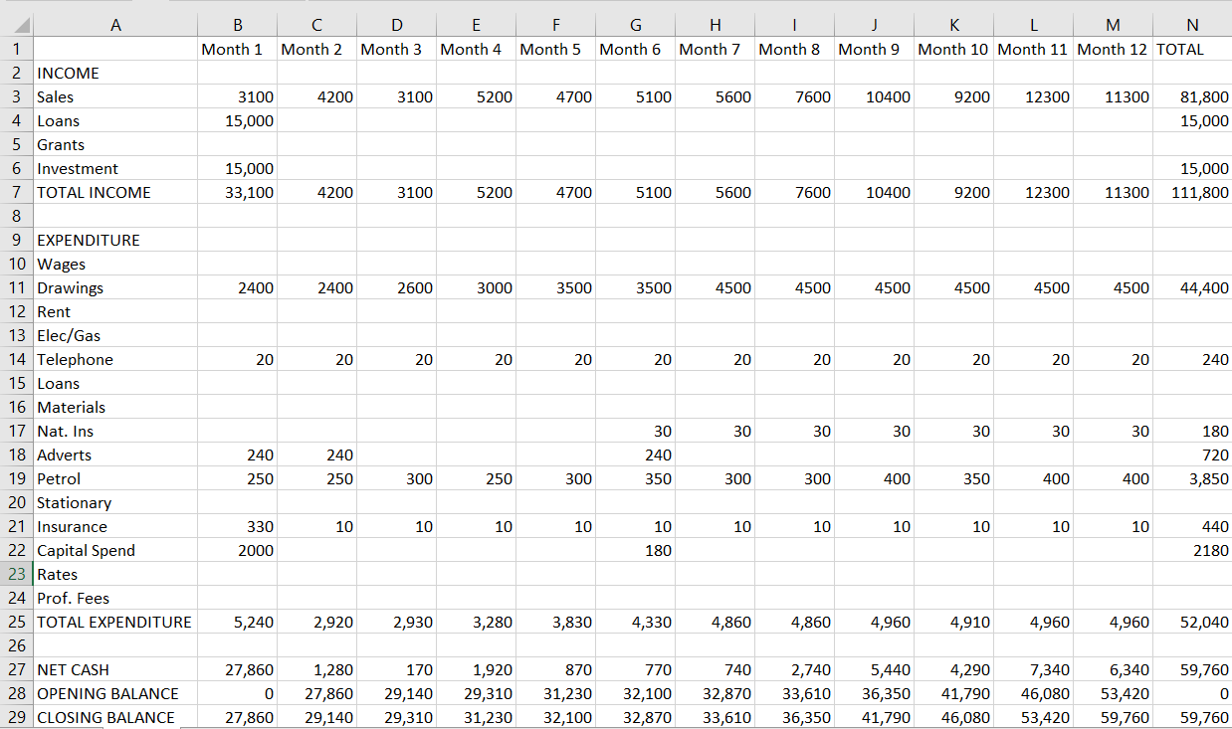

Fig 2.

Strengths | Weaknesses
- I can adapt the business according to the audience at any time  - The business can be flexible in terms of working hours  - The business can generate additional income through selling cleaning products and washing cars  - The owners of the business can work together, delivering any service related to the business and avoiding unnecessary spending hiring personnel | - The business is at the beginning, meaning less customers than expected  - The potential customers may not trust the business at the beginning, as the owners are young  - The business will need some time to get to the high standards that it aims for, as some of the owner have not worked in the cleaning industry before.
Opportunities | Threats
- Run projects that support a healthy environment and life, which will bring notoriety to the business  - Create competition and attract important people into the business  - Fast development as a result of the notoriety | - A slow start as there are many other cleaning companies on the Market  - Financial issues as I may not be eligible for the amount of money planned  - A poor management can easily make our business dissapear

9.0 References

https://www.franchise-uk.co.uk/advice-uk/, Published by Joel Bissitt on January 18th, 2018 [Accessed on 26.06.2020]
Schindler R. M. (2011) Pricing Strategy: A Marketing Approach, Published by SAGE
Gratton C., Jones I., (2004) Research Methods for Sport Studies, Published by Routledge
Blackwell E., (2008) How to Prepare a Business Plan, 5th Edition, Published by KOGAN PAGE
Lusted M., A., (2018) Understanding Economics-Supply and Demand, Published by Britannica
Thomas B., Tobe J., (2012) Anticipate: Knowing what Customers Need Before They Do, Published by WILEY
https://www.arcs-cleaning.co.uk/ [Accessed on 27.06.2020]
https://www.reddragongroup.co.uk/ [Accessed on 27.06.2020]
https://www.fastklean.co.uk/ [Accessed on 27.06.2020]
https://tvadvertising.co.uk/ [Accessed on 28.06.2020]
https://www.entrepreneur.com/ [Accessed on 28.0.2020]
https://www.workspace.co.uk/ [Accessed on 28.06.2020]
https://smallbusiness.chron.com/ [Accessed on 20.06.2020]
https://www.smartz.com/ [Accessed on 28.06.2020]
https://www.shopify.co.uk/ [Accessed on 28.06.2020]
https://www.hdfcbank.com/personal/resources/learning-centre/borrow/get-a-personal-loan-in-5-easy-steps [Accessed 29.06.2020]

