
APPENDIX GA36a

LEVEL 4 ASSESSMENT SPECIFICATION

Student name: | julian Milligan | Student ID number: | 1904804
Programme: | BSc Computing portfolio
Module: | Computer Architecture and Networks
Module code: | ACCD4001 | Contribution to Overall Module Assessment (%): | 50%
Lecturer: | Dr Kapilan Radhakrishnan | Internal Verifier: | Dr Carlene Campbell
Assignment Title: | ACCD4001 Portfolio Assignment | Word count (or equivalent): | 2000
Submission deadline: | 12/12/2019 | Return date of provisional marks & written feedback: | 17/01/2020

Lab 1: Building a Simple Network ( done )
Lab 2: Building a Switch and Router Network ( done )
Lab 3: IPv4, Subnetting, VLSM and IPv6 Addressing ( done )
Lab 4: Understanding Ethernet cable types
Lab 5: Securing Network devices for remote access

Lab 1: Building a Simple Network

Reflection (Max word count 200):
Write your reflection based on what you learned from this activity. This could include operation of Switch, configs and testing network connectivity.

Having never setup a Cisco switch it was nice to something new. From completing this Lab activity, I released it`s important to clear a switch of any previous configure if it`s being used for a new use. Setting up a Hostname, Message of the Day and Password with an accurate name will help monitor and diagnose any issues in the future. I made the mistake of trying to configure both switches the same time and as one reload a message was displayed on the other to show the state of change, I pressed enter which in the background must have reloaded the initial configuration so my setting were lost. I shall from now on only config one router / switch at a time. We worked a small team to set this lab using the hardware. One team member configured the switches, while another cabled them, and the others configured the IP addresses on the PC`s. We were able to ping the switches from a switch however we could not ping the computers, but they could ping the switch. Disabling the Windows Firewall allowed the packets to flow.

Lab 2: Building a Switch and Router Network

- Why were the pings not successful?
As the switch has not been configured yet the two PC`s are on different networks so would not be able to ping each other.
- Were the pings successful? Why?
No , this was because both the interfaces were Down on the router using the command ‘no shut’ brought both interfaces up and I was able to ping from PC-B to PC-A
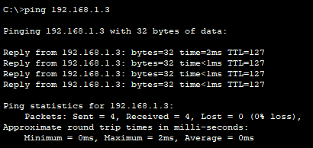

    - Use the show version command to answer the following questions about the router.
What is the name of the IOS image that the router is running?
IOS Software Version 15.5 (3) S5 which is the current release [1]

How much DRAM memory does the router have?
32768K or 0.3MB
How much NVRAM memory does the router have?
4194304K or 4.1MB
How much Flash memory does the router have?
3223551K or 3.2MB
    - Use the show version command to answer the following questions about the switch.
What is the name of the IOS image that the switch is running?
C2960-LANBASE-M
How much dynamic random access memory (DRAM) does the switch have?
21039K bytes
How much nonvolatile random-access memory (NVRAM) does the switch have?
63488K bytes
What is the model number of the switch?
C2960

Use the show ip route command on the router to answer the following questions.
What code is used in the routing table to indicate a directly connected network?
C
How many route entries are coded with a C code in the routing table?
2
What interface types are associated to the C coded routes?
GigabitEthernet 0/0/0 and GigabitEthernet 0/0/1
Use the show interface g0/1 to answer the following questions.
What is the operational status of the G0/1 interface?
Connected
What is the Media Access Control (MAC) address of the G0/1 interface?
The MAC Address is 0000.0cae.5102
How is the Internet address displayed in this command?
192.168.1.1/24 which indicates the first 24 bits are the network address and part is the host address, this would match with the subnet being 255.255.255.0

Reflection
If the G0/1 interface showed administratively down, what interface configuration command would you use to turn the interface up?
No shut

What would happen if you had incorrectly configured interface G0/1 on the router with an IP address of 192.168.1.2?
PC-A would not be able to ping PC-B as the default gateway for gateway for PC-A would have changed. To correct the issue, one could change the default gateway on PC-A or correct the IP address on the router.

Explain the operation of a Router and a Switch.
A router allows two or more different networks connect to each other, they would general be used to connect multiple sites together. A switch is used to connect multiple devices togethers.

Lab 3: IPv4, Subnetting, VLSM and IPv6 Addressing

Understanding IPv4 and IPv6 addressing (word count 1000)
This part of lab worksheet require you research and write a report on “Features of IPv6”. You may discuss but not limited to structure, address types, advanced functionalities and security.

Features of IPv6

IPv6 is due to replace IPv4 because we are running out of IP address for IPv4 , IPv4 uses a 32 bit IP address and the maximum number of address is 4,294,967,296 [2]. With the new era of Internet of Things where such devices as Cars , Fridges , Smart Lights etc. We will shortly run out of IPv4 devices. Currently there are over 22 billion individual devices connected to the internet. This figure is higher because if you take a typical home the home broadband router would use only one of the 4 billion IPv4 address but in side the home there could be 15 devices connected to the router which would issue IPv4 address that are not in the 4 billion pool. Another example would be a local council that may have 1 or 2 or the 4 billion IPv4 address but have thousands of devices connected internally. This is why something new is needed and this is where IPv6 comes in.

Below is a brief timeline of the IPv6 Protocol [3]

- Basic protocol (RFC 2460) published in 1998
- Basic socket API (RFC 2553) and DHCPv6 (RFC 3315) published in 2003.
- Mobile IPv6 (RFC 3775) published in 2004
- Flow label specifications (RFC 3697) added 2004
- Address architecture (RFC 4291) stable, minor revision in 2006
- Node requirements (RFC 4294) published 2006

Benefits of IPv6 [4]

- IPv6 will give us 3.4×10³⁸ which is around 340,282,366,920,938,000,000,000,000,000,000,000,000 IP address.
- Simplified Header. It has been simplified and all information that is not needed in the header and moved to the end of the header. The header is only twice as long because even though the IPv6 is 4 times longer than an IPv4 address.
- End-to-end Connectivity. Every IPv6 address will be unique. Whereas now I may have an IP address of 192.168.10.65 my next door neighbour may have the same address but because our Broadband routers are on different IPv4 address then there is no issue with us having the same address. IPv6 every device will be unique which would allow every device to talk to each other. However companies will still be able to enforce policy’s via firewalls.
- Mobility. Currently when your phone move from cell tower to cell tower it assigned a new IP address each time. With the new IPv6 protocol you will remain connected with the same IP.

There are several types of addresses used with IPv6. [5]

- Global Unicast address. The IPv6 is used to identify a single interface this could be a laptop , printer , smart device or mobile phone. The Global Unicast Address is internet routable.
- Link Local IPv6 address. This will allow communications between devices on a local network and they are not internet routable. The prefix for these is fe80::/10
- Multicast. A multicast will be sent packets to all the devices that are part of the multicast group. The address start with ff . The two important addresses are ff02::1 All interfaces on a local network segment and ff02::2 All routers on the local network segment
- Anycast. Sends a transmission packet to only the devices associated with the address.
- Loopback. This is similar to the IPv4 127.0.0.1 but in IPv6 it`s 0000:0000:0000:0000:0000:0000:0000:0001/128 or it can represented as ::1

Example of the IPv6 address

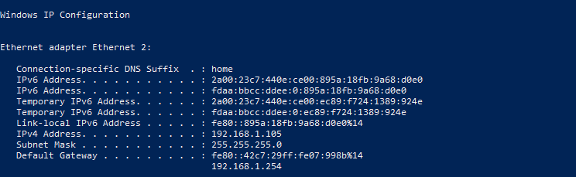

IPv6 Address – This is the Global address for the Network Interface Card or NIC the reason two are listed is because is assigned by the auto-configuration as defined by RFC 4862.
Temporary IPv6 Address – This is a temporary address with a randomly derived interface ID which is created by a resource request. As you can see the Temporary address match the IPv6 address.
To show these are being used below is a screen shot of all the current IPv6 on the authors computer.
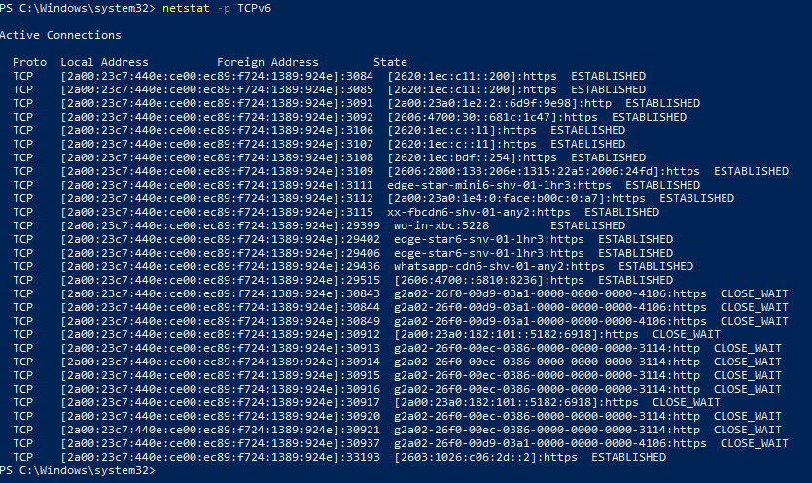
The screen shot shows the Protocol ‘TCP’ , the local address , Port , destination address , protocol ‘HTTPS or HTTP and the connection state.
Link-Local IPv6 Address – this is the local address and shows it zone ID ‘%14’ . The zone ID is used differentiate between two different subnets. This will allow a devices to use the same address for each NIC but the Zone ID will separate the two different links. [6]
Default Gateway – This is the address of the router and it has the same Zone ID as the Local-Link Address ‘ %14’

Currently the authors current router does not issue IPv6 address and all the above address are assigned by the device.

Below are some of the figures from the Internet Society with regards to IPv6 deployment. [7]

- Over 25% of all Internet-connected networks advertise IPv6 connectivity.
- Google reports 49 countries deliver more than 5% of traffic over IPv6, with new countries joining all the time.
- Google reports 24 countries whose IPv6 traffic exceeds 15%.
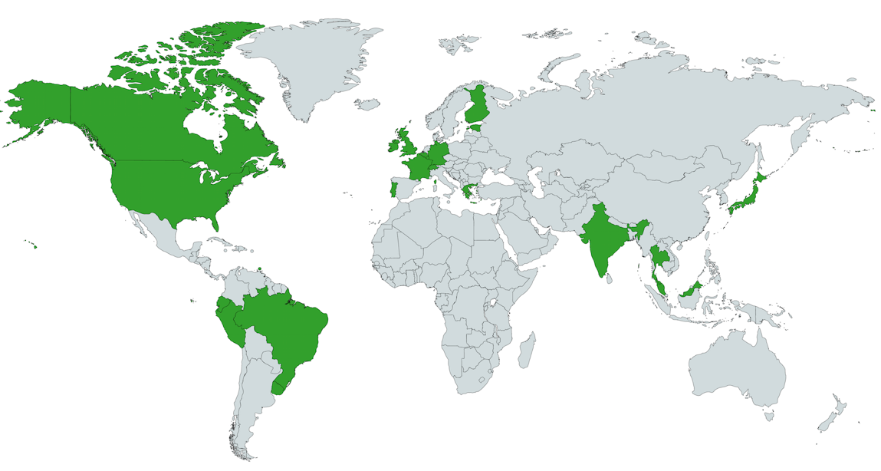

Figure 1 – Countries with IPv6 deployment greater than 15%

Web content
- Alexa Top Million Websites: 17% with working IPv6 (up from 13% in 2017)
- Alexa Top 1,000 Websites: 28% with working IPv6 (up from 23% in 2017)

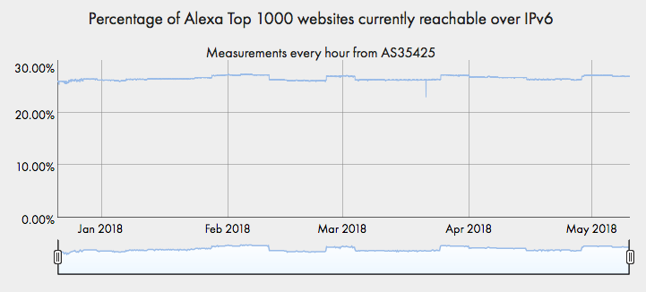

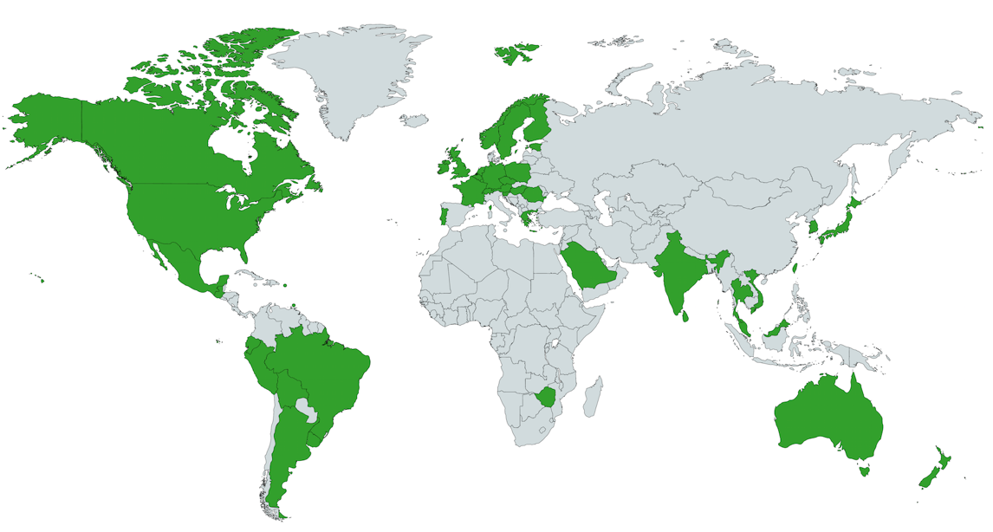

Figure 2 – Countries with IPv6 deployment greater than 5%

There are a number of reason why the adoption of IPv6 is taking so long as quoted on venturebeat.com “IPv6 will be fully implemented on May10, 2148” [8]
IPv6 is expensive to adopt in a large company, print servers , routes and switches may not be IPv6 compatible. Even though we are very close to running out of IPv4 address most companies will use NAT Network Address Translation to give themselves more internal IPv4 address and the cost is a lot less than replacing equipment to be compatible with IPv6.
The IPv6 protocol is not backwards compatible, this was not part of the requirements so an organization will need to make sure all devices are able to run IPv6 before they make the switch. Currently no one is being forced to switch over. If an ISP moved to only IPv6 then homes would need to make sure all their devices in a home are compatible. This would mean the ISP sent guides on who to check and so on again I suppose this would come down to expense. On the same basis if the ISP that provides a Local Government such as PSBA have not moved or not planning to so then there would be no reason for the Local Government to make the move.

Subnetting and VLSM

Using the Network address 172.16.2.0/24, VLSM the network to support the following requirements:
Subnet A: 16 hosts
Subnet B: 2000 hosts
Subnet C: 6 hosts
Subnet D: 500 hosts
Subnet E: 60 hosts
Subnet F: 180 hosts and Serial links between routers

Subnet | Network Address | Subnet mask | First Address | Last Address | Broadcast Address
B | 172.16.2.0 | 255.255.248.0 | 172.16.2.1 | 172.16.9.254 | 172.16.9.255
D | 172.16.10.0 | 255.255.254.0 | 172.16.10.1 | 172.16.11.254 | 172.16.9.255
F | 172.16.12.0 | 255.255.255.0 | 172.16.12.1 | 172.16.12.254 | 172.16.12.255
E | 172.16.13.0 | 255.255.255.192 | 172.16.13.1 | 172.16.13.62 | 172.16.13.63
A | 172.16.13.64 | 255.255.255.224 | 172.16.13.65 | 172.16.13.94 | 172.16.13.95
C | 172.16.13.96 | 255.255.255.248 | 172.16.13.97 | 172.16.13.102 | 172.16.13.103
R1 | 172.16.13.104 | 255.255.255.252 | 172.16.13.105 | 172.16.13.106 | 172.16.13.107
R2 | 172.16.13.108 | 255.255.255.252 | 172.16.13.109 | 172.16.13.110 | 172.16.13.111
R3 | 172.16.13.112 | 255.255.255.252 | 172.16.13.113 | 172.16.13.114 | 172.16.13.115

Lab 4: Understanding Ethernet cable types

Write a research report (Max word count 600) on Cat 5e and 6 Ethernet cable standards.

Research Report on Cat5e and Cat5 Ethernet cable standards.

Cat5e was introduced in 1999 and Cat6 was introduced in 2002 both are part of the Telecommunications Industry Association`s TIA/EIA-568 specification. Cat5e is TIA/EIA-568-A and Cat6 is TIA/EIA-568-B. [9] Cat6 was created as a replacement to the Cat5e standard. There are several reasons for this
- Cat5e supports up to Gigabit Ethernet 1000Mbps were as Cat 6 is certified for this speed. As quoted by Cisco Router [10] on overblog.
    - This helps with the number of devices that support 1GB
    - Even thought Cat6 can handle 1GB , the speed is still set by the slowest device on the network. So, for example if port on the wall is connected to 1gb port on a switch, connected to that is an IP phone that runs at 100Mbps and plugged into the phone is a laptop which can support 1Gb. The laptop will only run at 100Mps.
- Cat6 can support 10GBE but the cable will need to be shorter to support this speed. [11]
- Cat5e bandwidth up to 350mhz and Cat6 is up to 550mhz this has a bearing on how much data can be transmitted.

The wiring of the two standards is similar the only difference is the position of the Green and Orange wires they are switched in the Cat6.[9]
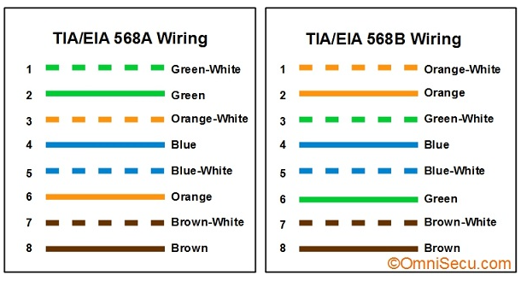
The Cat6 cable is backwards compatible with Cat5e. But when putting a new network infrastructure in place the best practice is to stick with one standard and using the latest.
The Cat6 cable does have a thicker cable gauge this is to support the ticker cooper core of the cable which is need for Gigabyte standard.
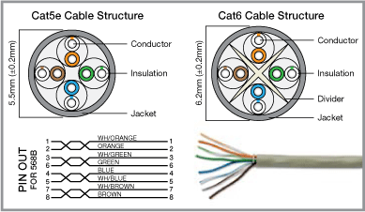 [12]
The Cat6 cable also has more twists in the cable this is reduce the signal-to-noise ratio, Cat5e has 1.5 twists per cm and Cat6 has 2 twists per cm. This will help prevent errors in the transmission of the data. Both cables have 4 twisted pairs but the Cat6 cable has a divider to sperate the 4 pairs this also helps eliminate any crosstalk and helps increase the bandwidth of the cable.
Both cables have a maximum length of 100 meters but if a users wants to utilize the 10Gbs on Cat6 then the length is halved to just 50 meters. Price is also a consideration when laying Cat6 cable because of the makeup and build the cables are generally 20% more expensive than Cat5e.

Reflection
  - Which part of making cables did you find the most difficult?
Cutting the cables small enough so that the jacket would fit into the RJ45 and be gripped by the strain relief.
  - Why do you have to learn how to make a cable if you can easily buy pre-made cables?
Even though network cables are made and supplied in a large number of lengths from 1meter to 100 meter, there will be situations where these cable would be to long or using a premade cable is not feasible as you need to go through a small gap of drill a hole. To keep the work neat and tidy you would only drill a hole the size of the cable. Doing this you would need to put a plug on to the lead. Other reasons to make your own lead is having excess cable could cause data loss.

Lab 5: Securing Network devices for remote access

R1(config)# login block-for 30 attempts 2 within 120
What does the 2 within 120 mean in the above command?
This indicates that if a user enters an incorrect password twice with 120 seconds, they are blocked for 30 seconds.
What does the block-for 30 mean in the above command?
This this is the length of time a user is blocked for.

    - Start Tera Term from PC-A.
    - Use Tera Term to telnet to R1.
Does R1 accept the Telnet connection? Explain.
Yes because enabled Telenet connections on the router.

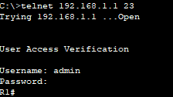
    - Use Tera Term, establish an SSH session to R1. Use the username admin and password adminpass. You should be able to establish an SSH session with R1.
Does R1 accept the SSH connection?
Yes it does accept the connection.
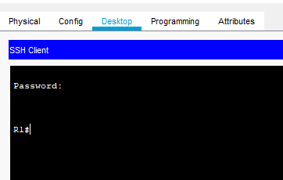
    - Intentionally mistype the user and password information to see if login access is blocked after two attempts.
What happened after you failed to login the second time?
It terminates the connection and requests you reestablish a new session.
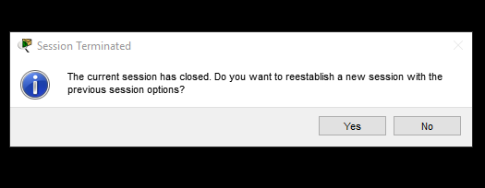
    - From your console session on the router, issue the show login command to view the login status. In the example below, the show login command was issued within the 30 second login blocking period and shows that the router is in Quiet-Mode. The router will not accept any login attempts for 14 more seconds.
R1# show login
A default login delay of 1 second is applied.
No Quiet-Mode access list has been configured.

Router enabled to watch for login Attacks.
If more than 2 login failures occur in 120 seconds or less,
logins will be disabled for 30 seconds.

Router presently in Quiet-Mode.
Will remain in Quiet-Mode for 14 seconds.
Denying logins from all sources.
R1#
    - After the 30 seconds has expired, SSH to R1 again and login using the SSHadmin username and Admin1p@55 for the password.
After you successfully logged in, what was displayed?
    - Enter privileged EXEC mode and use Enablep@55 for the password.
If you mistype this password, are you disconnected from your SSH session after two failed attempts within 120 seconds? Explain.
No as this configuration is only for SSH or remote logins
    - Issue the show running-config command at the privileged EXEC prompt to view the security settings you have applied.

Are you able to establish an SSH session with the switch?
Yes

What versions of SSH are supported from the CLI?
SSH 1.5 shown in Packet Tracer
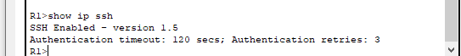
How would you provide multiple users, each with their own username, access to a network device?
Using the command ‘username admin privilege 15 secret adminpass’ but changing the username from admin and the privilage level.

Reflection (max 800 words):
Write a research report comparing various Encryption standards, e.g AES, SHA, DES, RSA.

Report to compare various Encryption standards.

How Encryption Works.

See you needed to send a message to some, and you did not want anyone other than the sender and receiver to view the message. You would need to encrypt the message a message like “Come on over for hot dogs and soda!” would look like
“wUwDPglyJu9LOnkBAf4vxSpQgQZltcz7LWwEquhdm5kSQIkQlZtfxtSTsmaw
q6gVH8SimlC3W6TDOhhL2FdgvdIC7sDv7G1Z7pCNzFLp0lgB9ACm8r5RZOBi
N5ske9cBVjlVfgmQ9VpFzSwzLLODhCU7/2THg2iDrW3NGQZfz3SSWviwCe7G
mNIvp5jEkGPCGcla4Fgdp/xuyewPk6NDlBewftLtHJVf
=PAb3”

Once encrypted and without knowing which type of encryption is used and the key needed to decrypt it then it would virtually impossible to force it to decrypt. Encryption is used everywhere from saving data on your hard drive to sending messages via What`s App.

The four standards this report will focus on are AES, SHA, DES and RSA.

AES (Advanced Encryption Standard)

AES is used by the US government and the National Security Agency to protect sensitive files. In August 1999 five algorithms were selected for more detailed analysis theses were

- MARS, submitted by a large team from IBM Research
- RC6, submitted by RSA Security
- Rijndael, submitted by two Belgian cryptographers, Joan Daemen and Vincent Rijmen
- Serpent, submitted by Ross Anderson, Eli Biham and Lars Knudsen
- Twofish, submitted by a large team of researchers from Counterpane Internet Security, including noted cryptographer Bruce Schneier
[13]

Rijndael was selected as the proposed algorithm in October 2000 and was published by NIST: National Institute of Standards and Technology. The US Government recommend that AES could be used to protect classified information in June 2003. Later it would be adopted by the private sector.
AES has 3 block cipers AES-128 , AES-192 and AES-256. The data is encrypted and decrypted in blocks of 128bits using crypto keys of 128, 192 and 256 bits.

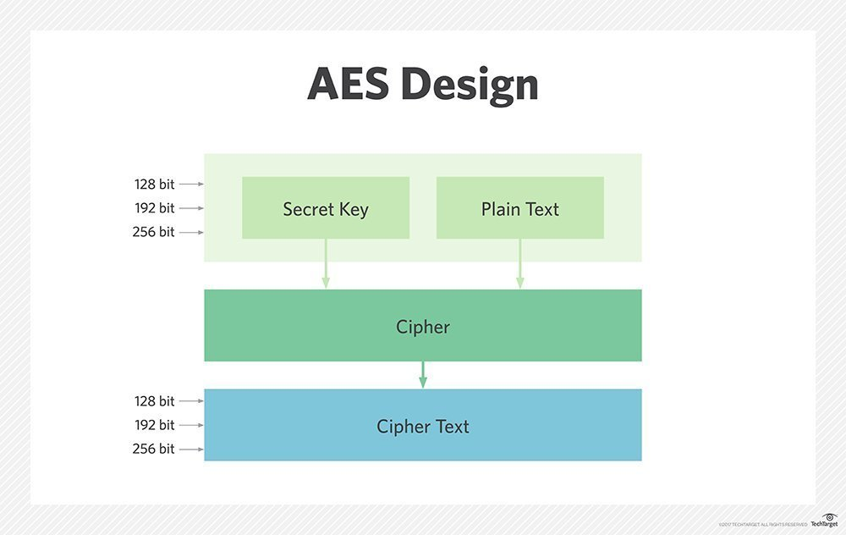[13]

AES is currently and still used by the US Government and NSA it is also used to encrypt some WIFI keys. Some popular applications that use it are Facebook messenger. What`s App messenger uses a combination of AES to key it`s keys secure and SHA to encrypt the message. [14]

SHA (Secure Hash Algorithm)

SHA is used to check that a file has not been altered when it arrives at its destination. This is done by creating a checksum before it`s transmitted and then again when it arrives. If the two checksums match then the file is considered genuine. This system is also used on some websites, when you enter a password to login it is not saved in a database in plain text. It will be encrypted. This can be demonstrated here http://www.sha1-online.com/

If you enter the password HelloWorld123 the result for SHA-1 would be d7b29e5d98bc080b3c51393e926184851ead31e2 where as for
SHA512 would be cb3cfdf4e432c5923da3985f217dbc048e9634ad5205f55c945e458674b39cefa6bbc45c9aa451a15b78c4ddf904ce7e268f735990e1b320292e655dc6f12f88. Without knowing which encryption method was used it would be very hard to crack but if you do know which one is used you are able to reserve hash it on site such as https://md5hashing.net/hash/sha512

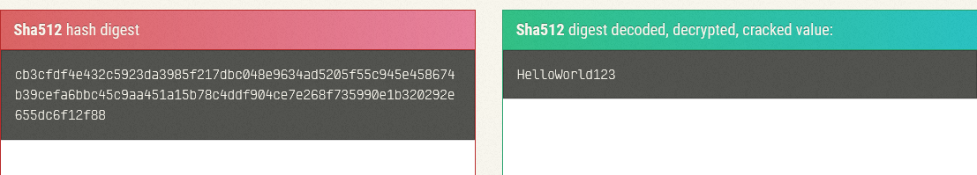

DES (Data Encryption Standard)

DES was developed in the 1970`s by IBM and was used by the US Government from 1977. DES uses one key to encrypt and decrypt information so the sender and receiver must both know the key.
DES takes some plain text as a fixed length string and through a series of operations transforms it into a bitstring cipher text. Each block size is 64bits.

Below is an image which show 64bits of text going in and being encrypted by a 56bit key, this then produces 64bits of ciphered text.

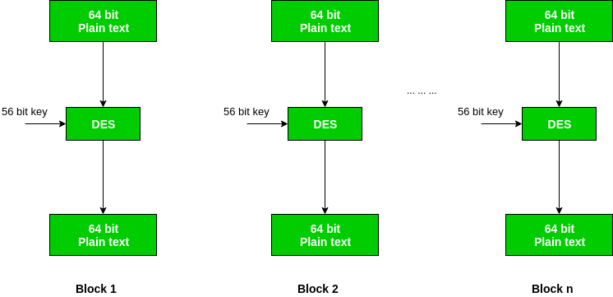 [15]

The encryption key starts life as a 64bit key but every 8th bit of the key is removed to make a 56bit key. As quoted on geeksforgeeks the steps involved are [15]

- In the first step, the 64 bit plain text block is handed over to an initial Permutation (IP) function.
- The initial permutation performed on plain text.
- Next the initial permutation (IP) produces two halves of the permuted block; says Left Plain Text (LPT) and Right Plain Text (RPT).
- Now each LPT and RPT to go through 16 rounds of encryption process.
- In the end, LPT and RPT are rejoined and a Final Permutation (FP) is performed on the combined block
- The result of this process produces 64 bit cipher text.

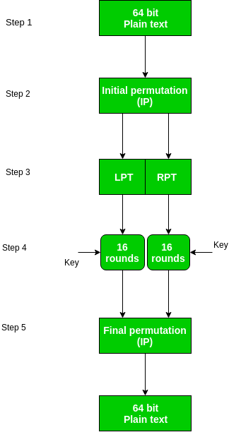

RSA (Rivest–Shamir–Adleman)

RSA is similar to DES where a message or text is encrypted and sent to another user, the main difference is that the other user does not need to know the key that was used to encrypt the original file. RSA falls under the public-key encryption scheme. RSA uses two keys a public key and a private key.

Reading List

https://www.lifewire.com/what-is-sha-1-2626011

https://scontent.whatsapp.net/v/t61/68135620_760356657751682_6212997528851833559_n.pdf/WhatsApp-Security-Whitepaper.pdf?_nc_ohc=_aFUhT-n_ZgAQnwt6gwZ8yNcNnC3MDBTALtK3DeopzwQylAbeGUCsvk5Q&_nc_ht=scontent.whatsapp.net&oh=b696d777ccb621331a194cad5aa30e25&oe=5DF00325

https://searchsecurity.techtarget.com/definition/Data-Encryption-Standard

https://www.tutorialspoint.com/cryptography/data_encryption_standard.htm

https://www.geeksforgeeks.org/data-encryption-standard-des-set-1/

https://www.comparitech.com/blog/information-security/rsa-encryption/

References

[1] | Cisco, “Release notes,” 6 10 2019. [Online]. Available: https://www.cisco.com/c/en/us/td/docs/ios/15_5s/release/notes/15_5s_rel_notes/15_5s_caveats_15_5_3s.html. [Accessed 17 11 2019].
[2] | W. R. Parkhurst.. [Online].
[3] | “IPv6 – The History and Timeline,” [Online]. Available: https://www.ipv6.com/general/ipv6-the-history-and-timeline/. [Accessed 8 12 2019].
[4] | “IPv6 - Features,” [Online]. Available: https://www.tutorialspoint.com/ipv6/ipv6_features.htm. [Accessed 8 12 2019].
[5] | “Types of IPv6 Addresses, Global Unicast, Link-local, Multicast, Anycast, Loopback addresses,” [Online]. Available: http://www.omnisecu.com/tcpip/ipv6/types-of-ipv6-addresses.php. [Accessed 8 12 2019].
[6] | M. Pietroforte, “4sysops,” 11 3 2011. [Online]. Available: https://4sysops.com/archives/ipv6-tutorial-part-7-zone-id-and-unique-local-ipv6-unicast-addresses/. [Accessed 8 12 2019].
[7] | “State of IPv6 Deployment 2018,” 6 6 2018. [Online]. Available: https://www.internetsociety.org/resources/2018/state-of-ipv6-deployment-2018/. [Accessed 8 12 2019].
[8] | J. Koetsier, “VentureBeat,” 7 6 2013. [Online]. Available: https://venturebeat.com/2013/06/07/at-our-current-rate-of-progress-ipv6-will-be-fully-implemented-on-may-10-2048/. [Accessed 8 12 2019].
[9] | “TIA/EIA 568A and TIA/EIA-568B standards,” [Online]. Available: http://www.omnisecu.com/basic-networking/tia-eia-568-standards.php. [Accessed 30 11 2019].
[10] | C. &. C. Router, “Overblog,” 03 12 2013. [Online]. Available: http://ciscorouterswitch.over-blog.com/article-cat5-vs-cat5e-vs-cat6-125134063.html. [Accessed 11 11 2019].
[11] | R. Tech, “Cat5e vs. Cat6 Cables,” 01 05 2014. [Online]. Available: https://blog.router-switch.com/2014/05/cat5e-vs-cat6-cables/. [Accessed 11 11 2019].
[12] | R. Baba, 14 3 2015. [Online]. Available: https://www.quora.com/What-is-CAT6. [Accessed 30 11 2019].
[13] | M. Rouse, “Search Security,” [Online]. Available: https://searchsecurity.techtarget.com/definition/Advanced-Encryption-Standard. [Accessed 8 12 2019].

