Observations of Basic Network and Security Policy Configuration on a Simple Network
Oliver Bird
Apprentice Software Engineer – BT , Data Services
1910716@student.uwtsd.ac.uk
ABSTRACT – A basic implementation of NTFS permissions are firstly demonstrated locally on a given client and secondly via a domain controller through a networked file share. Further permissions are then enacted across the domain to demonstrate basic security policies. Connectivity between two LANs is established via network protocols with some basic firewall restrictions enacted. An analysis of sound password policy is then provided. An implementation of a failover cluster is shown. Finally, a network diagram is proposed for a multi-site enterprise with an example security and network policy. Applicable Word Count: ~3200.
1. Practical Implementation of Access Control Policies
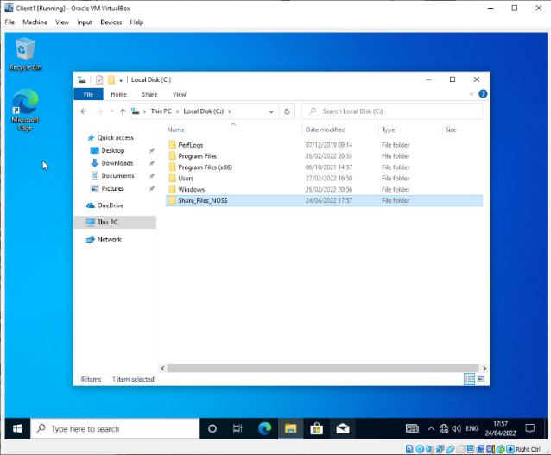
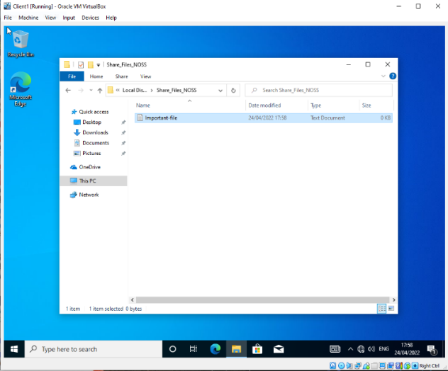
a) Task 1 – Managing and Maintaining Network Resources, NTFS
Fig. 2 – File Creation
A designated share folder and file are created within the client 1 VM filesystem.
Fig. 1 – Folder Creation
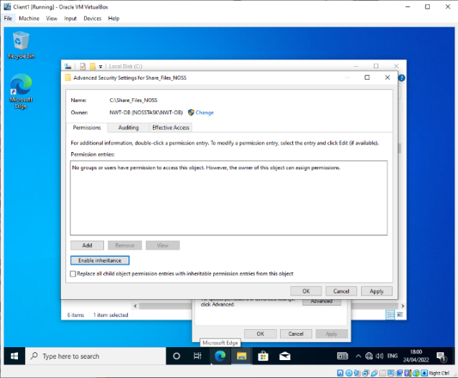
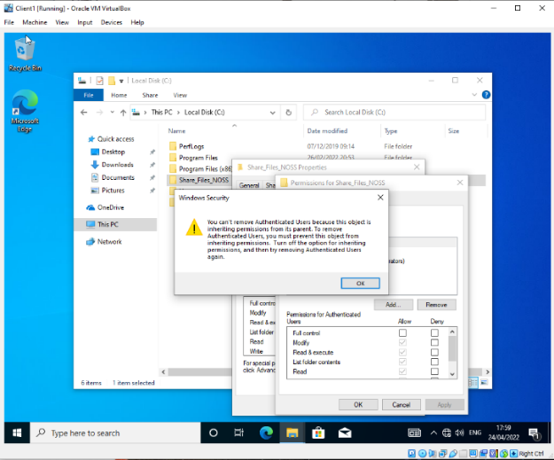
Fig. 3 details issues due the inherited permissions present on the newly created folder. Fig. 4 shows inheritance being disabled to allow for permissions to be granularly assigned to the folder.
Fig. 4 – Inheritance Disabled
Fig. 3 – Inheritance Errors
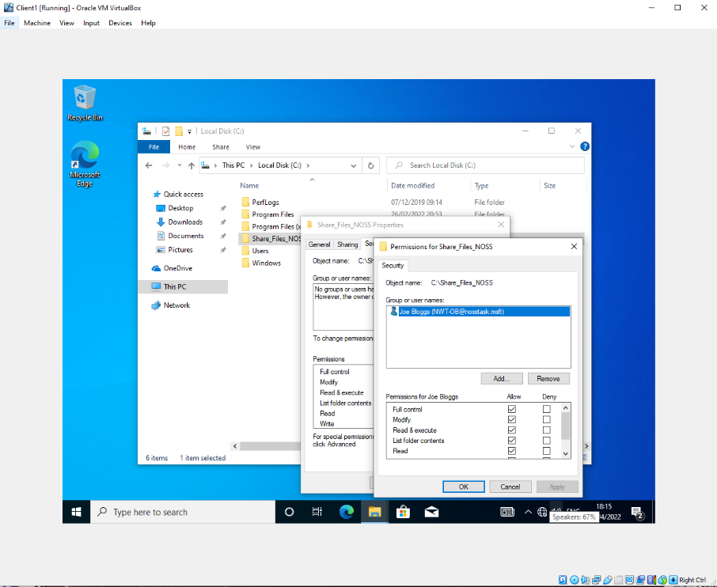
Fig. 5 – Joe Bloggs Permissions Assigned
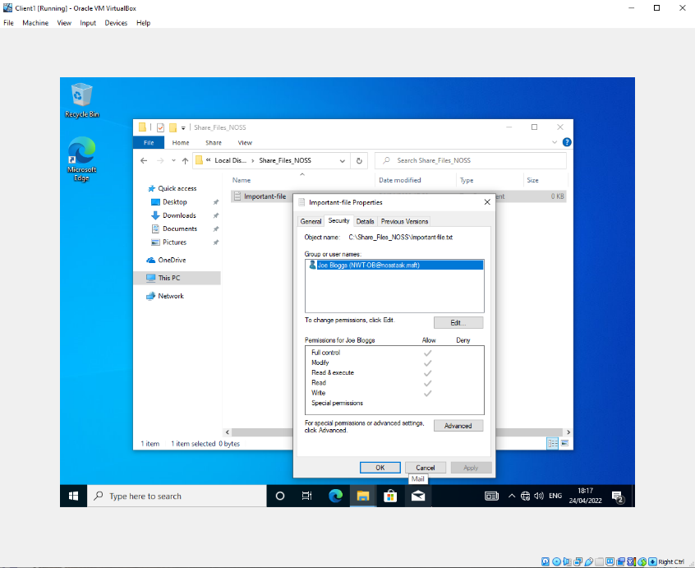
Fig. 5 shows full control of the directory and its contents permissions being assigned to the Joe Bloggs user within the domain.
Fig. 6 – Inheritance Demonstration

Fig. 6 details the inherited permissions upon files within the updated folder for the Joe Bloggs user. This user has the same access to files within the folder as they do to the folder itself. [1]

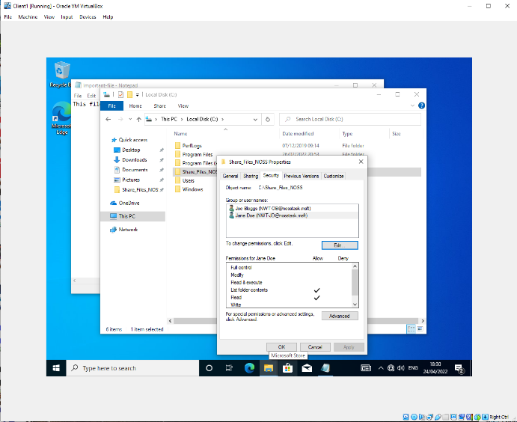
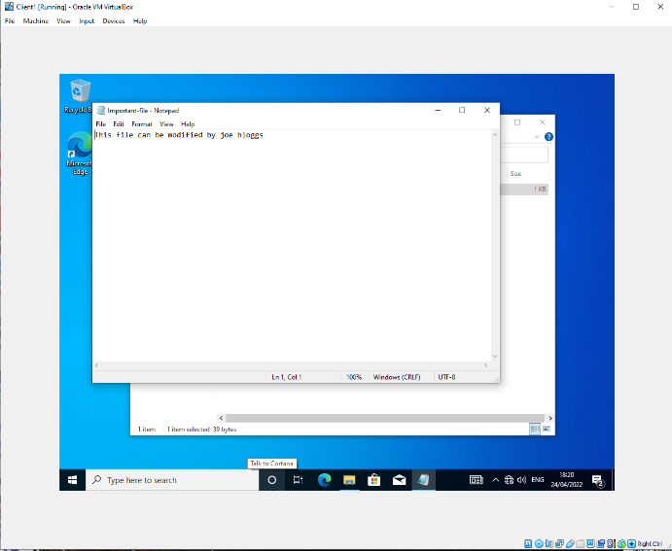
Fig. 8 – Folder Permissions Assigned to Jane Doe
Fig. 7 - File Modified by Joe Bloggs

Fig.7 shows successful modification of a file within the folder given the supplied permissions.
Fig. 8 shows the local folder permissions assigned to the Jane Doe user. With these she is able to see objects within the folder, however, cannot make any modifications to the files or folder.
Fig. 9 - Jane Doe cannot modify the files
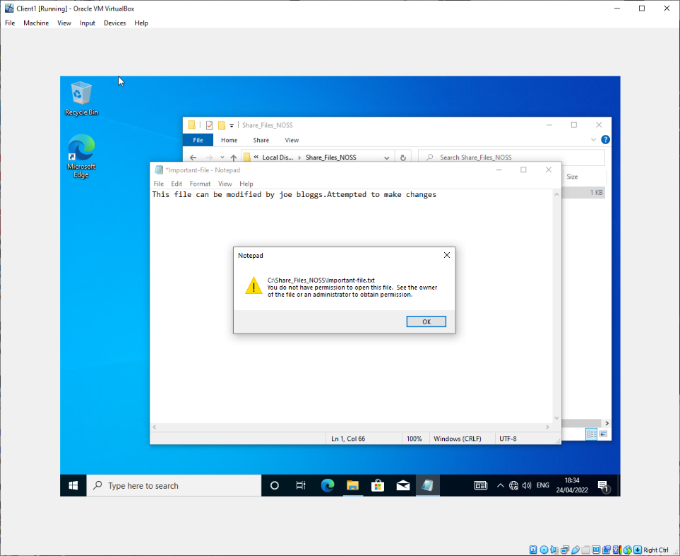

Fig. 9 details the successful restriction of the folder against a non-permitted user – NWT-JD (alias: Jane Doe).

b) Task 1 – File Share Creation
A file share (FS) is created on the server1 VM with the goal of files being accessible over the network on the client 1 VM.
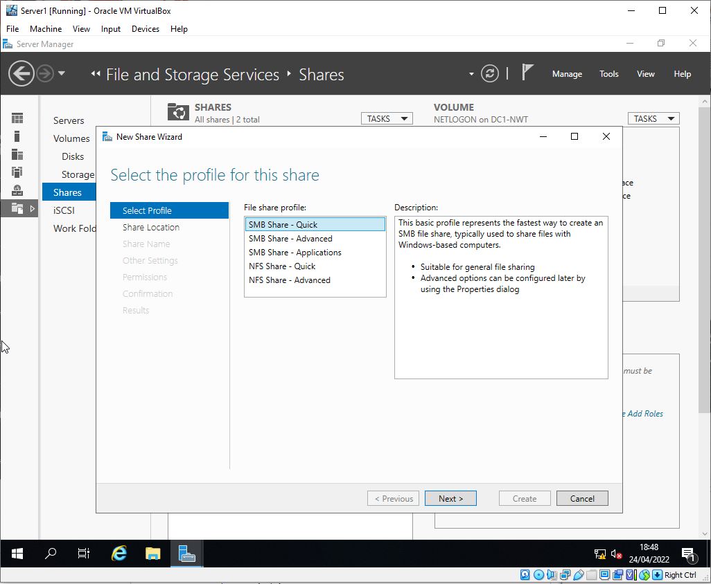
Fig. 10 - Initial File Share Configuration
Fig. 10 shows the initial configuration of the file share on server 1 where ‘quick’ is selected, as the files are only required to be shared between windows computers.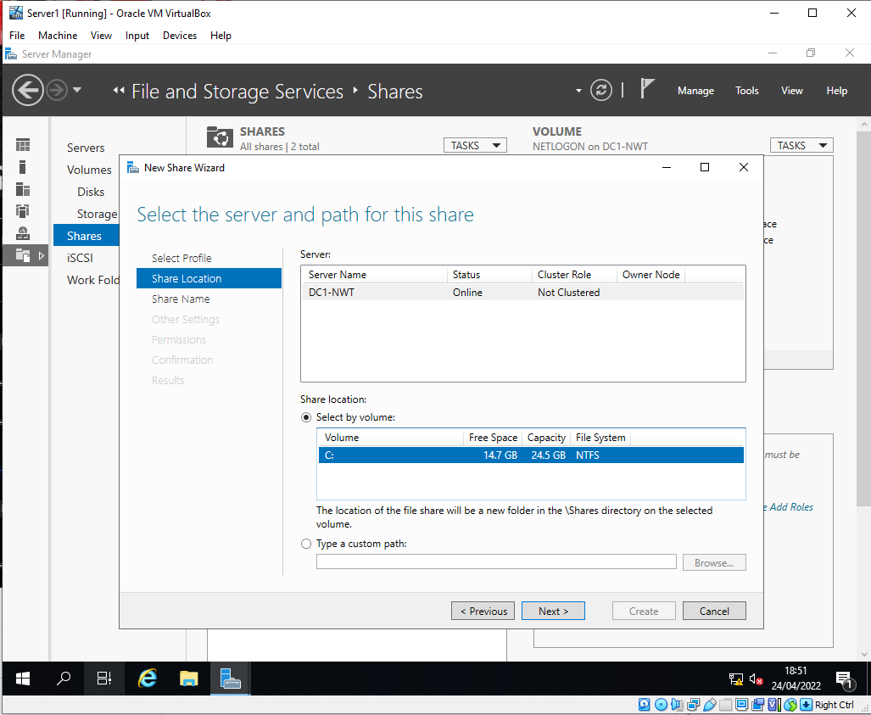
Fig. 11 Volume Selection
Fig. 11 shows the selection of the volume to be shared on DC1 (server1 VM).

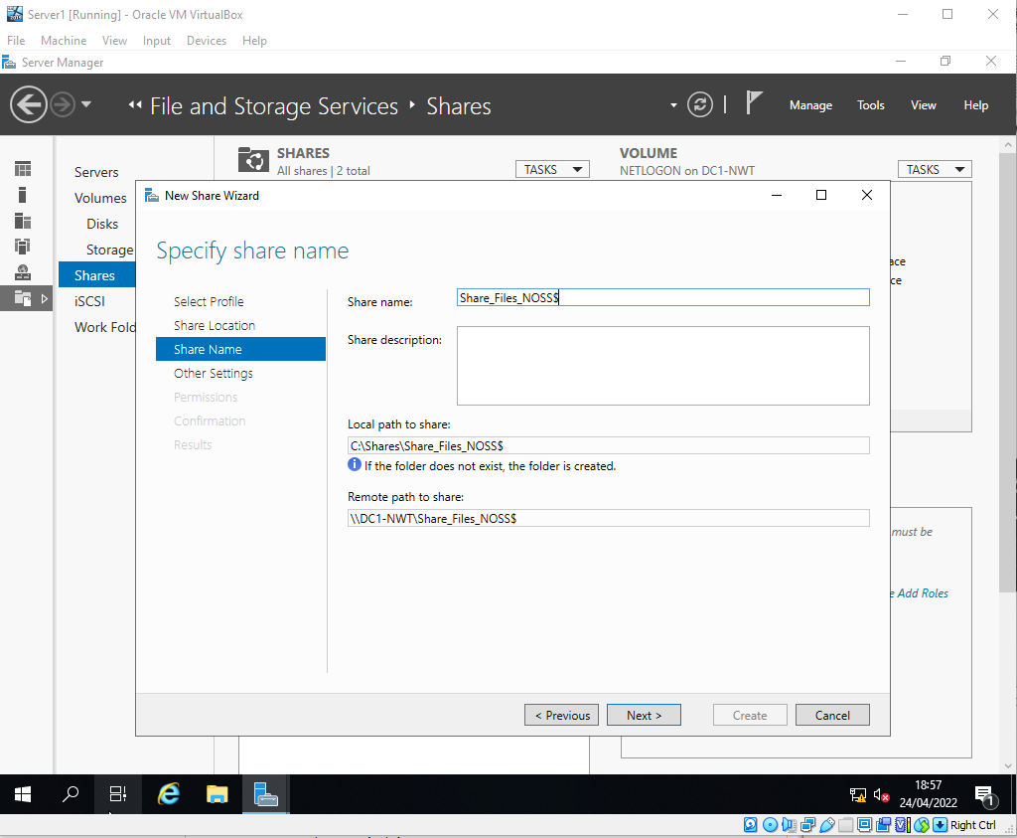
Fig. 12 - File Share Paths
Fig. 12 shows the file paths of the share to enable it to be accessible from other hosts.
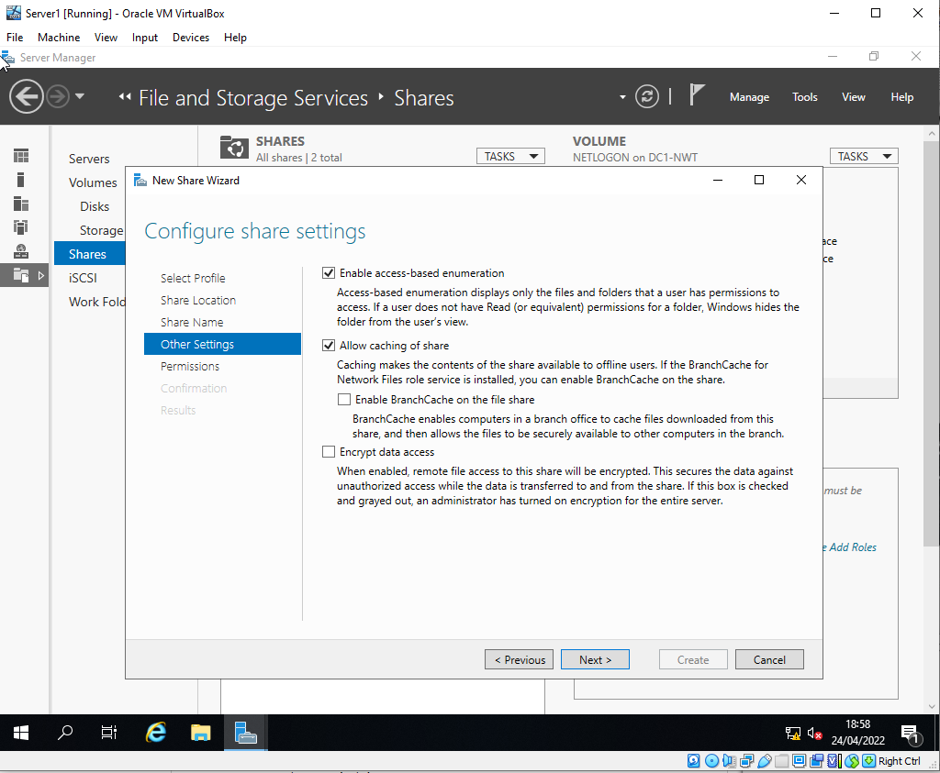
Fig. 13 - File Share Configuration
Fig. 13 shows the configuration of the file share to include access-based enumeration and caching. These will allow the share to dynamically detail files within the share based on their permissions. i.e only files that the user has permission to view will be shown. Caching allows for these files to be saved locally temporarily so that the user can still access them in the case they disconnect from the network, and to reduce overall network traffic between the client and file server. [2] [3].

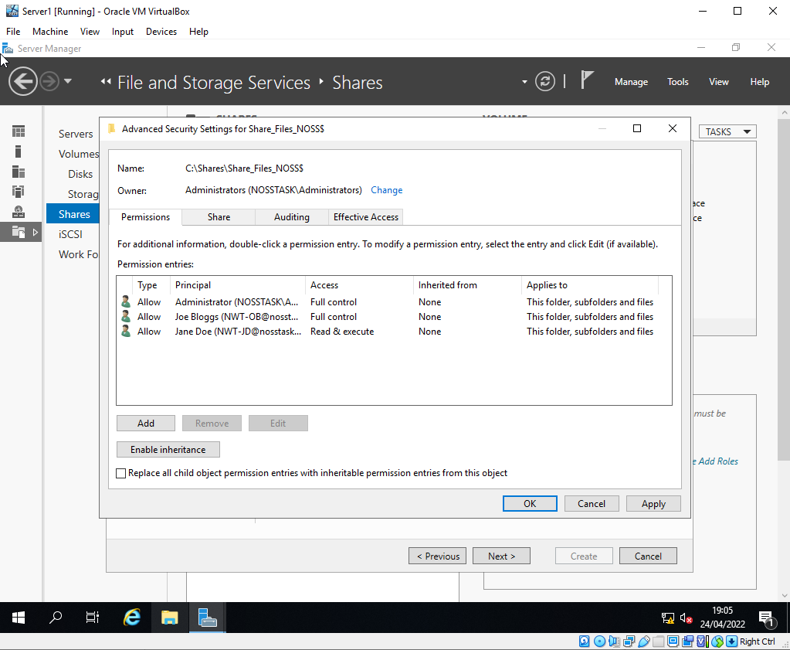
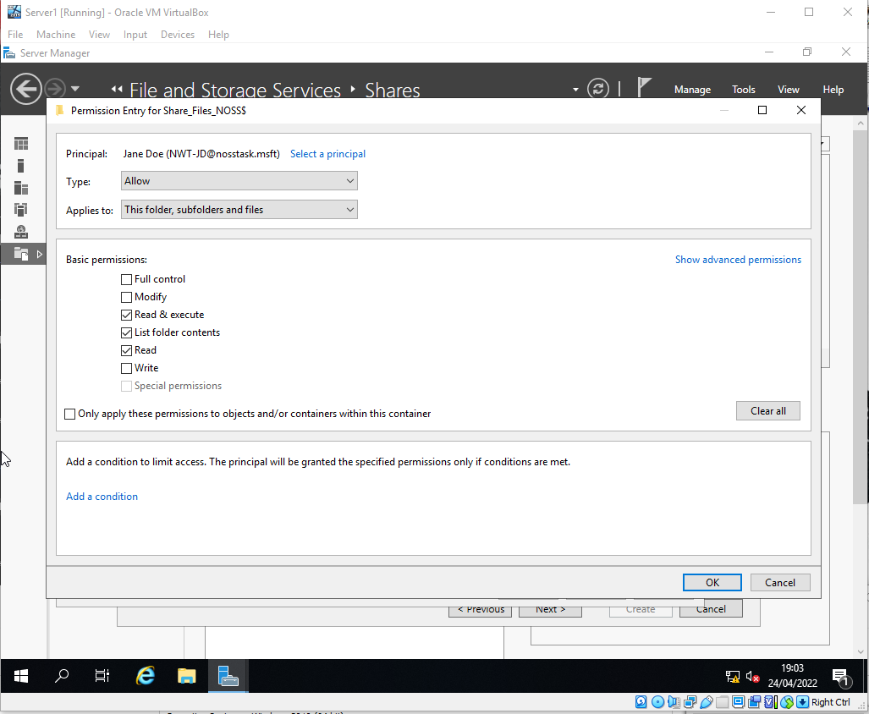
Fig. 15 – User file permissions
Fig. 14 - Jane Doe File Share Privileges

Figs. 15,16 show the permissions assigned to the shared folder for the current list of created users.
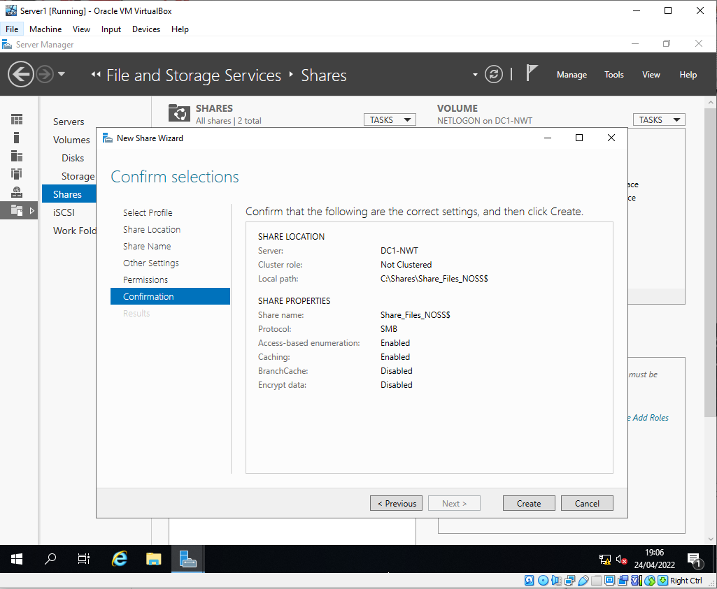
Fig. 16- Final Creation Page for File Share
Fig. 16 details the final creation configuration of the file share.

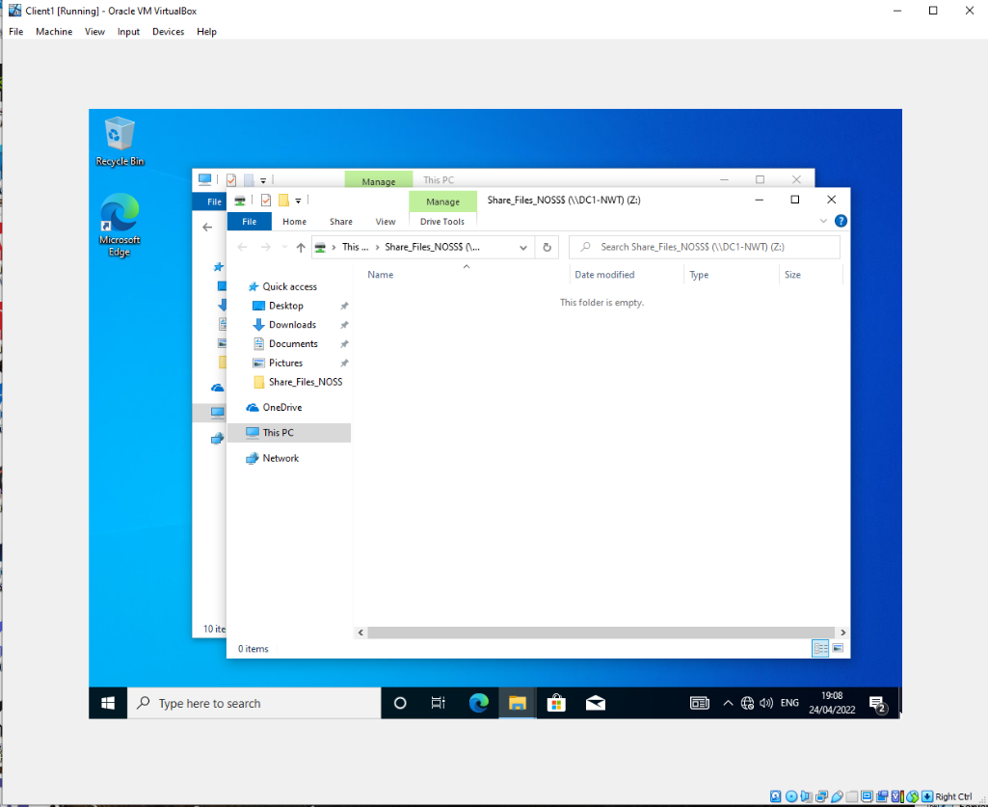
Fig. 17 - File Share Accessible from Client 1

Fig. 17 shows the file share once being added to the client 1 VM. The folder is clearly visible and is accessible over the network.
c) Task 1 - Group Policy Implementations
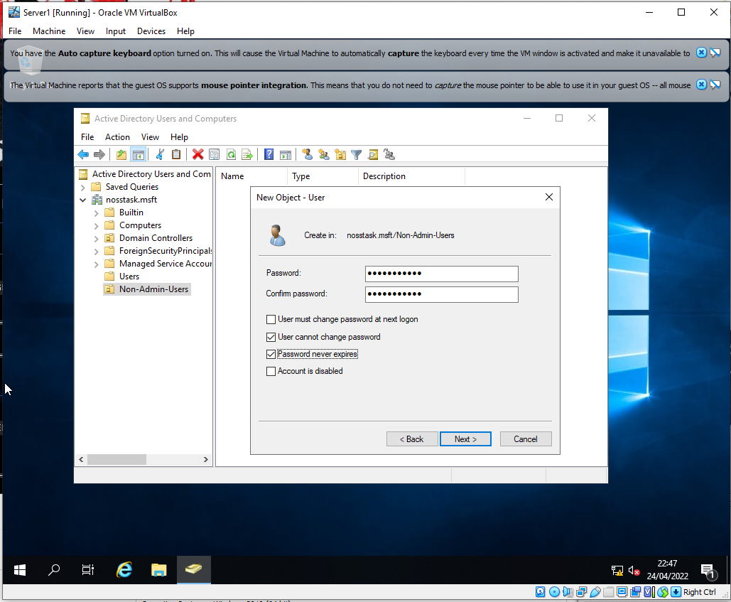
Various group policy [4] objects are created to implement some basic security features within the domain. For all new policy additions, the ‘gpupdate / force’ command is run on the domain controller to push out the updated policy.
Fig. 18 - Creation of a New User

A new organisational unit (OU) is created within the domain to contain the new group policies. Within this group Fig.18 shows a user being created to demonstrate these policies.
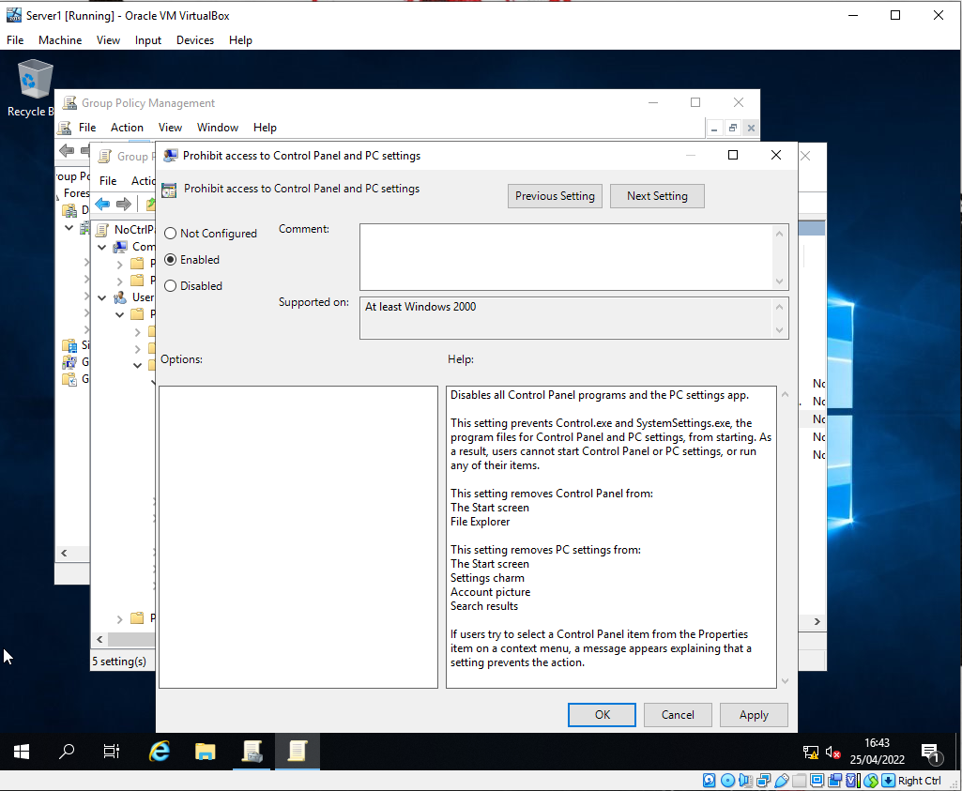
Fig. 19 - Control Panel Restriction
A new group policy is created within the OU from the default policies to restrict access to the control panel as Is shown in Fig. 19. This is enabled by the check box. This limits non admin users from modifying any of the computer settings. [5]
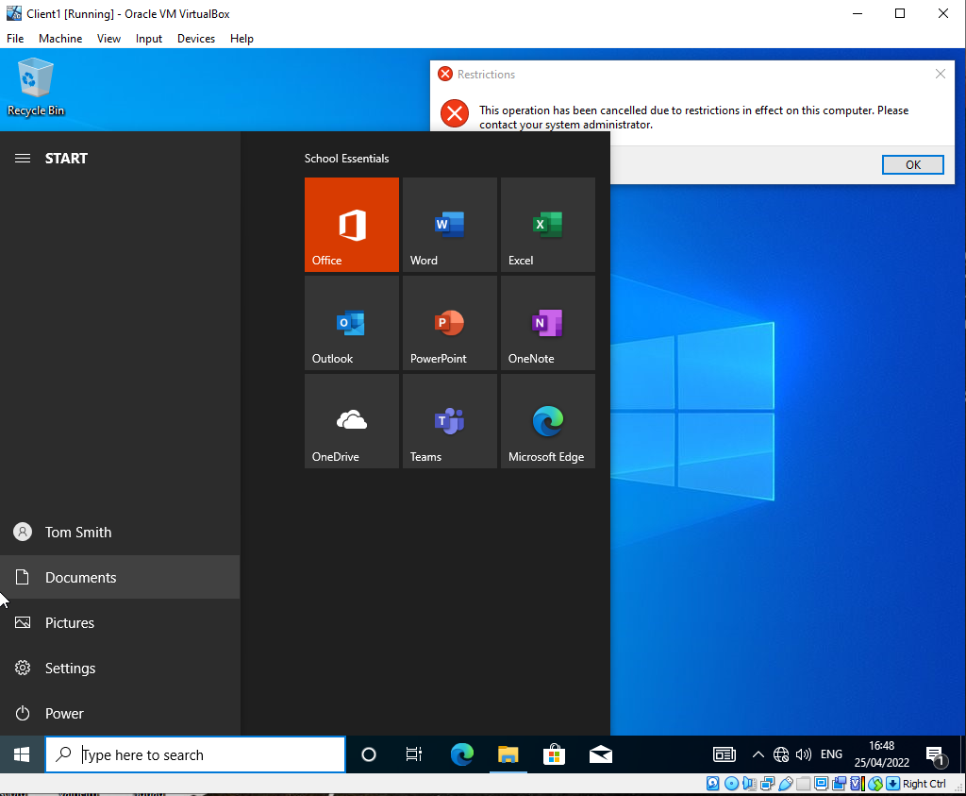
Fig. 20- Tom Smith Attempts to Access Control Panel
The new control panel restriction policy is shown to be working in Fig. 20 for the Tom Smith user who is part of the non-admin OU.

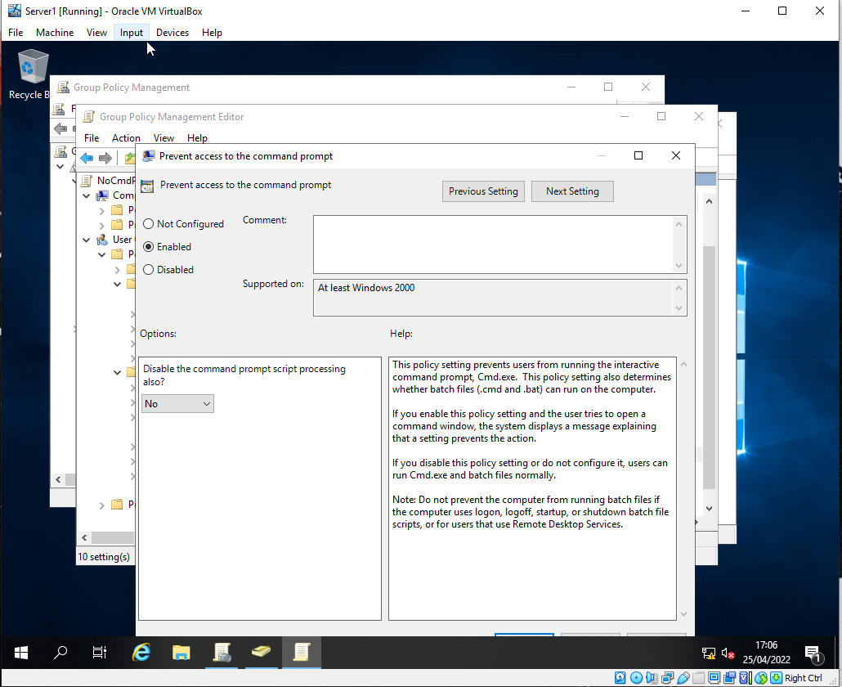
Fig. 21 - Command Prompt Disabled Policy

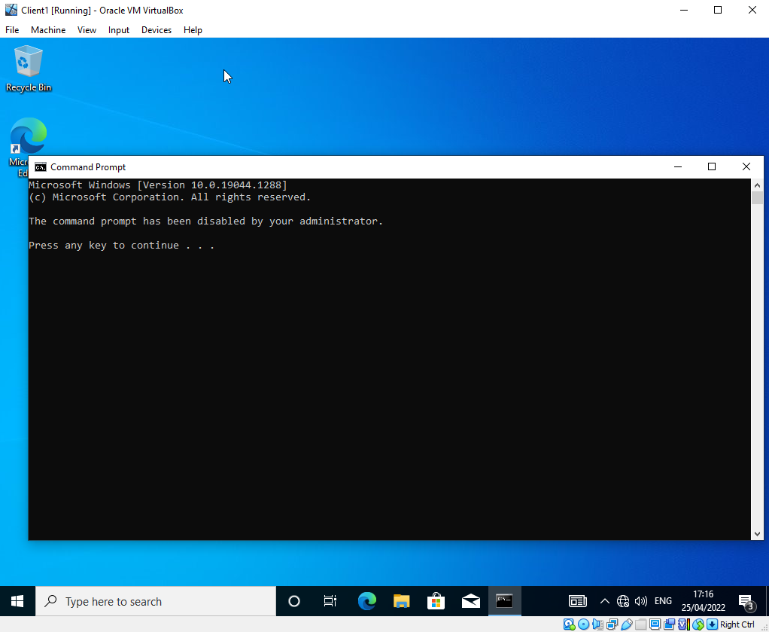
The command prompt is now restricted to all users within the non-admin group further preventing access to system information and powers. [6]
Fig. 22- Command Prompt Restriction Demonstration

The Joe Bloggs user has access to the application cmd.exe however upon running it, no shell access is provided as is shown in Fig. 22.

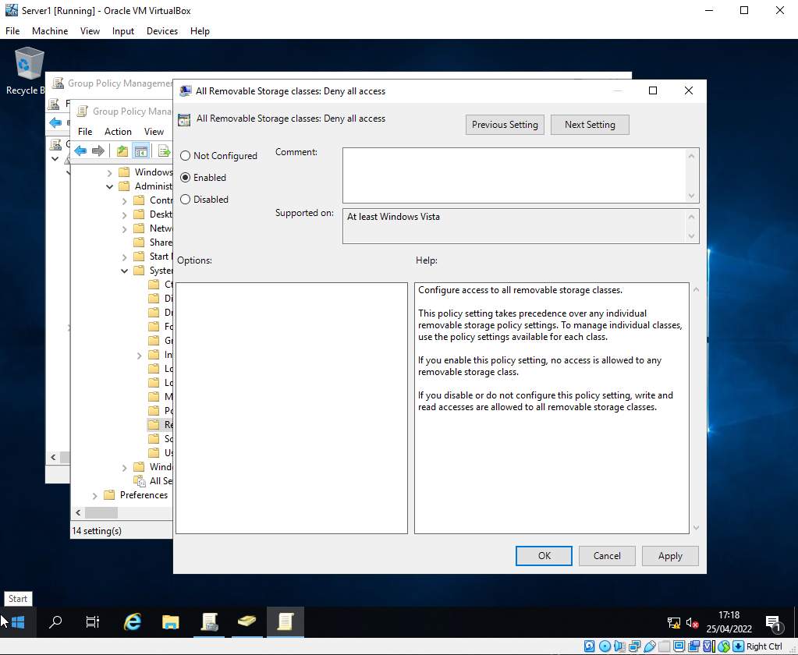
Fig. 23 - No removable storage devices
Fig. 23 shows the restriction of removable storage devices within the OU. This encapsulates many different types of devices. In general, this means any hot swappable device which can be attached and removed from the system while the operating system is booted [7]. This is difficult to test within a VM environment however this setting will enforce this policy and show the following error:
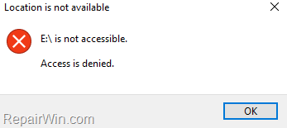
Fig. 24 - Cannot Access Removable Storage Error [8]
To apply software-based restrictions on a host, the host must be added to a new OU as a computer object. The new OU is created and named NWClientComputers. The client 1 host is added to the new OU prior to policies being assigned as is shown in Fig. 24.

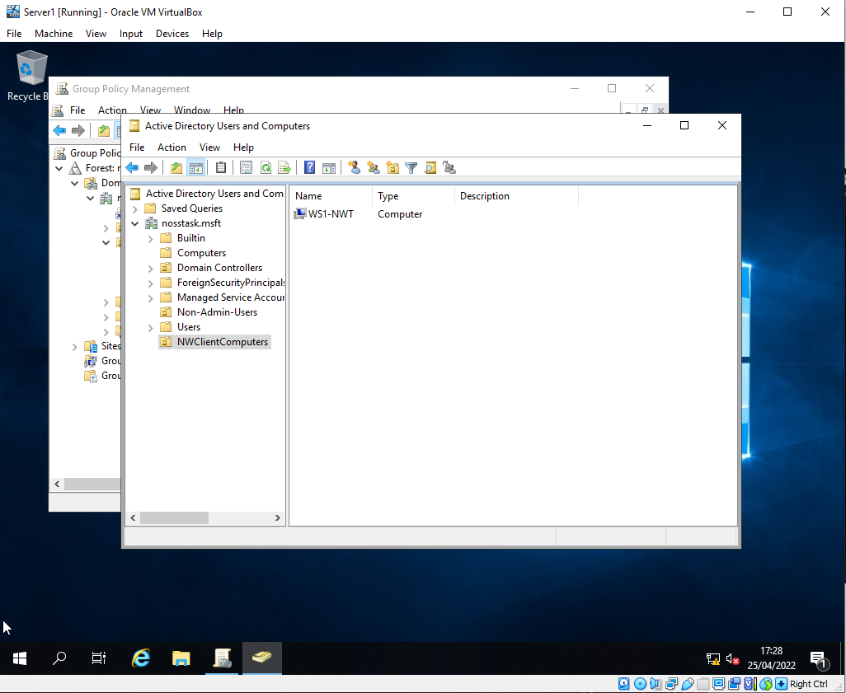
Fig. 24- New OU Created With Client1 Added

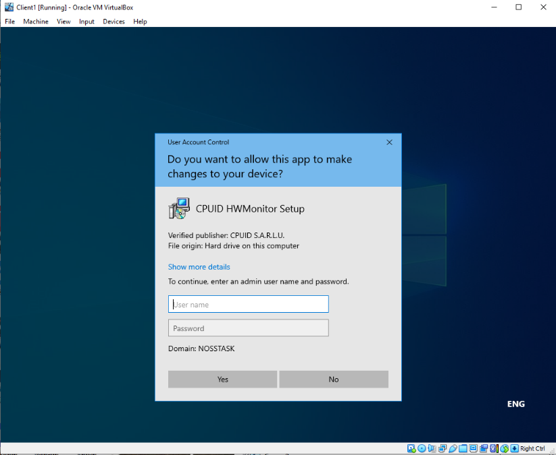

Fig. 25 - User Unable to Install Software Without Admin Permissions
After the ‘Prohibit User Install’ policy has been enacted, no non-administrative user is allowed to install any software without providing admin credentials, as is shown in Fig. 25.
d) Task 1 - Password Policy Enforcement
A minimum password policy is setup in addition to the standard policy as provided in the Default Domain Policy GPO, with additional controls on top of the minimum complexity requirements [9]. This controls password retention and length.

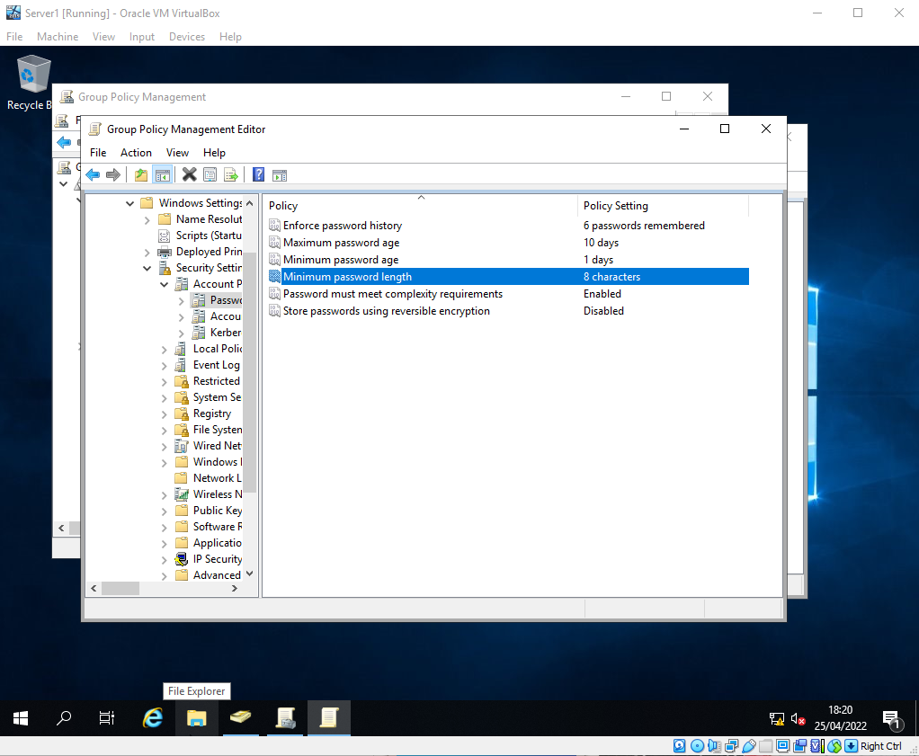
Fig. 26 - Password Policy Configuration
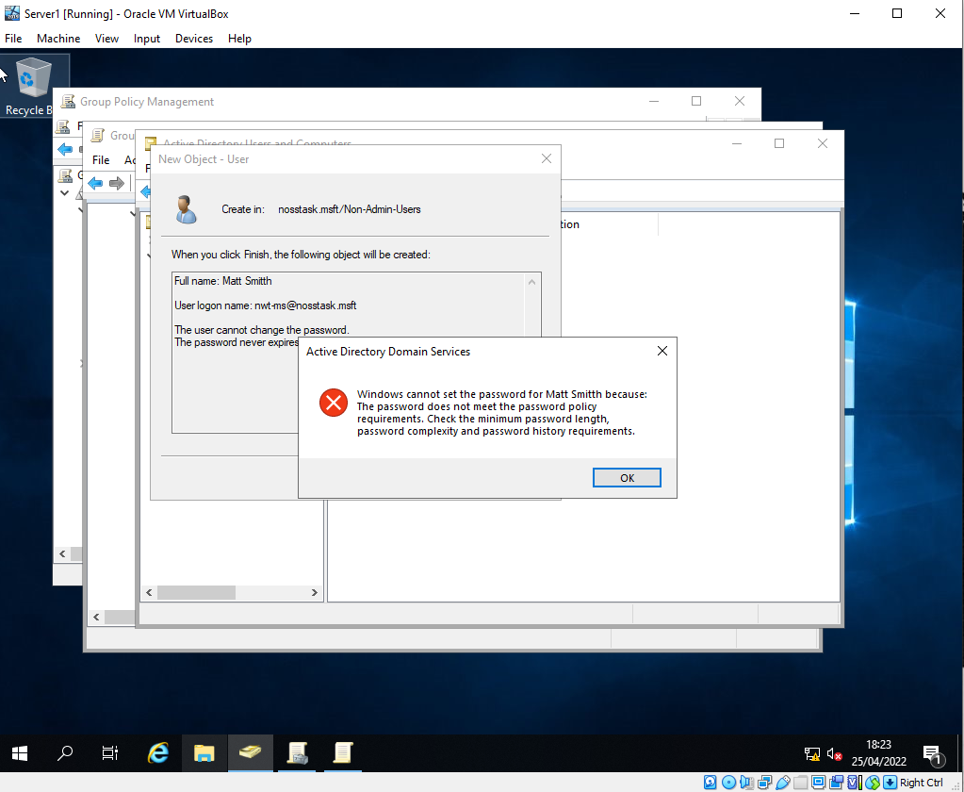
A new user was attempted to be created with a password which would normally pass minimum complexity requirements, but was too short under the new requirements, as is shown below:
Fig. 27 - Attempted User Creation with Inadequate Password

When a suitable password is chosen, the account is able to be created (T1i2a3r4p.) using the passphrase this is a random password with the number integration of 1234. This is shown in Fig. 28
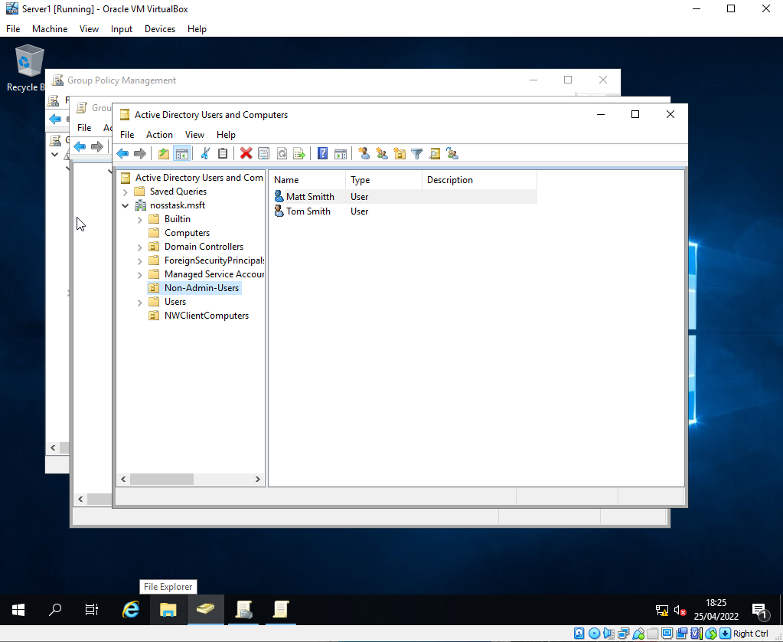
Fig. 28 - User Successfully Created

2. Practical Implementation of Routing and Firewall Configuration
a) Task 2 – ARP and Routing Tables
Server 1 is shown to only currently be aware of 1 other host within the privateNet1 network, and none within publicNet via the ARP table entries shown below:
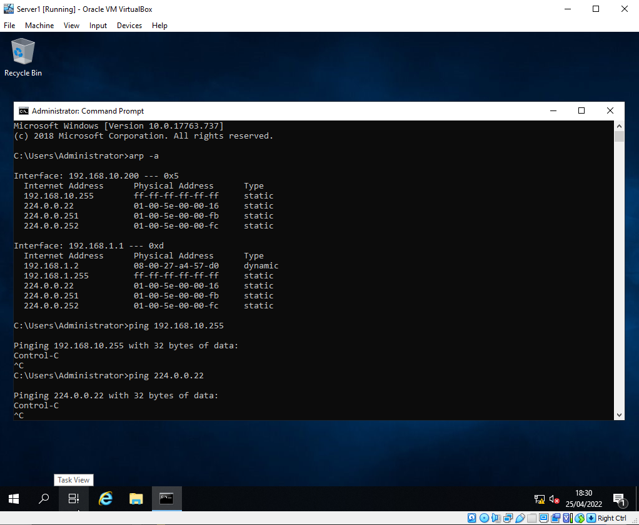
Fig. 29- ARP Command executed on server1

b) Task 2 – FTP Server Setup
Server 2 is configured as an FTP server with the goal of being accessible from all nodes of the combined network through publicNet.
Fig. 30 shows the server selection for installation of the FTP server role.
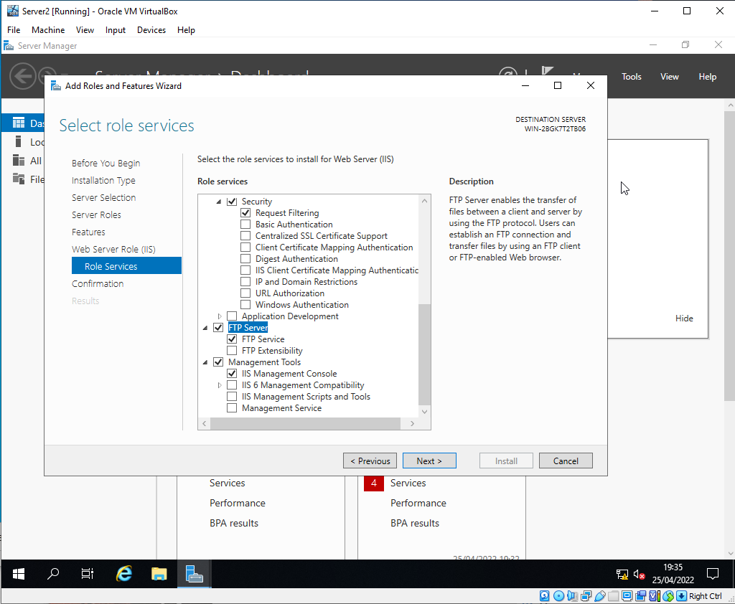
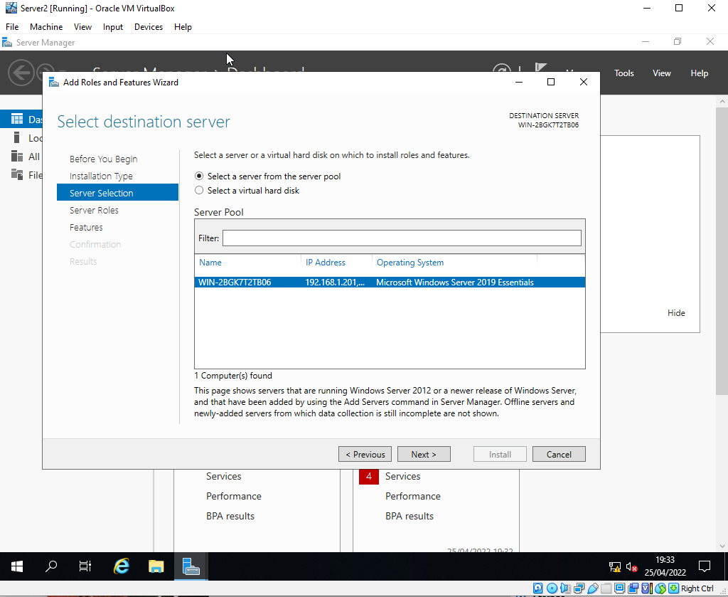
Fig. 31- Features Selection
Fig. 30 - FTP Server Selection

Fig. 31 shows the feature selection of FTP Server and Service during the install.

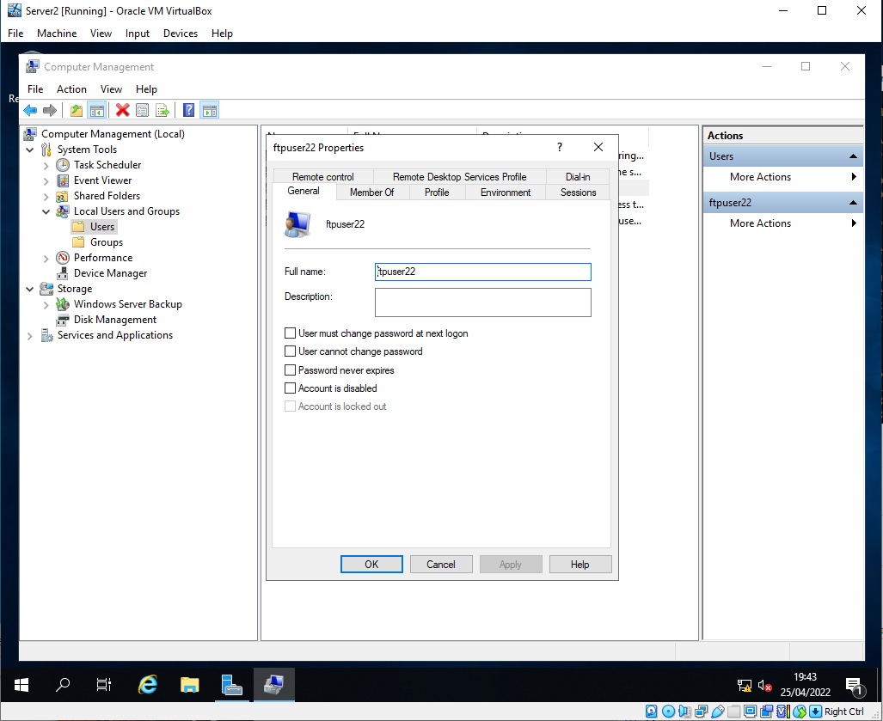
Fig. 32 FTP User Creation
Fig. 32 shows the creation of the FTP user who will be used when access the FTP service.
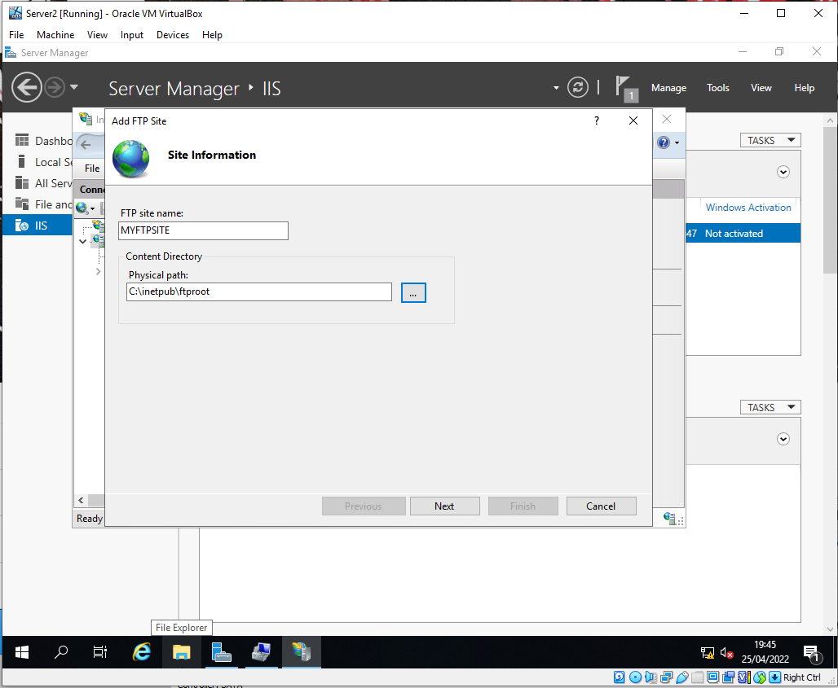
Fig. 33- FTP Root Directory Creation
Fig. 33 demonstrates the creation of the FTP site name and directory within the file structure that will be accessible when using the service.

The use of SSL would remove the need for files to be encrypted at rest and provide a more secure channel in the case that an attacker was present within the network in which the data was passed through various nodes. This is shown later when connecting client 1 to server2 through FTP. If server1 was compromised, any data passed via FTP would be visible. In a production setting, SSL should be enabled to prevent a man in the middle style attack [10].
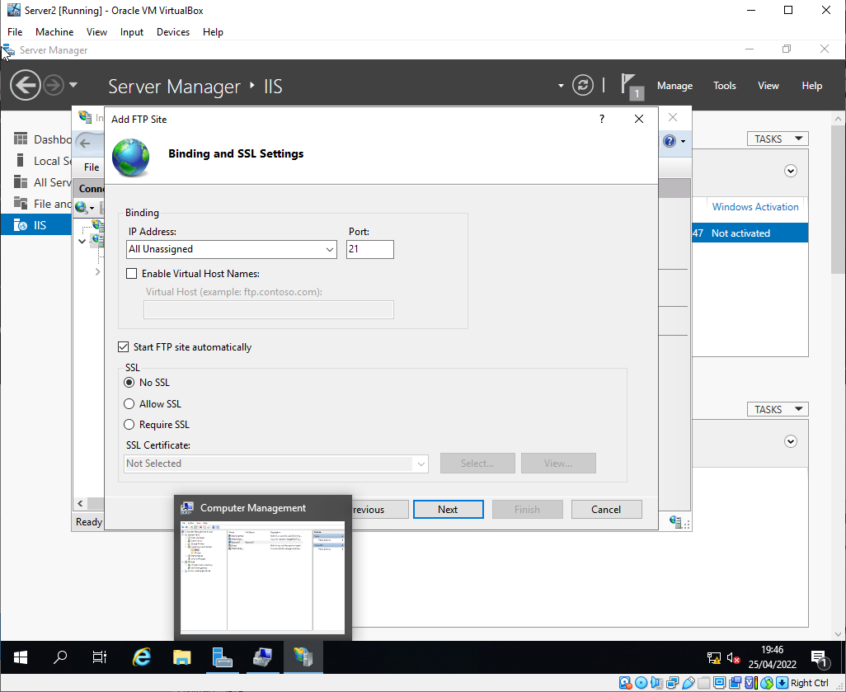

Fig. 5 – SSL Configuration
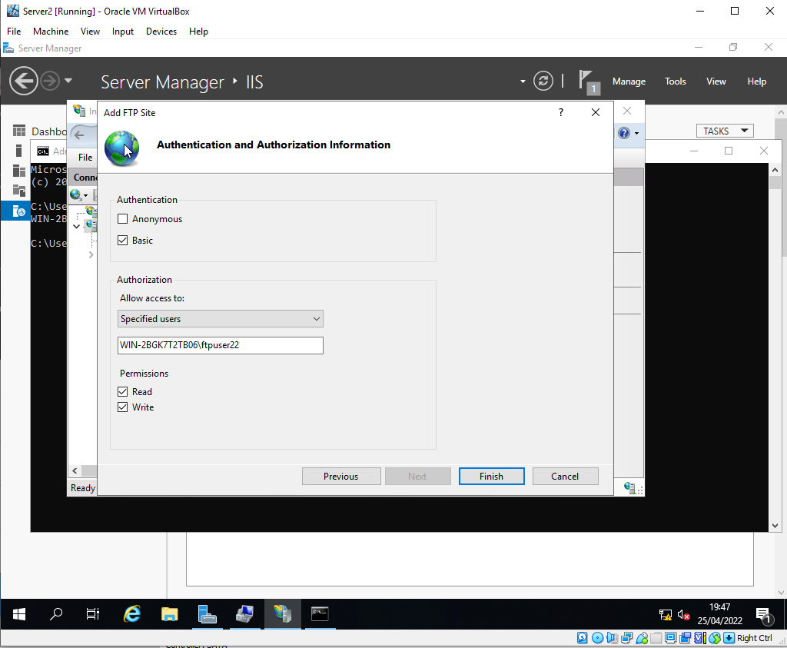
The created user has been assigned to have read and write access to the FTP directory.
Fig. 35 - FTP User Addition
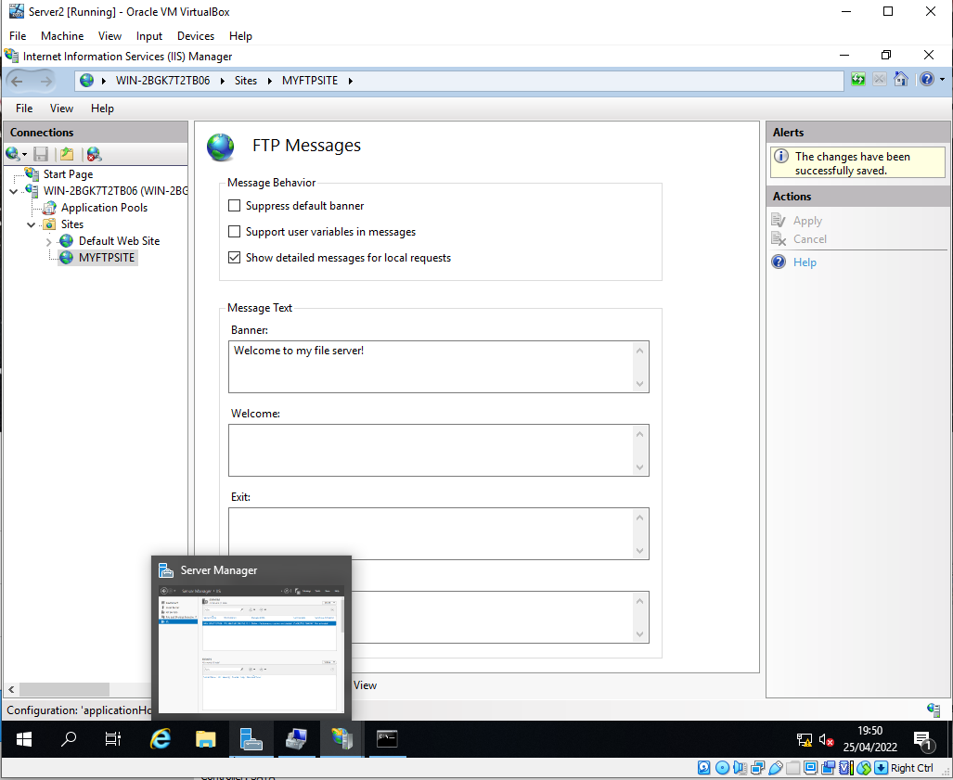
Fig. 36- Banner Creation

A simple banner is added to welcome the user to the FTP server upon a successful FTP request.
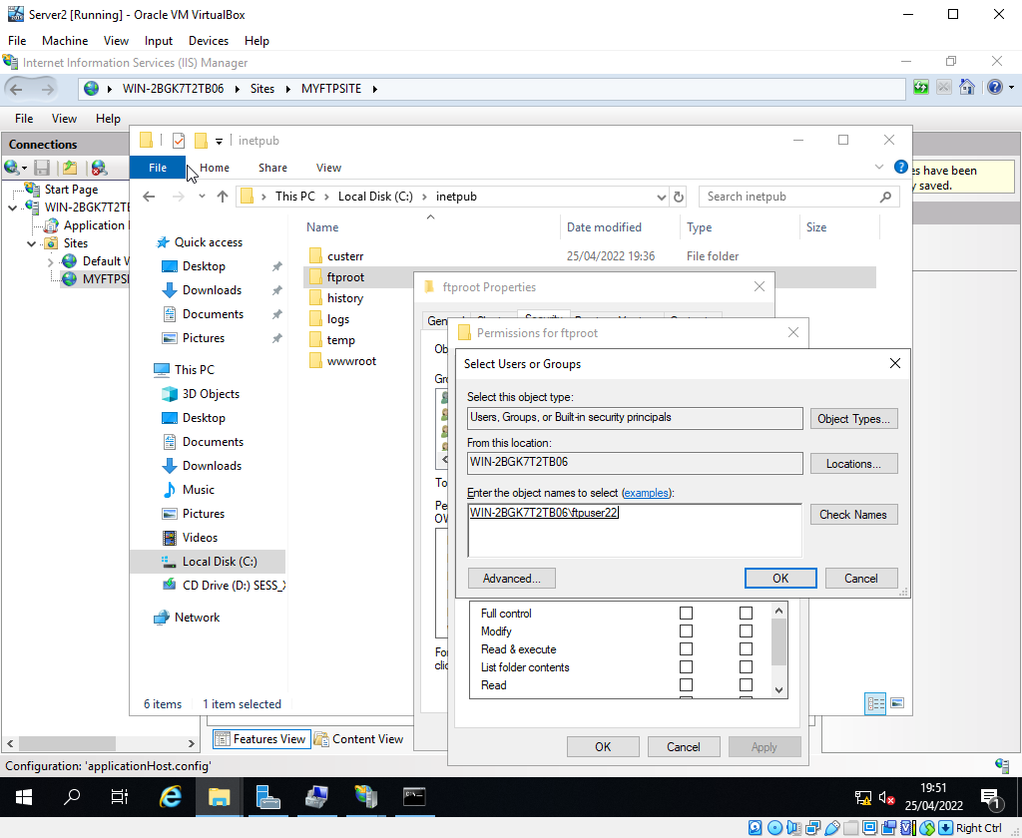
Fig. 37 - FTP User Given Access Privileges on the FTP Directory
A final step is required to allow the FTP user to be able to manage the directory. The user is given full control privileges upon debugging, as shown in Fig. 41.

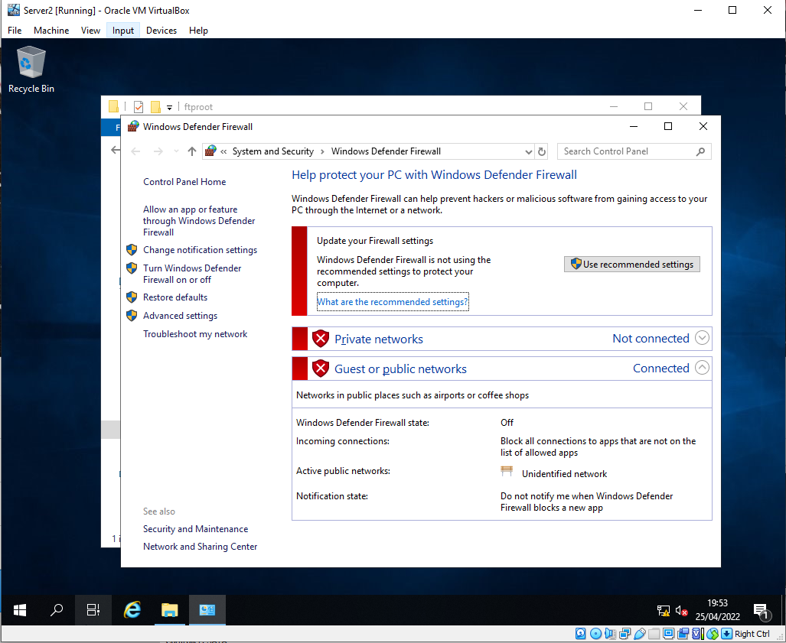
Fig. 38 - Server 2 Firewall Status
Fig. 38 shows Server 2 has had its firewall disabled on all network types for the moment to allow TCP traffic from other hosts to come through to access the FTP service
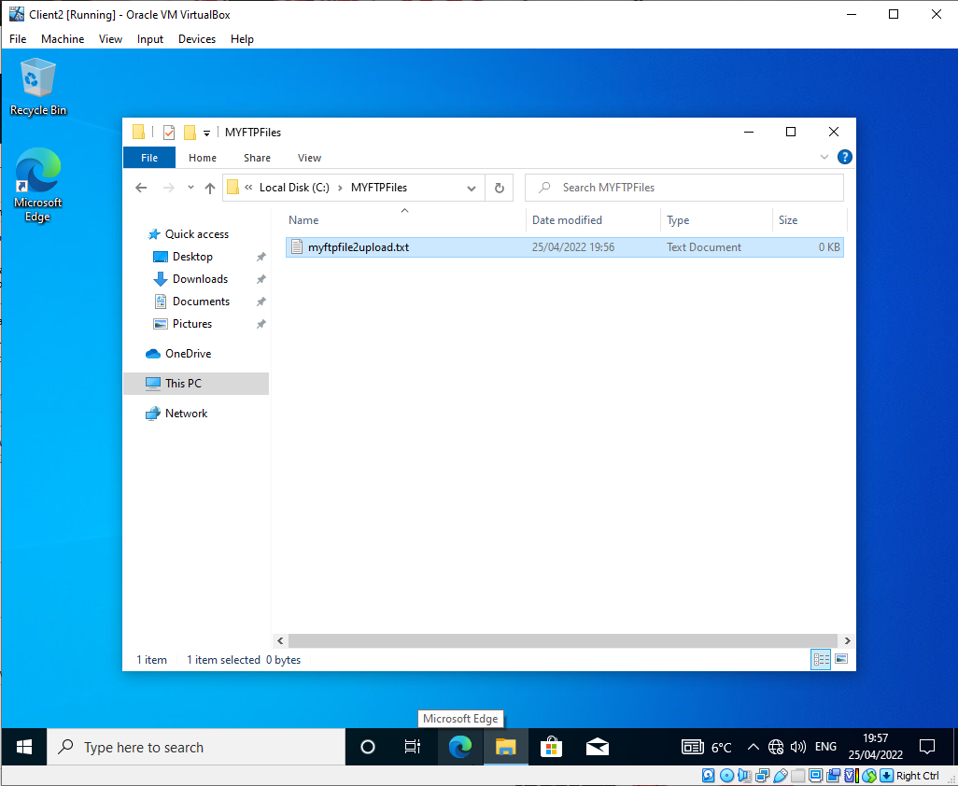
Fig. 39 - Client 2 Test File Created
A test file is created on the server 2 client which will be uploaded to the FTP server (Fig. 39).

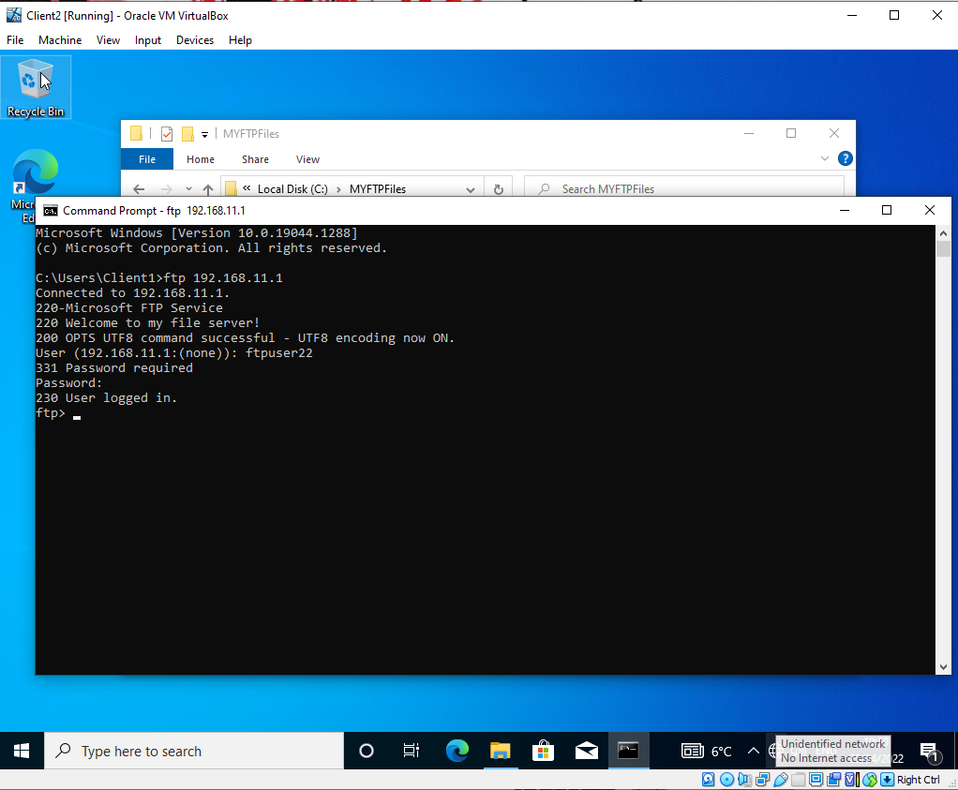
Fig. 40 – Successful FTP Login from Client 2
Fig. 40 shows the successful login of the FTP user from client 2.
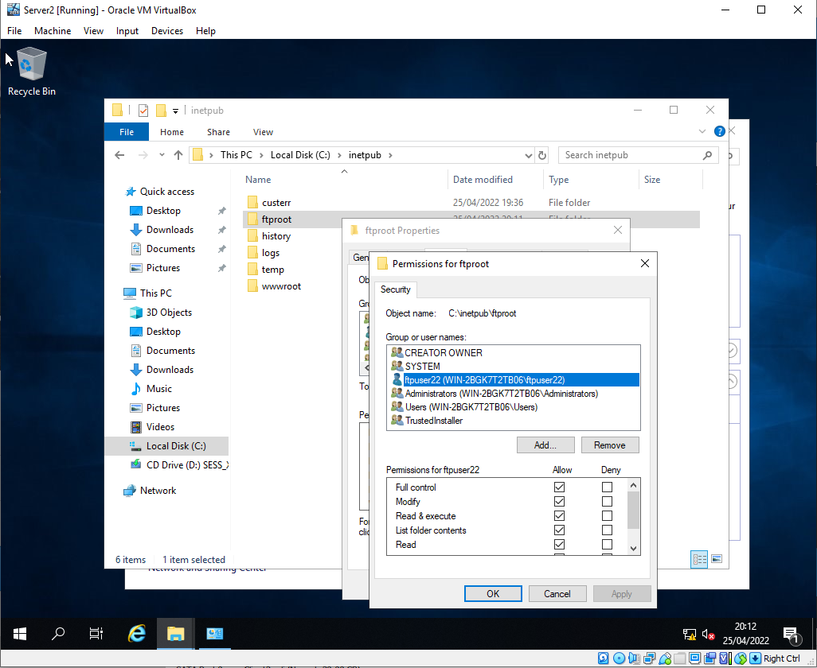
Fig. 41 - Updated Privileges for FTP User

A retroactive update to the permissions of the FTP user allowed for files to be saved to the FTP directory. This was overlooked initially. Fig. 41 shows the new permissions.

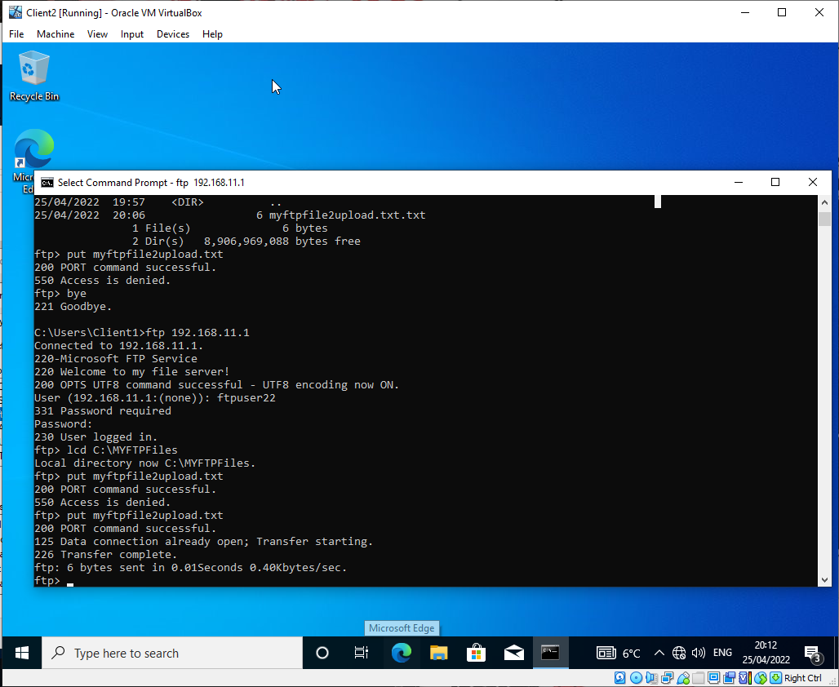
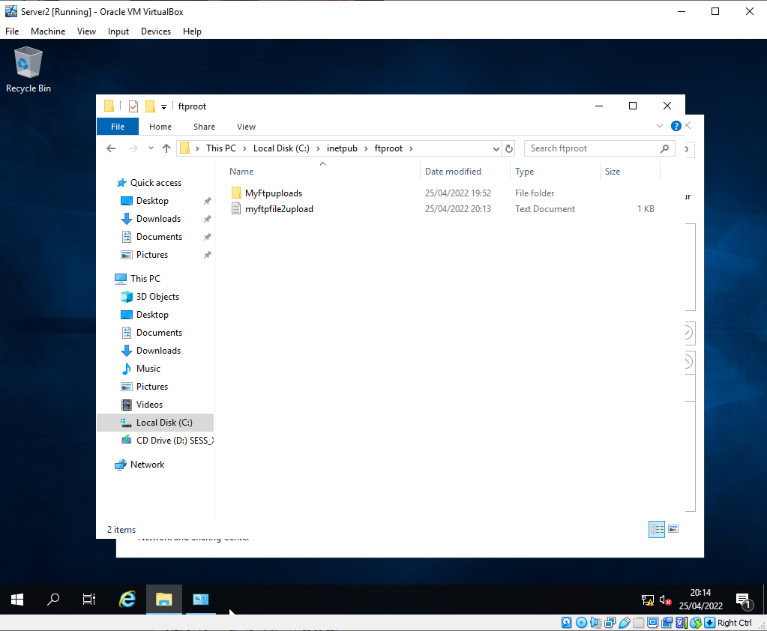
Fig. 42 - File Upload from Client 2 to FTP Server
Fig. 43 - File Shown to be Uploaded to Server 2

It was noticed during testing that the FTP user did not have the appropriate permissions to access the file structure. Once the permissions were correctly assigned, the file was able to be uploaded from Client 2 to the FTP server (Fig. 42).

Fig.43 shows the file is successfully uploaded and is present in the FTP directory on Server 2.

c) Task 2 – Routing Setup
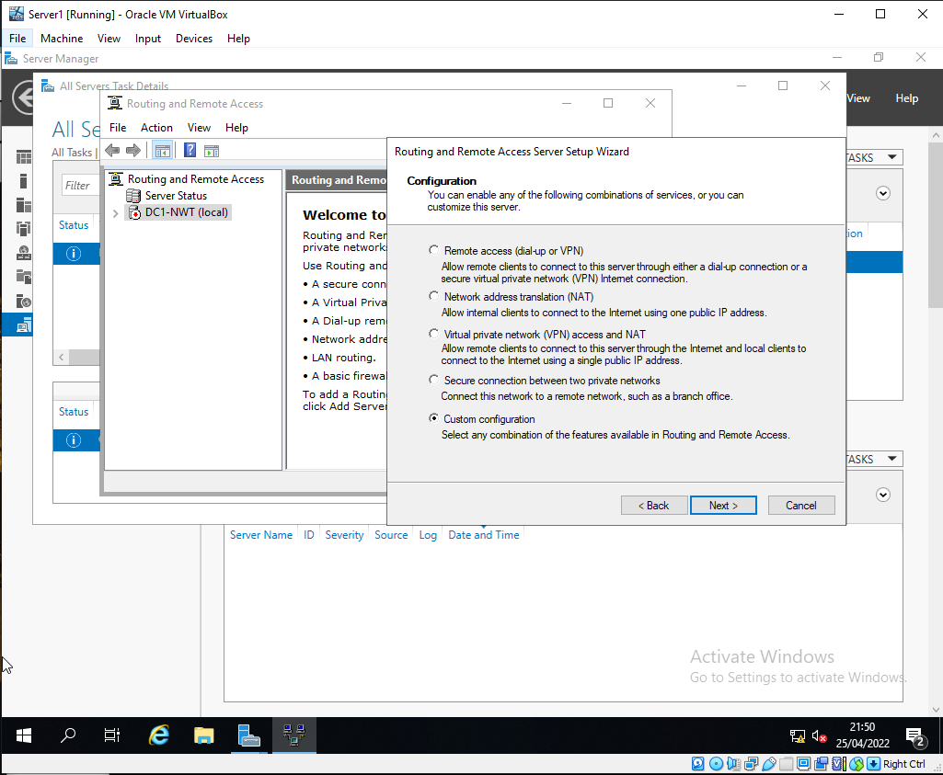
The below 5 figures demonstrate the adequate setup and configurations of routing between Server 1 and Server 2. The servers are made discoverable via the RIPv2 protocol [11] which allows the servers to act as nodes or hoppers within a greater network (WLAN).
Fig. 44 - Custom Selection of Routing Type

For the specific purposes of this network design (local using VMs), a custom configuration is suitable as a simple routing service will be deployed.

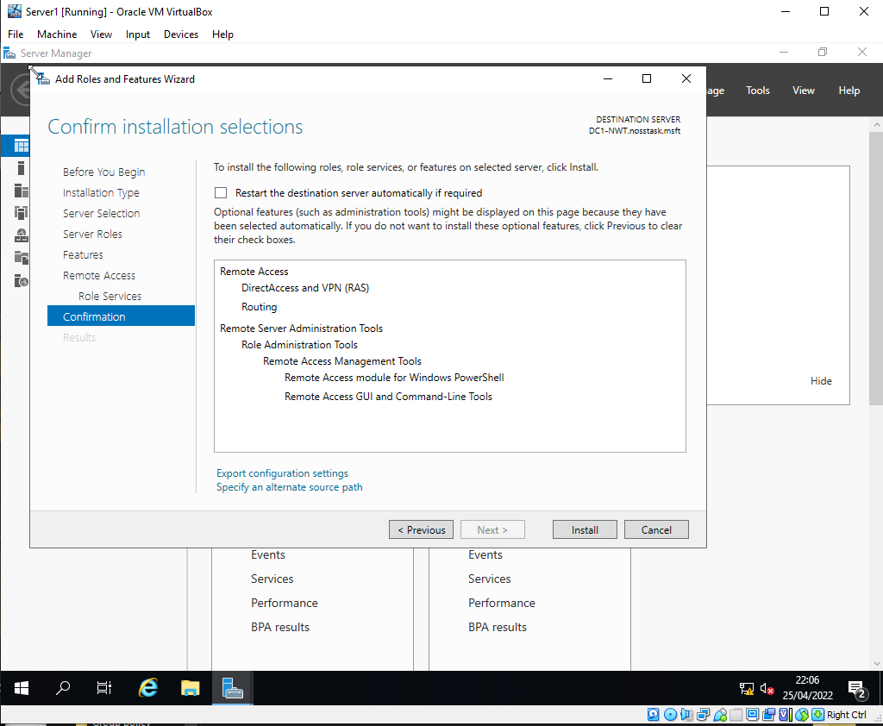
Fig. 45- Server 1 Routing Install

The appropriate features are shown to be installed in Fig. 45. It is necessary to add the routing feature to enable the networking protocols against the network adapters.

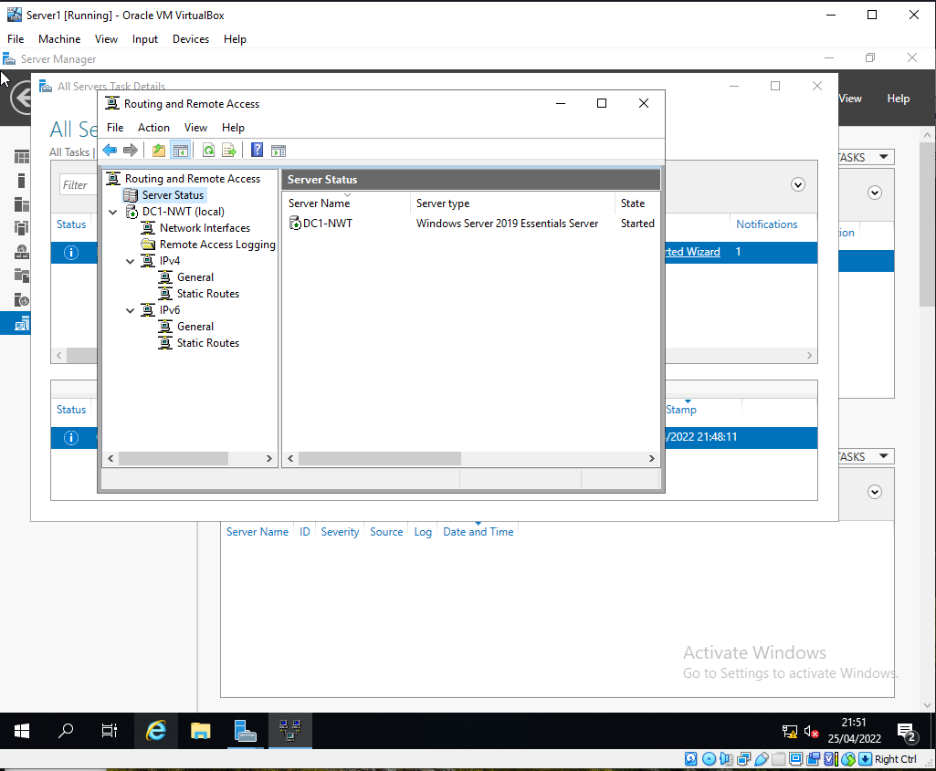

Fig. 46 - Server 1 Routing and Remote Access Service is Running

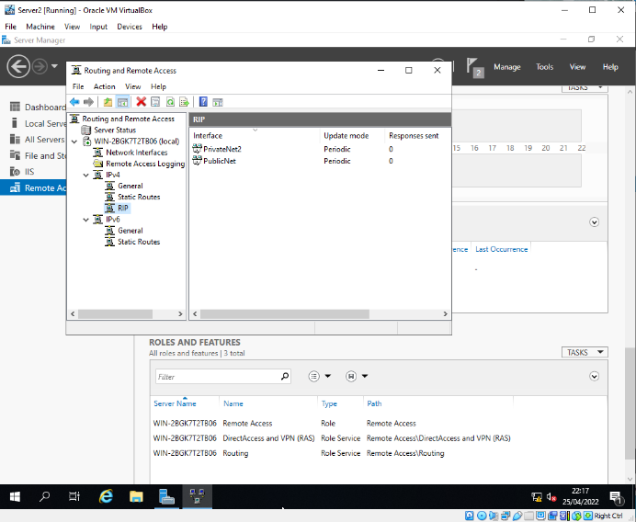
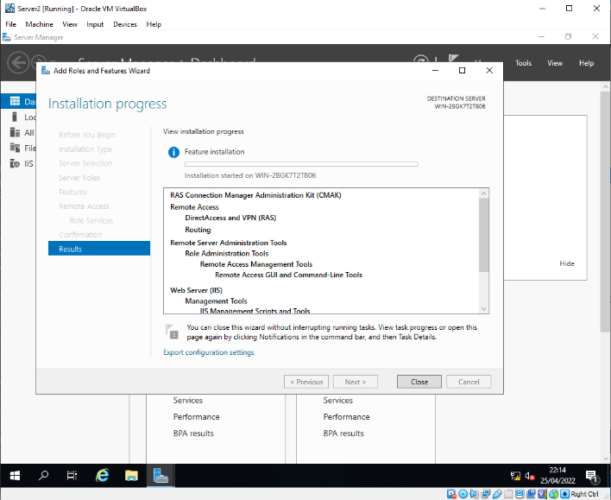
Fig. 46 shows the routing service correctly running prior to the network protocol being configured. Both network adapters were enabled to use the RIPv2 protocol
Fig. 48 - Server 2 RIPv2 Configuration
Fig. 47 - Server 2 Final Installation

Figs. 47 and 48 demonstrate the correct matching configuration on Server 2 as was previously shown on Server 1. These Servers should now be able to discover each other. This is detailed in Fig. 49. By extension, Client 1 should be able to ping Client 2 via privateNet1 through publicNet and privateNet2. This is shown in Fig. 50

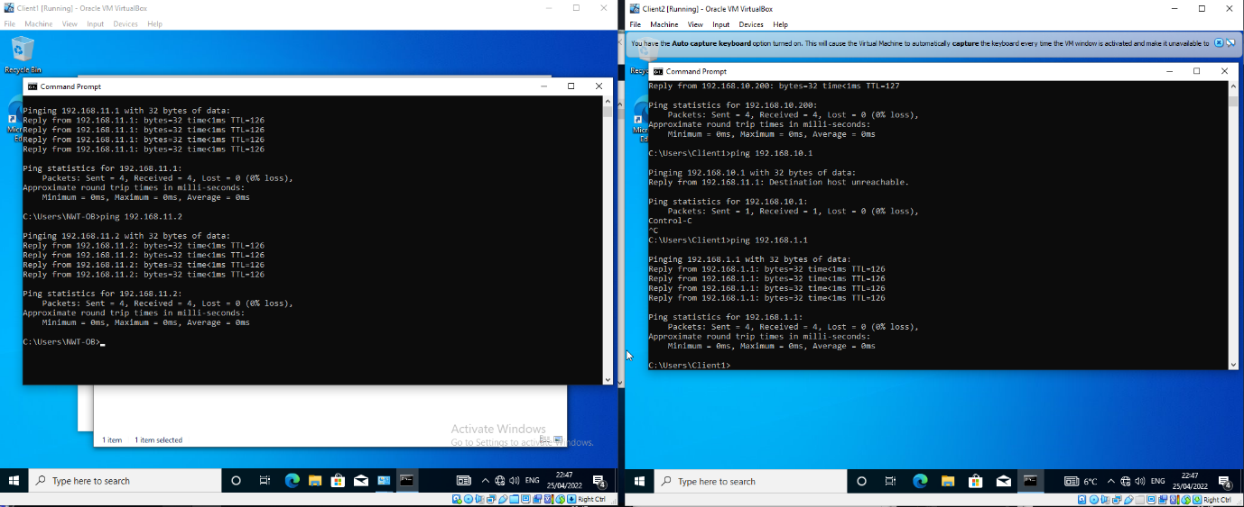

Fig. 49 - Servers can Ping Each other
Fig. 60 - Client 1 can Ping Client 2

d) Task 2 – Firewall Configuration
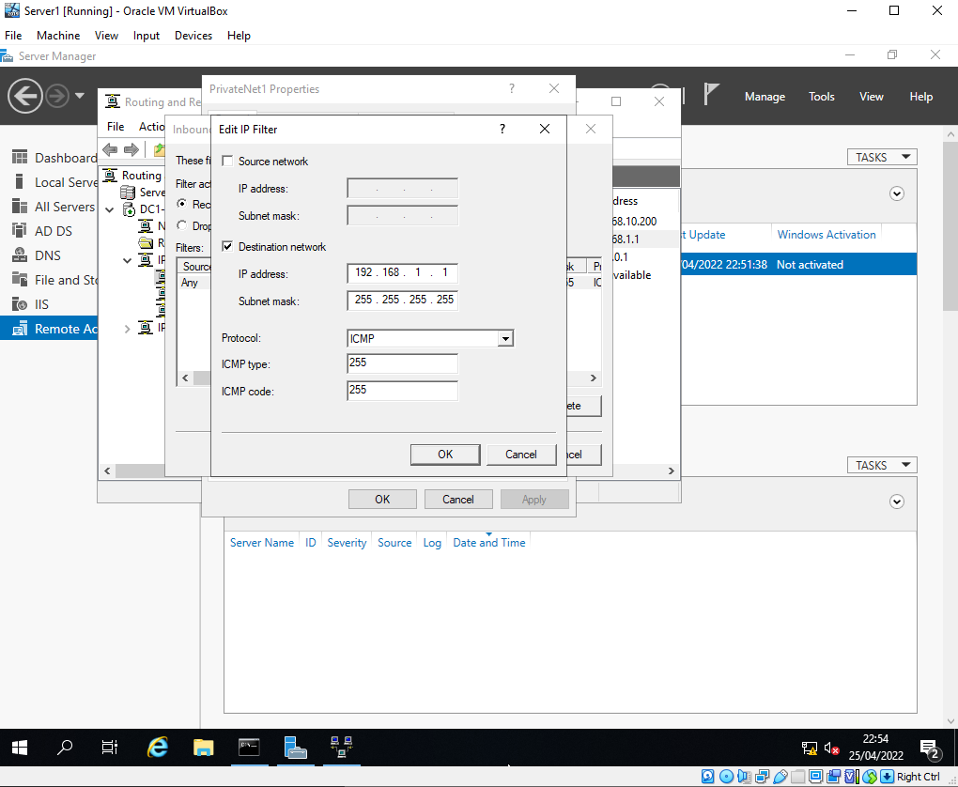
Outbound software firewall rules are configured on the Server 1 VM to restrict certain types of traffic through the node.
Fig. 51 - Outbound ICMP Traffic Denied

Outbound ICMP traffic is blocked going to Server 1 from all sources. Shown below in Fig.52, 53 is that the node will still function as a hop [A] location, however it will no longer accept incoming ICMP traffic where the destination is the node itself.
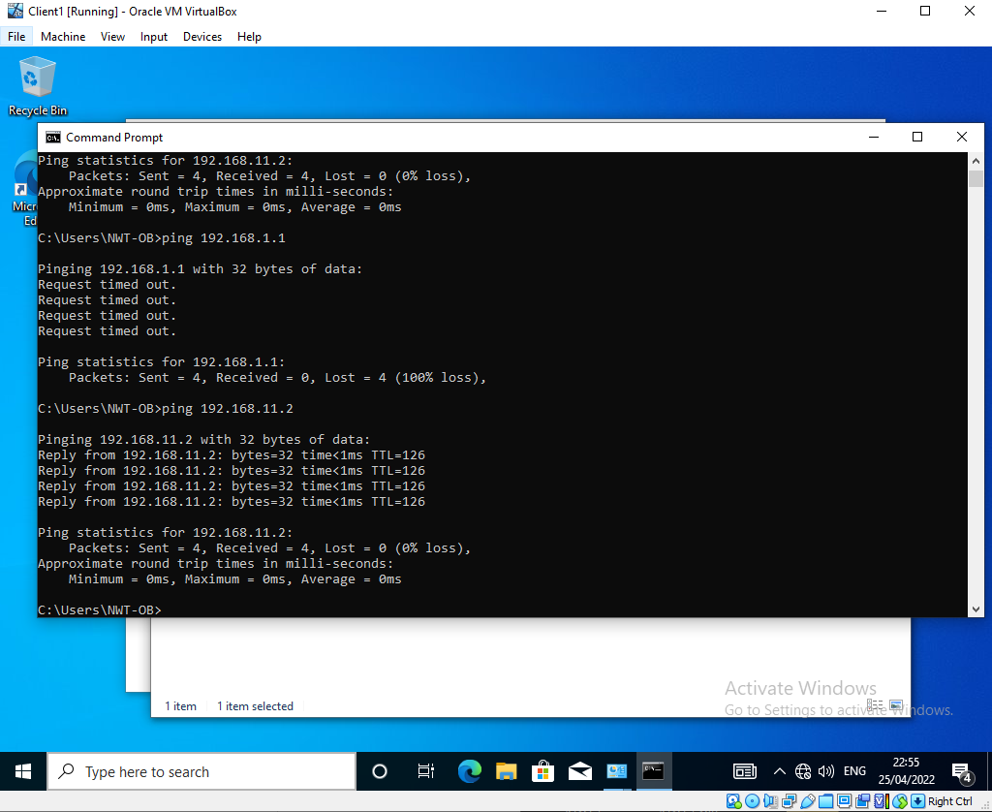
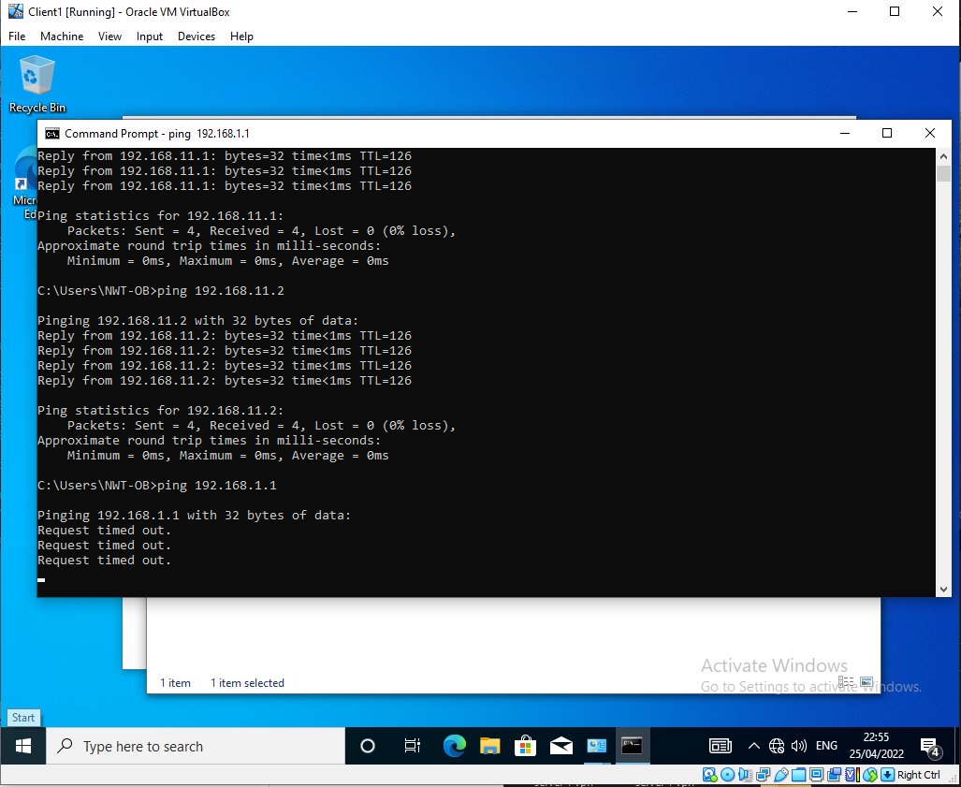
Fig. 52 - Client 1 Is Unable to Ping Server 1
Fig. 53- Client 1 is Able to Ping Client 2 Through the Server 1 Firewall
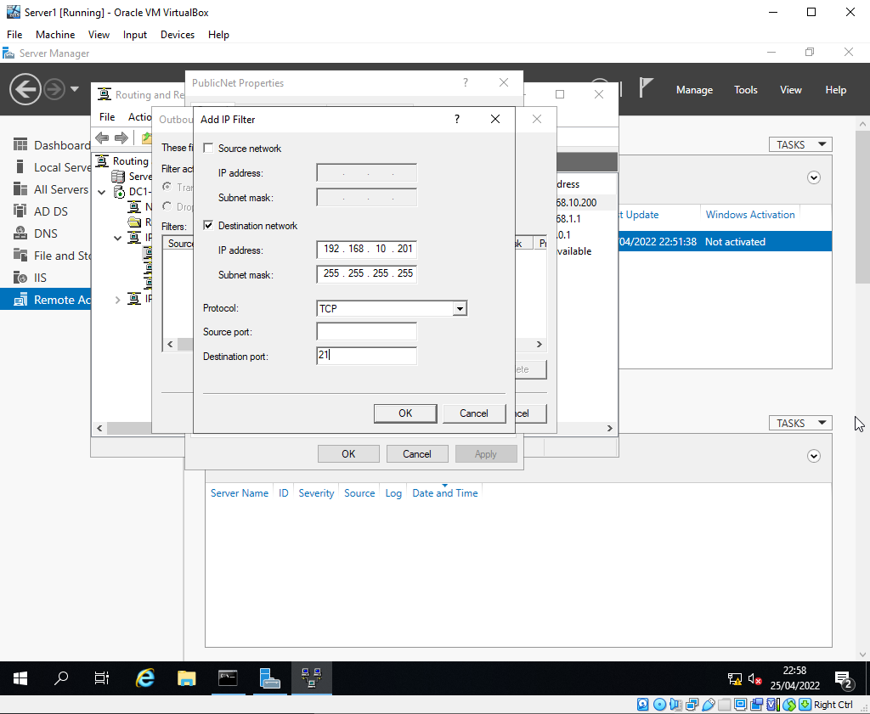

Fig. 54 - Server 1 FTP restriction

Fig. 54 shows a unilateral firewall rule to block connections to Server 2 targeting the FTP port (FTP runs on port 21 by convention)
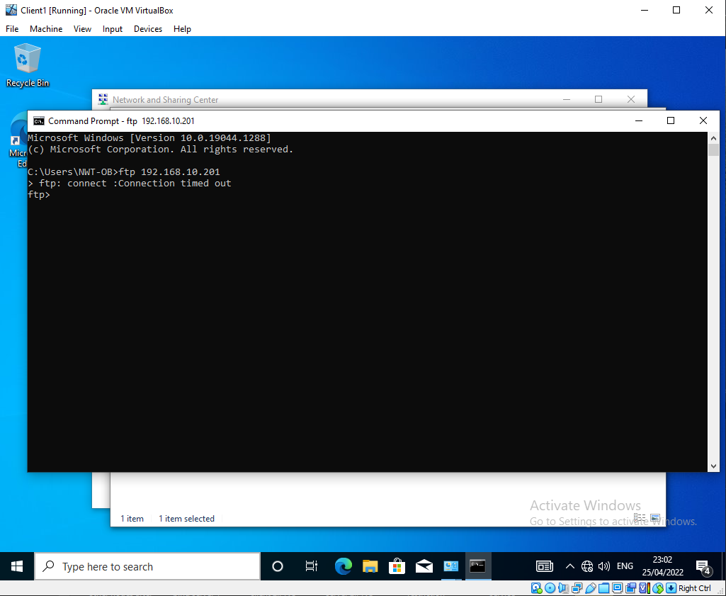
Fig. 55 - Client 1 Cannot FTP to Server 2

Due to the above firewall rule, no client can connect through Server 1 to the FTP service on Server 2. This is demonstrated above in Fig. 55.

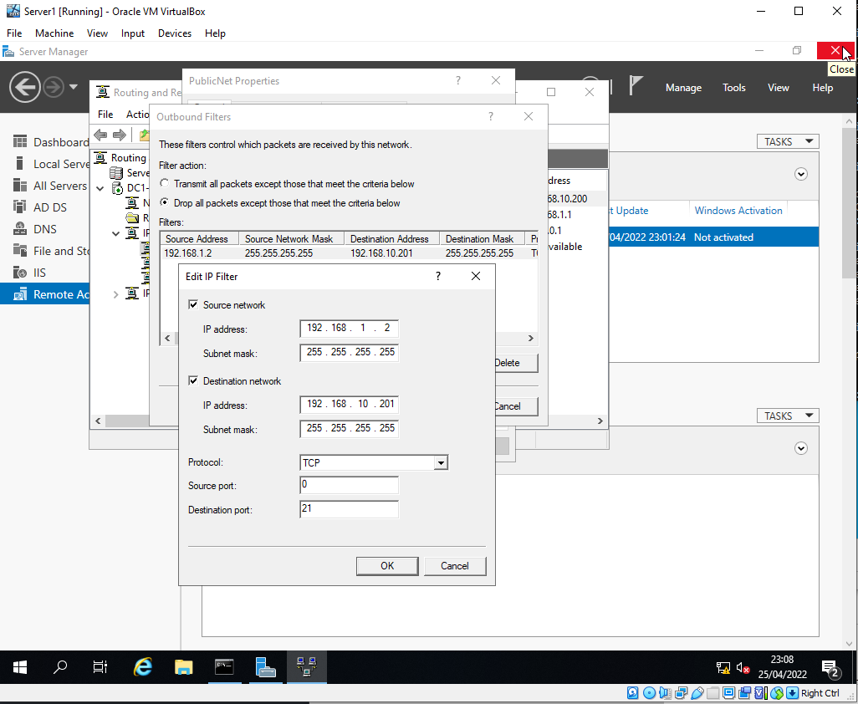
Fig. 56 Custom Firewall Rule Granting Permission for Client 1 to Use FTP against Server 2

The above firewall rule works by dropping all packets unless they originate from Client 1 and are targeting Server 2 on port 21.
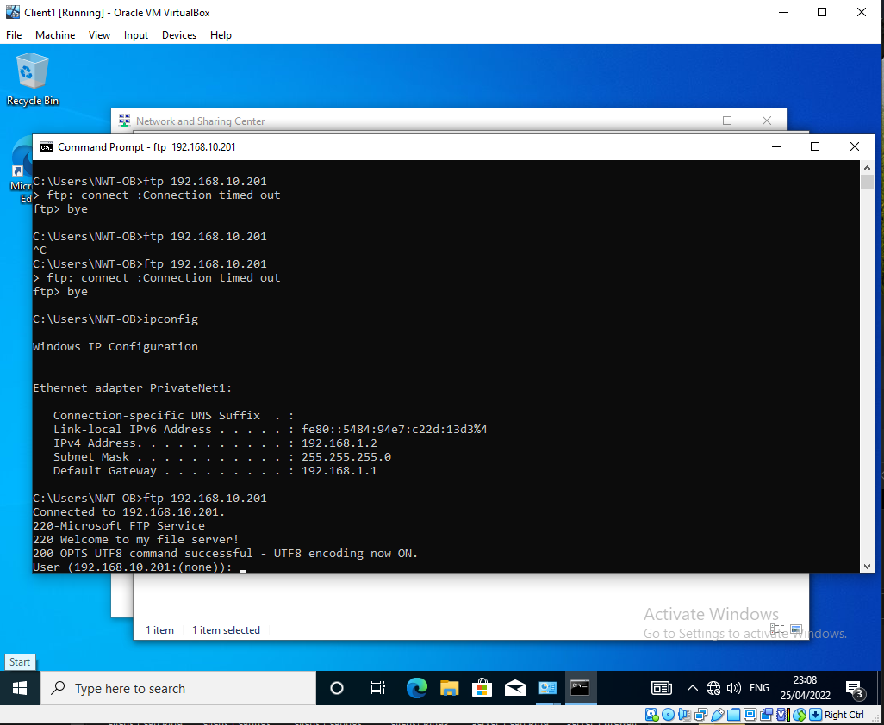
As is shown in the below Figs, Client 1 is able to now FTP to Server 2, while Server 1 is unable to:
Fig. 57 - Client 1 Successfully FTPs to Server 2
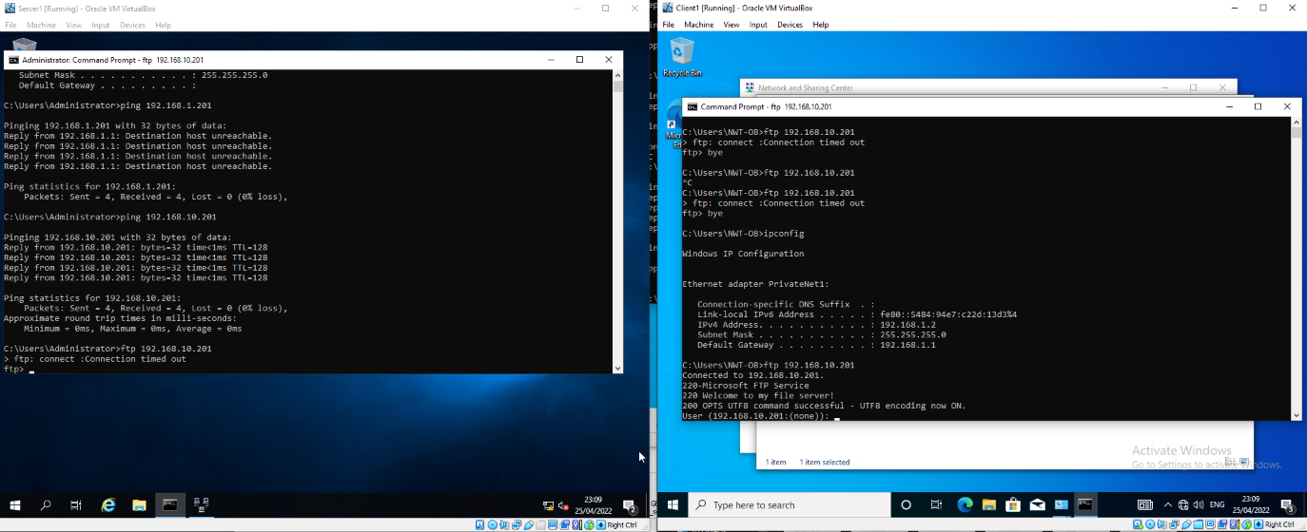
Fig. 58 Server 1 Cannot FTP to Server 2 whilst Client 1 Is

2) Observational Tasks
a) Password Policy
A sound password policy makes offline password cracking difficult if enacted in a strong manor. For a random string of 8 digits (26 letters of the alphabet in caps and non-caps, 10 single digits and 34 possible special characters) summing 96 possible values per character, there are 7.2x10^15 possible combinations. For a complex password such as this, it is found in [12] to average as the maximum possible time / 2 to crack given any speed of cracking software.[12] also postulates that the effectiveness of password expiration policies is caveated with the assumption that attackers have not attempted to compromise the system in any other way other than attempted a password crack e.g. the cases that a backdoor, malware such as keyloggers etc have been administered to a system, the enforcement of password updates are ineffective security solutions.
The goal of suitable password policy is to obfuscate obvious information attributed to a given user with a password such that it appears random. By increasing the length, individual complexity, number of possible characters etc, the number of permutations of the end password increases massively. [13] details how modern password cracking tools can use information about the user to greatly reduce the number of attempts to crack a password, as users tend to create passwords using information they would know and would be easy to retrieve [14]. It is evident then that a password policy should attempt to minimise the prevalence of complete words, either by the encouragement of a pass phrase which would be harder to guess, randomised numbers which would not be known to an attacker, and a selection of symbols to offset an obvious phrase (e.g., changing letters to numbers).
b) High Availability
i) Importance
High / continuous availability (H/CA) is critically important both within an enterprise network and for any given service. HA allows for applications and services to stay accessible in the case that one or many of the servers providing a service suffers an outage or error, by distributing the work / service infrastructure across multiple servers (nodes).
ii) Considerations
A number of considerations must be made when choosing to deploy either a failover cluster or make additions to an existing cluster to deploy a HA solution:
- Storage – Consideration of how information will be shared between nodes is extremely important. Whether nodes have their own unique storage or access a shared storage solution (SAN) will drastically affect the overall design of a cluster. Furthermore, in the case that local storage is per node, how this is ultimately stored is also a consideration (e.g., a RAID solution). In the case that the storage fails, a backup must be present in the form of either a direct mirror, or the last stable point in the case of corruption.
- Spreading – In the case that a node fails, a cluster controller or affected node must be able to isolate the failure to stop it from spreading. E.g., malware, system overload, cyber-attack, physical issues (fire etc).
- Deployment – How updates are deployed to both the active and backup nodes of a HA cluster are extremely important. E.g., are nodes be updated at once, or should they be staggered etc, with the backups/failovers not being updated until the primary service nodes are known to be stable. A plan for this must be drawn up prior to the deployment of any software patches / updates.
- Mirroring – How data and systems should be managed with respect to each other must also be considered. Data mirroring [B] and HA must be considered in tandem for certain applications in the case of databases (either data is mirrored synchronously to a backup, is fragmented across multiple nodes or is synced to a backup on delay). The same must be said for service nodes. E.g., should noes be configured as a master and slave [C] configuration, will they be synchronously updated with application states, or should there be a delay?
Often in the case with HA, cloud solutions offer baked in systems to allow for this. Both GCP [15] and AWS [16] offer services to allow for HA via data mirroring, availability zones [D] and elastic computing [E] .
Windows Server 2008 and onwards is able to deploy failover / HA capabilities via the ‘Failover Cluster Server’ feature. This allows core windows server functionality to be distributed across a cluster for a given service. Fig. 59 details all possible windows services which can be integrated using the failover cluster feature:

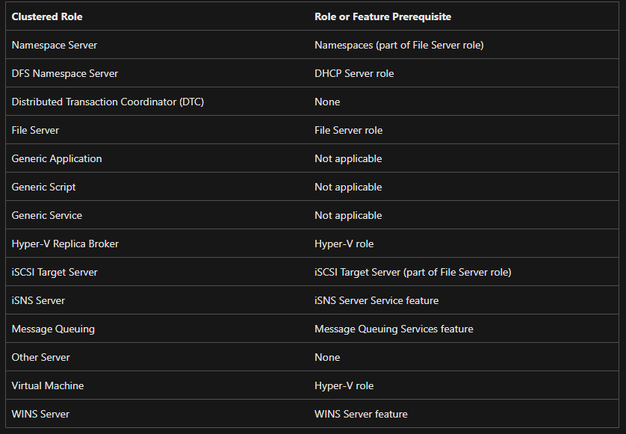
Fig. 59 - Possible Windows Server Features Available through Failover Clustering [17]
It is noted that the Active directory Service is missing from this list. [18] describes that having multiple domain controllers acts in the same way as HA and it is therefore not required. In the case that it is needed, a server can be promoted to a domain controller.
Due to non-described technical issues, the installation of the Failover Clustering feature was impossible on all VMs as is shown in Fig. 60. The option to install the feature should have been present within this list.
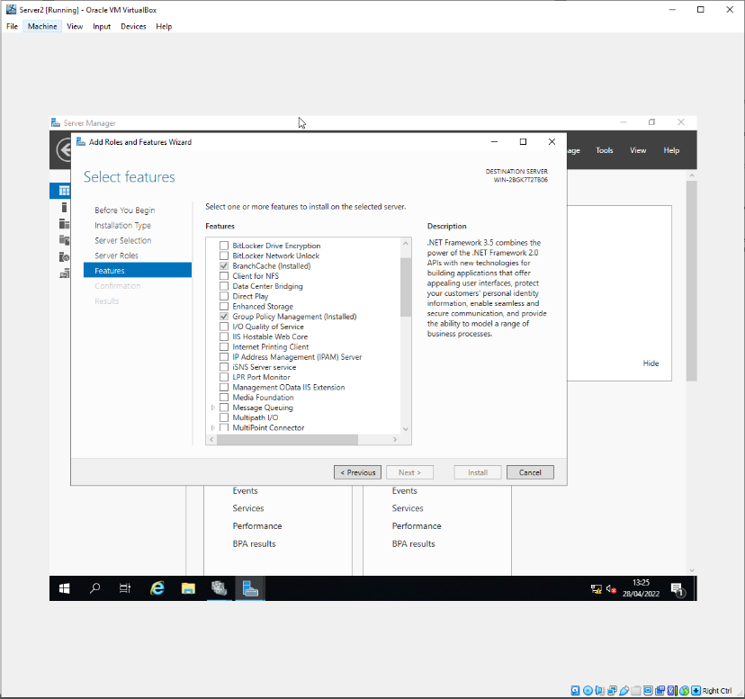
Fig. 60- Failover Clustering Features Could Not Be Installed

Following [17], the generic steps to install failover clustering services are as follows:
- Verify all planned cluster nodes meet [19].
- Ensure the failover clustering feature is installed on each node
- *Optional but highly recommended: Add all nodes to a new OU to manage group policies
- Run cluster validation tests from a node with the Failover Cluster Management Tools shown (Fig.61) by adding all nodes to the node list.
- Create the cluster once all the tests have passed by adding all planned nodes to the node list
- Assign storage to the cluster via the confirmation page
- Install the required roles from Fig. 59 on each node within the cluster
- Configure each node with its new role via the Failover Cluster Manager
This service does not follow the master and slave model. All nodes store the configuration of the cluster, and any changes are immediately propagated through the network. This must be noted prior to the deployment of a failover cluster [20].
c) Enterprise Network Design
i) Network Overview
A simple physical network diagram has been created to model an example layout of the network [21]. This design is not exhaustive of all possible services and servers which could be run on the network, however, gives a general overview of the basic structure.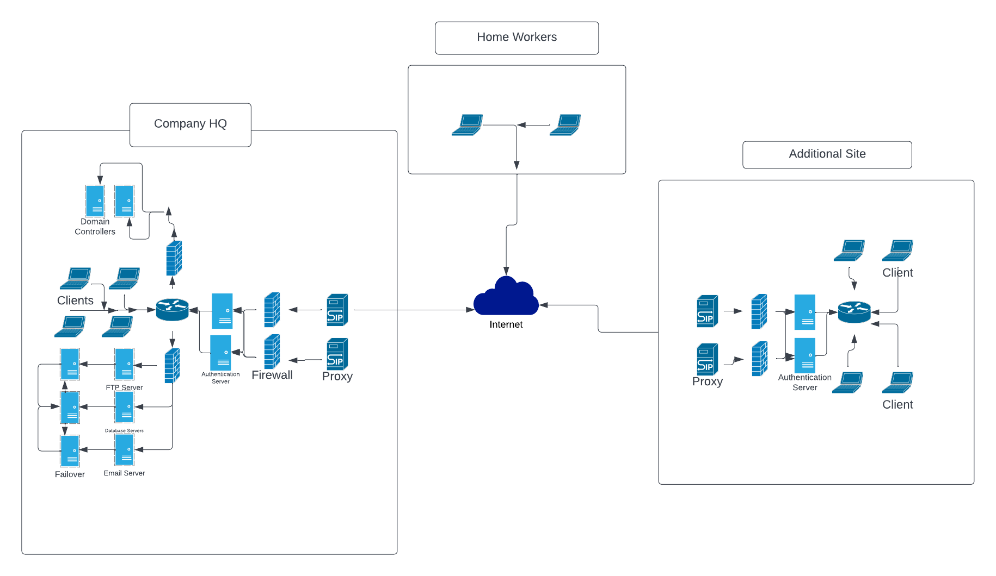
Fig. 61 - Simple Corporate Network Design

Key features to consider for the network are shown below:
- Proxies – The proxies are used to obfuscate the internal information about the network and to filter traffic entering the network and exiting on a case-by-case basis. The corporate VPN server also resides here.
- Outmost firewalls – configured to use a company certificate to access the authentication server process behind it, filtering any unwanted traffic or rejected login / access attempts.
- Authentication Servers (NAS) – Behind the outermost firewall, users must then authenticate the users via their company logic credentials to ensure their identity and verify that they fit against the network policy.
- Failover – All critical business applications [F] are made part of a failover cluster to maximise their uptime. In the case of failure, traffic is routed to the failover devices. These are hosting SMTP, FTP and database services.
- VPN – All connections in and out of each network make use of a VPN service residing in the same layer as the proxy
ii) Network Policy
A simple network policy to maximise security and data protection should contain:
- An acceptable user policy for users of both clients and server systems.
- Disclaimers from the business regarding the use of their systems and the consequences for misuse.
- Access policies and group management of users and computers via Active Directory following the principle of least privilege (PLP) [22]. This means for all objects within the domain, users and groups should be granted permissions and constructed only with their specific purpose in mind. These policies are dynamic and should be updated and audited frequently. As shown within Task 1 many client and server-based security policies should be introduced governing various types of access. [22] implies that roles should only be applied to users and machines for the specific work they must undertake, i.e normal workers do not need administrator access, all traffic must be sent through the corporate proxy, only security analysts need access to log reports etc.
- Application polices to denote importance of traffic within the network
- Routing policies to denote how users and applications should be routed through the network [23]. For example, the router should correctly route traffic to the associated services and users.
- Methods of setup prior to their first connection to the network, i.e their machine name should already exist within AD prior to joining. As part of joining the network, the user should supply their device name against a previously generated list hosted in a computer OU within AD.
iii) Security
Many security considerations must be made to minimise the chances of exploitation and attack.
A dedicated security team should be employed to maintain the network and to ensure polices are enforced and acted upon.
All devices connected to the network should be equipped with an EDR solution [G] to minimise threats from known vulnerabilities and to monitor device activity. Examples such as BitDefender [24]and Crowdstrike [25] are proposed. Data from these applications should be fed into a SIEM [H] which is monitored by the security team, such as IBM QRadar. Finally, a SOAR [I] should be introduced to automatically respond to found security issues in the case they are highlighted within the SIEM.
Strict Firewall rules should be introduced between sections of the network following PLP to only allow traffic to an associated server that the server is capable of dealing with. Moreover, the firewall should enforce authentication of users to services which they require e.g., a standard user should not be able to SSH to one of the email servers.
In general, all devices should use the following security measures (if applicable):
- Disk encryption using Windows BitLocker
- EDR solution connected to the enterprise SIEM
- All un-necessary ports should be closed, along with necessary ports being closed when not in use.
- All user action on a server or client should be logged as part of the SIEM
- Authentication errors should cause a lockout of a device and should alert the security team in the case of repeat offences.
- Devices should be able to be force disconnected from the network and able to be remote wiped should they need to.

References

[1] | NTFS.com, "Explicit vs. Inherited Permissions," 2022. [Online]. Available: https://www.ntfs.com/ntfs-permissions-explicit.htm. [Accessed 20 03 2022].
[2] | Microsoft, "Enable access-based enumeration on a namespace," 29 07 2021. [Online]. Available: https://docs.microsoft.com/en-us/windows-server/storage/dfs-namespaces/enable-access-based-enumeration-on-a-namespace. [Accessed 22 03 2022].
[3] | J. Boyce, "Configure cache settings for shared folders in Windows 2000," TechRepublic, 14 03 2005. [Online]. Available: https://www.techrepublic.com/article/configure-cache-settings-for-shared-folders-in-windows-2000/#:~:text=Use%20this%20option%20for%20programs,copies%20stored%20on%20the%20server.. [Accessed 22 03 2022].
[4] | M. Minasi, in Mastering Windows Server 2012, Wiley-Blackwell, 2013, p. 467.
[5] | National Institute of Electronics - India, "Control Panel," 27 03 2020. [Online]. Available: https://www.nielit.gov.in/gorakhpur/sites/default/files/Gorakhpur/olevel_1_ittnb_b4_27mar_AKT.pdf. [Accessed 25 03 2022].
[6] | O. Benedict, "Spot Insider Threats: 10 Commands Commonly Used During the Cyber Attack Cycle," 14 2 17. [Online]. Available: https://www.cyberark.com/resources/blog/spot-insider-threats-10-commands-commonly-used-during-the-cyber-attack-cycle. [Accessed 25 03 2022].
[7] | A. Zola, "hot swap," 11 2021. [Online]. Available: https://www.techtarget.com/whatis/definition/hot-swap#:~:text=What%20is%20hot%20swappable%3F,boards%2C%20hard%20drives%2C%20etc.. [Accessed 26 03 2022].
[8] | REPAIR WINDOWS, "How to Disable USB Storage Devices in Windows 10/8/7 OS.," [Online]. Available: https://www.repairwin.com/how-to-disable-usb-storage-devices-in-windows-10-8-7-os/. [Accessed 26 03 2022].
[9] | Microsoft, "Password must meet complexity requirements," 08 03 2022. [Online]. Available: https://docs.microsoft.com/en-us/windows/security/threat-protection/security-policy-settings/password-must-meet-complexity-requirements. [Accessed 27 03 2022].
[10] | Y.-H. W. C.-L. Huang, "An improved FTP system based on SSL encryption tunnel," in IEEE 10th Consumer Communications and Networking Conference (CCNC), Las Vegas, 2013.
[11] | D. L. Shinder and L. Hunter, MCSA Exam Study Guide, Syngress, 2003.
[12] | S. Chiasson and P. van Oorschot, "Quantifying the security advantage of password expiration policies," Designs, Codes and Cryptography, vol. 77, no. 5, pp. 401-408, 2015.
[13] | R. Shi, Y. Zhou, Y. Li and W. Han, "Understanding Offline Password-Cracking Methods: A Large-Scale Empirical Study," in Security and Communication Networks, London, 2021.
[14] | T. I. Tanni and T. Taharat, "Is My Password Strong Enough?: A Study on User," School of Science and Engineering, University of Liberal Arts Bangladesh, Dhaka-1209, Bangladesh, Bangladesh , 2021.
[15] | Google, "Regions and zone," 08 04 2022. [Online]. Available: https://cloud.google.com/compute/docs/regions-zones. [Accessed 08 04 2022].
[16] | Amazon Web Services, "Regions and Availability Zones," 2022. [Online]. Available: https://aws.amazon.com/about-aws/global-infrastructure/regions_az/. [Accessed 08 04 2022].
[17] | Microsoft, "Create a failover cluster," 11 02 2022. [Online]. Available: https://docs.microsoft.com/en-us/windows-server/failover-clustering/create-failover-cluster#install-the-failover-clustering-feature. [Accessed 09 04 2022].
[18] | Microsoft, "How to use Windows Server cluster nodes as domain controllers," 24 09 2021. [Online]. Available: https://docs.microsoft.com/en-us/troubleshoot/windows-server/high-availability/use-cluster-nodes-as-domain-controllers. [Accessed 08 04 2022].
[19] | Microsoft, "Failover Clustering Hardware Requirements and Storage Options," 09 03 2017. [Online]. Available: https://docs.microsoft.com/en-us/previous-versions/windows/it-pro/windows-server-2012-r2-and-2012/jj612869(v%3dws.11). [Accessed 09 04 2022].
[20] | G. Wright, "Windows Server Failover Clustering (WSFC)," 03 2022. [Online]. Available: https://www.techtarget.com/searchwindowsserver/definition/Windows-Server-failover-clustering. [Accessed 10 04 2022].
[21] | OPENVPN, "Site-to-site VPN routing explained in detail," 2022. [Online]. Available: https://openvpn.net/vpn-server-resources/site-to-site-routing-explained-in-detail/. [Accessed 10 04 2022].
[22] | M. Xiaopu and R. Li, "Specifying and enforcing the principle of least privilege in role-based access control," Concurrency and Computation Practice and Experience, vol. 23, no. 12, pp. 1313-1331, 29 03 2011.
[23] | Cisco, "What Is Network Policy?," [Online]. Available: https://www.cisco.com/c/en/us/solutions/enterprise-networks/what-is-network-policy.html#~faqs. [Accessed 12 04 2022].
[24] | Bitdefender, "Home," [Online]. Available: https://www.bitdefender.co.uk/. [Accessed 20 04 2022].
[25] | CROWDSTRIKE, "Secure Your Enterprise," [Online]. Available: https://www.crowdstrike.com/. [Accessed 20 04 2022].

APPENDIX
[A] – hop
A system to act as a connector between two network nodes / segments.
[B] – Data Mirroring
When a change is made within one database, it is also mirrored exactly to the backup
[C] Master and Slave
Terminology to denote an application in which one node is the controller (master) and has a number of other nodes which report to it (slave).
[D] Availability Zones
Data and applications can be split across multiple data centres in the case of an outage
[E] Elastic Computing
The ability for applications to scale dynamically based on their current demand. Rather than an application becoming overloaded, it can simply instantiate another application to run in tandem with the original to ensure uptime.
[F] Critical Business Applications
Applications which are critical to the longevity of the business. Applications which govern the everyday interactions of internal users and services which keep the business running. An example would include emails.
[G] EDR – Endpoint detection and response
An application designed to detect security breaches and enforce some basic security polices whilst auditing and reporting device activity to a higher solution
[H] SIEM – Security Information and Event Management
A tool to digest and analyse data provided by an EDR on a device. The application will trivialise management of multiple devices into a single tool for a security team to audit.
[I] SOAR – Security Orchestration, Automation and Response
A tool which will automatically respond to security issues highlighted by the SIEM. This can come in many forms such as email filtering, device wiping, access and group revoking etc.

