Ewan James Richards (1802187)
university of wales trinity st david Cloud-Based Web Services (BSc Computing - School of Applied Computing)
assignment 1

Contents
Introduction 2
Dynamic webpage 3
Implementation 3
Outcome 9
Testing 10
Test 1 10
Test 2 11
Test 3 12
Test 4 12
Test 5 13
SOAP, REST and GraphQL comparisons 14
SOAP 14
Advantages 14
Disadvantages 14
REST 15
Advantages 15
Disadvantages 16
Illustration 16
GraphQL 17
Advantages 17
Disadvantages 17
Conclusion 18
References 19
Table of Figures 20
Appendices 21
Appendix 1: HTML code (AJAX Web Service) 21
Appendix 2: JavaScript (.JS) file. 22

Document word count | 4,175
Total word count (not including front page, table of contents, word count table, references, and appendices) | 3,000

Introduction
A dynamic webpage that uses AJAX (Asynchronous JavaScript and XML) and a REST (Representational State Transfer) API (application programming interface) to exchange data will be created. It will include loading data in JSON (JavaScript Object Notation) format and display record while the page is being interacted with.

A report will also be written that compares and contrasts SOAP (Simple Object Access Protocol), REST and GraphQL web services. The main benefits and drawbacks of each will also be discussed.

Dynamic webpage

Implementation
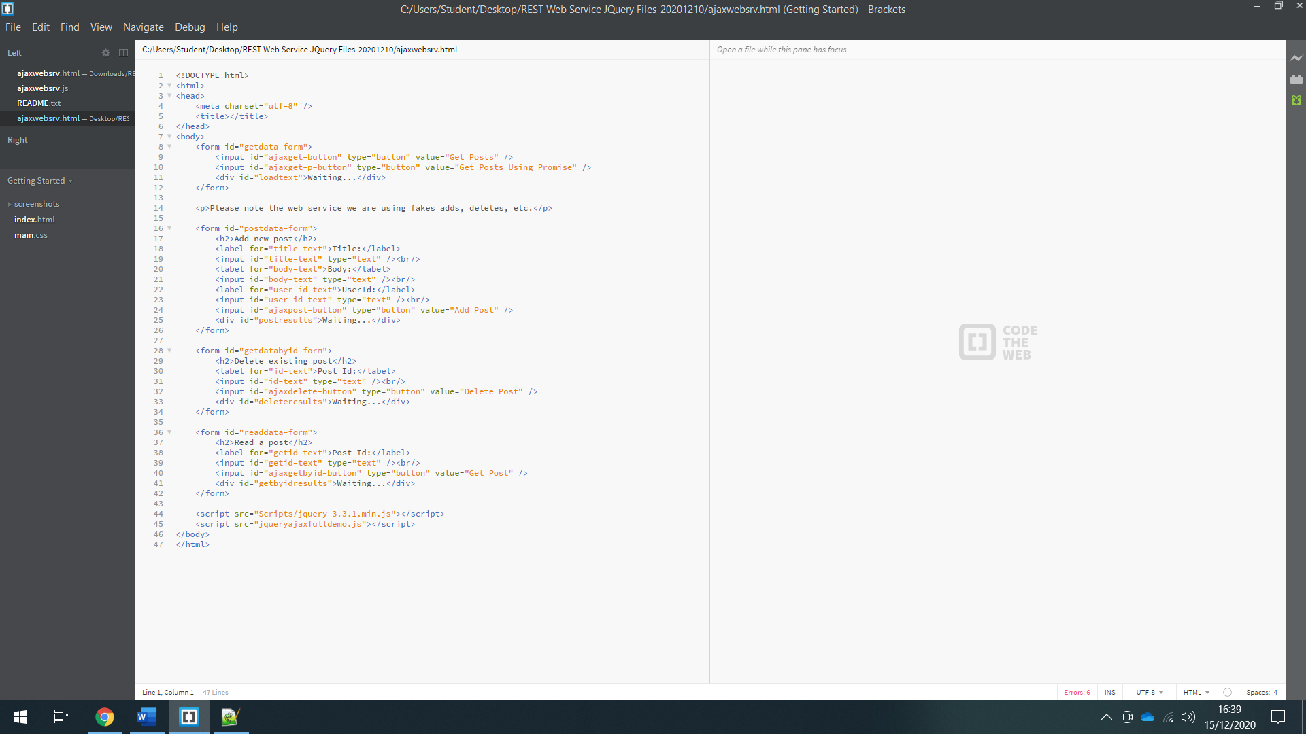
Figure 1: buttons.
‘Get Posts’ and ‘Get Posts Using Promise’ buttons. The main difference of getting posts through the normal method and getting them using promise is that promise provides a way of monitoring their state and serves as a placeholder and container for the data they will return. Promise returns data and the members of the collection of promises can be resolved independently without regard to timing [1].

Figure 2: forms for adding a new post and view an existing post.
For the ‘postdata-form’, there is a label and input for the post title. The data type for all the input boxes are text because of the information being sourced. The second label and input boxes are for the body text. The third label and input box are the user ID which is for the user who entered the post. The last input id for the ‘ajaxpost-button’ is a button which will add the post. The div called ‘postresults’ is acknowledging that the post is waiting to be posted.

Figure 3: Get Data by ID form
Figure 3 is the getting data by ID form. It retrieves data already posted from the web service. There is just 1 label and input text box which is the post ID. Each post will have a unique number which will identify them, no post will have duplicating ID numbers. For example, there will be no posts which will both have the number 1. The final input of this form is ‘ajaxdelete-button’ which is a button to delete the post from the service. The div at the bottom of the form is ‘deleteresults’ which demonstrates that once the post gets deleted it shows that it is waiting and will be removed.

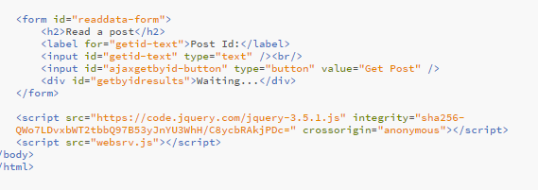
Figure 4: read post code.
This form is to read the data within the service. The only label and input text box are for the Post ID which will search the posts. The ‘ajaxbyid-button’ is the main button to fetch the post and it shall be retrieved. The ‘getbyidresult’ div is acknowledging that the post is waiting to be fetched from the web service. The bottom of the code is linking the JavaScript file and the current version of jQuery which is 3.5.1.

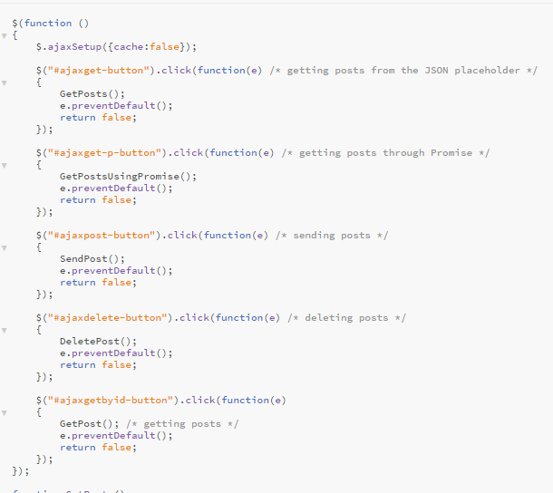
Figure 5: Buttons (JavaScript functions)
The ‘GetPosts’ and ‘GetPostsUsingPromise’ are for the 2 buttons located on the top of the HTML page. The ‘SendPost’, ‘DeletePost’ and ‘GetPost’ are also for the button functions on each of the different forms on the HTL page. Once the relevant buttons are pressed, they will complete their own action such as if the delete post button is pressed it shall delete the post or if the send post button is pressed it will send the post to the web service. The ‘SendPost’ function is an anonymous function because it is waiting for all the HTML elements to be rendered to jQuery objects and the dollar symbol means calling the function when all the browser elements have been rendered. It is secure as all the text boxes and buttons will exist when the function gets called. For the web service the cache has been turned off because the browser could cache something which does not require to be cached. Some parts of the code are using the CSS (Cascading Style Sheets) syntax. It is looking for the AJAX post button which is looking for an element with an ID for the unique ID which is ‘ajaxpost-button’.

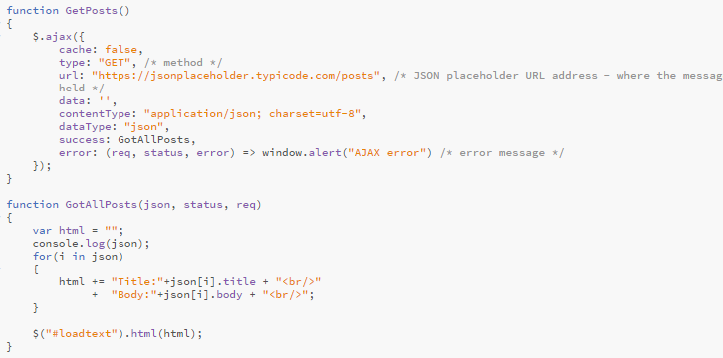
Figure 6: get all posts.
On the ‘$.ajax’ it demonstrates how the posts are going to be gathered, from JSON. The function ‘GotAllPosts’ demonstrates whether the posts have been gathered successfully from the JSON placeholder. If they are unable to be gathered an error message would then appear stating it had failed. The Uniform Resource Locator (URL) link to the JSON placeholder page where all the posts will be retrieved from. of the JSON placeholder which is where the messages and resources that will be coming from for the web service to be edited. The content data type that is going to be sent is JSON as well as the results and this will be converted into a JavaScript object. The type is GET; this is the method it where posts are gathered from the web service.

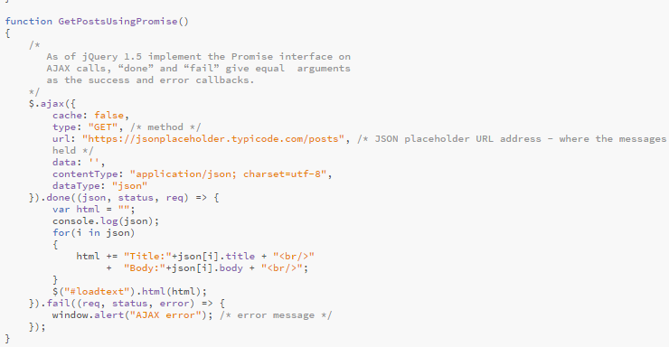
Figure 7: get posts using promise.
Once this function has been completed, it will console a message with the post title and information in the main body. The content data type that is going to be sent is JSON as well as the results and this will be converted into a JavaScript object. The type is GET; this is the method it where posts are gathered from the web service.

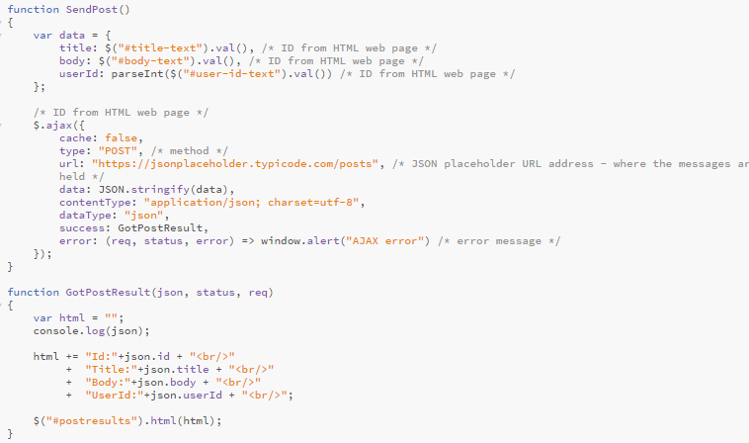
Figure 8: sending posts, getting posts and results.
For the ‘GetPostResults’, it shows that the result of getting the post has been successful and it shows the post and user ID, the post title, and the information within the main body. The top section is the setting a JavaScript object, it has a title and body field as well as a user ID. This object will be the JSON that will be communicated to the web service through the HTML request. When creating the data, we can use a JavaScript object. The ‘title-text’, ‘body-text’ and ‘user-id-text’ come from the HTML format on the web page. They are the identifiers for the various text boxes. The ‘.val’ elements of the coding signifies reading the value of the text boxes on the HTML page. The ‘parseInt’ for ‘user-id-text’ converts the text into an integer. This is beneficial because the service would understand what is text and what is a whole number. The type is POST, this is the method it gets sent to the web service. The content data type that is going to be sent is JSON as well as the results and this will be converted into a JavaScript object.

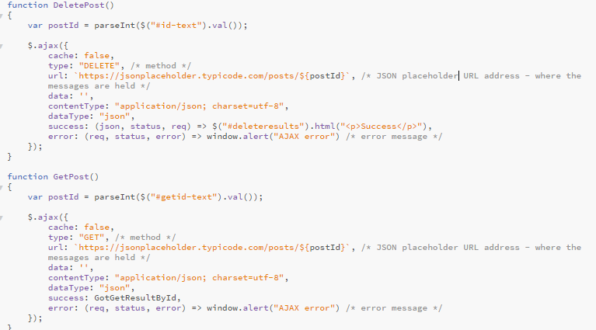
Figure 9: deleting and retrieving posts.
Figure 9 is demonstrating the ‘DeletePost’ and ‘GetPost’ JavaScript functions. For the ‘GetPost’, the post ID can be entered, the web service can be communicated with and the post will be retrieved. The content data type that is going to be sent is JSON as well as the results and this will be converted into a JavaScript object. The type is GET; this is the method it where posts are gathered from the web service.

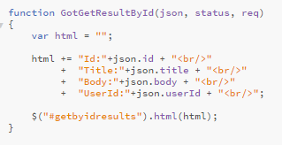
Figure 10: post results
Figure 10 demonstrates the structure of the results of getting posts. It would show as successful and show the post and user ID, the title of the post and what is in its main body.

Outcome
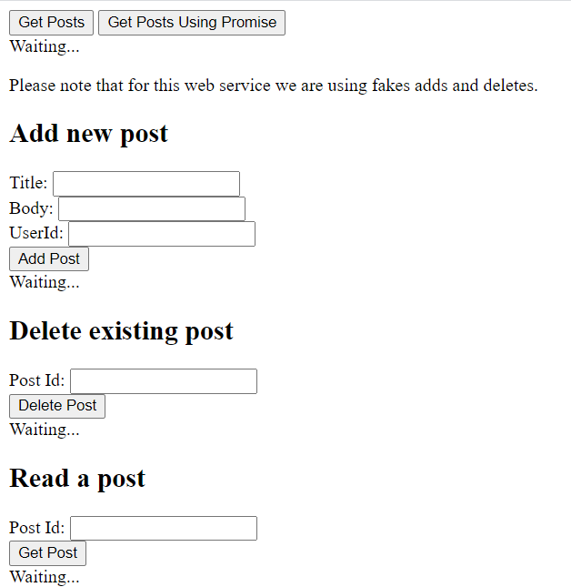
Figure 11: Web service interface
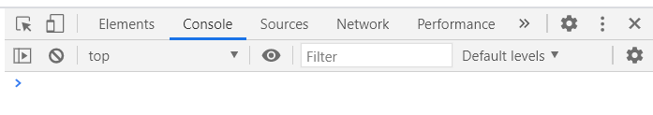
Figure 12: Console (developer tools)
The console on the developers’ tool on the internet browser was checked to see if there were any errors, none were discovered.

Testing

Test 1
The expected result of the test is that posts should be gathered using the ‘Get Posts’ button. It should gather all the posts from the JSON placeholder page. This test has been successful as all the posts have been gathered.

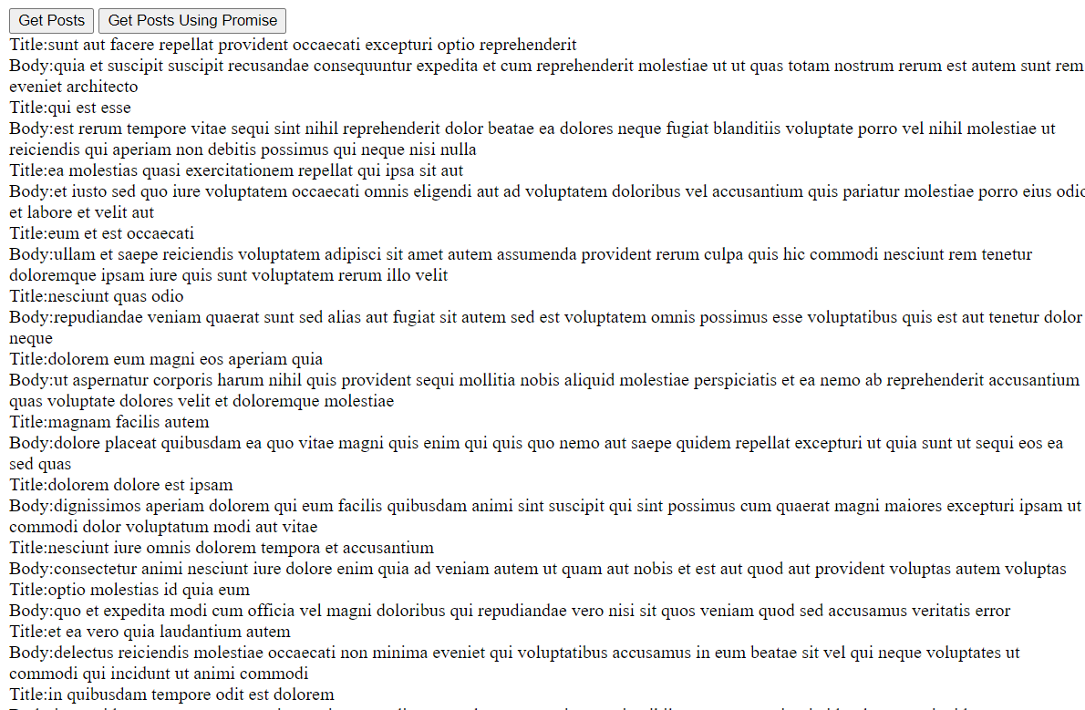
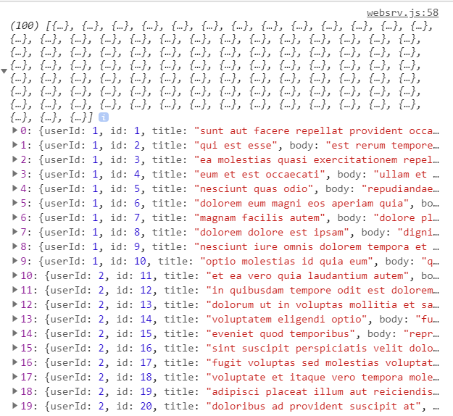
Figure 13: Get posts result with console log.

Test 2
The expected result of the test is that posts should be gathered using the ‘Get Posts Using Promise’ button. It should gather all the posts from the JSON placeholder page. This test has been successful as all the posts have been gathered.

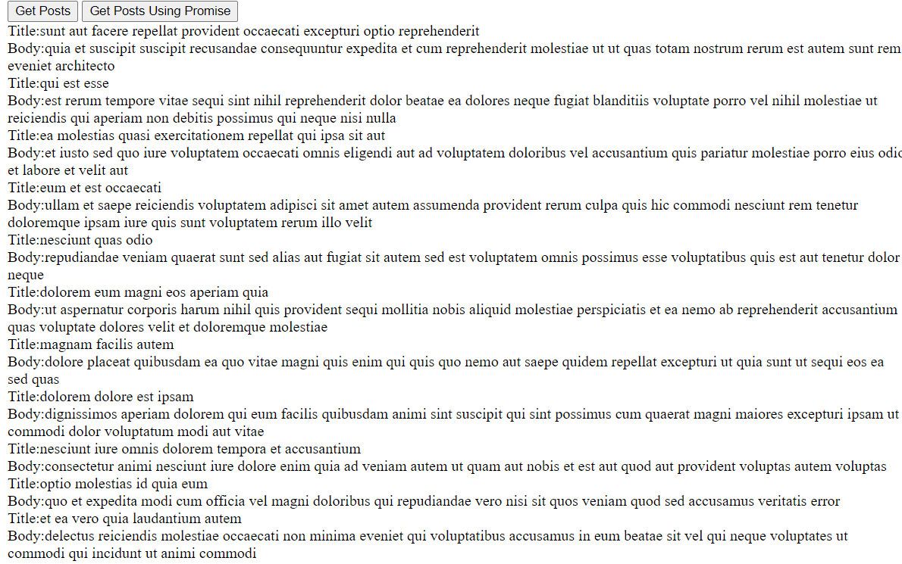
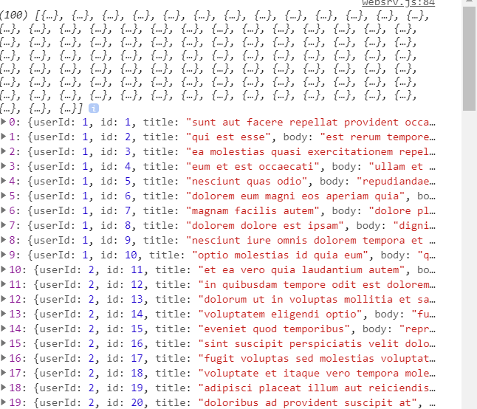
Figure 14: Get posts using promise result with console log.

Test 3
The expected result of the test is that a new post shall be added to the web service using the ‘Add new post’ form. The test has been successful as the post has been added.
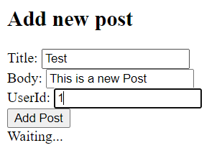
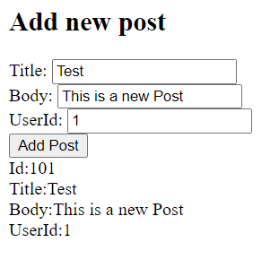
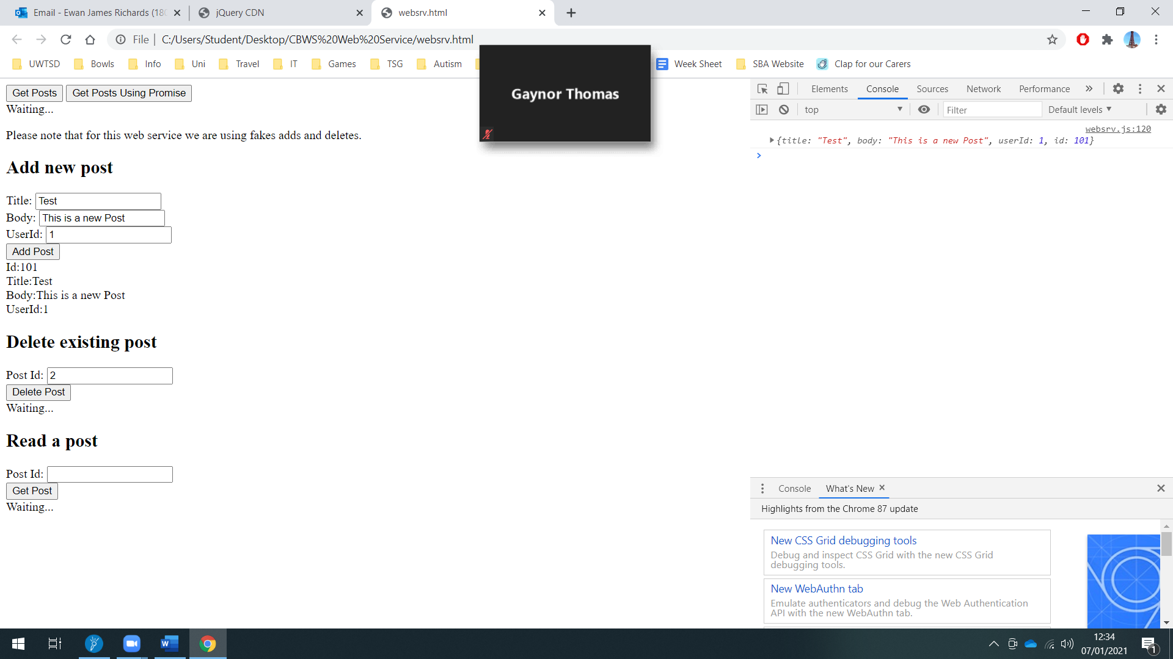
Figure 15: Add post result with console log.

Test 4
The expected result of the test is that a post shall be deleted from the service using the ‘Delete existing post’ form. The test has been successful as the post has been deleted.
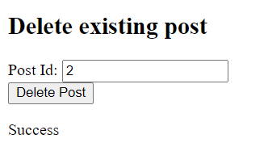
Figure 16: Delete post result.

Test 5
The expected result of the test is that a post should appear after entering the ‘Post Id’ on the ‘Read a post’ form. The test has been successful as post 4 has appeared.

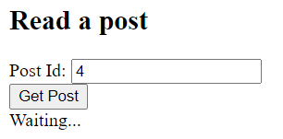
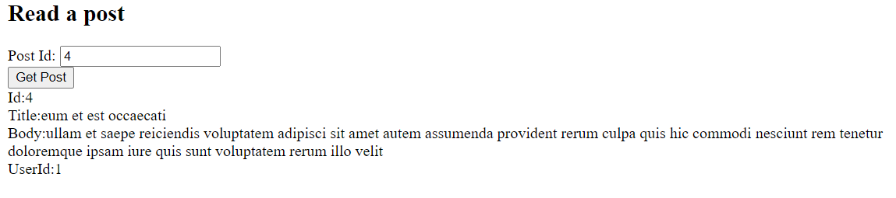
Figure 17: Read post result.

SOAP, REST and GraphQL comparisons
This part of the report will compare SOAP, REST and GraphQL. The advantages and drawbacks shall be discussed.

SOAP
SOAP is a web service access procedure which was founded in June 1998 and was formed by Microsoft. It was initially formed to take over older technologies that fail to work nicely on the internet such as the Distributed Component Object Model (DCOM) and Common Object Request Broker Architecture (CORBA). These technologies fail as they rely on binary messages. The eXtendible Markup Language (XML) interaction that SOAP engages with works more efficiently over the internet [2].

SOAP by 3 different entities – service provider, service registry and service requester. The provider is the network addressable unit that allows and performs demands from the consumer. The consumer is an appliance that needs a service. The registry is a network-based guide that includes accessible services. The consumer discovers the description in the registry which is distributed by the provider. The description consumer begins communicating with the service. The interaction between these entities is centered on the XML and SOAP rules. SOAP messages are created by envelope, header, and body. The envelope component finds the XML file as a SOAP message. The header component gathers call and reaction data. Communication and technique requests are specified as XML files and are delivered across a transport procedures Simple Mail Transfer Protocol (SMTV), File Transfer Protocol (FTP) and HyperText Transfer Protocol (HTTP) [4].

Advantages
The advantages are that the Web Service Definition Language (WSDL) document offers comparing and practical information of the web services for customer systems whilst not including the fundamental execution technologies. SOAP uses XML information for shipment as well as an agreement, so it can be interpreting any equipment. The SOAP protocol is universally understood to it is an industry specification methodology with many accessible open-source applications [5] [6] [7].

REST has demonstrated its ability to meet the requirements of the biggest companies while at being proficient to maintain internet of things appliances and products being created [7].

Disadvantages
The disadvantages of using SOAP is that it just uses the XML format, JSON format is not validated. SOAP is centered on a contract, so there is a strict coupling among the user and server applications. SOAP is a slow web service as the payload values are big for a string message, as it utilizes XML format. When there is an update in the server-side contract, the user sub classes should be produced again, and it cannot be examined easily in the web browser [5].

REST
The REST web service was introduced by Roy Fielding. REST is client server architecture in which client delivers applications to the server and then the server passes the application and sends information. A source is discovered by URL. Interpretation of properties is usually a file that collects the existing property status. REST does not need the communication structure such as envelope and header which is needed in SOAP communications. The design values of REST are addressability, statelessness, and uniform interface. For addressability REST models require the datasets to work on applications which are marked with URL. A uniform and standard interface are utilized to gain access to the REST resources such as using a static settings of HTTP techniques. Every operation is impartial and not related to the preceding operation as all information needed to process the application is included in that application only, client meeting details are not kept on server side so server reactions are impartial. These values make the REST function easy to use and lightweight. [4]

REST has its own principles which must be satisfied if an interface needs to be referred as RESTful.
Principle | Definition
Client-server | By dividing the user interface (UI) from the data storage capacity, it enhances the convenience of the UI throughout programs and increases scalability by streamlining the server elements.
Stateless | Each appeal from client to server should contain all the data required to interpret the application and should not take benefit of any collected information collated in the server. Session state is consequently kept completely on the client.
Cacheable | Cache limitations entail that the data inside a reaction to an application be labelled as cacheable or non-cacheable. If an application is cacheable, a client cache is awarded the right to recycle that reaction data for later, equal requests.
Uniform interface | By using the software engineering theory of simplification to the element interface, the system build is streamlined, and the profile of communications is enhanced. To have a standardized interface, many architectural limitations are needed to assist the performance of elements. REST is marked by some interface constraints: documentation and exploitation of resources around statements; self-descriptive communications; and software as the mechanism of system state.
Layered system | The system style lets an architecture to be comprised of hierarchical levels by limiting component performance such that every element cannot view after the first layer of which they are communicated with.
[8]

Advantages
An advantage of using the REST web service permits a larger assortment of data systems. When connected with JSON, REST is usually considered better to work with. Because of this, REST presents improved assistance for browser customers. REST offers great performance, especially through caching for data that is not modified or dynamic. REST is the protocol applied often for general services such as Amazon and Google. It is mostly faster and uses a smaller amount of bandwidth. It is also simpler to combine with current websites with no need to change site infrastructure. This allows developers to work quicker instead rather than spend time creating a site from the beginning. Developers can add extra functionality [9].

Same as SOAP, REST has demonstrated its ability to meet the requirements of the biggest companies while at being proficient to maintain the smallest internet of things appliances and products being created [9].

Disadvantages
One of the disadvantages of using this web service is that REST programming languages are non-resource oriented to the handling code that creates URL which could turn out to be complicated. There is some confusion of applying REST. REST over HTTP has come to be identical with REST which guides people to believe that HTTP is REST [10][11].

Other disadvantages of using this web service is that REST works on HTTP, there cannot be asynchronous calls. Also, sessions are unable to be preserved [4].

Illustration
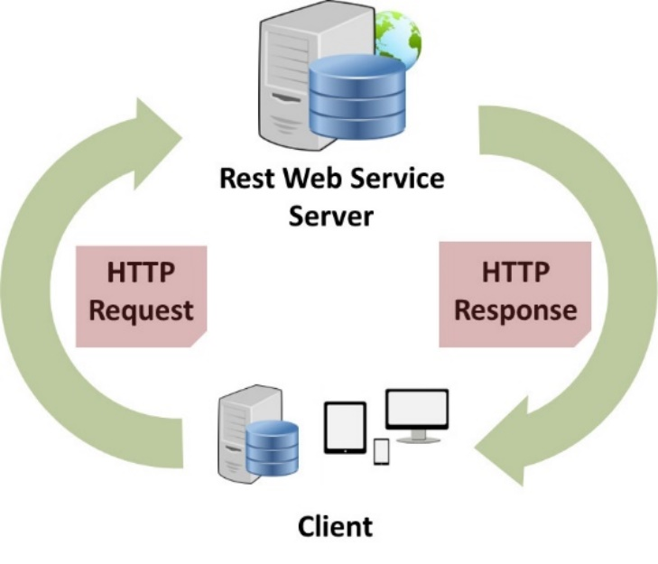
Figure 18: REST web service
The illustration above demonstrates how a typical REST web service would work. A client sends a HTTP request to the REST web service server and once that request has been processed, it sends a response to the client. For example, if there are 80 posts within the web service and the client wishes to view post 10, the client sends a HTTP request to view post 10. The web service then processes that request, finds the 10th post and the responds to the client with the post. Another example could be that if the client wants to delete a post, the send a request to the web service to delete a post, the server processes it and responds back acknowledging that the post has been deleted.

GraphQL
GraphQL is a query language for API’s and a runtime for completing queries with current data. GraphQL creates comprehensible information of the statistics in your API, provides people the ability to ask for precisely what they require, makes it simpler to make APIs, and allows effective developer devices. GraphQL queries send results. Applications using this service are quick and secure because they handle the data they receive, not the server [12][13].

The differences between REST and GraphQL web services are that REST collects information and you shall receive a full list of information. If users wanted to gather specific information, users are unable to limit the areas that the service sends, users always get a complete set of information. With GraphQL, this is powerful because users can fetch the data they specifically ask for, it limits the amount of processing required so it has the potential to be quicker than REST [14].

Advantages
The advantages are that it is useful for big projects. By combining multiple developments behind its API, GraphQL merges them and hides their complication. The GraphQL server is liable for collecting the information from existing systems and collect it up in the GraphQL response structure.

Disadvantages
While allowing clients to ask for what they need, the GraphQL web service could query face performance problems if client ask for many nested fields at the same time. It is recommended to use a REST API for bigger requests. While GraphQL is a useful method for many microservices, it is recommended to use the REST architecture. GraphQL does not identify files, an upload feature is not part of its requirements. To allow for uploads in your GraphQL application there are many alternatives such as creating a new API or using a library such as Apollo for creating the GraphQL complex request requirements [14].

Conclusion
A dynamic webpage that uses AJAX and a REST API to exchange data has been created using HTML and JavaScript. It includes loading data in JSON format and display record while the page is being interacted with.

A report has been written compares and contrasts SOAP, REST and GraphQL web services. The benefits and drawbacks of each have been discussed.

References

[1] | M. Treder, “Asynchronous JavaScript: Using Promises With REST APIs in Node.js,” Blog, 30 July 2020. [Online]. Available: https://www.twilio.com/blog/asynchronous-javascript-using-promises-rest-apis-nodejs. [Accessed 29 December 2020].
[2] | SmartBear, “SOAP vs REST. What's The Difference,” SmartBear, 2 January 2020. [Online]. Available: https://smartbear.com/blog/test-and-monitor/soap-vs-rest-whats-the-difference/. [Accessed 17 November 2020].
[3] | P. P. Snehal Mumbaikar, “Web Services On SOAP and REST Principles,” International Journal of Scientific and Research Publications, vol. 3, no. 5, pp. 668-671, 2013.
[4] | Pankaj, “Web Services Interview Questions,” Journal Dev, 2020. [Online]. Available: https://www.journaldev.com/9193/web-services-interview-questions-soap-restful#soap-advantages. [Accessed 18 November 2020].
[5] | W3C, “Web Services Description Language (WSDL) 1.1,” W3c, 15 March 2001. [Online]. Available: https://www.w3.org/TR/2001/NOTE-wsdl-20010315. [Accessed 18 November 2020].
[6] | w3schools.com, “Introduction to XML,” w3schools.com, 2020. [Online]. Available: https://www.w3schools.com/xml/xml_whatis.asp. [Accessed 18 November 2020].
[7] | S. Dhingra, “REST vs. SOAP: Choosing the best web service,” SearchAppArchitecture, 7 November 2016. [Online]. Available: https://searchapparchitecture.techtarget.com/tip/REST-vs-SOAP-Choosing-the-best-web-service. [Accessed 7 January 2021].
[8] | REST API Tutorial, “What is REST,” REST API Tutorial, 2020. [Online]. Available: https://restfulapi.net/. [Accessed 19 November 2020].
[9] | A. Stringfellow, “SOAP vs. REST: Differences in Performance, APIs, and More,” DZone, 28 March 2017. [Online]. Available: https://dzone.com/articles/differences-in-performance-apis-amp-more. [Accessed 23 November 2020].
[10] | “What is a URL,” Verisign, 2020. [Online]. Available: https://www.verisign.com/en_US/website-presence/online/what-is-a-url/index.xhtml. [Accessed 23 November 2020].
[11] | A. Rotem-gal-oz, “REST - The Good, Thr Bad and The Ugly,” DZone, 14 May 2009. [Online]. Available: https://dzone.com/articles/rest-%E2%80%93-good-bad-and-ugly. [Accessed 23 November 2020].
[12] | GraphQL, “GraphQL A query language for your API,” The GraphQL Foundation, 2020. [Online]. Available: https://graphql.org/. [Accessed 23 November 2020].
[13] | Upwork, “What is an API and How Does It Work?,” Upwork, 2020. [Online]. Available: https://careers.upwork.com/blogs/startup-resources-upwork-blog/what-is-an-api-and-how-does-it-work. [Accessed 23 November 2020].
[14] | D. Russell, “GraphQL vs REST: What You Need to Know,” Rubric, 21 November 2019. [Online]. Available: https://www.rubrik.com/en/blog/technology/19/11/graphql-vs-rest-apis. [Accessed 7 January 2021].
[15] | altexsoft, “GraphQL; Core Features, Architectures, Pros and Cons,” altexsoft, 23 March 2019. [Online]. Available: https://www.altexsoft.com/blog/engineering/graphql-core-features-architecture-pros-and-cons/. [Accessed 24 November 2020].

Table of Figures
Figure 1: buttons. 3
Figure 2: forms for adding a new post and view an existing post. 3
Figure 3: Get Data by ID form 3
Figure 4: read post code. 4
Figure 5: Buttons (JavaScript functions) 5
Figure 6: get all posts. 6
Figure 7: get posts using promise. 6
Figure 8: sending posts, getting posts and results. 7
Figure 9: deleting and retrieving posts. 8
Figure 10: post results 8
Figure 11: Web service interface 9
Figure 12: Console (developer tools) 9
Figure 13: Get posts result with console log. 11
Figure 14: Get posts using promise result with console log. 11
Figure 15: Add post result with console log. 12
Figure 16: Delete post result. 13
Figure 17: Read post result. 13
Figure 18: REST web service 16

Appendices

Appendix 1: HTML code (AJAX Web Service)
<!DOCTYPE html>
<html>
<head>
<meta charset="utf-8" />
<title></title>
</head>
<body>
<form id="getdata-form">
<input id="ajaxget-button" type="button" value="Get Posts" />
<input id="ajaxget-p-button" type="button" value="Get Posts Using Promise" />
<div id="loadtext">Waiting...</div>
</form>

<p>Please note that for this web service we are using fakes adds and deletes.</p>

<form id="postdata-form">
<h2>Add new post</h2>
<label for="title-text">Title:</label>
<input id="title-text" type="text" /><br/>
<label for="body-text">Body:</label>
<input id="body-text" type="text" /><br/>
<label for="user-id-text">UserId:</label>
<input id="user-id-text" type="text" /><br/>
<input id="ajaxpost-button" type="button" value="Add Post" />
<div id="postresults">Waiting...</div>
</form>

<form id="getdatabyid-form">
<h2>Delete existing post</h2>
<label for="id-text">Post Id:</label>
<input id="id-text" type="text" /><br/>
<input id="ajaxdelete-button" type="button" value="Delete Post" />
<div id="deleteresults">Waiting...</div>
</form>

<form id="readdata-form">
<h2>Read a post</h2>
<label for="getid-text">Post Id:</label>
<input id="getid-text" type="text" /><br/>
<input id="ajaxgetbyid-button" type="button" value="Get Post" />
<div id="getbyidresults">Waiting...</div>
</form>

<script src="https://code.jquery.com/jquery-3.5.1.js" integrity="sha256-QWo7LDvxbWT2tbbQ97B53yJnYU3WhH/C8ycbRAkjPDc=" crossorigin="anonymous"></script>
<script src="websrv.js"></script>
</body>
</html>

Appendix 2: JavaScript (.JS) file.
$(function ()
{
$.ajaxSetup({cache:false});

$("#ajaxget-button").click(function(e) /* getting posts from the JSON placeholder */
{
GetPosts();
e.preventDefault();
return false;
});

$("#ajaxget-p-button").click(function(e) /* getting posts through Promise */
{
GetPostsUsingPromise();
e.preventDefault();
return false;
});

$("#ajaxpost-button").click(function(e) /* sending posts */
{
SendPost();
e.preventDefault();
return false;
});

$("#ajaxdelete-button").click(function(e) /* deleting posts */
{
DeletePost();
e.preventDefault();
return false;
});

$("#ajaxgetbyid-button").click(function(e)
{
GetPost(); /* getting posts */
e.preventDefault();
return false;
});
});

function GetPosts()
{
$.ajax({
cache: false,
type: "GET", /* method */
url: "https://jsonplaceholder.typicode.com/posts", /* JSON placeholder URL address - where the messages are held */
data: '',
contentType: "application/json; charset=utf-8",
dataType: "json",
success: GotAllPosts,
error: (req, status, error) => window.alert("AJAX error") /* error message */
});
}

function GotAllPosts(json, status, req)
{
var html = "";
console.log(json);
for(i in json)
{
html += "Title:"+json[i].title + "<br/>"
+ "Body:"+json[i].body + "<br/>";
}

$("#loadtext").html(html);
}

function GetPostsUsingPromise()
{
/*
As of jQuery 1.5 implement the Promise interface on
AJAX calls, “done” and “fail” give equal arguments
as the success and error callbacks.
*/
$.ajax({
cache: false,
type: "GET", /* method */
url: "https://jsonplaceholder.typicode.com/posts", /* JSON placeholder URL address - where the messages are held */
data: '',
contentType: "application/json; charset=utf-8",
dataType: "json"
}).done((json, status, req) => {
var html = "";
console.log(json);
for(i in json)
{
html += "Title:"+json[i].title + "<br/>"
+ "Body:"+json[i].body + "<br/>";
}
$("#loadtext").html(html);
}).fail((req, status, error) => {
window.alert("AJAX error"); /* error message */
});
}

function SendPost()
{
var data = {
title: $("#title-text").val(), /* ID from HTML web page */
body: $("#body-text").val(), /* ID from HTML web page */
userId: parseInt($("#user-id-text").val()) /* ID from HTML web page */
};

/* ID from HTML web page */
$.ajax({
cache: false,
type: "POST", /* method */
url: "https://jsonplaceholder.typicode.com/posts", /* JSON placeholder URL address - where the messages are held */
data: JSON.stringify(data),
contentType: "application/json; charset=utf-8",
dataType: "json",
success: GotPostResult,
error: (req, status, error) => window.alert("AJAX error") /* error message */
});
}

function GotPostResult(json, status, req)
{
var html = "";
console.log(json);

html += "Id:"+json.id + "<br/>"
+ "Title:"+json.title + "<br/>"
+ "Body:"+json.body + "<br/>"
+ "UserId:"+json.userId + "<br/>";

$("#postresults").html(html);
}

function DeletePost()
{
var postId = parseInt($("#id-text").val());

$.ajax({
cache: false,
type: "DELETE", /* method */
url: `https://jsonplaceholder.typicode.com/posts/${postId}`, /* JSON placeholder URL address - where the messages are held */
data: '',
contentType: "application/json; charset=utf-8",
dataType: "json",
success: (json, status, req) => $("#deleteresults").html("<p>Success</p>"),
error: (req, status, error) => window.alert("AJAX error") /* error message */
});
}

function GetPost()
{
var postId = parseInt($("#getid-text").val());

$.ajax({
cache: false,
type: "GET", /* method */
url: `https://jsonplaceholder.typicode.com/posts/${postId}`, /* JSON placeholder URL address - where the messages are held */
data: '',
contentType: "application/json; charset=utf-8",
dataType: "json",
success: GotGetResultById,
error: (req, status, error) => window.alert("AJAX error") /* error message */
});
}

function GotGetResultById(json, status, req)
{
var html = "";

html += "Id:"+json.id + "<br/>"
+ "Title:"+json.title + "<br/>"
+ "Body:"+json.body + "<br/>"
+ "UserId:"+json.userId + "<br/>";

$("#getbyidresults").html(html);
}

