How are cats portrayed in art throughout history?

From Ancient Egypt to the 19th century and modern day, cats have been the muse of many artists throughout history, whether it was for their unique personalities, or their efficient pest control abilities, there is no doubt that cats have inspired humanity since the beginning of time. However, it is within this essay I am going to research whether this inspiration is positive or negative, by looking at civilizations like Ancient Egypt and Europe during the Middle Ages; both of which have differing views on cats and what they represent, I will answer the question ‘How are cats portrayed in art throughout history?’

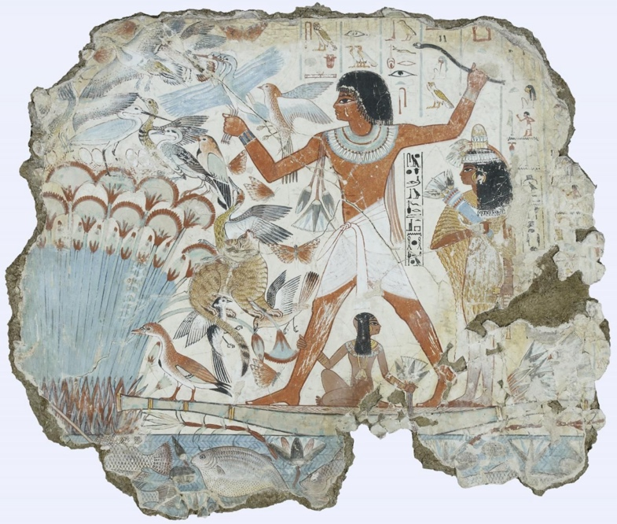
Some of the earliest depictions of cats that we know of have been in Ancient Egypt, Elizabeth Yuko, the author of the article ‘How Cats Became Divine Symbols in Ancient Egypt’ states, “The animals were initially adopted as useful predators in ancient Egypt and gradually became symbols of divinity and protection.” (E. Yuko, 2023), this is shown in a painting that was discovered inside the tomb of Nebamun.
(Britishmuseum.org, Date unknown)
(Unknown (Approximately 1350BC) Nebamun hunting in the marshes)

The painting above depicts Nebamun standing on a small boat hunting birds, while a cat catches a bird in its mouth and two others in its claws. While the paintings were being conserved and researched The British Museum told, “One notable discovery was the gold leaf gilding on the eye of the cat on the Fowling in the Marshes fragment. This is the only known example of gilding on wall paintings in Theban tomb chapels.” (The British Museum, no date). This could mean that the cat in that painting played a prominent role in Nebamun’s life that it was significant enough to be honored with him after he died. The cat in this piece also is painted to look powerful and possibly even sneaky with it being able to capture three birds at the same time.

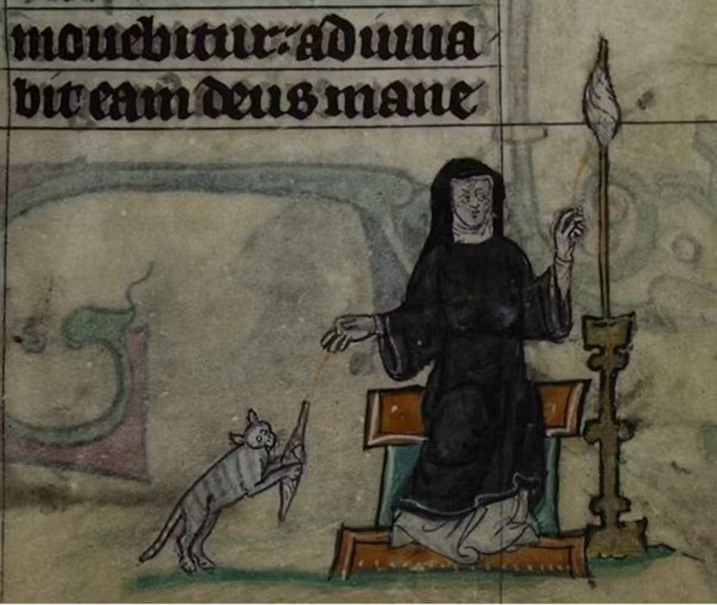
Comparing this to how cats are viewed in the Middle Ages is a stark and noticeable contrast, Margherita Cole the author of the article ‘Look At How Cats Were Portrayed in Medieval Art’ said, “Paintings of cats in Medieval art are known for their humorously strange appearances, which is perhaps tied to their poor standing in European society in the Middle Ages.” (M. Cole, 2022). And she isn’t entirely wrong.
(Bangor.ac.uk, Date unknown)
(Unknown (Early 14th century) No title)
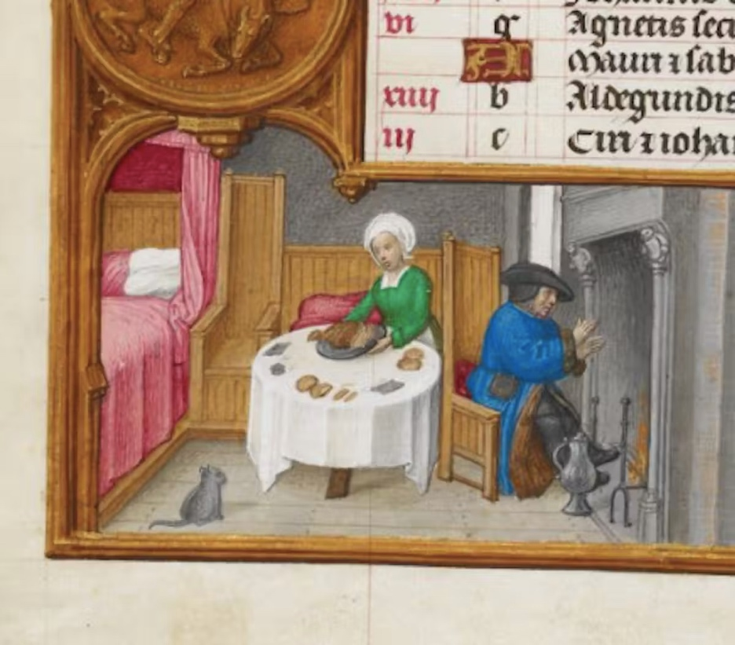
Even though the illustration above shows a cat and a nun together, cats were seen as being associated with the devil so many people thought that they should not be allowed in religious spaces. Madeline S Killacky, author of the article ‘Cats in the Middle Ages: What Medieval Manuscripts Teach Us About Our Ancestors Pets’ said, “There do not seem to have been any formal rules, however, stating that members of religious communities were not allowed to keep cats – and the constant criticism of the practice perhaps suggests that pet cats were common” (M. S. Killacky, 2022) so even though it was frowned upon to keep cats in religious spaces, it seemed like many people still enjoyed their company. Surprisingly, this could also be said about keeping cats in medieval households too.
(Bangor.ac.uk, Date unknown)
(Gerard Horenbout (1500-05) No title)
The illustration above shows a man sitting by the fire and a woman making food at the table in their home while a small cat sits on the floor looking up at them. This scene could suggest that the small cat was originally being kept around for catching rats and mice, however the way the cat is sat on the floor waiting for food; could imply the couple now have accepted the cat as part of their family, despite their reputation.

Even though some were more accepting of cats in the average medieval household, they were not as accepting as Japan and China at the time. According to Laura. A. Vocelle, author of the article ‘Cats in Asian Art’, “Early scrolls show cats on leashes and living in luxurious lives indoors. In contrast, in China cats were depicted as hunters.” (L.A. Vocelle, 2016) Comparing this to Ancient Egypt, Japanese and Chinese views on cats are quite similar.
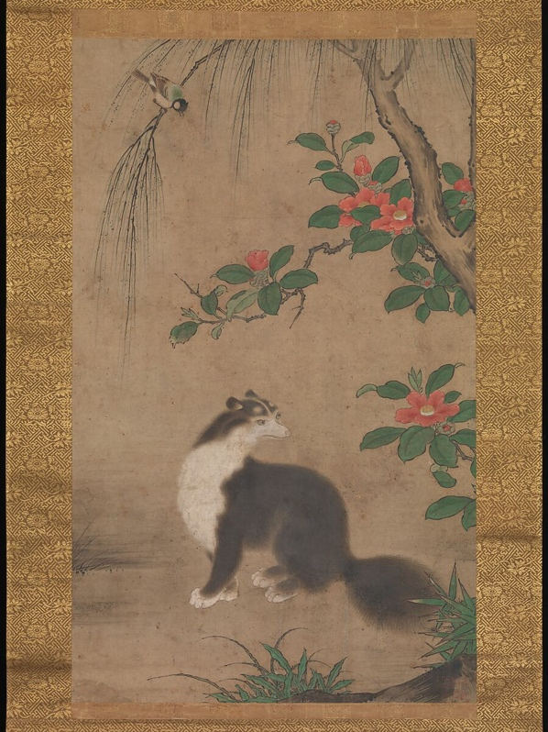

(Metmuseum.org, 2000)
(Uto Gyoshi (Muromachi Period 1392-1573) Musk Cat)

The painting above depicts a Musk Cat sitting near some red camellia flowers while a bird taunts the cat from a Willow tree branch above. The Musk cat is painted to look very fluffy and elegant compared to the flowers and trees which have a noticeable outline, this could mean the artist Uto Gyoshi wanted the Musk Cat to be the focal point of the painting, and by using different visual textures he’s definitely succeeded. Continuing this point, since he has made the cat the focal point this shows he found the Musk Cat appealing and that he definitely has some form of appreciation for cats in general.
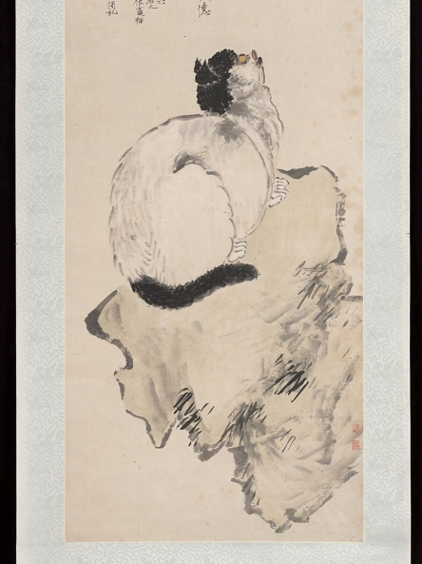

(Metmuseum.org, 2000)
(Wang Li (Qing Dynasty 1644-1911) Cat)
The illustration above depicts a white and black cat looking upwards while sitting on what appears to be a rock. The cat is painted to look like a quick sketch with there not being much detail compared to the Musk Cat; this could suggest the artist wanted to capture the cat’s likeness before it moved. To continue this point, this could be why there isn’t much of a background or surroundings, or Wang Li the artist just wanted the cat to be the focus of the piece; furthering how influential cats were at this time.

Around this time an artist by the name of Louis Wain started gaining popularity for his vibrant and imaginative illustrations of cats partaking in human activities, such as playing football or golf, having tea parties, or dressing up in fashionable clothing. Chris Beetles author of the book Louis Wains Cats says, “Louis Wain cats appear in action-packed panoramas, sometimes dozens of them in running battle with one another or with the dogs, the ghastly outcome of which can only be conjectured.” (C. Beetles, 2021, p.46)
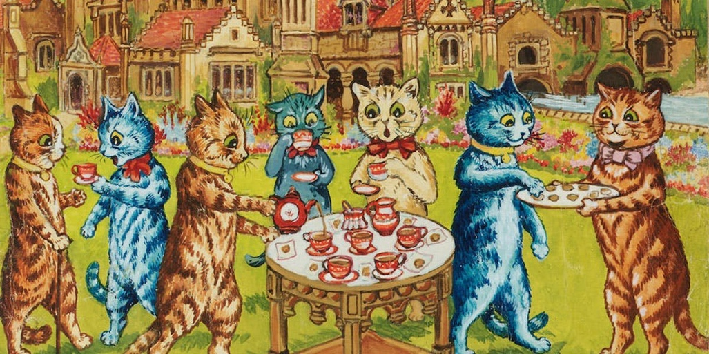
(Bonhams.com, 2005)
(Louis Wain (Date unknown) A tea party on the lawn
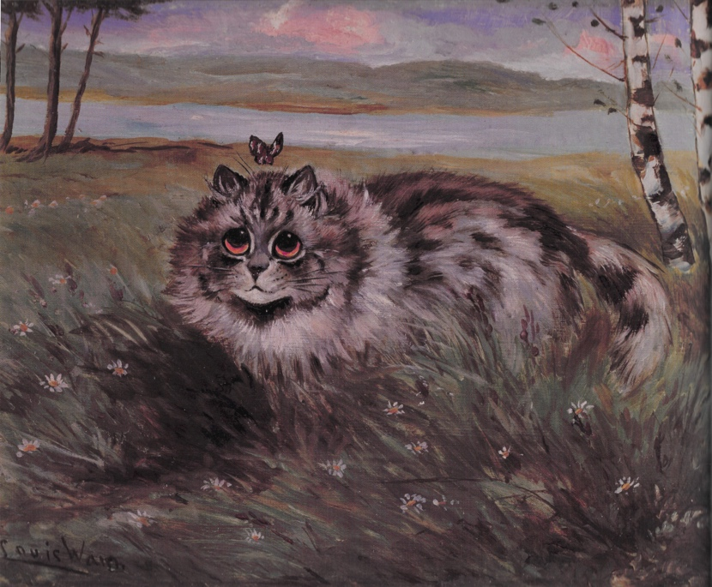
The painting above depicts seven cats having a tea party in what looks to be the flower garden of a big mansion or hospital. The colours are very vibrant and flashy, each of the cats are unique from one another, with all of them having different fur patterns, colours, collars/bows, and facial expressions. The way Louis Wain uses watercolour paints reminds me of crayons or coloured pencils; like a children’s drawing, which could be the effect he is trying to go for to make the cats look more friendly, or to appeal to a younger audience.

(C. Beetles, 2021, p.26.)
(Louis Wain (Date unknown) Watching the Butterfly)
The portrait above shows a fluffy grey tabby cat standing in a grassy field admiring a butterfly above its head. Compared to most of his other works the colours in this painting are much duller, however that does not mean it’s a bad thing. The painting has a very melancholic feel to it and the grey tones and subtle colour in the sky could be a representation of Louis Wains declining mental health. According to Chris Beetles author of the book ‘Louis Wains Cats’, “His post-war financial difficulties may have contributed to a rapid decline into schizophrenia as Wain became isolated, impecunious and unmanageable.” (C. Beetles, 2021, p.6, p.7), which could explain the dull colours.

Another artist who is very well known for their portraits of cats is Martin Leman. Much like Louis Wain, Martin Lemans cat portraits can sometimes be found wearing fancy business suits, lounging on sofas with a glass of wine, or even dressed up like military leaders; however, the majority of his paintings are just of regular cats. “It is impossible for Leman to suppress a mischievous and knowing smile. Choosing carefully the type of cat, the exact colouration and most importantly, the facial expression, the clothing overlaid, enhances the undeniable character within…” (R. Dutt, 2004, p.40).
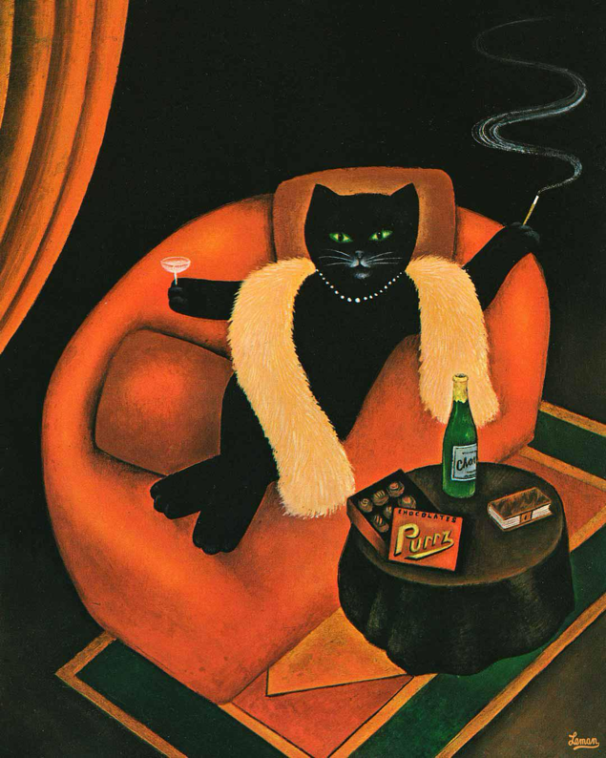

(R. Dutt, 2004, p.42)
(Martin Leman (1980) Cat in Sofa)

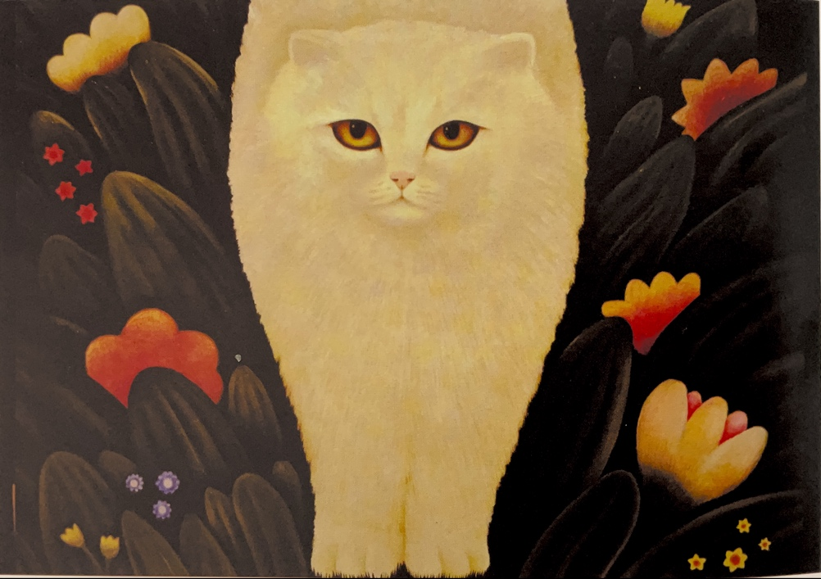
The portrait above depicts a black cat lounging on a red sofa wearing some pearls and a yellow shawl drinking a cocktail and smoking a cigarette. The colour palette of this piece is quite limited with the two main colours being black and red, however the colours that are there are incredibly bold and vibrant. The cat in this piece is posed very confidently, leading me to believe Martin Leman could have based them off of a cat he has interacted with before; maybe thinking the cat has a strong personality and wanted to capture it in a humorously exaggerated way. Or perhaps the idea is based on someone who he’s met, and decided to turn them into a cat, once again in a humorously exaggerated way.

(R .Dutt, 2004, p.18)
(Martin Leman (Date unknown) Cat in the Garden)

The painting above shows a fluffy white cat with orange eyes, standing in a field of grass and colourful flowers. Compared to the other Martin Leman painting I referenced the colours are much lighter however the palette is still quite warm, this could suggest the painting is mean to be set in the evening as the sun is setting, giving the scene a warm glow. The most detailed part in this painting is the cat's eyes, they are a bright orange with a yellow gradient and heavy shading, based on the point I just suggested the cat's eyes could be a representation of the sunset as its not actually shown in the painting itself; Robin Dutt author of Martin Lemans Cats points this out, “And those eyes – anything from marmalade orange to jade green seem to shine and glister. In fact, cats’ eyes do shine by night and have a totally different quality by day.” (R. Dutt, 2004, p.65).

From all the research that I have gathered I have found out that cats have been portrayed quite positively throughout history especially in art. I’ve also found out that cats represent many different things for different cultures and people; Ancient Egyptians liked cats because of their hunting abilities but kept them around as a symbol of divinity, people in the Middle Ages had the same idea however some people didn’t agree, and at the same time people in Ancient Japan and China kept cats because of their elegance and symbolism of wealth. Then finally there’s people like Louis Wain and Martin Leman who both portray cats in a humorous personified manner; so, my point from the start still stands, cats will forever be inspirational for artists around the world, now and for the future yet to come.

Bibliography
Bonhams. (2005). Louis Wain. [Online]. Bonhams.com. Last Updated: 8 November. Available at: https://www.bonhams.com/auctions/11963/lot/177/ [Accessed 7 December 2024].

Chris Beetles. (2021). Louis Wain’s Cats. Great Britain: CanonGate. p.46.

Chris Beetles. (2021). Louis Wain’s Cats. Great Britain: CanonGate. p.26.

Cyril Aldred. (1993). Egyptian art. London: Thames and Hudson.

Elizabeth Yuko. (2023). How Cats Became Divine Symbols in Ancient Egypt. [Online]. History.com. Last Updated: August 9th. Available at: https://www.history.com/news/cats-ancient-egypt [Accessed 3 December 2024].

Gerard Horenbout (1500-05) No title [Unknown materials] The British Library, London.

Laura. A. Vocelle. (2016). Cats in Asian art. [Online]. Thegreatcat.org. Last Updated: (Unknown). Available at: https://www.thegreatcat.org/the-cat-in-art-and-photos-2/cats-asian-art/ [Accessed 3 December 2024].

Louis Wain (Date unknown) A tea party on the lawn [Watercolour and body colour] Location Unknown

Louis Wain (Date unknown) Watching the Butterfly [Oil on board] Location unknown.

Madeleine S Killacky. (2022). Cats in the Middle Ages: What Medieval Manuscripts Teach Us About Our Ancestors’ Pets. [Online]. Bangor.ac.uk. Last Updated: December 23. Available at: https://www.bangor.ac.uk/news/2022-12-23-cats-in-the-middle-ages-what-medieval-manuscripts-teach-us- [Accessed 6 December 2024].

Margharita Cole. (2022). Look at How Cats Were Portrayed in Medieval Art. [Online]. Mymodernmet.com. Last Updated: October 31st. Available at: https://mymodernmet.com/cats-in-medieval-art/ [Accessed 3 December 2024]. .

Marie-Laure Bernadac. (1991). Picasso Museum Paris: The Masterpieces. Munich: Prestel.

Martin Leman (1880) Cat in Sofa [Oil on board] Location unknown.

Martin Leman (Date unknown) Cat in the Garden [Oil on board] Location unknown.

Robin Dutt. (2004). Martin Leman’s Cats. London: Chaucer Press. p.18.

Robin Dutt. (2004). Martin Leman’s Cats. London: Chaucer Press. p.40.

Robin Dutt. (2004). Martin Leman’s Cats. London: Chaucer Press. p.42.

Robin Dutt. (2004). Martin Leman’s Cats. London: Chaucer Press. p.65.

The British Museum. (No date). Egyptian life and death. [Online]. Britishmuseum.org. Last Updated: 2024. Available at: https://www.britishmuseum.org/collection/galleries/egyptian-life-and-death [Accessed 3 December 2024].

The Metropolitan Museum of Art (Unknown). Cat. [Online]. Metmuseum.org. Last Updated: Unknown. Available at: https://www.metmuseum.org/art/collection/search/49470 [Accessed 7 December 2024]

The Metropolitan Museum of Art (Unknown). Musk Cat. [Online]. Metmuseum.org. Last Updated: Unknown. Available at: https://www.metmuseum.org/art/collection/search/53222 [Accessed 7 December 2024].

Unknown (Approximately 1350BC) Nebamun hunting in the marshes. [Paint on Plaster] The British Museum, London.

Unknown (Early 14th century) No title [Unknown materials] The British Library, London.

Uto Gyoshi (Muromachi Period 1392-1573) Musk Cat [Ink and colour on paper] The Metropolitan Museum of Art, New York.

Veronica Sekules. (2001). Medieval Art. Oxford: Oxford University Press.

Wang Li (Qing Dynasty 1644-1911) Cat [Ink and colour on paper] The Metropolitan Museum of Art, New York.

