Mihail Tutunaru
University of wales trinity saint david
student id 1910014
Academic and Emplyability Skills

Contents
Personal overview ...................................................................................................................... 2
Skill Evaluation ............................................................................................................................3
Personal Evaluation ...................................................................................................................... 4
Action Plans ...................................................................................................................... 7
Application ...................................................................................................................... 8
Conclusion and Evaluation .......................................................................................................... 9
References ...................................................................................................................... 10

Personal overview
My name is Mihail Tutunaru born in Moldova. I am 30 years old currently living in UK, in London, studying Cloud Computing at University of Wales Trinity Saint David.
At 7 years old I went to school and i studied 12 years. At school I started to learn English and Russian. After 9th grade I started to learn informatics and I liked it very much. For me was very interesting to learn more about computers about how it works. After I graduated school I went to college. There I was studying “Automatics and Informatics” for three years. My first job after college was like a IT Technician in a PC store. The college gave me a valuable set of skills so I could use them at my work. I managed to gather a good set of technical knowledge and skills by myself. I started to learn “java” programming language by myself, then I went to some courses of “java”. At the college I was studying “C++” so I had some ideas of programming. At that job I gained a lot of useful skills like working with software, hardware, managing my own time and prioritizing everything. Then I came to London to get a job in IT field. Here in London IT roles are very competitive so you need to know a lot and to be very smart. That’s why I applied for studying here, to get an UK degree, and to learn new things and to continue my education. Its very important to improve your job prospect.

Skill Evaluation
I think there are a lot of skills, which you will need throughout your high education. Different people have different methods of learning, because everybody is different.
Evaluative skills are used to assess the credibility of the claims people make or post, and to assess the quality of the reasoning people display when they make arguments or give explanations. We can also apply our evaluation skills to assess the quality of many other elements that are important for good thinking, such as analyses, interpretations, explanations, inferences, options, opinions, beliefs, hypotheses, proposals, and decisions. People with strong evaluation skills can judge the quality of arguments and the credibility of speakers and writers.
Corporations have to adapt fast to the changing environment, so do the employees of those companies. To make the change smooth, HR managers should know precisely what skills the company’s staff already have and what competencies they are lacking. Based on this information, they can organize trainings and seminars to fill the gaps in the knowledge and skills.
Presentation is the first and most important of them. To start a job you must first be hired and for that you need to present yourself well. First, the CV, this is where a lot of people struggle. It’s not an easy task to convince someone to choose you over hundreds of other candidates with just a piece of paper. Creativity, good grammar and professional styling help a lot in that regard. Next comes the interview, meeting a stranger face to face and convincing them to work with you for the foreseeable future requires looking professionally, proper body language, good manners and the ability to impress and catch the attention of someone are essential for a successful interview.
For communication skills you may have to clarify exactly what the event was intended to achieve, so that the stakeholders were always completely satisfied obtain information from venues about their capacity, availability and facilities, so that you had all the information at your fingertips when you needed it. Explain exactly what you want from any suppliers or speakers, so that they don’t do the wrong thing negotiate over terms and conditions for venue and equipment hire, so that you get the best deals. Draft publicity materials targeted at an appropriate audience, so that you get all the right people coming. Write clear joining instructions for delegates and exhibitors, so that you minimize the number of questions they ask respond promptly to enquiries with accuracy, patience and tact, so that nobody experiences delays or confusion provide regular reports and updates on the event’s progress, so that stakeholders feel fully informed and don’t worry.

Personal Evaluation

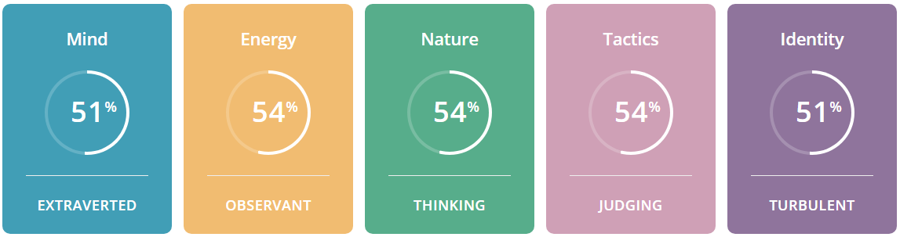
Figure 1 Personal Test Graphic

My personality type is an Executive.
Executives are representatives of tradition and order, utilizing their understanding of what is right, wrong and socially acceptable to bring families and communities together. Embracing the values of honesty, dedication and dignity, people with the Executive personality type are valued for their clear advice and guidance, and they happily lead the way on difficult paths. Taking pride in bringing people together, Executives often take on roles as community organizers, working hard to bring everyone together in celebration of cherished local events, or in defense of the traditional values that hold families and communities together.
Demand for such leadership is high in democratic societies, and forming no less than 11% of the population, it’s no wonder that many of America’s presidents have been Executives. Strong believers in the rule of law and authority that must be earned, Executive personalities lead by example, demonstrating dedication and purposeful honesty, and an utter rejection of laziness and cheating, especially in work. If anyone declares hard, manual work to be an excellent way to build character, it is Executives.
Executives are aware of their surroundings and live in a world of clear, verifiable facts – the surety of their knowledge means that even against heavy resistance, they stick to their principles and push an unclouded vision of what is and is not acceptable. Their opinions aren’t just empty talk either, as Executives are more than willing to dive into the most challenging projects, improving action plans and sorting details along the way, making even the most complicated tasks seem easy and approachable.
However, Executives don’t work alone, and they expect their reliability and work ethic to be reciprocated – people with this personality type meet their promises, and if partners or subordinates jeopardize them through incompetence or laziness, or worse still, dishonesty, they do not hesitate to show their wrath. This can earn them a reputation for inflexibility, a trait shared by all Sentinel personalities, but it’s not because Executives are arbitrarily stubborn, but because they truly believe that these values are what make society work.
The main challenge for Executives is to recognize that not everyone follows the same path or contributes in the same way. A true leader recognizes the strength of the individual, as well as that of the group, and helps bring those individuals’ ideas to the table. That way, Executives really do have all the facts, and are able to lead the charge in directions that work for everyone.
Strengths
Dedicated – Seeing things to completion borders on an ethical obligation for Executives. Tasks aren’t simply abandoned because they’ve become difficult or boring – people with the Executive personality type take them up when they are the right thing to do, and they will be finished so long as they remain the right thing to do.
Strong-willed – A strong will makes this dedication possible, and Executives don’t give up their beliefs because of simple opposition. Executives defend their ideas and principles relentlessly, and must be proven clearly and conclusively wrong for their stance to budge.
Direct and Honest – Executives trust facts far more than abstract ideas or opinions. Straightforward statements and information are king, and Executive personalities return the honesty (whether it’s wanted or not).
Loyal, Patient and Reliable – Executives work to exemplify truthfulness and reliability, considering stability and security very important. When Executives say they’ll do something, they keep their word, making them very responsible members of their families, companies and communities.
Enjoy Creating Order – Chaos makes things unpredictable, and unpredictable things can’t be trusted when they are needed most – with this in mind, Executives strive to create order and security in their environments by establishing rules, structures and clear roles.
Excellent Organizers – This commitment to truth and clear standards makes Executives capable and confident leaders. People with this personality type have no problem distributing tasks and responsibilities to others fairly and objectively, making them excellent administrators.
Weaknesses
Inflexible and Stubborn – The problem with being so fixated on what works is that Executives too often dismiss what might work better. Everything is opinion until proven, and Executive personalities are reluctant to trust an opinion long enough for it to have that chance.
Uncomfortable with Unconventional Situations – Executives are strong adherents to tradition and when suddenly forced to try not reviewed solutions, they become uncomfortable and stressed. New ideas suggest that their methods weren’t good enough, and abandoning what has always worked before in favor of something that may yet fail risks their image of reliability.

Judgmental – Executives have strong convictions about what is right, wrong, and socially acceptable. Executives’ compulsion to create order often extends to all things and everyone, ignoring the possibility that there are two right ways to get things done. Executives do not hesitate to let these “deviants” know what they think, considering it their duty to set things right.
Too Focused on Social Status – Executives take pride in the respect of their friends, colleagues and community and while difficult to admit, are very concerned with public opinion. Executives (especially Turbulent ones) can get so caught up in meeting others’ expectations that they fail to address their own needs.
Difficult to Relax – This need for respect fosters a need to maintain their dignity, which can make it difficult to cut loose and relax for risk of looking the fool, even in good fun.
Difficulty Expressing Emotion – This is all evidence of Executives’ greatest weakness: expressing emotions and feeling empathy. People with the Executive personality type get so caught up in the facts and most effective methods that they forget to think of what makes others happy, or of their sensitivity. A detour can be breathtakingly beautiful, a joy for the family, but Executives may only see the consequence of arriving at their destination an hour late, hurting their loved ones by rejecting the notion too harshly.

So in conclusion I can say that few personality types are as practical and strong-willed as Executives. Known for their reliability and administrative skills, Executives are good at creating and maintaining a secure and stable environment for themselves and their loved ones. Executives’ dedication is invaluable in many areas, including their own personal growth. Yet Executives can be easily tripped up in areas where their rational and practical approach is more of a liability than an asset. Whether it is finding (or keeping) a partner, learning to relax or improvise, reaching dazzling heights on the career ladder, or managing their workload, Executives need to put in a conscious effort to develop their weaker traits and additional skills. What you have read so far is just an introduction into the complex concept that is the Executive personality type. You may have muttered to yourself, “wow, this is so accurate it’s a little creepy” or “finally, someone understands me!” You may have even asked “how do they know more about me than the people I’m closest to?” This is not a trick. You felt understood because you were. We’ve studied how Executives think and what they need to reach their full potential. And no, we did not spy on you – many of the challenges you’ve faced and will face in the future have been overcome by other Executives. You simply need to learn how they succeeded. But in order to do that, you need to have a plan, a personal roadmap. The best car in the world will not take you to the right place if you do not know where you want to go. We have told you how Executives tend to behave in certain circumstances and what their key strengths and weaknesses are. Now we need to go much deeper into your personality type and answer “why?”, “how?” and “what if?”
Action Plans
My short term goals include improving my computer skills like software development and networking. My goal right now is getting better at programming in general and develop my knowledge of Python to prepare for the next semester. I’d also like to learn new software in the near future and possibly to make some projects. While I might be good at programming I struggle at networking. I’d like to improve a lot in that direction and this is going to be my main focus for the next couple of months. Also my goal is to concentrate on training my education and academic skills.
My long term goals for the future are to open my own company to operate in IT field.
When I’m confident enough with my knowledge and practical skills, I will try to grow a business.
The business will be a MSP (Managed Service Provider). I have a friend and he wants as well to grow such a company so I think we will try together to realize this idea.

Action plan
Short term
- Expand academic and education skills
- Grow more knowledge in networking and software development
- Grow some practical experience in networking and software development
- Manage time better
- Improve English language

Long Term
- To graduate UWTSD
- Find a job in IT field
- To get marred
- Make new friends
- Grow up my own business

Application
How to secure your data
Any information that your business stores digitally needs to be properly protected. From financial information and payment details to contact information for your staff, data usage in the UK is protected by law. Data protection is the process of safeguarding important information from corruption, compromise or loss. Consequently, a large part of a data protection strategy is ensuring that data can be restored quickly after any corruption or loss. Protecting data from compromise and ensuring data privacy are other key components of data protection. In present days more than 95% or even more of the business is using computers daily and they store crucial files on them. To prevent data loss, it is sensible to have a backup strategy to preserve the consistency of the valuable data. One of the disaster scenario that can corrupt my data that I can think of is a virus and to be honest I am quite vulnerable to this threat as I never use an antivirus on my laptops. In my opinion for an experienced user an antivirus software is a waste of resources. In case of such a disaster a quick reinstall of the windows fixes the problem and as explained previously my sensible data is already backed up. Another disaster could be accidentally formatting the wrong partition when reinstalling the OS, but even then there is a software that can restore data. Third disaster can be physical damage to a hard drive which is the worst option because it’s unavoidable and the data in most cases is unrecoverable or very expensive to recover. In such a case the only hope is the lost data was backed up beforehand.

Principles of data protection
The key principles of data protection are to safeguard and make available data under all circumstances. The term data protection is used to describe both the operational backup of data and business continuity/disaster recovery. Data protection strategies are evolving along two lines: data availability and data management. Data availability ensures users have the data they need to conduct business even if the data is damaged or lost. There are two key areas of data management used in data protection: data lifecycle management and information lifecycle management. Data lifecycle management is the process of automating the movement of critical data to online and offline storage. Information lifecycle management is a comprehensive strategy for valuing, cataloging and protecting information assets from application and user errors, malware and virus attacks, machine failure or facility outages and disruptions. More recently, data management has come to include finding ways to unlock business value from otherwise dormant copies of data for reporting, test/dev enablement, analytics and other purposes.

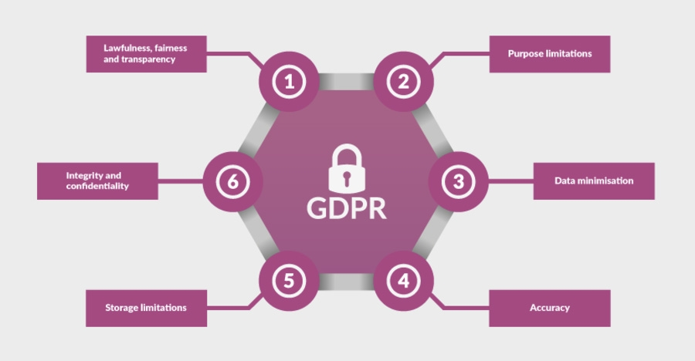
Figure 2 Six principles of data protection
Conclusion and Evaluation
My opinion is, that the above-mentioned qualities are hugely important for good academic and professional growth in the short and long term. With improving more important skills like time management and presentation skills, academic development can be easier and more pleasant to learn. Improvement of CV and Motivation letter writing skills, as well as motivation and ambition, the curve of professional progress can be elevated and pushed forward.
The path of life is not easy, and that is the amazing part of it. The obstacles; they’re carving you as a character and person. And each hurdle is an exam to evaluate yourself and see how much you want to achieve your goals. This should be the main reason to improve yourself and make the world a better place for you and others. The most important personality trait is passion because without any interest in a subject, we can never concentrate on the task before us. Creativity and problem solving skills are necessary to use the gained knowledge in a real world scenario and achieve results. Social skills like making friends and personality traits like interesting hobbies, kindness and being reliable are also very helpful in a work or study environment. Because of these thoughts and my skills, qualities, advanced thinking, and hard work, I strongly believe that they will guide me to a brighter future in a personal and professional manner. Considering the conclusion from this report in the future I’d like to be more proactive and not so distracted with gaming and focus more on learning new things.

References

Figure 1. Personality test available [Online] at https://www.16personalities.com/
Figure 2. Six privacy principles for general data protection available [Online] at https://www.consultancy.uk/news/13487/six-privacy-principles-for-general-data-protection-regulation-compliance

