

LOCATION: CARMARTHEN / LAMPETER /Swansea | LLEOLIAD: CAERFYRDDIN/ LLAMBED/abertawe
LEVEL 4/5/6/7 | LEFEL 4/5/6/7
EXAMINATION PERIOD | CYFNOD ARHOLIADAU
may 2021 | IONAWR 2021/ mai 2021/ Gorffennaf 2021

MODULE CODE: Enter abcd1234
OME CHEMISTRY ADVANCED

TIME: 2 HOURS plus ½ hour upload time
answer all questions

Equipment or materials required – None
Adnoddau neu ddefnyddiau sydd eu hangen - Dim

DO NOT change Margins/Headers/Footers/Layout of Cover page
Font: Times New Roman
Headings: 14px and BOLD
Body text: 12px

BEGIN EXAM QUESTIONS HERE!

ANSWER ALL QUESTIONS

Question 1 (8 marks)

a. Sketch the Bohr model of a deuterium atom, annotate each particle, and state the charge polarity of each particle. (3 marks)

b. State Bohr’s three postulates. (1 mark)

c. Explain why hydrogen emits light at discrete frequencies forming a spectrum which is unique to hydrogen. (3 mark)

d. State some practical uses for this phenomenon. (1 mark)

Model answer

a. Deuterium has a one proton with positive charge, one neutron which is neutral, and one electron which is negatively charged.
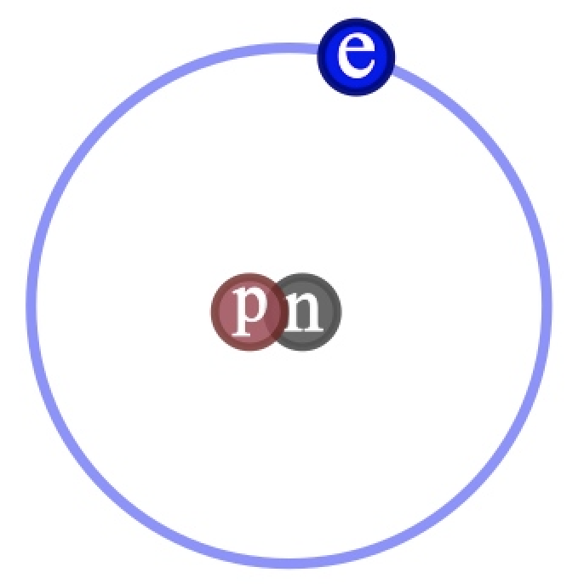
b.
1. An electron can revolve around the nucleus in certain fixed orbits of definite energy without emission of any radiant energy. Such orbits are called stationary orbits
2. An electron can make a transition from a stationary orbit of higher energy to a stationary orbit of lower energy and in so doing emits a single photon with a characteristic wavelength.
3. Only those orbits are allowed for which the angular momentum of the orbit is an integer multiple of h/2π where h is Planck’s constant.

c. The phenomena whereby unique frequencies at which hydrogen radiates light when electrons are excited is explained by Bohr’s second postulate above.

d. Elements can be identified from their unique spectra which is exploited in spectroscopy.

Question 2 (15 marks)

a. Name the 8 groups of elements in the periodic table. (1 mark)

b. Define the mass number A and the atomic number Z for an element. (2 marks)

c. State the number of electrons in the outer shell of nitrogen, oxygen, fluorine, and neon. (4 marks)

d. State the valency of nitrogen, oxygen, fluorine, and neon. (3 marks)

e. Explain the reactivity of this sequence of elements in terms of the number of electrons in the outer shell. (4 marks)

f. Which elements have most application to explosives and pyrotechnics? (1 mark)

Model answer

a.
- Hydrogen
- Alkali metals
- Alkali earth metals
- Transition metals
- Poor metals
- Non-metals
- Noble gases
- Rare earth metals

b. A is the mass number of an element, being the sum of protons and neutrons in one atom. Z is the atomic number of an element, being the number of protons in one atom of the element.

c.

Nitrogen - 5
Oxygen - 6
Flourine - 7
Neon - 8

d. Atoms achieve lower energy states by having filled outer shells. Neon has a completed outer shell and is unreactive. Flourine has only one electron missing, and can lower its energy significantly by filling this one vacancy. Nitrogen has three electrons missing from its outer shell and but the energy to complete its shell is lower and it is less reactive. Oxygen sits between flourine and nitrogen.

e.

Nitrogen - 3
Oxygen - 2
Flourine - 1

f. CHNO

Question 3 (18 marks)

a. Explain the meaning of stability in the context of explosives chemistry. (1 mark)

b. What is Boltzmann energy distribution? (3 marks)

c. What is activation energy? (3 marks)

d. Explain why nitrocellulose (NC) with an activation energy of 86 kJmol⁻¹ is less stable than RDX with an activation energy of 199 kJmol⁻¹. (3 marks)

e. Explain how stabilisers extend the life of NC-based propellants. (3 marks)

f. Artillery propelling charges formulated to have a 30-year life at 20°C are to be shipped to an equatorial operational theatre for field storage in ISO shipping containers. Assume the charges are 20 years old, having been stored at 20°C. The average temperature in the shipping containers is 50°C. Using a rule of thumb for how the rate of chemical reactions increases with temperature, estimate the life of the propelling charges in this container. (4 marks)

g. Explain a possible hazard if the propelling charges are left in the storage container after the time calculated. (1 mark)

Model answer

a. Stability in the context of explosives is the property of not changing over time.

b. Boltzmann energy distribution describes that molecules do not all have the same kinetic energy. A few will have very low energy. A few will have very high energy. Most will have energy part way between.

c. Activation energy is the minimum kinetic energy that must be obtained by an atom or molecule for it to take part in a reaction.

d. A greater proportion of molecules are able to achieve the activation energy in NC than RDX. NC therefore decomposes faster over time.

e. Stabilisers do not prevent decomposition of NC over time. Some decomposition is inevitable. However, breakdown products can auto-catalyse, i.e., accelerate this decomposition. Stabilisers prevent accelerated decomposition by reacting – mopping up – the breakdown products.

f. A rule of thumb is that the rate of chemical reaction doubles for an increase in temperature of 10°C. (But actually dependent on activation energy.) Of 30 years’ planned life, 20 have been spent, leaving 10 years remaining life. Storage at 10°C higher than 20°C, i.e., 30°C will halve the life, 40°C will quarter, and 50°C will reduce to 1/8th. 10 years or 120 months divided by 8 is 15 months.

g. If stored in mass, the propellant may spontaneously ignite.

Question 4 (11 marks)

a. State Hess’s law (1 mark)

A pyrotechnic composition is to be made from ammonium nitrate and magnesium in a stoichiometric ratio.

b. Set out a balanced equation for the decomposition of this mixture. (3 marks)

c. Using the standard heats of enthalpy below, calculate the heat of reaction for molar quantities of the reactants. (4 marks)

Ammonium nitrate -365 kJmol⁻¹
Magnesium oxide -601 kJmol⁻¹
Water (gas) - 242 kJmol⁻¹

d. How does the heat of reaction from this reaction compare with 2.8 kJg⁻¹ provided by one gram of TNT. (3 marks)

Model answer

a. Hess’s Law states that the enthalpy change for a chemical reaction is independent of the route taken.

b. NH₄NO₃ + Mg ⇌ N₂ + 2H₂O + MgO

c. (2 x -242) + (-601) - (-365) = 720 kJ

d. 80 g + 24 g ⇌ 28 g + 36 g + 40 g = 104 g. 720 kJ for 104 g is 6.9 Jg-¹. This is higher than TNT.

Question 5 (18 marks)

A charge of 130 g is initiated and decomposes to form nitrogen and sodium.

a. Write a balanced equation for the decomposition of sodium azide. (2 marks)

b. How many grams of nitrogen are formed by the decomposition of 130 g of sodium azide? (2 marks)

c. At standard temperature and pressure (0°C, 100 kPa) how many litres of gas are formed? (2 marks)

d. Suppose 130 g sodium azide is mixed with other substances which give decomposition products of negligible volume but raise the nitrogen temperature. The composition is placed in a cylinder closed at one end, confined by a piston providing a perfect forward obturation. Assume the piston moves to maintain constant pressure. Calculate the volume of gas at 100 °C. (2 marks)

e. Suppose 130 g sodium azide is mixed with other substances which give decomposition products of negligible volume, but raise the nitrogen temperature. Assume the piston is fixed to maintain constant volume. Calculate the pressure of the gas at 100 °C. (2 marks)

f. Suppose 130 g sodium azide is mixed with other substances which gives decomposition products of negligible volume, but raises the nitrogen temperature to 100 °C. Suppose the mass of the piston is 500 g. Calculate the highest theoretical velocity which could be attained by the piston. (3 marks)

g. State reasons why this velocity cannot be attained in practice. (2 marks)

Model answer

a. 2Na(N₃)⇌ 2Na + 3N₂

b. 3 x 28 g = 84 g

c. 3 x 22.7 litres = 68.1 litres

d. 68.1 litres x 373/273 = 93 litres

e. 100 kPa x 373/273 = 137 kPa

f. PV = nRT = 3 x 8.314 JK⁻¹mol⁻¹ x 373 K = 9.3 kJ = ½ mv² => 192 ms⁻¹.

g. Require no heat lost to gun barrel, infinitely long gun barrel, no friction, perfect obturation etc.

Question 6 (18 marks)

a. State why nitrocellulose is a technically a misnomer and give a more correct name. (2 marks)

b. Describe the stages in manufacturing nitro-cellulose. (3 marks)

c. Explain the role of the nitronium ion in the manufacture of nitrocellulose and how it is formed. (2 marks)

d. What is ‘poaching’ of nitro-cellulose and why is it done? (2 marks)

e. What is meant by ‘low-nitrogen’ nitrocellulose and ‘high-nitrogen’ nitrocellulose? (1 mark)

f. What is meant by single-base, double-base and triple-base propellant and what would be suitable applications for each? (6 marks)

g. Name two major hazards of double-base propellant. (2 marks)

h. Given the above hazards, why is nitrocellulose still in service? (3 marks)

Model answer

a. ‘Nitro-’ designates -NO₂, whilst NC has NO₃ groups and should therefore be called ‘cellulose nitrate.’

b. Mixing and cooling of nitric and sulphuric acid to about 10 °C
Cooling of glycerine to about 10 °C;
Mixing of acids and glycerine with efficient cooling;
Warming to room temperature to complete reaction;
Separation of NG from spent acids by settling;
Washing of NG to remove acid;
Neutralisation of NG, e.g., sodium carbonate:

c. The role of the nitronium ion is to assist nitration. It is formed by the protonation of nitric acid by sulfuric acid.

d. Boiling to cause breakdown of unstable by products.

e. Low nitrogen NC is less than 12%. High nitrogen NC is greater than 12%.

f. Single-base. NC alone. High pressure, e.g., rifle cartridge propellant.
Double-base. NC plus NG. Low pressure e.g., pistol, shotgun, mortar propellant.
Triple base. NC + NG + nitroguanidine. High pressure lower temperature , e.g., artillery.

g. Poor stability, poor vulnerability.

h.
acceptable energy to volume;
predictable burning rate over a wide range of pressures
acceptable low flame temperature
capable of easy ignition
cheap and easy to manufacture
low signature i.e., minimum tendency to produce flash or smoke
reproduceable performance over a wide range of temperatures

Question 7 (17 marks)

a. Explain the meaning of sensitivity and sensitiveness as used within UK government services in the context of explosives engineering. (2 marks)

An emulsion explosive is made from the following components, shown below as % by mass, for packaging in cartridges.

ammonium nitrate 78%
sodium nitrate 5%
water 7%
oil 5%
aluminium 2%
sorbitan sesquioleate 2%
glass micro-balloons 1%

b. State the main use for emulsion explosives and the merits of emulsion explosives in this use. (3 marks)

c. Explain role of each component. (7 marks)

d. Explain the microstructure of an emulsion explosive. (2 marks)

e. Explain how the glass micro-balloons achieve their purpose. (3 marks)

Model answer

a. Sensitivity refers to the response of an explosive to stimuli such as flame or impact where initiation is intended. Sensitiveness refers to the response of an explosive to stimuli such as flame or impact where initiation is not intended.

b. Main uses are mining. Merits of emulsion explosives include safety, economy, performance, resistance to water and low gas emissions.

c. Ammonium nitrate - oxidiser
Sodium nitrate - oxidiser and sensitizing agent.
Water - binder and phlegmatiser
Oil - fuel
Aluminium – fuel and sensitiser
Sorbitan sesquioleate – emulsifier
Glass micro-balloons – sensitiser

d. Droplets of super-cooled ammonium nitrate solution forming the discontinuous phase, surrounded by oil as the continuous phase.

e. As the detonation wave impinges on unreacted explosive, the glass micro-balloons collapse. Air inside the micro-balloons is adiabatically compressed to a temperature above that required to ignite the surrounding explosive. Fragments of glass also contribute to initiation by impact and friction.

Question 8 (16 marks)

a. State three ways in which the pressure-time profile of a rocket propellant can be controlled. (3 marks)

b. Sketch the pressure-time profile for a tubular rocket grain burning on the inside surface only. (3 marks)

c. State Veille’s Law. Explain each term and its units. (4 marks)

d. Calculate the Pressure Index α and Burning Rate Coefficient β from the burning rate of a strand of propellant measured using a strand burner, as recorded in Table 1 below. (6 marks)
Pressure [MPa] | Rate r [mms⁻¹]
25 | 71
50 | 139
75 | 206
100 | 273
125 | 338
150 | 404
175 | 469
200 | 534

Table 1. Record of burn rate vs pressure.

Model answer

a. Chemical composition, grain geometry, chamber geometry.

b. Sketch should show correct curve shape and correctly labelled axes.

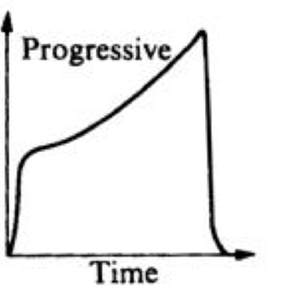
c. r = βP^{α}

r = burning rate [mm s⁻¹]
β = burning rate coefficient (specific to a given propellant)
P = pressure [MPa]
α = pressure index

d.
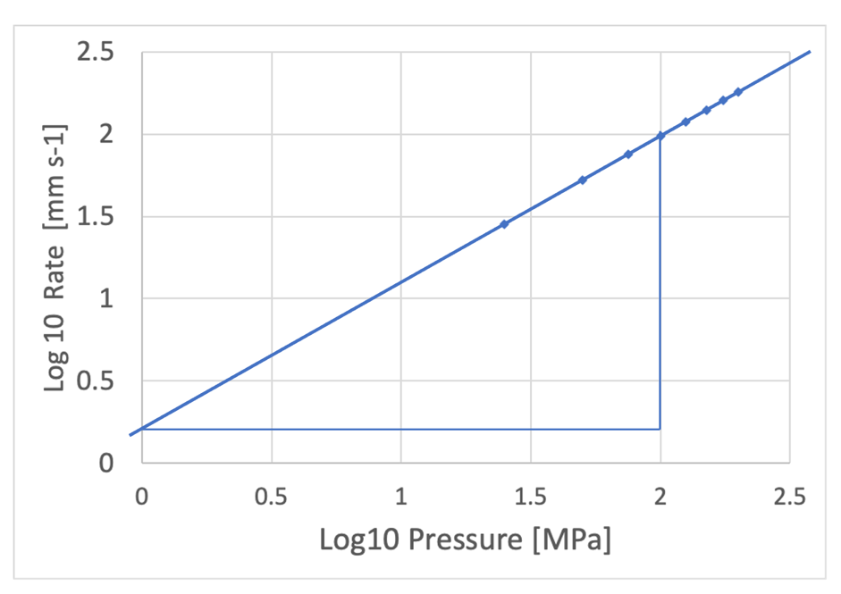

Burning rate coefficient β = line crosses axis at Log₁₀ rate = 0.21. 10 ^{0.21} = 1.62

Pressure index α = gradient of line = 1.8/2 = 0.9

Question 9 (19 Marks)

A red smoke signal is required to designate a parachute drop zone and indicate wind direction and speed. A pyrotechnic smoke composition is to be made from potassium chlorate, lactose and a volatile red dye (methylaminoanthraquinone).

a. Explain how volatile dyes can make coloured smokes. (4 marks)

b. Propose a practical form for the pyrotechnic composition in a hand-held signal and describe in a few steps how this could be made. (3 marks)

c. Before starting any practical work, what key activities must be carried out? (4 marks)

d. State factors which would change the rate of smoke production. (3 marks)

e. What is to be avoided when considering a rapid reaction? (1 mark)

f. What is the role of the gas produced in the smoke signal? (1 mark)

Consider the reactions below:

Reaction 1: 8KClO₃ + C₁₂H₂₂O₁₁ = 8KCl + 12 CO₂ + 12 H₂O (4.43 MJkg⁻¹)

Reaction 2: 4KClO₃ + C₁₂H₂₂O₁₁ = 4KCl + 12 CO + 12 H₂O (2.63 MJkg⁻¹)

g. Assuming the water produced by the reactions to be gaseous, and that the reactions take place at atmospheric pressure, compare the volume of gas generated in Reaction 1 with the volume of gas in Reaction 2. Think carefully before answering! (3 marks)

Model answer

a. Lactose is a fuel which burns using oxygen provided by potassium chlorate. The dye is volatilised by this heat, condenses as particles in the air forming coloured smoke.

b. Pressed as a pellet. Weighing, mixing, pressing.

c. Method Statement and Risk Assessment.

d. Chemical composition, pellet geometry, casing geometry.

e. The dye catching fire.

f. To propel the volatilised dye into the surrounding air.

g. The volume of gas at STP would be the same for both reactions. However, more heat is liberated in Reaction 1, so the temperature will be higher. The gas in Reaction 1 will expand more to create a greater volume.

Question 10 (16 marks)

The Al-Cu phase diagram is shown below.

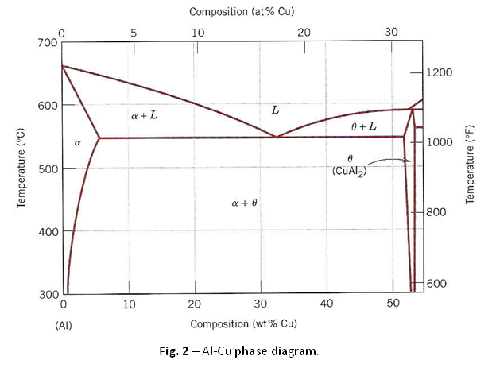
Figure 1. Al-Cu phase diagram

a. Sketch and explain the microstructure of the L, α, θ, α + θ, θ + L, phases. (5 marks)

b. Describe the phenomenon of dislocations. (4 marks)

c. Explain why the α + θ phase is likely to be stronger and less ductile than the α-phase. (2 marks)

d. Cups to contain booster pellets are to be drawn from discs of aluminium alloy containing 4% copper. Describe a suitable treatment process with reference to the phase diagram. (5 marks)

Model answer

a. L is liquid molten metal
α is a solid solution of copper dissolved in aluminium
θ is an intermetallic compound of copper aluminide
α + θ is precipitates of copper aluminide set in a matrix of solid solution of copper dissolved in aluminium
θ + L is a mixture of copper aluminide particles in a liquid solution of copper and aluminium.

b. Dislocations are stacking faults in the crystal structure which allow easy deformation of metals crystals.

c. The presence of θ precipitates in the α + θ phase prevents the easy movement of dislocations, thereby strengthening the metal.

d. Heat the discs about 550 °C to dissolve precipitates.
Cool to room temperature.
Alloy is soft because precipitates have not had time to reform.
Draw discs into cups.
Allow the precipitates to reform by aging.
Cups are now stronger and less ductile.

Diwedd/End

